
4
15TH OCTto3RD NOV,2022

KEYFEATURES
- DeputyCommissionerstoleadtheinitiative
- RuraldevelopmentDepartmenttobethenodaldepartment
- PlanningDevelopment&MonitoringdepartmentandITtobethesupport departments

ACTIONSANDTIMELINES
ACTION | RESPONSIBILITY | LATESTBY | REMARKS
Janabhiyan | Alldepartments | Oct15-26th | Goingon
DeputationofSecttstaff/ HoDs | GAD | Oct14 | Done
DeploymentofStaffto Panchayatsandservingof ordersondeployedofficers | DCs | Oct25 | DCswilldeployseniorlevelstaff fromthedistricts.Strictactionto betakenagainstabstentions.No exemptionstobegiven
Trainingofdistricttrainors onB2V4 | RDD | Oct26
Trainingofvisitingofficers | DCs | Oct27
FieldVisitstobecompleted by | VisitingOfficers | Nov3 | DCstosuperviseandensurethat eachPanchayatisvisitedwithin theperiodspecified
DataofB2V4tobe uploadedby | VisitingOfficers | Nov10 | DCstosuperviseandensurethat dataofallPanchayatsisupload- edbythevisitingofficerwithin theperiodspecified

INSTRUCTIONSFORTHEVISITINGOFFICER(DAYWISE)

DATE | INSTRUCTIONS | ACTIONPOINTS
Day0 | Meetingwithdeputy commissionerandhis/her team | - TakeprintoutsoffilledbookletsofB2V1,B2V2andB2V3from www.jkpanchayat.in  - Alsotakeprintoutsofthesummarizedexcelsheetsofthe previousphasesfromwww.jkpanchayat.in  - CollectATRsonissuesraisedduringprevious3phasesfromthe officeofDeputyCommissioner(Planningdeptt)  - Takeprintsofblank 2bookletsofB2V4fromwww.jkpanchayat.ine.Takeplansfor2previousyear sandATRsfromtheplanningdeptt f.  CompletetrainingsondifferentcomponentsofB2V4being organizedbyrespectiveDeputyCommissioners  g.CollectListofnewworksstarted/ongoing/completedduringthe previousandcurrentFinancialyearunderthefollowingheads:  - PRIgrants  - DistrictPlan  - UTplan  - MGNREGA  - Otherschemesofotherdepartments  - Anyotherwork  - Plans/beneficiarylists:  - MGNREGAdraftplandocumentfortheyear2022-23.  - ListofAwaas+beneficiariesalongwithIHHL Convergence  - Listofpensionbeneficiaries.  - ListofSHGs  - Listofagricultureschemebeneficiaries  - Listsofbeneficiariesfor:  - Variouscertificates/benefitstobedistributedbythe visitingofficer.  - Anyotheractivitiesidentifiedbydifferentdepartments

Day1 | Reachthevillage | 1. | Ensurethatallfrontlineworkersofdifferentdepttsarepresent.
 |  | 2. | Ensureexhibitionbydifferentdepts.aboutindividualbeneficiary schemes
 |  | 3. | InspectJKB/PSBcounters/outlets
 |  | 4. | Participate/ensureorganizationofsportsactivityinplayfield,talent hunt/culturalevent/youthactivity
 |  | 5. | GandhiKatha(suggesteddetailsuploadedonjkpanchayat.in)
 |  | 6. | Visitatleast2amritsarovarsandgetitsgeotaggedphotos
 |  | 7. | InspectKhidmat(CSC)CentresandcreateGenerateawarenesson 225schemesparticularlyG2CschemeslikeBEAMS,Janbhagidari, AapkiZaminAapkiNigrani,DigitalJ&K
 |  | 8. | Visitingofficershallalsoplanandconductpanchayatlevelconver- gencemeetingofalldepartments
 |  | 9. | CheckeffectivenessofCentrallysponsoredschemes
 |  | 10. | VisitandinspectallgovernmentestablishmentsincludingPHE, AWC,FPS,schools,etc
 |  | 11. | Attemptsaturationofdeliverableso JanAbhiyanandwherever deficienciesfound,leadadrivetoachievealldeliverables
 |  | 12. | Assesseffectivenessofsanitationcampaigninthepanchayat
 |  | 13. | Ensureselfemploymentactivitiesfor15youthperpanchayat
 |  | 14. | Identify20potentialcandidatesperpanchayatforHIMAYATtraining alongwiththetradeonwhichtheywanttraining
 |  | 15. | Whereverpossible,distributeemploymentlettersforpeopleselect- edundervariousgovernmentemployments
 |  | 16. | Intheevening,holdnormalmeetingwith seniorcitizens,govtem- ployeesincludingretiredemployees,exservicemen,youthclub,and any citizens ofthevillagewhoareenrolledincollege/university
 |  | 17. | OpendiscussiononNashaMuktAbhiyan

Day2 | Haveameetingwithall stakeholders-depttofficials andpanchayatmembers | - Discussionontheandassesstheprogressofdifferentschemesrelating tothelocalizedSDGsprioritizedforthatvillageaspertheresolution passedby thatGramPanchayaton21st April22,onNationalPanchayti RajDay.  - Sensitizevillage residentsaboutmyScheme”portal(myscheme.in) whichincludesinformationaboutalltheschemesbeingrunbyCen- tral/State/UTgovtacrossthecountry  - Hold meeting of theBiodiversityManagementCommitteestodeliber- ateonissuespertaining toconservation of biodiversityandsustaina- bleutilizationof biologicalresources.  - PrepareVillagedevelopmentplan,inconsultancywithGrampanchayat, discussitingramsabhaandgetitapproved.  - Ensure saturationofsoilhealthcardandgoldenhealthcardunderGold- enHealthCardunderAyushmanBharat,  - Ensuresaturation of OldAge PensionScheme  - EnsureDomicileSaturation.  - EnsureKCCSaturation  - Ensure saturationoflandpassbooks  - Ensureregistrationofvillagevendorsneededforanyscheme,onGEM portal  - Ensurepanchayatcontractors registration  - EncouragePanchayatmembers forimportanceofplantationdrivein PanchayatunderHarGaonHariyali  - Ensure paintingondigitalJ&Kinpanchayatghars  - Ensure paintingonpanchayatactivitesandCSSinpanchayatghars  - Thevisiting officeshallchecknoof kindergarten andplayfields present inthepanchayat for kidsandstudents,iftheinfrastructure present inthesearegoodenough.  - Holdmeeting withpanchayatmembers todiscussaboutcorruption menaceandstepsrequiredtomakeJ&Kcorruptionfree  - Obtaina candidassessmentaboutperformanceofvariousdeptts in- cludingfairfeedbackaboutdiscrepanciesinfunctioning  - Check thestatusof NashaMuktAbhiyanandreporting of drugad- dictstoDeputyCommissioner.  - IdentifyTouristDestinations,Circuits,ThemeTreks,IdentifyHomestays, providesupportfortourismactivities throughVillageCooperative  - OrganizeTalentHuntatPanchayatLevel  - Conductsocialauditofatleast5worksunderfollowingschemes:  - MGNREGA b.PMAY  c. IHHLtoiletsandpayments d.CSCs  e.AMRITSAROVARS  - Holda mahilasabha anda balsabhaandrecordproceedingsinthefor- matgiven  - InauguratevillagehaatunderJKSRLM  - Checkifyouthclubsareformedinthepanchayatandwhatactivities theyareengagedin  - Organizea villagelevelculturaleventtoengagepanchayatmembers  - SensitizeGPaboutE-kitabkoshaninitiativeofJ&KGovtforempowering youthsthrough onlinedigitalliteracy

GENERALINSTRUCTIONS
- Thevisitingofficershallrefrainhimself/herselfgivingorofferinganycommitmentonbehalfofthe governmentandshalladoptanunbiasedattitudeinreportingissues.As faraspossible,his/her observation shouldbebasedona fairandanalytical viewemergingfromhis/herinteractioninthe village.
- Heisgoingtothevillageasplanningofficer,notforsanctioninganyworksorformakinganycom- mitments.
- Whilepreparingvillagedevelopmentplan,hehastoensurethat,demandsareprioritizedandre- flectedunderavailableschemes,wherevernecessarythelargerworksaretobereferredtoadminis- trativedepttunderCSS/UTplansunderintimationtoDCsandrestoftheworkstoDCsforreflecting itunderdistrict/CSS plans
- His workshallbehardcoreplanningandauditandisnota PRexercise.
- EveryDeputyCommissionerhastoensurethatatleastoneRDDofficial(ideallyPanchayatSecre- tary)ispresent ineverypanchayatwithrelevantpanchayatrecords,toensureconductofallactivi- tiesasplanned.Panchayatwiseorderneedstobeissuedinadvance.
- Visitingofficershouldideallycarryhis/herlaptoptocompletethereportsatthepanchayatlevel itselfanduploadthefinalreport,duly signedbothbythesarpanchandbythevisitingofficeron www.jkpanchayat.inportal,beforetheyleavepanchayat.
- Focus ofvisitareyouth,skills,self-employment,nashamukt,bhrashtracharmukt,Rozgaryukt J&K, besidestocarryforwardtheactivities duringJanAbhiyanandsaturatethem.
- Inadditionattentionmaybegiventothefollowingareas a. MakefulluseofCentrallySponsoredSchemes b.Saturationofindividualbeneficiaryschemes c.
Self-employmentschemes
d.Banklinkedschemes-includingdepartmentalsubsidyschemes e.Empowermentandtransparencythrough digitalinitiatives
- Effectivenessofgrassrootsmachinery–
  - Patwari,VLWpresent andavailable
  - AvailablefundsutilizedinpublicinterestandasperGramSabharesolutions iii.
Fairness ingovernance
iv. CSS/Individual beneficiaryschemesetc v.
BrashtacharMuktJ&K
- BhaiMuktJ&K
- NashaMuktJ&K

- ThePRImembers (Sarpanchs,Panchs,BDCChairperson)shallbeattheforefrontofallactivities and givendueimportanceandtheapproach shouldbetostrengthenthemandmakethemfeelem- powered.He/sheshallensurethattheBDCchairpersonandSarpanch/Panch arepresent atthetime ofinaugurationandceremonies.
- Visitingofficershallnotleavethedistrictwithoutuploadingthereport,duly signedonthewww. jkpanchayat.inportal.EveryDeputyCommissionerhastoensurethat.

A) Details of Reporting Officer:

Name: SUHAIL UL ISLAM, JKAS

Designation: DEPUTY SECRETARY TO THE GOVERNMENT

Department/place of posting: DEPARTMENT OF FOREST, ECOLOGY AND ENVIRONMENT/ CIVIL SECRETARIAT, J&K, SRINAGAR/JAMMU

Mobile No.: 7006305727
Email ID: suhail.jnu@jk.gov.in

Home District: Pulwama

Dates of visit: 28.10.2022 to 29.10.2022

B) Locational details of Panchayat: (to be pre-filled, information to be taken from the previous phases booklets/summarized excel sheet uploaded on jkpanchayat.in/b2v4.php)(to be vali- dated by the visiting officer and missing details to be filled)

Name of the Panchayat: DADASARA- B
Local Government Directory (LGD) code of the Panchayat: 263041

Name of CD Block: DADASARA
Name of Tehsil: TRAL

Name of District: PULWAMA

C) Panchayat Profile:

No. of revenue villages in the Panchayat: ONE

No. of hamlets in the Panchayat: NIL

No. of households in the Panchayat: 485

Population (approx) of the Panchayat: 2420

Part-II:
(To be filled up by the Visiting Officer during his/her two day visit to the Panchayat. All Fields have to be
Filled by the Visiting Officer before the booklet is handed over to the DC

Frontline Officers/Officials who were assigned to the Panchayat for the programme:

Department | Name | Designation
RDD | Mr. Ab. Hameed Wani | Secretary Panchayat
RDD | Mr. Sheikh Tariq | GRS
Labour Dept. | Mr. Sheikh Showkat Shafi | Labour Officer
Agricultural Production Dept. | Mr. Susheel Koul | JAEO
Irrigation Dept. | Mr. Muzaffar Rashid | JE
School Education Dept. | Mr. Mohd. Ashraf Ahanger | Teacher
YSS | Mr. Nisar Ahmad Pal | PEM
Revenue | Mr. Parvaiz Ahmad Wani | Patwari
A&SH Dept. | Mr. Abdul Majeed Ganai | Asstt. Livestock Officer
PDD | Mr. Lateef Ahmad Ganai | Inspector/Technician
Forest Dept. | Ajaz Ahmad Parray | Forester
Health & FW Dept. | Mrs. Farida | FMPHW
PHE (Jal Shakti Dept.) | Mr. Manzoor Ahmad Mir | Helper
PMGSY | Mr. Zahid Hussain Bhat | JE
Horticulture Dept. | Mr. Rafiq Hussain | Tech. III
Social Welfare Dept. | Mr. Ishfaq Bashir Bhat | Social Worker
CSC | Mr. Javaid Ahmad Naik | VLE
ICDS/Poshan Abhiyan | Mrs. Neelofer Jan | AWW
NRLM | Ms. Subbi Jan | Cluster Coordinator
Full list/attendance of officials/frontline workers who attended the programme on two days of visit is enclosed as Annexure ‘A’ with this report.

Details of absent employees vis-à-vis list furnished by the DC office:

Department | Name | Designation
NA

DAY1-ACTIVITIES

AGENDA 1: PANCHAYAT ASSET REGISTER

Infrastructure:

  - Panchayat Ghar Infrastructure
    - Govt building/private: Private building
    - New/needing repairs: -
  - Furniture(Y/N): No. Just few old chairs
  - Computer/printer(Y/N): No
  - Internet(Y/N): No
  - Telephone(Y/N): No
  - Toilet(CSC/part of panchayat ghar)(Y/N): Yes
  - Water(Y/N): Yes
  - Electricity(Y/N) : Yes
  - Bank branch(Y/N) : Yes
  - CSC(Y/N) : Yes. In private shop
  - Patwarkhana(Y/N) : No
  - Village haat(Y/N): No
  - Playground(Y/N): No
  - School-
    - Kindergarten(Y/N) : No
    - Primary(Y/N): No. Housed in private building.
    - Secondary(Y/N): No. Housed temporarily in HSS premises.
    - College (Y/N) : No
    - University (Y/N) : No
  - Anganwadi Centre(Y /N): Yes. Seven (07) in number.
    - (govt/private): Private
b. Total children enrolled: 172

Amrit Sarovars–details, location, condition: There is no amrit sarovar in the panchayat halqa, except 3-4 Springs which stand preserved.
- Government offices-details, whether functional or not: All Government offices viz., BDO Office, Niabat (NT) office, PHC, J&K Bank, schools like GMS, GGHS, GHSS, ration depot, Intensive Cattle Dev. Centre, AWCs are functioning in a proper way.
- Ration shop (Y/N): Yes
- Places of tourism importance–names, little details on historical/cultural importance: Astan Shareef (Ziyarat Akbar Din/ Birthplace of Zai Ded Sahiba (Wife of Sheikhul Alam).
- Village heritage sites/treks-names, little details on historical/cultural importance: Astan Shareef (Ziyarat Akbar Din/ Birthplace of Zai Ded Sahiba (Wife of Sheikhul Alam).
- VLW Office (Y/N): Yes
- Primary Healthcare Centre(Y/N): Yes
- List of Incomplete Buildings-names, year of construction: Nil
- List of Underutilized Buildings-names: Nil

DAY1-ACTIVITIES
AGENDA2: DIFFERENT INSTITUTIONS/ INFRASTRUCTURE PROJECTS TO BE VISITED

AMRITSAROVARS | Visit,verify | COMMENTS
KhidmatCentres | Create/Generateawarenesson225schemes particularlyG2CschemsAapkiZaminAapkiNigrani, Beams,Janbhagidari,DigitalJ&K | Functioning well. The centre is providing the services of banking, registrations, online application and other departmental services that have been made online.
JKB/PSBcounters/outlets | - Status of counter  - Number of visitors | JKB is functioning well with an average footfall of over 300 customers per day.
Incomplete buildings/pro- jects | Verify whether identification and redistribution done | -
PDS | Visit, evaluate, online status | All the details of the households have been made online. All the entries of ration distribution are made online.
PHC | Visit- evaluate, status of staff, equipment and quality | Functions well. However, the building needs an Emergency Exit. A separate casualty building/room is demanded. Besides, there is dearth of technical staff/doctors for operating USG/X-ray/ECG equipment.
Youthclubs | Meet, interact, seek suggestions | Youth clubs need to be engaged in a participatory mode. Youth demand recreational/playfield facilities.
SHG | Meet, identify problems, seek suggestions | There is presence of SHGs but it needs further penetration. Existing SHGs sought marketing support.
PMAY | Inspect, Inaugurate | Inspected & Inaugurated. More eligible households to be covered.
My school, my pride progress; schools-water, toilets, staff | Visit, check for water, electricity, sanitation, meet students and staff | The schools are functioning well. However, there is requirement of an administrative decision of shifting the GMS and GGHS into GHSS premises and for identification of land and construction of a new building for GHSS Dadasara.
SwachhSBM | Evaluate | Solid Waste Management needs a push.
Panchayat playground, Sportskits distribution Village games | Ensure, verify. Participate in atleast one game in the playground | This is a persistent demand of the youth of the halqa
Har Gaon Hariyali, Planta- tion drive | Evaluate status, feedback | The Panchayat is having purely an agricultural land and is lush patches of poplars.




4

Village cultural event Dangal/Haat/Mela | Participate in; ensure that it is held |  | Sports activities conducted in GHSS
 | Ensure that every department participates and that it continues for the entire duration of B2V |  | Ensured.
Exhibition of schemes
Jal Jeewan Mission: verification- WSS/JSD Electricitysupply |  | Verify | JJM is expected to be implemented in next 15 days which shall mitigate the drinking water supply issues However, there has been a demand for upgradation of LT network.

DAY1-ACTIVITIES
AGENDA3: SATURATE JANBHIYAN DELIVERABLES AND RECORD DEFICIENCIES IFANY (INSERT DELIVERABLES LIST HERE AS PER GAD FORMAT
S.No. | Department | Work/Deliverable with Observation(s)
 | Rural Development | GPDP was prepared and finalised under the convergence mode.
 |  | Village Haat at level found feasible was organized.
 | Information | CSC camp was organized wherein:  Awareness camp regarding 225 Online Services was organized to disseminate information regarding such services like BEAMS, Jan Bhagidari and also provided assistance in the enrolment for Golden cards, Domiciles etc.  Banners, wall paintings were displayed at prominent places regarding the digital J&K and services.
 | Finance Department | Target achieved
 |  | Aadhaar seeding of most of the account holders/individual beneficiary Schemes in the JK Bank has been done. Saturation is under progress. (As reported by J&K Bank rep.)
Counter set up by J&K Bank for verification, sanctioning, disbursement of cases and acceptance of fresh applications under JDY, JJB etc.
Approximately 250 people visited the bank.
Digital M-Pay completed.
18 SHG accounts have been opened in the bank.
 | Revenue | Campaigned for dissemination of information regarding ‘Aap ki zameen aap ki nigrani’ was held.  Issued20 land passbooks to landholders.  Issued 3 Income certificates  Issued 10 domicile certificates.  100% Digitization of jamabandi of Dadasara Revenue Village achieved.  All inheritance mutations effected. However, survey regarding recently necessitated cases under way to ensure 100% saturation in a time-bound manner.
 | Health | Over 97% saturation has been achieved in Golden Cards issuance in the village. Pendency of a miniscule is due to the fact that their ration cards have not been Shifted to Ration Card Management system (RCMS) or that the citizen is out of station. Progress under way.  100% achievement in vaccination of all eligible individuals against COVID-19.  Children are being immunized as per the Government notified schedule.
 | Hospital | PHC Dadasara has a clean and neat premise. Interior of the hospital is also very clean.
 | Social Welfare | Regular checkups for anemic patients.  100% plantation under PoshanVatika mission.  100% Aadhar seeding of Laadlibeeti and Anganwadi beneficiaries. New cases being identified.  100% target achieved in NOAPS/ISSS pensions.  Senior citizens’ club formed in the Panchayat  BBBP event held.
 | Forest Department | Inaugurated plantation drive sponsored by the Forest Department under the Green J&K drive -Jan Abhiyan. A number of saplings were planted at many places like HSS, Ziyarat Shareef premise and a High School.  Local populace was sensitized about the merits of afforestration.
 | Tourism Department | Shrine of Syed Akbar Din, Birth place of Zai Ded Sahiba (Wife of Sheikh Nooruddin^{RA}) can be developed as Tourist/Heritage site.
 | Labour and Employment | Over 98% saturation under E-Shram cards achieved.
 | School Education | Organized Cleanliness and maintenance drive in the Govt. Hr. Sec. School premises.  Participated in the sports events of Volley ball/ Cricket/ Tug of War.  Interacted with the students and staff.  No out-of-school children reported.
 | Culture | Cultural events of singing and kath baath held at informal levels.
 | Youth affairs | Inaugurated/ participated in Volley Ball match/cricket match and Tug of War organized by YSS representative in HSS.
 | Power Development | Distribution Transformers (DTs):  Unique Nos. checked  DTs with load imbalance only a result of shortfall of DTs. Two more DTs of 250 kva and 63 kva demanded by locals. Demand to be reflected.  Foliage removed around DTs.  No electrical accident claim pending.  No DT without earthing. However, DT platform Near Nalyan Nag to be raised/repaired.
 | Food, Civil Supplies and Consumer Affairs | 100% achievement. Newly emerged families without separate Ration Tickets being identified though.
 | Jal Shakti | An OHT is under construction under JJM in the village which shall cater to the requirements of the Panchayat.
 | ARI &Trainings | Government offices like Schools, PHC, JK Bank, ICDS Centres, CSC etc. in the village and found them functional.
 | Agriculture | 50% target achieved. Shortfall in Targets under PM–Kissan reported. Departmental rep. assured of proactive steps in this regard. Instructions for clearing the pendency given to the Departmental rep., and Patwari concerned. Significant progress under KCC, E-Shram schemes witnessed. Saturation yet to be ensured though.
 | Public grievances | Perception of the public regarding the Government employees is good and overall satisfactory.

DAY 1- ACTIVITIES

AGENDA 4:
SELF EMPLOYMENT ACTIVITIES
Ensure Self-employment activities for youth, distribute employment letters for people selected under various social schemes (15 IS THE TARGET PER PANCHAYAT)

Number of cases in different categories sanctioned: 08
Details of the bank sanctioning it: J&K Bank B/U Dadsara
Total amount involved: Rs 21.80 lacs

DAY 1 ACTIVITIES

AGENDA 5
In the evening, hold informal meetings with senior citizens,govt employees, retd employees, youth club and other citizens who are enrolled on college/university and have discussion on Gandhi Katha, Nasha Mukt Abhiyan, corruption free governance, doubling farmers income and record the proceedings

DAY 2
- No of Individual Compost Pits constructed: nil
- No of Individual Soak Pits constructed: 40
- No. of Biodiversity management committee meetings held: 01
- Is the name of Sarpanch displayed on citizen information boards of all RD&PR schemes:No (Panchayat halqa

is un-notified)
- Are Sarpanchs being involved in start/inauguration of activities: No (un-notifed)
- Whether subjects have been assigned by the Sarpanch to the Panchs: No (un-notified)
- Whether grievances redressal box is installed: yes
- No of grievances received pertaining to Panchayat level: 07
- No of grievances disposed of at Panchayat level:- 07
- Whether the Sarpanch/Panchayat Secretary have digital signatures: Yes, only Pyt Secy. No Sarpanch in the Pyt. Halqa
- Whether all MGNREGA/14thFCpayments are being made by Sarpanch through Digital Signature Certificate (DSC): Yes (by Administrator)

HUMAN RESOURCEAVAILABLEATTHEPANCHAYAT LEVEL:
SRNO. | DEPARTMENTWISESTAFF | NUMBERS |  | NAMES
 |  | SANCTIONED | ACTUAL
 | Rural development department:  BDO JE GRS TA | 01  01  01  01 | 01  -  01  01 | Mr. Shafeeq Ahmad Wani, JKAS  Being looked after by TA.  Mr. Sheikh Tariq  Ms. Farhat Agha
 | SCHOOLEDUCATION: TEACHER HEADMASTER ANYOTHER | -  - | -  - | List attached as Annexure B
 | JAL JEEVAN: | 01  01  01 | 01  01  01 | Mr. Manzoor Ahmad (Helper) Mr. Afeen Ahmad Bhat (ITI DRW) Mr. Showkat A. Bund (DRW Mech.)
 | PDD: LINEMAN JE ANYOTHER | 01  01  01 | 01  01  01 | Mr. Lateef Ahmad Ganaie (Inspector)  Mr. Mohd. Yousuf Mir (Lineman)  Mr. Humaiyon (JE)  (In addition, three PDL/TDL workers, namely Mr. Ajaz Ahamd Mir, Mr. Ashiq Hussain and Mr. Nadeem Wani are working in the village)
 | FOOD&CIVILSUPPLIES | 02 | 02 | Mr. Khurshid Bashir (FPS dealer)  Mr. Mohd. Maqbool Bhat (Store keeper, Sale Centre)
 | AGRICULTURE&ANIMALHUS- BANDARY | 01 VAS  01 Sr. VP  02 Attendants | 01  01  01 | Dr Rooh-ul-Amin (VAS)  Mr. Aijaz A. Bhat (VP)  Mr. Zeeshan A. Dar (Attendant)
 | SOCIALWELFARE | 07AWWs  07 Helpers | 07  07 | Neelofer/Nusrat/Fareeda/Rukhsana/ Yasmeena/Zareefa/Rafeeqa  Gousia/Rafia/Aisha/Haseena/Unsi/Fazi/Rahti
 | HEALTH: ASHA ANM  AYUSHDOCTOR ALLOPATHICDOCTOR | 02  01  01  03 | 02  01  01  03 | Rozy/Naseema (Asha)  List of staff available at PHC Dadasara is attached as Annexure-C
 | ANYOTHERDEPARTMENT

DAY2-ACTIVITIES

AGENDA NO.1
Discussion on the and assess the progress of different schemes relating to the localized SDGs prioritized for that village as per the resolution passed by that Gram Panchayat on 21st April 22, on National Panchayati RajDay (Copy of the resolution to be taken from www.jkpanchayat.in portal under the link of Gram Swaraj Month)

  - SDGs AGREED FORTHATVILLAGE, TO BE IMPLEMENTED BY MARCH 2024: 01
  - STATUS OF WORKS UNDER THE FOLLOWING SCHEMES:

- Clean and green village
- Initiatives taken by the Panchayat for managing Solid and Liquid Waste: soakage pits planned for construction. Site for Solid Waste disposal to be identified by RDD in consultation with Revenue Dept.
- Initiatives taken by the Panchayat for using green sources of fuel like solar, biogas: Nil
- Has mapping of land use, water bodies forest, slopes, wetlands, degraded forest within the Gram Panchayat been done? No. Only mapping of land use has to be done. Rest does not pertain.
- Has the Climate Resilience Plan been developed for the GP? No
- Steps taken by the Gram Sabha about the climate change mitigation factors like reducing energy consumption, usage of fossil fuels, plastics, non-renewable building materials and also to promote measures like planting oftrees, conserving forests, usage of good agricultural practices like drip irrigation, water conservation measures and conservation of wetlands: Nothing specific
- Whether schools have started segregating waste: No
- Whether schools have their own compost/soakage pits for solid/liquid waste management: Partly

- Healthy village
- Are meetings related to Village Health and Sanitation Committee being held regularly? Yes
- Do all the eligible individuals been provided the Golden Card? 95% achieved. (Rest are either out of station or are new born)
- Are all the Children being immunized as per the Schedule recommended by Govt. of India? Yes
- Are all the eligible individuals been vaccinated against COVID-19? Yes
- Does Gram Panchayat ensure tha tall pregnant women are getting necessary prenatal checkups? Yes
- Whether all the deliveries were Institutionalized or conducted by trained Midwives? Yes

- Water sufficient village
- Do all the IHHs in the Gram Panchayat have water pipeline connections? More than 90%. Rest being covered under JJM.
- WhetherGramPanchayathastakenstepsforgreywatermanagement.If Yes please specify: No
- Do all the IHHs in the Gram Panchayat have toilets? Yes. New households resulting from expanding families may require coverage.
- Are all the IHHs toilets functional or not? Yes

- Do all the Schools/ Anganwadi centers have a toilet facility or not? Yes
- Are all the toilets in the schools/ Aaganwadi functional or not? Yes
- Whether Gram Panchayat Bhawan has separate toilets for women or not? NA

- Child Friendly village
- Do all the children under the age of 0-6 years been enrolled in the Anganwadi centers for pre- schooling? Yes
- How many Bal Sabha’s were organized in the Gram Panchayat: 02
- Whether the issues raised by Bal Sabha are addressed during the Gram Sabha. Yes
- Whether Gram Panchayat is tracking the data related to dropout children and children with irregular attendance? Yes
- Do all the schools under the Gram Panchayat have separate toilets for girls and boys? Yes

- Villagewithgoodgovernance
- Is CSC located in the Gram Panchayat Bhawan or not? No (it is located in a private accommodation)
- Is the listofbeneficiariesrelatedtotheSchemes/ProgramsdisplayedontheGrampanchayatwallor not? No
- DoestheGramPanchayathasitsbuildingornot? Yes
- Is the GramPanchayatoffice functional or not? Yes
- Are the activities approved under the Halqa Panchayat Development Plan displayed on the Gram
Panchayat wall or not? No
- Is Social Audit of earlier Schemes/Programs carried out or not? Yes

- Poverty free and enhanced livelihood village
- HasGramPanchayatdevelopedanycriteria fortheidentificationofthepoor?Yes/No. if yes, specify No
- Have all the eligible households registered in PDS or not? Yes. Newly emerged families require separate ration cards though.
- HasGramPanchayatprovidedspaceforSelf-helpGroupsinPanchyatGharforholdingmeetings or not? Meetings being held in private houses.
- Have all the eligible households been registered for Pension or not? Yes (by Social Welfare Department)
- HasGramPanchayatfacilitatedYouthforSkillEnhancementCoursesandPlacement? No
- HasJobCardsbeendistributedtoalltheeligibleindividualsunderMGNREGA? Yes
- HasGramPanchayatfacilitatedSHGsforBankAccountLinkages? Yes

- Sociallysecuredvillage
- WhetherGramPanchayatismaintainingdatarelatedtoDifferentlyAbledPeople? Yes
- IsGramPanchayatOffice DisabledFriendlyornot? Yes
- Areprovisionsfora separate BudgetundertheResourceEnvelopeforWomenandChildrenmadeor not? No
- DoalltheSchools intheGramPanchayathavefacilitiesforDifferentlyAbledChildrenliketoilets, barrier- freeaccess,etc.,ornot? Yes
- Arealltheeligibleindividualsaregettingpensions,likeoldagepension,widowpension,etc? Yes
- Are all the eligible households getting benefits from IAY or not? No. Several eligible households are awaiting assistance under IAY/PMAY as budgetary allocation is limited.

- EngenderedDevelopmentinVillage
- HowmanyMahilaSabha’swereorganizedintheGramPanchayat: 02
- Whether SHGs federations have been provided space for meetings in the PanchayatBhawan: No. Panchayat Bhawan not available in halqa.
- WhetherGPshavetakenstepsforincreasingwomen’sparticipationinGramSabha:- Yes
- Number of womenbeneficiariesheadedhouseholdscoveredunderPDS system: 05
- Number of beneficiaries(out of total eligible population)receiving social protection benefits under: 30/38
Pradhan Mantri Matritva VandanaYojana

- Self-sufficientinfrastructureinthevillage
- WhetherGP has a CommunityHall withaccesstoelectricity,furniture,watersupply,toilet: No
- WhethertheDisastermanagementplanisavailableattheGPLevel: No
- Whetherchild-friendlyparkwithrequiredfacilitiesisavailableinGP: No
- WhethertheGPhaseasyaccesstoGodownforstorage: No
- Whether streetlights are provided in public places for ensuring safety: No. This remains a pressing demand of the people.

DAY2ACTIVITIES

AGENDANO.2
SensitizevillageresidentsaboutmyScheme”portal(myscheme.in)whichincludesinformationaboutall theschemesbeingrunbyCentral/State/UT govtacrossthecountry (Scheme Material available from https://jkpanchayat.in/b2v4.php) DONE

DAY2ACTIVITIES

AGENDANO.3
Hold meeting of the Biodiversity Management Committees to deliberate on issues pertaining to conservation of biodiversity and sustainable utilization of biological resources. He should check People Biodiversity register (PBR) of that panchayat and review if Biodiversity Management Committee constituted for that panchayat is holding minimum 4 meetings in a year and meeting once in every 3 months (Role of BMC availableathttps://jkpanchayat.in/b2v4.php)
COMMITTEE MEMBERS PRESENT BIODIVERSITYREGISTERPHOTOS
PAST 4MEETINGDETAILS-DATES,MINUTESPHOTOS: ONE MEETING HELD. Register checked. Advice to hold more meetings tendered to Pyt.

DAY2ACTIVITIES

AGENDA4
Visitingofficershallalsoplanandconductpanchayatlevelconvergencemeeting ofalldepartmentsand prepareVillagedevelopmentplanforvillage,inconsultancywithGrampanchayat,discussitingram sabhaandgetitapproved.
(GPDPformatavailableonhttps://jkpanchayat.in/b2v4.php) DONE

In addition GPDP plan shall also include:

Tourist places which need to be developed Specific product which needs to be developed Tourism-homestays
20candidatesfortrainingunderHimayatschemealongwithtradeinwhich training is to be given

DAY 2 ACTIVITIES

AGENDA 5
Ensure saturation of following schemes and give status:
NAME OF THE SCHEME | TOTAL ELIGIBLE BENEFICIARIES IN THE VILLAGE | TOTAL BENEFICIARIES WHO AVAILED THE BENEFITS OF THE SCHEME | REASONS FOR PENDENCY
Golden Health Card under Ayushman Bharat | 2196 | 2093 | Saturation under progress. Some citizens being out of station/ or newly born result in pendency.
Janani suraksha yojana | 11 | 10 | Pregnant ladies visiting  private clinics for deliveries are not eligible
OLD AGE pension | 101 | 101 | Nil
Widow pension | 55 | 55 | Nil
Disability pension | 43 | 43 | Nil
Domicile certificate | 410 | 410 | Depending upon applications
Kisan Credit Card | N/A | 468 | -do-
PM kisan sammannidhi | 315 | 315 | -do-

Land passbook | 500 | 20 | Verification of beneficiaries under progress.
Registration of village ven- dors on GEM portal | 15 | 0 | None applied. Awareness to be intensified.
 | Open target | 08 | -
Registration of village con-
tractors on jktenders portal
 | Open target | NA | Lack of awareness
Registration of village con-
tractors on PWD portal
Incomplete buildings/ projects | Nil | - | -

DAY2ACTIVITIES

AGENDA6
NASHA MUKT ABHIYAN

  - Whether gram sabha resolution passed: Yes

  - Details of activities conducted: Informal talks held about the drug menace. Poster/banner presentation, Pledge Ceremony also conducted.

  - Whether all activities and GS resolution uploaded on jkpanchayats.in portal: Yes

  - How many drug addicts in the village: None reported

  - Whether reported to the Deputy Commissioner: NA

  - How many registered for rehabilitation under government programme: NA

DAY2 ACTIVITIES
AGENDA7
SOCIAL AUDIT
Conduct social audit of atleast 5 works under following schemes:

NAME OF THE SCHEME | DETAILS O FTHE WORKS | YEAR OF WORK APPROVAL | AMOUNT APPROVED  FOR THE WORK | WHETHER  WORK EXECUTED SATISFACTORILY | GEO- TAGGED PHOTOS | ANY GRIEVANCE RECORDED RELATING TO THAT WORK
MGNREGA | Construction of P.Bund near the L/o Jalaluddin Bhat, Gh. Mohmad Bhat and Ors. at Dadasara B | 2021-22 | 2.90 lacs (in Rs.) | Yes | Yes | None
PMAY | Ab. Rashid Mir S/o Ab. Gani Mir | 2021-22 | Rs. 1.5 lacs | Yes | Yes | None
IHHL  UNDERSBM-G | Ab. Hameed Mir S/o Ab. Gani Mir | 2021-22 | Rs. 12000/- | Yes | Yes | None
CSC UNDER SBM G | NA | NA | NA | NA | NA | Locals demand construction of a CSC in the Astan Shareef premises near PHC
AMRIT SAROVARS | NA | NA | NA | NA

DAY2 ACTIVITIES
AGENDA 8

MAHILA SABHA
Total women in the village above the age of 18: 353
Total attended: 50
Proceedings: Discussed women’s rights, health and hygiene and need for gender budgeting in schemes and progammes of development

DAY2 ACTIVITIES

AGENDA 9

BALSABHA
Hold a Bal Sabha and record proceedings: DONE
Total children in the village above age 15: 280
Total attended: 45
Proceedings: Importance of education, feedback about govt. schemes and issues faced by children were discussed. Children expressed the need for a playfield and a children park in the panchayat.

DAY2ACTIVITIES
AGENDA 10 INAUGURATIONS
SR NO. | ASSETS/ACTIVITIES INAUGRATED | STATUSOFTHEASSET/AC- TIVITIES(NUMBER,OTHER DETAILS) | GEO-TAGGED PHOTOS
 | VILLAGE HAAT under JKSRLM (SUN- DAYMARKET) | A small stall was laid at the B2V venue for the purpose. | Yes  Yes  NA  NA  Yes  -  Yes
 | PMAY houses if any ready for inauguration | One house inaugurated
 | Swachh gram projects-segregation sheds etc | Not constructed yet
 | Amritsarovars | No such water body available
 | Sports kits | No sports kits available. However, Two kits (one containing a Carrom Board and another a Chess Board) was distributed among senior citizens.
 | Village cultural events | Not held
 | JJM assets/projects | OHT being constructed under JJM
 | Any other to be identified at district level | Nothing specific

FOLLOW UP OF (B2V1, B2V2 & B2V3):
(Prefilled excel sheet to be taken from district level/ and also to be downloaded from www.jkpanchayat.in)
S.No | Particulars | Actiontaken | Remarks#
I. Urgent Public Requirements/Demands-B2V1
1 | Upgradation of existing LT/HT Network system | Done. Partially |  | PDD to meet the demand of the rest of the village w.r.t. this.
2 | Implementation of New PHE proposed Scheme with OHT | Under progress. |  | -
3 | Dev. Of interior link roads/lanes including drainage | Done. Partially. |  | Left out interior roads like road from HSS towards Mir Mohalla Graveyard, Nalyan Nag to Zabil etc to be taken up.
4 | Establishment of ZEO office | Nil |  | Education Dept. has denied feasibility which the people demanded to be revisited.
5  6  7. | Upgradation of Dadasara-Lariyar Road  Posting of specialist doctors to PHC  Creation of Sports Infrastructure like playfield etc. | Macadamized  -  - |  | Needs widening  People seek posting of X-ray Tech./ Radiodiag. Tech./doctor in PHC for operating the equipment  Land identified in Dadasara A at ‘Aadabal’ for the purpose by Revenue Dept. to be transferred to YSS/ RDD. Work on playfield undertaken by RDD, however, walnut trees planted by encroachers need to be removed which requires permission of competent authority.
II. Urgent Public Requirements/Demands-B2V2
1 | Construction of Interior Roads/Link Roads | Done. Partially. |  | Left out interior roads like road from HSS towards Mir Mohalla Graveyard, Nalyan Nag to Zabil etc to be taken up.
2 | Improvement of Water Supply Schemes etc. | Under progress |  | OHT being constructed under JJM
3 | Filtration Plant for Water supply | Nil |  | After OHT construction may be catered to.
4 | Upgradation of Electric Receiving Station | Partially augmented. |  | Further augmentation needed to improve the power scenario.
5  6.  7 | Playfield for youth.  Land & Govt. Building for Schools (UPS/GHS )  Solar Street Lighting System in Village | -  Nil  Nil |  | Land identified in Dadasara A at ‘Aadabal’ for the purpose by Revenue Dept. to be transferred to YSS/ RDD. Work on playfield undertaken by RDD, however, walnut trees planted by encroachers need to be removed which requires permission of competent authority.  Administrative decision of shifting UPS and Govt. Girls High School to HSS premise and identifying land and constructing new building for HSS will solve the issue. Old Girls High school premise can be transferred, in turn, to RDD for BDO office.  -
S. N | Particulars | Actiontaken |  | Remarks#
III. Major Problems–B2V1
1 | Erratic Electric Supply in the village | Partially improved. | Augmentation of local receiving station and provision of two more DTs (250 Kva and 63 kva) to the village demanded.
2 | Lack of advanced medical facilities at PHC | Some Equipment obtained and improvement made. | Technicians/Radio Diag. doctor needs to be posted by Health Dept.
3 | Lack of proper drainage / Solid waste disposal | - | RDD to take up the matter w.r.t. identification of site for Solid Waste disposal with Revenue Dept. Drainage works to be intensified in works plans.

4  5. | Playfield for youth.  Unfiltered drinking water supply | -  - | Land identified in Dadasara A at ‘Aadabal’ for the purpose by Revenue Dept. to be transferred to YSS/ RDD. Work on playfield undertaken by RDD, however, walnut trees planted by encroachers need to be removed which requires permission of competent authority.  After OHT construction under JJM may be catered to.
IV. MajorProblems-B2V2
1 | Lack of Playfield for youth. | - | Land identified in Dadasara A at ‘Aadabal’ for the purpose, by Revenue Dept., to be transferred to YSS/ RDD. Work on playfield undertaken by RDD, however, walnut trees planted by encroachers need to be removed which requires permission of competent authority.
2 | Lack of Public parks and Community Hall | - | Requires identification of Land
3  4.  5 | Construction of Lanes/drains  Lack of building for Panchayat Ghar  Up-gradation of Electric Infrastructure | Significant progress Works being undertaken by RDD.  Land to be identified -  Progress made TWO more DTs (250 kva and 63 kva) needed.
V. MajorProblems-B2V3
1 | Identification of Land and Construction of Building for Schools (UPS and Girls HS) | - | Administrative decision of shifting UPS and Govt. Girls High School to HSS premise and identifying land (maybe at Aadabal) and constructing new building for HSS will solve the issue. Old Girls High school premise can be transferred, in turn, to RDD for BDO office*. This has the consensus of local population.
2 | Playground for youth | - | Land identified in Dadasara A at ‘Aadabal’ for the purpose, by Revenue Dept., to be transferred to YSS/ RDD. Work on playfield undertaken by RDD, however, walnut trees planted by encroachers need to be removed which requires permission of competent authority.
3 | Unfiltered drinking water supply | - | After OHT construction under JJM may be catered to.
4 | Installation of New Dental Unit/CBC Analyzer & Biochem. Analyzer/Genset in PHC | DONE | Technicians/Radio Diag. doctor needs to be posted by Health Dept.
5 | Site for Solid Waste Disposal to be identified |  | RDD to prioritize taking up the matter with Revenue Dept. Authorities to identify land for the purpose. This is a burning issue in the village as all solid waste goes into water bodies/roads.
VI. MajorComplaints-B2V1
1 | Proper Solid Waste Disposal mechanism lacking |  | RDD to prioritize taking up the matter with Revenue Dept. authorities to identify land for the purpose. This is a burning issue in the village as all solid waste goes into water bodies/roads.
2 | Provision of basic amenities in the Pyt. | Progress made
3 | -
VII. MajorComplaints-B2V2
1 | Slow progress in Developmental works | Improved
2 | Nepotism and other influences in distribution of benefits under Govt. schemes. | Improved significantly.
3 | -
VIII. MajorComplaints-B2V3
1 | Issue of School buildings remains unresolved | - | CEO, Pulwama/ DC Pulwama requested to be proactive in considering the action on suggestion made by people and recorded hereinabove (* marked).  RDD to prioritize taking up the matter with Revenue Dept. authorities to identify land for the purpose. This is a burning issue in the village as all solid waste goes into water bodies/roads.
2 | Lack of proper Solid waste Management system | Soakage pits planned by RDD
3 | Land for BDO’s Office/Pyt. Ghar/ Playfield/ Patwarkhana/ Veterinary (Integ. Cattle DS) to be identified and Govt. Buildings to be constructed. | - | Concerned Departments to take up the matter with Revenue authorities for identification of land. ADC (Tral) assured of positive steps.

OVERALL PERCEPTION OF FUCNTIONING OF GOVERNMENT DEPARTMENTS

BEST DEPARTMENT: RURAL DEVELOPMENT DEPARTMENT
- LEAST RESPONSIVE DEPARTMENT: -

GENERALASSESSMENTOFTHEVISTINGOFFICER

I | Any major complaint brought to the notice of the Visiting Officer: Non-implementation of previous B2V commitments.
II | Major/urgent public demands that was/were reflected earlier but have not been addressed so far:  - Lack of proper Solid Waste Management System in the village  - Encroachments on roads and irrigation canals.  - Lack of a playfield in the village.  - Identification of Land and construction of buildings for UPS and Girls High School.  - Erratic Electricity supply in the village and provision of steel tubular poles in the left out parts of the village.  - Lack of Technical staff/ Doctors for handling USG/X-ray/ ECG equipment at PHC Dadasara.
III | Overall assessment of the visit and suggestions:  People are very receptive and are, by and large, satisfied with the working of different departments. However, one of the major observations has been the lack of proactive steps on behalf of the Govt. to identify land and remove bottlenecks for construction of school buildings/ Govt. Offices.  CEO needs to take up the suggestions put forth by the locals seriously for further course of action. Revenue Dept. to expedite the identification/transfer of land in favour of the indenting Departments and to accord requisite permissions for removal of bottlenecks for construction of playfield/ School buildings and Govt. Offices like that of BDO/Pyt Ghar/Veterinary (ICDS) etc.  Solid Waste Management needs to be prioritized to save water bodies and irrigation canals and roads need to be revived to original profiles by way of removal of encroachments.
IV  V | Overall Rating of govt. functioning as given by the Panchayat (Scale of 0 to10): 07  Certificate from Sarpanch that the visiting officer has stayed in the panchayat for 2 days: No Sarpanch elected

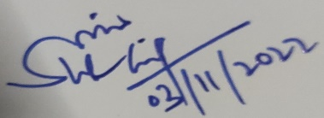

Signature of Sarpanch (Not applicable) Signature of the Visiting Officer

Name: NA Name: SUHAIL-UL-ISLAM

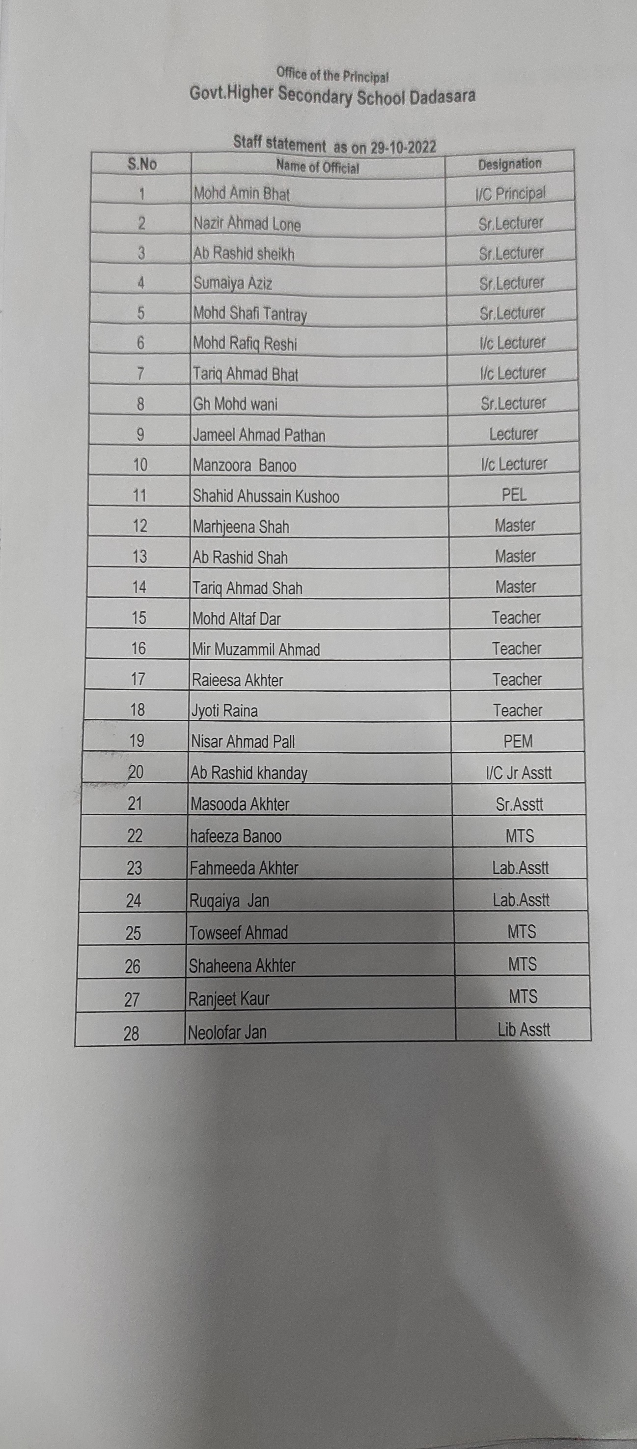
Annexure ‘B’
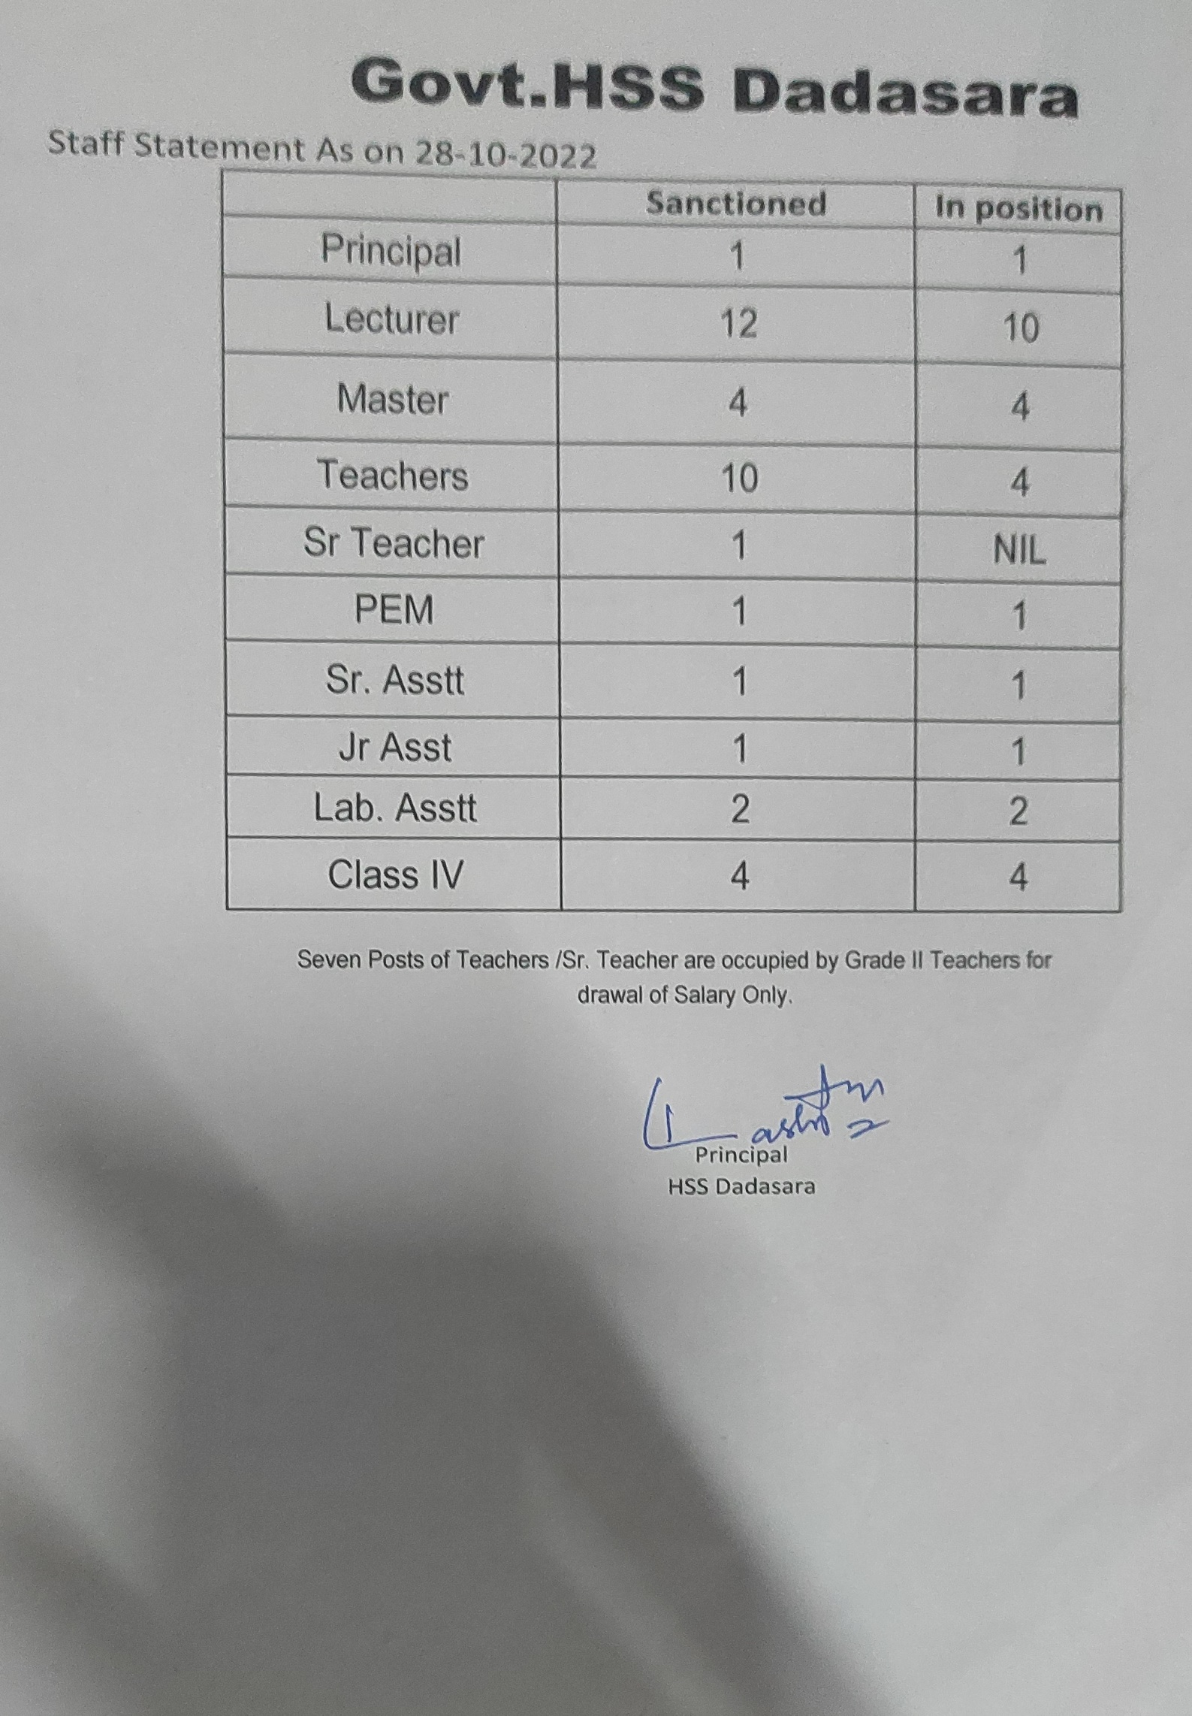
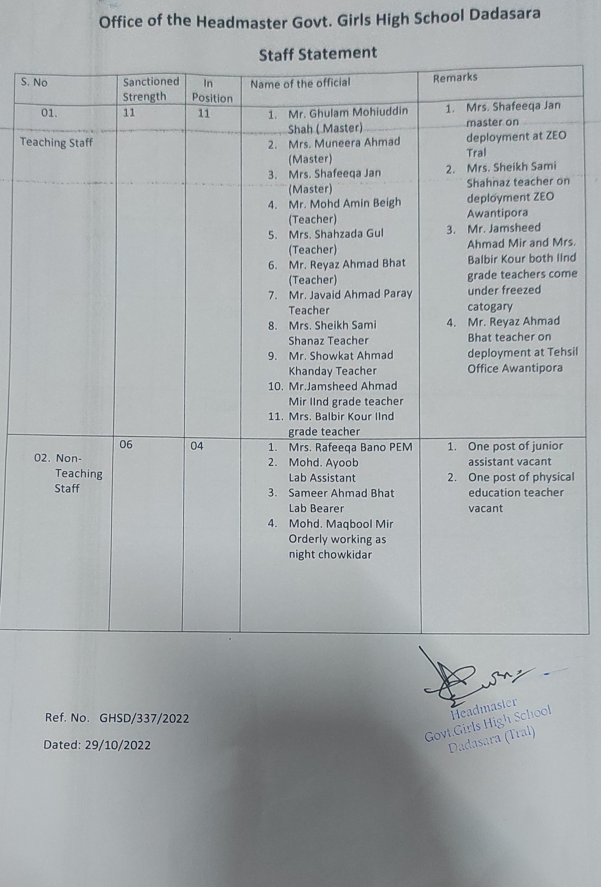

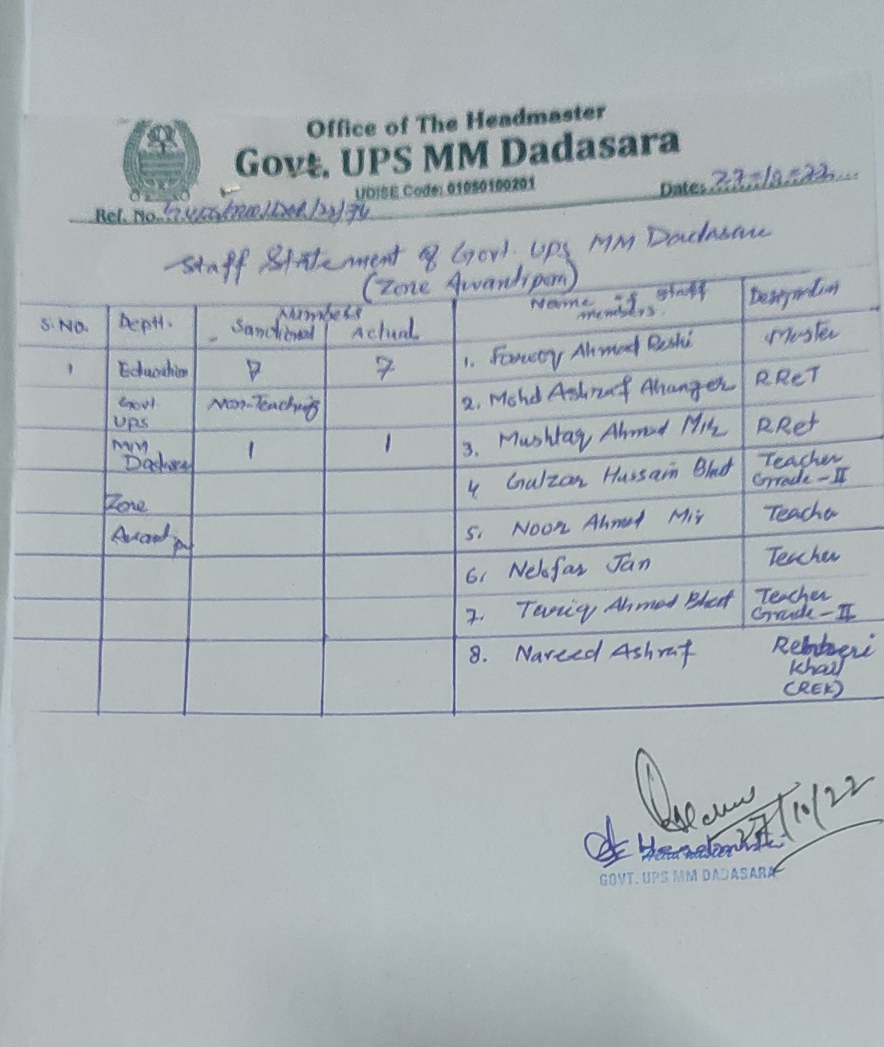

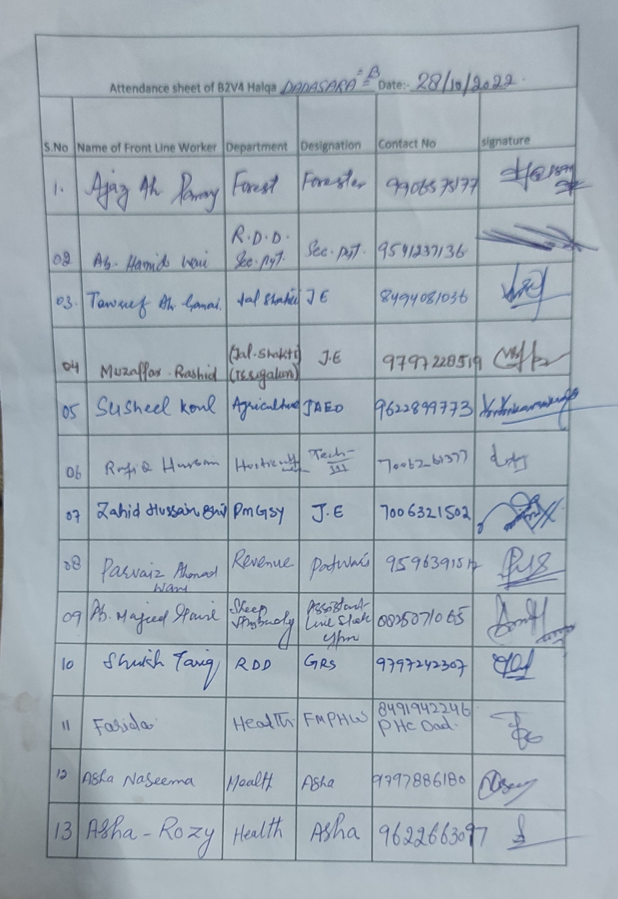
Annexure ‘A’

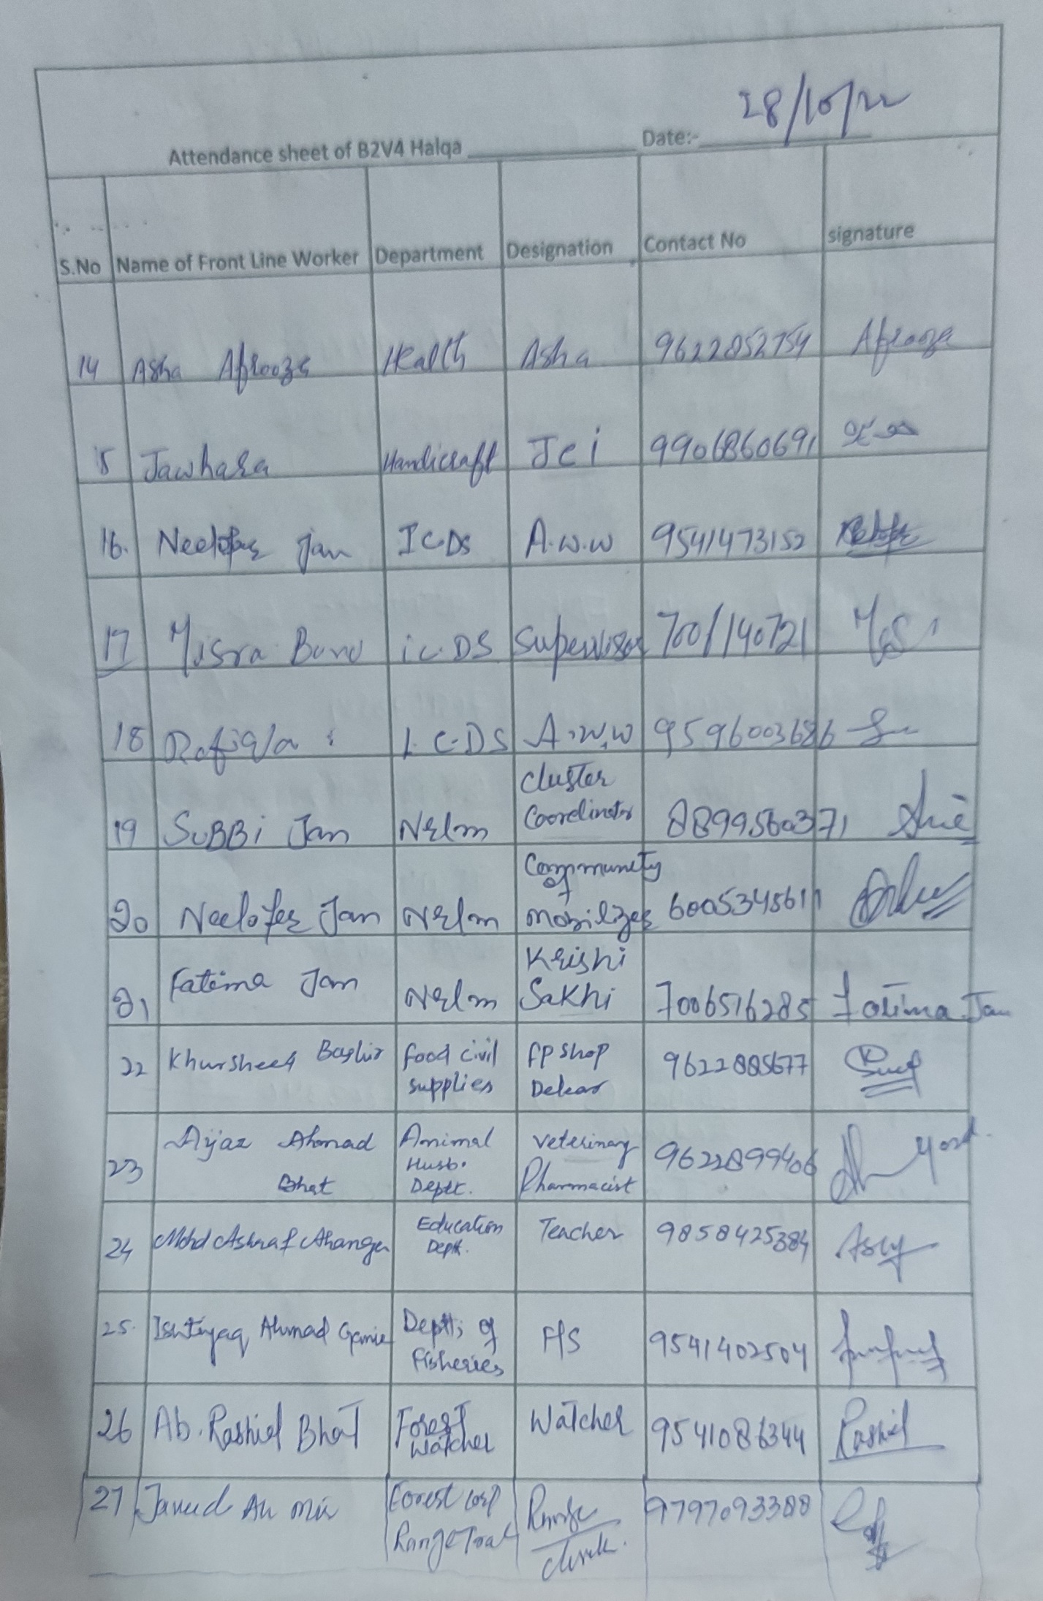
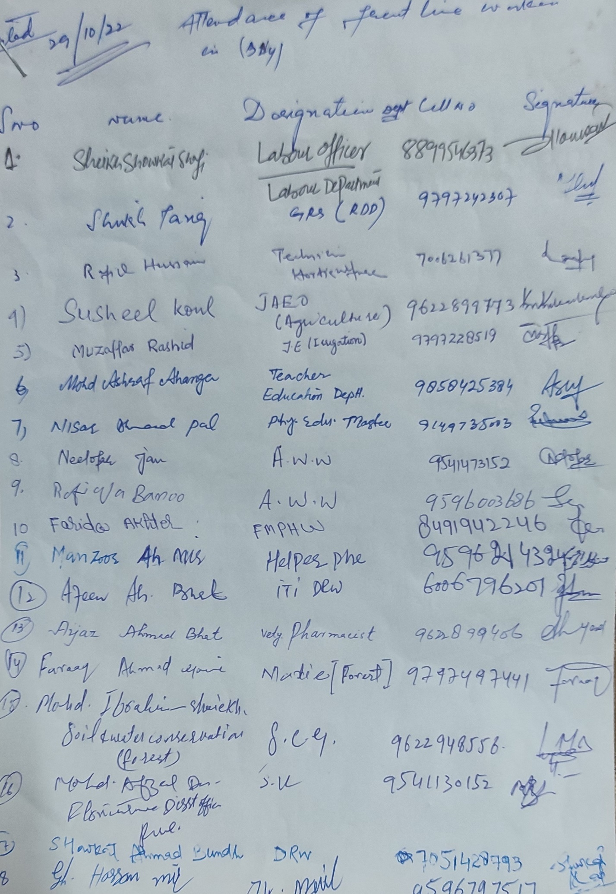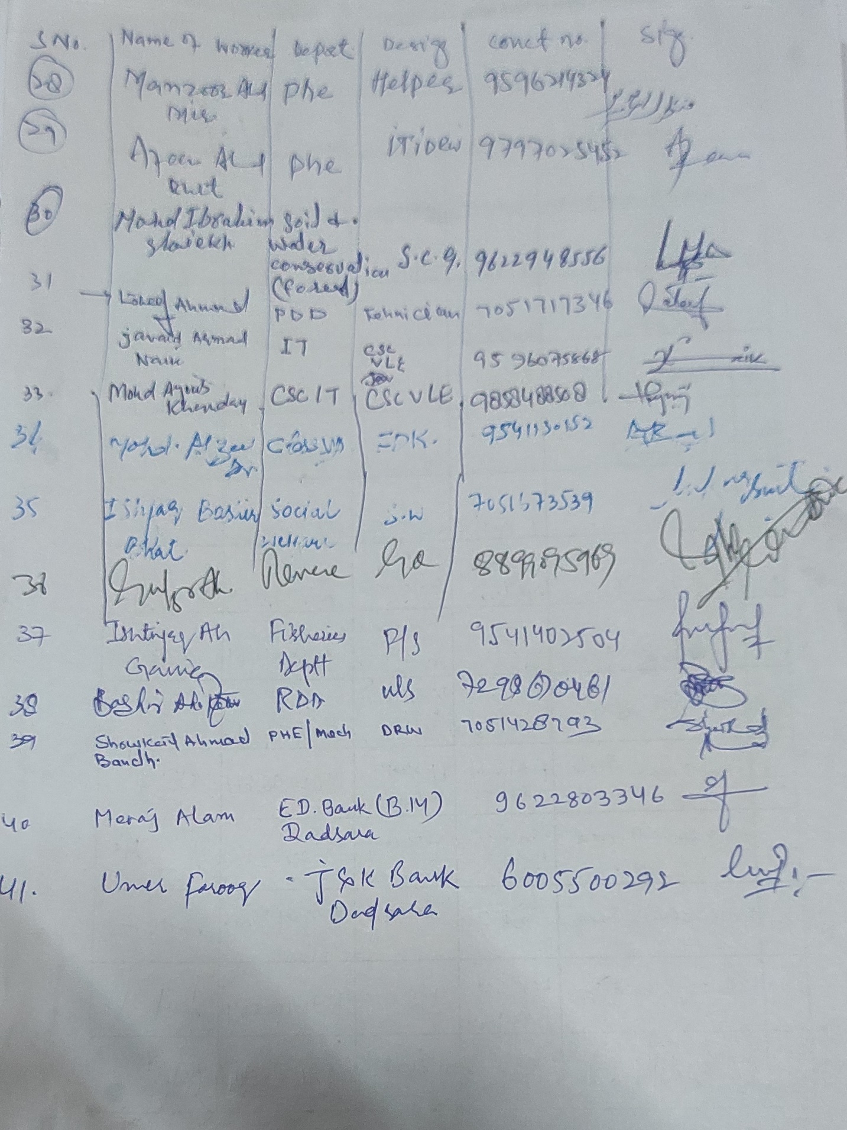
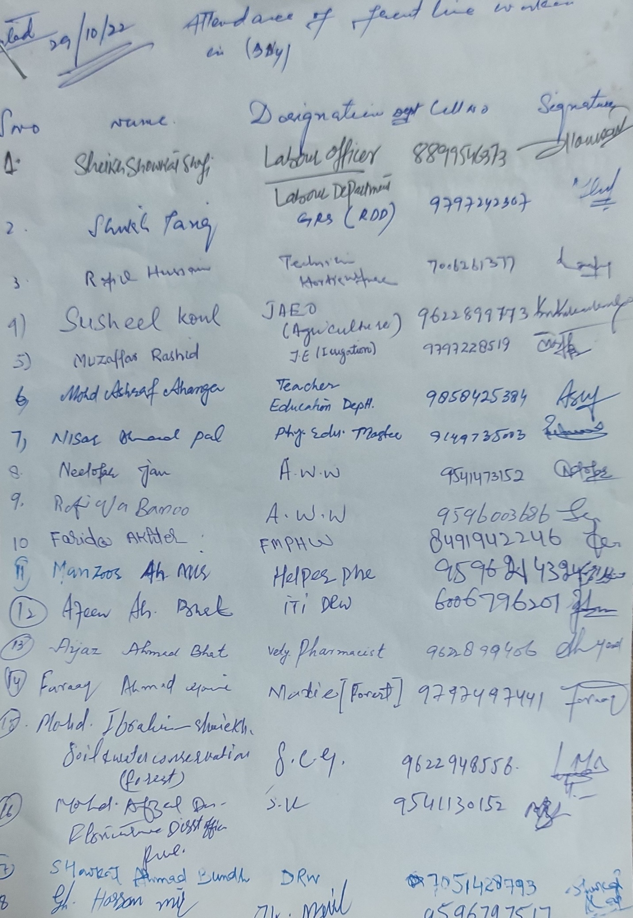

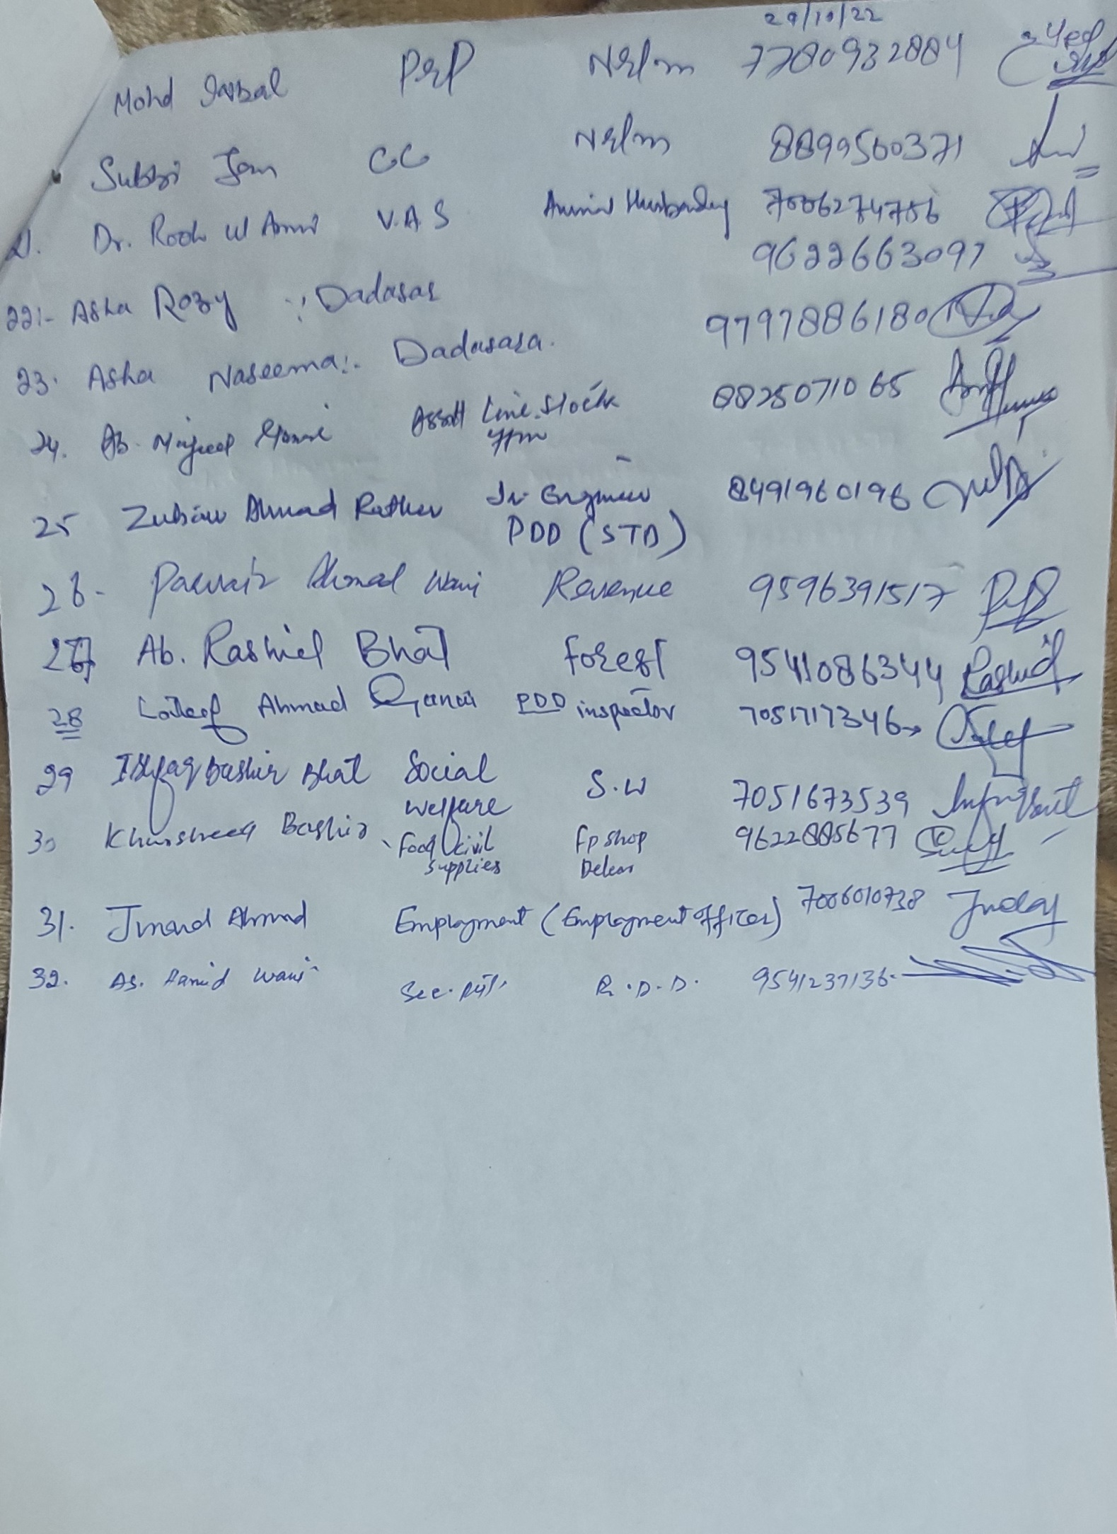
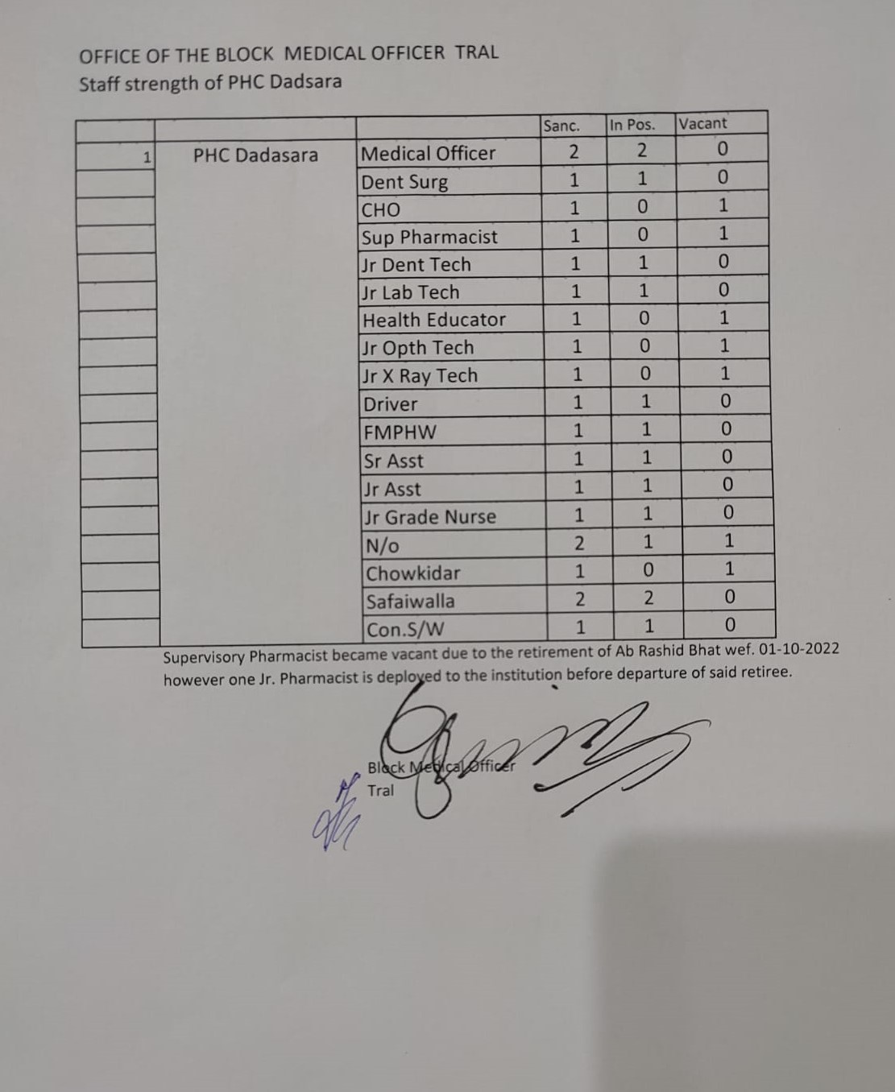
Annexure ‘C’
[Type a quote from the document or the summary of an interesting point. You can position the text box anywhere in the document. Use the Text Box Tools tab to change the formatting of the pull quote text box.]

