







4

**15TH OCT to 3RD NOV, 2022**

4





**15TH OCT to 3RD NOV, 2022**

**KEY FEATURES**

• Deputy Commissioners to lead the initiative

• Rural development Department to be the nodal department

• Planning Development & Monitoring department and IT to be the support departments

**ACTIONS AND TIMELINES**

|  |  |  |  |
| --- | --- | --- | --- |
| **ACTION** | **RESPONSIBILITY** | **LATEST BY** | **REMARKS** |
| **Jan abhiyan** | All departments | Oct 15 -26th | Going on |
| **Deputation of Sectt staff/ HoDs** | GAD | Oct 14 | Done |
| **Deployment of Staff to Panchayats and serving of orders on deployed officers** | DCs | Oct 25 | DCs will deploy senior level staff from the districts. Strict action to be taken against abstentions. No exemptions to be given |
| **Training of district trainors on B2V4** | RDD | Oct 26 |  |
| **Training of visiting officers** | DCs | Oct 27 |  |
| **Field Visits to be completed by** | Visiting Officers | Nov 3 | DCs to supervise and ensure that each Panchayat is visited within the period specified |
| **Data of B2V4 to be uploaded by** | Visiting Officers | Nov 10 | DCs to supervise and ensure that data of all Panchayats is upload- ed by the visiting officer within the period specified |

**INSTRUCTIONS FOR THE VISITING OFFICER (DAY WISE)**

|  |  |  |
| --- | --- | --- |
| **DATE** | **INSTRUCTIONS** | **ACTION POINTS** |
| **Day 0** | Meeting with deputy commissioner and his/her team | a. Take print outs of filled booklets of B2V1, B2V2 and B2V3 from [www.jkpanchayat.in](http://www.jkpanchayat.in)  b. Also take print outs of the summarized excel sheets of the previous phases from [www.jkpanchayat.in](http://www.jkpanchayat.in)  c. Collect ATRs on issues raised during previous 3 phases from the office of Deputy Commissioner (Planning deptt)  d. Take prints of blank 2 booklets of B2V4 from [www.jkpanchayat.in](http://www.jkpanchayat.in) e. Take plans for 2 previous years and ATRs from the planning deptt f. Complete trainings on different components of B2V4 being  organized by respective Deputy Commissioners  g. Collect List of new works started/ ongoing/ completed during the previous and current Financial year under the following heads:  • PRI grants  • District Plan  • UT plan  • MGNREGA  • Other schemes of other departments  • Any other work  h. Plans/ beneficiary lists:  • MGNREGA draft plan document for the year 2022-23.  • List of Awaas+ beneficiaries alongwith IHHL Convergence  • List of pension beneficiaries.  • List of SHGs  • List of agriculture scheme beneficiaries  i. Lists of beneficiaries for:  • Various certificates/ benefits to be distributed by the visiting officer.  • Any other activities identified by different departments |

|  |  |  |  |
| --- | --- | --- | --- |
| **Day 1** | Reach the village | 1. | Ensure that all front line workers of different deptts are present. |
|  |  | 2. | Ensure exhibition by different depts. about individual beneficiary schemes |
|  |  | 3. | Inspect JKB/PSB counters/outlets |
|  |  | 4. | Participate/ensure organization of sports activity in playfield, talent hunt/cultural event/youth activity |
|  |  | 5. | Gandhi Katha (suggested details uploaded on jkpanchayat.in) |
|  |  | 6. | Visit atleast 2 amritsarovars and get its geo tagged photos |
|  |  | 7. | Inspect Khidmat (CSC) Centres and create Generate awareness on  225 schemes particularly G2C schemes like BEAMS, Janbhagidari, AapkiZaminAapkiNigrani, Digital J&K |
|  |  | 8. | Visiting officer shall also plan and conduct panchayat level conver- gence meeting of all departments |
|  |  | 9. | Check effectiveness of Centrally sponsored schemes |
|  |  | 10. | Visit and inspect all government establishments including PHE, AWC, FPS, schools, etc |
|  |  | 11. | Attempt saturation of deliverable so Jan Abhiyan and wherever deficiencies found, lead a drive to achieve all deliverables |
|  |  | 12. | Assess effectiveness of sanitation campaign in the panchayat |
|  |  | 13. | Ensure self employment activities for 15 youth per panchayat |
|  |  | 14. | Identify 20 potential candidates per panchayat for HIMAYAT training alongwith the trade on which they want training |
|  |  | 15. | Wherever possible, distribute employment letters for people select- ed under various government employments |
|  |  | 16. | In the evening, hold normal meeting with senior citizens, govt em- ployees including retired employees, ex servicemen, youth club, and any citizens of the village who are enrolled in college/university |
|  |  | 17. | Open discussion on Nasha Mukt Abhiyan |

Day2 Have a meeting with all stakeholders- deptt officials and panchayat members

1. Discussion on the and assess the progress of different schemes relating to the localized SDGs prioritized for that village as per the resolution passed by that Gram Panchayat on 21st April 22, on National Panchayti Raj Day.

2. Sensitize village residents about myScheme” portal (myscheme.in) which includes information about all the schemes being run by Cen- tral/ State/ UT govt across the country

3. Hold meeting of the Biodiversity Management Committees to deliber- ate on issues pertaining to conservation of biodiversity and sustaina- ble utilization of biological resources.

4. Prepare Village development plan, in consultancy with Gram panchayat, discuss it in gram sabha and get it approved.

5. Ensure saturation of soil health card and golden health card under Gold- en Health Card under Ayushman Bharat,

6. Ensure saturation of Old Age Pension Scheme

7. Ensure Domicile Saturation.

8. Ensure KCC Saturation

9. Ensure saturation of land pass books

10. Ensure registration of village vendors needed for any scheme, on GEM

portal

11. Ensure panchayat contractors registration

12. Encourage Panchayat members for importance of plantation drive in

Panchayat under Har Gaon Hariyali

13. Ensure painting on digital J&K in panchayat ghars

14. Ensure painting on panchayat activites and CSS in panchayat ghars

15. The visiting office shall check no of kindergarten and playfields present in the panchayat for kids and students, if the infrastructure present in these are good enough.

16. Hold meeting with panchayat members to discuss about corruption menace and steps required to make J&K corruption free

17. Obtain a candid assessment about performance of various deptts in- cluding fair feedback about discrepancies in functioning

18. Check the status of Nasha Mukt Abhiyan and reporting of drug ad- dicts to Deputy Commissioner.

19. Identify Tourist Destinations, Circuits, Theme Treks, Identify Homestays, provide support for tourism activities through Village Cooperative

20. Organize Talent Hunt at Panchayat Level

21. Conduct social audit of atleast 5 works under following schemes:

a. MGNREGA

b. PMAY

c. IHHL toilets and payments d. CSCs

e. AMRIT SAROVARS

22. Hold a mahilasabha and a balsabha and record proceedings in the for- mat given

23. Inaugurate village haat under JKSRLM

24. Check if youth clubs are formed in the panchayat and what activities they are engaged in

25. Organize a village level cultural event to engage panchayat members

26. Sensitize GP about E-kitab kosh an initiative of J&K Govt for empowering youths through online digital literacy

**GENERAL INSTRUCTIONS**

1. The visiting officer shall refrain himself/ herself giving or offering any commitment on behalf of the government and shall adopt an unbiased attitude in reporting issues. As far as possible, his/her observation should be based on a fair and analytical view emerging from his/her interaction in the village.

2. He is going to the village as planning officer, not for sanctioning any works or for making any com- mitments.

3. While preparing village development plan, he has to ensure that, demands are prioritized and re- flected under available schemes, wherever necessary the larger works are to be referred to adminis- trative deptt under CSS/UT plans under intimation to DCs and rest of the works to DCs for reflecting it under district/CSS plans

4. His work shall be hard core planning and audit and is not a PR exercise.

5. Every Deputy Commissioner has to ensure that atleast one RDD official (ideally Panchayat Secre- tary) is present in every panchayat with relevant panchayat records, to ensure conduct of all activi- ties as planned. Panchayat wise order needs to be issued in advance.

6. Visiting officer should ideally carry his/her laptop to complete the reports at the panchayat level itself and upload the final report, duly signed both by the sarpanch and by the visiting officer on [www.jkpanchayat.in](http://www.jkpanchayat.in) portal, before they leave panchayat.

7. Focus of visit are youth, skills, self-employment, nasha mukt, bhrashtrachar mukt, Rozgar yukt J&K, besides to carry forward the activities during Jan Abhiyan and saturate them.

8. In addition attention may be given to the following areas a. Make full use of Centrally Sponsored Schemes

b. Saturation of individual beneficiary schemes c. Self-employment schemes

d. Bank linked schemes- including departmental subsidy schemes e. Empowerment and transparency through digital initiatives

f. Effectiveness of grass roots machinery –

i. Patwari, VLW present and available

ii. Available funds utilized in public interest and as per Gram Sabha resolutions iii. Fairness in governance

iv. CSS/Individual beneficiary schemes etc v. BrashtacharMukt J&K

vi. Bhai Mukt J&K

vii. NashaMukt J&K

9. The PRI members (Sarpanchs, Panchs, BDC Chairperson) shall be at the forefront of all activities and given due importance and the approach should be to strengthen them and make them feel em- powered. He/she shall ensure that the BDC chairperson and Sarpanch/Panch are present at the time of inauguration and ceremonies.

10. Visiting officer shall not leave the district without uploading the report, duly signed on the **www. jkpanchayat.in** portal. Every Deputy Commissioner has to ensure that.

**A) Details of Reporting Officer:**

Name: **Mir Tafazul Majeed**

Designation: **Assistant Legal Remembrancer (ALR)**

Department/ place of posting: **General Administration / Chief Secretary’s Office**

Mobile No: **9596374813**

Email ID: **mirtafazulmajeed@gmail.com**

Home District: **Pulwama**

Dates of visit: **28-29/10/2022**

**B) Locational details of Panchayat: (to be pre-filled, information to be taken from the previous phases booklets/summarized excel sheet uploaded on jkpanchayat.in/b2v4.php) (to be vali- dated by the visiting officer and missing details to be filled)**

Name of the Panchayat: **BATAGUND**

Local Government Directory (LGD) code of the Panchayat: **242934**

Name of CD Block: **Aripal**

Name of Tehsil: **Tral**

Name of District: **Pulwama**

**C) Panchayat Profile:**

No. of revenue villages in the Panchayat: **01**

No. of hamlets in the Panchayat: **02**

No. of households in the Panchayat: **470**

Population (approx.) of the Panchayat: **2226**

**Part-II:**

(To be filled up by the Visiting Officer during his/her two day visit to the Panchayat. All Fields have to be

filled by the Visiting Officer before the booklet is handed over to the DC

**Frontline Officers/Officials who were assigned to the Panchayat for the programme:**

|  |  |  |
| --- | --- | --- |
| **Department** | **Name** | **Designation** |
| Jal Shakti (PHE) | Abdul Ahad Bhat | J.E |
| Rural Development & P.R | Mohammad Yousuf Wani | Panchayat Secretary |
| Horticulture | Noor Mohammad Alai | Technician |
| Rural Development & P.R | Ruksana aqbool | J.E |
| Health | Ravinder Kour | FMPHW |
| Sheep Husbandry | Dr. Rafia Ahmad Bhat | Veterinary Assistant Surgeon |
| School Education | Gayas-ud-Din Shah | Lab Assisitant, Hr. Sec. School. |
| Handicrafts | Mohammad Maqbool Lone | Helper |
| Revenue | Muneer Ahmad | Patwari |
| Forest | Mohammad Maqbool Bhat | Mali |
| Animal Husbandry | Dr. Ashiq Hussain | VAS |
| Social welfare | Zareefa Bano | C. Assistant |
| IT | Syed Aijaz Ahmad | CSC |
| Health | Fehmeeda | Asha |
| Health | Shahmeema Akhter | Asha |
| ICDS | Hanifa Bano | A.W.W |
| PHE | Abdul Rashid | Helper |
| ICDS | Tanveer-un Nisa | A.W.W |
| I& FC | Gh Nabi Kuna | W/S |
| School Education | Gayas ud din | Lab. Assistant |
| FDC | Nasir Ahmad Shah | Range Manager |
| DIC | Abdul Rashid Mir | Worker |
| J&K Bank | Aejaz Ahmad | Manager |
| School Education | Abdul Rashid Shergojri | Teacher |
| ICDS | Asha Bano | AWW |
| FCS | Abid Hussain Mir | Dealer |
| FCS&CA | Mohammad Amin | Worker |
| Jal Shakti | Abdul Rashid Ganaie | W/Supervisor |
| RDD | Bashir Ahmad Parrey | VLW |
| ICDS | Ssalma Jan | AWW |
| Agriculture | Hafizulah | Jr. AEO |
| PHE | Mohammad Maqbool Shah | Helper |
| Physical Education | Asmut Fayaz | NYC |
| Floriculture | Rafiq Ahmad Sheikh | Gardner |
| PHE | M Haneef Gojar | Helper |
| RDD | Ishtaq Ahmad Mir | GRS |
| Fisheries | Ali Mohammad Mir | Supervisor |
| E/C | Bilal Ahmad | ID Tral |
| Health | Feroz Ahmad Baht | MMPHW |
| ICDS | Rahila Rashid | Supervisor |
| FCS&CA | Hilal Ahmad Wani | TSO |
| Health | Nazir Ahmad Bhat | CHO |
| PHE | Firdous Ahmad | W/Supervisor |
| **See annexure I** | | |

**Details of absent employees vis-à-vis list furnished by the DC office:**

|  |  |  |
| --- | --- | --- |
| **Department** | **Name** | **Designation** |
| **No absentees** | | |

**DAY 1- ACTIVITIES**

**AGENDA 1: PANCHAYAT ASSET REGISTER**

**Infrastructure:**

1. Panchayat Ghar Infrastructure a. **Private Building**

b. New/needing repairs **(needing repairs)**

2. Furniture **(N)**

3. Computer/printer **(Y)**

4. Internet **(N)**

5. Telephone **(N)**

6. Toilet (CSC/part of panchayat ghar) **(Y)**

7. Water **(Y)**

8. Electricity **(Y)**

9. Bank branch **(Y)**

10. CSC **(Y)**

11. Patwarkhana **(N)**

12. Village haat **(Y)**

13. Playground **(Y)**

14. School-

a. Kindergarten **(Y)**

b. Primary **(Y)**

c. Secondary **(Y)**

d. College **(N)**

e. University **(N)**

15. Anganwadi Centre **(Y)**

a. **private**

b. Total children enrolled: **148**

15. Amrit Sarovars – details, location, condition

**One Amrit Sarovar has been developed and managed by the Panchayat near Masjid Dastageer Sahab (Rh) . The spring was dry at the time of the visit/inspection.**

16. Government offices- details, whether functional or not

|  |  |
| --- | --- |
| 1. **Panchayat Ghar** 2. **NTPHC** 3. **Veterinary Centre** 4. **JK Bank** 5. **ICDS/Anganwadi Centres** 6. **Schools and Hr. Secondary.** 7. **CSC** | **Functional** |

17. Ration shop **(Y)**

18. Places of tourism importance – names, little details on historical/cultural importance

19. Village heritage sites/ treks- names, little details on historical/cultural importance

|  |
| --- |
| **Shrine of Hazrat Syed Miskeen Badshah(Rh) can be developed as Tourism/ Heritage site.** |

20. VLW Office (Y)

21. Primary Healthcare Centre **(N)**

22. List of Incomplete Buildings- names, year of construction: **None**

23. List of Underutilized Buildings- names: **None**

**DAY 1-ACTIVITIES**

**AGENDA 2:**

**DIFFERENT INSTITUTIONS/INFRASTRUCTURE PROJECTS TO BE VISITED**

|  |  |  |
| --- | --- | --- |
| **AMRIT SAROVARS** | **Visit, verify** | **COMMENTS** |
| Khidmat Centres | Create /Generate awareness on 225 schemes particularly G2C schems Aapki Zamin Aapki Nigrani, Beams, Janbhagidari, Digital J&K | Visited the centre and found it functional. Local populace has hailed the role of the centre in the dissemination of information/ awareness among the masses regarding the schemes including Aapki zameen Aapki ki Nigrani, Beams, digital JK etc. |
| JKB/PSB counters/outlets | a) Status of counter : Functional  b) Number of visitors: 120 (Approx.) | Visited the branch and found it operational. The branch is assisting the local populace in availing the hassle free financial help under various schemes like PMEGP, KVIB etc. Bank informed that the Aadhar seeding of almost all the accounts as been done. |
| Incomplete buildings / projects | Verify whether identification and redistribution done | No incomplete building / projects in the Halqa |
| PDS | Visit, evaluate, online status | Visited FPS, found it operational. Ration is being distributed through on-line system to the house-holds. |
| PHC | Visit- evaluate, status of staff, equipment and quality | Visited NTPHC. Interacted with the staff. Inspected the centre and found X-Ray machine intact without a technician, Ambulance without driver and dental unit without faculty. |
| Youth clubs | Meet, interact, seek suggestions | Had a detailed discussion with the youth clubs. They suggested that the sports infrastructure should be upgraded, opening of a library in the panchayat. |
| SHG | Meet, identify problems, seek suggestions | Met SHGs. During the meet, it came to the fore that the raw materials like wool/yarn are available at high rates while the return is low. They suggested that more and more skill and trade oriented centers be opened in the halqa to generate more avenues for employment generation. |
| PMAY | Inspect, Inaugurate | Inaugurated and inspected under construction House for an Orphan Mr. Umar Nabi S/o: Ghulam Nabi Shergojri. |
| My school, my pride progress; schools- water, toilets, staff | Visit, check for water, electricity, sanitation assured, met students and staff | Visited the Middle and Higher Secondary Schools. Interacted with students and Staff. Although the basic facilities of drinking water, toilets, sanitation and electricity are available yet need urgent up-gradation. There is dearth of staff in the Hr. Secondary as 07 posts lecturers are vacant against the sanctioned strength of 11 posts. |
| Swachh SBM | Evaluate | The panchayat of the Halqa has been active in implementing the mission. Mostly the area appears to be free from open defecation. |
| Panchayat play ground, Sports kits distribution Village games | Ensure, verify. Participate in at least one game in the playground | The panchayat has a playground where certain sporting events like cricket, volleyball etc were organised and the undersigned participated in cricket sport. Further, inaugurated one Volley Ball court. However, there were no sports kits available for distribution. |
| Har Gaon Hariyali, Plantation drive | Evaluate status, feedback | Forest Department has played a pivotal role in afforest ration in the area. Participated in plantation drive organised by the department at various locations including Eidgah, playground and schools. |
| Village cultural event  Dangal/Haat/Mela | Participate in; ensure that it is held | Certain stall were installed by the departments Handicrafts, Social Welfare, ICDS, Health, CSC, forest, SHGs. Etc. |
| Exhibition of schemes | Ensure that every department participates and that it continues for the entire duration of B2V | The exhibition of schemes in which the line departments participated continued for the whole B2V event. |
| Jal Jeewan Mission verification- WSS/JSD  Electricity supply | Verify | The JJM is yet to start in the Panchayat. |

**DAY 1 - ACTIVITIES**

**AGENDA 3: SATURATE JAN BHIYAN**

**DELIVERABLES AND RECORD DEFICIENCIES IF ANY (INSERT DELIVERABLES LIST HERE AS PER GAD FORMAT**

|  |  |  |
| --- | --- | --- |
| **S.No.** | **Department** | **Work/Deliverable with Observation(s)** |
|  | Rural Development | GPDP was prepared and finalised under the convergence mode. |
| Village Haat was inaugurated. |
|  | Information | CSC camp was organized where in:  Awareness camp regarding 225 Online Services was organized to disseminate information regarding services like BEAMS, Jan Bhagidari and also provided assistance in the enrolment for Golden cards, Domiciles etc.  Banners, wall paintings were displayed at prominent places regarding the digital J&K and services. |
|  |  |
|  | Finance Department | Target achieved |
| Aadhar seeding of all account holders/individual beneficiary Schemes in the JK Bank has been achieved. |
| Counter set up by JK Bank for verification, sanctioning, disbursement of cases and acceptance of fresh applications under JDY, JJB etc.  Approximately 170 people visited the bank.  Digital M-Pay completed.  10 SHG accounts have been opened in the bank. |
|  | Revenue | Campaigned for dissemination of information regarding Aap ki zameen aap ki nigrani was held.  Distributed 30 land pass books to landholders.  Distributed 2 Income certificates  Distributed 15 domicile certificates  Digitalisation of jamabandi of 05 villages (Aripal, Gadpora, Darmgund, Darganigund and Heewan) has been done.  Digitalisation of Gulshanpora under quality check.  Instructed to complete the pending inheritance mutations in a time bound manner. |
|  | Health | 97% saturation has been achieved in Golden Cards in the village. The shortage of 3% is due to the fact that their ration cards have not been Shifted to Ration Card Management System (RCMS).  100% achievement in vaccination of all eligible individuals against COVID-19.  Children are being immunized as per the government schedule. |
|  | Hospital | NTPHC, Batagund has junk free premises. Interior of hospital was clean but toilets need further attention of the administration. |
|  | Social Welfare | Regular checkups for anemic patients.  100% plantation under Poshan Vatika mission.  Aadhar seeding of laadli beeti and Anganwadi beneficiaries  100% target achieved in NOAPS/ISSS pensions.  Senior citizen s’ club formed in the Panchayat.  BBBP event held. |
|  | Forest Department | Inaugurated plantation drive sponsored by the Forest Department under the green J&K drive -Jan Abhiyan. A number of saplings were planted at many places like Eidgah, Middle School/Hr. Sec. School etc.  Local populace was sensitized about the merits of afforestration. |
|  | Tourism Department | Shrine of Hazrat Miskeen Badshah Sahib (RH) can be developed as Tourist/Heritage site. |
|  | Labour and Employment | 300 E-Sharam cards issued till date, 10 E-Sharam cards distributed among the beneficiaries during the event. . |
|  | School Education | Organized Cleanliness and maintenance drive in the Middle /Hr. Sec. School.  Participated in the sports event (volley ball).  Interacted with the students and staff.  No out of school children reported. |
|  | Culture | Organized singing and dancing events in the Middle /Hr. Sec. School. |
|  | Youth affairs | Inaugurated volley Ball Court and participated in a cricket match. |
|  | Power Development | Distribution Transformers (DTs):  Unique Nos. checked  No DT with load imbalance  Foliage removed around DTs  No electrical accident claim pending.  No DT without earthing. |
|  | Food, Civil Supplies and Consumer Affairs | 100% achievement. All the ration cards were shifted to Ration Card Management system (RCMS) |
|  | Jal Shakti | Held a thorough discussion with the local populace regarding their role in planning, implementation and Monitoring of JJM.  JJM is yet to take off in the village and accordingly, instructed the line department to pace up the execution of the project in a time bound manner. |
|  | ARI &Trainings | Inspected all the Government offices (like Schools, Hr. Secondary, Animal Husbandry, NTPHC, Panchayat Ghar, JK Bank, ICDS Centres, CSC etc.) in the village and were found functional. |
|  | Agriculture | Achieved 100% targets in PM –Kissan covered, KCC, E-Sharam schemes. |
|  | Public grievances | Perception of the public regarding the government employees is good and overall satisfactory. |

**DAY 1- ACTIVITIES**

**AGENDA 4:**

**SELF EMPLOYMENT ACTIVITIES**

Ensure Self-employment activities for youth, distribute employment letters for people selected under various social schemes (15 IS THE TARGET PER PANCHAYAT)

Number of cases in different categories sanctioned**: 22 through JKB and 01 by Agriculture Production Department**

Details of the bank sanctioning it**: J&K Bank**

Total amount involved**: Please See annexure - I**

**DAY 1 ACTIVITIES**

**AGENDA 5**

In the evening, hold informal meetings with senior citizens, govt employees, retd. employees, youth club and other citizens who are enrolled on college/university and have discussion on Gandhi Katha, Nasha Mukt Abhiyan, corruption free governance, doubling farmers income and record the proceedings:  
**Had a meeting with senior citizens, government employees, youth clubs etc. and discussed the Gandhian principles and Nasha Mukt Abhiyan. It was resolved that two important principles which Gandhi Ji followed throughout his life were Satya (Truth) and Ahimsa (non-violence) and believed them to be as old as Himalayas. He demonstrated them in his own life and in the present context of human life, by practicing and living Satya and Ahimsa in his own behavior and every action. It was unanimously resolved that such principles should be followed to live a successful life. Further stress was laid on the measures to eradicate the menace of drugs from Jammu and Kashmir under the Nasha Mukt Abhiyan.**

**DAY 2**

a. No of Individual Compost Pits constructed **NIL**

b. No of Individual Soak Pits constructed **52**

V. No. of Biodiversity management committee meetings held: **01**

VI. Is the name of Sarpanch displayed on citizen information boards of all RD&PR schemes: **Yes**

VII. Are Sarpanchs being involved in start/inauguration of activities: **Yes**

VIII. Whether subjects have been assigned by the Sarpanch to the Panchs: **Yes**

**IX.** Whether grievances redressal box is installed: **Yes**

X. No of grievances received pertaining to Panchayat level: **NIL**

XI. NoofgrievancesdisposedofatPanchayatlevel: **NIL**

XII. Whetherthe Sarpanch/PanchayatSecretaryhavedigitalsignatures:**Yes**

XIII. Whether all MGNREGA/ 14th FC payments are being made by Sarpanch through Digital Signature

Certificate (DSC): **Yes**

**HUMAN RESOURCE AVAILABLE AT THE PANCHAYAT LEVEL:**

|  |  |  |  |  |
| --- | --- | --- | --- | --- |
| **SR NO.** | **DEPARTMENT WISE STAFF** | **NUMBERS** | | **NAMES** |
|  |  | SANCTIONED | ACTUAL |  |
|  | Rural development department: BDO  JE GRS TA | 0  1  1  1 | 0  1  1  1 | Ruksana Maqbool  Irshad Ahmad  Mohammad Idress Wani |
|  | SCHOOL EDUCATION: TEACHER  HEAD MASTER ANY OTHER | 10 | 10 | **Middle School**  Bashir Ahmad Malik  Suhail Bashir  Irshad Ahmad Parray  Farooq Ahmad Bhat  Saleema Akhter  Zamrooda Akhter  Mehmooda Akhter  Roheena Akhter  Faizan Ahmad Malik  Mohammad Yaseen Shah  **Primary School**  Abdul Rashid Shergujri  Mohammad Muzaffar |
|  | JAL JEEVAN: | 08 | 04 | Abdul Rashid Shah  Mohammad Ashraf Lone  Adil  Mohammad Yousuf Bhat |
|  | PDD: LINEMAN JE  ANY OTHER | 1  1  0 | 1  1  8 | Shabir Ahmad Mir  Harminder Singh  08- need based. |
|  | FOOD & CIVIL SUPPLIES | 1 | 2 | Mohammad Amin Shergujri  Adil Hussain Mir |
|  | AGRICULTURE &  ANIMAL HUSBANDRY | 2  4 | 1  4 | Ravinder Nain Singh (AEA)  Ashiq Hussain Dar (VAS)  Ghulam Rasool Bhat (Sr. V. Pharmacist)  Mohammad Aslam Khan (V. Pharmacist)  Nazir Ahmad Sheikh (attendant) |
|  | SOCIAL WELFARE | 0 | 0 |  |
|  | HEALTH: ASHA  ANM  AYUSH DOCTOR ALLOPATHIC DOCTOR | 02  1  0  2 | 02  2  0  2 | Shahmeema Bano  Fareeda Bano  Ravinder Kour  Dr. Riyaz  Dr. Tasleema Bano |
|  | ANY OTHER DEPARTMENT | ----  ------ | ----  ------ | ----  ------ |

**DAY 2-ACTIVITIES**

**AGENDA NO. 1**

Discussion on the and assess the progress of different schemes relating to the localized SDGs prioritized for that village as per the resolution passed by that Gram Panchayat on 21st April 22, on National Panchayati Raj Day (Copy of the resolution to be taken from [www.jkpanchayat.in](http://www.jkpanchayat.in) portal under the link of Gram Swaraj Month)

1. SDGs AGREED FOR THAT VILLAGE, TO BE IMPLEMENTED BY MARCH2024: **Clean, Green and Healthy Village**

2. STATUS OF WORKS UNDER THE FOLLOWING SCHEMES:

**1 Clean and green village**

i. Initiatives taken by the Panchayat for managing Solid and Liquid Waste: **no such facility is available. Instructed to identify land for installation of proper mechanism for management for solid and liquid waste.**

ii. Initiatives taken by the Panchayat for using green sources of fuel like solar, biogas Initiatives: **no such initiative taken by the Panchayat. Instructed to encourage people to use green sources of fuel like solar, biogas so as to reduce air pollution.**

iii. Has mapping of land use, water bodies, forest, slopes, wet lands, degraded forest within the Gram

Panchayat been done? **Yes**

iv. Has the Climate Resilience Plan been developed for the GP? **No**

v. Steps taken by the Gram Sabha about the climate change mitigation factors like reducing energy consumption, usage of fossil fuels, plastics, non-renewable building materials and also to promote measures like planting of trees, conserving forests, usage of good agricultural practices like drip irrigation, water conservation measures and conservation of wetlands. **Done**

vi. Whether schools have started segregating waste: **NO**

Vi. Whether schools have their own compost/soakage pits for solid/liquid waste management: **NO**

**2 Healthy village**

i) Are meetings related to Village Health and Sanitation Committee being held regularly? **YES**

ii) Do all the eligible individuals been provided the Golden Card? **97% target achieved.**

iii) Are all the Children being immunized as per the Schedule recommended by Govt. of India? **YES**

iv) Are all the eligible individuals been vaccinated against COVID-19? **YES**

v) Does Gram Panchayat ensure that all pregnant women are getting necessary prenatal checkups? **YES**

vi) Whether all the deliveries were Institutionalized or conducted by trained Midwives? **YES**

**3 Water sufficient village**

i) Do all the IHHs in the Gram Panchayat have water pipeline connections? **Newly constructed houses not covered.**

ii) Whether Gram Panchayat has taken steps for grey water management. If Yes please specify : **Soakage pits were constructed in various households.**

iii) Do all the IHHs in the Gram Panchayat have toilets? **YES**

iv) Are all the IHHs toilets functional or not? **FUNCTIONAL**

v) Do all the Schools/Anganwadi centers have a toilet facility or not? **YES**

vi) Are all the toilets in the schools/Aaganwadi functional or not? **FUNCTIONAL**

vii) Whether Gram Panchayat Bhawan has separate toilets for women or not? **No Gram Panchayat Bhawan available**.

**4 Child Friendly village**

i) Do all the children under the age of 0-6 years been enrolled in the Anganwadi centers for pre- schooling? **YES**

ii) How many Bal Sabha’s were organized in the Gram Panchayat: **03**

iii) Whether the issues raised by Bal Sabha are addressed during the Gram Sabha. **YES**

iv) Whether Gram Panchayat is tracking the data related to dropout children and children with irregular attendance? **YES**.

v) Do all the schools under the Gram Panchayat have separate toilets for girls and boys? **YES**

**5 Village with good governance**

i) Is CSC located in the Gram Panchayat Bhawan or not? **YES**

ii) Is the list of beneficiaries related to the Schemes/Programs displayed on the Gram Panchayat wall or not? **YES**

iii) Does the Gram Panchayat has its building or not? **NO**

iv) Is the Gram Panchayat office functional or not? **YES**

v) Are the activities approved under the Halqa Panchayat Development Plan displayed on the Gram

Panchayat wall or not? **YES**

vi) Is Social Audit of earlier Schemes/Programs carried out or not? **YES**

**6 Poverty free and enhanced livelihood village**

1. Has Gram Panchayat developed any criteria for the identification of the poor? **NO**
2. Have all the eligible households registered in PDS or not? **YES**

iii) Has Gram Panchayat provided space for Self-help Groups in PanchyatGhar for holding meetings or not? **YES**

iv) Have all the eligible households been registered for Pension or not? **YES**

v) Has Gram Panchayat facilitated Youth for Skill Enhancement Courses and Placement? **YES**

vi) Has Job Cards been distributed to all the eligible individuals under MGNREGA? **YES**

vii) Has Gram Panchayat facilitated SHGs for Bank Account Linkages? **YES**

**7 Socially secured village**

i) Whether Gram Panchayat is maintaining data related to Differently Abled People? **YES**

ii) Is Gram Panchayat Office Disabled friendly or not? **NO**

iii) Are provisions for a separate Budget under the Resource Envelope for Women and Children made or not? **YES**

iv) Do all the Schools in the Gram Panchayat have facilities for Differently Abled Children like toilets, barrier-free access, etc., or not? **NO**

v) Are all the eligible individuals are getting pensions, like old age pension, widow pension, etc? **YES**

vi) Are all the eligible households getting benefits from IAY or not? **YES**

**8 Engendered Development in Village**

i) How many Mahila Sabha’s were organized in the Gram Panchayat: **04**

ii) Whether SHGs federations have been provided space for meetings in the Panchayat Bhawan **YES**

iii) Whether GPs have taken steps for increasing women’s participation in Gram Sabha: **YES**

iv) Number of women beneficiaries headed households covered under PDS system: **60**

v) Number of beneficiaries (out of total eligible population) receiving social protection benefits under

Pradhan Mantri Matritva Vandana Yojana: **30**

9 Self-sufficient infrastructure in the village

i. Whether GP has a Community Hall with access to electricity, furniture, water supply, toilet **NO**

ii. Whether the Disaster management plan is available at the GP Level: **YES**

iii. Whether child-friendly park with required facilities is available in GP: **NO**

Iv. Whether the GP has easy access to Godown for storage **NO**

v. Whether street lights are provided in public places for ensuring safety: **YES**

**DAY 2 ACTIVITIES**

**AGENDA NO.2**

Sensitize village residents about myScheme” portal (myscheme.in) which includes information about all the schemes being run by Central/ State/ UT govt across the country

*(Scheme Material available from* [*https://jkpanchayat.in/b2v4.php*](https://jkpanchayat.in/b2v4.php)*)*

**The local populace was sensitized about the portal and were requested to take advantage/benefits of the schemes being provided by the Government.**

**DAY 2 ACTIVITIES**

**AGENDA NO.3**

Hold meeting of the Biodiversity Management Committees to deliberate on issues pertaining to conservation of biodiversity and sustainable utilization of biological resources. He should check People Biodiversity register (PBR) of that panchayat and review if Biodiversity Management Committee constituted for that panchayat is holding minimum 4 meetings in a year and meeting once in every 3 months.

**Biodiversity Management Committee (BMC):**

**A Biodiversity Management Committee (BMC) was constituted to deliberate on the issues pertaining to conservation of biodiversity and sustainable use of biological resources. In its meeting, it was decided that the committee shall prepare People's Biodiversity Register (PBR) in consultation with local people, containing comprehensive information on availability and knowledge of local biological resources, their medicinal or any other use or any other traditional knowledge associated with them.**

**COMMITTEE MEMBERS**

1. **Gulshana Akhter Chairperson**
2. **Bashir Ahmad Parrey Member Secretary**
3. **Ashia Bano Member**
4. **Mushtaq Ahmad Mir Member**
5. **Abdul Ahad Wani Member**
6. **Nisar Ahmad Bhat Member**
7. **Ghulam Nabi Dar Member**

PRESENT: **Chairperson and Members were present in the first meeting of the Committee.**

BIODIVERSITY REGISTER PHOTOS: **Please see annexure II**

PAST 4 MEETING DETAILS- DATES, MINUTES PHOTOS : **Committee was constituted on 29.10.2022**

**DAY 2 ACTIVITIES**

**AGENDA 4**

Visiting officer shall also plan and conduct Panchayat level convergence meeting of all departments and prepare Village development plan for village, in consultancy with Gram Panchayat, discuss it in gram Sabha and get it approved.

**In addition GPDP plan shall also include :**

▪ Tourist places which need to be developed

▪ Specific product which needs to be developed

▪ Tourism- home stays

▪ 20 candidates for training under Himayat scheme alongwith trade in which training is to be given

**Pursuant to the agenda 4, a Panchayat level convergence meeting of all departments was called in which Village Development Plan was prepared for the village Batagund in consultancy with Gram Panchayat, discuss it in the gram Sabha and got it approved as follows:**

|  |  |  |
| --- | --- | --- |
| **S.No.** | **Demand** | **Department concerned** |
| 1. ` | Installation of four way street lights with protection on Centre at Bus Stand , Batagund | Rural Development and Panchayati Raj |
|  | Up-gradation of PHC | Health |
|  | P/bunds on both sides chandrihar arrah | Irrigation and Flood Control |
|  | Installation of Solar lights at various spots in Batagund | Rural Development and Panchayati Raj |
|  | Construction of tiles lanes at various spots | Rural Development and Panchayati Raj |
| 1. 6 | Construction of bridge at denbal on chandri nallah | Rural Development and Panchayati Raj |
|  | Improvement of dankard road from khalbagh on wards | Rural Development and Panchayati Raj |
|  | Filtration plant for different water supply schemes | Jal Shakti |
|  | Supply of water from Aripal Nag to Batagund village | Jal Shakti |
|  | Establishment of Patwari Khana anad separate patwari for Batagund | Revenue |
|  | Handicraft centre | Industries and Commerce |
|  | Horticulture and Agriculture sub Centres for the Panchayat halqa Batagund | Horticulture and Agriculture Production |
|  | Establishment of cooperative godown | Cooperative |
|  | Improvement / development of Madoora Irrigation canal | Irrigation and Flood control |
|  | Availability of sports kits for distribution among children | Youth Service and Sports |
|  | Installation of electric poles / wires different spots in Batagund | Power Development |
|  | Construction of protection bund and fencing around Gousia Masjid | Rural Development and Panchayati Raj |
|  | Development of Eid Gah | Rural Development and Panchayati Raj |
|  | Construction of protection bund from culvert onwards | Rural Development and Panchayati Raj |
|  | Construction of road from play field culvert to Khulbagh | Rural Development and Panchayati Raj |
|  | Improvement of road from culvert to H/o Aijaz Ahmad Sheikh at Sheikh Mohalla | Rural Development and Panchayati Raj |
|  | Development of 04 children parks | Rural Development and Panchayati Raj |
|  | Construction of foot bridge near chopan basti | Rural Development and Panchayati Raj |
|  | Development of shrine of Hazrat Miskeen Sheikh sahib (Rh) at Mir Mohalla | Rural Development and Panchayati Raj |
|  | CSC point at Bus stand Batagund | Rural Development and Panchayati Raj |
|  | CSC point at play field Batagund | Rural Development and Panchayati Raj |
|  | Development of wazu khana near jinaz gah | Rural Development and Panchayati Raj |
|  | Fencing of Masjid Aisha | Rural Development and Panchayati Raj |
|  | Installation of electric transformers 63 KW at sheikh Mohalla | Power Development |
|  | Development of road from grave yard to Gujjar basti | Rural Development and Panchayati Raj |
|  | Development of public park near PHC | Rural Development and Panchayati Raj |
|  | Construction of p/bund on back side of PHC | Rural Development and Panchayati Raj |
|  | Development of play filed | Rural Development and Panchayati Raj |
|  | Dust bins for schools | Housing and Urban Development |
|  | Flood channel at different spots in Batagund | I&F and Rural Development and Panchayati Raj |
|  | Development of Shrine of Hazrat Sheikh Miskeen Sb as Heritage/Tourist site | Tourism |

**List of 20 candidates for training under Himayat scheme is given as follows:**

|  |  |  |
| --- | --- | --- |
|  | Adfar Hussain Mir s/o: Nazir Ahmad Mir | graduate |
|  | Younus Ahmad Sofi s/o: Nazir Ahmad Sofi | 12th |
|  | Danish Nisar S/o: Nisar Ahmad Hajjam | 10th |
|  | Aabid Amin S/o: Mohammad Amin Hajjam | 12th |
|  | Aadil Rashid Waza S/o: Abdul Rashid Ahmad | 10th |
|  | Jamsheed Ahmad Shah s/o: Ghulam Mohammad Shah | 10th |
|  | Mohammad Ashraf Malik s/o: Mohammad Malik | 10th |
| 1. H | Ghulam Rasool Mir, S/o: Mohammad Amin Mir | 10th |
|  | Umar Nabi S/o: Ghulam Nabi Dar | 10th |
|  | Junaid Ahmad waza S/o: Abdul Rashid waza | 10th |
|  | Owais Mushtaq s/o: Mushtaq Ahmad Sofi | Graduate |
|  | Zahoor Ahmad Sheikh s/o: Ghulam Nabi sheikh | 10th |
|  | Niyazul Islam s/o Abdul Salam Dar | 12th |
|  | Javaid Ahmad Mir s/o: Hamza Mir | 12th |
|  | Zahid Ahmad Mir s/o: Mohammad Ishaq Mir | Graduate |
|  | Umar Rashid Mir s/o: Abdul Rashid Mir | Graduate |
|  | Adnan Nazir s/o: Nazir Ahmad Azad | 12th |
|  | Jamsheed Farooq s/o: Farooq Ahmad Dar | 12th |
|  | Shahid Ahmad Shah s/o: M. Rafiq Shah | 10th |
|  | Aadil Rasool s/o: Ghulam Rasool Sofi | 10th |

**DAY 2 ACTIVITIES**

**AGENDA 5**

Ensure saturation of following schemes and give status:

|  |  |  |  |
| --- | --- | --- | --- |
| **NAME OF THE SCHEME** | **TOTAL ELIGIBLE BENEFICIARIES IN THE VILLAGE** | **TOTAL BENEFICIARIES WHO AVAILED THE BENEFITS OF THE SCHEME** | **REASONS FOR PENDENCY** |
| Golden Health Card under  Ayushman Bharat | 2226 | 1996 | Not availed facility of online ration card system. |
| Janani suraksha yojana | 37 | 37 | Nil |
| OLD AGE pension | 162 | 162 | Nil |
| Widow pension | 81 | 81 | Nil |
| Disability pension | 49 | 49 | Nil |
| Domicile certificate | 2226 | 1100 | Not applying |
| Kisan credit card | 366 | 366 | Nil |
| PM kisan sammannidhi | 225 | 225 | Nil |
| Land pass book | 1000 | 500 | Under process |
| Registration of village vendors on GEM portal | Nil | Nil | Nil |
| Registration of village con- tractors on jktenders portal | 10 | 08 | Not applying for card registration |
| Registration of village con- tractors on PWD portal | 03 | 03 | Nil |
| Incomplete buildings /  Projects | Nil | Nil | Nil |

**DAY 2 ACTIVITIES**

**AGENDA 6**

**NASHA MUKT ABHIYAN**

1. Whether gram sabha resolution passed: **YES**

2. Details of activities conducted: **took pledge, spoke to the students, rallies, banners/placards**

3. Whether all activities and GS resolution uploaded on jkpanchayats.in portal **YES**

4. How many drug addicts in the village **Not reported**

5. Whether reported to the Deputy Commissioner: **Not reported**

6. How many registered for rehabilitation under government Programme: **None reported**

**DAY 2 ACTIVITIES**

**AGENDA 7**

**SOCIAL AUDIT**

Conduct social audit of atleast 5 works each under following schemes:

|  |  |  |  |  |  |  |
| --- | --- | --- | --- | --- | --- | --- |
| NAME OF THE SCHEME | DETAILS OF THE WORKS | YEAR OF WORK APPROVAL | AMOUNT APPROVED  FOR THE WORK | WHETHER  WORK EXECUTED SATISFACTORILY | GEO- TAGGED PHOTOS | ANY GRIEVANCE RECORDED RELATING TO THAT WORK |
| GNREGA | 1. c/o flood channel  2.c/o road from main road to playfield  3. dev. of playfield with road  4. repairment of dankad road from khulbagh to Gojar top phase 3 | 2021-22  2021-22  2021-22  2021-2021 | 10.00 lacs  05.00 lacs  10.00 lacs  05.00 lacs | Yes  Yes  Yes  Yes | Yes  Yes  Yes  Yes | No  No  No  No |
| PMAY | 1.Umar Nabi Sheikh  2.Aalimudin Barghat  3.mohammad Latief Barghat  4.Bashir Ahmad Barghat | 2021-22  2021-22  2021-22  2021-22 | 01.50 lacs  01.50 lacs  01.50 lacs  01.50 lacs | Yes  Yes  Yes  Yes | Yes  Yes  Yes  Yes | No  No  No  No |
| IHHL  UNDER SBM-G | 1.Adbul Gani lone  2.Abdul Hameed Waza  3.Bilal Ahmad Shah  4.Farooq Ahmad Shah  5.Jameela Akhter | 2022  2022  2022  2022  2022 | 12,000/-  12,000/-  12,000/-  12,000/-  12,000/- | Yes  Yes  Yes  Yes  Yes | Yes  Yes  Yes  Yes  Yes | No  No  No  No  No |
| CSC UNDER SBMG | 1. CSC at Gousia Masjid  2.CSC at Masjid Mohammadia  3.CSC at Masjid Aashia  4. CSC at Masjid Mir Mohalla  5.CSC at Jamia Masjid  6. CSC at Masjid Sharif Danbal | 2020  2020  2021  2020  2022  2020  2 | 01.80 lacs  01.80 lacs  01.80 lacs  01.80 lacs  01.80 lacs  01.80 lacs | Yes  Yes  Yes  Yes  Yes  Yes | Yes  Yes  Yes  Yes  Yes  Yes | No  No  No  No  No  No |
| AMRIT SAROVARS | Amrit Sarovar near Masjid  Gousia | 2021 | 02.00 lacs | Yes | Yes | No |
|  |  |  |  |  |  |  |

**DAY 2 ACTIVITIES**

**AGENDA 8**

**MAHILA SABHA**

Total women in the village above the age of 18: **826**

Total attended: **42**

Proceedings: **A Mahela Sabha was organized in the Halqa in which women from all walks of life participated. They were made aware about their rights guaranteed by the law. Stress was laid on *women empowerment and the rights* *of women*. Information, regarding various women related schemes of Government, was disseminated among them so that they can take benefits of such schemes. A Maheela Sabha consists of following members was constituted:**

***Shookhee Jan w/o: Suhail Mohammad Mir Chairperson***

***Rohi Jan w/o: Javaid Ahmad Bhat Member***

***Tawheeda D/o: Mohammad Ismail Shah Member***

***Khalida W/o: Irshad Ahmad Mir Member***

***Rehana w/o: Jahangir Ahmad Sheikh Member***

**DAY 2 ACTIVITIES**

**AGENDA 9**

**BAL SABHA**

Hold a bal sabha and record proceedings

Total children in the village above the age of 9 **years: 385**

Total attended: **45**

Proceedings: **Children participated in various activities including singing, dancing, sports etc. They were sensitized about the ill effects of drug menace and other related crimes. Took pledge to remain at bay from the drug menace while participating in Nasha Mukt Abhiyan.**

**DAY 2 ACTIVITIES**

**AGENDA 10**

**INAUGURATIONS**

|  |  |  |  |
| --- | --- | --- | --- |
| **SR NO.** | **ASSETS /ACTIVITIES INAUGRATED** | **STATUS OF THE ASSET/AC- TIVITIES (NUMBER, OTHER DETAILS)** | **GEO-TAGGED PHOTOS** |
|  | VILLAGE HAAT under JKSRLM (SUN- DAY MARKET) | Seven stalls were installed by the line departments which continued for both the days of the visit. | Yes |
|  | PMAY houses if any ready for inauguration | One under construction house was for Umar Nabi, inaugurated and inspected | Yes |
|  | Swachh gram projects- segregation sheds etc | Project yet to take of | No |
|  | Amrit Sarovars | One Amrit Sarovar managed and constructed by RDD at Batagund near Masjid Dastageer Sb. (Rh). | yes |
|  | Sports kits | Not available | No |
|  | Village cultural events | Senior citizens meet.  Singing  Dancing  Sports  Exhibition | yes |
|  | JJM assets/projects | Yet to start | No |
|  | Any other to be identified at district level | ------- | ------ |

**FOLLOW UP OF (B2V1, B2V2 & B2V3):**

|  |  |  |  |
| --- | --- | --- | --- |
| S.NO. | Particulars | Action taken | Remarks # |
| I. Urgent Public Requirements/ Demands- B2V1 | | | |
|  | Construction of Gram Panchayat building | No action taken |  |
| 2 | Flood protection bund on both sides of nallah chandrihar CRPF camp to downstream. | No action taken |  |
| 3 | Construction of playfield in gram Panchayat | No action taken |  |
| 4 | Up gradation of health care facility, providing gynae and ambulance driver | No action taken |  |
| 5 | Common facility Centre |  |  |
| II. Urgent Public Requirements/ Demands- B2V2 | | | |
| 1 | Concrete flood protection bund on both sides of nallah chandrihar | No action taken |  |
| 2 | Up-gradation of PHC |  |  |
| 3 | Construction of community hall | No action taken |  |
| 4 | Construction of Government building for Animal Husbandry | No action taken |  |
| 5 | Construction of damaged Brest wall near RD-2400 mts. cannal | No action taken |  |
| 6 | Additional Anganwadi Centres for Najar and Sofi Mohallas | No action taken |  |
| 7 | Supply of electric poles, HT and LT 180 Nos. | Partial action taken |  |
| S.NO. | Particulars | Action taken | Remarks # |
| III. Major Problems – B2V1 | | | |
| 1 | Up gradation health care facilities, lack of gynae, up gradation of laboratory and providing of ambulance driver | No action taken |  |
| 2 | Staff for newly upgraded higher secondary School | No action taken |  |
| 3 | Flood protection bund on both sides of nallah chandrihar | No action taken |  |
| 4. | Common facility Centre | No action taken |  |
| 5. | Construction of culvert on chandrihar nallah from Khulbagh to Dambal Masjid | No action taken |  |
| IV. Major Problems- B2V2 | | | |
| 1 | Dilapidated condition of road from dobiwan to Panchayat halqa Batagund | No action taken |  |
| 2 | Lack of public transport | No action taken |  |
| V. Major Problems- B2V3 | | | |
| 1 | Higher Secondary building not constructed despite being the project sanctioned | No action taken |  |
| 2 | Building for animal husbandry | No action taken |  |
| 3 | Insufficient staff in different educational institutions | No action taken |  |
| VI. Major Complaints- B2V1 | | | |
| 1 | Immediate repairing of main road and approaching road in the Panchayat | No action taken |  |
| 2 | Lack of bunds on the chandrihar nallah | No action taken |  |
| VII. Major Complaints- B2V2 | | | |
| 1 | Dilapidated condition of road from dobiwan to Panchayat halqa Batagund | No action taken |  |
| 2 | Lack of public transport | No action taken |  |
| VIII. Major Complaints- B2V3 | | | |
| 1 | Immediate starting of the filtration plant under PHE (Jal Shakti) Department | No action taken |  |
| 2 | Dumping site for garbage disposal and supply of dustbins | No action taken |  |
| 3 | Non availability of ambulance driver and X-Ray technician | No action taken |  |

**OVERALL PERCEPTION OF FUNCTIONING OF GOVERNMENT DEPARTMENTS**

**1. BEST DEPARTMENT: Rural Development and Panchayati Raj**

**2. LEAST RESPONSIVE DEPARTMENT: Public Works (R&B) Department**

**GENERAL ASSESSMENT OF THE VISTING OFFICER**

|  |  |
| --- | --- |
| I | Any major complaint brought to the notice of the Visiting Officer: **Non availability of Patwari Khana in the village** |
| II | Major/ urgent public demands that was/ were reflected earlier but have not been addressed so far: **Up gradation of NTPHC** |
| III | Overall assessment of the visit and suggestions:  (The visiting officer to ensure that the overall assessment is recorded in details along with concrete suggestions) **See annexure -III** |
| IV | Overall Rating of govt functioning as given by the Panchayat (Scale of 0 to 10): **07.50** |
| V | Certificate from Sarpanch that the visiting officer has stayed in the panchayat for 2 days |

**Signature of Sarpanch Signature of the Visiting Officer**

**Name: Gulshan Name: Mir Tafazul Majeed**

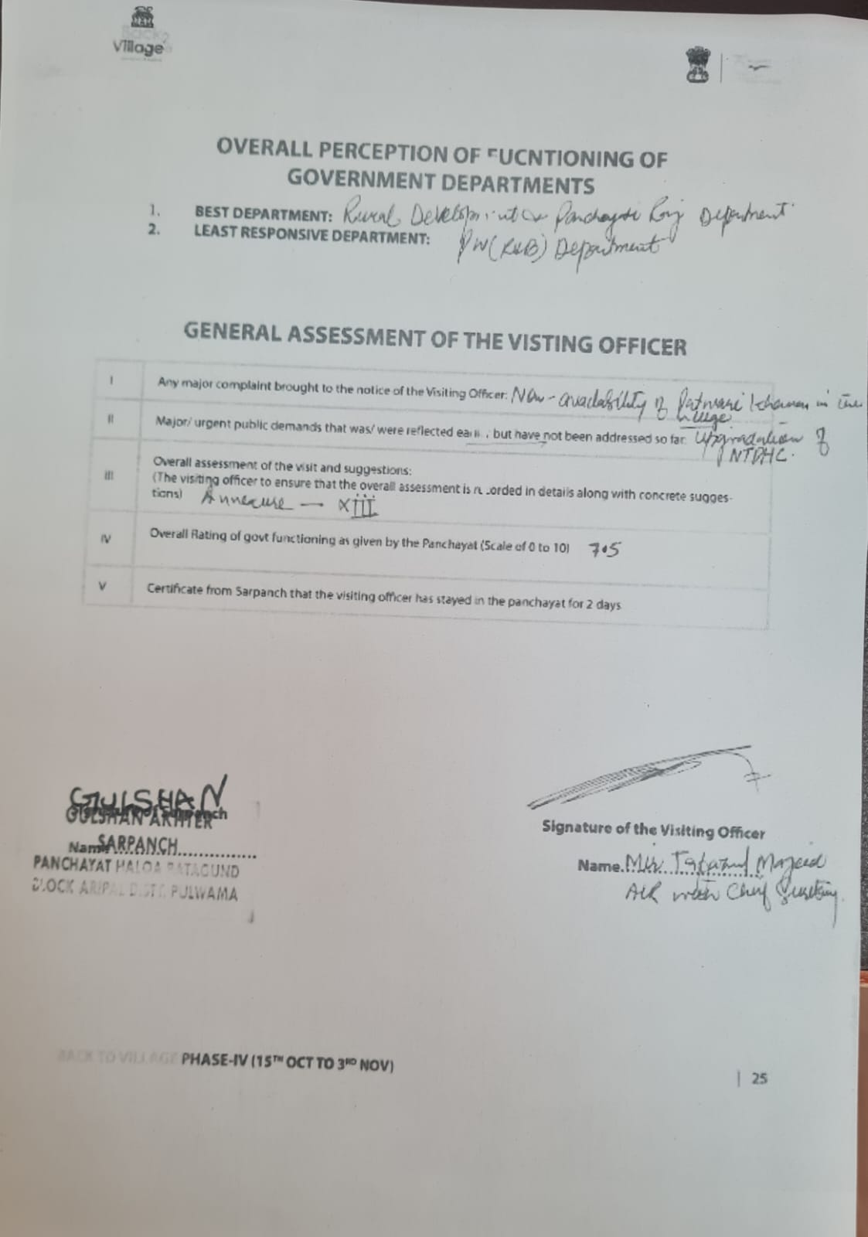

**Annexure- I**

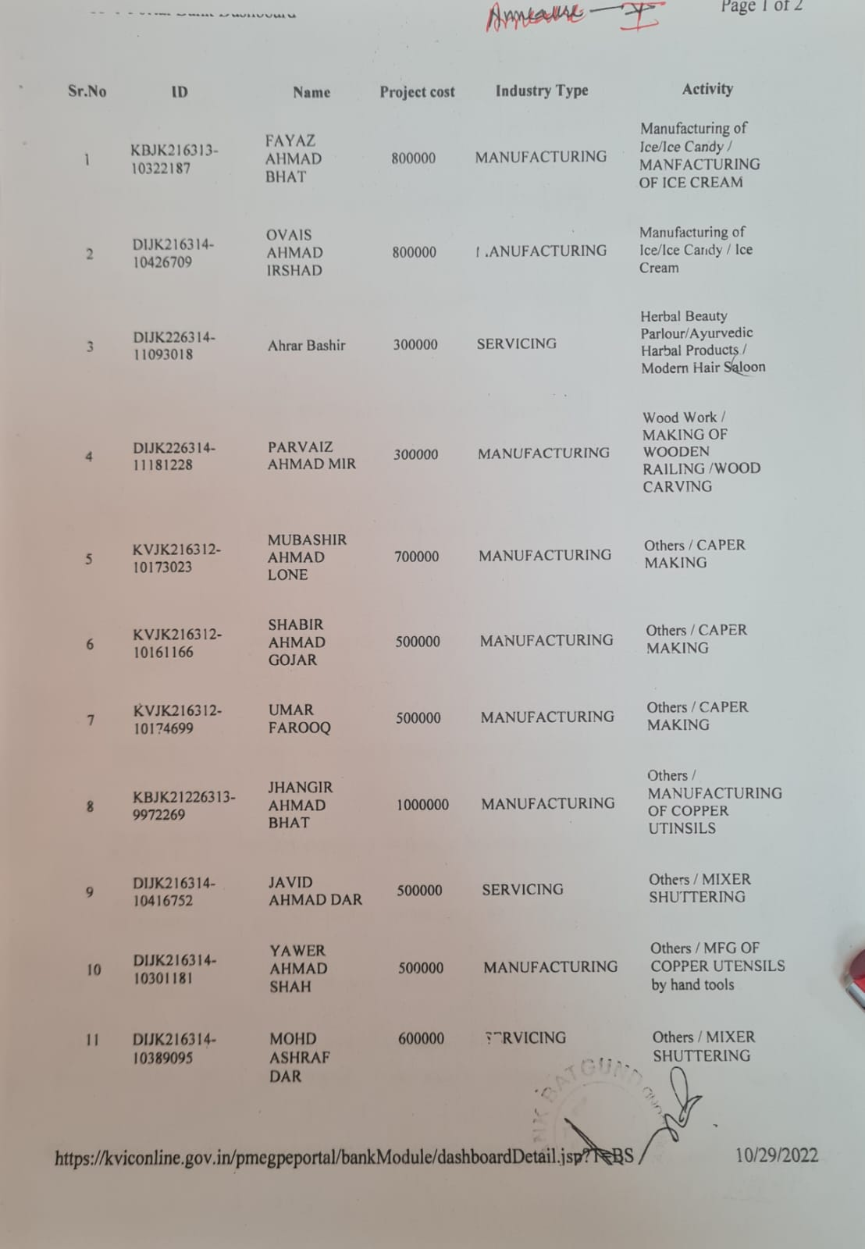

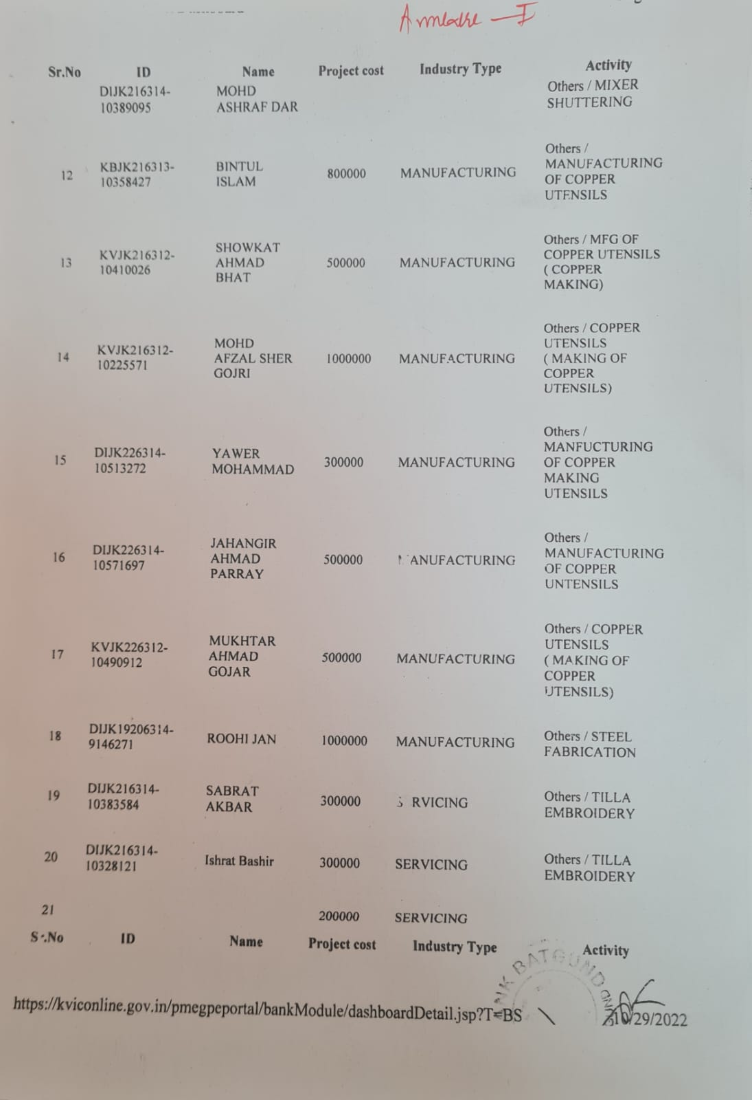

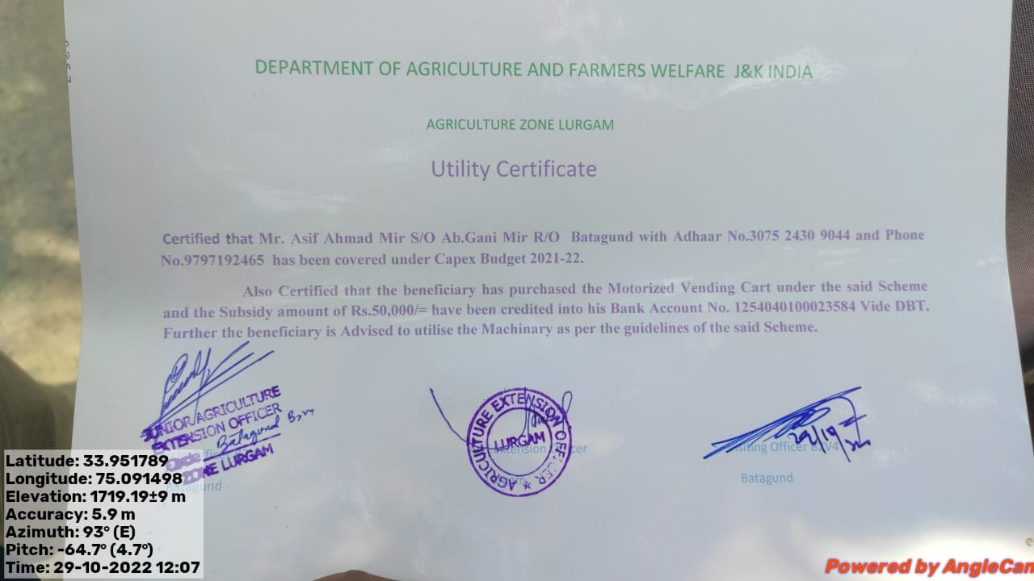

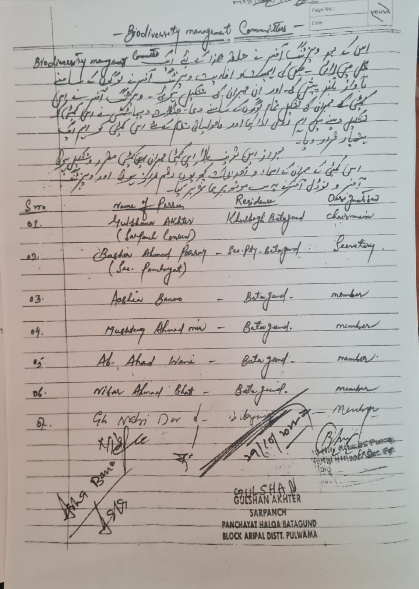

**Annaexure - II**

**annexure –III**

**Overall assessment of the visit and suggestions:**

Back to Village (B2V) is one of the best initiatives undertaken by the Government of Jammu and Kashmir to make available Government at the doorsteps of the Rural Population to listen to them and put their genuine demands/grievances before the Government Jammu and Kashmir for redressal.

Government has provided the undersigned an opportunity to be part of this mission with the directions to visit the village/halqa assigned to evaluate and asses the developmental works/ online services being provided in the village, Batagund, Tral.

During the visit, it was observed that lot of works have been undertaken/executed by the line Departments like Rural Development and Panchayati Raj, Social Welfare, Health and Medical Education, Youth Services and Sports, Power Development, Forest, Ecology and Environment, Industries and Commerce, Revenue, Labour and Employment, Agriculture and Farmers’ Welfare, Horticulture, School Education, Information Technology, Culture, Food, Civil Supplies and Consumers, Jal Shakti and Finance/J&K Bank.

During analysis, it came to the fore that 97% saturation has been achieved in the issuance of Golden Cards, 22 Self Employment cases have been sanctioned mostly in the field of manufacturing and services, Land Passbooks, income Certificates, domicile Certificates were distributed, digitalization of Jamabandi of the village has been done, Cent percent targets have been achieved in KCC, E-Sharm and PM Kissan Schemes, vaccination against Covid-19, regular immunization of children as per the government schedule is being done in the said village, etc.

Further, the undersigned participated in a number of events including sports, Haat, plantation drive, Nasha Mukt Abhiyan, Bal Sabha, Mahila Sabha, Gram Sabha/Gram Panchayat, organized in the village. Besides, visited various government offices and inspected the infrastructure available there after interacting with the staff. However, it was also observed that there are certain other aspects which need attention of the government, like dearth of staff in Schools/ Higher Secondary in the village, up gradation of infrastructure and providing staff (Dental Surgeon, Ophthalmologist, X-Ray Technician and Ambulance Driver) in the NTPHC, unavailability of Patwari Khana in the village, besides, stress be laid on the cleanliness of the village.

I would like to congratulate the Government of Jammu and Kashmir for conducting such a holistic programme particularly for overall development of rural populace who enthusiastically participated and put forth their view point.

In view of above, the following recommendations are submitted for the consideration of the Government:

1. Incomplete projects/works be completed in a time bound manner and the under progress projects should be accelerated to ease out the hardships being faced by the rural population. Accordingly, the work on under progress project regarding the construction of Higher Secondary School building at Batagund should be expedited for early redressal of the grievances regarding inappropriate accommodation for the students.
2. CEO/ZEO be instructed to have fortnight visits to atleast one panchayat to assess the availability of basic facilities including, quality education toilets, drinking water, laboratory, library, kitchen and accommodation, being provided in the schools under their jurisdiction and submit their ATR to the Deputy Commissioner concerned for further course of action.
3. Since the villages are prone to floods/flash floods, and as a preventive measure, it is suggested that a Short Term Two Year Plan be introduced to ensure the execution of some immediate works including repairment of bunds of nallas/streams/canals so as to prevent the leakage into the fields and nearby residential houses to avoid great havoc from being caused to the life (including livestock) and property of the villagers.
4. Health and Medical facilities are not provided at larger scale to carter the needs of the villagers. It was observed during the visit that there is one NTPHC for 17 adjoining villages and at times it becomes difficult for it to carter the medical and emergency needs of the residents of 17 villages. Therefore, it is submitted that the Medical and Emergency facilities in the NTPHC, Batagund village be upgraded and the requisite dearth of staff be immediately provided. This may reduce the work load on the District and sub-District Hospitals too.
5. In order to generate more and more employment opportunities for the educated youth in villages and to make them self dependent, it is suggested that at least one Trade and Skill Development Training Centre like repairing of electric and electronic gadgets, be established/installed in every panchayat to enable them to earn their livelihood.
6. Tourism Department should be instructed to develop Tourist and Heritage sites in a panchayat wherever available. This may also help employment generation and add to the revenue of the concerned village. According, it is requested that in Halqa Batagund shrine of Hazrat Miskeen Badshah Sahib (RH) be brought on Tourism Map of Jammu and Kashmir and appropriate steps should be taken for its development as Tourist/Heritage Site.
7. In every Panchayat, a well-established and organized Public Library be installed to provide literature to the aspiring students/candidates preparing for the Civil Services and other competitive exams. Such steps may also help the educated senior citizens to grasp the knowledge and share their valuable thoughts and experiences of reading books with youth population of the village in order the inculcate the habit of reading books among them.
8. In every Panchayat, two youth (male/female) with science background at 10+2 level should be given Medical Laboratory Technician Course Training on subsidy basis, so that the villagers should get their primary tests like Urine examination, bold sampling, ECG etc. done at their doorsteps and that too at low costs. This will save their precious time and may amount to one more source of employment generation in the village.
9. Each Administrative Secretary should adopt atleast one Panchayat, to visit on monthly basis to have firsthand information about the developmental works being carried out in the concerned panchayat and may issue immediate necessary instructions as may deem fit in the circumstances and may file their ATR to the Government for further course of action.
10. Government should arrange day visits of women/Children/youth to the Government/ Semi-Government/Public Sector Undertakings in the nearby cities to enable them to imbibe the work culture in them, so that they can share their first hand experiences with the local populace back in the village.
11. Since the villagers are mostly agriculturists and may not be having appropriate knowledge about the agriculture activities to be carried out in the fields. Therefore, it is necessary in every panchayat one Agriculture Sub-Centre be established where training regarding basic agricultural activities and hybrid seeds are made available to the villagers at their doorsteps under one roof. On the same analogy, Horticulture Sub-Centre may also be established in every panchayat.
12. Since, all the Government Departments are carrying out the developmental works in coordination and cooperation with each other, however to my understanding there should be some sort of supervision/monitoring over on overall developmental works/activities being carried out in a village. Accordingly, it is submitted that a Monitoring/Supervisory Mechanism of officers/officials from Departments of Rural Development, Planning and Monitoring, Finance and General Administration, besides, respectable senior citizens and panchayat members be established to monitor/supervise the activates being carried out in the village.

Visiting Officer,

Mir Tafazul Majeed,

ALR with Chief Secretary,

Government of J&K.



**Department of Rural Develompent and Panchayati Raj**

**Government of Jammu & Kashmir**