4





**15TH OCTto3RD NOV,2022**

**KEYFEATURES**

• DeputyCommissionerstoleadtheinitiative

• RuraldevelopmentDepartmenttobethenodaldepartment

• PlanningDevelopment&MonitoringdepartmentandITtobethesupport departments

**ACTIONSANDTIMELINES**

|  |  |  |  |
| --- | --- | --- | --- |
| **ACTION** | **RESPONSIBILITY** | **LATESTBY** | **REMARKS** |
| **Janabhiyan** | Alldepartments | Oct15-26th | Goingon |
| **DeputationofSecttstaff/ HoDs** | GAD | Oct14 | Done |
| **DeploymentofStaffto Panchayatsandservingof ordersondeployedofficers** | DCs | Oct25 | DCswilldeployseniorlevelstaff fromthedistricts.Strictactionto betakenagainstabstentions.No exemptionstobegiven |
| **Trainingofdistricttrainors onB2V4** | RDD | Oct26 |  |
| **Trainingofvisitingofficers** | DCs | Oct27 |  |
| **FieldVisitstobecompleted by** | VisitingOfficers | Nov3 | DCstosuperviseandensurethat eachPanchayatisvisitedwithin theperiodspecified |
| **DataofB2V4tobe uploadedby** | VisitingOfficers | Nov10 | DCstosuperviseandensurethat dataofallPanchayatsisupload- edbythevisitingofficerwithin theperiodspecified |

**INSTRUCTIONSFORTHEVISITINGOFFICER(DAYWISE)**

|  |  |  |
| --- | --- | --- |
| **DATE** | **INSTRUCTIONS** | **ACTIONPOINTS** |
| **Day0** | Meetingwithdeputy commissionerandhis/her team | a. TakeprintoutsoffilledbookletsofB2V1,B2V2andB2V3from [www.jkpanchayat.in](http://www.jkpanchayat.in)  b.Alsotakeprintoutsofthesummarizedexcelsheetsofthe previousphasesfrom[www.jkpanchayat.in](http://www.jkpanchayat.in)  c. CollectATRsonissuesraisedduringprevious3phasesfromthe officeofDeputyCommissioner(Planningdeptt)  d.Takeprintsofblank 2bookletsofB2V4from[www.jkpanchayat.in](http://www.jkpanchayat.in)e.Takeplansfor2previousyearsandATRsfromtheplanningdeptt f. CompletetrainingsondifferentcomponentsofB2V4being  organizedbyrespectiveDeputyCommissioners  g.CollectListofnewworksstarted/ongoing/completedduringthe previousandcurrentFinancialyearunderthefollowingheads:  • PRIgrants  • DistrictPlan  • UTplan  • MGNREGA  • Otherschemesofotherdepartments  • Anyotherwork  h. Plans/beneficiarylists:  • MGNREGAdraftplandocumentfortheyear2022-23.  • ListofAwaas+beneficiariesalongwithIHHL Convergence  • Listofpensionbeneficiaries.  • ListofSHGs  • Listofagricultureschemebeneficiaries  i. Listsofbeneficiariesfor:  • Variouscertificates/benefitstobedistributedbythe visitingofficer.  • Anyotheractivitiesidentifiedbydifferentdepartments |

|  |  |  |  |
| --- | --- | --- | --- |
| **Day1** | Reachthevillage | 1. | Ensurethatallfrontlineworkersofdifferentdepttsarepresent. |
|  |  | 2. | Ensureexhibitionbydifferentdepts.aboutindividualbeneficiary schemes |
|  |  | 3. | InspectJKB/PSBcounters/outlets |
|  |  | 4. | Participate/ensureorganizationofsportsactivityinplayfield,talent hunt/culturalevent/youthactivity |
|  |  | 5. | GandhiKatha(suggesteddetailsuploadedonjkpanchayat.in) |
|  |  | 6. | Visitatleast2amritsarovarsandgetitsgeotaggedphotos |
|  |  | 7. | InspectKhidmat(CSC)CentresandcreateGenerateawarenesson  225schemesparticularlyG2CschemeslikeBEAMS,Janbhagidari, AapkiZaminAapkiNigrani,DigitalJ&K |
|  |  | 8. | Visitingofficershallalsoplanandconductpanchayatlevelconver- gencemeetingofalldepartments |
|  |  | 9. | CheckeffectivenessofCentrallysponsoredschemes |
|  |  | 10. | VisitandinspectallgovernmentestablishmentsincludingPHE, AWC,FPS,schools,etc |
|  |  | 11. | Attemptsaturationofdeliverableso JanAbhiyanandwherever deficienciesfound,leadadrivetoachievealldeliverables |
|  |  | 12. | Assesseffectivenessofsanitationcampaigninthepanchayat |
|  |  | 13. | Ensureselfemploymentactivitiesfor15youthperpanchayat |
|  |  | 14. | Identify20potentialcandidatesperpanchayatforHIMAYATtraining alongwiththetradeonwhichtheywanttraining |
|  |  | 15. | Whereverpossible,distributeemploymentlettersforpeopleselect- edundervariousgovernmentemployments |
|  |  | 16. | Intheevening,holdnormalmeetingwith seniorcitizens,govtem- ployeesincludingretiredemployees,exservicemen,youthclub,and any citizens ofthevillagewhoareenrolledincollege/university |
|  |  | 17. | OpendiscussiononNashaMuktAbhiyan |

Day2 Haveameetingwithall stakeholders-depttofficials andpanchayatmembers

1. Discussionontheandassesstheprogressofdifferentschemesrelating tothelocalizedSDGsprioritizedforthatvillageaspertheresolution passedby thatGramPanchayaton21st April22,onNationalPanchayti RajDay.

2. Sensitizevillage residentsaboutmyScheme”portal(myscheme.in) whichincludesinformationaboutalltheschemesbeingrunbyCen- tral/State/UTgovtacrossthecountry

3. Hold meeting of theBiodiversityManagementCommitteestodeliber- ateonissuespertaining toconservation of biodiversityandsustaina- bleutilizationof biologicalresources.

4. PrepareVillagedevelopmentplan,inconsultancywithGrampanchayat, discussitingramsabhaandgetitapproved.

5. Ensure saturationofsoilhealthcardandgoldenhealthcardunderGold- enHealthCardunderAyushmanBharat,

6. Ensuresaturation of OldAge PensionScheme

7. EnsureDomicileSaturation.

8. EnsureKCCSaturation

9. Ensure saturationoflandpassbooks

10. Ensureregistrationofvillagevendorsneededforanyscheme,onGEM

portal

11. Ensurepanchayatcontractors registration

12. EncouragePanchayatmembers forimportanceofplantationdrivein

PanchayatunderHarGaonHariyali

13. Ensure paintingondigitalJ&Kinpanchayatghars

14. Ensure paintingonpanchayatactivitesandCSSinpanchayatghars

15. Thevisiting officeshallchecknoof kindergarten andplayfields present inthepanchayat for kidsandstudents,iftheinfrastructure present inthesearegoodenough.

16. Holdmeeting withpanchayatmembers todiscussaboutcorruption menaceandstepsrequiredtomakeJ&Kcorruptionfree

17. Obtaina candidassessmentaboutperformanceofvariousdeptts in- cludingfairfeedbackaboutdiscrepanciesinfunctioning

18. Check thestatusof NashaMuktAbhiyanandreporting of drugad- dictstoDeputyCommissioner.

19. IdentifyTouristDestinations,Circuits,ThemeTreks,IdentifyHomestays, providesupportfortourismactivities throughVillageCooperative

20. OrganizeTalentHuntatPanchayatLevel

21. Conductsocialauditofatleast5worksunderfollowingschemes:

a. MGNREGA

b.PMAY

c. IHHLtoiletsandpayments d.CSCs

e.AMRITSAROVARS

22. Holda mahilasabha anda balsabhaandrecordproceedingsinthefor- matgiven

23. InauguratevillagehaatunderJKSRLM

24. Checkifyouthclubsareformedinthepanchayatandwhatactivities theyareengagedin

25. Organizea villagelevelculturaleventtoengagepanchayatmembers

26. SensitizeGPaboutE-kitabkoshaninitiativeofJ&KGovtforempowering youthsthrough onlinedigitalliteracy

**GENERALINSTRUCTIONS**

1. Thevisitingofficershallrefrainhimself/herselfgivingorofferinganycommitmentonbehalfofthe governmentandshalladoptanunbiasedattitudeinreportingissues.As faraspossible,his/her observation shouldbebasedona fairandanalytical viewemergingfromhis/herinteractioninthe village.

2. Heisgoingtothevillageasplanningofficer,notforsanctioninganyworksorformakinganycom- mitments.

3. Whilepreparingvillagedevelopmentplan,hehastoensurethat,demandsareprioritizedandre- flectedunderavailableschemes,wherevernecessarythelargerworksaretobereferredtoadminis- trativedepttunderCSS/UTplansunderintimationtoDCsandrestoftheworkstoDCsforreflecting itunderdistrict/CSS plans

4. His workshallbehardcoreplanningandauditandisnota PRexercise.

5. EveryDeputyCommissionerhastoensurethatatleastoneRDDofficial(ideallyPanchayatSecre- tary)ispresent ineverypanchayatwithrelevantpanchayatrecords,toensureconductofallactivi- tiesasplanned.Panchayatwiseorderneedstobeissuedinadvance.

6. Visitingofficershouldideallycarryhis/herlaptoptocompletethereportsatthepanchayatlevel itselfanduploadthefinalreport,duly signedbothbythesarpanchandbythevisitingofficeron [www.jkpanchayat.in](http://www.jkpanchayat.in)portal,beforetheyleavepanchayat.

7. Focus ofvisitareyouth,skills,self-employment,nashamukt,bhrashtracharmukt,Rozgaryukt J&K, besidestocarryforwardtheactivities duringJanAbhiyanandsaturatethem.

8. Inadditionattentionmaybegiventothefollowingareas a. MakefulluseofCentrallySponsoredSchemes

b.Saturationofindividualbeneficiaryschemes c. Self-employmentschemes

d.Banklinkedschemes-includingdepartmentalsubsidyschemes e.Empowermentandtransparencythrough digitalinitiatives

f. Effectivenessofgrassrootsmachinery–

i. Patwari,VLWpresent andavailable

ii. AvailablefundsutilizedinpublicinterestandasperGramSabharesolutions iii. Fairness ingovernance

iv. CSS/Individual beneficiaryschemesetc v. BrashtacharMuktJ&K

vi. BhaiMuktJ&K

vii. NashaMuktJ&K

9. ThePRImembers (Sarpanchs,Panchs,BDCChairperson)shallbeattheforefrontofallactivities and givendueimportanceandtheapproach shouldbetostrengthenthemandmakethemfeelem- powered.He/sheshallensurethattheBDCchairpersonandSarpanch/Panch arepresent atthetime ofinaugurationandceremonies.

10. Visitingofficershallnotleavethedistrictwithoutuploadingthereport,duly signedonthe**www. jkpanchayat.in**portal.EveryDeputyCommissionerhastoensurethat.

**A) DetailsofReportingOfficer:**

Name: MUSHTAQ AHMAD GANIE

Designation: A.E.E (R&B)

Department/placeof posting: (R&B) SUB DIVISION PAMPORE

MobileNo: 8493859906

EmailID: mushtaqganaie99@gmail.com

HomeDistrict: PULWAMA

Datesof visit: 30th & 31th of October 2022

**B) LocationaldetailsofPanchayat:(tobepre-filled,informationtobetakenfromtheprevious phasesbooklets/summarizedexcelsheetuploadedonjkpanchayat.in/b2v4.php)(tobevali- datedbythevisitingofficerandmissingdetailstobefilled)**

NameofthePanchayat: PANNER JAGIR

LocalGovernmentDirectory(LGD)codeof thePanchayat:242902

Nameof CDBlock:TRAL

NameofTehsil:TRAL

Nameof District: PULWAMA

**C) PanchayatProfile:**

No.ofrevenuevillagesinthePanchayat: O1

No.ofhamletsinthePanchayat: 04

No.ofhouseholdsinthePanchayat: 371

Population(approx)of thePanchayat: 2250

**Part-II:**

(TobefilledupbytheVisitingOfficerduringhis/hertwodayvisittothePanchayat.AllFieldshavetobe

filledbytheVisitingOfficerbeforethebookletishandedovertotheDC

**FrontlineOfficers/OfficialswhowereassignedtothePanchayatfortheprogramme: SEPARATE SHEET ATTACHED AT THE END OF BOOKLET**

|  |  |  |
| --- | --- | --- |
| Department | Name | Designation |
| Rural Development Department | Sheeraz Ahmad Shah | Panchayat Secretary |
| PDD | Ab Salam Lone | MR |
| Horticulture | Javaid Ahmad Shah | Field Asst |
| Food and Supplies | Khursheed Ah Khan | Store keeper |
| Forest Deptt. | Bashir Ahmad Bhat | Watcher |
| Social welfare | Tahir Majeed | Field Asst |
| Agriculture | Ab Rasheed Shah | Khalice |
| Health | Aabida | Asha Worker |
| ICDS | Nanha Akhter | Supervisior |
| Revenue | Ishtiyaq Ahmad | Patwari |
| Sericulture | Irshad Ahmad Magray | M/Man |
| Sheep Husbandry | Nisar Ahmad Hajam | Flock Supervisior |
| Flood Control | Rayees Ahmad Sheikh | Works supervisior |

**Detailsofabsentemployeesvis-à-vislistfurnishedbytheDCoffice:**

|  |  |  |
| --- | --- | --- |
| Department | Name | Designation |
|  |  |  |
|  |  |  |
|  |  |  |
|  |  |  |
|  |  |  |
|  |  |  |
|  |  |  |
|  |  |  |
|  |  |  |
|  |  |  |
|  |  |  |
|  |  |  |
|  |  |  |
|  |  |  |
|  |  |  |

**DAY1-ACTIVITIES**

**AGENDA1:PANCHAYATASSETREGISTER**

**Infrastructure:**

1. PanchayatGharInfrastructure a. Govtbuilding/private **private building**

b. New/needingrepairs **New panchayat ghar (government building) required**

2. Furniture(Y/N) **Insufficient Furniture**

3. Computer/printer(Y/N) **No**

4. Internet(Y/N) **No**

5. Telephone(Y/N) **No**

6. Toilet(CSC/partofpanchayatghar)(Y/N) **No**

7. Water(Y/N) **Yes**

8. Electricity(Y/N) **Yes**

9. Bankbranch(Y/N) **No**

10. CSC(Y/N) **Yes**

11. Patwarkhana(Y/N) **No**

12. Villagehaat(Y/N) **Temporary established in UPS panner**

13. Playground(Y/N) **No**

14. School-

a. Kindergarten(Y/N) **No**

b.Primary(Y/N) **Yes**

c. Secondary(Y/N) **No**

d. College (Y/N) **No**

e.University(Y/N) **No**

15. AnganwadiCentre(Y/N) **Yes**

a. (govt/private) **private**

b.Totalchildrenenrolled **144**

15. AmritSarovars–details,location,condition **Yes panner dam ,good condition**

16. Governmentoffices-details,whetherfunctionalornot **Separate sheet attached**

17. Rationshop(Y/N) **Yes**

18. Placesoftourismimportance–names,littledetailsonhistorical/culturalimportance **Panner Dam**

19. Villageheritagesites/treks-names,littledetailson historical/culturalimportance

20. VLWOffice (Y/N) **Rented Accommodation**

21. PrimaryHealthcareCentre(Y/N), **No (sub centre available)**

22. ListofIncompleteBuildings-names,yearofconstruction **Nil**

23. ListofUnderutilizedBuildings-names **Nil**

**DAY1-ACTIVITIES**

**AGENDA2:**

**DIFFERENTINSTITUTIONS/INFRASTRUCTUREPROJECTSTOBEVISITED**

|  |  |  |
| --- | --- | --- |
| **AMRITSAROVARS** | **Visit,verify** | **COMMENTS** |
| KhidmatCentres | Create/Generateawarenesson225schemes particularlyG2CschemsAapkiZaminAapkiNigrani, Beams,Janbhagidari,DigitalJ&K | Khidmat center available |
| JKB/PSBcounters/outlets | a)Statusofcounter b)Numberofvisitors | JK Bank not available |
| Incompletebuildings/pro- jects | Verify whetheridentificationandredistribution done | Nil |
| PDS | Visit,evaluate,onlinestatus | Available |
| PHC | Visit-evaluate,statusofstaff,equipmentand quality | No PHC available but Sub Center available |
| Youthclubs | Meet,interact,seeksuggestions | 01 youth club established |
| SHG | Meet,identifyproblems,seeksuggestions | 10 SHG available |
| PMAY | Inspect,Inaugurate | 5 no. inspected including 2 no. inaugurated . |
| Myschool,mypride progress;schools-water, toilets,staff | Visit,checkforwater,electricity,sanitation,meet studentsandstaff | No electricity, no water available at PS Kathward |
| SwachhSBM | Evaluate | SBM Drive is carried out regularly |
| Panchayatplayground, Sportskitsdistribution Villagegames | Ensure,verify.Participateinatleastonegamein theplayground | No playground available  sports kit distributed |
| HarGaonHariyali, Planta- tiondrive | Evaluatestatus,feedback | One no. of plantation drive carried out by Social Forestry Department |
| Villageculturalevent  Dangal/Haat/Mela | Participatein;ensurethatitisheld | Village culture event carried out |
| Exhibitionofschemes | Ensurethateverydepartmentparticipatesand thatitcontinuesfortheentiredurationofB2V | ICDS, Agriculture, Horticulture, Sericulture, RDD carries out exhibition of schemes regularly |
| JalJeewanMission verifica- tion- WSS/JSD  Electricitysupply | Verify | Pipe laid to Hoyinard Gujar Basti at Panner  water flow yet to be tested |

**DAY1-ACTIVITIES**

**AGENDA3:SATURATEJANBHIYAN**

**DELIVERABLESANDRECORDDEFICIENCIESIFANY(INSERTDELIVERABLESLISTHEREASPERGADFORMAT**

|  |  |  |  |  |
| --- | --- | --- | --- | --- |
| **S. No.** | **Deliverable** | **Department** | **Unit** | **Remarks** |
| 1 | Golden Health Cards | Health | 1692 | Almost 94% completed.Fingerprint scanning of (0-5)yr age group is difficult |
| 2 | Land Passbooks | Revenue | 500 | Passbook generation under process |
| 3 | Inheritance Mutations | Revenue | 80-90 | _ |
| 4 | Self Employment Drive | J&K Bank Industries | _ | _ |
| 5 | Identify candidates for skill training under HIMAYAT and other schemes | RDD | 10 | List attached |
| 6 | CSC/IT Camps in every Panchayat | IT | 1 | CSC available in the GP and is providing every scheme related facilities |
| 7 | Creating Awareness of Jan Bhagidari among PRIs and general public | IT | _ | Awareness related to jan bhagidari portal was created during the entire duration of B2V4 |
| 8 | Painting of Digital J&K in every Panchayat | RDD | At various places | For ceating awareness among general public about various developmental Schemes/Works and e governance models |
| *9* | *Pani Samitis* meetings to be held | Jal Shakti | _ | Pani samiti meetings were held on 2 days of B2V4 |
| 10 | Field testing kits to be provided for all Panchayats and trainings given | Jal Shakti | _ | Water quality was ensured under JJM by using test kits in earlier held Gram sabhas |
| 11 | Certification of water sufficiency and quality of Panchayats | Jal Shakti | _ | Water quality was good,but not Sufficient,availability of water supply was low.Some areas like Kathiward lacks water facility. |
| 12 | Implement Swachh Gram Plans • Door to door collection and disposal- ensure • Management of grey water, black water and solid waste | RDD | Newly constructed Soakage pits | Almost every HH of GP has a dustbin and for grey water management Soakage pits are given to HHs.Also new solid waste management shed is under construction |
| 13 | UDID Cards to be converted to Digital Format | Social Welfare | 23 | Almost 70% completed |
| 14 | E-shram Cards | Labour | 350-400 | - |
| 15 | Inspect Playfields and ensure that at least one sports event is helpd | YSSS | 0 | No Playfield available in GP,Youth demand for development of Playground |
| 16 | Inspect office of Patwari, VLW and ensure that name and phone number of the Patwari/VLW is painted on the wall of the office | Revenue, RDD | 2 | Inspected both the offices are in Rented accommodation ,so need of Govt Building for both the offices |
| 17 | Amrit Sarovars- Inspect quality | RDD | 2 | 1. Panner dam needs further improvement to make it an attractive tourist destination as it will be a good step to boast the economy of locals 2. Bud chamb,Alam khan,Khoshmoh,Hajinad,and Herkhah nag springs also needs attention from higher authorities |
| 18 | Youth Clubs Interact | Youth Mission | _ | Interacted with youth club members and ensured their participation in different games,but unfortunately there long pending demand for development of playground is not fullfiled yet. |
| 19 | Azadi Ka Amrit Mahotsav- Upload High Quality videos | Culture DCs | _ | _ |
| 20 | Hold Gram Sabha meetings and assess quality and effectiveness of service delivery, performance and ranking of departments and perception of corruption | All visiting Officers | _ | Gram sabhas held and accordingly assessed the services rendered by the departments |
| 21 | To check quality of works executed | All VO’s | Visited various Works | Found satisfactory especially works executed by RDD |

**DAY1-ACTIVITIES**

**AGENDA4:**

**SELFEMPLOYMENTACTIVITIES**

EnsureSelf-employmentactivities foryouth,distributeemploymentlettersforpeopleselectedunder varioussocialschemes(15ISTHETARGETPERPANCHAYAT)

**Numberofcasesindifferentcategoriessanctioned: Detailsofthebanksanctioningit:**

**Totalamountinvolved:**

**DAY1ACTIVITIES**

**AGENDA5**

Intheevening,holdinformalmeetings withseniorcitizens,govtemployees,retdemployees,youthclub andothercitizenswhoareenrolledoncollege/universityandhavediscussiononGandhiKatha,Nasha MuktAbhiyan,corruptionfreegovernance,doublingfarmersincomeandrecordtheproceedings

**DAY2**

a. NoofIndividualCompostPitsconstructed **01 (horticulture deptt. Assisted)**  
b.NoofIndividualSoakPitsconstructed **70 (RDD)**

V. No.ofBiodiversitymanagementcommitteemeetingsheld: **01 meeting held on 05-09-2020**

VI. IsthenameofSarpanchdisplayedoncitizeninformationboardsofallRD&PRschemes:Yes/No **Sarpanch Absconding since 6-march**

VII. AreSarpanchsbeinginvolvedinstart/inaugurationofactivities:Yes/No **sarpanch absconding**

VIII. WhethersubjectshavebeenassignedbytheSarpanchtothePanchs:Yes/No **sarpanch absconding 6-march**

IX. Whethergrievancesredressalboxisinstalled:Yes/No **No**

X. NoofgrievancesreceivedpertainingtoPanchayatlevel: **Not available**   
XI. NoofgrievancesdisposedofatPanchayatlevel: **Not available**

XII. WhethertheSarpanch/PanchayatSecretaryhavedigitalsignatures:Yes/No**Yes with pyt. Secretary only**

XIII. WhetherallMGNREGA/14thFCpayments arebeingmadebySarpanchthrough DigitalSignature

Certificate(DSC):Yes/No **Yes with pyt. Secretary only**

**HUMAN RESOURCEAVAILABLEATTHEPANCHAYAT LEVEL:**

|  |  |  |  |  |
| --- | --- | --- | --- | --- |
| **SRNO.** | **DEPARTMENTWISESTAFF** | **NUMBERS** | | **NAMES** |
|  |  | SANCTIONED | ACTUAL |  |
|  | Ruraldevelopmentdepartment: BDO  JE GRS TA | 01 01 01 01 | 01 01 01 01 | Shafeeq Ahmad Wani  Mohd. Ayoub Shaida Ajaz Ahmad Naik  Adil Manzoor |
|  | SCHOOLEDUCATION: TEACHER  HEADMASTER ANYOTHER REK/cosk/sweaper | 12 01 01 | 11 01 01 | Separate sheet Attached |
|  | JAL JEEVAN: JE Helper | 01 03 | 01 03 | Abdul Ahad Shah. Gh. Mohiuddin dar,Gh.Rasool Dar,Gh. Mohi-ud-din bhat |
|  | PDD: LINEMAN JE  ANYOTHER Incharge M.B PDL | 01 01 01 03 | 01 01 01 03 | Mohd. Yousf Chopan  Harmindar Paul Abdul Salam Ab. Rasheed Sheikh,Zahid ah. Hajam,M. Ayoub dar. |
|  | FOOD&CIVILSUPPLIES Store keeper | 01 | 01 | Khursheed Ahmad Khan |
|  | AGRICULTURE&ANIMALHUS- BANDARY Agriculture deptt. (JAEo) Animal Husbandary | 01  - | 01  - | Amarjeet Singh  Services provided by Animal husbandry centre Bathnoor |
|  | Social Welfare  Field Asst | 1 | 1 | Tahir majeed |
|  | HEALT Angwadi helper ASHA ANM  AYUSHDOCTOR ALLOPATHICDOCTOR |  |  |  |
|  | ANY OTHER DEPARTMENT  ICDS  Supervisor  Angwadi worker  Anganwadi helpers  HWC  HORTICULTURE  Field Asst.  IRRIGATION  JE  Works Supervisor  Helper | 01 05 05  05  02  01  01  01  01  01 | 01 05 05  05  02  01  01  01  01  01 | Nanha Akhter Tahira bano,Ameena akhter,Rafiqa,Zahida bano,Dazy jan  Abida,Raja Jan,Khateja,Mugli Aabida Ali, Nigeena Akhter,  Gower Rasheed  Javaid Ah. Shah  Manzoor ah Bhat  Gh Mohi ud din Baba  Bashir Ah wani |

**DAY2-ACTIVITIES**

**AGENDANO.1**

DiscussionontheandassesstheprogressofdifferentschemesrelatingtothelocalizedSDGsprior-itizedforthatvillageaspertheresolutionpassedbythatGramPanchayaton21stApril22,onNational PanchayatiRajDay(Copyoftheresolutiontobetakenfrom[www.jkpanchayat.in](http://www.jkpanchayat.in)portalunderthelinkof GramSwarajMonth)

1. SDGs AGREED FORTHATVILLAGE,TOBEIMPLEMENTED BYMARCH2024:

2. STATUSOFWORKSUNDERTHEFOLLOWINGSCHEMES:

**1 Cleanandgreenvillage**

i.InitiativestakenbythePanchayatformanagingSolidandLiquidWaste **work on solid waste segregation shed in progress**

ii. InitiativestakenbythePanchayatforusinggreensourcesoffuellikesolar,biogas **Nil**

iii. Hasmappingoflanduse,waterbodies,forest,slopes,wetlands,degradedforestwithintheGram

Panchayatbeendone?Yes/No.IfNo,reason,thereof **Not done**

iv. HastheClimateResiliencePlanbeendevelopedfortheGP?Yes/No **No**

v. StepstakenbytheGramSabhaabouttheclimatechangemitigationfactorslikereducingenergy consumption,usageoffossilfuels,plastics,non-renewablebuildingmaterialsandalsotopromote measureslikeplantingoftrees,conservingforests,usageofgoodagriculturalpracticeslikedrip irrigation,waterconservationmeasuresandconservationofwetlands.**Yes(By way of planting of trees,conserving of Forests)**

vi. Whetherschoolshavestartedsegregatingwaste **Yes**

vii. Whetherschoolshavetheirowncompost/soakagepitsforsolid/liquidwastemanagement **Nil**

**2 Healthyvillage**

i) Aremeetings relatedtoVillageHealthandSanitationCommitteebeingheldregularly?**Yes**

ii) DoalltheeligibleindividualsbeenprovidedtheGoldenCard? **Yes**

iii) ArealltheChildrenbeingimmunizedaspertheSchedulerecommendedbyGovt.ofIndia? **Yes**

iv) ArealltheeligibleindividualsbeenvaccinatedagainstCOVID-19? **Yes**

v) DoesGramPanchayatensurethatallpregnantwomenaregettingnecessaryprenatalcheckups? **Yes**

vi) WhetherallthedeliverieswereInstitutionalizedorconductedbytrainedMidwives? **Yes**

**3 Watersufficientvillage**

i) DoalltheIHHsintheGramPanchayathavewaterpipelineconnections? **Yes**

ii) WhetherGramPanchayathastakenstepsforgreywatermanagement.IfYespleasespecify? **Yes in form of soakage pits**

iii) DoalltheIHHsintheGramPanchayathavetoilets? **Yes**

iv) ArealltheIHHstoiletsfunctionalornot? **Yes**

v) DoalltheSchools/Anganwadicentershavea toiletfacilityornot? **Yes**

vi) Areallthetoiletsintheschools/Aaganwadifunctionalornot? **Yes**

vii) WhetherGramPachachayatBhawanhasseparate toiletsforwomenornot?**No gram panchayat Bhawan available**

**4 ChildFriendlyvillage**

i) Doallthechildrenundertheageof0-6yearsbeenenrolledintheAnganwadicentersforpre- schooling?Yes/NO **Yes**

ii) HowmanyBalSabha’swereorganizedintheGramPanchayat **02**

iii) WhethertheissuesraisedbyBalSabhaareaddressedduringtheGramSabha. Yes/NO **Yes**

iv) WhetherGramPanchayatistrackingthedatarelatedtodropoutchildrenandchildrenwithirregular attendance?Yes/NO. **Yes**

v) DoalltheschoolsundertheGramPanchayathaveseparate toiletsforgirlsandboys?Yes/No **Yes**

**5 Villagewithgoodgovernance**

i) IsCSClocatedintheGramPanchayatBhawanornot?**No panchayat bhawan available**

ii) IsthelistofbeneficiariesrelatedtotheSchemes/ProgramsdisplayedontheGrampanchayatwallor not?**List of beneficiaries displayed near UPS Panner**

iii) DoestheGramPanchayathasitsbuildingornot?**No**

iv) IstheGramPanchayatofficefunctionalornot?**Office is functional but in a private building**

v) Aretheactivities approved undertheHalqaPanchayatDevelopmentPlandisplayedontheGram

Panchayatwallornot? **Yes board displayed near graveyard panner**

vi) IsSocialAuditofearlierSchemes/Programscarriedoutornot? **Yes**

**6 Povertyfreeandenhancedlivelihoodvillage**

1. HasGramPanchayatdevelopedanycriteria fortheidentificationofthepoor?Yes/Noifyesspecify **Yes poor housing critera**

(ii) HavealltheeligiblehouseholdsregisteredinPDSornot?**Some houses are leftout and need to be incorporated**

iii) HasGramPanchayatprovidedspaceforSelf-helpGroupsinPanchyatGharforholdingmeetings or not?**No panchayat ghar available**

iv) HavealltheeligiblehouseholdsbeenregisteredforPensionornot? **Yes**

v) HasGramPanchayatfacilitatedYouthforSkillEnhancementCoursesandPlacement? **Group formed under Himayat Scheme**

vi) HasJobCardsbeendistributedtoalltheeligibleindividualsunderMGNREGA? **Yes**

vii) HasGramPanchayatfacilitatedSHGsforBankAccountLinkages? **Yes**

**7 Sociallysecuredvillage**

i) WhetherGramPanchayatismaintainingdatarelatedtoDifferentlyAbledPeople? **No**

ii) IsGramPanchayatOffice DisabledFriendlyornot?

iii) Areprovisionsfora separate BudgetundertheResourceEnvelopeforWomenandChildrenmadeor not? **Nil**

iv) DoalltheSchools intheGramPanchayathavefacilitiesforDifferentlyAbledChildrenliketoilets, barrier-freeaccess,etc.,ornot?**Facility needs a lot of improvement**

v) Arealltheeligibleindividualsaregettingpensions,likeoldagepension,widowpension,etc? **Yes**

vi) ArealltheeligiblehouseholdsgettingbenefitsfromIAYornot? **IAY cases sanctioned needs to be enhanced**

**8 EngenderedDevelopmentinVillage**

i) HowmanyMahilaSabha’swereorganizedintheGramPanchayat **02**

ii) WhetherSHGsfederationshavebeenprovidedspaceformeetings inthePanchayatBhawan(Yes/ No) **No Govt accommodation for Panchayat Bhawan(Rented accommodation)**

iii) WhetherGPshavetakenstepsforincreasingwomen’sparticipationinGramSabha(Yes/No) **Yes**

iv) NumberofwomenbeneficiariesheadedhouseholdscoveredunderPDS

system **16**

v) Numberofbeneficiaries(outoftotaleligiblepopulation)receivingsocialprotectionbenefitsunder

PradhanMantriMatritvaVandanaYojana **11**

9 Self-sufficientinfrastructureinthevillage

i.WhetherGPhasa CommunityHallwithaccesstoelectricity,furniture,watersupply, toilet **No**

ii.WhethertheDisastermanagementplanisavailableattheGPLevel(Yes/No) **No**

iii. Whetherchild-friendlyparkwithrequiredfacilitiesisavailableinGP(Yes/No) **No**

iv. WhethertheGPhaseasyaccesstoGodownforstorage(Yes/No) **No**

v. Whetherstreetlightsareprovidedinpublicplacesforensuringsafety(Yes/No) **Yes,but more street lights required in GP**

**DAY2ACTIVITIES**

**AGENDANO.2**

SensitizevillageresidentsaboutmyScheme”portal(myscheme.in)whichincludesinformationaboutall theschemesbeingrunbyCentral/State/UT govtacrossthecountry

*(SchemeMaterialavailablefromhttps://jkpanchayat.in/b2v4.php)*

**DAY2ACTIVITIES**

**AGENDANO.3**

HoldmeetingoftheBiodiversityManagementCommitteestodeliberateonissues pertainingtoconserva- tionofbiodiversityandsustainableutilizationofbiologicalresources.HeshouldcheckPeopleBiodiversity register(PBR)ofthatpanchayatandreviewifBiodiversityManagementCommittee constitutedforthat panchayatis holdingminimum4meetings inayearandmeeting onceinevery3months *(RoleofBMC availableathttps://jkpanchayat.in/b2v4.php)*

COMMITTEEMEMBERS **07**  PRESENT **07**

BIODIVERSITYREGISTERPHOTOS

PAST 4MEETINGDETAILS-DATES,MINUTESPHOTOS

**(Minutes attached at the end of Booklet)**

**DAY2ACTIVITIES**

**AGENDA4 (Separate sheet of village development plan attached at the end of booklet)**

Visitingofficershallalsoplanandconductpanchayatlevelconvergencemeeting ofalldepartmentsand prepareVillagedevelopmentplanforvillage,inconsultancywithGrampanchayat,discussitingram sabhaandgetitapproved.

(GPDPformatavailableonhttps://jkpanchayat.in/b2v4.php)

**InadditionGPDPplanshallalsoinclude:**

▪ Touristplaceswhichneedtobedeveloped

▪ Specificproductwhichneedstobedeveloped

▪ Tourism-homestays

▪ 20candidatesfortrainingunderHimayatschemealongwithtradeinwhich trainingistobegiven

B **DAY2ACTIVITIES**

**AGENDA5**

Ensuresaturationoffollowingschemesandgivestatus:

|  |  |  |  |
| --- | --- | --- | --- |
| **NAMEOFTHESCHEME** | **TOTALELIGIBLE BENEFICIARIESIN THE VILLAGE** | **TOTALBENEFICIARIESWHO AVAILEDTHEBENEFITSOFTHESCHEME** | **REASONSFOR PENDENCY** |
| GoldenHealthCardunder  AyushmanBharat | 1836 | 1692 | Pending 144 ,Finger scanning of age group(0-5)yrs is difficult |
| Jananisurakshayojana | 20 | 20 |  |
| OLDAGEpension | 151 | 151 |  |
| Widowpension | 103 | 103 |  |
| Disabilitypension | 44 | 44 |  |
| Domicilecertificate | 2250 | 1500 | As the Scheme is online rest beneficiaries have not applied |
| Kisancreditcard | 263 | 263 |  |
| PMkisansammannidhi | 202 | 202 |  |

|  |  |  |  |
| --- | --- | --- | --- |
| Landpassbook | 500 | __ | Passbook generation in progress |
| Registrationofvillageven- dorsonGEMportal | _ | _ | No awareness of the registration of village vendors GEM portal |
| Registrationofvillagecon- tractorsonjktendersportal | _ | _ | No contractor of village Panner is registered on jketenders portal |
| Registrationofvillagecon- tractorsonPWDportal | _ | _ | No contractor of village Panner is registered on PWD portal |
| Incompletebuildings/pro- jects | _ | _ | There is lot of scope for development of dam at panner for creating tourism facilities |

**DAY2ACTIVITIES**

**AGENDA6**

**NASHAMUKTABHIYAN**

1. Whethergramsabharesolutionpassed **Yes**

2. Detailsofactivities conducted **Awareness compaign conducted to make aware the people of drug menance**

3. Whetherallactivities andGSresolutionuploadedonjkpanchayats.inportal

4. Howmanydrugaddictsinthevillage **No information of drug addicts**

5. WhetherreportedtotheDeputyCommissioner **No information of drug addicts**

6. Howmanyregisteredforrehabilitationundergovernmentprogramme

**No information**

**DAY2ACTIVITIES**

**AGENDA7**

**SOCIALAUDIT (Separate Sheet attached at the end of Booklet)**

Conductsocialauditofatleast5workseachunderfollowingschemes:

|  |  |  |  |  |  |  |
| --- | --- | --- | --- | --- | --- | --- |
| NAMEOFTHE SCHEME | DETAILSOFTHE WORKS | YEAROFWORK APPROVAL | AMOUNT APPROVED  FORTHEWORK | WHETHER  WORKEXECUTED SATISFACTORILY | GEO- TAGGED PHOTOS | ANY GRIEVANCE RECORDED RELATINGTOTHAT WORK |
| MGNREGA |  |  |  |  |  |  |
| PMAY |  |  |  |  |  |  |
| IHHL  UNDERSBM-G |  |  |  |  |  |  |
| CSCUNDER SBMG |  |  |  |  |  |  |
| AMRIT SAROVARS |  |  |  |  |  |  |

**DAY2ACTIVITIES**

**AGENDA8**

**MAHILASABHA**

Totalwomeninthevillageabovetheageof18= **644**

Totalattended= **21**

Proceedings: **(Minutes attached at the end of Booklet)**

*(Plinsertpointerstobediscussedthere–referpalliproceedings)*

**DAY2ACTIVITIES**

**AGENDA9**

**BALSABHA**

Holda balsabhaandrecordproceedings

Totalchildreninthevillageabovetheageof 6yr= **332** Totalattended=**23**

Proceedings: **(Minutes attached at the end of Booklet)**

*(Plinsertpointerstobediscussedthere–referpalliproceedings)*

**DAY2ACTIVITIES**

**AGENDA10**

**INAUGURATIONS**

|  |  |  |  |
| --- | --- | --- | --- |
| **SR NO.** | **ASSETS/ACTIVITIES INAUGRATED** | **STATUSOFTHEASSET/AC- TIVITIES(NUMBER,OTHER DETAILS)** | **GEO-TAGGED PHOTOS** |
| 01 | VILLAGEHAATunderJKSRLM (SUN- DAYMARKET) | Knitting,Tailoring,Tila sozi,Cultivation of Vegetables | Yes |
| 02 | PMAYhousesifanyreadyforinaugra- tion | Inspected 05 including inauguration of 02 PMAY houses | Yes |
| 03 | Swachhgramprojects-segregation shedsetc | SWM shed at panner IHHL units inspected Soakage Pits inspected | Yes |
| 04 | Amritsarovars | Panner dam,Bud chamb,Khushmoh,Herkhah nag Springs | Yes |
| 05 | Sportskits | Carrom and Chess boards distributed | Yes |
| 06 | Villageculturalevents | Cultural events as warm welcome played by students of UPS Panner | Yes |
| 07 | JJMassets/projects | All JJM assets are in good condition | Yes |
| 08 | Anyothertobeidentifiedatdistrict level | Panner dam to be developed for Tourist Destination | Yes |

**FOLLOWUPOF(B2V1,B2V2&B2V3):**

*(Prefilledexcelsheet tobetakenfromdistrictlevel/andalsotobedownloaded*

*from*[*www.jkpanchayat.in)*](http://www.jkpanchayat.in)

|  |  |  |  |
| --- | --- | --- | --- |
| S.NO. | Particulars | Actiontaken | Remarks# |
| I. UrgentPublicRequirements/Demands-B2V1 | | | |
| 1 | Constt.of new water supply scheme | Under Progress | Constt of Bore well yet to be completed |
| 2 | Upgradation of UPS to High School | Not feasible | High School Available at a distance of 2Km |
| 3 | Upgradation of Sub Center to PHC | Not Feasible | Sub center including its Building needs improvement |
| 4 | Constt of Roads | PMGSY roads constructed for Sangnard,Hajinard | Kathiward Road needs to be Constructed |
| 5 | Installation/Upgradation of Electric Infrastructure | Upgradation in Progress | But needs Further improvement |
| 6 | Animal Husbandry Extension Center | Not Feasible | Facility provided by ICD Bathnoor |
| 7 | Constt. Of Panchayat Ghar | Not Constructed | Case forwarded to Higher Authorities |
| II. UrgentPublicRequirements/Demands-B2V2 | | | |
| 1 | Constt. Of Panchayat Ghar | Not Constructed | Case forwarded to Higher Authorities |
| 2 | Upgradation of Sub Center to PHC | Not Feasible | Population is less |
| 3 | Constt/Upgradation of Roads | PMGSY roads constructed for Sangnard,Hajinard | Kathiward Road needs to be Constructed |
| 4 | Constt.of new water supply scheme | Under Progress | Constt of Bore well yet to be completed |
| 5 | Opening Animal Husbandry Extension Center | Not Feasible | Facility provided by ICD Bathnoor |
| 6 | Upgradation of UPS to High School | Not feasible | High School Available at a distance of 2Km |
| 7 | Improvement in Electric Infrastructure | In Progress | But needs Further improvement |
| S.NO. | Particulars | Actiontaken | Remarks# |
| III. MajorProblems–B2V1 | | | |
| 1 | Health | No action | Building of Sub center needs Infrastructure,man power,Govt. Building |
| 2 | Education | No action | Walling of UPS panner,computer Lab Facility required |
| 3  4  5 | Drinking water Supply  Road Connectivity  Electricity Infrastructure | improved  In progress | Slow progress of Proiding drinking water facility due to non completion of Bore well at sangnard  Road for Kathward to be Constructed  Needs Improvement |

|  |  |  |  |  |
| --- | --- | --- | --- | --- |
|  |  | |  |  |
|  |  | |  |  |
| IV. MajorProblems-B2V2 | | | | |
| 1 | Constt of New water supply Scheme | | Under Progress | Distribution of pipe line is low Also Bore well Construction at sangnard is yet to be completed |
| 2 | Improvement in road infrastructure | | Roads at Sangnard and Hajinard constructed | But Kathward road to be Constructed |
| 3 |  | |  |  |
| 4 |  | |  |  |
| 5 |  | |  |  |
| V. MajorProblems-B2V3 | | | | |
| 1 | Upgradation of Health center to PHC | | Not Feasible |  |
| 2 | Upgradation of UPS to High School | | Not Feasible |  |
| 3 | Constt of Panchayat Ghar | | DPR Submitted |  |
| 4 | Animal Husbandry Extension Center | | Not Feasible |  |
| 5 |  | |  |  |
| VI. MajorComplaints-B2V1 | | | | |
| 1 | |  |  |  |
| 2 | |  |  |  |
| 3 | |  |  |  |
| VII. MajorComplaints-B2V2 | | | | |
| 1 | Drinking Water Facility | | Under Progress |  |
| 2 |  | |  |  |
| 3 |  | |  |  |
| VIII. MajorComplaints-B2V3 | | | | |
| 1 | Portable Water Supply for Drinking;Repairment of borewell | | Under progress | Needs special Attention for early completion |
| 2 | Upgradation of Electricity Infrastructure | | In Progresss | Needs Improvement |
| 3 | Constt of Water Harvesting Dam | | DPR submitted to Higher Authorities of Irrigation Deptt. | Needs Followup |

**OVERALLPERCEPTIONOFFUCNTIONING OF GOVERNMENTDEPARTMENTS**

1. **BESTDEPARTMENT: Rural Development Department and Education Department**

**2. LEASTRESPONSIVEDEPARTMENT:**

**GENERALASSESSMENTOFTHEVISTINGOFFICER**

|  |  |
| --- | --- |
| I | AnymajorcomplaintbroughttothenoticeoftheVisitingOfficer: **NO Govt.accomodation for sub center Health,No Panchayat Ghar, No sheep center** |
| II | Major/urgentpublicdemandsthatwas/werereflectedearlierbuthavenotbeenaddressedsofar: **Govt Accomodation by way of Construction of Panchayat Ghar** |
| III | Overallassessmentofthevisitandsuggestions:**(On a separate sheet attached at the end of Booklet)**  (Thevisitingofficertoensurethattheoverallassessmentisrecordedindetailsalongwithconcretesugges- tions) |
| IV | OverallRatingofgovtfunctioningas givenbythePanchayat(Scaleof0to10)= **7.5** |
| V | CertificatefromSarpanchthatthevisitingofficerhasstayedinthepanchayatfor2days ( **Sarpanch not Available from last few months as reported by the locals of the GP as well as Secretary Panchayat verbally.However chairman Auqaf committee was mad available by the locals for assessment**.) |

**SignatureofSarpanch (sarpanch not available)**

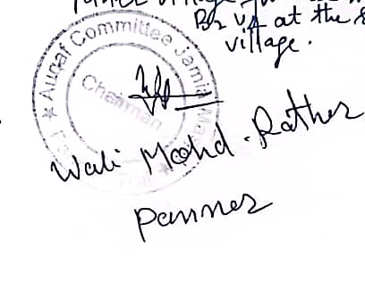

**Name: Wali Mohd Rather(Chairman Auqaf committee panner)**

**SignatureoftheVisitingOfficer**

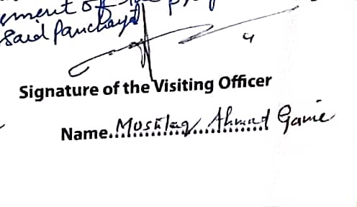

**Name :Mushtaq Ahmad Ganie**

**Social Audit of Works Under different Schemes:**

|  |  |  |  |  |  |  |  |
| --- | --- | --- | --- | --- | --- | --- | --- |
| NAMEOFTHE SCHEME | DETAILSOFTHE WORKS | YEAROFWORK APPROVAL | AMOUNT APPROVED  FORTHEWORK | WHETHER  WORKEXECUTED SATISFACTORILY | | GEO- TAGGED PHOTOS | ANY GRIEVANCE RECORDED RELATINGTOTHAT WORK |
| **MGNREGA** | (1)C/o road from H/o Ab Gani Khanday to Bagendar at Panner  (2)C/o road from Masjid Usmania to Nowpora at Panner  (3) Earth filling of Graveyard at Panner  (4) C/o road from H/o Manzoor Ah Wani to Tahir nag at Panner  (5)C/o road from Panner to Gojer Basti Kathiward | 2021  2021  2020  2021  2021 | 6.5469  3.8722  2.00  1.8673  6.48 | | Ongoing  Yes  Yes  Yes  Yes | Yes  Yes  Yes  Yes  Yes | No  No  No  No  No |
| **PMAY** | (1)Manzoor Ah Gojer S/o Aalam din Gojer  (2)Karim Gojer S/o Noor ud din Gojer  (3)Nazir Ah Gojer S/o Ali Gojer  (4)Manzoor Ah Gojer S/o Noor Gojer  (5)Gh Mohi ud din Lone S/o Rehman Lone | 2022  2022  2022  2022  2022 | Approved=1.50  Received=0.50  Approved=1.50  Received=0.50  Approved=1.50  Received=0.50  Approved=1.50  Received=0.50  Approved=1.50  Received=0.50 | | Yes  Yes  Yes  Yes  Yes | Yes  Yes  Yes  Yes  Yes | No  No  No  No  No |
| **IHHL units under SBM-G** | (1)Siraj Gojer S/o Yousuf Gojer  (2)Ismail Gojer S/o Alam din Gojer  (3) Gh Mohd Khanday S/o M Khalil Khanday  (4)Bashir Ah Chopan S/o waham chopan  (5)Bashir Ah Dar S/o Khaliq Dar | 2021  2021  2021  2021  2021 | 0.12  0.12  0.12  0.12  0.12 | | Yes  Yes  Yes  Yes  Yes | Yes  Yes  Yes  Yes  Yes | No  No  No  No  No |
| **CSC Under SBM** | CSC at Jamia Masjid Panner | 2021 | 1.60 | | Yes | Yes | No |
| **Amrit Sarovar** | (1)Panner Dam  (2)Bud chamb,Alam khan,Khushmoh,Hajinard and Hernag springs | 2022  2022 | 0.80  1.45 | | Yes  Yes | Yes  Yes | No  No |

**Village Development plan(B2V4):**

|  |  |  |  |
| --- | --- | --- | --- |
| **S.No** | **Name of work with location** | **Department** | **Tentiative Est. Cost in lacs** |
| 1 | C/o of Bunkhah road at Panner | RDD | 7.00 |
| 2 | C/o playfield at panner | PDD | 10.00 |
| 3 | Constt of P.bund on Various spots at Nalchinard Cheewas | RDD | 4.00 |
| 4 | Repairement/Construction of Kathward road with P.bund at Panner | RDD | 5.00 |
| 5 | C/o P.Bund on different spots Hajinard and Botwadi at Panner | RDD | 7.00 |
| 6 | Constt. Of road with P Bund from Budurbagh to L/o M Ramzan Ganie at panner | RDD | 4.00 |
| 7 | Constt of road with P Bund at Hajinard from L/o Laliya Gojer to H/o Mushtaq Gojer at Panner | RDD | 4.00 |
| 8 | Constt of P Bund behind Middle School at Panner | RDD | 2.00 |
| 9 | Constt of road with drain from Main Road ,L/o Khazir Bhat to L/o M Yousuf Rather | RDD | 4.00 |
| 10 | Constt of road from Graveyard (near Dar ul uloom) to H/o Wali Mohd Bhat at panner | RDD | 5.00 |
| 11 | Development of graveyard at Gojer Basti Panner | RDD | 4.00 |
| 12 | Constt of checkdam at Nallah Lough at panner | RDD | 4.00 |
| 13 | C/o footpath with drain from main road to H/o Gulzar Ahmad Rather(Nagbal) | RDD | 1.00 |
| 14 | Constt of B/Path with drain from H/o Ab gani Rather to Public park at panner | RDD | 2.00 |
| 15 | Constt of Dandi on watal ara from L/o Ali Mohd Bhat to Gori mohalla And others | RDD | 1.00 |
| 16 | Constt of P Bund behind the house of M Maqbool Hajam,Ab Rehman Hajam,and others | RDD | 1.50 |
| 17 | Constt of P bund on Nallah Lough Bunkhah at panner | RDD | 7.00 |
| 18 | Constt of P Bund from H/o jabbar dar to H/o Ab Rashid Dar | RDD | 1.50 |
| 19 | Constt of P bund on different spots at wanidar waserpal at Panner | RDD | 4.00 |
| 20 | Constt of P Bund on different spots at Dumbdar at Panner | RDD | 2.00 |
| 21 | Constt of B path near L/o Hassan Ali at Bathnoor road at panner | RDD | 3.00 |
| 22 | Constt of P bund at Bunkhah Khatenseer near L/o Ghulam Dar at Panner | RDD | 2.00 |
| 23 | Constt of Bore well near Masjid Usmania at panner | RDD | 4.00 |
| 24 | Extension of RCC culvert at dar Mohalla Nayi Basti near UPS Panner | RDD | 2.50 |

**List of Youth under Himayat Scheme(B2V4)**

|  |  |  |  |  |
| --- | --- | --- | --- | --- |
| **S.NO** | **Name of Youth with Parentage** | **Residence** | **Qualification** | **Trade** |
| 1 | Faizan Ahmad Reshi S/o Mohd Akram Reshi | Panner | Under Graduate | Electrician |
| 2 | Ubaid Ahmad Reshi S/o Mohd Akram Reshi | Panner | Under Graduate | Electrician |
| 3 | Abrar Bashir S/o Bashir Ahmad Dar | Panner | 12th | Plumbing |
| 4 | Sahil Fayaz S/o Fayaz Ahmad Dar | Panner | 10th | Motor Mechanic |
| 5 | Umar Bashir S/o Bashir Ahmad Wani | Panner | Under Graduate | Plumbing |
| 6 | Suhaib Khursheed Hajam S/o Khursheed Ah Hajam | Panner | 10th pass | Plumbing |
| 7 | Shabir Ahmad Lone S/o Gh Rasool Lone | Panner | Graduate with COPA | Computer |
| 8 | Nazir Ahmad Rather S/o Gh Mohd rather | Panner | 10th Pass | Painting |
| 9 | Aqib Satar S/o Ab Satar Lone | Panner | Under Graduate | Electrician |

**General Assessment of Visiting Officer**

It was observed during the visit of the area that the panner village is a remote village having hilly terrain and there is scope for further improvement in supplying electricity and portable water to the local households.There is a torrential nallah flowing through the mid of the village and there is a dire need for construction of protection works to protect the local population especially at dar Mohalla nayi basti near UPS panner.There is also a need for raising of RCC culvert on main road at muqdam mohalla panner to protect the local households against the Storm waters.A number of Govt Offices are Functioning in Private buildings with insufficient accommodation(like Health sub center,Sheep center etc), the same needs to be provided with Govt owned accommodation.Besides there is a dire need of Construction of Govt owned Panchayat Building.

Panner dam located in the GP has a good potential of developing as a tourist destination and establishment of Trout fish rearing Farms and a special attention needs to be given for the same.

PMAY houses being Sanctioned on a routine basis needs to be enhanced because during the visit it was observed that a number of beneficiaries approached the undersigned for Sanctioning of PMAY houses.The demands were found genuine and hence the same needs to be addressed on priority basis.

**Attendance Sheet Of Front line Workers**

1. 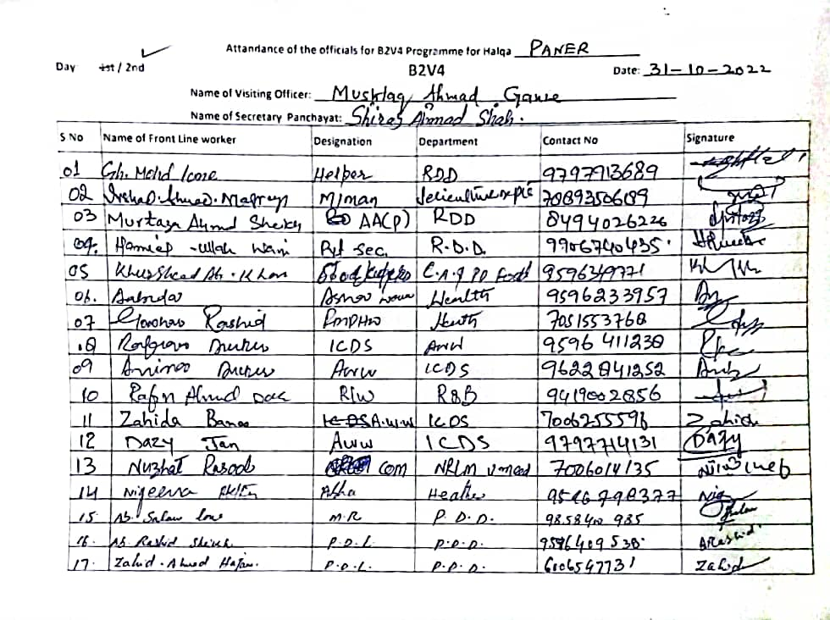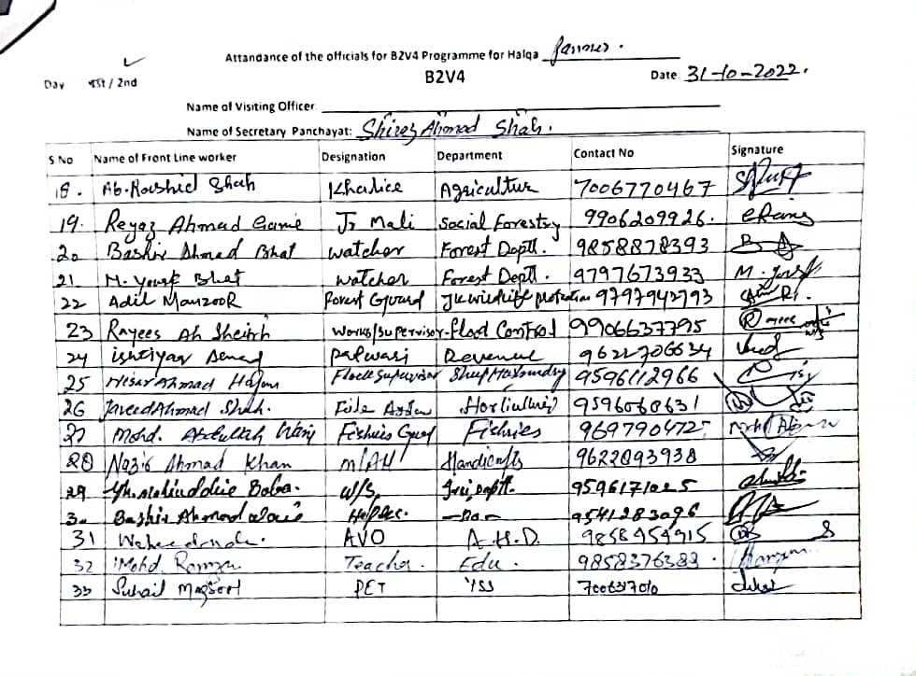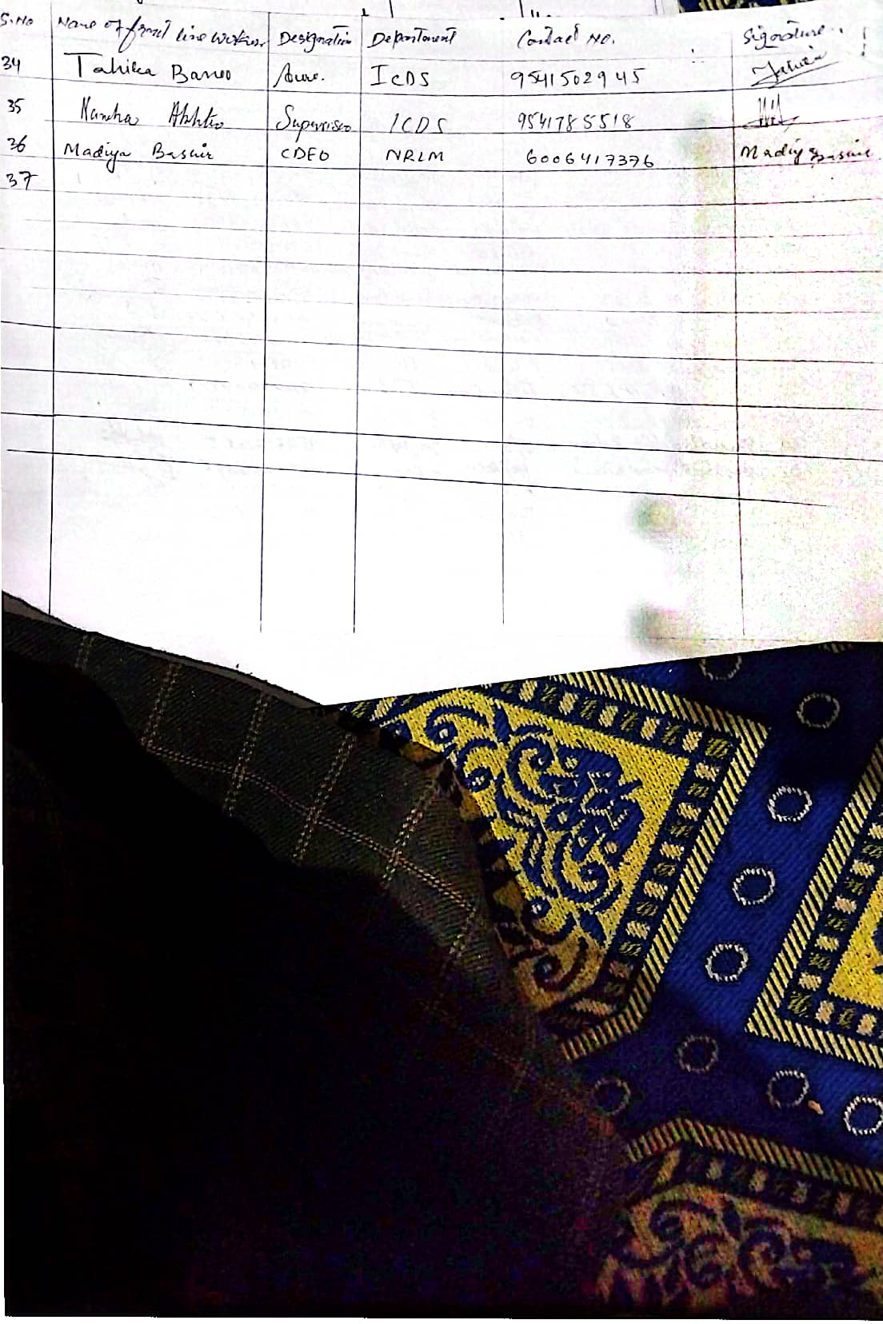
2. Targets and Deliverables B2V4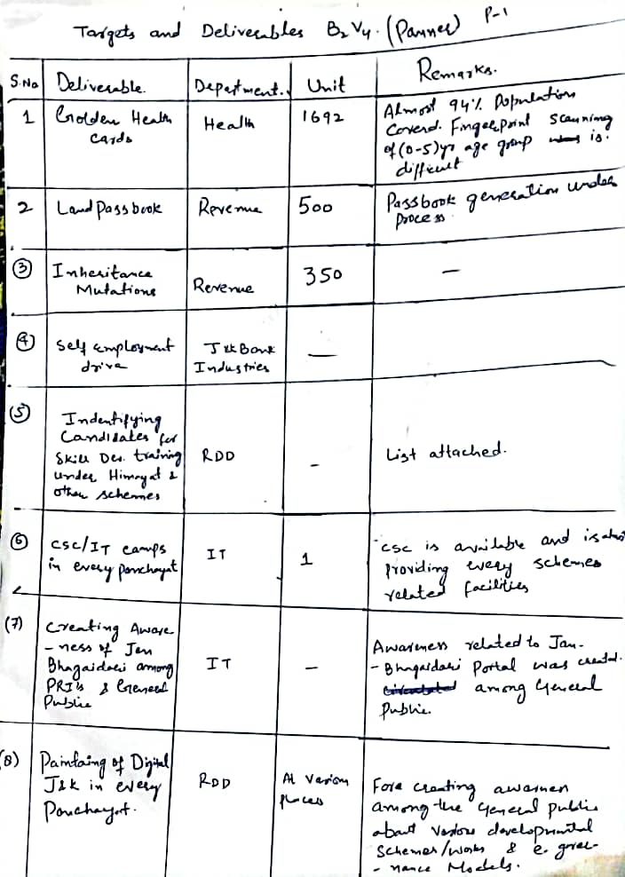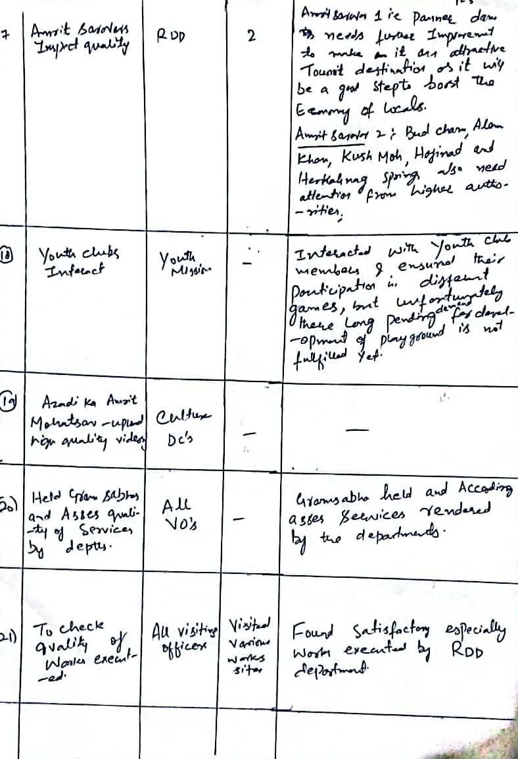
3. Social Audit of Works under different Schemes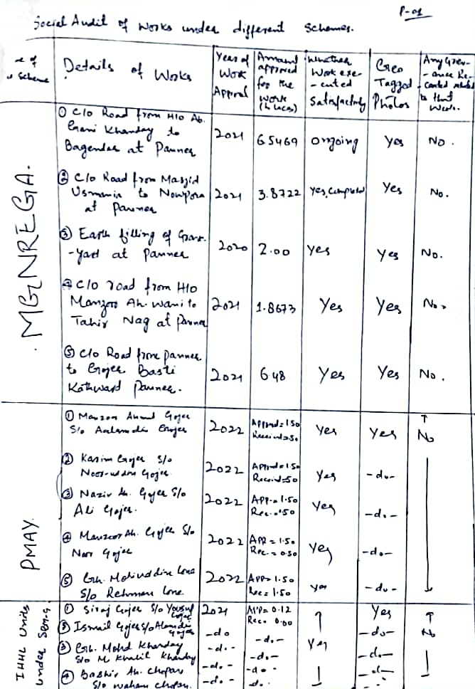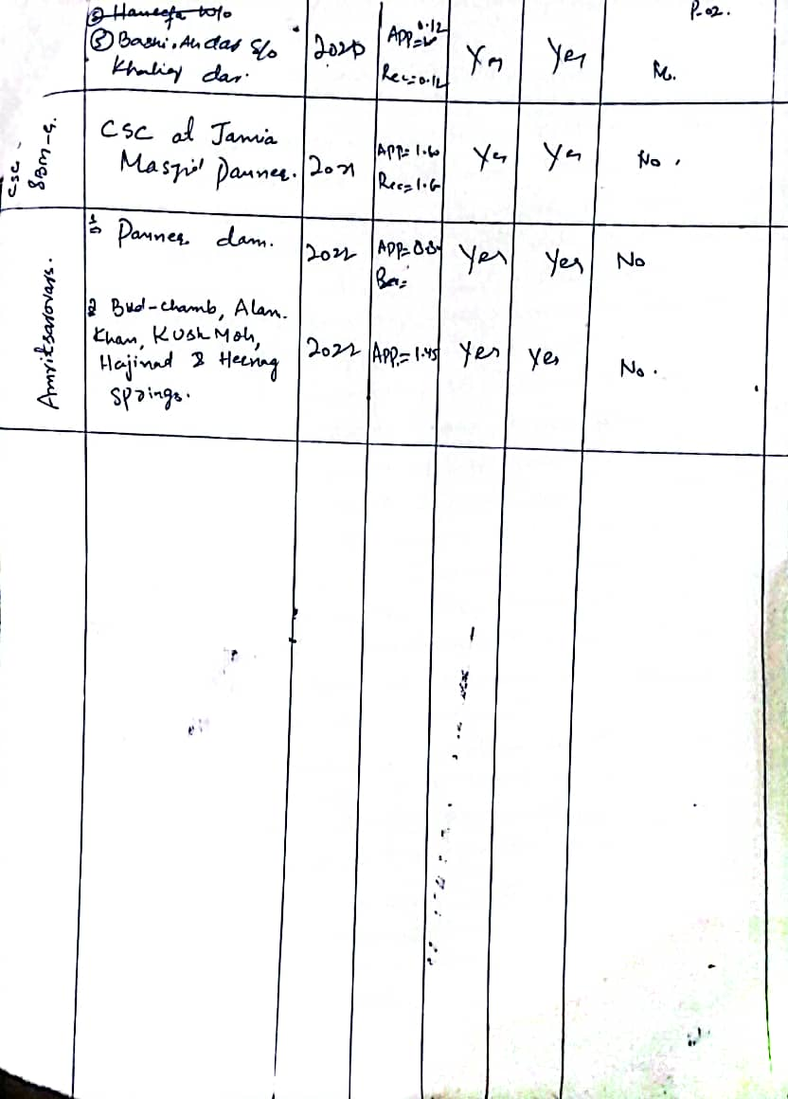
4. Village Development Plan under B2V4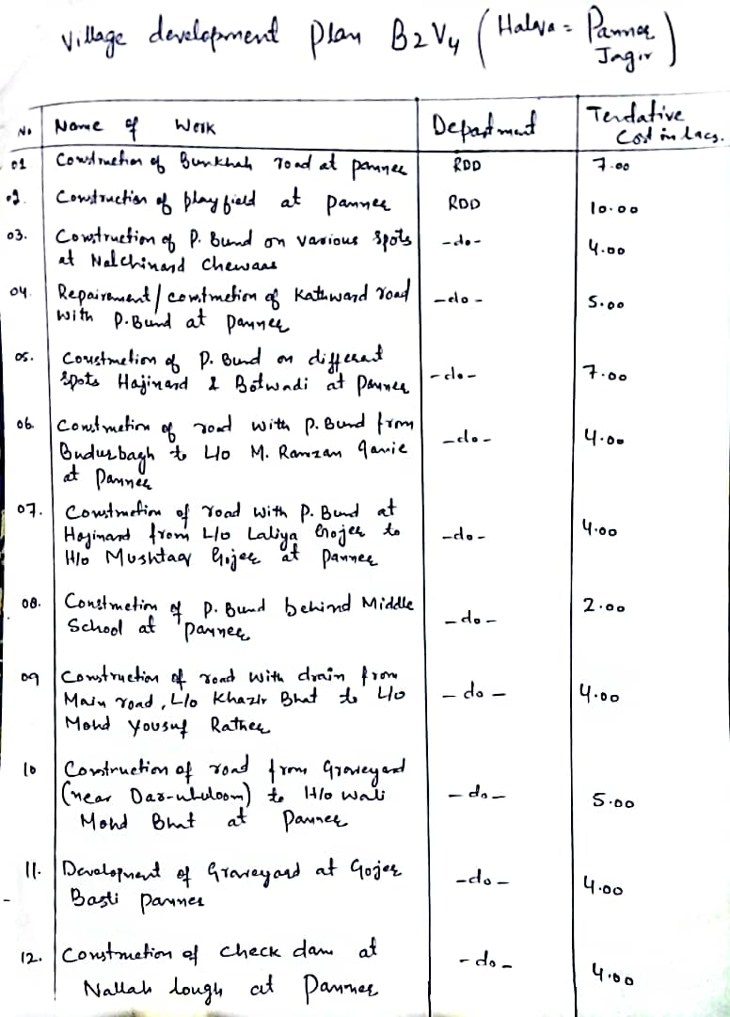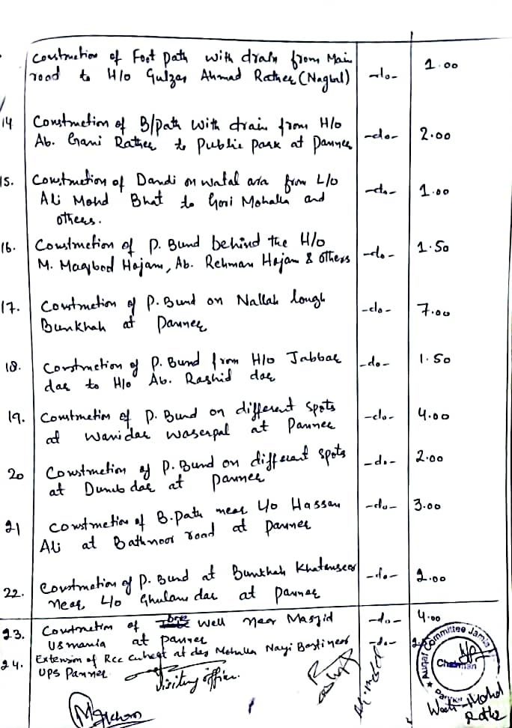
5. List of Youth Under Himayat Scheme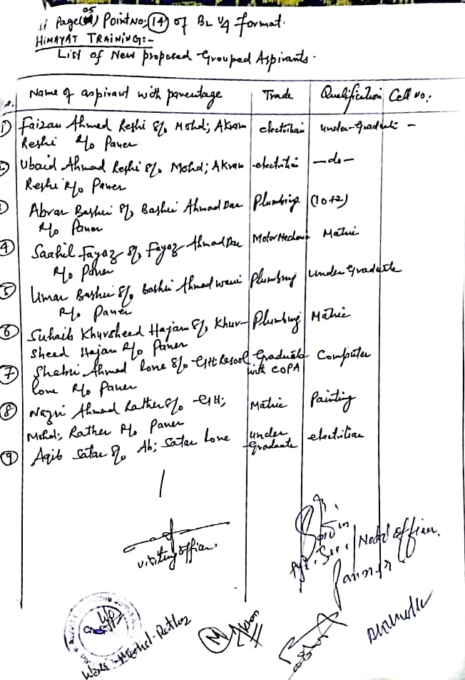
6. Information about various Govt offices,Teachers at UPS Panner etc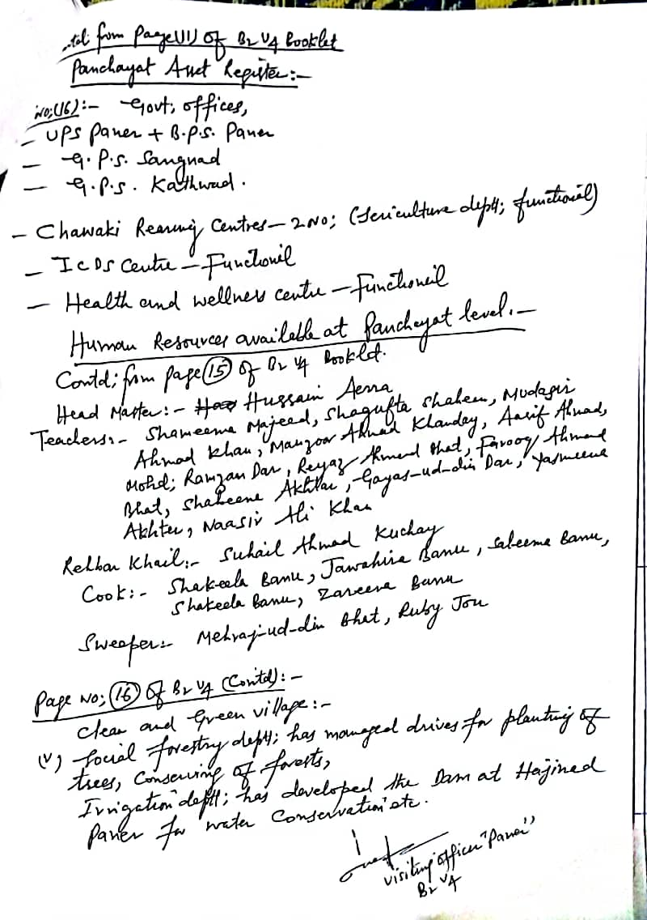
7. Assessment of Visiting Officer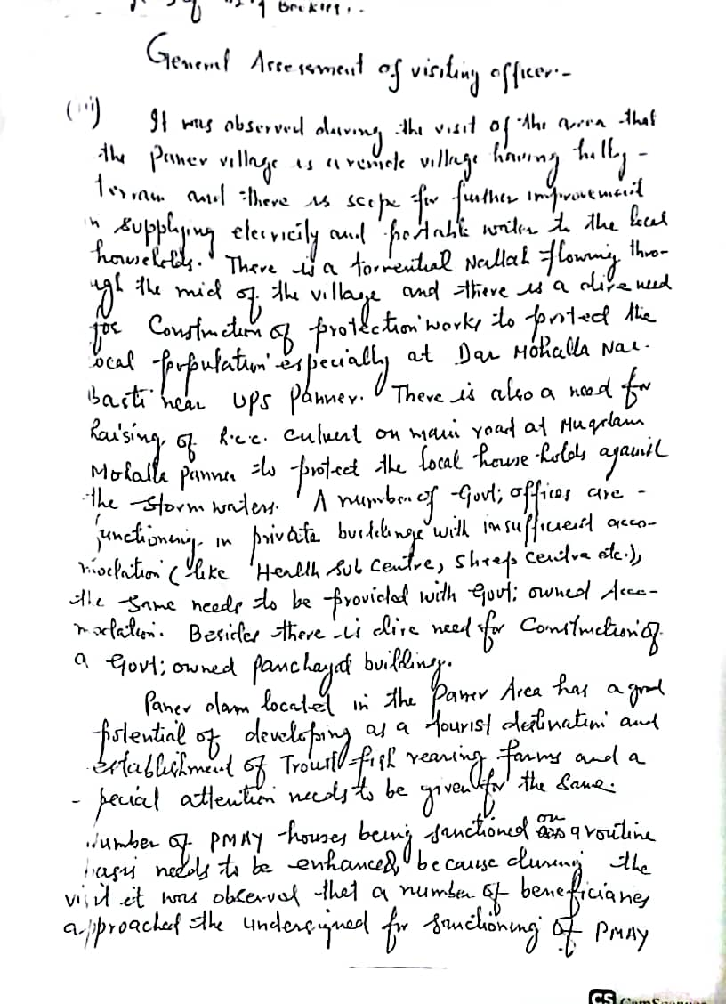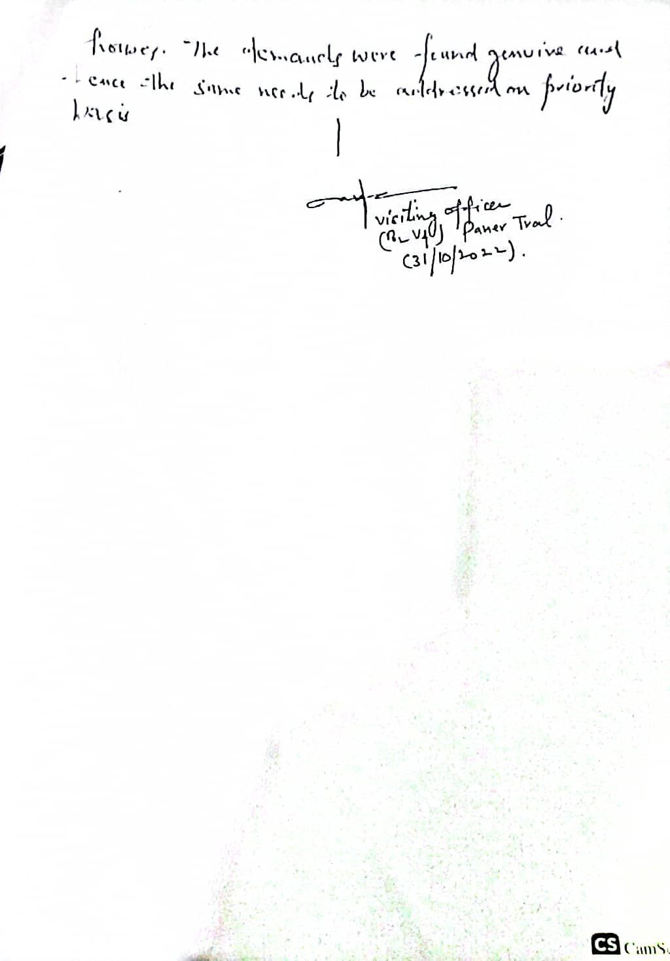



**DepartmentofRuralDevelompentandPanchayatiRaj**

**GovernmentofJammu &Kashmir**