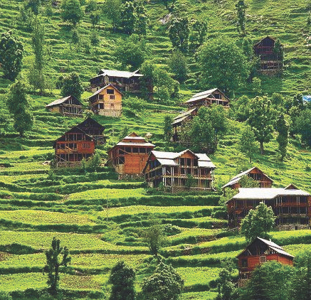
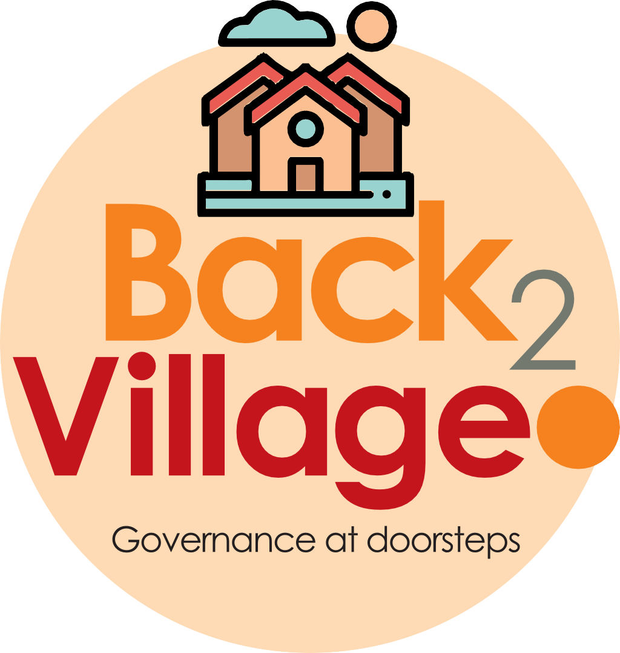
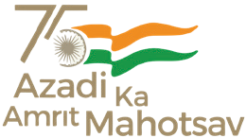

4

15TH OCT to 3RD NOV, 2022

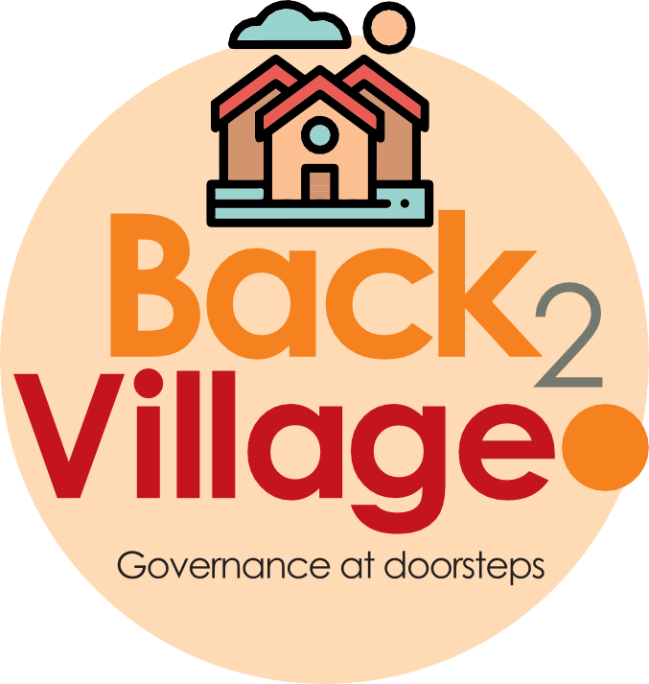
4
15TH OCT to 3RD NOV, 2022

KEY FEATURES
- Deputy Commissioners to lead the initiative
- Rural development Department to be the nodal department
- Planning Development & Monitoring department and IT to be the support departments

ACTIONS AND TIMELINES
ACTION | RESPONSIBILITY | LATEST BY | REMARKS
Jan abhiyan | All departments | Oct 15 -26th | Going on
Deputation of Sectt staff/ HoDs | GAD | Oct 14 | Done
Deployment of Staff to Panchayats and serving of orders on deployed officers | DCs | Oct 25 | DCs will deploy senior level staff from the districts. Strict action to be taken against abstentions. No exemptions to be given
Training of district trainors on B2V4 | RDD | Oct 26
Training of visiting officers | DCs | Oct 27
Field Visits to be completed by | Visiting Officers | Nov 3 | DCs to supervise and ensure that each Panchayat is visited within the period specified
Data of B2V4 to be uploaded by | Visiting Officers | Nov 10 | DCs to supervise and ensure that data of all Panchayats is upload- ed by the visiting officer within the period specified

INSTRUCTIONS FOR THE VISITING OFFICER (DAY WISE)

DATE | INSTRUCTIONS | ACTION POINTS
Day 0 | Meeting with deputy commissioner and his/her team | - Take print outs of filled booklets of B2V1, B2V2 and B2V3 from www.jkpanchayat.in  - Also take print outs of the summarized excel sheets of the previous phases from www.jkpanchayat.in  - Collect ATRs on issues raised during previous 3 phases from the office of Deputy Commissioner (Planning deptt)  - Take prints of blank 2 booklets of B2V4 from www.jkpanchayat.in  - Take plans for 2 previous years and ATRs from the planning deptt  - Complete trainings on different components of B2V4 being organized by respective Deputy Commissioners  - Collect List of new works started/ ongoing/ completed during the previous and current Financial year under the following heads:  - PRI grants  - District Plan  - UT plan  - MGNREGA  - Other schemes of other departments  - Any other work  - Plans/ beneficiary lists:  - MGNREGA draft plan document for the year 2022-23.  - List of Awaas+ beneficiaries alongwith IHHL Convergence  - List of pension beneficiaries.  - List of SHGs  - List of agriculture scheme beneficiaries  - Lists of beneficiaries for:  - Various certificates/ benefits to be distributed by the visiting officer.  - Any other activities identified by different departments

Day 1 | Reach the village | - Ensure that all front line workers of different deptts are present.  - Ensure exhibition by different depts. about individual beneficiary schemes  - Inspect JKB/PSB counters/outlets  - Participate/ensure organization of sports activity in playfield, talent hunt/cultural event/youth activity  - Gandhi Katha (suggested details uploaded on jkpanchayat.in)  - Visit atleast 2 amritsarovars and get its geo tagged photos  - Inspect Khidmat (CSC) Centres and create Generate awareness on 225 schemes particularly G2C schemes like BEAMS, Janbhagidari, AapkiZaminAapkiNigrani, Digital J&K  - Visiting officer shall also plan and conduct panchayat level conver- gence meeting of all departments  - Check effectiveness of Centrally sponsored schemes  - Visit and inspect all government establishments including PHE, AWC, FPS, schools, etc  - Attempt saturation of deliverable so Jan Abhiyan and wherever deficiencies found, lead a drive to achieve all deliverables  - Assess effectiveness of sanitation campaign in the panchayat  - Ensure self employment activities for 15 youth per panchayat  - Identify 20 potential candidates per panchayat for HIMAYAT training alongwith the trade on which they want training  - Wherever possible, distribute employment letters for people select- ed under various government employments  - In the evening, hold normal meeting with senior citizens, govt em- ployees including retired employees, ex servicemen, youth club, and any citizens of the village who are enrolled in college/university  - Open discussion on Nasha Mukt Abhiyan

Day2 | Have a meeting with all stakeholders- deptt officials and panchayat members | - Discussion on the and assess the progress of different schemes relating to the localized SDGs prioritized for that village as per the resolution passed by that Gram Panchayat on 21st April 22, on National Panchayti Raj Day.  - Sensitize village residents about myScheme” portal (myscheme.in) which includes information about all the schemes being run by Cen- tral/ State/ UT govt across the country  - Hold meeting of the Biodiversity Management Committees to deliber- ate on issues pertaining to conservation of biodiversity and sustaina- ble utilization of biological resources.  - Prepare Village development plan, in consultancy with Gram panchayat, discuss it in gram sabha and get it approved.  - Ensure saturation of soil health card and golden health card under Gold- en Health Card under Ayushman Bharat,  - Ensure saturation of Old Age Pension Scheme  - Ensure Domicile Saturation.  - Ensure KCC Saturation  - Ensure saturation of land pass books  - Ensure registration of village vendors needed for any scheme, on GEM portal  - Ensure panchayat contractors registration  - Encourage Panchayat members for importance of plantation drive in Panchayat under Har Gaon Hariyali  - Ensure painting on digital J&K in panchayat ghars  - Ensure painting on panchayat activites and CSS in panchayat ghars  - The visiting office shall check no of kindergarten and playfields present in the panchayat for kids and students, if the infrastructure present in these are good enough.  - Hold meeting with panchayat members to discuss about corruption menace and steps required to make J&K corruption free  - Obtain a candid assessment about performance of various deptts in- cluding fair feedback about discrepancies in functioning  - Check the status of Nasha Mukt Abhiyan and reporting of drug ad- dicts to Deputy Commissioner.  - Identify Tourist Destinations, Circuits, Theme Treks, Identify Homestays, provide support for tourism activities through Village Cooperative  - Organize Talent Hunt at Panchayat Level  - Conduct social audit of atleast 5 works under following schemes:  - MGNREGA  - PMAY  - IHHL toilets and payments  - CSCs  - AMRIT SAROVARS  - Hold a mahilasabha and a balsabha and record proceedings in the for- mat given  - Inaugurate village haat under JKSRLM  - Check if youth clubs are formed in the panchayat and what activities they are engaged in  - Organize a village level cultural event to engage panchayat members  - Sensitize GP about E-kitab kosh an initiative of J&K Govt for empowering youths through online digital literacy

GENERAL INSTRUCTIONS
- The visiting officer shall refrain himself/ herself giving or offering any commitment on behalf of the government and shall adopt an unbiased attitude in reporting issues. As far as possible, his/her observation should be based on a fair and analytical view emerging from his/her interaction in the village.
- He is going to the village as planning officer, not for sanctioning any works or for making any com- mitments.
- While preparing village development plan, he has to ensure that, demands are prioritized and re- flected under available schemes, wherever necessary the larger works are to be referred to adminis- trative deptt under CSS/UT plans under intimation to DCs and rest of the works to DCs for reflecting it under district/CSS plans
- His work shall be hard core planning and audit and is not a PR exercise.
- Every Deputy Commissioner has to ensure that atleast one RDD official (ideally Panchayat Secre- tary) is present in every panchayat with relevant panchayat records, to ensure conduct of all activi- ties as planned. Panchayat wise order needs to be issued in advance.
- Visiting officer should ideally carry his/her laptop to complete the reports at the panchayat level itself and upload the final report, duly signed both by the sarpanch and by the visiting officer on www.jkpanchayat.in portal, before they leave panchayat.
- Focus of visit are youth, skills, self-employment, nasha mukt, bhrashtrachar mukt, Rozgar yukt J&K, besides to carry forward the activities during Jan Abhiyan and saturate them.
- In addition attention may be given to the following areas
  - Make full use of Centrally Sponsored Schemes
  - Saturation of individual beneficiary schemes
  - Self-employment schemes
  - Bank linked schemes- including departmental subsidy schemes
  - Empowerment and transparency through digital initiatives
  - Effectiveness of grass roots machinery –
    - Patwari, VLW present and available
    - Available funds utilized in public interest and as per Gram Sabha resolutions
    - Fairness in governance
    - CSS/Individual beneficiary schemes etc
    - BrashtacharMukt J&K
    - Bhai Mukt J&K
    - NashaMukt J&K

- The PRI members (Sarpanchs, Panchs, BDC Chairperson) shall be at the forefront of all activities and given due importance and the approach should be to strengthen them and make them feel em- powered. He/she shall ensure that the BDC chairperson and Sarpanch/Panch are present at the time of inauguration and ceremonies.
- Visiting officer shall not leave the district without uploading the report, duly signed on the www. jkpanchayat.in portal. Every Deputy Commissioner has to ensure that.

Details of Reporting Officer:

Name: MOHAMMAD SAJAD Designation: LECTURER Department/ place of posting: EDUCATION/HSS BHATA DHURIAN Mobile No: 9797326129 Email ID: MOHDSAJAD9876@GMAIL.COM Home District: POONCH Dates of visit: 02/11/2022 - 03/11/2022

Locational details of Panchayat: (to be pre-filled, information to be taken from the previous
phases booklets/summarized excel sheet uploaded on jkpanchayat.in/b2v4.php) (to be vali- dated by the visiting officer and missing details to be filled)

Name of the Panchayat: SANGLANI Local Government Directory(LGD) code of the Panchayat: 239184 Name of CD Block: BUFLIAZ Name of Tehsil: SURANKOTE Name of District: POONCH

Panchayat Profile:

No. of revenue villages in the Panchayat: 01 SANGLANI No. of hamlets in the Panchayat: 07 No. of households in the Panchayat: 510
Population (approx) of the Panchayat: 2170

Part-II:
(To be filled up by the Visiting Officer during his/her two day visit to the Panchayat. All Fields have to be filled by the Visiting Officer before the booklet is handed over to the DC

Frontline Officers/Officials who were assigned to the Panchayat for the programme:

Department | Name | Designation
RDD | KHALID MAHMOOD | VLW
RDD | TAHIR MAQBOOL | AA(P)
ICDS | SURIYA BEGUM | AWW
DYSS | MAQSOOD AIJAZ | PET
REVENUE | MOHD ZULIFQAR | PATHWARI
EDUCATION | ABDUL GANI | TEACHER
HEALTH | ZARINA KHATOON | MPW
SOCIAL WELFARE | MOHD. AKRAM
PDD | SHEERAZ KHAN | LINE MAN
AGRICULTURE | PARMINDER SINGH | AEO
JAL JEEVAN | BARKAT HUSSAIN | DRW
FOOD SUPPLY | ABDUL GAFOOR | DEALER
SOCIAL WELFARE | NASEEM KHAN
Details of absent employees vis-à-vis list furnished by the DC office:

Department | Name | Designation
NIL

DAY 1- ACTIVITIES

AGENDA 1: PANCHAYAT ASSET REGISTER

Infrastructure:

  - Panchayat Ghar Infrastructure
    - Govt building
    - New
  - Furniture (Y)
  - Computer/printer (Y)
  - Internet (Y)
  - Telephone (N)
  - Toilet (CSC/part of panchayat ghar) (Y)
  - Water (N)
  - Electricity (N)
  - Bank branch (N)
  - CSC (N)
  - Patwarkhana (N)
  - Village haat (Y)
  - Playground (N)
  - School-
    - Kindergarten (Y)
    - Primary (Y)
    - Secondary (N)
    - College (N)
    - University (N)
  - Anganwadi Centre (Y)
    - (govt): FUNCTIONING IN PVT BUILDING
    - Total children enrolled: 121
- Amrit Sarovars – details, location, condition: W.NO.1 SANGLANI,work completed payment pending
- Government offices- details, whether functional or not: anganwani centre , school, health centre
- Ration shop (Y)
- Places of tourism importance – names, little details on historical/cultural importance: sanglani dhok top.
- Village heritage sites/ treks- names, little details on historical/cultural importance: nil
- VLW Office (Y)
- Primary Healthcare Centre (N),: only subcentre
- List of Incomplete Buildings- names, year of construction: four schools and one culvert.
- List of Underutilized Buildings- names: primary school subi namberdarian

DAY 1-ACTIVITIES

AGENDA 2:
DIFFERENT INSTITUTIONS/INFRASTRUCTURE PROJECTS TO BE VISITED

AMRIT SAROVARS | Visit, verify | COMMENTS
Khidmat Centres | Create /Generate awareness on 225 schemes particularly G2C schems Aapki Zamin Aapki Nigrani, Beams, Janbhagidari, Digital J&K | NIL
JKB/PSB counters/outlets | - Status of counter  - Number of visitors | NIL
Incomplete buildings/pro- jects | Verify whether identification and redistribution done: YES | m/s khet sanglani ,3 p/s and culvert
PDS | Visit, evaluate, online status | Verified and functioning
PHC | Visit- evaluate, status of staff, equipment and quality: | Only subcentre,lack of medicines and infrastructure
Youth clubs | Meet, interact, seek suggestions | Nil
SHG | Meet, identify problems, seek suggestions | Yes
PMAY | Inspect, Inaugurate | Yes verified
My school, my pride progress; schools- water, toilets, staff | Visit, check for water, electricity, sanitation, meet students and staff | Yes, lack of water electricity and toilet facility
Swachh SBM | Evaluate | Yes, verified
Panchayat play ground, Sports kits distribution Village games | Ensure, verify. Participate in at least one game in the playground | Not available
Har Gaon Hariyali, Planta- tion drive | Evaluate status, feedback | Launched
Village cultural event Dangal/ Haat/Mela | Participate in; ensure that it is held | Not
Exhibition of schemes | Ensure that every department participates and that it continues for the entire duration of B2V | Nil
Jal Jeewan Mission verifica- tion- WSS/JSD  Electricity supply | Verify | Potable water is insufficient in panchayat . 50% houses lacks this facility

DAY 1 - ACTIVITIES

AGENDA 3: SATURATE JAN BHIYAN DELIVERABLES AND RECORD DEFICIENCIES IF ANY
(INSERT DELIVERABLES LIST HERE AS PER GAD FORMAT

DAY 1- ACTIVITIES

AGENDA 4:
SELF EMPLOYMENT ACTIVITIES
Ensure Self-employment activities for youth, distribute employment letters for people selected under various social schemes (15 IS THE TARGET PER PANCHAYAT)

Number of cases in different categories sanctioned :
Details of the bank sanctioning it :
Total amount involved :

DAY 1 ACTIVITIES

AGENDA 5
In the evening, hold informal meetings with senior citizens , govt employees, retd employees, youth club and other citizens who are enrolled on college/university and have discussion on Gandhi Katha, Nasha Mukt Abhiyan, corruption free governance, doubling farmers income and record the proceedings

DAY 2
- No of Individual Compost Pits constructed: nil
- No of Individual Soak Pits constructed: 140
- No.ofBiodiversity management committee meetingsheld: yes
- IsthenameofSarpanchdisplayedoncitizeninformationboardsofallRD&PRschemes:Yes
- AreSarpanchsbeinginvolvedinstart/inaugurationofactivities:Yes
- Whethersubjectshavebeenassignedbythe Sarpanchtothe Panchs:Yes
- Whethergrievancesredressalboxisinstalled:Yes
- NoofgrievancesreceivedpertainingtoPanchayatlevel: 02
- NoofgrievancesdisposedofatPanchayatlevel: 02
- Whetherthe Sarpanch/PanchayatSecretaryhavedigitalsignatures:Yes
- Whether all MGNREGA/ 14th FC payments are being made by Sarpanch through Digital Signature Certificate (DSC): Yes

HUMAN RESOURCE AVAILABLE AT THE PANCHAYAT LEVEL:
SR NO. | DEPARTMENT WISE STAFF | NUMBERS |  | NAMES
 |  | SANCTIONED | ACTUAL
 | Rural development department: BDO  JE GRS  TA | Nil  01  01  01 | 01  01  01 | Mustafa khwaja  Yasir khan  Charag din
 | SCHOOL EDUCATION: TEACHER  HEAD MASTER  ANY OTHER: cooks | 11  08 | 09  08 | Annexure ii
 | JAL JEEVAN: | 01( supervisor)  04(DRW) | 01  04 | Mohd Javaid  Mohd nasar  Mohd sadiq, barkat Hussain  Wazir mohammad
 | PDD: LINEMAN JE  ANY OTHER | 01  01  01(DRW) | 01  01  01 | Babar khan  Mohd ishfaq  Sheraz khan
 | FOOD & CIVIL SUPPLIES |  |  | Dealer abdul gafoor
 | AGRICULTURE & ANIMAL HUS- BANDARY
 | SOCIAL WELFARE
 | HEALTH:  ASHA ANM  AYUSH DOCTOR  ALLOPATHIC DOCTOR | 06  02 | 03  02 | Zarina Khatoon (mpw)  Shokia sultan (mpw)  Mohd akram (s.w)  Rubeena kousar (asha)  Shahnaz Akhter (asha)
 | ANY OTHER DEPARTMENT | 01: revenue  04: anganwadi(icds)  04: helper (icds) | 01  04  04 | Mukhtar Hussain shah ( patwari)  Annexure iii

DAY 2-ACTIVITIES

AGENDA NO.1
Discussion on the and assess the progress of different schemes relating to the localized SDGs prior- itized for that village as per the resolution passed by that Gram Panchayat on 21st April 22, on National Panchayati Raj Day (Copy of the resolution to be taken from www.jkpanchayat.in portal under the link of Gram Swaraj Month)

  - SDGs AGREED FOR THAT VILLAGE, TO BE IMPLEMENTED BY MARCH2024: YES
  - STATUS OF WORKS UNDER THE FOLLOWING SCHEMES:

Clean and green village
- Initiatives taken by the Panchayat for managing Solid and Liquid Waste: YES
- Initiatives taken by the Panchayat for using green sources of fuel like solar, biogas
NO
- Has mapping of land use, water bodies, forest, slopes, wet lands, degraded forest within the Gram Panchayat been done? Yes
- Has the Climate Resilience Plan been developed for the GP? No
- Steps taken by the Gram Sabha about the climate change mitigation factors like reducing energy consumption, usage of fossil fuels, plastics, non-renewable building materials and also to promote measures like planting of trees, conserving forests, usage of good agricultural practices like drip irrigation, water conservation measures and conservation of wetlands. NO
- Whether schools have started segregating waste: YES
- Whether schools have their own compost/soakage pits for solid/liquid waste management: YES

Healthy village
- Are meetings related to Village Health and Sanitation Committee being held regularly? YES
- Do all the eligible individuals been provided the Golden Card?YES
- Are all the Children being immunized as per the Schedule recommended by Govt. of India?YES
- Are all the eligible individuals been vaccinated against COVID-19?YES
- Does Gram Panchayat ensure that all pregnant women are getting necessary prenatal checkups?YES
- Whether all the deliveries were Institutionalized or conducted by trained Midwives? INSTUTIONALISED

Water sufficient village
- Do all the IHHs in the Gram Panchayat have water pipeline connections? NO
- Whether Gram Panchayat has taken steps for grey water management. NO
- Do all the IHHs in the Gram Panchayat have toilets? YES
- Are all the IHHs toilets functional or not? YES
- Do all the Schools/Anganwadi centers have a toilet facility or not? NO
- Are all the toilets in the schools/Aaganwadi functional or not? NO
- Whether Gram Pachachayat Bhawan has separate toilets for women or not? NO

Child Friendly village
- Do all the children under the age of 0-6 years been enrolled in the Anganwadi centers for pre- schooling? YeS
- How many Bal Sabha’s were organized in the Gram Panchayat----one
- Whether the issues raised by Bal Sabha are addressed during the Gram Sabha. NO
- Whether Gram Panchayat is tracking the data related to dropout children and children with irregular attendance? NO.
- Do all the schools under the Gram Panchayat have separate toilets for girls and boys? No

Village with good governance
- Is CSC located in the Gram Panchayat Bhawan or not? NOT
- Is the list of beneficiaries related to the Schemes/Programs displayed on the Gram panchayat wall or not? YES
- Does the Gram Panchayat has its building or not? YES
- Is the Gram Panchayat office functional or not? YES
- Are the activities approved under the Halqa Panchayat Development Plan displayed on the Gram Panchayat wall or not? YES
- Is Social Audit of earlier Schemes/Programs carried out or not? YES

Poverty free and enhanced livelihood village
- Has Gram Panchayat developed any criteria for the identification of the poor? No
- Have all the eligible households registered in PDS or not? YES
- Has Gram Panchayat provided space for Self-help Groups in PanchyatGhar for holding meetings or not? YES
- Have all the eligible households been registered for Pension or not?NO
- Has Gram Panchayat facilitated Youth for Skill Enhancement Courses and Placement? YES
- Has Job Cards been distributed to all the eligible individuals under MGNREGA?YES
- Has Gram Panchayat facilitated SHGs for Bank Account Linkages?YES

Socially secured village
- Whether Gram Panchayat is maintaining data related to Differently Abled People? YES
- Is Gram Panchayat Office Disabled Friendly or not? YES
- Are provisions for a separate Budget under the Resource Envelope for Women and Children made or not? YES
- Do all the Schools in the Gram Panchayat have facilities for Differently Abled Children like toilets, barrier-free access, etc., or not? NO
- Are all the eligible individuals are getting pensions, like old age pension, widow pension, etc?NO
- Are all the eligible households getting benefits from IAY or not? YES

Engendered Development in Village
- How many Mahila Sabha’s were organized in the Gram Panchayat-------------------02
- Whether SHGs federations have been provided space for meetings in the Panchayat Bhawan (Yes)
- Whether GPs have taken steps for increasing women’s participation in Gram Sabha(Yes)
- Number of women beneficiaries headed households covered under PDS system………………………600
- Number of beneficiaries (out of total eligible population) receiving social protection benefits under Pradhan Mantri Matritva Vandana Yojana………………….10

- Self-sufficient infrastructure in the village
- Whether GP has a Community Hall with access to electricity, furniture, water supply, toilet……………………….NO
- Whether the Disaster management plan is available at the GP Level (No)
- Whether child-friendly park with required facilities is available in GP (No)
- Whether the GP has easy access to Godown for storage (No)
- Whether street lights are provided in public places for ensuring safety (No)

DAY 2 ACTIVITIES

AGENDA NO.2
Sensitize village residents about myScheme” portal (myscheme.in) which includes information about all the schemes being run by Central/ State/ UT govt across the country: YES INFORMATION PROVIDED
(Scheme Material available from https://jkpanchayat.in/b2v4.php)

DAY 2 ACTIVITIES

AGENDA NO.3
Hold meeting of the Biodiversity Management Committees to deliberate on issues pertaining to conserva- tion of biodiversity and sustainable utilization of biological resources. He should check People Biodiversity register (PBR) of that panchayat and review if Biodiversity Management Committee constituted for that panchayat is holding minimum 4 meetings in a year and meeting once in every 3 months (Role of BMC available at https://jkpanchayat.in/b2v4.php)
COMMITTEE MEMBERS PRESENT
BIODIVERSITY REGISTER PHOTOS
PAST 4 MEETING DETAILS- DATES, MINUTES PHOTOS

DAY 2 ACTIVITIES

AGENDA 4
Visiting officer shall also plan and conduct panchayat level convergence meeting of all departments and prepare Village development plan for village, in consultancy with Gram panchayat, discuss it in gram sabha and get it approved. YES MEETING HELD AND AWARED ABOUT IT
(GPDP format available on https://jkpanchayat.in/b2v4.php)

In addition GPDP plan shall also include :
Tourist places which need to be developed: DOBA TOP SANGLANI WHICH HAS HIGH POTENTIAL FOR TOURISM
Specific product which needs to be developed Tourism- home stays
20 candidates for training under Himayat scheme alongwith trade in which training is to be given: ANNEXURE IV

DAY 2 ACTIVITIES

AGENDA 5
Ensure saturation of following schemes and give status:
NAME OF THE SCHEME | TOTAL ELIGIBLE BENEFICIARIES IN THE VILLAGE | TOTAL BENEFICIARIES WHO  AVAILED THE BENEFITS OF THE SCHEME | REASONS FOR PENDENCY
Golden Health Card under Ayushman Bharat | 1750 | 1550 | LACK OF INFORMATION
Janani suraksha yojana | 25 | 25 | NIL
OLD AGE pension | 30 | 30 | NIL
Widow pension | 3 | 3
Disability pension | 14 | 14
Domicile certificate | 2170 | 2100 | Remaining are under process
Kisan credit card | 327 | 214 | Due to old age no mutation
PM kisan sammannidhi | 327 | 197 | ineligible

Land pass book | 434 | 333 | Under process
Registration of village ven- dors on GEM portal
Registration of village con- tractors on jktenders portal | 10 | 10
Registration of village con- tractors on PWD portal | 01 | 01
Incomplete buildings/pro- jects | 05 |  | Lack of funds

DAY 2 ACTIVITIES

AGENDA 6
NASHA MUKT ABHIYAN

- Whether gram sabha resolution passed: YES

- Details of activities conducted: AWARENESS REGARDING DRUG ABUSE AND PLEDGE

- Whether all activities and GS resolution uploaded on jkpanchayats.in portal: YES

- How many drug addicts in the village: NIL

- Whether reported to the Deputy Commissioner: NIL

- How many registered for rehabilitation under government programme: NIL
:

DAY 2 ACTIVITIES

AGENDA 7 SOCIAL AUDIT

Conduct social audit of atleast 5 works each under following schemes:

NAME OF THE  SCHEME | DETAILS OF THE  WORKS | YEAR OF WORK  APPROVAL | AMOUNT  APPROVED FOR THE WORK | WHETHER  WORK EXECUTED SATISFACTORILY | GEO-  TAGGED PHOTOS | ANY GRIEVANCE  RECORDED RELATING TO THAT WORK
MGNREGA | 06 | 2021-22 | 4.92 LAKH | YES | YES | NO
PMAY | 05 | 2021-22 | 7.40 LAKH | YES | YES | NO
IHHL  UNDER SBM-G | 05 | 2021-22 | 0.60 LAKH | YES | YES | NO
CSC UNDER SBMG | 01 | 2021-22 | 2.00 LAKH | YES | YES | NO
AMRIT SAROVARS | 01 | 2022-23 | 5.00 LAKH | YES | YES | PAYMENT PENDING

DAY 2 ACTIVITIES

AGENDA 8 MAHILA SABHA
Total women in the village above the age of 18: 530
Total attended : : 3 0 Proceedings:AWARENESS ABOUT EDUCATING CHILDREN AND SOCIAL EVILS
(Pl insert pointers to be discussed there – refer palli proceedings)

DAY 2 ACTIVITIES

AGENDA 9 BAL SABHA
Hold a balsabha and record proceedings
Total children in the village above the age of 0-15 Years …350 Total attended:75
Proceedings :AWARENESS ABOUT DRUG ABUSE,HYGIENE AND EDUCATION

(Pl insert pointers to be discussed there – refer palli proceedings)

DAY 2 ACTIVITIES
AGENDA 10 INAUGURATIONS
SR NO. | ASSETS /ACTIVITIES INAUGRATED | STATUS OF THE ASSET/AC- TIVITIES (NUMBER, OTHER DETAILS) | GEO-TAGGED PHOTOS
 | VILLAGE HAAT under JKSRLM (SUN- DAY MARKET)
 | PMAY houses if any ready for inaugra- tion | 05 | YES
 | Swachh gram projects- segregation sheds etc | 05 | 05
 | Amrit sarovars | 01 | YES
 | Sports kits | 01 | YES
 | Village cultural events
 | JJM assets/projects
 | Any other to be identified at district level | culvert | YES

FOLLOW UP OF (B2V1, B2V2 & B2V3):
(Pre filled excel sheet to be taken from district level/ and also to be downloaded from www.jkpanchayat.in)
S.NO. | Particulars | Action taken | Remarks #
I. Urgent Public Requirements/ Demands- B2V1
1 | ROAD IS URGENT PUBLIC REQUIREMENT
2 | HOSPITAL IS OTHER DEMAND
3 | HIGH SCHOOL IS ALSO ANOTHER DEMAND
4 | PHH/BPL LEFTOUT BE COVERED
5
6
7
II. Urgent Public Requirements/ Demands- B2V2
1 | ROAD IS URGENT PUBLIC REQUIREMENT
2 | 03 NUMBER WATER TANKS
3 | UPGRADATION OF MIDDLE SCHOOL TO HIGH SCHOOL
4 | COMMUNITY HALL/GANG GHAR
5 | 01 PHC AND 04 SUB CENTRES
6 | 04 NUMBER ANGANWADI CENTRES
7 | 02 NUMBER DAMS
S.NO. | Particulars | Action taken | Remarks #
III. Major Problems – B2V1
1 | NON-FUNCTIONAL ROAD CONNECTIVITY
2 | NON-AVAILABILITY OF HIGH SCHOOL IN GP
3

4
5
IV. Major Problems- B2V2
1 | PEOPLE COMPLAINT ABOUT PHE, PDD AND SOCIAL WELFARE DEPARTMENT
2
3
4
5
V. Major Problems- B2V3
1 | ROAD CONNECTIVITY IS THE MAJOR PROBLEM
2
3
4
5
VI. Major Complaints- B2V1
1 | THE EMPLOYEES OF THE DEPARTMENTS ARE NOT PERFORMING THEIR DUTIES
2
3
VII. Major Complaints- B2V2
1 | MAJOR COMPLAINTS AGAINST PHE, PDD AND SOCIAL WELFARE DEPARTMENT
2
3
VIII. Major Complaints- B2V3
1 | A HOUSE OF MOHD ASLAM S/O GHULAM HUSSIAN WITH ID NO. K1234002 UNDER IAY SCHEME IS TRANSFERRED IN THE NAME OF OTHER PERSON WITH DIFFERENT ID
2
3

OVERALL PERCEPTION OF FUCNTIONING OF GOVERNMENT DEPARTMENTS

BEST DEPARTMENT:
- LEAST RESPONSIVE DEPARTMENT:

GENERAL ASSESSMENT OF THE VISTING OFFICER

I | Any major complaint brought to the notice of the Visiting Officer:
II | Major/ urgent public demands that was/ were reflected earlier but have not been addressed so far:
III | Overall assessment of the visit and suggestions:  (The visiting officer to ensure that the overall assessment is recorded in details along with concrete sugges- tions)
IV | Overall Rating of govt functioning as given by the Panchayat (Scale of 0 to 10)
V | Certificate from Sarpanch that the visiting officer has stayed in the panchayat for 2 days

Signature of Sarpanch Signature of the Visiting Officer Name ……………………… Name………………………

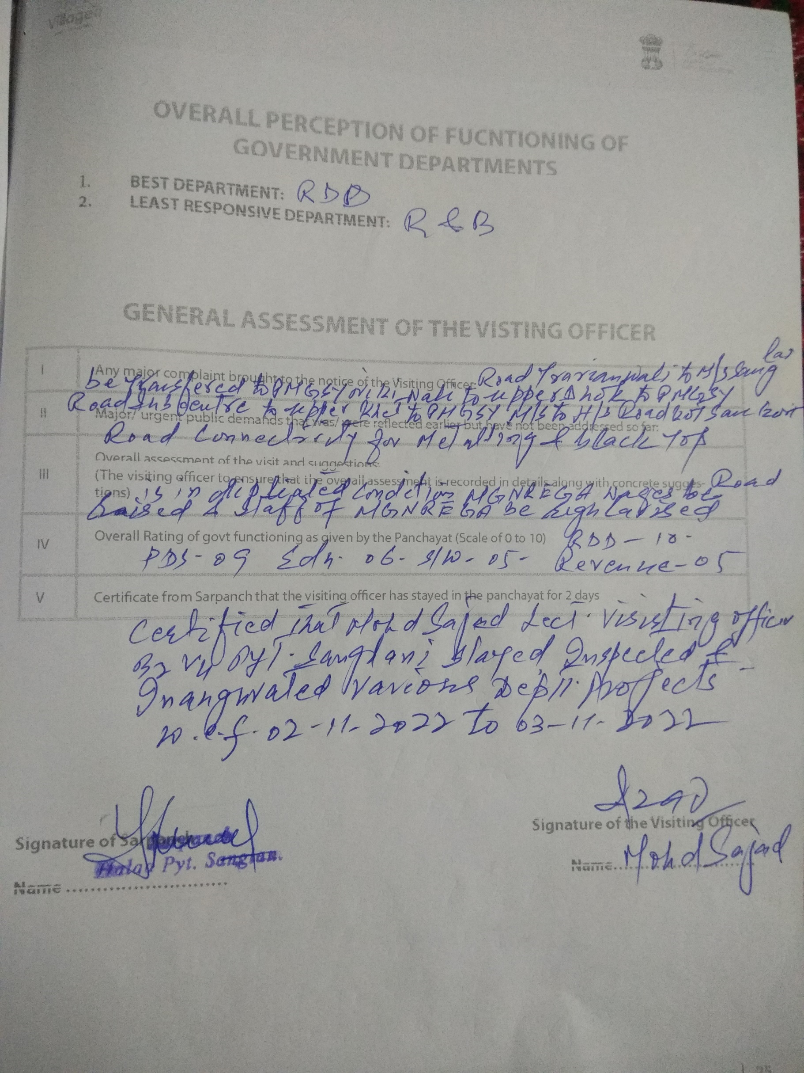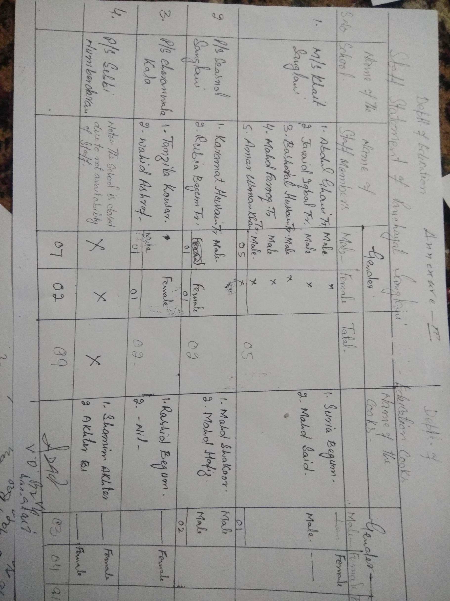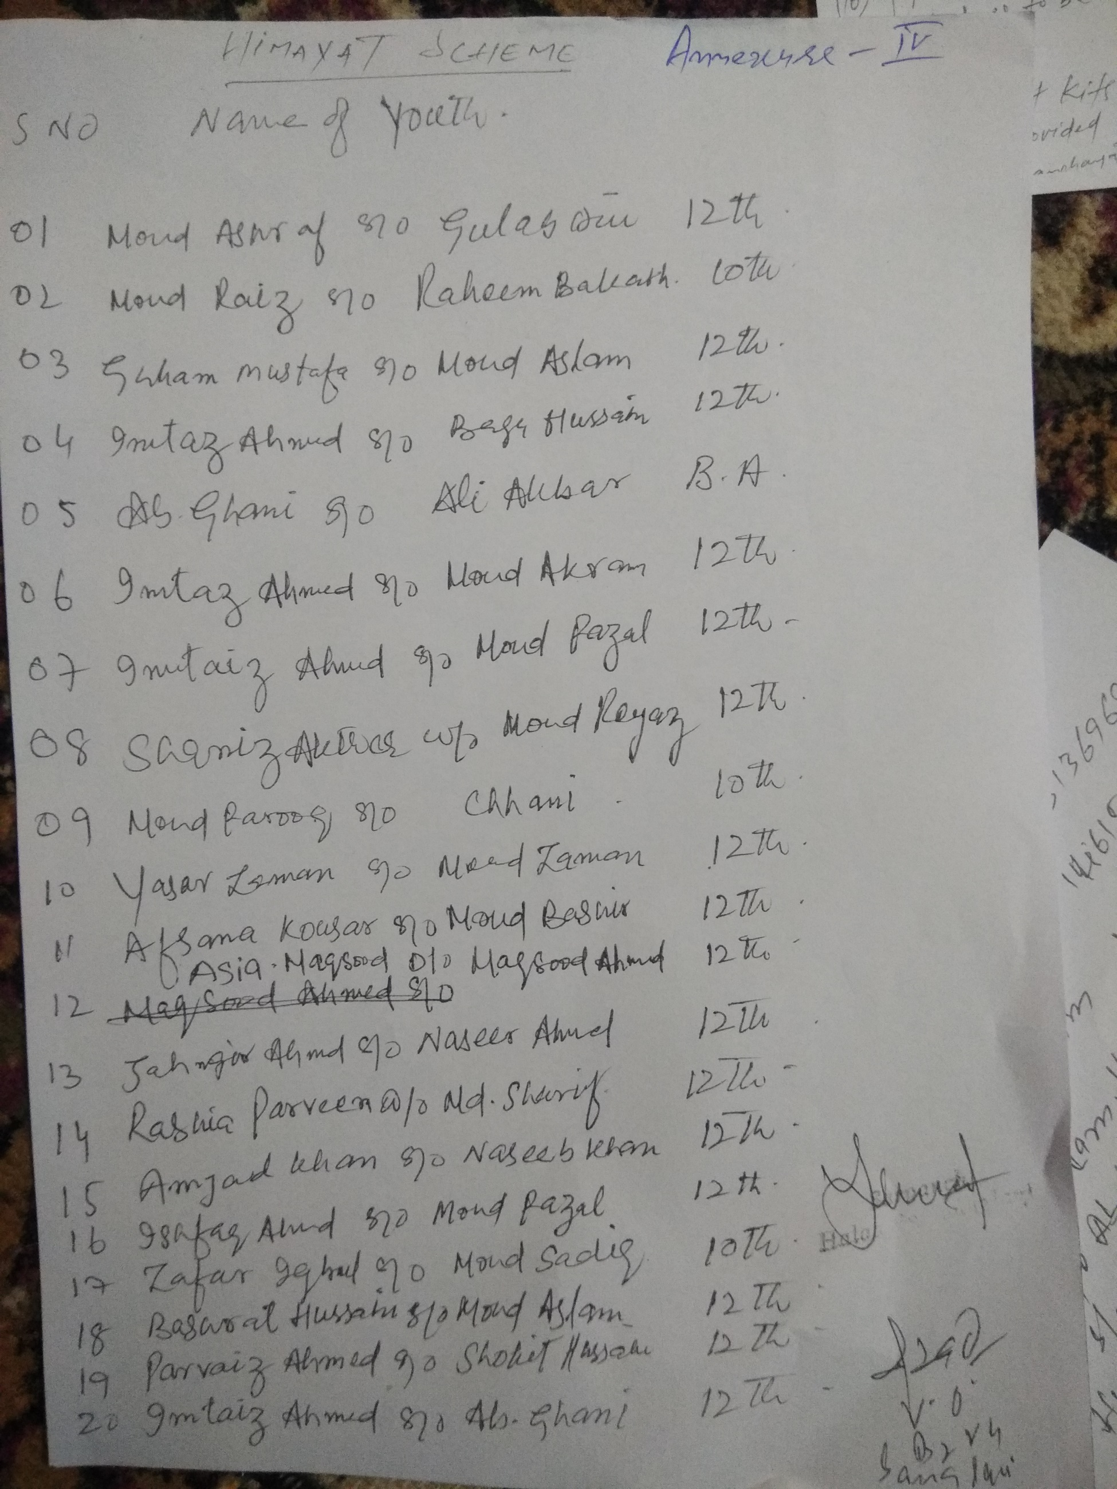

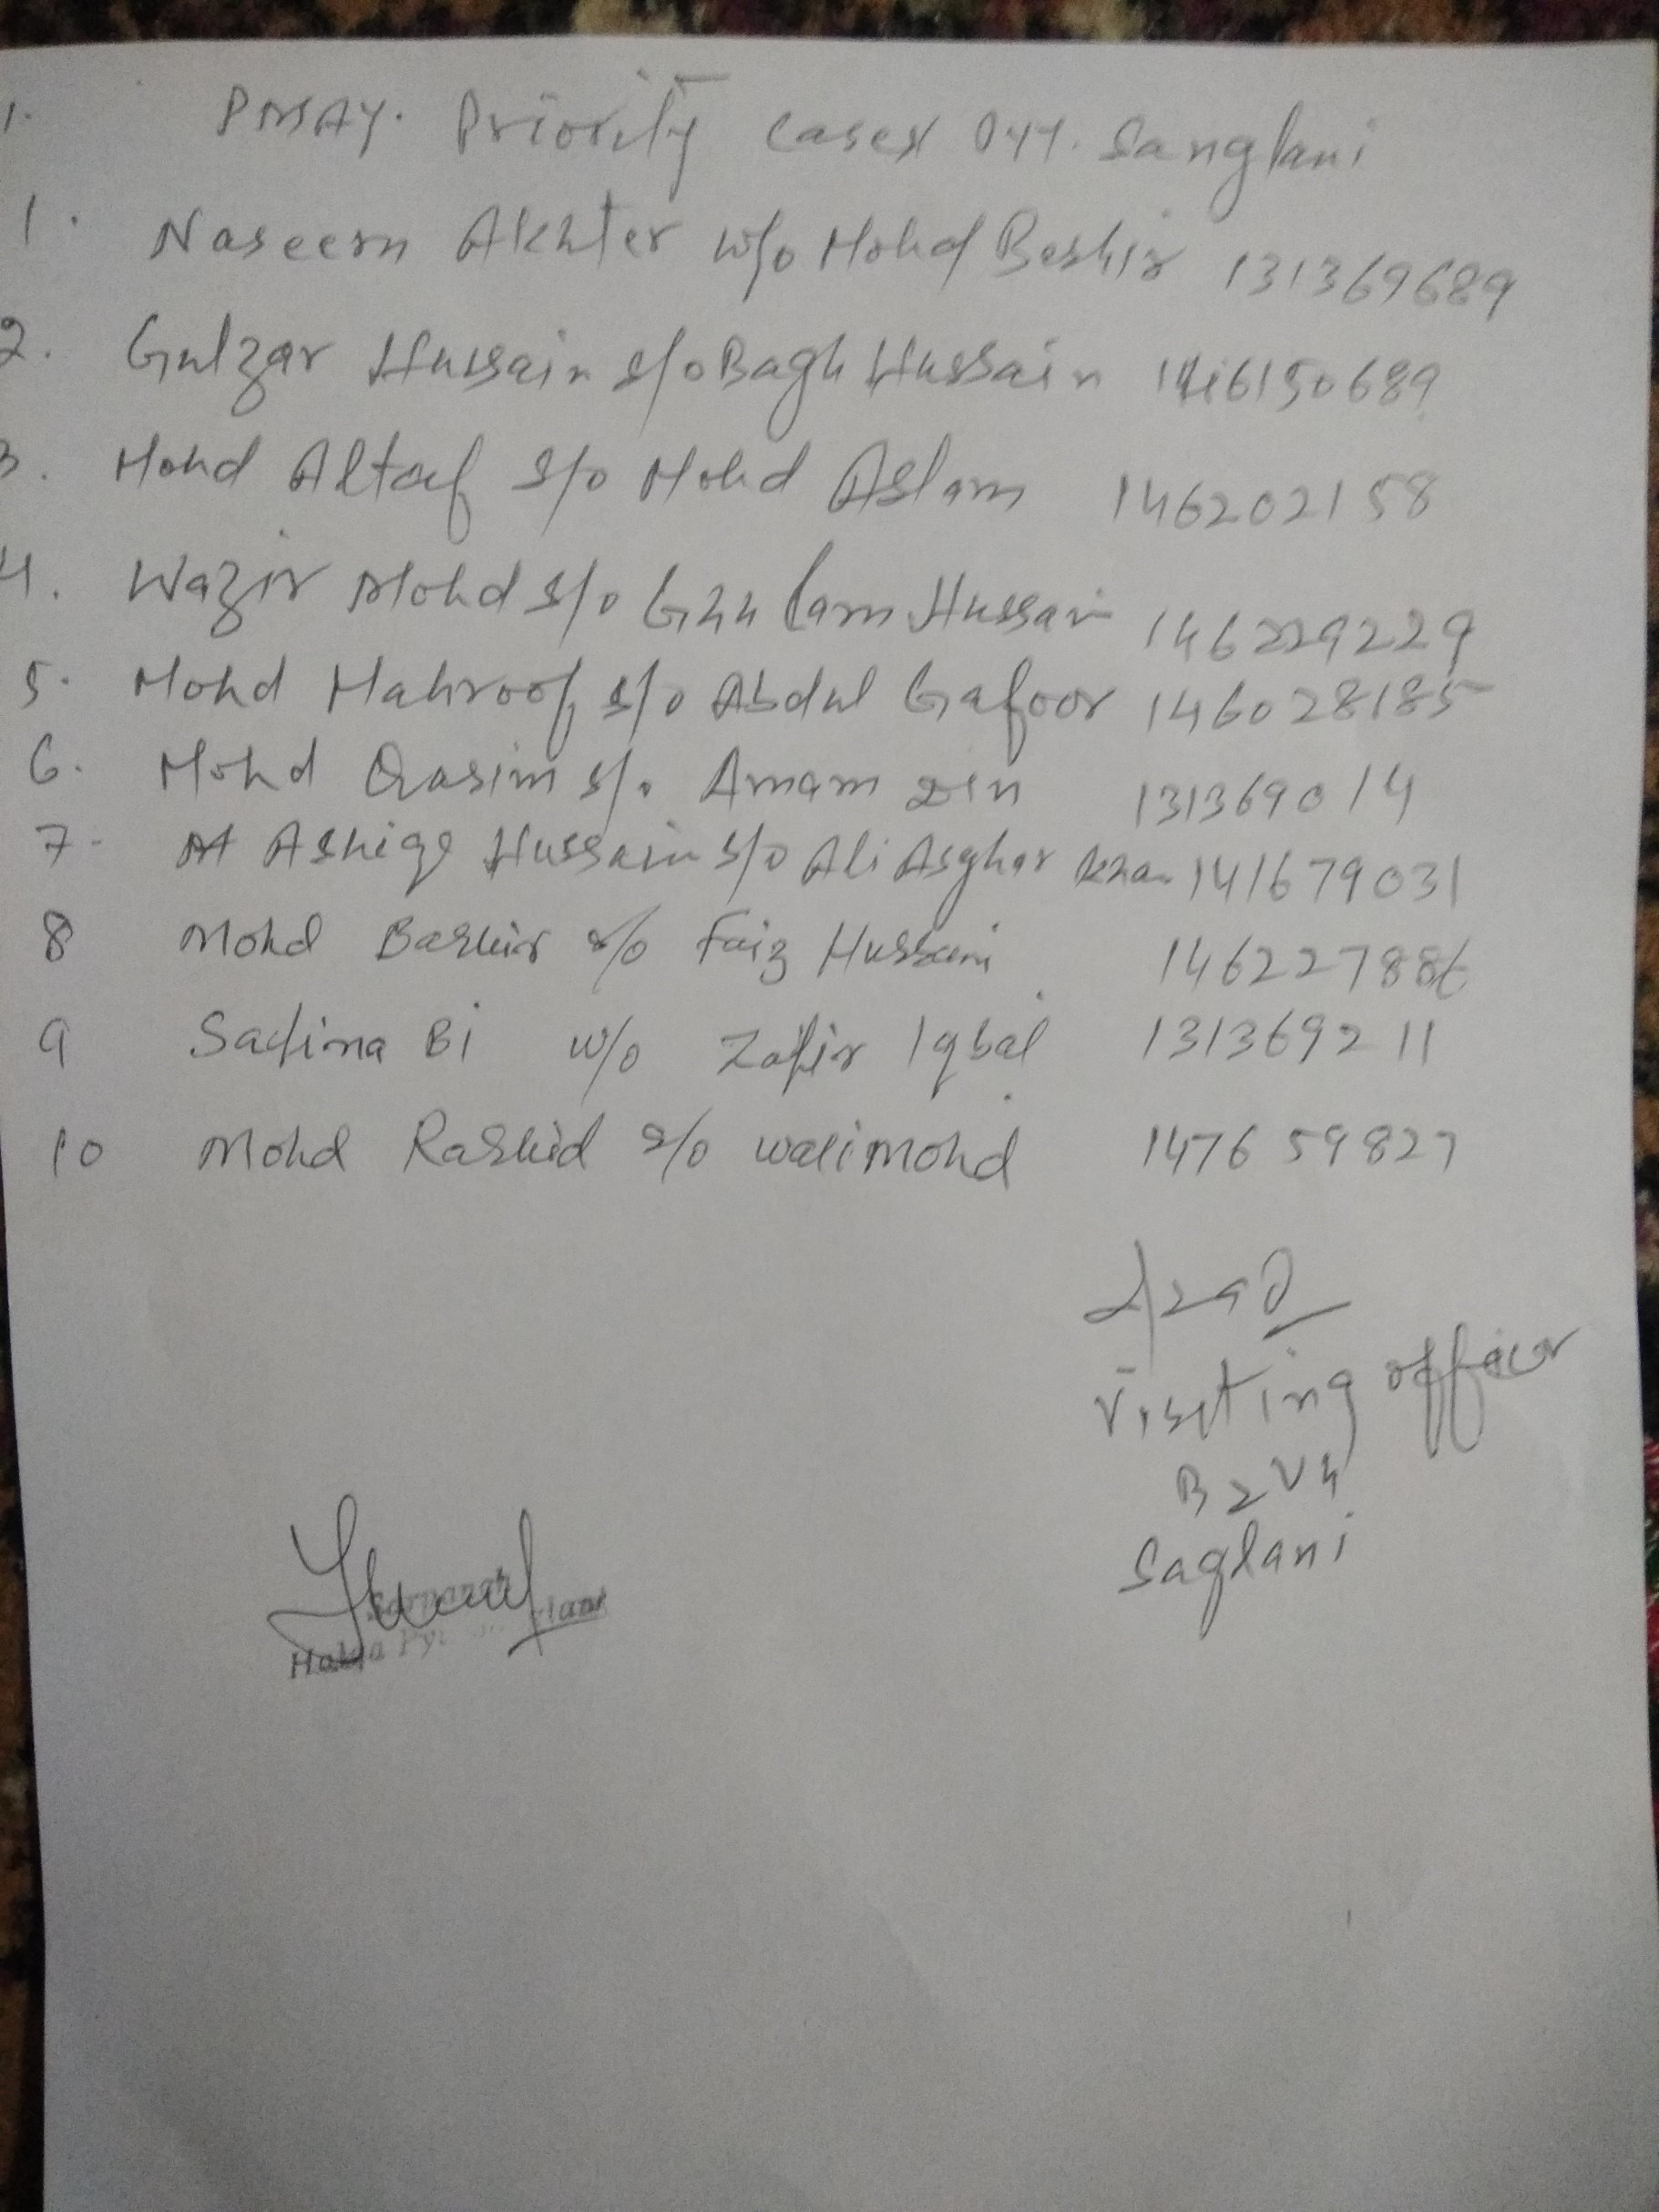
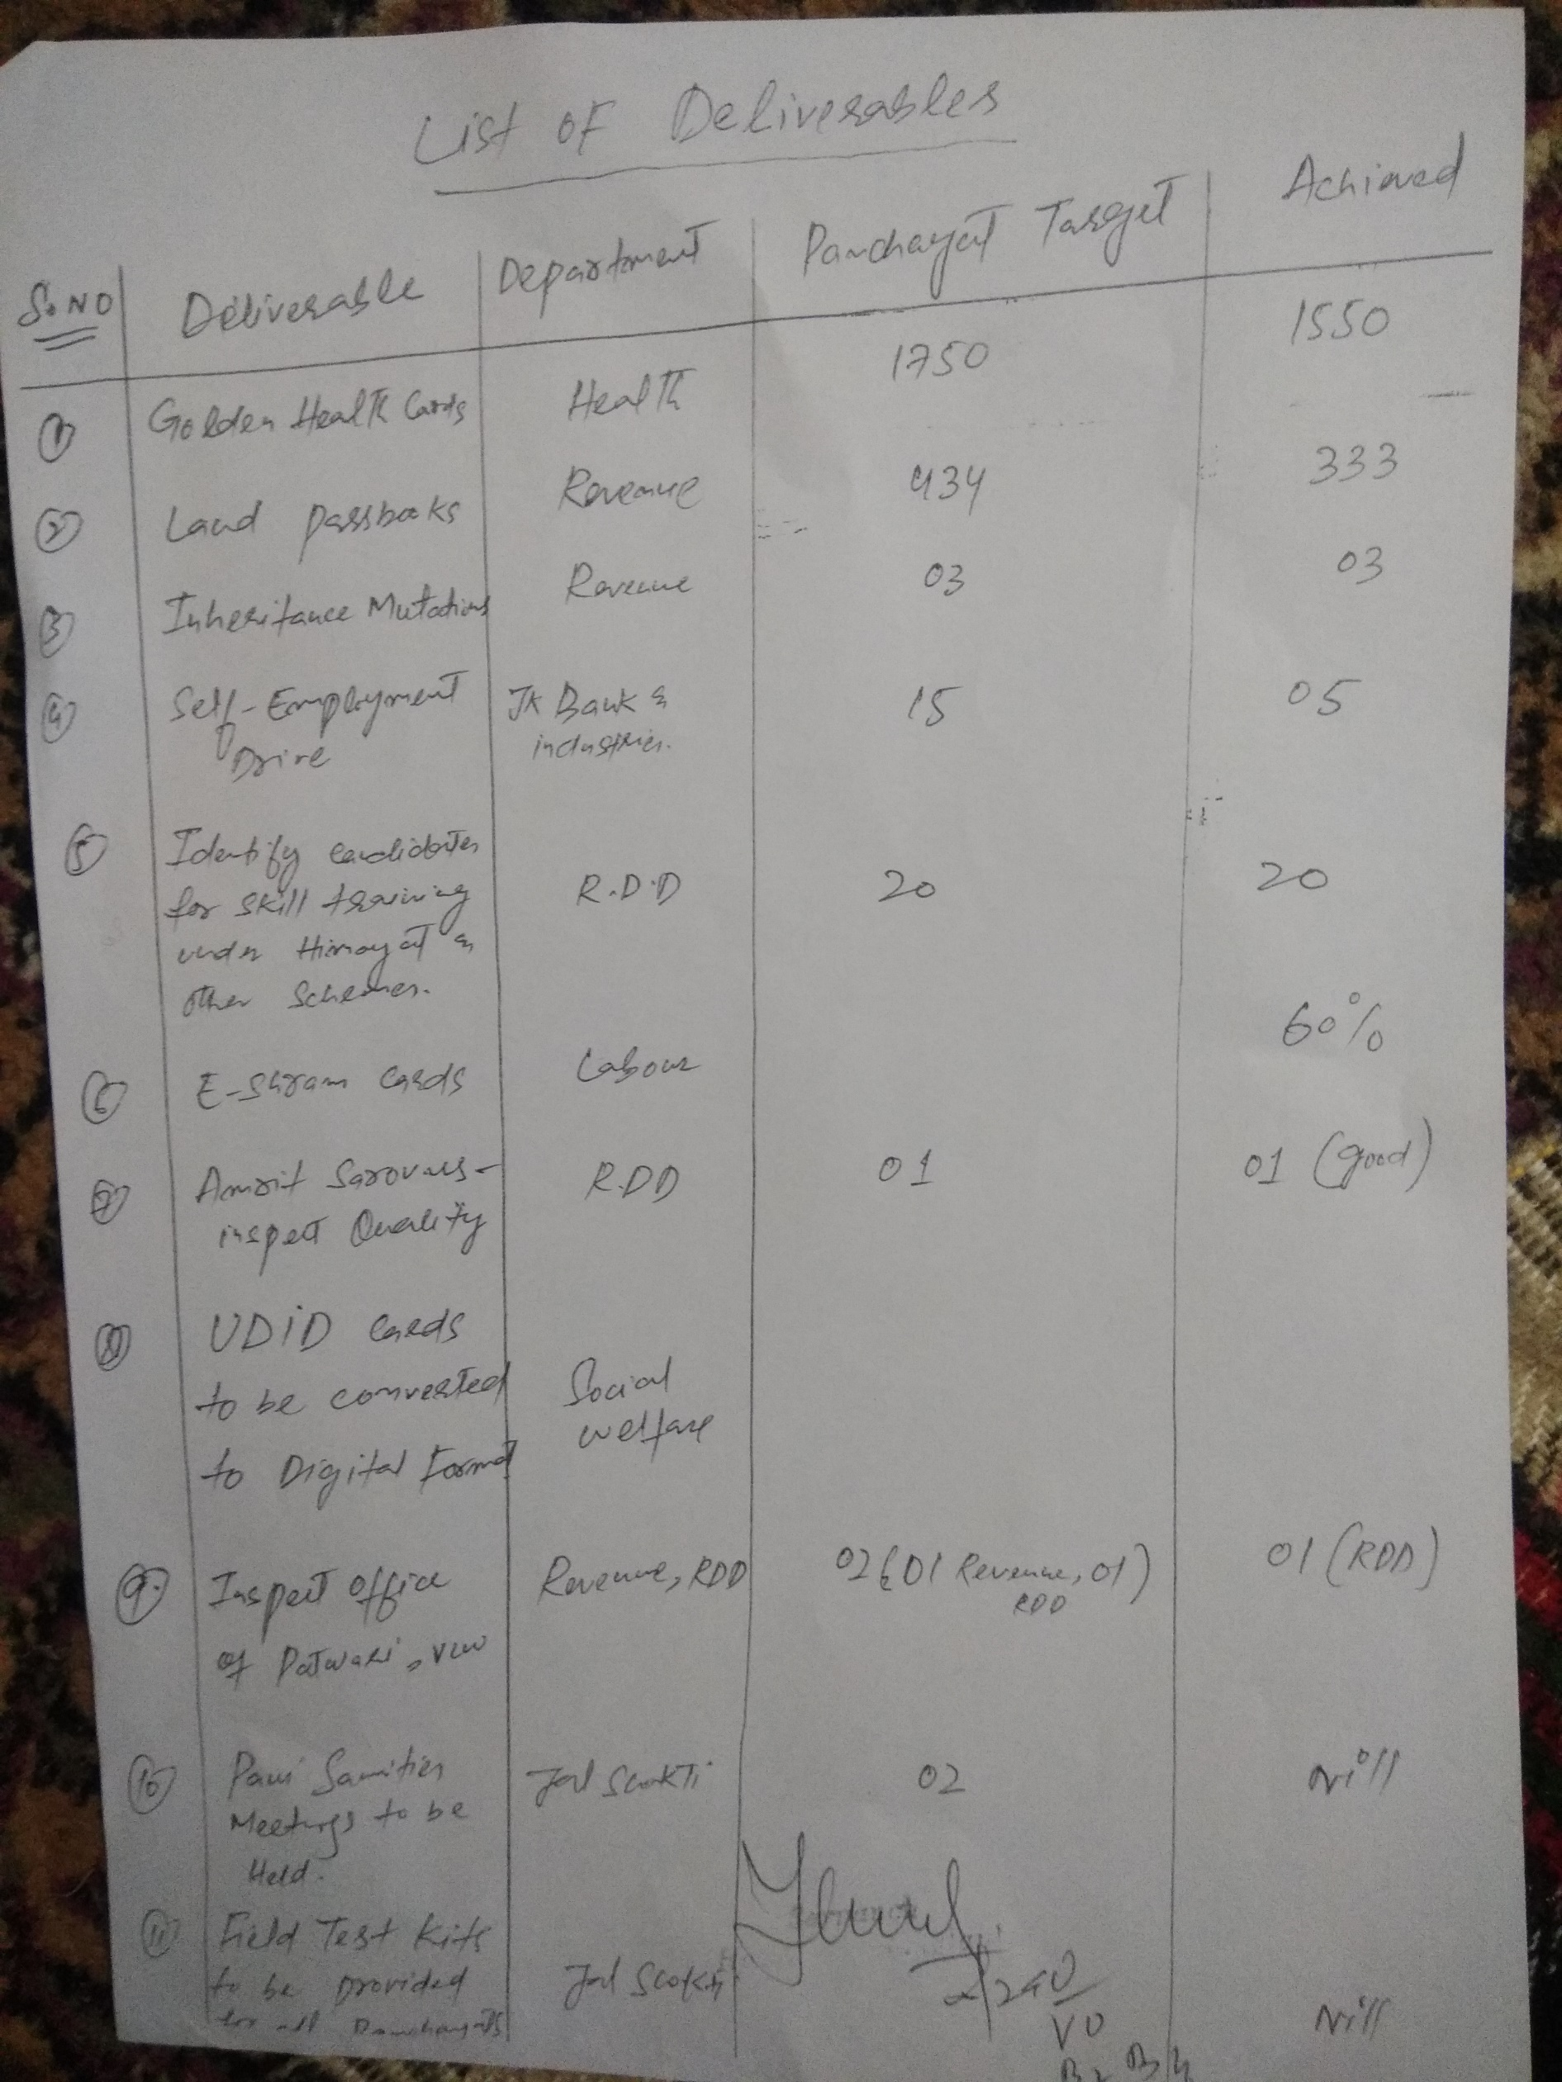

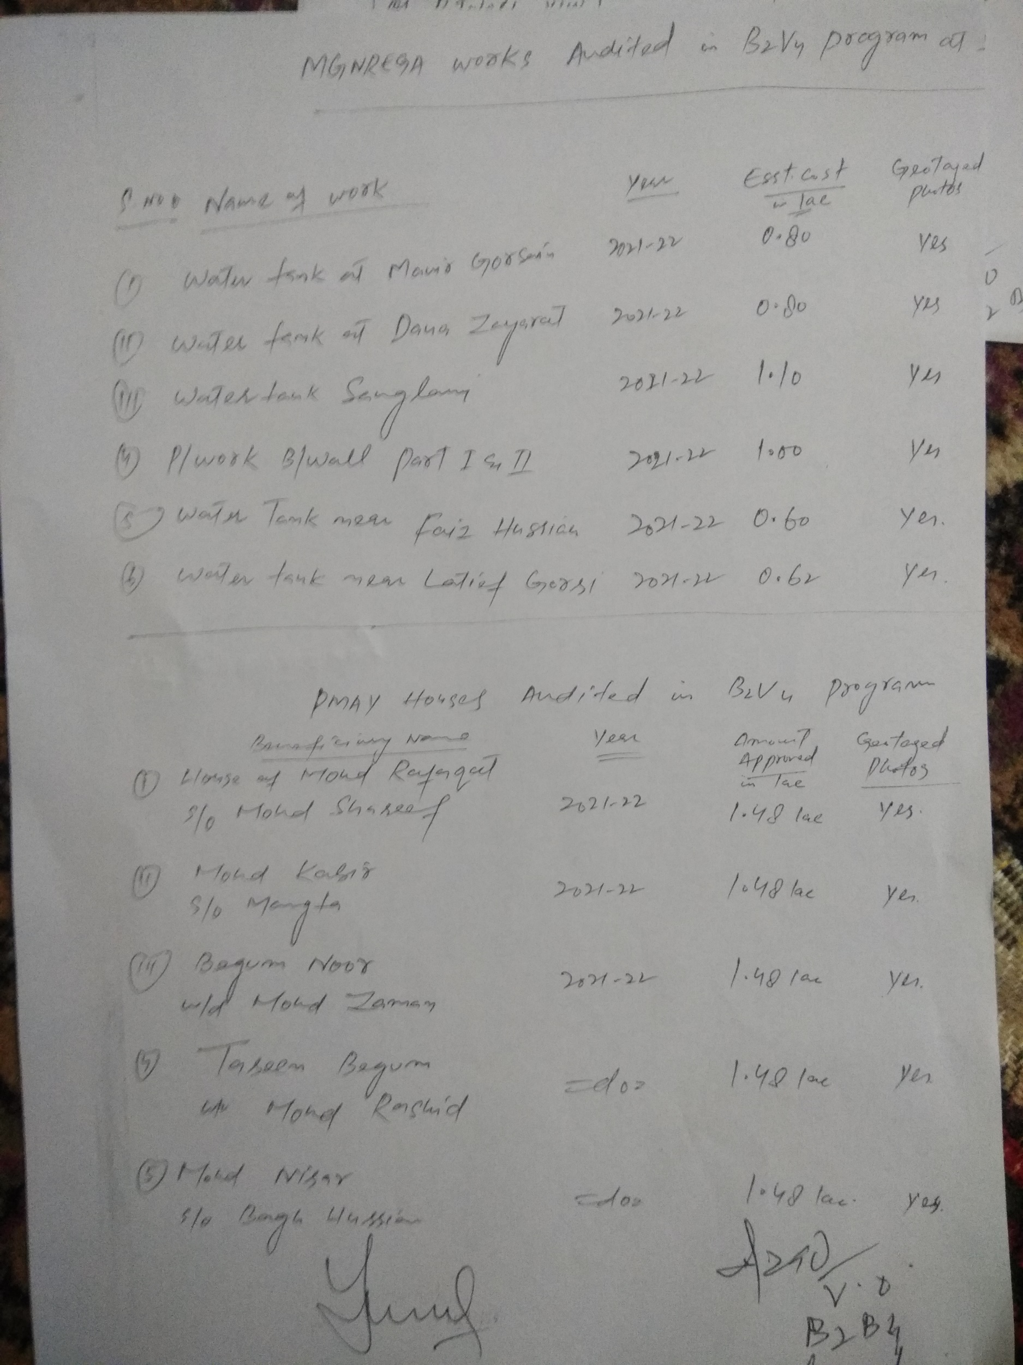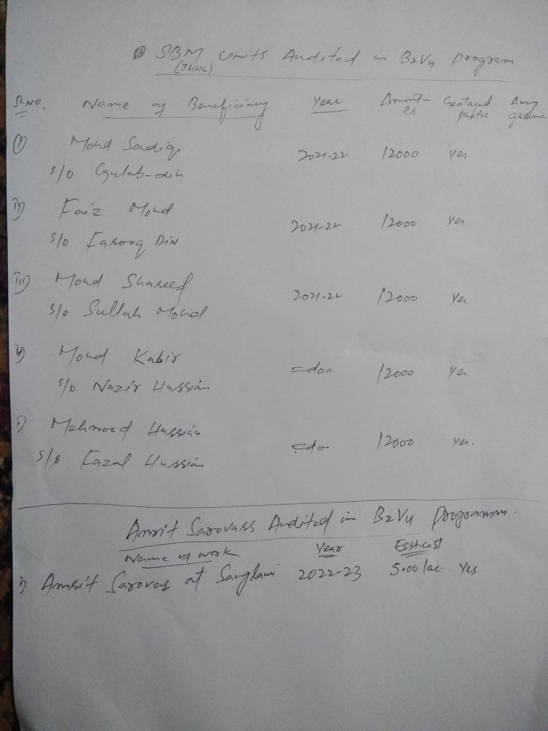

Department of Rural Develompent and Panchayati Raj Government of Jammu & Kashmir

