`

4


15TH OCTto3RD NOV,2022

KEYFEATURES
• DeputyCommissionerstoleadtheinitiative
• RuraldevelopmentDepartmenttobethenodaldepartment
• PlanningDevelopment&MonitoringdepartmentandITtobethesupport departments

ACTIONSANDTIMELINES
ACTION | RESPONSIBILITY | LATESTBY | REMARKS
Janabhiyan | All departments | Oct15-26th | Going on
DeputationofSecttstaff/ HoDs | GAD | Oct14 | Done
DeploymentofStaffto Panchayatsandservingof ordersondeployedofficers | DCs | Oct25 | DCswilldeployseniorlevelstaff fromthedistricts.Strictactionto betakenagainstabstentions.No exemptionstobegiven
Trainingofdistricttrainors onB2V4 | RDD | Oct26
Trainingofvisitingofficers | DCs | Oct27
FieldVisitstobecompleted by | VisitingOfficers | Nov3 | DCstosuperviseandensurethat eachPanchayatisvisitedwithin theperiodspecified
DataofB2V4tobe uploadedby | VisitingOfficers | Nov10 | DCstosuperviseandensurethat dataofallPanchayatsisupload- edbythevisitingofficerwithin theperiodspecified

INSTRUCTIONSFORTHEVISITINGOFFICER(DAYWISE)

DATE | INSTRUCTIONS | ACTIONPOINTS
Day0 | Meetingwithdeputy commissionerandhis/her team | a. TakeprintoutsoffilledbookletsofB2V1,B2V2andB2V3from www.jkpanchayat.in  b.Alsotakeprintoutsofthesummarizedexcelsheetsofthe previousphasesfromwww.jkpanchayat.in  c. CollectATRsonissuesraisedduringprevious3phasesfromthe officeofDeputyCommissioner(Planningdeptt)  d.Takeprintsofblank 2bookletsofB2V4fromwww.jkpanchayat.ine.Takeplansfor2previousyearsandATRsfromtheplanningdeptt f. CompletetrainingsondifferentcomponentsofB2V4being  organizedbyrespectiveDeputyCommissioners  g.CollectListofnewworksstarted/ongoing/completedduringthe previousandcurrentFinancialyearunderthefollowingheads:  • PRIgrants  • DistrictPlan  • UTplan  • MGNREGA  • Otherschemesofotherdepartments  • Anyotherwork  h. Plans/beneficiarylists:  • MGNREGAdraftplandocumentfortheyear2022-23.  • ListofAwaas+beneficiariesalongwithIHHL Convergence  • Listofpensionbeneficiaries.  • ListofSHGs  • Listofagricultureschemebeneficiaries  i. Listsofbeneficiariesfor:  • Variouscertificates/benefitstobedistributedbythe visitingofficer.  • Anyotheractivitiesidentifiedbydifferentdepartments

Day1 | Reachthevillage | 1. | Ensurethatallfrontlineworkersofdifferentdepttsarepresent.
 |  | 2. | Ensureexhibitionbydifferentdepts.aboutindividualbeneficiary schemes
 |  | 3. | InspectJKB/PSBcounters/outlets
 |  | 4. | Participate/ensureorganizationofsportsactivityinplayfield,talent hunt/culturalevent/youthactivity
 |  | 5. | GandhiKatha(suggesteddetailsuploadedonjkpanchayat.in)
 |  | 6. | Visitatleast2amritsarovarsandgetitsgeotaggedphotos
 |  | 7. | InspectKhidmat(CSC)CentresandcreateGenerateawarenesson  225schemesparticularlyG2CschemeslikeBEAMS,Janbhagidari, AapkiZaminAapkiNigrani,DigitalJ&K
 |  | 8. | Visitingofficershallalsoplanandconductpanchayatlevelconver- gencemeetingofalldepartments
 |  | 9. | CheckeffectivenessofCentrallysponsoredschemes
 |  | 10. | VisitandinspectallgovernmentestablishmentsincludingPHE, AWC,FPS,schools,etc
 |  | 11. | Attemptsaturationofdeliverableso JanAbhiyanandwherever deficienciesfound,leadadrivetoachievealldeliverables
 |  | 12. | Assesseffectivenessofsanitationcampaigninthepanchayat
 |  | 13. | Ensureselfemploymentactivitiesfor15youthperpanchayat
 |  | 14. | Identify20potentialcandidatesperpanchayatforHIMAYATtraining alongwiththetradeonwhichtheywanttraining
 |  | 15. | Whereverpossible,distributeemploymentlettersforpeopleselect- edundervariousgovernmentemployments
 |  | 16. | Intheevening,holdnormalmeetingwith seniorcitizens,govtem- ployeesincludingretiredemployees,exservicemen,youthclub,and any citizens ofthevillagewhoareenrolledincollege/university
 |  | 17. | OpendiscussiononNashaMuktAbhiyan

Day2 Haveameetingwithall stakeholders-depttofficials andpanchayatmembers
1. Discussionontheandassesstheprogressofdifferentschemesrelating tothelocalizedSDGsprioritizedforthatvillageaspertheresolution passedby thatGramPanchayaton21st April22,onNationalPanchayti RajDay.
2. Sensitizevillage residentsaboutmyScheme”portal(myscheme.in) whichincludesinformationaboutalltheschemesbeingrunbyCen- tral/State/UTgovtacrossthecountry
3. Hold meeting of theBiodiversityManagementCommitteestodeliber- ateonissuespertaining toconservation of biodiversityandsustaina- bleutilizationof biologicalresources.
4. PrepareVillagedevelopmentplan,inconsultancywithGrampanchayat, discussitingramsabhaandgetitapproved.
5. Ensure saturationofsoilhealthcardandgoldenhealthcardunderGold- enHealthCardunderAyushmanBharat,
6. Ensuresaturation of OldAge PensionScheme
7. EnsureDomicileSaturation.
8. EnsureKCCSaturation
9. Ensure saturationoflandpassbooks
10. Ensureregistrationofvillagevendorsneededforanyscheme,onGEM
portal
11. Ensurepanchayatcontractors registration
12. EncouragePanchayatmembers forimportanceofplantationdrivein
PanchayatunderHarGaonHariyali
13. Ensure paintingondigitalJ&Kinpanchayatghars
14. Ensure paintingonpanchayatactivitesandCSSinpanchayatghars
15. Thevisiting officeshallchecknoof kindergarten andplayfields present inthepanchayat for kidsandstudents,iftheinfrastructure present inthesearegoodenough.
16. Holdmeeting withpanchayatmembers todiscussaboutcorruption menaceandstepsrequiredtomakeJ&Kcorruptionfree
17. Obtaina candidassessmentaboutperformanceofvariousdeptts in- cludingfairfeedbackaboutdiscrepanciesinfunctioning
18. Check thestatusof NashaMuktAbhiyanandreporting of drugad- dictstoDeputyCommissioner.
19. IdentifyTouristDestinations,Circuits,ThemeTreks,IdentifyHomestays, providesupportfortourismactivities throughVillageCooperative
20. OrganizeTalentHuntatPanchayatLevel
21. Conductsocialauditofatleast5worksunderfollowingschemes:
a. MGNREGA
b.PMAY
c. IHHLtoiletsandpayments d.CSCs
e.AMRITSAROVARS
22. Holda mahilasabha anda balsabhaandrecordproceedingsinthefor- matgiven
23. InauguratevillagehaatunderJKSRLM
24. Checkifyouthclubsareformedinthepanchayatandwhatactivities theyareengagedin
25. Organizea villagelevelculturaleventtoengagepanchayatmembers
26. SensitizeGPaboutE-kitabkoshaninitiativeofJ&KGovtforempowering youthsthrough onlinedigitalliteracy

GENERALINSTRUCTIONS

1. Thevisitingofficershallrefrainhimself/herselfgivingorofferinganycommitmentonbehalfofthe governmentandshalladoptanunbiasedattitudeinreportingissues.As faraspossible,his/her observation shouldbebasedona fairandanalytical viewemergingfromhis/herinteractioninthe village.

2. Heisgoingtothevillageasplanningofficer,notforsanctioninganyworksorformakinganycom- mitments.

3. Whilepreparingvillagedevelopmentplan,hehastoensurethat,demandsareprioritizedandre- flectedunderavailableschemes,wherevernecessarythelargerworksaretobereferredtoadminis- trativedepttunderCSS/UTplansunderintimationtoDCsandrestoftheworkstoDCsforreflecting itunderdistrict/CSS plans

4. His workshallbehardcoreplanningandauditandisnota PRexercise.

5. EveryDeputyCommissionerhastoensurethatatleastoneRDDofficial(ideallyPanchayatSecre- tary)ispresent ineverypanchayatwithrelevantpanchayatrecords,toensureconductofallactivi- tiesasplanned.Panchayatwiseorderneedstobeissuedinadvance.

6. Visitingofficershouldideallycarryhis/herlaptoptocompletethereportsatthepanchayatlevel itselfanduploadthefinalreport,duly signedbothbythesarpanchandbythevisitingofficeron www.jkpanchayat.inportal,beforetheyleavepanchayat.

7. Focus ofvisitareyouth,skills,self-employment,nashamukt,bhrashtracharmukt,Rozgaryukt J&K, besidestocarryforwardtheactivities duringJanAbhiyanandsaturatethem.

8. Inadditionattentionmaybegiventothefollowingareas a. MakefulluseofCentrallySponsoredSchemes
b.Saturationofindividualbeneficiaryschemes c. Self-employmentschemes
d.Banklinkedschemes-includingdepartmentalsubsidyschemes e.Empowermentandtransparencythrough digitalinitiatives
f. Effectivenessofgrassrootsmachinery–

i. Patwari,VLWpresent andavailable

ii. AvailablefundsutilizedinpublicinterestandasperGramSabharesolutions iii. Fairness ingovernance
iv. CSS/Individual beneficiaryschemesetc v. BrashtacharMuktJ&K
vi. BhaiMuktJ&K

vii. NashaMuktJ&K

9. ThePRImembers (Sarpanchs,Panchs,BDCChairperson)shallbeattheforefrontofallactivities and givendueimportanceandtheapproach shouldbetostrengthenthemandmakethemfeelem- powered.He/sheshallensurethattheBDCchairpersonandSarpanch/Panch arepresent atthetime ofinaugurationandceremonies.

10. Visitingofficershallnotleavethedistrictwithoutuploadingthereport,duly signedonthewww. jkpanchayat.inportal.EveryDeputyCommissionerhastoensurethat.

A) DetailsofReportingOfficer:

Name: Mrs Tanveer Ali

Designation: Chief Engineer PMGSY Kashmir

Department/placeof posting: PMGSY/Kashmir division

Mobile No: 9469046525

EmailID:

Home District:

Datesof visit: 30-31 Oct 2022

B) LocationaldetailsofPanchayat:(tobepre-filled,informationtobetakenfromtheprevious phasesbooklets/summarizedexcelsheetuploadedonjkpanchayat.in/b2v4.php)(tobevali- datedbythevisitingofficerandmissingdetailstobefilled)

Nameof thePanchayat: Seer

Local Government Directory(LGD )codeof the Panchayat: 242913

Nameof CD Block: Aripal

NameofTehsil: Aripal

Nameof District: Pulwama

C) PanchayatProfile:

No.ofrevenuevillagesinthePanchayat:df 1

No.ofhamletsinthePanchayat: 02(Seer and Gang)

No.ofhouseholdsinthePanchayat: 247

Population(approx)of thePanchayat: 1338

Part-II:
(TobefilledupbytheVisitingOfficerduringhis/hertwodayvisittothePanchayat.AllFieldshavetobe
filledbytheVisitingOfficerbeforethebookletishandedovertotheDC

FrontlineOfficers/OfficialswhowereassignedtothePanchayatfortheprogramme:

Department | Name | Designation
RDD | Mohd Yousuf Wani | Panchayat Secretary(Nodal officer)
PMGSY | Shabir Ahmad Tak | AEE
Agriculture | Madinat UL Nisa | Jr. AEO
Health | Waheeda Bano | Aisha Worker
Education | Zahoor Ahmad Bhat | Teacher
RDD | Manzoor Ahmad Waza | GRS
ICDS | Ameena Bano | Anganwadi Worker
FCS and CA | Obaid Bashir | Head Assistant
Forest Department | Manzoor Ahmad shah | Orderly
PDD | Manzoor Ahmad Khan | Jr. Line man
Jal Shakti | Ab Hamid Dar | Assistant Line man
Social Welfare | Zareefa Bano | Craft assistant
irrigation | Gh Hassan Bhat | JE

Details of absent employees vis-à-vis list furnished by the DC office:

Department | Name | Designation
NIL
NIL
NIL
NIL
NIL
NIL
NIL
NIL
NIL
NIL
NIL

DAY1-ACTIVITIES
AGENDA1:PANCHAYATASSETREGISTER

Infrastructure: Red color indicates availibility

1. PanchayatGharInfrastructure a. Govtbuilding/private
b. New/needingrepairs
2. Furniture(Y/N)
3. Computer/printer(Y/N)
4. Internet(Y/N)
5. Telephone(Y/N)
6. Toilet(CSC/partofpanchayatghar)(Y/N)
7. Water(Y/N)
8. Electricity(Y/N)
9. Bankbranch(Y/N)
10. CSC(Y/N)
11. Patwarkhana(Y/N)
12. Villagehaat(Y/N)
13. Playground(Y/N) needs upgradation
14. School-
a. Kindergarten(Y/N)
b.Primary(Y/N)
c. Secondary(Y/N)
d. College (Y/N)
e.University(Y/N)
15. AnganwadiCentre(Y/N)
a. (govt/private)
b.Totalchildren enrolled 99
15. AmritSarovars–details,location,condition Nill
16. Governmentoffices-details,whetherfunctional or not Yes Functional
17. Rationshop(Y/N)
18. Placesoftourismimportance–names,littledetailsonhistorical/culturalimportance Nill
19. Villageheritagesites/treks-names,littledetailson historical/culturalimportance (Trek Connection can be produced to Tarsar and Marsar)
20. VLWOffice (Y/N)
21. PrimaryHealthcareCentre(Y/N),
22. ListofIncompleteBuildings-names,yearofconstruction Nill
23. ListofUnderutilizedBuildings-names Nill

DAY1-ACTIVITIES
AGENDA2:
DIFFERENTINSTITUTIONS/INFRASTRUCTUREPROJECTSTOBEVISITED

AMRITSAROVARS | Visit,verify | COMMENTS
KhidmatCentres | Create/Generateawarenesson225schemes particularlyG2CschemsAapkiZaminAapkiNigrani, Beams,Janbhagidari,DigitalJ&K | Awareness done by Csc operator near about 225 schemees in Gram Panchayt Seer
JKB/PSBcounters/outlets | a)Statusofcounter b)Numberofvisitors
Incompletebuildings/pro- jects | Verify whetheridentificationandredistribution done | Nill
PDS | Visit,evaluate,onlinestatus | Satisfactory
PHC | Visit-evaluate,statusofstaff,equipmentand quality | Establish PHC for Pyt Halqa seer and this the most genuine demand of local people
Youthclubs | Meet,interact,seeksuggestions | Needs more awareness regarding employment generation schemes
SHG | Meet,identifyproblems,seeksuggestions | Emphasis on Bank to provide loans for establishment of new SHGs in Seer
PMAY | Inspect,Inaugurate | Great Job done by RDD department
Myschool,mypride progress;schools-water, toilets,staff | Visit,checkforwater,electricity,sanitation,meet studentsandstaff | Satisfactory but needs improvement
SwachhSBM | Evaluate | Satisfactory
Panchayatplayground, Sportskitsdistribution Villagegames | Ensure,verify.Participateinatleastonegamein theplayground | Sport events organized by Middle school seer and overall performance was quite remarkable
HarGaonHariyali, Planta- tiondrive | Evaluatestatus,feedback | Done by forest department at Py Halqa seer
Villageculturalevent  Dangal/Haat/Mela | Participatein;ensurethatitisheld | Organized by school students and local youths and performance was really remarkable
Exhibitionofschemes | Ensurethateverydepartmentparticipatesand thatitcontinuesfortheentiredurationofB2V | Exhibitions by Social welfare, Handicraft and ICDS was good
JalJeewanMission verifica- tion- WSS/JSD  Electricitysupply | Verify | Lalgam- Gulshanpora Scheme verified and inspected and suggested to improvement

DAY1-ACTIVITIES
AGENDA3:SATURATEJANBHIYAN
DELIVERABLESANDRECORDDEFICIENCIESIFANY(INSERTDELIVERABLESLISTHEREASPERGADFORMAT

S.No. Department Observattions
1 RDD Saturated all JAN ABHIYAN activities
2 IT CSC Joint with Gang. No Seprate Gang
3 Finance No self Employment as part of JAN ABHIYAN.

4 Revenue Patwar Khana not available in Panchayat.
Inheritance Mutations complete (FY:2022-23 -----10 cases).
Land passbooks --- All generated and few issued by VO on spot
5 Health -PMJAY Golden Cards
Total Population: 1338 Pending 23

- SWACHH Hospitals ; No Health subcentre .
6 Social Welfare
Divyang Camps----- not available
Disability cards 14 Beneficiaries all of which have been saturated online
Anemia checkups being conducted regularly
7 Forest One Forest guard for each village of Panchyat already available
plantation drive carried out in the Halqa as part of Jan Abhiyan
8 Tourism Nagaberi(Tarsar Marsar) can become the best tourist destination if road connectivity is provided to it or else access can be made possible by providing Gandola facility
9 Labour e-SHRAM --- 90- 95% already saturated but none as part of JAN ABHIYAN
10 School Education
Bringing back all out of school children------ 2 children were out of school in Panchyat all of them were enrolled
- Transport No transport facility (Service) available
Mumkin Scheme --- Not available
- PDD a. Unique Nos checked.
b DTs with low oil --Topped up
c. Not DT found with load imbalance.
d. No non standard fuses found
e. Proper earthing ensured
f. Foliage removed
g. No claims pending
13. CAPD Shift to RCMS –100%
14. PWD 100% online payment with no manual interface---YES
15. GAD -100% Biometric attendance in Govt offices like Schools Health centres etc (offices available panchyat)
-EPM by all employees present
-100% property returns filled in by are present employees.
Online APKS HRMS impletation under progress
16. JALSHAKTI
17. Youth Services & Sports: Sport activities carried out at PH Seer
18. Public Grivances Perception of departments among public is good and satisfying overall.
19. Agriculture & allied Sectors PM Kissan – 122, Target -122, Saturated – 122 Skill
Kissan Mella – one held during current year

DAY1-ACTIVITIES

AGENDA4:
SELFEMPLOYMENTACTIVITIES
EnsureSelf-employmentactivities foryouth,distributeemploymentlettersforpeopleselectedunder varioussocialschemes(15ISTHETARGETPERPANCHAYAT)

Numberofcasesindifferentcategoriessanctioned: Detailsofthebanksanctioningit:
Totalamountinvolved:

DAY1ACTIVITIES

AGENDA5
Intheevening,holdinformalmeetings withseniorcitizens,govtemployees,retdemployees,youthclub andothercitizenswhoareenrolledoncollege/universityandhavediscussiononGandhiKatha,Nasha MuktAbhiyan,corruptionfreegovernance,doublingfarmersincomeandrecordtheproceedings
Procedings recorded as below:--
A meeting in which senior citizens and Govt employees, rated employees youth club and other citizens was held as
part of B2V4 program inside the premises of Govt. UPS School Seer. The deliberations on the following topics
were made by the visiting officer.
- Gandhi Katha :- The role of Gandhi Ji in the independence of India, his policy of none violence, his simplicity, his life style and steadfastness were discussed in detail. Awareness about Gandhi Katha being broadcasted on radio and telecasted on TV was given so that people from different walks could benefit from it.
- Nasha Mukt Abhiyan :- The bad effects on the life of the drug dependent people and that on the life and property of others was deliberated in detail. Various methods like how counseling and treatment facilities in hospitals and rehabilition centres, capacity building programs with special focus on young population can help in avoiding/giving away this mence
- Corruption free govervance:- The focus was given on the fact that how can we build a corruption free society which inturn will lead to corruption free governance .
- Doubling farmers income:- Detailed deliberations were made by visiting officer on the initiative by PM to focus on how to double the income of farmers by the year 2022-23. Awareness about the fact that when was the scheme launched and it’s purpose was given.

DAY2
a.Noof Individual Compost Pits constructed Nill
b.No ofI ndividualSoak Pitsconstructed 64
V. No.ofBiodiversitymanagementcommitteemeetingsheld:02
VI. IsthenameofSarpanchdisplayedoncitizeninformationboardsofallRD&PRschemes:Yes/No
VII. AreSarpanchsbeinginvolvedinstart/inaugurationofactivities:Yes/No
VIII. WhethersubjectshavebeenassignedbytheSarpanchtothePanchs:Yes/No
IX. Whethergrievancesredressalboxisinstalled:Yes/No
X. NoofgrievancesreceivedpertainingtoPanchayatlevel:Nill
XI. NoofgrievancesdisposedofatPanchayatlevel:Nill
XII. WhethertheSarpanch/PanchayatSecretaryhavedigitalsignatures:Yes/No
XIII. WhetherallMGNREGA/14thFCpayments arebeingmadebySarpanchthrough DigitalSignature
Certificate(DSC):Yes/No

HUMAN RESOURCEAVAILABLEATTHEPANCHAYAT LEVEL:
SRNO. | DEPARTMENTWISESTAFF | NUMBERS |  | NAMES
 |  | SANCTIONED | ACTUAL
 | Ruraldevelopmentdepartment: BDO  JE GRS TA | 0  1  1 | 0  1  1 | At block level  Ruksana maqbool  Manzoor ahmad waza
 | SCHOOLEDUCATION: TEACHER  HEADMASTER  ANYOTHER | 11  1  NyC | 10  1  1 | List Enclosed Anx- 1,  List Enclosed Anx-2  Mohd Maqbool waza
 | JAL JEEVAN: | 02 | 02 | Showkat Ahmad  Ab Hamid
 | PDD: LINEMAN JE  ANYOTHER | 01  01  02(PDL) | 01  01  02 | Manzoor Ahmad Khan  Harmindar Singh  Jan Mohd Rather and Zafar
 | FOOD&CIVILSUPPLIES | 01 | 01 | List Enclosed
 | AGRICULTURE&ANIMALHUS- BANDARY | 01 | 01 | Ravindar Nain Singh
 | SOCIALWELFARE | 01 | 01 | Zareefa
 | HEALTH: ASHA ANM  AYUSHDOCTOR ALLOPATHICDOCTOR | 03  01  Nill  Nill | 02  01  Nill | Nahida Bano and Sarwa  Sabi Jan
 | ANYOTHERDEPARTMENT | Nill

Annuxure I and II

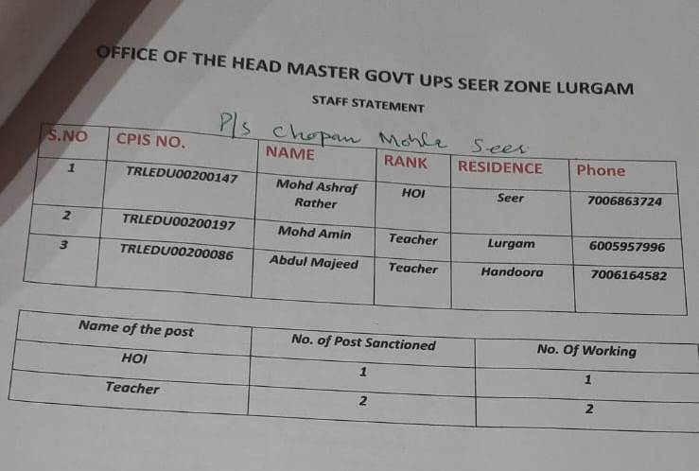

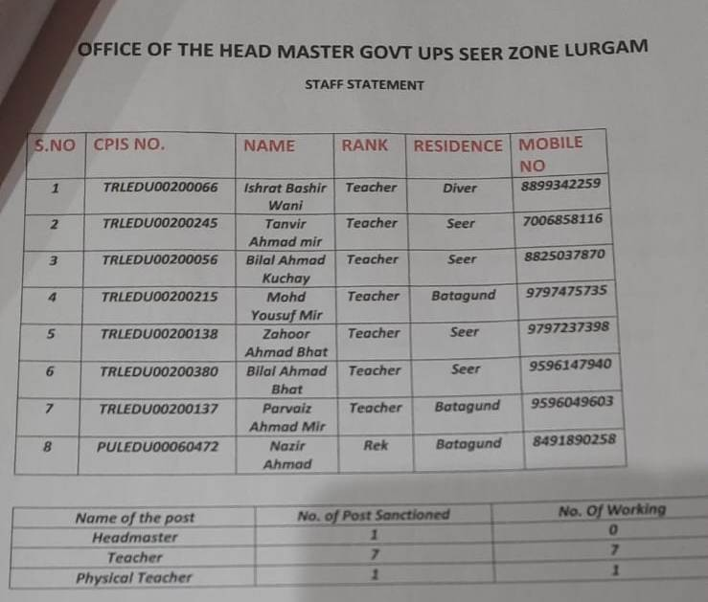

DAY2-ACTIVITIES

AGENDANO.1
DiscussionontheandassesstheprogressofdifferentschemesrelatingtothelocalizedSDGsprior-itizedforthatvillageaspertheresolutionpassedbythatGramPanchayaton21stApril22,onNational PanchayatiRajDay(Copyoftheresolutiontobetakenfromwww.jkpanchayat.inportalunderthelinkof GramSwarajMonth)

1. SDGs AGREED FORTHATVILLAGE,TOBEIMPLEMENTED BYMARCH2024:
2. STATUSOFWORKSUNDERTHEFOLLOWINGSCHEMES:

1 Cleanandgreenvillage
  - i.InitiativestakenbythePanchayatformanagingSolidandLiquidWaste under progress
  - ii. InitiativestakenbythePanchayatforusinggreensourcesoffuellikesolar,biogas
      - NO

  - iii. Hasmappingoflanduse,waterbodies,forest,slopes,wetlands,degradedforestwithintheGram
    - Panchayatbeendone?Yes/No.IfNo,reason,thereof In Progress
  - iv. HastheClimateResiliencePlanbeendevelopedfortheGP?Yes/No
  - v. StepstakenbytheGramSabhaabouttheclimatechangemitigationfactorslikereducingenergy consumption,usageoffossilfuels,plastics,non-renewablebuildingmaterialsandalsotopromote measureslikeplantingoftrees,conservingforests,usageofgoodagriculturalpracticeslikedrip irrigation,waterconservationmeasuresandconservationofwetlands.(Awareness and Motivation among people)
  - vi. Whether schools have started segregating waste In Progress
  - vii. Whetherschoolshavetheirowncompost/soakagepitsforsolid/liquidwastemanagement proposed in Current plan

2 Healthyvillage
i) Aremeetings relatedtoVillageHealthandSanitationCommitteebeingheldregularly?NO
ii) DoalltheeligibleindividualsbeenprovidedtheGoldenCard?NO
iii) ArealltheChildrenbeingimmunizedaspertheSchedulerecommendedbyGovt.ofIndia?Yes
iv) ArealltheeligibleindividualsbeenvaccinatedagainstCOVID-19?Yes
v) DoesGramPanchayatensurethatallpregnantwomenaregettingnecessaryprenatalcheckups?Yes
vi) WhetherallthedeliverieswereInstitutionalizedorconductedbytrainedMidwives?yes

3 Watersufficientvillage
i) DoalltheIHHsintheGramPanchayathavewaterpipelineconnections?Yes
ii) WhetherGramPanchayathastakenstepsforgreywatermanagement.IfYespleasespecify yes(Through soakage Pits)
iii) DoalltheIHHsintheGramPanchayathavetoilets?yes
iv) ArealltheIHHstoiletsfunctionalornot?Yes
v) DoalltheSchools/Anganwadicentershavea toiletfacilityornot?Yes
vi) Areallthetoiletsintheschools/Aaganwadifunctionalornot?yes
vii) WhetherGramPachachayatBhawanhasseparate toiletsforwomenornot?
NO

4 ChildFriendlyvillage
i) Doallthechildrenundertheageof0-6yearsbeenenrolledintheAnganwadicentersforpre- schooling?Yes/NO
ii) HowmanyBalSabha’swereorganizedintheGramPanchayat-------02------------
iii) WhethertheissuesraisedbyBalSabhaareaddressedduringtheGramSabha. Yes/NO
iv) WhetherGramPanchayatistrackingthedatarelatedtodropoutchildrenandchildrenwithirregular attendance?Yes/NO.
v) DoalltheschoolsundertheGramPanchayathaveseparate toiletsforgirlsandboys?Yes/No

5 Villagewithgoodgovernance
i) IsCSClocatedintheGramPanchayatBhawanornot?Yes
ii) IsthelistofbeneficiariesrelatedtotheSchemes/ProgramsdisplayedontheGrampanchayatwallor not?Yes
iii) DoestheGramPanchayathasitsbuildingornot?Yes
iv) IstheGramPanchayatofficefunctionalornot?Yes
v) Aretheactivities approved undertheHalqaPanchayatDevelopmentPlandisplayedontheGram
Panchayatwallornot:
Yes
vi) IsSocialAuditofearlierSchemes/Programscarriedoutornot?Yes

6 Povertyfreeandenhancedlivelihoodvillage
i) HasGramPanchayatdevelopedanycriteria fortheidentificationofthepoor?Yes/Noifyesspecify ii) HavealltheeligiblehouseholdsregisteredinPDSornot?yes
iii) HasGramPanchayatprovidedspaceforSelf-helpGroupsinPanchyatGharforholdingmeetings or not?Yes
iv) HavealltheeligiblehouseholdsbeenregisteredforPensionornot?yes
v) HasGramPanchayatfacilitatedYouthforSkillEnhancementCoursesandPlacement?
vi) HasJobCardsbeendistributedtoalltheeligibleindividualsunderMGNREGA?Yes
vii) HasGramPanchayatfacilitatedSHGsforBankAccountLinkages?Yes

7 Sociallysecuredvillage
i) WhetherGramPanchayatismaintainingdatarelatedtoDifferentlyAbledPeople?NO
ii) IsGramPanchayatOffice DisabledFriendlyornot?NO
iii) Areprovisionsfora separate BudgetundertheResourceEnvelopeforWomenandChildrenmadeor not?NO
iv) DoalltheSchools intheGramPanchayathavefacilitiesforDifferentlyAbledChildrenliketoilets, barrier-freeaccess,etc.,ornot?NO
v) Arealltheeligibleindividualsaregettingpensions,likeoldagepension,widowpension,etc?Yes
vi) ArealltheeligiblehouseholdsgettingbenefitsfromIAYornot?
yes

8 EngenderedDevelopmentinVillage
i) HowmanyMahilaSabha’swereorganizedintheGramPanchayat-----------04--------
ii) WhetherSHGsfederationshavebeenprovidedspaceformeetings inthePanchayatBhawan(Yes/ No)
iii) WhetherGPshavetakenstepsforincreasingwomen’sparticipationinGramSabha(Yes/No)
iv) NumberofwomenbeneficiariesheadedhouseholdscoveredunderPDS
system………12………………
v) Numberofbeneficiaries(outoftotaleligiblepopulation)receivingsocialprotectionbenefitsunder
PradhanMantriMatritvaVandanaYojana……15…………….

9 Self-sufficientinfrastructureinthevillage
i. WhetherGPhasa CommunityHallwithaccesstoelectricity,furniture,watersupply, toilet………NO……………….
ii. WhethertheDisastermanagementplanisavailableattheGPLevel(Yes/No)
iii. Whetherchild-friendlyparkwithrequiredfacilitiesisavailableinGP(Yes/No) iv. WhethertheGPhaseasyaccesstoGodownforstorage(Yes/No)
v. Whetherstreetlightsareprovidedinpublicplacesforensuringsafety(Yes/No)

DAY2ACTIVITIES

AGENDANO.2
SensitizevillageresidentsaboutmyScheme”portal(myscheme.in)whichincludesinformationaboutall theschemesbeingrunbyCentral/State/UT govtacrossthecountry
(SchemeMaterialavailablefromhttps://jkpanchayat.in/b2v4.php)

DAY2ACTIVITIES

AGENDANO.3
HoldmeetingoftheBiodiversityManagementCommitteestodeliberateonissues pertainingtoconserva- tionofbiodiversityandsustainableutilizationofbiologicalresources.HeshouldcheckPeopleBiodiversity register(PBR)ofthatpanchayatandreviewifBiodiversityManagementCommittee constitutedforthat panchayatis holdingminimum4meetings inayearandmeeting onceinevery3months (RoleofBMC availableathttps://jkpanchayat.in/b2v4.php)
COMMITTEEMEMBER:ListEnclosed
Present
BIODIVERSITYREGISTERPHOTOS
PAST 4MEETINGDETAILS-DATES,MINUTESPHOTOS
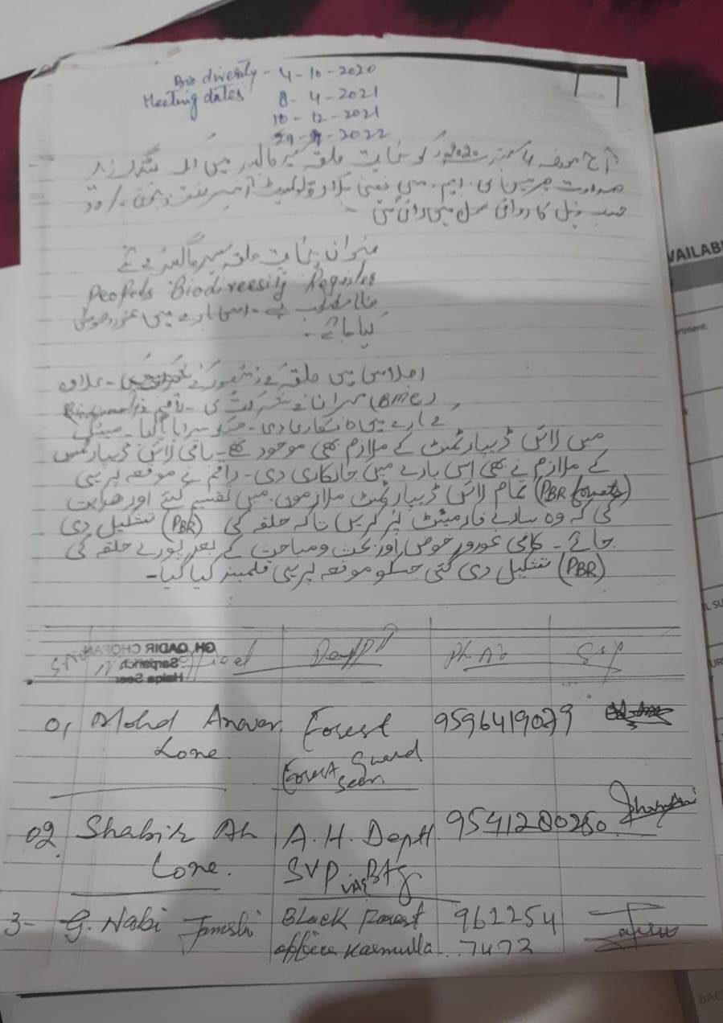

DAY2ACTIVITIES

AGENDA4
Visitingofficershallalsoplanandconductpanchayatlevelconvergencemeeting ofalldepartmentsand prepareVillagedevelopmentplanforvillage,inconsultancywithGrampanchayat,discussitingram sabhaandgetitapproved.
(GPDPformatavailableonhttps://jkpanchayat.in/b2v4.php)

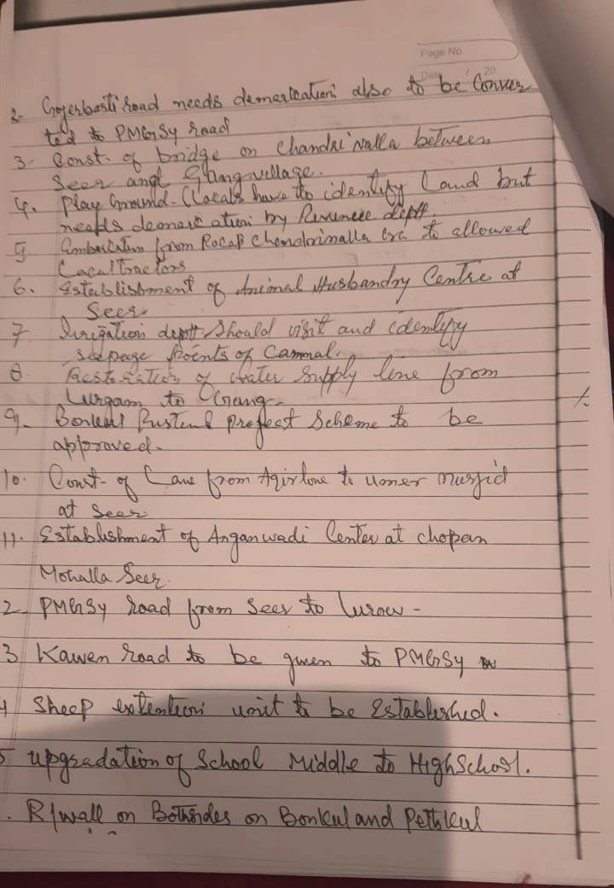
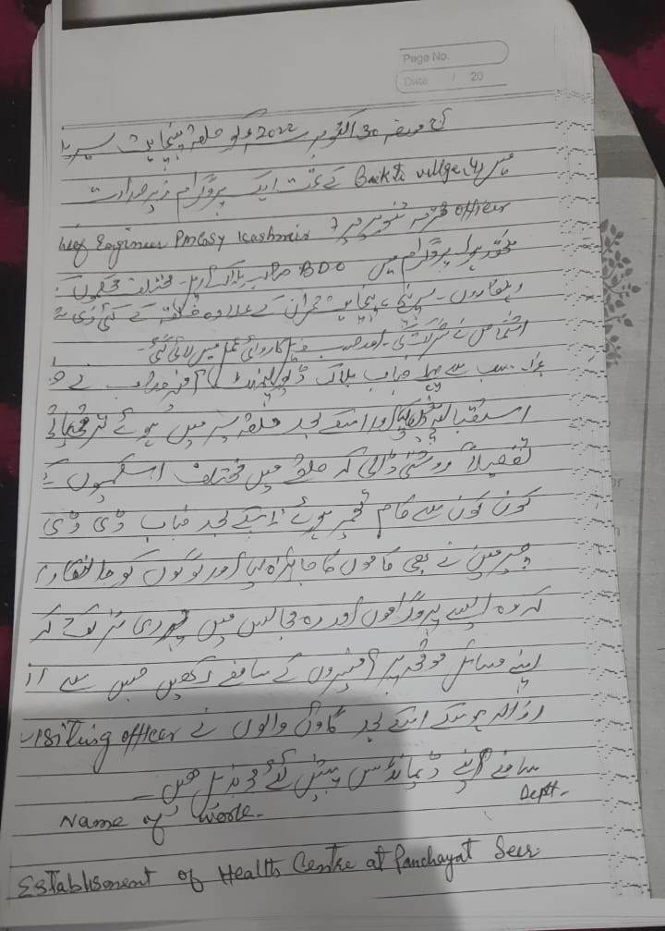

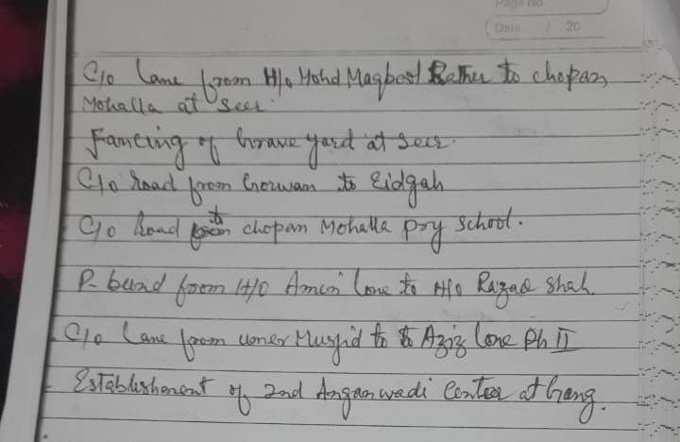

InadditionGPDPplanshallalsoinclude:
▪ Touristplaceswhichneedtobedeveloped Tarsar and Marsar and wasturwan top
Specificproductwhichneedstobedeveloped Animal Husbandry and sheep husbandry
▪ Tourism-homestays Nill
▪ 20candidatesfortrainingunderHimayatschemealongwithtradeinwhich trainingistobegiven

List enclosed
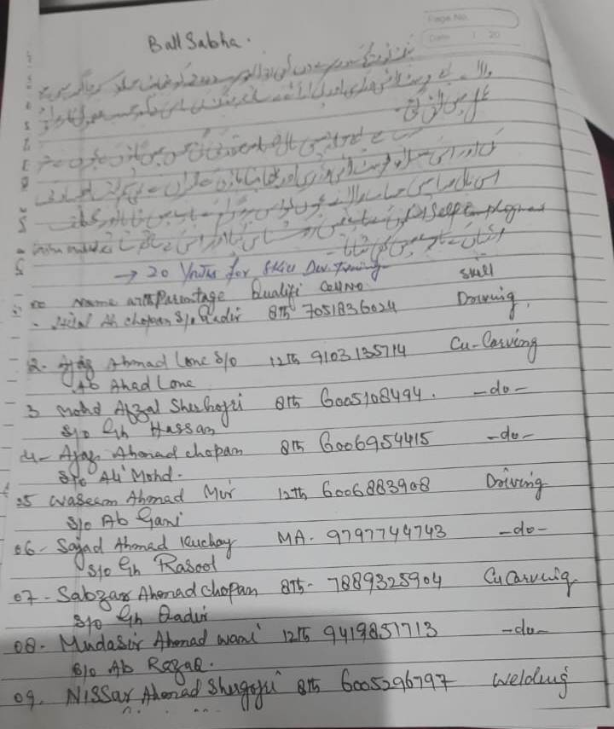

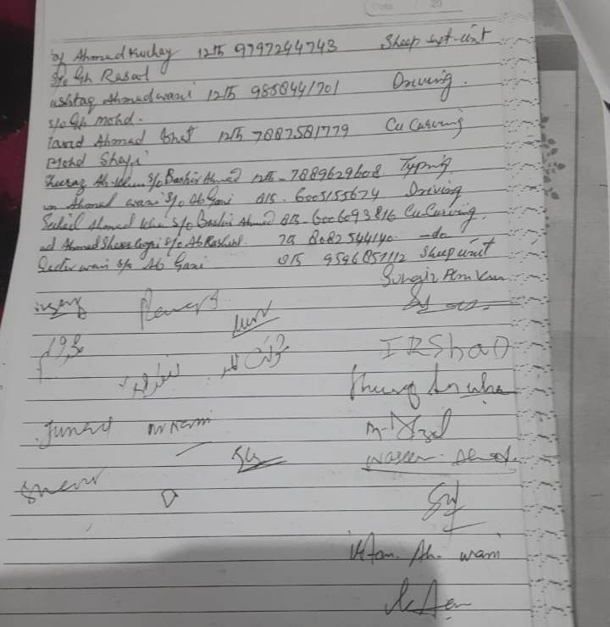
DAY2ACTIVITIES

AGENDA5
Ensuresaturationoffollowingschemesandgivestatus:

NAMEOFTHESCHEME | TOTALELIGIBLE BENEFICIARIESIN THE VILLAGE | TOTALBENEFICIARIESWHO AVAILEDTHEBENEFITSOFTHESCHEME | REASONSFOR PENDENCY
GoldenHealthCardunder  AyushmanBharat | 1338 | 1120 | Ration Card Problem
Jananisurakshayojana | 11 | 08 | 03 Under progress
OLDAGEpension | 102 | 102
Widowpension | 41 | 41
Disabilitypension | 33 | 33
Domicilecertificate | 1338 | 645 | Not Applied yet
Kisancreditcard | 128 | 76 | Not Applied yet
PMkisansammannidhi | 122 | 122

Landpassbook | 181 | 100 | Under Progress
Registrationofvillageven- dorsonGEMportal | Nill
Registrationofvillagecon- tractorsonjktendersportal | 40 | 4 | Not Applied
Registrationofvillagecon- tractorsonPWDportal | 01 | 1
Incompletebuildings/pro- jects | nill

DAY2ACTIVITIES

AGENDA6
NASHAMUKTABHIYAN

1. Whethergramsabharesolutionpassed Yes

2. Detailsofactivities conducted List enclosed in Karwai

3. Whetherallactivities andGSresolutionuploadedonjkpanchayats.inportal Yes

4. Howmanydrugaddictsinthevillage Nill

5. WhetherreportedtotheDeputyCommissioner Yes

6. Howmanyregisteredforrehabilitationundergovernmentprogramme Nill

DAY2ACTIVITIES

AGENDA7
SOCIALAUDIT

Conductsocialauditofatleast5workseachunderfollowingschemes:

NAMEOFTHE SCHEME | DETAILSOFTHE WORKS | YEAROFWORK APPROVAL | AMOUNT APPROVED  FORTHEWORK | WHETHER  WORKEXECUTED SATISFACTORILY | GEO- TAGGED PHOTOS | ANY GRIEVANCE RECORDED RELATINGTOTHAT WORK
MGNREGA | 5 | 2021-22 | 31 lacs | yes | yes | No
PMAY | 02 | 2021 | 1.50 lacs per beneficiary | Yes | Yes | No
IHHL  UNDERSBM-G | 05 | 2021-22 | 12000 per beneficiary | Yes | Yes | NO
CSCUNDER SBMG | 03 | 2020-21 | 1.80 per unit | Yes | Yes | no
AMRIT SAROVARS | Nill | NIll

DAY2ACTIVITIES

AGENDA8

MAHILASABHA
Totalwomeninthevillageabovetheageof18 554
Totalattended 232
Proceedings: Awareness regarding women empowerment, gender inequality, Mal Nuitrition
(Plinsertpointerstobediscussedthere–referpalliproceedings)

DAY2ACTIVITIES

AGENDA9

BALSABHA
Holda balsabhaandrecordproceedings Yes
Totalchildreninthevillageabovetheageof….. 218 Totalattended 145
Proceedings: Awareness regarding Nasha Mukht Bharat and Corruption free

(Plinsertpointerstobediscussedthere–referpalliproceedings)

DAY2ACTIVITIES

AGENDA10

INAUGURATIONS

SR NO. | ASSETS/ACTIVITIES INAUGRATED | STATUSOFTHEASSET/AC- TIVITIES(NUMBER,OTHER DETAILS) | GEO-TAGGED PHOTOS
 | VILLAGEHAATunderJKSRLM (SUN- DAYMARKET) | Paper Machie, Copper Utensils Manufacture,Sozni etc
 | PMAYhousesifanyreadyforinaugra- tion | 02(01 Complete and 01 under progress | Yes
 | Swachhgramprojects-segregation shedsetc | Under Construction | Yes
 | Amritsarovars | nill
 | Sportskits | In Progress for Purchase
 | Villageculturalevents | Folk songs, National Song and Ladisha | Yes
 | JJMassets/projects | 02 Projects Completed | Yes
 | Anyothertobeidentifiedatdistrict level | Nill

FOLLOWUPOF(B2V1,B2V2&B2V3):
(Prefilledexcelsheet tobetakenfromdistrictlevel/andalsotobedownloaded
fromwww.jkpanchayat.in)

S.NO. | Particulars | Actiontaken | Remarks#
I. UrgentPublicRequirements/Demands-B2V1
1 | Road connectivity from seer to gong | Yes | funds r not availbale
2 | establishment of primary health centre | NO | population cause
3 | establishment of sheep and animal husbandary | no | already existing with in 2 kms
4 | channalisation of chandi nallah lorow taar to bunkawan | no | authorisation not received and covered in B2v1
5 | Road connectivity from nagbal gulshnapora to astan mohalla seer | no | authorisation not received
6 | Upgradation of ups seer to high school | no | availble in adjacent village batagund
7 | construction of bridge at chandri nallah | no | authorisation not received
II. UrgentPublicRequirements/Demands-B2V2 |  |  |  |  | no
1 | improvement of electric infra structure at seer | no | tendered
2 | completion of 33 kv receiving station at takiya batagund | yes | completed
3 | channelisation of chandri nallah with p bund on both sides at seer and gang | No | 5 lacs may b arranged for channelisation from B2v2
4 | upgradation of interior roads/ lanes at seer | No | tendered
5 | levelling of playground at UPS seer | yes | completed
6 | c/o brige near ups seer and flour mill | No | included in 14th and 15th fc plan
7 | c/o brige seer to lorow | No | funds not available
S.NO. | Particulars | Actiontaken | Remarks#
III. MajorProblems–B2V1
1 | channelisation of chandri nallah with p bund on both side seer and gang | NO
2 | improvement of electric infra structure at seer | Yes but needs to improve
3 | PHC at Seer | Not feasible

4
5
IV. MajorProblems-B2V2
1 | Upgradation of ups seer to high school | NO | authorisation not received
2 | Road connectivity from nagbal gulshnapora to astan | no | availble in adjacent village batagund
3 | PHC at Seer | No
4
5
V. MajorProblems-B2V3
1 | Road Connectivity between Seer and Gang | Action taken by RDD and in Progreess
2 | Establishment of Sheep Centre | Not Feasible
3 | Establishment of PHC Seer | Available in adjacent village
4 | Upgradation of UPS Seer
5 |  | Available in adjacent village
VI. MajorComplaints-B2V1
1 | improvement of drainage system at gang | funds not availble
2 | establishment of CAPD at Gang | funds not availble
3 | Establishment of PHC at Seer
VII. MajorComplaints-B2V2
1
2 | establishment of CAPD at Gang | funds not availble
3 | Establishment of PHC at Seer | funds not availble
VIII. MajorComplaints-B2V3
1 | Lack of drinking water at Seer | funds not availble
2 | Road Connectivity to upper Pry School seer | funds not availble
3 | Reverification of Social Welfare Schemees | Under progress

OVERALLPERCEPTIONOFFUCNTIONING OF GOVERNMENTDEPARTMENTS

1. BESTDEPARTMENT: RDD
2. LEASTRESPONSIVEDEPARTMENT:

GENERALASSESSMENTOFTHEVISTINGOFFICER

I | AnymajorcomplaintbroughttothenoticeoftheVisitingOfficer:
II | Major/urgentpublicdemandsthatwas/werereflectedearlierbuthavenotbeenaddressedsofar:
III | Overallassessmentofthevisitandsuggestions:  (Thevisitingofficertoensurethattheoverallassessmentisrecordedindetailsalongwithconcretesugges- tions)
IV | OverallRatingofgovtfunctioningas givenbythePanchayat(Scaleof0to10)
V | CertificatefromSarpanchthatthevisitingofficerhasstayedinthepanchayatfor2days

SignatureofSarpanch SignatureoftheVisitingOfficer

Name……………………… Name………………………

URGENT PUBLIC DEMANDS

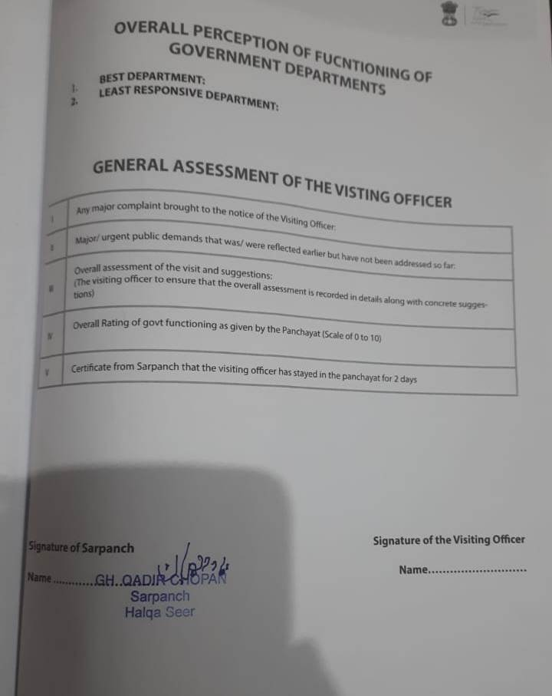

Major complaint :- The major complaint brought forward by the public is that many demands Govt has not promoted NAGABERI as Tourist Destination by way of making it accessible via road connectivity or installation of GANDOLA, despite having immense potential.
S. No. 2
Major / urgent public demands reflected earlier:-
- Up gradation of road from Satoora to Pranigam and Satoora to Hajinar.
- Health Centre Establishment.
- Separate village guard.
- Construction of foot bridge from gang to seer
S. No. 3
The visit was satisfying overall. People very candidly raised their demands and their expectations were found very high . However due to non addressal of few urgent public demands some were hopeless. Most of them demanded timely addressal of the balance demands already raised in B2V1, B2V2 and B2V3 programs.
Further public demanded promotion of NAGABERI as tourist destination which has got immense potential to become the BEST tourist destination of Jammu & Kashmir. The need could be primarily fulfilled by either road connectivity or making it accessible by installation of GANDOLA like the one at Gulmarg (J&K ). This could be very helpful in the revenue generation besides reducing or in fact eradicating the poverty of TRAL area as whole and seer Panchayat Halqa in particular. Moreover the overall functioning of Govt machinery was found satisfactory.

S. No. 4
Overall Govt Functioning rated by Panchayat is ‘7’
S. No. 5
Certificate:-
Certified that the visiting officer has stayed in the Panchayat Halqa for two (02) days i.e, 30/10/2022 and 31/10/2022 in connection with B2V4
SD
sarpach halqa Seer


DepartmentofRuralDevelompentandPanchayatiRaj
GovernmentofJammu &Kashmir

