4





**15TH OCTto3RD NOV,2022**

**KEY FEATURES**

• Deputy Commissioners to lead the initiative

• Rural development Department to be the nodal department

• Planning Development & Monitoring department and IT to be the support departments

**ACTIONS AND TIMELINES**

|  |  |  |  |
| --- | --- | --- | --- |
| **ACTION** | **RESPONSIBILITY** | **LATESTBY** | **REMARKS** |
| **Janabhiyan** | All departments | Oct15-26th | Going on |
| **Deputation of Sectt staff/ HoDs** | GAD | Oct14 | Done |
| **Deployment of Staff to Panchayat sand serving of orders on deployed officers** | DCs | Oct25 | DCs will deploy senior level staff from the districts. Strict action to be taken against abstentions. No exemptions to be given |
| **Training of district trainors on B2V4** | RDD | Oct26 |  |
| **Training of visiting officers** | DCs | Oct27 |  |
| **Field Visits to be completed by** | Visiting Officers | Nov3 | DCs to supervise and ensure that each Panchayat is visited within the period specified |
| **Data of B2V4 to be uploaded by** | Visiting Officers | Nov10 | DCs to supervise and ensure that each Panchayat is visited within the period specified |

**INSTRUCTIONS FOR THE VISITING OFFICER(DAYWISE)**

|  |  |  |
| --- | --- | --- |
| **DATE** | **INSTRUCTIONS** | **ACTIONPOINTS** |
| **Day0** | Meeting with deputy commissioner and his/her team | a. Take print out so filled booklets of B2V1, B2V2 and B2V3 from [www.jkpanchayat.in](http://www.jkpanchayat.in)  b. Also take printouts of the summarized excel sheets of the previous phases from [www.jkpanchayat.in](http://www.jkpanchayat.in)  c. Collect ATRs on issues raised during previous 3 phases from the office of Deputy Commissioner (Planning deptt)  d.Takeprintsofblank2 bookletsofB2V4from[www.jkpanchayat.in](http://www.jkpanchayat.in)e.Takeplansfor2previousyearsandATRsfromtheplanningdeptt  f. Complete trainings on different components of B2V4 being  organized by respective Deputy Commissioners  g. Collect List of new works started/ongoing/completed during the previous and current Financial year under the following heads:  • PRI grants  • District Plan  • UT plan  • MGNREGA  • Other schemes of other departments  • Any other work  h. Plans/beneficiary lists:  • MGNREGA draft plan document for the year 2022-23.  • List of Awaas+beneficiaries along with IHHL Convergence  • List of pension beneficiaries.  • List of SHGs  • List of agriculture scheme beneficiaries  i. Lists of beneficiaries for:  • Various certificates/ benefits to be distributed by the visiting officer.  • Any other activities identified by different departments |

|  |  |  |  |
| --- | --- | --- | --- |
| **Day1** | Reach the village | 1. | Ensure that all front line workers of different deptts are present. |
|  |  | 2. | Ensure exhibition by different depts. About individual beneficiary schemes |
|  |  | 3. | Inspect JKB/PSB counters/outlets |
|  |  | 4. | Participate/ensure organization of sports activity in playfield, talent hunt/cultural event/youth activity |
|  |  | 5. | Gandhi Katha (suggested details uploaded on jkpanchayat.in) |
|  |  | 6. | Visit at least 2 amritsarovars and get its geotagged photos |
|  |  | 7. | Inspect Khidmat(CSC)Centres and create Generate awareness on  225schemes particularly G2C schemes like BEAMS, Janbhagidari, Aapki Zamin Aapki Nigrani, Digital J&K |
|  |  | 8. | Visiting officer shall also plan and conduct panchayat level conver- gence meeting of all departments |
|  |  | 9. | Check effectiveness of Centrally sponsored schemes |
|  |  | 10. | Visit and inspect all government establishments including PHE, AWC,FPS,schools,etc |
|  |  | 11. | Attempt saturation of deliverables of Jan Abhiyan and wherever deficiencies found, lead a drive to achieve all deliverables |
|  |  | 12. | Assess effectiveness of sanitation campaign in the panchayat |
|  |  | 13. | Ensureself employment activities for 15 youth perpanchayat |
|  |  | 14. | Identify 20 potential candidates per panchayat for HIMAYAT training along with the trade on which they want training |
|  |  | 15. | Wherever possible, distribute employment letters for peoples elect- ed under various government employments |
|  |  | 16. | In the evening, hold normal meeting with senior citizens, govt em- ployees including retired employees, ex-service men, youth club, and any citizens of the village who are enrolled in college/university |
|  |  | 17. | Open discussion on Nasha Mukt Abhiyan |

Day2 Have a meeting with all stake holders-deptt fficials and panchayat members

1. Discussion on the and assess the progress of different schemes relating to the localized SDGs prioritized for that village as per there solution passed by that Gram Panchayat on 21st April22,on National Panchayti RajDay.

2. Sensitize village residents about my Scheme” portal (my scheme.in) which includes information about all the schemes being run by Cen- tral/State/UT govt across the country

3. Hold meeting of the Biodiversity Management Committees to deliber- ate on issues pertaining to conservation of biodiversity and sustaina- ble utilization of biological resources.

4. Prepare Village development plan, in consultancy with Grampanchayat, discuss it in gram sabha and get it approved.

5. Ensure saturation of soil health card and golden health card under Gold- en Health Card under Ayushman Bharat,

6. Ensure saturation of Old Age Pension Scheme

7. Ensure Domicile Saturation.

8. Ensure KCC Saturation

9. Ensure saturation of land passbooks

10. Ensure registration of village vendors needed for any scheme, on GEM

portal

11. Ensure panchayat contractors registration

12. Encourage Panchayat members for importance of plantation drive in

Panchayat under Har Gaon Hariyali

13. Ensure painting on digital J&K in panchayat ghars

14. Ensure painting on panchayat activites and CSS in panchayat ghars

15. The visiting office shall check no of kindergarten and playfields present in the panchayat for kids and students, if the infrastructure present in these are good enough.

16. Hold meeting with panchayat members to discuss about corruption menace and steps required to make J&K corruption free

17. Obtain a candid assessment about performance of various deptts in- cluding fair feed back about discrepancies infunctioning

18. Check the status of Nasha Mukt Abhiyan and reporting of drugad- dicts to Deputy Commissioner.

19. Identify Tourist Destinations, Circuits, Theme Treks, Identify Homestays, provides upport for tourism activities through Village Cooperative

20. Organize Talent Huntat Panchayat Level

21. Conduct social audit of at least 5 works under following schemes:

a. MGNREGA

b. PMAY

c. IHHL toilets and payments d. CSCs

e. AMRIT SAROVARS

22. Hold a mahila sabha and a bal sabha and record proceedings in the for- mat given

23. Inaugurate village haat under JKSRLM

24. Check if youth clubs are formed in the panchayat and what activities they are engaged in

25. Organize a village level cultural event to engage panchayat members

26. Sensitize GP about E-kitab ko shan initiative of J&K Govt for empowering youths through on line digital literacy

**GENERAL INSTRUCTIONS**

1. The visiting officer shall refrain himself/herself giving or offering any commitment on behalf of the government and shall adopt an unbiased attitude in reporting issues. As far as possible, his/her observation should be based on a fair and analytical view emerging from his/her interaction in the village.

2. He is going to the village as planning officer, not for sanctioning any works or for making any com- mitments.

3. While preparing village development plan, he has to ensure that, demands are prioritized and re- flected under available schemes, wherever necessary the larger works are to be referred to adminis- trative deptt under CSS/UT plans under intimation to DCs and rest of the works to DCs for reflecting it under district /CSS plans

4. His work shall be hard core planning and audit and is not a PR exercise.

5. Every Deputy Commissioner has to ensure that atleast one RDD official(ideallyPanchayatSecre- tary) is present in every panchayat with relevant panchayat records, to ensure conduct of all activi- ties as planned. Panchayat wise order needs to be issued in advance.

6. Visiting officer should ideally carry his/ her laptop to complete there ports at the panchayat level itself and upload the final report,duly signed both by the sarpanch and by the visiting officer on [www.jkpanchayat.in](http://www.jkpanchayat.in)portal,before they leave panchayat.

7. Focus of visit are youth,skills,self-employment,nashamukt,bhrashtracharmukt,Rozgaryukt J&K, besides to carry forward the activities during Jan Abhiyan and saturate them.

8. In addition attention may be given to the following areas

a. Make full use of Centrally Sponsored Schemes

b. Saturation of individual beneficiary schemes

c. Self-employment schemes

d. Bank linked schemes-including departmental subsidy schemes

e. Empowerment and transparency through digital initiatives

f. Effectiveness of grass roots machinery–

i. Patwari, VLWpresent and available

ii. Available funds utilized in public interest and as per Gram Sabha resolutions iii. Fairness in governance

iv. CSS/Individual beneficiary schemes etc

v. Brasht achar Mukt J&K

vi. Bhai Mukt J&K

vii. Nasha Mukt J&K

9. The PRI members (Sarpanchs,Panchs,BDCChairperson)shall beat the fore front of all activities and given due importance and the approach should be to strengthen the mand make them feel em- powered. He/she shall ensure that the BDC chairperson and Sarpanch/Panch are present at the time of inauguration and ceremonies.

10. Visiting officer shall not leave the district with out uploading there port,duly signed on the **www. jkpanchayat.in** portal. Every Deputy Commissioner has to ensure that.

**A) Details of Reporting Officer:**

Name: Rayees Ahmad Mir

Designation: Assistant Executive Engineer

Department/place of posting: Irrigation Division Tral

Mobile No: 7006944525

Email ID: meerraies129@gmail.com

Home District: Anantnag

Datesof visit: 28-10-2022 to 29-10-2022

**B) Locational details of Panchayat:(to be pre-filled, information to be taken from the previous phases booklets/summarized excel sheet uploaded on jkpanchayat.in / b2v4.php)(to be vali- dated by the visiting officer and missing details to be filled)**

Name of the Panchayat: Jawaherpora

Local Government Directory(LGD)code of the Panchayat: 3038

Name of CD Block: Aripal

Name of Tehsil: Aripal

Name of District: Pulwama

**C) Panchayat Profile:**

No. of revenue villages in the Panchayat: 03

No.of hamlets in the Panchayat: 05

No.of house holds in the Panchayat: 626

Population(approx)of the Panchayat: 2785

**Part-II:**

(To be filled up by the Visiting Officer during his/ her two day visit to the Panchayat. All Fields have to be

Filled by the Visiting Officer before the book let is handed over to the DC

**Frontline Officers/Officials who were assigned to the Panchayat for the programme:**

|  |  |  |
| --- | --- | --- |
| Department | Name | Designation |
| Animal Husbandry | Randheer Singh | Attendent |
| P.D.D | Nazir Ahmad Chopan | LM-II |
| R&B | Mohd Amin Bhat | Works Supervisor |
| Forest Deptt. | Mohd Shafi Teli | Forester |
| Irrigation Department | Ali Mohd Mir | Helper |
| P.H.E (JSD) | Mohd Akbar Khan | Asstt. Lineman |
| R.D.D | Gh Hassan Khan | G.R.S |
| Food & Supplies | Feroz Ahmad | Storekeeper |
| J&K Bank | Naseer Ahmad | Branch Head |
| Flood Control | Junaid Bashir | Jr. Engineer |
| Health | Dr. Sajad Ahmad | M.O |
| ICDS | Naseema | AWW ICDS |
| Agriculture | Farooq Ahmad Mir | J.A.E.O |

**Details of absent employees vis-à-vis list furnished by the DC office:**

|  |  |  |
| --- | --- | --- |
| Department | Name | Designation |
| Nil | Nil | Nil |

**DAY1-ACTIVITIES**

**AGENDA1:PANCHAYAT ASSET REGISTER**

**Infrastructure:**

1. Panchayat Ghar infrastructure . Govt building/private √

b. New/needing repairs Partly Constructed

2. Furniture(Y/N) Y

3. Computer/printer(Y/N) N

4. Internet(Y/N) N

5. Telephone(Y/N) N

6. Toilet(CSC/part of panchayat ghar)(Y/N) N

7. Water(Y/N) N

8. Electricity(Y/N) N

9. Bank branch(Y/N) N

10. CSC(Y/N) N

11. Patwar khana(Y/N) N

12. Village haat(Y/N) Y

13. Playground(Y/N) Y

14. School-

a. Kindergarten(Y/N) N

b. Primary(Y/N) Y

c. Secondary(Y/N) N

d. College (Y/N) N

e. University(Y/N) N

15. Anganwadi Centre(Y/N) Y

a. (govt/private) Private

b. Total children enrolled 250 (6-centers)

15. Amrit Sarovars–details, location, condition 01 No (Guggar Basti Zisbal)

16. Government offices-details, whether functional or not

17. Rationshop(Y/N) Y

18. Places of tourism importance–names, little details on historical/cultural importance 1. Gujjar Saran

19. Village heritage sites/treks-names, little details on historical/cultural importance N

20. VLWOffice (Y/N) N

21. Primary Health care Centre(Y/N), N (Wellness Centre)

22. List of In complete Buildings-names, year of construction 1 No (Panchayat Ghar) 13-FC

23. List of Underutilized Buildings-names N

**DAY1-ACTIVITIES**

**AGENDA2:**

**DIFFERENT INSTITUTIONS/INFRASTRUCTURE PROJECTS TO BE VISITED**

|  |  |  |
| --- | --- | --- |
| **AMRITSAROVARS** | **Visit,verify** | **COMMENTS** |
| Khidmat Centres | Create/Generate awareness on 225schemes particularly G2CschemsAapki Zamin AapkiNigrani, Beams, Janbhagidari, DigitalJ&K | There is no Khidmat Centre in Panchayat Jawaherpora |
| JKB/PSB counters/outlets | a)Status of counter b)Number of visitors | No bank in Jawharpora  Panchayat |
| Incomplete buildings/pro- jects | Verify whether identification and redistribution done | Panchayat Ghat is incomplete (Verified) |
| PDS | Visit, evaluate, online status | Working Satisfactorily |
| PHC | Visit-evaluate, status of staff, equipment and quality | No PHC / Family Wellness Centre in Panchayat with deficient staff |
| Youth clubs | Meet, interact, seek suggestions | Youth Club demanded improvement in play field and sports kits |
| SHG | Meet,identify problems, seek suggestions | Working Satisfactorily |
| PMAY | Inspect, Inaugurate | Inspected and Inaugurated |
| Myschool,my pride progress; schools-water, toilets, staff | Visit, check for water, electricity, sanitation, meet students and staff | Need of separate wash rooms for Girls, No electricity in High School  (Only Solar) |
| Swachh SBM | Evaluate | Visited 5 No’s and are in Good Condition |
| Panchay at play ground, Sports kits distribution Village games | Ensure, verify. Participate in at least one game in the play ground | Play ground not in Good Condition |
| HarGaon Hariyali, Planta- tiondrive | Evaluate status, feedback | Participated in Plantation drive |
| Village cultural event  Dangal/Haat/Mela | Participate in ensure that it is held | Participated |
| Exhibition of schemes | Ensure that every department participates and that it continues for the entire duration of B2V | Every department participated and awareness regarding every scheme was created |
| JalJeewan Mission verifica- tion- WSS/JSD  Electricity supply | Verify | WSS under JJM as tendered |

**DAY1-ACTIVITIES**

**AGENDA3:SATURATE JAN ABHIYAN**

**DELIVERABLES AND RECORD DEFICIENCIES IF ANY(INSERT DELIVERABLES LIST HERE AS PER GAD FORMAT**

* Aap Ki Zamin Apki Nigrani- Awareness was provided by Revenue officials during B2V4.
* Land Passbooks were distributed to the farmers onspot.
* Awareness regarding Nasha Mukt Abiyan and corruption free panchayat was also given during B2V4 and accordingly pledge was taken by officials and local people.
* Carrom Board and Chess Board was distributed among Senior Citizens by social welfare department.
* Awareness regarding different schemes was given by Social welfare Department.
* Awareness regarding Self employment was given by J&K Bank Aripal.
* People were made aware about My Scheme Portal.
* Awareness regarding Poshan Abiyan was given by ICDS Department.
* Awareness regarding Ayushman Bharat was given by Health Department and full satisfaction of Goldencards are ensured.
* Plantation drive was carried out during B2V4 with the officials of Forest department and local people at Govt High School Jawaharpora.
* Saturation of wall paintings depicting the mames of old age, widow, disabled, beneficiaries in the panchayat was already achieved by Social Welfare Department.
* Interaction with youth clubs was done wherein they demanded improvement of play fields and distribution of Spots Kits.

**DAY1-ACTIVITIES**

**AGENDA4:**

**SELF EMPLOYMENT ACTIVITIES**

Ensure Self-employment activities for youth, distribute employment letters for people selected under various social schemes(15ISTHETARGETPERPANCHAYAT)

**Number of cases in different categories sanctioned: 7(PMEGP) = 66.50 lacs Details of the bank sanction in it: J&k Bank Aripal 2 (handloom) = 1.60 lacs**

**Total amount involved: 70.5 Lacs 6 (whenever Mudra Card) = 2.40 lacs**

**DAY1ACTIVITIES**

**AGENDA5**

In the evening, hold in formal meetings with senior citizens, govt employees, retd employees, youth club and other citizens who are enrolled on college/university and have discussion on Gandhi Katha,Nasha MuktAbhiyan, corruption free governance, doubling farmers income and record the proceedings :

Done with Zeal and Zest.

**DAY2**

a. No of Individual Compost Pits constructed Nil

b. No of Individual Soak Pits constructed 60

V. No.of Biodiversity management committee meetings held: 02

VI. Is the name of Sarpanch displayed on citizen information boards of all RD&PRschemes:Yes/No No

VII. Are Sarpanchs being involved in start/inauguration of activities: Yes/No Yes (Panchs) There is no sarpansh

VIII. Whether subjects have been assigned by the Sarpanch to the Panchs:Yes/No No

IX. Whether grievances redressal box is installed:Yes/No Yes

X. No of grievances received pertaining to Panchayat level: Nil.

XI. No of grievances disposed of at Panchayat level: Nil

XII. Whether the Sarpanch/Panchayat Secretary have digital signatures:Yes/No Yes

XIII. Whether all MGNREGA/14thFCpayments are being made by Sarpanch through DigitalSignature

Certificate(DSC):Yes/No Yes (by BDO as Sarpanch is not elected or in office)

**HUMAN RESOURCE AVAILABLE AT THE PANCHAYAT LEVEL:**

|  |  |  |  |  |
| --- | --- | --- | --- | --- |
| **SRNO.** | **DEPARTMENTWISESTAFF** | **NUMBERS** | | **NAMES** |
|  |  | SANCTIONED | ACTUAL |  |
|  | Rural development department: BDO  JE GRS TA | 01  01  01  01 | 01  01  01  01 | Farooq Ahmad Mir  Shamsudin Shah  Irshad Khanday  Adil Manzoor |
|  | SCHOOLEDUCATION: TEACHER  HEADMASTER ANYOTHER (Master) | 10  01  02 | 05  01  02 | M. Sahfi Andrabi  (Headmaster)  details of teaching staff attatched below for high school and Primiary School) |
|  | JAL JEEVAN:  JE   1. Line Man | 01  01 | 01  01 | Kashid Hassan  Mohd Akbar |
|  | PDD: LINEMAN JE  ANYOTHER | 03  01  01 | 03  01  01 | Rafiq Ahmad , Ayaz Ahmad, Nazir Ahmad  Gulzar Ahmad  Harvinder Singh (JE) |
|  | FOOD&CIVILSUPPLIES  Storekeeper | 01 | 01 | Feroz Ahmad |
|  | AGRICULTURE&ANIMALHUS- BANDARY  JAEO  Attendant | 01  01 | 01  01 | Farooq Ahmad Mir  Randhar Singh |
|  | SOCIALWELFARE (NYV) | 01 | 01 | Hilal Ahmad Naiko |
|  | HEALTH: ASHA ANM  AYUSHDOCTOR ALLOPATHICDOCTOR | 04  02  01  - | 04  01  01  - | Shareefa, Shahzada and Gulshanan  Dr. Sajad Ahmad |
|  | ANYOTHERDEPARTMENT |  |  |  |

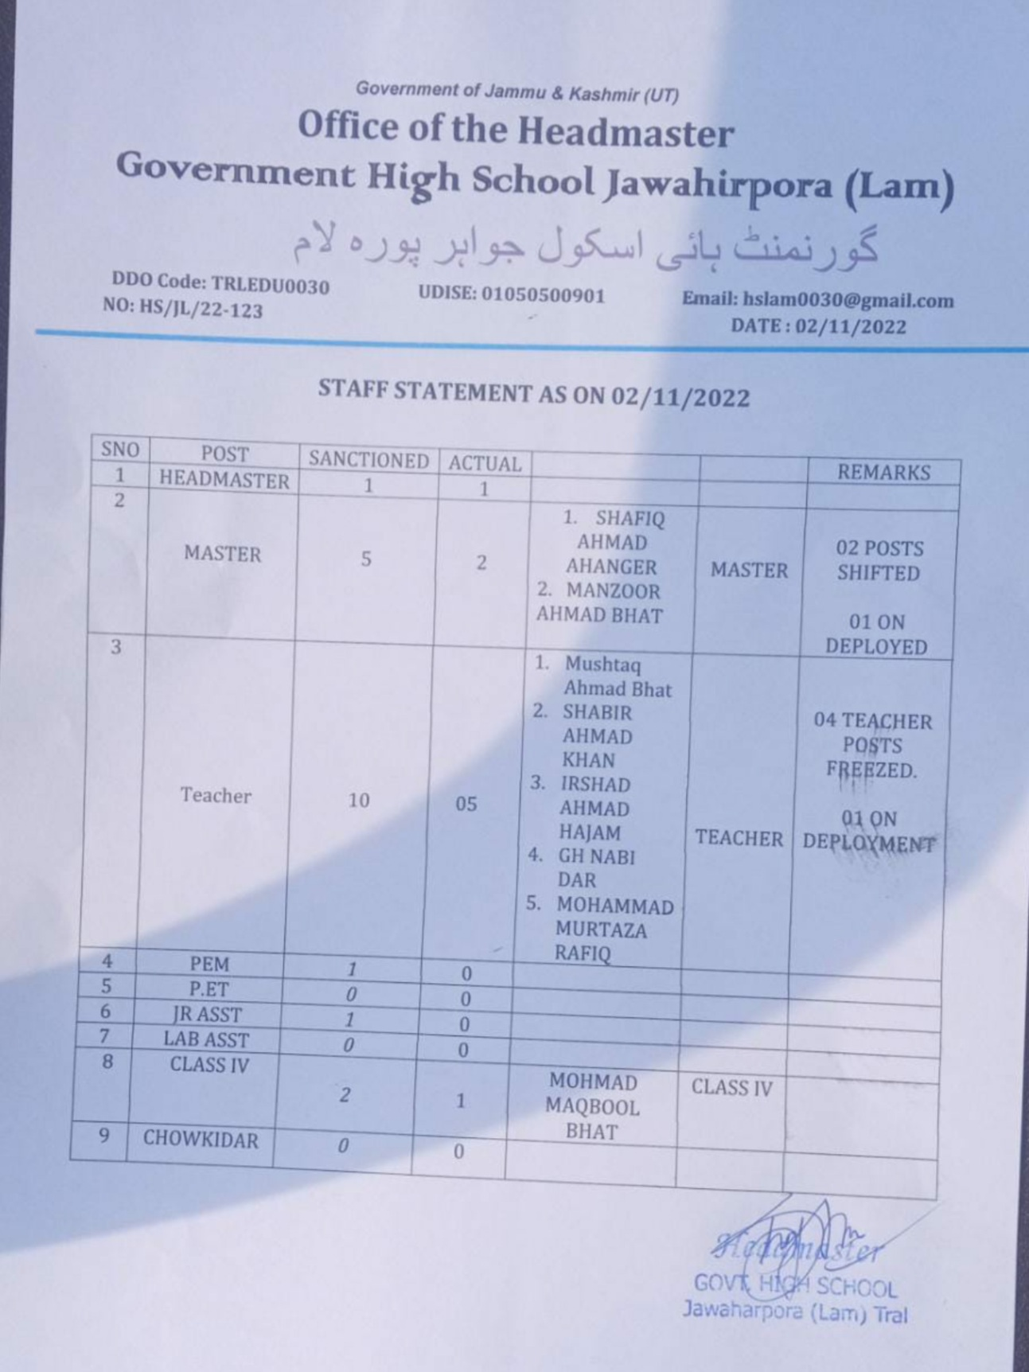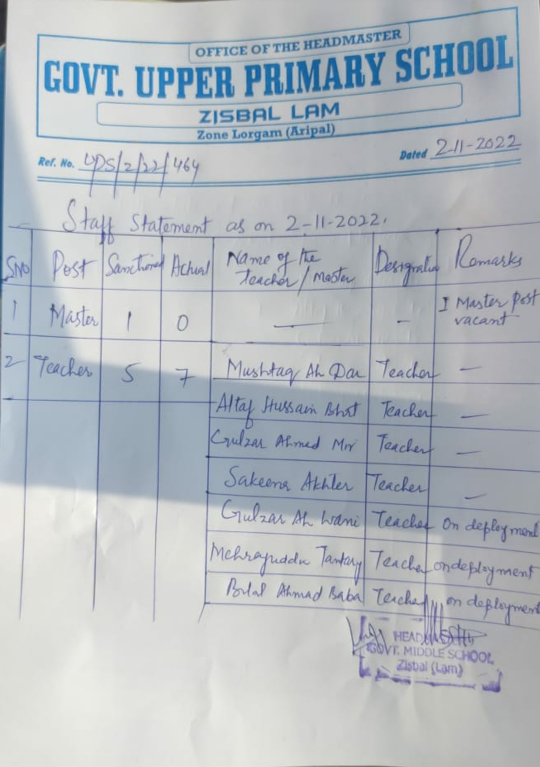

**DAY2-ACTIVITIES**

**AGENDANO.1**

Discussion on the assess the progress of different schemes relating to the localized SDGs prior-itized for that village as per there solution passed by that Gram Panchayat on 21stApril22,on National Panchayati Raj Day(Copy of there solution to be taken from [www.jkpanchayat.in](http://www.jkpanchayat.in) portal under the link of Gram Swaraj Month)

1. SDGs AGREED FORTHATVILLAGE,TOBEIMPLEMENTED BYMARCH2024: Yes

2. STATUS OF WORKS UNDER THE FOLLOWING SCHEMES:

**1 Clean and green village**

i.Initiatives taken by the Panchayat form an aging Solid and Liquid Waste Yes

ii. Initiatives taken bythe Panchayat for using green sources of fuel like solar,biogas

No

iii. Has mapping of landuse, waterbodies,forest,slopes,wetlands,degraded forest within the Gram

Panchayat been done?Yes/No. IfNo, reason, thereof Yes

iv. Has the Climate Resilience Plan been developed for the GP? Yes/No No

v. Steps taken by the Gram Sabha about the climate change mitigation factors like reducing energy consumption,usage of fossil fuels,plastics,non-renewable building materials and also to promote measures like planting of trees, conserving forests,usage of good agricultural practices like drip irrigation, water conservation measures and conservation of wetlands. No

vi. Whether schools have started segregating waste No

vii. Whether schools have their own compost/soakage pits for solid/liquid waste management Yes

**2 Healthy village**

i) Aremeetings related to Village Health and Sanitation Committee being held regularly? No

ii) Do all the eligible individuals been provided the Golden Card? Yes (with some pendency)

iii) Are all the Children being immunized as per the Schedule recommended by Govt.of India? Yes

iv) Are all the eligible individuals been vaccinated against COVID-19? Yes

v) Does Gram Panchayat ensure that all pregnant women are getting necessary prenatal checkups? Yes

vi) Whether all the deliveries were Institutionalized or conducted by trained Mid wives? Yes

**3 Water sufficient village**

i) Do all the IHHs in the Gram Panchayat have water pipe line connections? Yes

ii) Whether Gram Panchayat has taken steps for grey water management. If Yes please specify Yes ( Soakage pits)

iii) Do all the IHHs in the Gram Panchayat have toilets? Yes

iv) Are all the IHHs toilets functional or not? Yes

v) Do all the Schools/Anganwadi centers have a toilet facility or not? (AWC are in private accommodation lacking W/R facility)

vi) Are all the toilets in the schools/Aaganwadi functional or not? No

vii) Whether Gram Pachachayat Bhawan has separate toilets for women or not? No

**4 Child Friendly village**

i) Do all the children under the age of 0-6years been enrolled in the Anganwadi centers for pre- schooling ?Yes/NO Yes

ii) How many Bal Sabha’s were organized in the Gram Panchayat 02

iii) Whether the issues raised by BalSabha are addressed during the Gram Sabha. Yes/NO Yes

iv) Whether GramPanchayat is tracking the data related to drop out children and children with irregular attendance ?Yes/NO. No

v) Do all the schools under the Gram Panchayat have separate toilets for girls and boys?Yes/No No

**5 Village with good governance**

i) Is CSC located in the GramPanchay at Bhawan o r not? Yes

ii) Is the list of beneficiaries related to the Schemes/Programs displayed on the Gram panchayat wall or not? Yes

iii) Does the Gram Panchayat has its building or not? Yes

iv) Is the Gram Panchayat office functional or not? No

v) Are the activities approved under the Halqa Panchayat Development Plan displayed on the Gram

Panchayat wall or not? No

vi) Is Social Audit of earlier Schemes/ Programs carried out or not? Yes

1. **Poverty free and enhanced livelihood village**
2. Has Gram Panchayat developed any criteria for the identification of the poor ? Yes/No if yes specify No
3. Have all the eligible house holds registered in PDS or not? Yes

iii) Has Gram Panchayat provided space for Self-help Groups in Panchyat Ghar for holding meetings or not? N0

iv) Have all the eligible house holds been registered for Pension or not? Yes

v) Has Gram Panchayat facilitated Youth for Skill Enhancement Courses and Placement? No

vi) Has Job Cards been distributed to all the eligible individuals under MGNREGA? Yes

vii) Has Gram Panchayat facilitated SHGs for Bank Account Linkages? Yes

**7 Socially secured village**

i) Whether Gram Panchayat is maintaining data related to Differently Abled People? Yes

ii) Is Gram Panchayat Office Disabled Friendly or not? No

iii) Are provisions for a separate Budget under the Resource Envelope for Women and Children made or not? No

iv) Do all the Schools in the Gram Panchayat have facilities for Differently Abled Children like toilets, barrier-free access, etc.,or not? No

v) Are all the eligible individuals are getting pensions, like old age pension, widow pension,etc? Yes

vi) Are all the eligible house holds getting benefits from IAY or not? Yes

**8 Engendered Development in Village**

i) How many Mahila Sabha’s were organized in the Gram Panchayat----------02------

ii) Whether SHGs federations have been provided space for meetings in the Panchayat Bhawan(Yes/ No) No

iii) Whether GPs have taken steps for increasing women’s participation in Gram Sabha (Yes/No) Yes

iv) Number of women beneficiaries headed house holds covered under PDS

system………34………………

v) Number of beneficiaries(out of total eligible population) receiving social protection benefits under

Pradhan Mantri Matritva VandanaY ojana………275………….

9 Self-sufficient infrastructure in the village

i. Whether Phasa Community Hall with access to electricity, furniture, water supply, toilet…………No…………….

ii. Whether the Disaster management plan is available at the GPLevel(Yes/No) No

iii. Whether child-friendly park with required facilities is available in GP(Yes/No) Yes (01 No)

iv. Whether the G P has easy access to Go down for storage (Yes/No) Yes

v. Whether street lights are provided in public places for ensuring safety(Yes/No) Yes

**DAY 2 ACTIVITIES**

**AGENDANO.2**

Sensitize village residents about my Scheme”portal (myscheme.in)which includes information about all the schemes being run by Central/State/UT govt across the country.

*(SchemeMaterialavailablefromhttps://jkpanchayat.in/b2v4.php)*

Done with good Number of villagers present.

**DAY 2 ACTIVITIES**

**AGENDA NO.3**

Hold meeting of the Biodiversity Management Committees to deliberate on issues pertaining to conserva- tion of biodiversity and sustainable utilization of biological resources. He should check People Biodiversity register (PBR) of that panchayat and review if Biodiversity Management Committee constituted for that panchayat is holding minimum 4 meetings in ayear and meeting once in every 3 months *(RoleofBMC availableathttps://jkpanchayat.in/b2v4.php)*

COMMITTEEMEMBERS PRESENT

BIODIVERSITYREGISTERPHOTOS

PAST 4MEETINGDETAILS-DATES,MINUTESPHOTOS

BMC exists and only 01 Meeting held so far.

(01 Meeting held)

**DAY2ACTIVITIES**

**AGENDA 4**

Visiting officer shall also plan and conduct panchayat level convergence meeting of all departments and prepare Village development plan for village, in consultancy with Gram panchayat, discuss it in gram sabha and get it approved.

(GPDPformatavailableonhttps://jkpanchayat.in/b2v4.php)

Plan was already prepared and was discussed.

**In addition GPDP plan shall also include:**

▪ Tourist places which need to be developed Guggar Saran

▪ Specific product which needs to be developed Nil

▪ Tourism-home stays

▪ 20 candidates for training under Himayat scheme along with trade in which training is to be given Nil

**DAY2ACTIVITIES**

**AGENDA5**

Ensure saturation of following schemes and give status:

|  |  |  |  |
| --- | --- | --- | --- |
| **NAMEOFTHESCHEME** | **TOTALELIGIBLE BENEFICIARIESIN THE VILLAGE** | **TOTALBENEFICIARIESWHO AVAILEDTHEBENEFITSOFTHESCHEME** | **REASONSFOR PENDENCY** |
| Golden Health Card under  Ayushman Bharat | 2834 | 2618 | Haven’t applied |
| Janani suraksha yojana | 291 | 280 | Under Process |
| OLDAGE pension | 234 | 234 | -- |
| Widow pension | 117 | 117 | -- |
| Disability pension | 53 | 53 | -- |
| Domicile certificate | 2145 | 1126 | Not applied |
| Kisan credit card | Horticulture 109  Agriculture 421 | 47  271 | Inelligible |
| PM kisans amman nidhi | 287 | 411 | Do |

|  |  |  |  |
| --- | --- | --- | --- |
| Land pass book | 678 | 8 issued onspot | Digitization under process |
| Registration of village even- dorson GEM portal | 7 | -- |  |
| Registration of village con- tractors on jktenders portal | 7 | -- |  |
| Registration of village con- tractors on PWD portal | 7 | -- |  |
| Incomplete buildings/pro- jects | 1 | -- | Panchayat Ghar (under 13FC) |

**DAY 2 ACTIVITIES**

**AGENDA 6**

**NASHA MUKT ABHIYAN**

1. Whether gram Sabha resolution passed Yes

2. Details of activities conducted General awareness, pledge, demerits of drugs etc

3. Whether all activities and GS resolution uploaded on jkpanchayats.in portal Yes

4. How many drug addicts in the village Nil

5. Whether reported to the Deputy Commissioner Nil

6. How many registered for rehabilitation under government Programme Nil

**DAY2ACTIVITIES**

**AGENDA 7**

**SOCIAL AUDIT**

Conduct social audit of atleast 5 works each under following schemes:

|  |  |  |  |  |  |  |
| --- | --- | --- | --- | --- | --- | --- |
| NAMEOFTHE SCHEME | DETAILSOFTHE WORKS | YEAROFWORK APPROVAL | AMOUNT APPROVED  FORTHEWORK | WHETHER  WORKEXECUTED SATISFACTORILY | GEO- TAGGED PHOTOS | ANY GRIEVANCE RECORDED RELATINGTOTHAT WORK |
| MGNREGA | Const. of road from shop of Gh Nabi to panchayat ghar | 2021-22 | 2.50 lacs | Yes | Yes | No |
| PMAY | 02 No’s | 2022-23 | 3.00 lacs | Yes | Yes | No |
| IHHL  UNDERSBM-G | Noor mohd Wani (Existed) | 2019-20 | Rs 12000 | Yes | Yes | No |
| CSCUNDER SBMG | At Masjid Umer BG Gund | 2020-21 | 1.80 lacs | Yes | Yes | No |
| AMRIT SAROVARS | Zisbal | 2022-23 | Rs 50000 | Yes | Yes | No |

**DAY 2 ACTIVITIES**

**AGENDA 8**

**MAHILASABHA**

Total women in the village above the age of 18 252

Total attended 25

Proceedings:

*(Plinsertpointers to be discussed there–refer palli proceedings.*

Following points were raised.

1. Girls toilets to be made available in schools.

2. Fencing needs to be done in schools,

3. Road connectivity for schools

**DAY2ACTIVITIES**

**AGENDA 9**

**BALSABHA**

Hold a bal sabha and record proceedings

Total children in the village above the age of….. Total attended 50

*(Pl insert pointers to be discussed there–refer palli proceedings)*

Proceedings:

Following issues were raised :

1. Electricity and heating facility in schools,
2. Development of play field
3. Distribution of sports kits.

**DAY2 ACTIVITIES**

**AGENDA 10**

**INAUGURATIONS**

|  |  |  |  |
| --- | --- | --- | --- |
| **SR NO.** | **ASSETS/ACTIVITIES INAUGRATED** | **STATUSOFTHEASSET/AC- TIVITIES(NUMBER,OTHER DETAILS)** | **GEO-TAGGED PHOTOS** |
|  | VILLAGE HAAT under JKSRLM (SUN- DAYMARKET) | No | -- |
|  | PMAY houses if any ready for inaugra- tion | 11  02 Inaugurated | Uploaded |
|  | Swach gram projects-segregation sheds etc | Nil | Nil |
|  | Amrit sarovars | 01 | Uploaded |
|  | Sport skits | 01 | Uploaded |
|  | Village cultural events | 0 | Was not arranged in time |
|  | JJ Massets /projects | Nil | JJM scheme  tendered |
|  | Any other to be identified at district level | -- | -- |

**FOLLOW UP OF (B2V1,B2V2&B2V3):**

*(Pre filled excel sheet to be taken from district level/and also to be downloaded*

*from[www.jkpanchayat.in)](http://www.jkpanchayat.in)*

|  |  |  |  |
| --- | --- | --- | --- |
| S.NO. | Particulars | Actiontaken | Remarks# |
| I. Urgent Public Requirements/Demands-B2V1 | | | |
| 1 | Flood channel on Lam Nallah at Jawharpora DG Gund | Taken up | Completed at Spots |
| 2 | 3-bridges which will connect DG gund with Hean and Jawharpora with DG Pora | Not taken up | Demand repeated |
| 3 | Widespread of Aripal Jawharpora road | Not taken up | Demand repeated |
| 4 | Upgradation of family welfare centre PHC | Not taken up | Demand repeated |
| 5 | Food supply store for upper Zisbal | Not taken up | Demand repeated |
| 6 | Animal Husbandary at DG Gund | Not taken up | Not repeated |
| 7 | Mobile network coverage of GP | One Airtel Tower completed | Demand for BSNL and Jio Towers |
| II. UrgentPublicRequirements/Demands-B2V2 | | | |
| 1 | Electric connectivity of Gujjar Basti Nizam | Partly taken up (09 poles) | Not completed |
| 2 | C/O road from proposed bridge to to Sairnad via deedarpora | Not taken up | Demand repeated |
| 3 | C/O second story over GM School DG Gund | Not taken up | Demand repeated |
| 4 | Estt of Public park in Ziraat Laymani DG Gund | Completed | Completed |
| 5 | Borewell in Zisbal | Not taken up | Not repeated |
| 6 | Vermicompost establishment | To be taken up | -- |
| 7 | Road from old graveyard to playground field | Partly done | Needs grade I, II and Mecdamization |
| S.NO. | Particulars | Actiontaken | Remarks# |
| III. MajorProblems–B2V1 | | | |
| 1 | Flood threat at Jawharpora DG Gund Kalen Nallah | Resolved | Taken up at Spots |
| 2 | Threat to life due to encroachment of Lam Zisbal | Not Resolved | Repeated |
| 3 | Dilapidated interior roads | In Progress | To be taken up |

|  |  |  |  |
| --- | --- | --- | --- |
| 4 | Poor mobile coverage | Airtel Tower Completed | BSNL and Jio demanded |
| 5 | Inadequate transport | Partly Resolved |  |
| IV. MajorProblems-B2V2 | | | |
| 1 | POS quota to be enhanced | Not resolved | Major demand |
| 2 | Road issue in Zisbal Soinard | Not taken | Due to land issue |
| 3 | Electric Connectivity | Partly taken | Major demand |
| 4 | PHE Schemes | Laid in 1980 | Tendered in JJM |
| 5 | Poor Transport facility | Partly resolved | -- |
| V. MajorProblems-B2V3 | | | |
| 1 | No macdamization of interior roads | Not take up | Demanded by people |
| 2 | Poor electricity Network | Partly Done |  |
| 3 | Cellular Network |  | Needs to be improved |
| 4 |  |  |  |
| 5 |  |  |  |
| VI. MajorComplaints-B2V1 | | | |
| 1 | Inadequate Staff | Inadequate | Need of more staff in Govt. Offices |
| 2 | Lack of basic amenities at FW Centre at Jawharpora | Not done Yet | Should be upgraded to PHC |
| 3 | Salary of daily wagers | Not on regular basis |  |
| VII. MajorComplaints-B2V2 | | | |
| 1 | Less cellular network | Partly resolved |  |
| 2 | Less electric connectivity | Partly resolved |  |
| 3 | Most of works of B2V1 | Not takenup |  |
| VIII. MajorComplaints-B2V3 | | | |
| 1 | Threat to life due to wildBear | Not resolved |  |
| 2 | Play groung at DG Gund | Not taken up | Repeated |
| 3 | Load to play field | Partly done | Repeated |

**OVER ALL PERCEPTION OF FUCNTIONING OF GOVERNMENT DEPARTMENTS**

1. **BESTDEPARTMENT:**

**2. LEASTRESPONSIVEDEPARTMENT:**

**GENERALASSESSMENTOFTHEVISTINGOFFICER**

|  |  |
| --- | --- |
| I | Any major complaint brought to the notice of the Visiting Officer: **Annexure ‘A”** |
| II | Major/urgent public demands that was/were reflected earlier but have not been addressed so far: **Annexure ‘B”** |
| III | Over all assessment of the visit and suggestions:  (The visiting officer to ensure that the over all assessment is recorded in details along with concrete sugges- tions) **Annexure C ‘”** |
| IV | Overall Rating of govt functioning as given by the Panchayat (Scaleof0to10) 07 |
| V | Certificate from Sarpanch that the visiting officer has stayed in the panchayat for 2days Uploaded |

**Signature of Sarpanch Signature of the Visiting Officer**

**Name: Nundai Ganie Dy. Sarpanch Name: Er. Rayees Ahmad Mir**

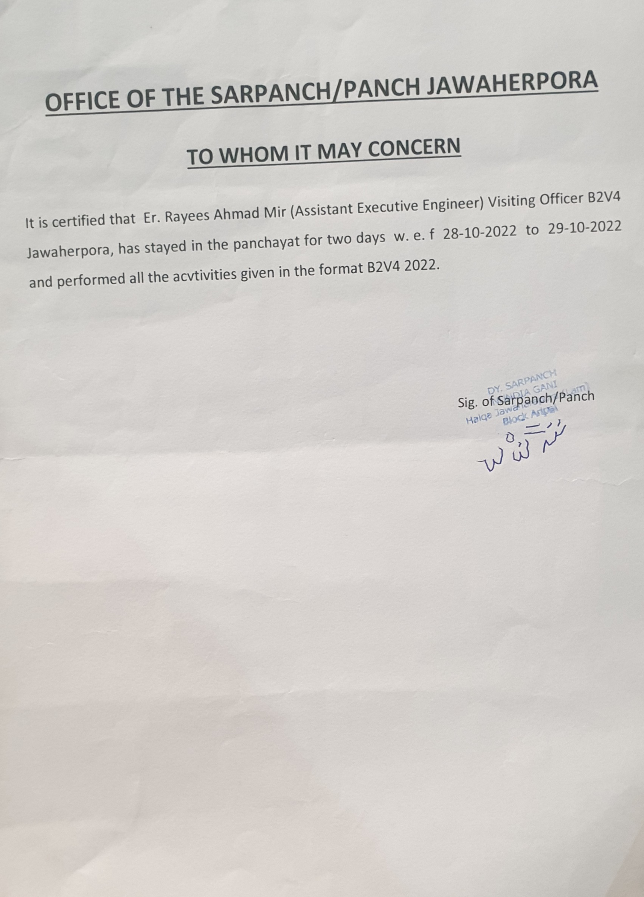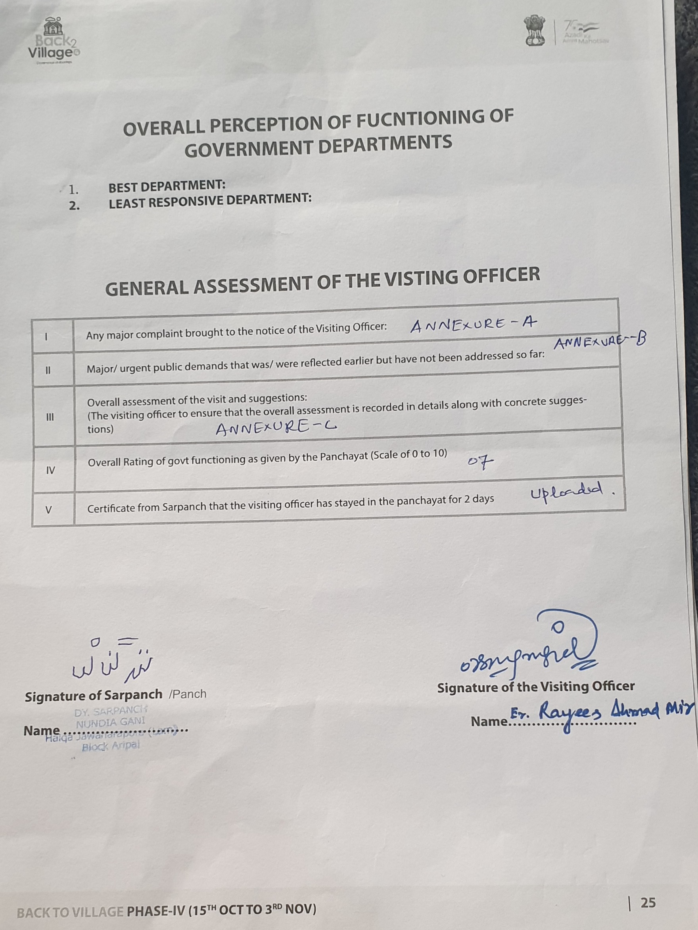

**Annexure “A”**

**Major demands / complaints of Public during B2V4**

1. Installation of 63 KV transformer for Ahanger Mohalla D.G Gund Jawharpora.
2. Fencing of grave yard at D.G Gund (Nundraz).
3. Construction of road from main raod to Ahanger Mohalla D.G Gund.
4. Construction of washrooms for boys and Girls at Govt High School Lam Jawharpora.
5. Construction of protection wall for Govt. upper Primary School building at Zisbal Lam Jawharpora.
6. Construction of road from main road adda to Bonpora (length 0.2 km)
7. Desilting of Nallah Kallen from house of Mohd Shaban to House of Ab Rashid Khan at Lam.
8. Construction of bridge on Nallah Lam near house of Assadullah Master at Lam.
9. Construction of lane from house of Fayaz Ahmad Dar to land of Bashir Ahmad Lone at Sheetnag.
10. Protection bund on Nallah Ganie near the land of Shafat Ahmad Hajam on onwards.
11. Fencing around primary school Soinard Lam.
12. Protection bund from land of Mohd Akram Dar and Others at Lam (Phase-II).
13. Protection bund for Masjid Sharief Gujjer Basti with culvert at Lam.
14. Improving of road facility to Govt. High School Lam Jawharpora.
15. Demand for 03 more Anganwadi Centers in Lam Jawharpora.
16. Improvement of playfield at Lam.
17. New School Building , Replacement of water supply line and protection wall For Govt Upper Primary School Dar Ganie Gund.

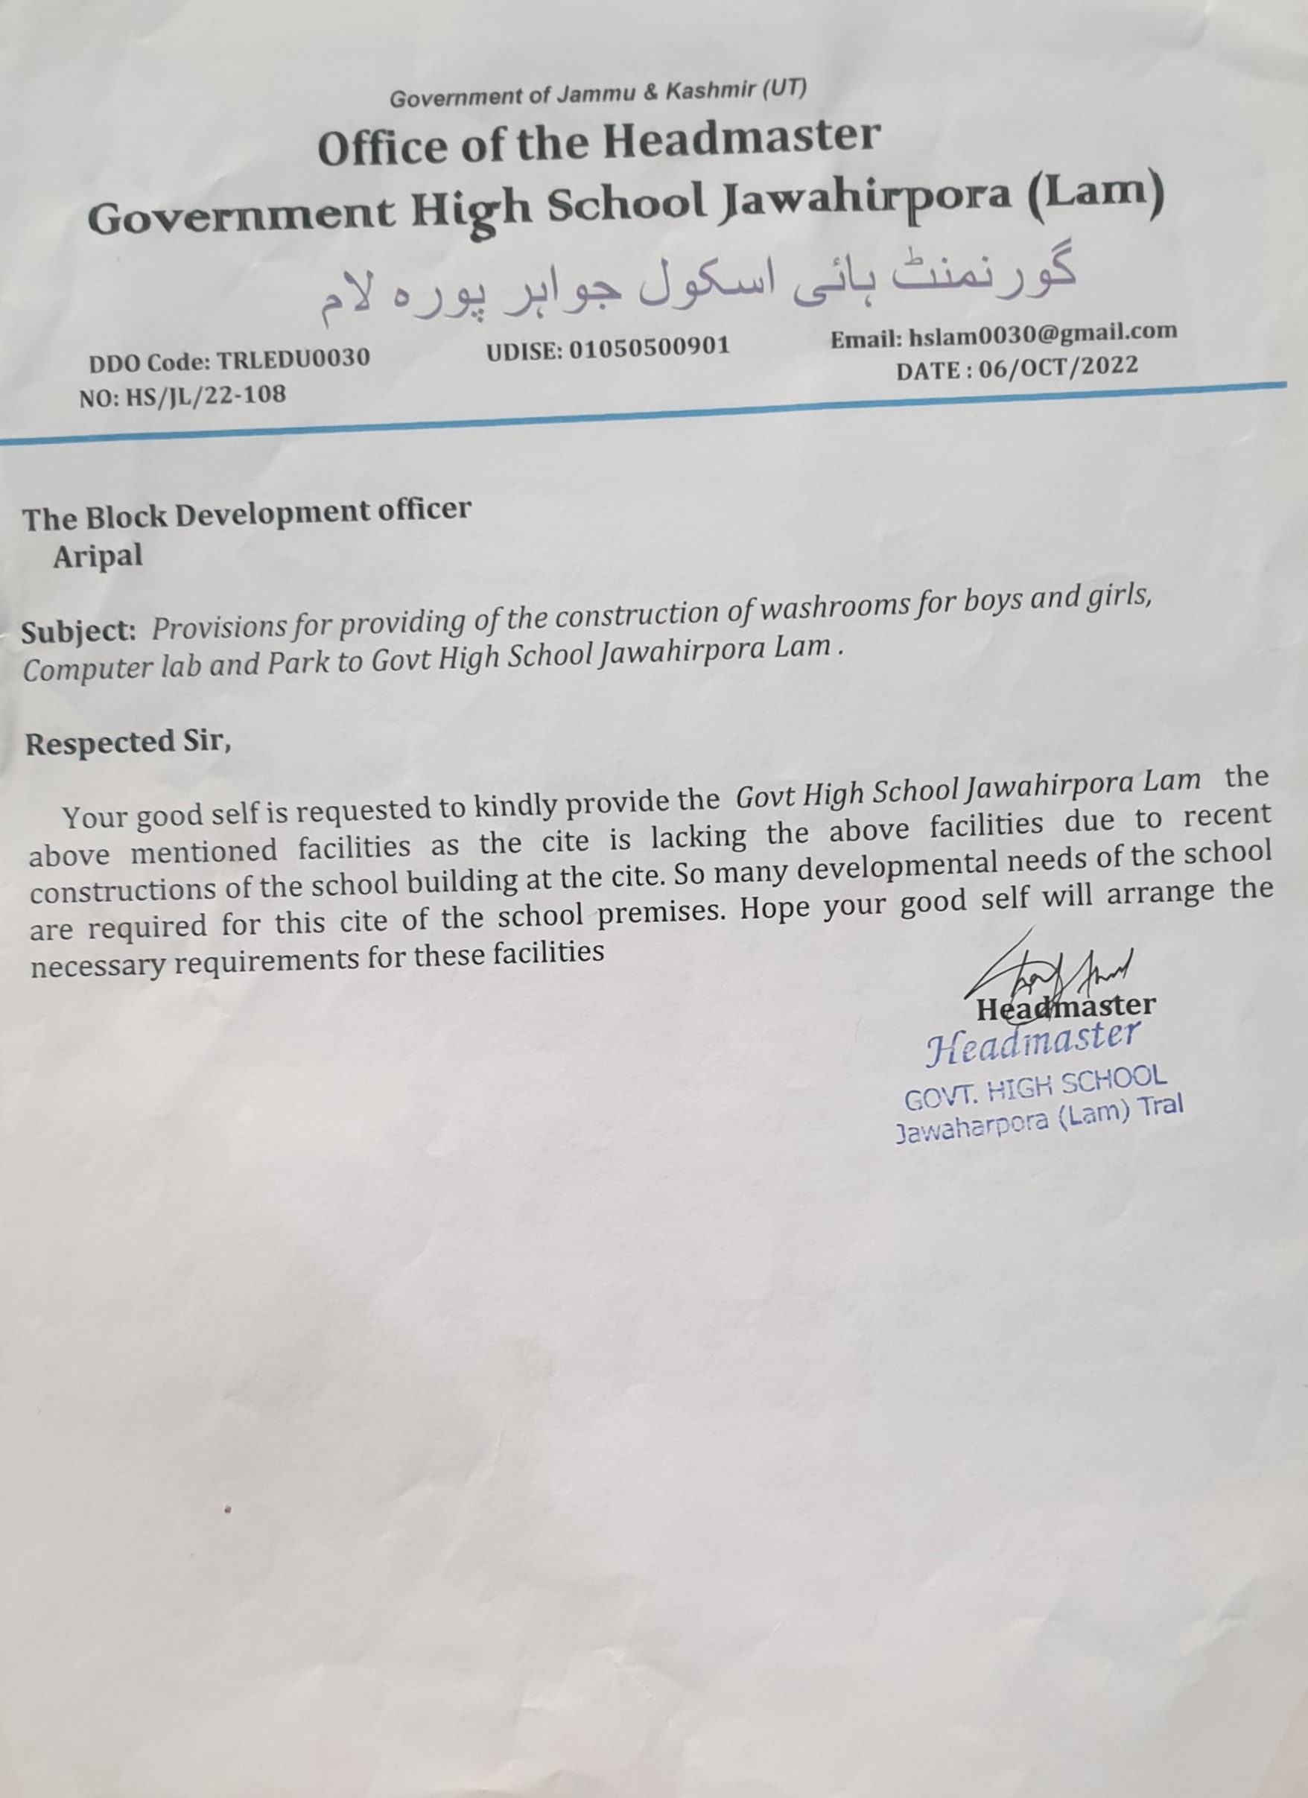

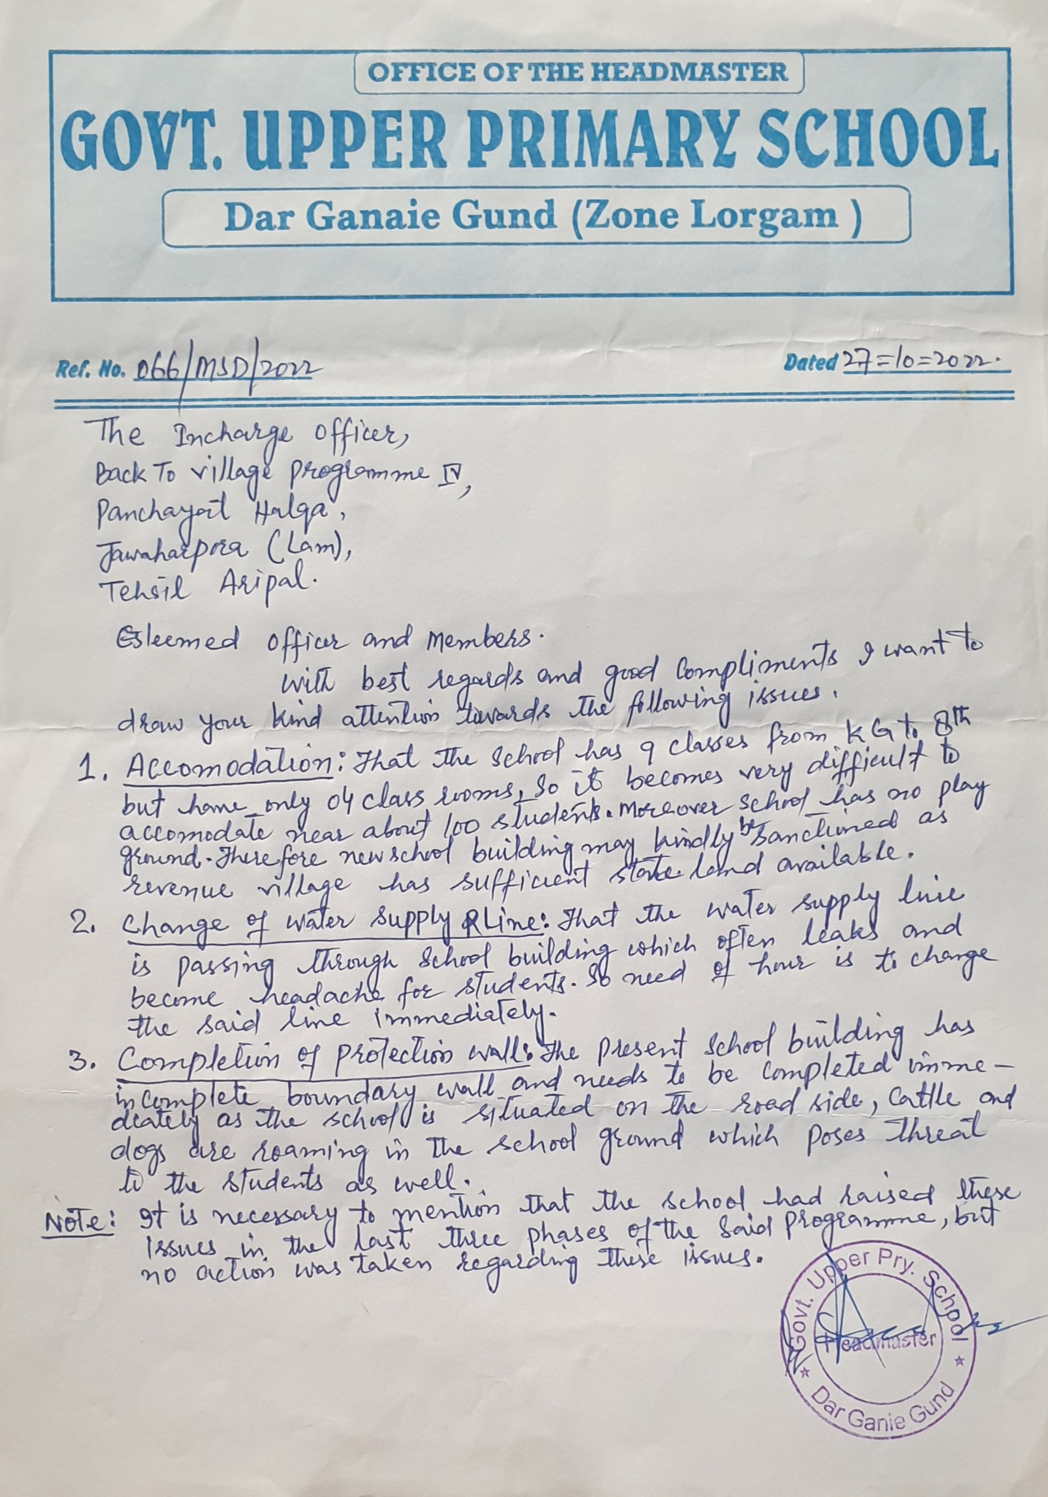

**Annexure “B”**

1. Poor Network connectivity. (demand for BSNL and Jio towers).
2. Replacement of PHE pipe lines (JJM scheme tendered).
3. Poor electricity Network.
4. Inadequate staff in Govt. Offices.
5. Family Welfare Centre to be upgraded to PHC.
6. Mechadamisation of Interior link roads.
7. PDS quota to be enhanced.

**Annexure “C”**

**On visiting the whole Panchayat Lam Jawherpora,**

I came to the conclusion that there are some issues like improper Health Facility (PHC), Drinking water system (Replacement of Pipe network), Road connectivity, Development of play fields, Up-gradation of school infrastructure and electricity network which demand resolution on priority basis.

It is also pertinent to mention here that all the government departments are working tooth and nail for betterment of the Panchayat Lam Jawherpora and only hurdle that comes in their way is inadequate staff.

For the overall development of the Gram Panchayat, I suggest the GPDP should be made for period of 05 years and a team should be constituted to access the performance of all works / schemes after every month and suggest the necessary changes/precautions if required.



**Department of Rural Develompent and Panchayati Raj**

**Government of Jammu & Kashmir**