

4



**15TH OCTto3RD NOV,2022**

**KEYFEATURES**

• Deputy Commissionerstoleadtheinitiative

• RuraldevelopmentDepartmenttobethenodaldepartment

• PlanningDevelopment&MonitoringdepartmentandITtobethesupport departments

**ACTIONSANDTIMELINES**

|  |  |  |  |
| --- | --- | --- | --- |
| **ACTION** | **RESPONSIBILITY** | **LATESTBY** | **REMARKS** |
| **Janabhiyan** | Alldepartments | Oct15-26th | Goingon |
| **DeputationofSecttstaff/ HoDs** | GAD | Oct14 | Done |
| **DeploymentofStaffto Panchayatsandservingof ordersondeployedofficers** | DCs | Oct25 | DCswilldeployseniorlevelstaff fromthedistricts.Strictactionto betakenagainstabstentions.No exemptionstobegiven |
| **Trainingofdistricttrainors onB2V4** | RDD | Oct26 |  |
| **Trainingofvisitingofficers** | DCs | Oct27 |  |
| **FieldVisitstobecompleted by** | VisitingOfficers | Nov3 | DCstosuperviseandensurethat eachPanchayatisvisitedwithin theperiodspecified |
| **DataofB2V4tobe uploadedby** | VisitingOfficers | Nov10 | DCstosuperviseandensurethat dataofallPanchayatsisupload- edbythevisitingofficerwithin theperiodspecified |

**INSTRUCTIONSFORTHEVISITINGOFFICER(DAYWISE)**

|  |  |  |
| --- | --- | --- |
| **DATE** | **INSTRUCTIONS** | **ACTIONPOINTS** |
| **Day0** | Meetingwithdeputy commissionerandhis/her team | a. TakeprintoutsoffilledbookletsofB2V1,B2V2andB2V3from [www.jkpanchayat.in](http://www.jkpanchayat.in)  b.Alsotakeprintoutsofthesummarizedexcelsheetsofthe previousphasesfrom[www.jkpanchayat.in](http://www.jkpanchayat.in)  c. CollectATRsonissuesraisedduringprevious3phasesfromthe officeofDeputyCommissioner(Planningdeptt)  d.Takeprintsofblank 2bookletsofB2V4from[www.jkpanchayat.in](http://www.jkpanchayat.in)e.Takeplansfor2previousyearsandATRsfromtheplanningdeptt f. CompletetrainingsondifferentcomponentsofB2V4being  organizedbyrespectiveDeputyCommissioners  g.CollectListofnewworksstarted/ongoing/completedduringthe previousandcurrentFinancialyearunderthefollowingheads:  • PRIgrants  • DistrictPlan  • UTplan  • MGNREGA  • Otherschemesofotherdepartments  • Anyotherwork  h. Plans/beneficiarylists:  • MGNREGAdraftplandocumentfortheyear2022-23.  • ListofAwaas+beneficiariesalongwithIHHL Convergence  • Listofpensionbeneficiaries.  • ListofSHGs  • Listofagricultureschemebeneficiaries  i. Listsofbeneficiariesfor:  • Variouscertificates/benefitstobedistributedbythe visitingofficer.  • Anyotheractivitiesidentifiedbydifferentdepartments |

|  |  |  |  |
| --- | --- | --- | --- |
| **Day1** | Reachthevillage | 1. | Ensurethatallfrontlineworkersofdifferentdepttsarepresent. |
|  |  | 2. | Ensureexhibitionbydifferentdepts.aboutindividualbeneficiary schemes |
|  |  | 3. | InspectJKB/PSBcounters/outlets |
|  |  | 4. | Participate/ensureorganizationofsportsactivityinplayfield,talent hunt/culturalevent/youthactivity |
|  |  | 5. | GandhiKatha(suggesteddetailsuploadedonjkpanchayat.in) |
|  |  | 6. | Visitatleast2amritsarovarsandgetitsgeotaggedphotos |
|  |  | 7. | InspectKhidmat(CSC)CentresandcreateGenerateawarenesson  225schemesparticularlyG2CschemeslikeBEAMS,Janbhagidari, AapkiZaminAapkiNigrani,DigitalJ&K |
|  |  | 8. | Visitingofficershallalsoplanandconductpanchayatlevelconver- gencemeetingofalldepartments |
|  |  | 9. | CheckeffectivenessofCentrallysponsoredschemes |
|  |  | 10. | VisitandinspectallgovernmentestablishmentsincludingPHE, AWC,FPS,schools,etc |
|  |  | 11. | Attemptsaturationofdeliverableso JanAbhiyanandwherever deficienciesfound,leadadrivetoachievealldeliverables |
|  |  | 12. | Assesseffectivenessofsanitationcampaigninthepanchayat |
|  |  | 13. | Ensureselfemploymentactivitiesfor15youthperpanchayat |
|  |  | 14. | Identify20potentialcandidatesperpanchayatforHIMAYATtraining alongwiththetradeonwhichtheywanttraining |
|  |  | 15. | Whereverpossible,distributeemploymentlettersforpeopleselect- edundervariousgovernmentemployments |
|  |  | 16. | Intheevening,holdnormalmeetingwith seniorcitizens,govtem- ployeesincludingretiredemployees,exservicemen,youthclub,and any citizens ofthevillagewhoareenrolledincollege/university |
|  |  | 17. | OpendiscussiononNashaMuktAbhiyan |

Day2 Haveameetingwithall stakeholders-depttofficials andpanchayatmembers

1. Discussionontheandassesstheprogressofdifferentschemesrelating tothelocalizedSDGsprioritizedforthatvillageaspertheresolution passedby thatGramPanchayaton21st April22,onNationalPanchayti RajDay.

2. Sensitizevillage residentsaboutmyScheme”portal(myscheme.in) whichincludesinformationaboutalltheschemesbeingrunbyCen- tral/State/UTgovtacrossthecountry

3. Hold meeting of theBiodiversityManagementCommitteestodeliber- ateonissuespertaining toconservation of biodiversityandsustaina- bleutilizationof biologicalresources.

4. PrepareVillagedevelopmentplan,inconsultancywithGrampanchayat, discussitingramsabhaandgetitapproved.

5. Ensure saturationofsoilhealthcardandgoldenhealthcardunderGold- enHealthCardunderAyushmanBharat,

6. Ensuresaturation of OldAge PensionScheme

7. EnsureDomicileSaturation.

8. EnsureKCCSaturation

9. Ensure saturationoflandpassbooks

10. Ensureregistrationofvillagevendorsneededforanyscheme,onGEM

portal

11. Ensurepanchayatcontractors registration

12. EncouragePanchayatmembers forimportanceofplantationdrivein

PanchayatunderHarGaonHariyali

13. Ensure paintingondigitalJ&Kinpanchayatghars

14. Ensure paintingonpanchayatactivitesandCSSinpanchayatghars

15. Thevisiting officeshallchecknoof kindergarten andplayfields present inthepanchayat for kidsandstudents,iftheinfrastructure present inthesearegoodenough.

16. Holdmeeting withpanchayatmembers todiscussaboutcorruption menaceandstepsrequiredtomakeJ&Kcorruptionfree

17. Obtaina candidassessmentaboutperformanceofvariousdeptts in- cludingfairfeedbackaboutdiscrepanciesinfunctioning

18. Check thestatusof NashaMuktAbhiyanandreporting of drugad- dictstoDeputyCommissioner.

19. IdentifyTouristDestinations,Circuits,ThemeTreks,IdentifyHomestays, providesupportfortourismactivities throughVillageCooperative

20. OrganizeTalentHuntatPanchayatLevel

21. Conductsocialauditofatleast5worksunderfollowingschemes:

a. MGNREGA

b.PMAY

c. IHHLtoiletsandpayments d.CSCs

e.AMRITSAROVARS

22. Holda mahilasabha anda balsabhaandrecordproceedingsinthefor- matgiven

23. InauguratevillagehaatunderJKSRLM

24. Checkifyouthclubsareformedinthepanchayatandwhatactivities theyareengagedin

25. Organizea villagelevelculturaleventtoengagepanchayatmembers

26. SensitizeGPaboutE-kitabkoshaninitiativeofJ&KGovtforempowering youthsthrough onlinedigitalliteracy

**GENERALINSTRUCTIONS**

1. Thevisitingofficershallrefrainhimself/herselfgivingorofferinganycommitmentonbehalfofthe governmentandshalladoptanunbiasedattitudeinreportingissues.As faraspossible,his/her observation shouldbebasedona fairandanalytical viewemergingfromhis/herinteractioninthe village.

2. Heisgoingtothevillageasplanningofficer,notforsanctioninganyworksorformakinganycom- mitments.

3. Whilepreparingvillagedevelopmentplan,hehastoensurethat,demandsareprioritizedandre- flectedunderavailableschemes,wherevernecessarythelargerworksaretobereferredtoadminis- trativedepttunderCSS/UTplansunderintimationtoDCsandrestoftheworkstoDCsforreflecting itunderdistrict/CSS plans

4. His workshallbehardcoreplanningandauditandisnota PRexercise.

5. EveryDeputyCommissionerhastoensurethatatleastoneRDDofficial(ideallyPanchayatSecre- tary)ispresent ineverypanchayatwithrelevantpanchayatrecords,toensureconductofallactivi- tiesasplanned.Panchayatwiseorderneedstobeissuedinadvance.

6. Visitingofficershouldideallycarryhis/herlaptoptocompletethereportsatthepanchayatlevel itselfanduploadthefinalreport,duly signedbothbythesarpanchandbythevisitingofficeron [www.jkpanchayat.in](http://www.jkpanchayat.in)portal,beforetheyleavepanchayat.

7. Focus ofvisitareyouth,skills,self-employment,nashamukt,bhrashtracharmukt,Rozgaryukt J&K, besidestocarryforwardtheactivities duringJanAbhiyanandsaturatethem.

8. Inadditionattentionmaybegiventothefollowingareas a. MakefulluseofCentrallySponsoredSchemes

b.Saturationofindividualbeneficiaryschemes c. Self-employmentschemes

d.Banklinkedschemes-includingdepartmentalsubsidyschemes e.Empowermentandtransparencythrough digitalinitiatives

f. Effectivenessofgrassrootsmachinery–

i. Patwari,VLWpresent andavailable

ii. AvailablefundsutilizedinpublicinterestandasperGramSabharesolutions iii. Fairness ingovernance

iv. CSS/Individual beneficiaryschemesetc v. BrashtacharMuktJ&K

vi. BhaiMuktJ&K

vii. NashaMuktJ&K

9. ThePRImembers (Sarpanchs,Panchs,BDCChairperson)shallbeattheforefrontofallactivities and givendueimportanceandtheapproach shouldbetostrengthenthemandmakethemfeelem- powered.He/sheshallensurethattheBDCchairpersonandSarpanch/Panch arepresent atthetime ofinaugurationandceremonies.

10. Visitingofficershallnotleavethedistrictwithoutuploadingthereport,duly signedonthe**www. jkpanchayat.in**portal.EveryDeputyCommissionerhastoensurethat.

**A) DetailsofReportingOfficer:**

Name**: Mohd Azam**

Designation: **Lecturer**

Department/placeof posting**: Education/ HSS Seri Khawaja.**

MobileNo**:9697676810**

EmailID**: Azam9596981002@gmail.com**

HomeDistrict: **Poonch**

Datesof visit: **28/10/2022 to 29/10/2022**

**B) LocationaldetailsofPanchayat:(tobepre-filled,informationtobetakenfromthepreviousphasesbooklets/summarizedexcelsheetuploadedonjkpanchayat.in/b2v4.php)(tobevali- datedbythevisitingofficerandmissingdetailstobefilled)**

NameofthePanchayat: **Gagrian Chool**

Local Government Directory(LGD)code of the Panchayat: **7446**

Name of CDB lock**: Mandi**

Name of Tehsil**: Mandi**

Name of District: **Poonch**

**C) PanchayatProfile:**

No.ofrevenuevillagesinthePanchayat: 01 (One)

No.ofhamletsinthePanchayat: 06

No.ofhouseholdsinthePanchayat: 675

Population(approx)of thePanchayat: 3000

**Part-II:**

(TobefilledupbytheVisitingOfficerduringhis/hertwodayvisittothePanchayat.AllFieldshavetobe

filledbytheVisitingOfficerbeforethebookletishandedovertotheDC

**FrontlineOfficers/OfficialswhowereassignedtothePanchayatfortheprogramme:**

|  |  |  |
| --- | --- | --- |
| Department | Name | Designation |
| Education | Mehraj Khalid | Teacher |
| ICDS | Shaina Begum | Supervisor |
| Forest | Abdul Samad | Forest Guard |
| PHE | Abdul Hamid | Supervisor |
| CSC | Khaleem Ahmed | CSC (VLE) |
| Revenue | Imran Ali Bamba | Patwari |
| RDD | Mumtaz Ahmed | GRS |
| DYSS | Mohd Ashraq | NYC |
| Health | Dr Ali Mohd | M.O PHC Sawjian |
| PWD | Mohd Farooq | G.C |
| Social Welfare | Mohd AShraf | Jr. Assistant |
| Agriculture | Susheel Kumar | AEA |
| Food supply | Wasim Raja | Sale Man |
| Animal Husbandary | Tarlok Singh | SBP |
| Social Forestary | Mohd Rafiq | Watcher Man |
| Sheep Husbandary | Maroof Hussain | Astt. Stockmen |

**Detailsofabsentemployeesvis-à-vislistfurnishedbytheDCoffice:**

|  |  |  |
| --- | --- | --- |
| Department | Name | Designation |
|  |  |  |
|  |  |  |
|  |  |  |
|  |  |  |
|  |  |  |
|  |  |  |
|  |  |  |
|  |  |  |
|  |  |  |
|  |  |  |
|  |  |  |
|  |  |  |
|  |  |  |
|  |  |  |
|  |  |  |

**DAY1-ACTIVITIES**

**AGENDA1:PANCHAYATASSETREGISTER**

**Infrastructure:**

1. PanchayatGharInfrastructure a. Govtbuilding/private -- **(Govt Building)**

b. New/needingrepairs--

( Needing Repairs)

2. Furniture(Y/N)--- **( Yes)**

3. Computer/printer(Y/N**)---- No**

4. Internet(Y/N**)—( No)**

5. Telephone(Y/N**)—(No)**

6. Toilet(CSC/partofpanchayatghar)(Y/N**)—(Yes)**

7. Water(Y/N**)---(Yes)**

8. Electricity(Y/N**)----(Yes)**

9. Bankbranch(Y/N**)---(Yes)**

10. CSC(Y/N**)--------YES**

11. Patwarkhana(Y/N**)-----(Yes)**

12. Villagehaat(Y/N**)--------(Yes)**

13. Playground(Y/N**)-------(Yes)**

14. School-

a. Kindergarten(Y/N**)—(Yes**)

b.Primary(Y/N**)----(Yes)**

c. Secondary(Y/N**)-------(Yes)**

d. College (Y/N**)-------(NO)**

e.University(Y/N**)-----(No)**

15. AnganwadiCentre(Y/N**)—(Yes)**

a. (govt/private**)-------(Govt)**

b.Totalchildrenenrolled **:- 264**

15. AmritSarovars–details,location,condition-----

16. Governmentoffices-details,whetherfunctionalornot

17. Rationshop(Y/N**)—(Yes)**

18. Placesoftourismimportance–names,littledetailsonhistorical/culturalimportance.

19. Villageheritagesites/treks-names,littledetailson historical/culturalimportance

20. VLWOffice (Y/N**)-(Yes)**

21. PrimaryHealthcareCentre(Y/N**),---(yes)**

22. ListofIncompleteBuildings-names,yearofconstruction**--- HS Gagrian 2017-18**

23. ListofUnderutilizedBuildings-names

**---- Nil**

**DAY1-ACTIVITIES**

**AGENDA2:**

**DIFFERENTINSTITUTIONS/INFRASTRUCTUREPROJECTSTOBEVISITED**

|  |  |  |
| --- | --- | --- |
| **AMRITSAROVARS** | **Visit,verify** | **COMMENTS** |
| KhidmatCentres | Create/Generateawarenesson225schemes particularlyG2CschemsAapkiZaminAapkiNigrani, Beams,Janbhagidari,DigitalJ&K | . |
| JKB/PSBcounters/outlets | a)Statusofcounter b)Numberofvisitors | **03 Counters**  **80 Visitors** |
| Incompletebuildings/pro- jects | Verify whetheridentificationandredistribution done | **Incomplete building of HS Gagrian Under RMSA Scheme 2nd floor 2017-18** |
| PDS | Visit,evaluate,onlinestatus | **Finger Online** |
| PHC | Visit-evaluate,statusofstaff,equipmentand quality | **Staff Insufficient**  **Equipment - sufficient** |
| Youthclubs | Meet,interact,seeksuggestions | **Nasha Mukt Awareness** |
| SHG | Meet,identifyproblems,seeksuggestions | **---** |
| PMAY | Inspect,Inaugurate | **Complete** |
| Myschool,mypride progress;schools-water, toilets,staff | Visit,checkforwater,electricity,sanitation,meet studentsandstaff | **Yes** |
| SwachhSBM | Evaluate | **Satisfactory** |
| Panchayatplayground, Sportskitsdistribution Villagegames | Ensure,verify.Participateinatleastonegamein theplayground | **Yes at M/s Maidan** |
| HarGaonHariyali, Planta- tiondrive | Evaluatestatus,feedback | **Satisfactory** |
| Villageculturalevent  Dangal/Haat/Mela | Participatein;ensurethatitisheld | **No** |
| Exhibitionofschemes | Ensurethateverydepartmentparticipatesand thatitcontinuesfortheentiredurationofB2V | **No** |
| JalJeewanMission verifica- tion- WSS/JSD  Electricitysupply | Verify | **No** |

**DAY1-ACTIVITIES**

**AGENDA3:SATURATEJANBHIYAN**

**DELIVERABLESANDRECORDDEFICIENCIESIFANY(INSERTDELIVERABLESLISTHEREASPERGADFORMAT**

**DAY1-ACTIVITIES**

**AGENDA4:**

**SELFEMPLOYMENTACTIVITIES**

EnsureSelf-employmentactivities foryouth,distributeemploymentlettersforpeopleselectedunder varioussocialschemes(15ISTHETARGETPERPANCHAYAT)

**Numberofcasesindifferentcategoriessanctioned: Detailsofthebanksanctioningit:**

**Totalamountinvolved.**

**DAY1ACTIVITIES**

**AGENDA5**

Intheevening,holdinformalmeetings withseniorcitizens,govtemployees,retdemployees,youthclub andothercitizenswhoareenrolledoncollege/universityandhavediscussiononGandhiKatha,Nasha MuktAbhiyan,corruptionfreegovernance,doublingfarmersincomeandrecordtheproceedings

**DAY2**

a. NoofIndividualCompostPitsconstructed :- **No**

b.NoofIndividualSoakPitsconstructed:-**400**

V. No.ofBiodiversitymanagementcommitteemeetingsheld:

VI. IsthenameofSarpanchdisplayedoncitizeninformationboardsofallRD&PRschemes:Yes/No**---(Yes)**

VII. AreSarpanchsbeinginvolvedinstart/inaugurationofactivities:Yes/No**----(Yes)**

VIII. WhethersubjectshavebeenassignedbytheSarpanchtothePanchs:Yes/No**-(Yes)**

IX. Whethergrievancesredressalboxisinstalled:Yes/No**-----No**

X. NoofgrievancesreceivedpertainingtoPanchayatlevel**:Nil**

XI. NoofgrievancesdisposedofatPanchayatlevel: **Nil**

XII. WhethertheSarpanch/PanchayatSecretaryhavedigitalsignatures:Yes/No**---(Yes)**

XIII. WhetherallMGNREGA/14thFCpayments arebeingmadebySarpanchthrough DigitalSignature

Certificate(DSC):Yes/No**-----(Yes)**

------

**HUMAN RESOURCEAVAILABLEATTHEPANCHAYAT LEVEL:**

|  |  |  |  |  |
| --- | --- | --- | --- | --- |
| **SRNO.** | **DEPARTMENTWISESTAFF** | **NUMBERS** | | **NAMES** |
|  |  | SANCTIONED | ACTUAL |  |
|  | Ruraldevelopmentdepartment: BDO  JE GRS TA | **Nil**  **Nil**  **01**  **01** | **Nil**  **Nil**  **01**  **01** | **Nil**  **Nil**  **Mumtaz Ahmed**  **Sh. Zaheer Abas.** |
|  | SCHOOLEDUCATION: TEACHER  HEADMASTER ANYOTHER | **41**  **01** | **29**  **01** |  |
|  | JAL JEEVAN: | **-----** | **-----** |  |
|  | PDD: LINEMAN JE  ANYOTHER | **Nil**  **01**  **02** | **Nil**  **01**  **02** | **Javid Iqbal**   1. **Mohd Shabir. ( C/ Lab.)** 2. **.** |
|  | FOOD&CIVILSUPPLIES | **02** | **02** | **2. Mukhtar Ahmed ( C/ lab.)**  **Wasim Raja ( Saleman0**  **Ahmed Khalil ( weight man)** |
|  | AGRICULTURE&ANIMALHUS- BANDARY | **01**  **03** | **01**  **02** | **Susheel Kumar (AEA)**  **Ishtaq Ahmed Dar ( VAS)**  **Mohd Kabir (Attendant)** |
|  | SOCIALWELFARE | **----** | **------** |  |
|  | HEALTH: ASHA ANM  AYUSHDOCTOR ALLOPATHICDOCTOR | **06**  **02**  **01**  **03** | **06**  **01**  **01**  **Nil** | **Tahira, Hanifa, Sarba,Zubida, Taj Begum, Farida Begum.**  **Jan Bibi**  **Ali Mohd** |
|  | ANYOTHERDEPARTMENT |  |  |  |

**DAY2-ACTIVITIES**

**AGENDANO.1**

DiscussionontheandassesstheprogressofdifferentschemesrelatingtothelocalizedSDGsprior-itizedforthatvillageaspertheresolutionpassedbythatGramPanchayaton21stApril22,onNational PanchayatiRajDay(Copyoftheresolutiontobetakenfrom[www.jkpanchayat.in](http://www.jkpanchayat.in)portalunderthelinkof GramSwarajMonth)

1. SDGs AGREED FORTHATVILLAGE,TOBEIMPLEMENTED BYMARCH2024:

2. STATUSOFWORKSUNDERTHEFOLLOWINGSCHEMES:

**1 Cleanandgreenvillage**

i.InitiativestakenbythePanchayatformanagingSolidandLiquidWaste **(Yes)**

ii. InitiativestakenbythePanchayatforusinggreensourcesoffuellikesolar,biogas **Yes**

iii. Hasmappingoflanduse,waterbodies,forest,slopes,wetlands,degradedforestwithintheGram

Panchayatbeendone?Yes/No.IfNo,reason,thereof (**Yes)**

iv. HastheClimateResiliencePlanbeendevelopedfortheGP?Yes/No**------(Yes)**

v. StepstakenbytheGramSabhaabouttheclimatechangemitigationfactorslikereducingenergy consumption,usageoffossilfuels,plastics,non-renewablebuildingmaterialsandalsotopromote measureslikeplantingoftrees,conservingforests,usageofgoodagriculturalpracticeslikedrip irrigation,waterconservationmeasuresandconservationofwetlands**----(Yes).**

vi. Whetherschoolshavestartedsegregatingwaste----Yes

vii. Whetherschoolshavetheirowncompost/soakagepitsforsolid/liquidwastemanagement**------(No)**

**2 Healthyvillage**

i) Aremeetings relatedtoVillageHealthandSanitationCommitteebeingheldregularly**?-(Yes)**

ii) DoalltheeligibleindividualsbeenprovidedtheGoldenCard?-----**Yes**

iii) ArealltheChildrenbeingimmunizedaspertheSchedulerecommendedbyGovt.ofIndia?-(**Yes)**

iv) ArealltheeligibleindividualsbeenvaccinatedagainstCOVID-19?—**Yes**

v) DoesGramPanchayatensurethatallpregnantwomenaregettingnecessaryprenatalcheckups?---(**Yes)**

vi) WhetherallthedeliverieswereInstitutionalizedorconductedbytrainedMidwives? **Yes**

**3 Watersufficientvillage**

i) DoalltheIHHsintheGramPanchayathavewaterpipelineconnections? **No**

ii) WhetherGramPanchayathastakenstepsforgreywatermanagement.IfYespleasespecify

**Yes**

iii) DoalltheIHHsintheGramPanchayathavetoilets? **Yes**

iv) ArealltheIHHstoiletsfunctionalornot? **Yes**

v) DoalltheSchools/Anganwadicentershavea toiletfacilityornot? **Yes**

vi) Areallthetoiletsintheschools/Aaganwadifunctionalornot? **No**

vii) WhetherGramPachachayatBhawanhasseparate toiletsforwomenornot? **No**

**4 ChildFriendlyvillage**

i) Doallthechildrenundertheageof0-6yearsbeenenrolledintheAnganwadicentersforpre- schooling?Yes/NO**--- yes**

ii) HowmanyBalSabha’swereorganizedintheGramPanchayat-----**Yes 112**

iii) WhethertheissuesraisedbyBalSabhaareaddressedduringtheGramSabha. Yes/NO--- **No**

iv) WhetherGramPanchayatistrackingthedatarelatedtodropoutchildrenandchildrenwithirregular attendance?Yes/NO**.-----No**

v) DoalltheschoolsundertheGramPanchayathaveseparate toiletsforgirlsandboys?Yes/No**--- No**

**5 Villagewithgoodgovernance**

i) IsCSClocatedintheGramPanchayatBhawanornot? **No**

ii) IsthelistofbeneficiariesrelatedtotheSchemes/ProgramsdisplayedontheGrampanchayatwallor not? **Yes**

iii) DoestheGramPanchayathasitsbuildingornot? **Yes**

iv) IstheGramPanchayatofficefunctionalornot?**Yes**

v) Aretheactivities approved undertheHalqaPanchayatDevelopmentPlandisplayedontheGram

Panchayatwallornot? **Yes**

vi) IsSocialAuditofearlierSchemes/Programscarriedoutornot? **Yes**

**6 Povertyfreeandenhancedlivelihoodvillage**

1. HasGramPanchayatdevelopedanycriteria fortheidentificationofthepoor?Yes/Noifyesspecify--**Yes**

ii) HavealltheeligiblehouseholdsregisteredinPDSornot**?---Yes**

iii) HasGramPanchayatprovidedspaceforSelf-helpGroupsinPanchyatGharforholdingmeetings or not? **Yes**

iv) HavealltheeligiblehouseholdsbeenregisteredforPensionornot**?--- Yes**

v) HasGramPanchayatfacilitatedYouthforSkillEnhancementCoursesandPlacement**?--- Yes**

vi) HasJobCardsbeendistributedtoalltheeligibleindividualsunderMGNREGA**?--- Yes**

vii) HasGramPanchayatfacilitatedSHGsforBankAccountLinkages**?---- No**

**7 Sociallysecuredvillage**

i) WhetherGramPanchayatismaintainingdatarelatedtoDifferentlyAbledPeople? **Yes**

ii) IsGramPanchayatOffice DisabledFriendlyornot?--- **Yes**

iii) Areprovisionsfora separate BudgetundertheResourceEnvelopeforWomenandChildrenmadeor not?-- **Yes**

iv) DoalltheSchools intheGramPanchayathavefacilitiesforDifferentlyAbledChildrenliketoilets, barrier-freeaccess,etc.,ornot?--- **No**

v) Arealltheeligibleindividualsaregettingpensions,likeoldagepension,widowpension,etc?-- **Yes**

vi) ArealltheeligiblehouseholdsgettingbenefitsfromIAYornot?

**--- No**

**8 EngenderedDevelopmentinVillage**

i) HowmanyMahilaSabha’swereorganizedintheGramPanchayat-----**02**

ii) WhetherSHGsfederationshavebeenprovidedspaceformeetings inthePanchayatBhawan(Yes/ No**)-- Yes**

iii) WhetherGPshavetakenstepsforincreasingwomen’sparticipationinGramSabha(Yes/No**)--- Yes**

iv) NumberofwomenbeneficiariesheadedhouseholdscoveredunderPDS

system **25**

v) Numberofbeneficiaries(outoftotaleligiblepopulation)receivingsocialprotectionbenefitsunder

PradhanMantriMatritvaVandanaYojana---- **No.**

9 Self-sufficientinfrastructureinthevillage

i. WhetherGPhasa CommunityHallwithaccesstoelectricity,furniture,watersupply, toilet…**No**

ii. WhethertheDisastermanagementplanisavailableattheGPLevel(Yes/No)---**Yes**

iii. Whetherchild-friendlyparkwithrequiredfacilitiesisavailableinGP(Yes/No)

**---YES**

iv. WhethertheGPhaseasyaccesstoGodownforstorage(Yes/No**)--- No**

v. Whetherstreetlightsareprovidedinpublicplacesforensuringsafety(Yes/No**)---No**

**DAY2ACTIVITIES**

**AGENDANO.2**

SensitizevillageresidentsaboutmyScheme”portal(myscheme.in)whichincludesinformationaboutall theschemesbeingrunbyCentral/State/UT govtacrossthecountry

*(SchemeMaterialavailablefromhttps://jkpanchayat.in/b2v4.php)*

**DAY2ACTIVITIES**

**AGENDANO.3**

HoldmeetingoftheBiodiversityManagementCommitteestodeliberateonissues pertainingtoconserva- tionofbiodiversityandsustainableutilizationofbiologicalresources.HeshouldcheckPeopleBiodiversity register(PBR)ofthatpanchayatandreviewifBiodiversityManagementCommittee constitutedforthat panchayatis holdingminimum4meetings inayearandmeeting onceinevery3months *(RoleofBMC availableathttps://jkpanchayat.in/b2v4.php)*

COMMITTEEMEMBERS**—Yes**

PRESENT---**07**

BIODIVERSITYREGISTERPHOTOS--- **Yes**

PAST 4MEETINGDETAILS-DATES,MINUTESPHOTOS

**DAY2ACTIVITIES**

**AGENDA4**

Visitingofficershallalsoplanandconductpanchayatlevelconvergencemeeting ofalldepartmentsand prepareVillagedevelopmentplanforvillage,inconsultancywithGrampanchayat,discussitingram sabhaandgetitapproved.

(GPDPformatavailableonhttps://jkpanchayat.in/b2v4.php)

**InadditionGPDPplanshallalsoinclude:**

▪ Touristplaceswhichneedtobedeveloped

▪ Specificproductwhichneedstobedeveloped

▪ Tourism-homestays

▪ 20candidatesfortrainingunderHimayatschemealongwithtradeinwhich trainingistobegiven

**DAY2ACTIVITIES**

**AGENDA5**

Ensuresaturationoffollowingschemesandgivestatus:

|  |  |  |  |
| --- | --- | --- | --- |
| **NAMEOFTHESCHEME** | **TOTALELIGIBLE BENEFICIARIESIN THE VILLAGE** | **TOTALBENEFICIARIESWHO AVAILEDTHEBENEFITSOFTHESCHEME** | **REASONSFOR PENDENCY** |
| GoldenHealthCardunder  AyushmanBharat | **3412** | **3337** | **Migration population Adhar not uploaded, new born babies.** |
| Jananisurakshayojana | **99** | **93** | **Deliverey are still awaited** |
| OLDAGEpension | **50** | **50** | **Nil** |
| Widowpension | **20** | **20** | **Nil** |
| Disabilitypension | **15** | **15** | **Nil** |
| Domicilecertificate |  |  |  |
| Kisancreditcard | **200** | **140** | **Overage cases, nomad,Migrated population.** |
| PMkisansammannidhi | **199** | **199** | **Nil** |

|  |  |  |  |
| --- | --- | --- | --- |
| Landpassbook | **110** | **50** | **Network not available** |
| Registrationofvillageven- dorsonGEMportal | **Nil** | **Nil** | **Nil** |
| Registrationofvillagecon- tractorsonjktendersportal | **03** | **03** | **Nil** |
| Registrationofvillagecon- tractorsonPWDportal | **11** | **09** | **Works/ Rates not suitable.** |
| Incompletebuildings/pro- jects | **01** | **01** | **Funds not available.** |

**DAY2ACTIVITIES**

**AGENDA6**

**NASHAMUKTABHIYAN**

1. Whethergramsabharesolutionpassed

2. Detailsofactivities conducted---**02**

3. Whetherallactivities andGSresolutionuploadedonjkpanchayats.inportal

4. Howmanydrugaddictsinthevillage**----Nil**

5. WhetherreportedtotheDeputyCommissioner**--- Yes**

6. Howmanyregisteredforrehabilitationundergovernmentprogramme

**--- No**

**DAY2ACTIVITIES**

**AGENDA7**

**SOCIALAUDIT**

Conductsocialauditofatleast5workseachunderfollowingschemes:

|  |  |  |  |  |  |  |
| --- | --- | --- | --- | --- | --- | --- |
| NAMEOFTHE SCHEME | DETAILSOFTHE WORKS | YEAROFWORK APPROVAL | AMOUNT APPROVED  FORTHEWORK | WHETHER  WORKEXECUTED SATISFACTORILY | GEO- TAGGED PHOTOS | ANY GRIEVANCE RECORDED RELATINGTOTHAT WORK |
| MGNREGA | **B. Path w.no 02 Land drain** | **2021-22** | **70000** | **Yes** | **Yes** | **No** |
| PMAY | **Manzoor Ahmed JK-12 300292** | **2020-21** | **130000** | **Yes** | **Yes** | **No** |
| IHHL  UNDERSBM-G | **Gh. Rasool S/o Sultana SBM** | **2022-23** | **12000** | **Yes** | **Yes** | **No** |
| CSCUNDER SBMG | **Nil** | **nil** | **Nil** | **Nil** | **Nil** | **Nil** |
| AMRIT SAROVARS | **Nil** | **Nil** | **Nil** | **Nil** | **Nil** | **Nil** |

**DAY2ACTIVITIES**

**AGENDA8**

**MAHILASABHA**

Totalwomeninthevillageabovetheageof18

Totalattended--**-20**

Proceedings:---**20**

*(Plinsertpointerstobediscussedthere–referpalliproceedings)*

**DAY2ACTIVITIES**

**AGENDA9**

**BALSABHA**

Holda balsabhaandrecordproceedings

Totalchildreninthevillageabovetheageof**…---06..** Totalattended**----25**

Proceedings**:----25**

*(Plinsertpointerstobediscussedthere–referpalliproceedings)*

**DAY2ACTIVITIES**

**AGENDA10**

**INAUGURATIONS**

|  |  |  |  |
| --- | --- | --- | --- |
| **SR NO.** | **ASSETS/ACTIVITIES INAUGRATED** | **STATUSOFTHEASSET/AC- TIVITIES(NUMBER,OTHER DETAILS)** | **GEO-TAGGED PHOTOS** |
|  | VILLAGEHAATunderJKSRLM (SUN- DAYMARKET) | **Panchayat Ghar Chool. Activity… Nil** | **Yes** |
|  | PMAYhousesifanyreadyforinaugra- tion | **Complete** | **Yes** |
|  | Swachhgramprojects-segregation shedsetc | **Nil** | **Nil** |
|  | Amritsarovars | **Nil** | **Nil** |
|  | Sportskits | **Yes** | **Yes** |
|  | Villageculturalevents | **Nil** | **Nil** |
|  | JJMassets/projects | **Nil** | **Nil** |
|  | Anyothertobeidentifiedatdistrict level | **Nil** | **Nil** |

**FOLLOWUPOF(B2V1,B2V2&B2V3):**

*(Prefilledexcelsheet tobetakenfromdistrictlevel/andalsotobedownloaded*

*from*[*www.jkpanchayat.in)*](http://www.jkpanchayat.in)

|  |  |  |  |
| --- | --- | --- | --- |
| S.NO. | Particulars | Actiontaken | Remarks# |
| I. UrgentPublicRequirements/Demands-B2V1 | | | |
| 1 | **1 Save Drinking Water** | **Nil** | LACK OF FUNDS |
| 2 | **2Road Connectivity** | **Nil** |  |
| 3 | **3Brigade of nallah Jamia Gali** | **Nil** |  |
| 4 | **4 Three more transformer** | **Nil** |  |
| 5 | **5One primary school for Moh. gujjaran** | **Nil** |  |
| 6 | **6One AWC for w.no 02** | **Nil** |  |
| 7 | **7 tourism, building huts etc** | **Nil** |  |
| II. UrgentPublicRequirements/Demands-B2V2 | | | |
| 1 | **1Save Drinking water** | **Nil** |  |
| 2 | **2Play ground in pyt Chool** | **Work Completed** |  |
| 3 | **3Community Hall** | **Work in Progress** |  |
| 4 | **4Transformer PDD** | **Nil** |  |
| 5 | **5Road Connectivity in Pyt.** | **Nil** |  |
| 6 | 6 |  |  |
| 7 | 7 |  |  |
| S.NO. | Particulars | Actiontaken | Remarks# |
| III. MajorProblems–B2V1 | | | |
| 1 | **1 Road Connectivity** |  |  |
| 2 | **2Drinking water** |  |  |
| 3 | **Electricity** |  |  |

|  |  |  |  |
| --- | --- | --- | --- |
| 4 |  |  |  |
| 5 |  |  |  |
| IV. MajorProblems-B2V2 | | | |
| 1 | **1Road Connectivity in panchayat** |  |  |
| 2 | **2 Electricity** |  |  |
| 3 | **3 drinking Water** |  |  |
| 4 |  |  |  |
| 5 |  |  |  |
| V. MajorProblems-B2V3 | | | |
| 1 | **1Road Connectivity of w.no 6,7,9,11,14** |  |  |
| 2 | **2Anganwari Centre w.no 1,7,9,11** |  |  |
| 3 | **3 Bridge of nallah Jamia** |  |  |
| 4 | **4 Transformer w.no 4,9,11** |  |  |
| 5 |  |  |  |
| VI. MajorComplaints-B2V1 | | | |
| **1Opening of Bank** | **Matter Solved** | **J&K Bank Sawjian** |  |
| **2Road Connectivity** | **Nil** | **Lack of Funds** |  |
| **3Ambulance Service** | **Matter Solved** | **02 Ambulance Available in PHC** |  |
| **VII. MajorComplaints-B2V2** | | | |
| **1Services of P.H.E** | **Nil** |  |  |
| 2 |  |  |  |
| 3 |  |  |  |
| VIII. MajorComplaints-B2V3 | | | |
| **1P/S Chool** | **Sr. 01 to sr. 03 works completed** | **Overall works of plans were some implement on ground. B2V3** |  |
| **2Tractor Road Main road to Malpar** |  |  |  |
| **3Tractor road main road to M/S Brari** |  |  |  |

**OVERALLPERCEPTIONOFFUCNTIONING OF GOVERNMENTDEPARTMENTS**

1. **BESTDEPARTMENT: Education/ RDD**

**2. LEASTRESPONSIVEDEPARTMENT: P.H.C**

**GENERALASSESSMENTOFTHEVISTINGOFFICER**

|  |  |
| --- | --- |
| I | AnymajorcomplaintbroughttothenoticeoftheVisitingOfficer**:--- Road Connectivity** |
| II | Major/urgentpublicdemandsthatwas/werereflectedearlierbuthavenotbeenaddressedsofar**:--- Electricity** |
| III | Overallassessmentofthevisitandsuggestions:  (Thevisitingofficertoensurethattheoverallassessmentisrecordedindetailsalongwithconcretesugges- tions)--- **All the members of the pyt Gagrian Chool including sarpanch are doing wonderful work on the ground in the implementation of their proposed planwith the help[ of RDD and MGNREGA supporting staff.**  Nderful work |
| IV | OverallRatingofgovtfunctioningas givenbythePanchayat(Scaleof0to10)---**0to06** |
| V | CertificatefromSarpanchthatthevisitingofficerhasstayedinthepanchayatfor2days |

**SignatureofSarpanch SignatureoftheVisitingOfficer**

**Name……………………… Name………………………**

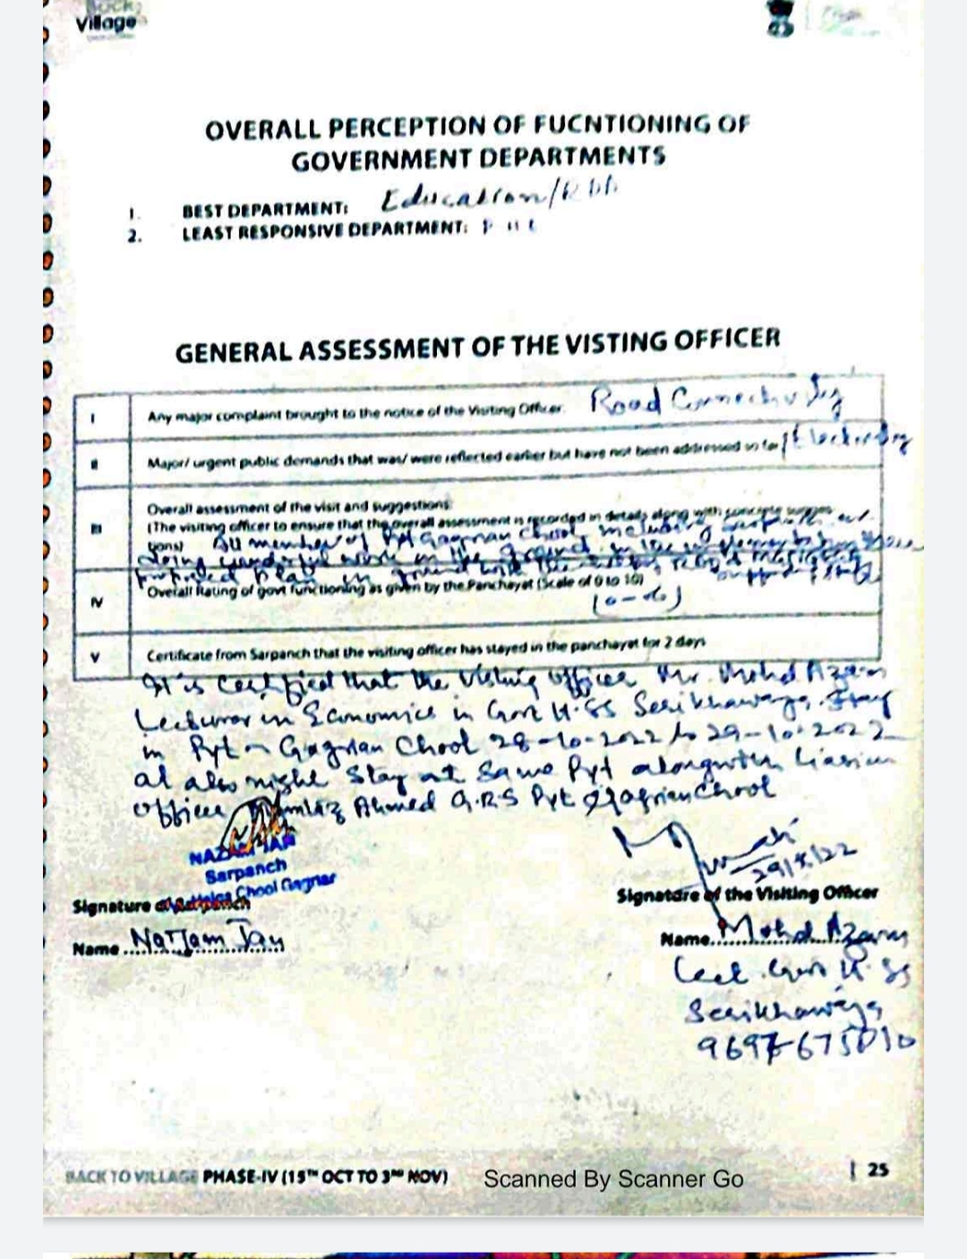

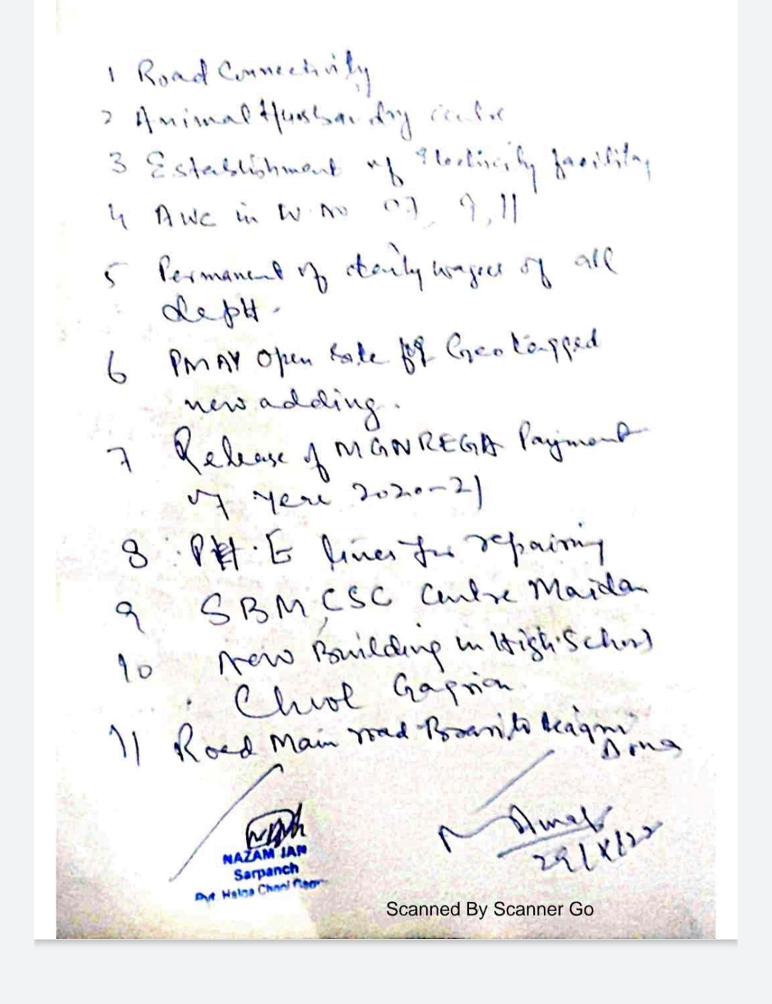

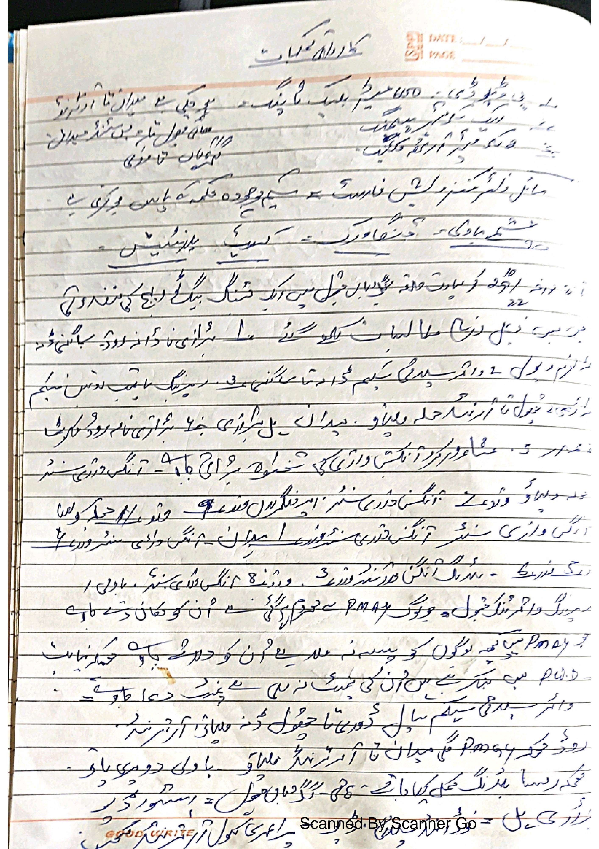

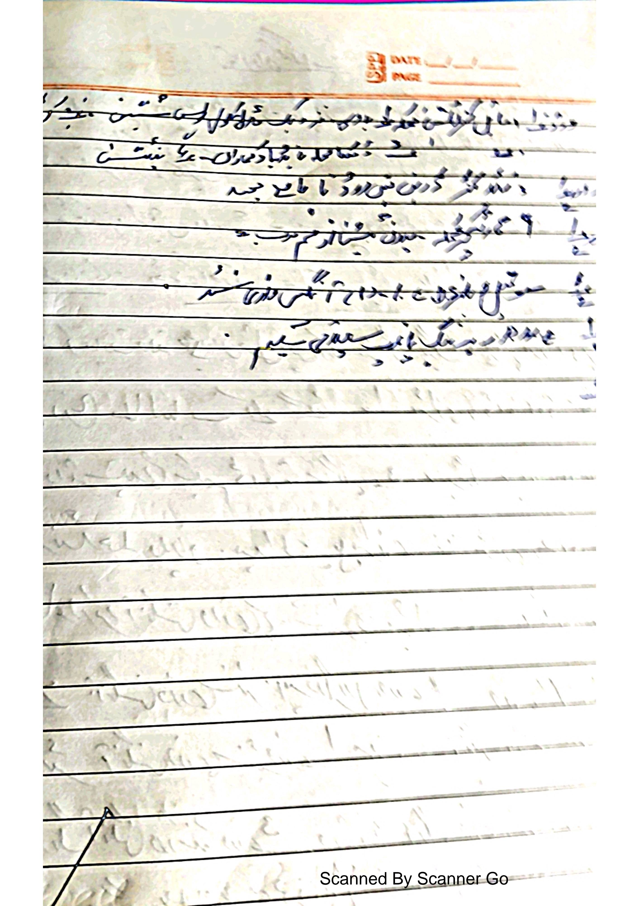

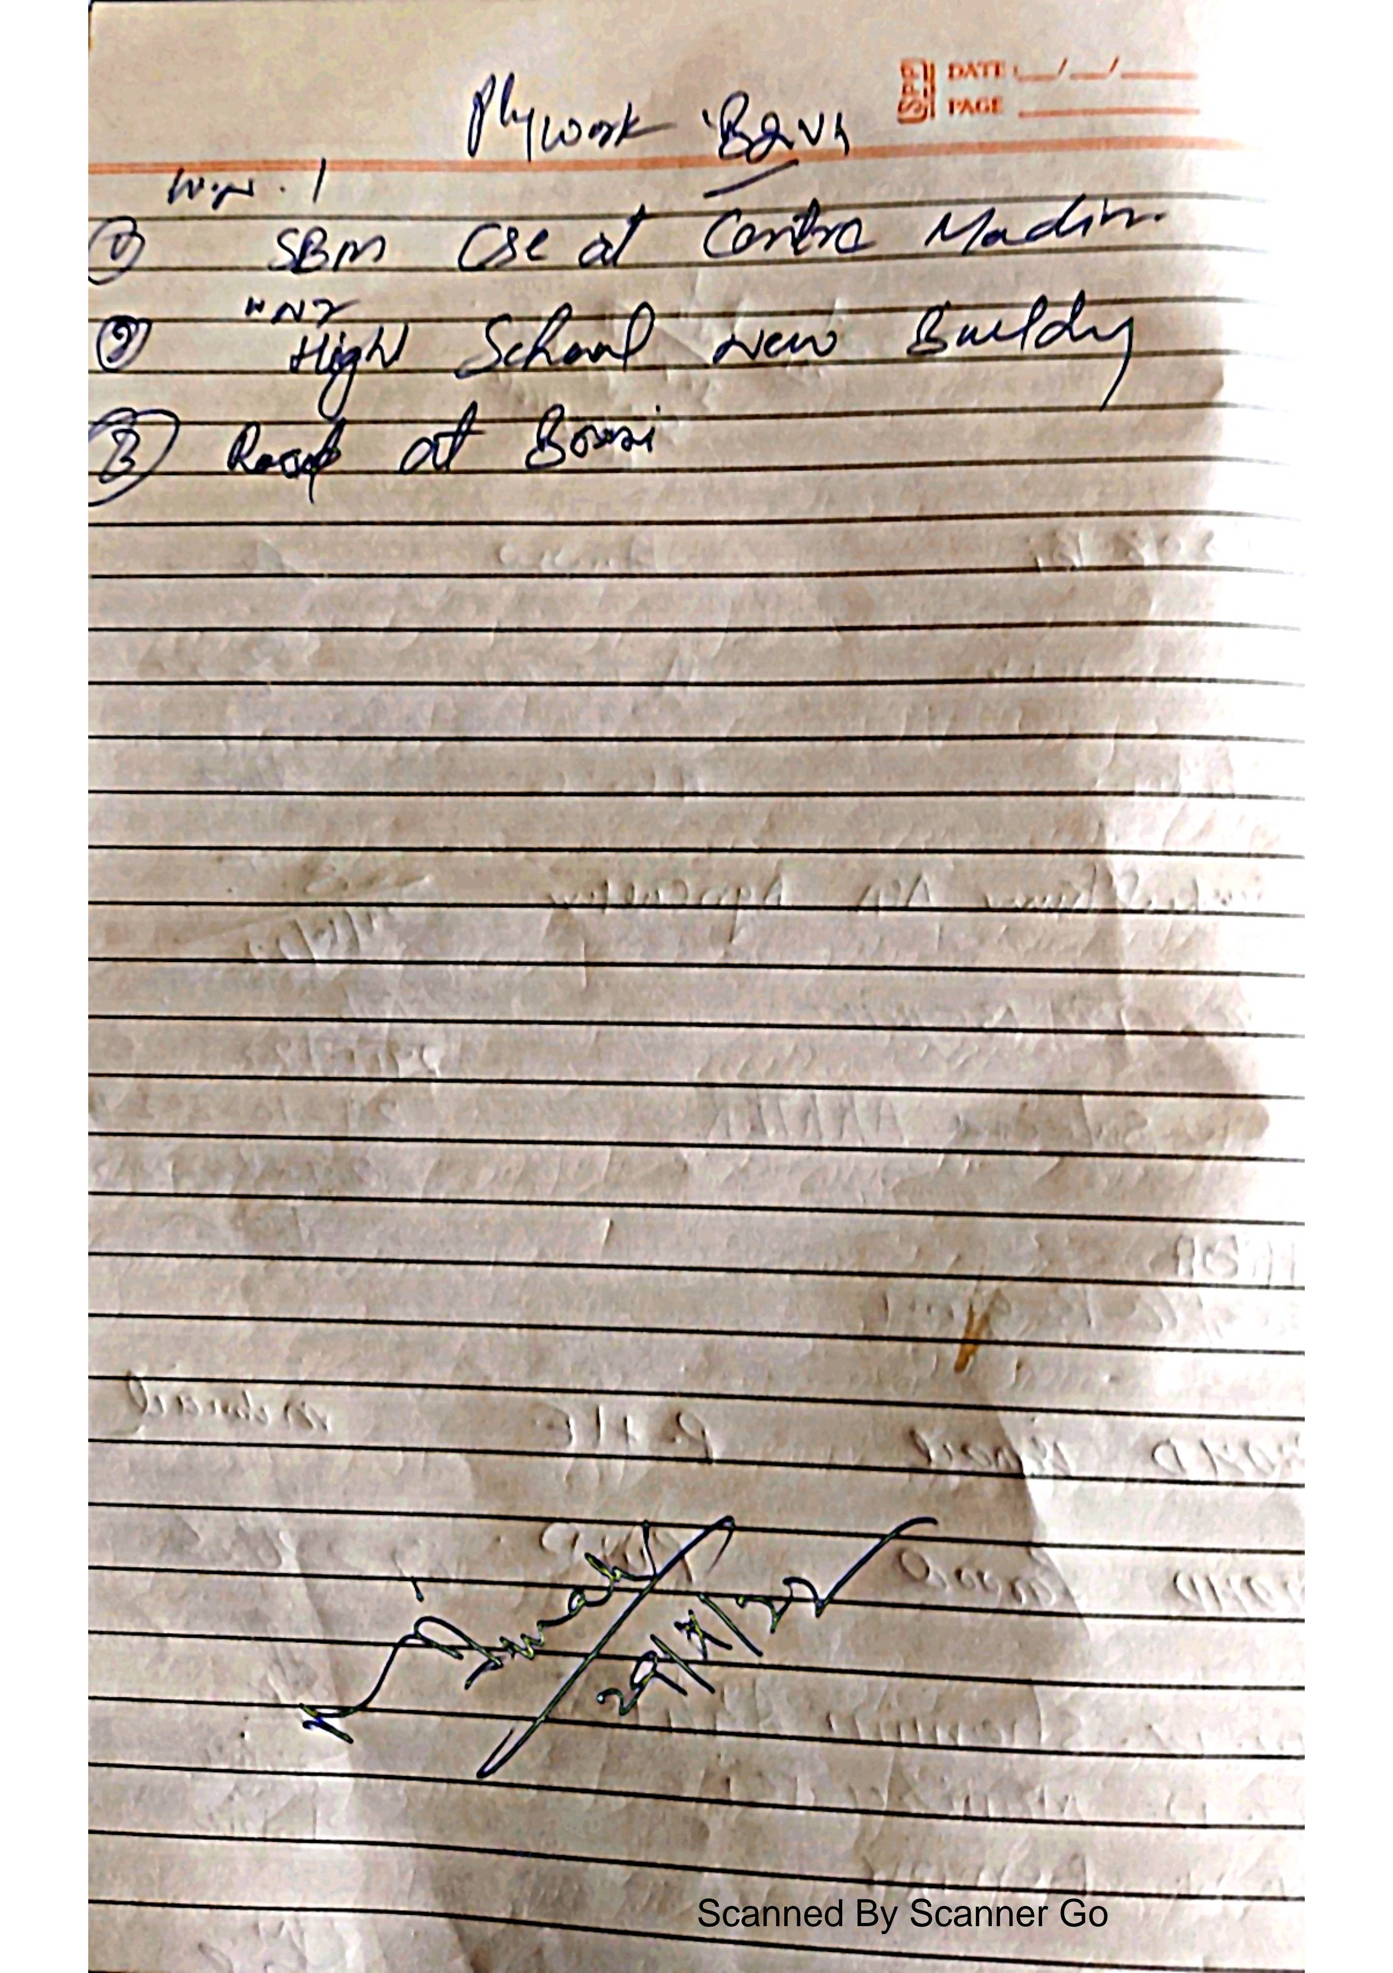

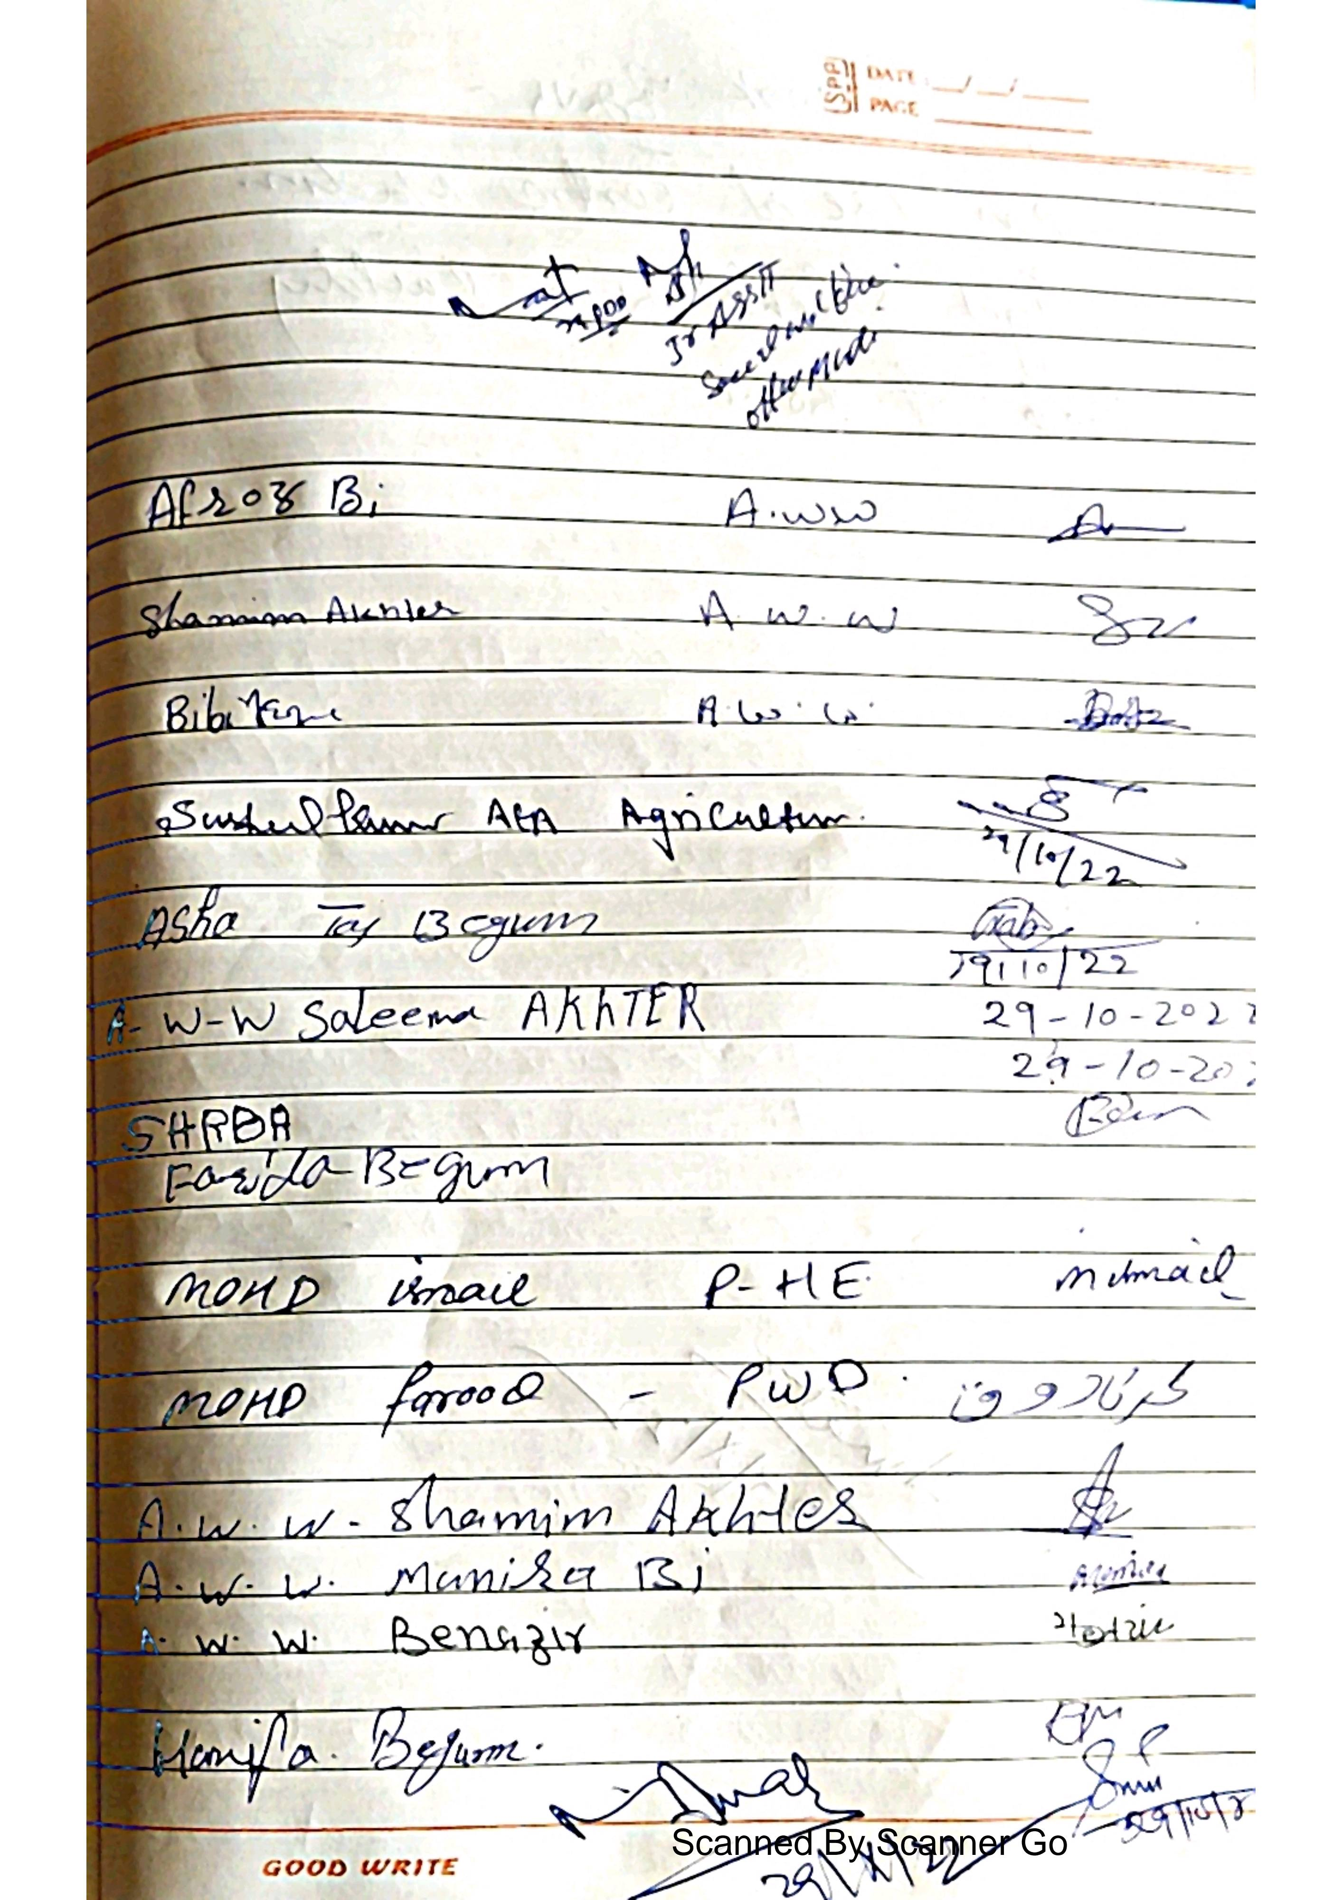

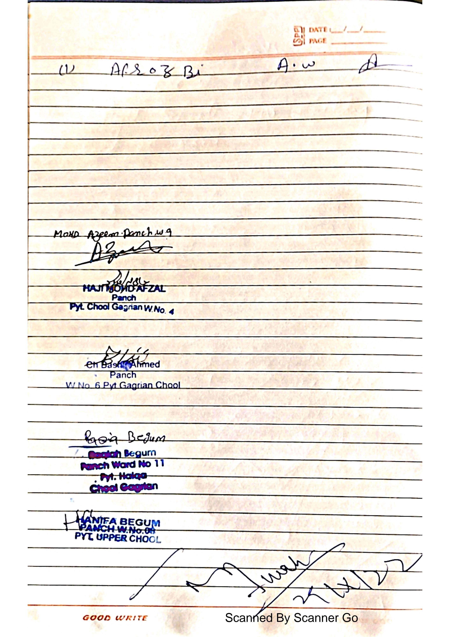



**DepartmentofRuralDevelompentandPanchayatiRaj**

**GovernmentofJammu &Kashmir**