4





**15TH OCTto3RD NOV,2022**

**KEYFEATURES**

• DeputyCommissionerstoleadtheinitiative

• RuraldevelopmentDepartmenttobethenodaldepartment

• PlanningDevelopment&MonitoringdepartmentandITtobethesupport departments

**ACTIONSANDTIMELINES**

|  |  |  |  |
| --- | --- | --- | --- |
| **ACTION** | **RESPONSIBILITY** | **LATESTBY** | **REMARKS** |
| **Janabhiyan** | Alldepartments | Oct15-26th | Goingon |
| **DeputationofSecttstaff/ HoDs** | GAD | Oct14 | Done |
| **DeploymentofStaffto Panchayatsandservingof ordersondeployedofficers** | DCs | Oct25 | DCswilldeployseniorlevelstaff fromthedistricts.Strictactionto betakenagainstabstentions.No exemptionstobegiven |
| **Trainingofdistricttrainors onB2V4** | RDD | Oct26 |  |
| **Trainingofvisitingofficers** | DCs | Oct27 |  |
| **FieldVisitstobecompleted by** | VisitingOfficers | Nov3 | DCstosuperviseandensurethat eachPanchayatisvisitedwithin theperiodspecified |
| **DataofB2V4tobe uploadedby** | VisitingOfficers | Nov10 | DCstosuperviseandensurethat dataofallPanchayatsisupload- edbythevisitingofficerwithin theperiodspecified |

**INSTRUCTIONSFORTHEVISITINGOFFICER(DAYWISE)**

|  |  |  |
| --- | --- | --- |
| **DATE** | **INSTRUCTIONS** | **ACTIONPOINTS** |
| **Day0** | Meetingwithdeputy commissionerandhis/her team | a. TakeprintoutsoffilledbookletsofB2V1,B2V2andB2V3from [www.jkpanchayat.in](http://www.jkpanchayat.in)  b.Alsotakeprintoutsofthesummarizedexcelsheetsofthe previousphasesfrom[www.jkpanchayat.in](http://www.jkpanchayat.in)  c. CollectATRsonissuesraisedduringprevious3phasesfromthe officeofDeputyCommissioner(Planningdeptt)  d.Takeprintsofblank 2bookletsofB2V4from[www.jkpanchayat.in](http://www.jkpanchayat.in)e.Takeplansfor2previousyearsandATRsfromtheplanningdeptt f. CompletetrainingsondifferentcomponentsofB2V4being  organizedbyrespectiveDeputyCommissioners  g.CollectListofnewworksstarted/ongoing/completedduringthe previousandcurrentFinancialyearunderthefollowingheads:  • PRIgrants  • DistrictPlan  • UTplan  • MGNREGA  • Otherschemesofotherdepartments  • Anyotherwork  h. Plans/beneficiarylists:  • MGNREGAdraftplandocumentfortheyear2022-23.  • ListofAwaas+beneficiariesalongwithIHHL Convergence  • Listofpensionbeneficiaries.  • ListofSHGs  • Listofagricultureschemebeneficiaries  i. Listsofbeneficiariesfor:  • Variouscertificates/benefitstobedistributedbythe visitingofficer.  • Anyotheractivitiesidentifiedbydifferentdepartments |

|  |  |  |  |
| --- | --- | --- | --- |
| **Day1** | Reachthevillage | 1. | Ensurethatallfrontlineworkersofdifferentdepttsarepresent. |
|  |  | 2. | Ensureexhibitionbydifferentdepts.aboutindividualbeneficiary schemes |
|  |  | 3. | InspectJKB/PSBcounters/outlets |
|  |  | 4. | Participate/ensureorganizationofsportsactivityinplayfield,talent hunt/culturalevent/youthactivity |
|  |  | 5. | GandhiKatha(suggesteddetailsuploadedonjkpanchayat.in) |
|  |  | 6. | Visitatleast2amritsarovarsandgetitsgeotaggedphotos |
|  |  | 7. | InspectKhidmat(CSC)CentresandcreateGenerateawarenesson  225schemesparticularlyG2CschemeslikeBEAMS,Janbhagidari, AapkiZaminAapkiNigrani,DigitalJ&K |
|  |  | 8. | Visitingofficershallalsoplanandconductpanchayatlevelconver- gencemeetingofalldepartments |
|  |  | 9. | CheckeffectivenessofCentrallysponsoredschemes |
|  |  | 10. | VisitandinspectallgovernmentestablishmentsincludingPHE, AWC,FPS,schools,etc |
|  |  | 11. | Attemptsaturationofdeliverableso JanAbhiyanandwherever deficienciesfound,leadadrivetoachievealldeliverables |
|  |  | 12. | Assesseffectivenessofsanitationcampaigninthepanchayat |
|  |  | 13. | Ensureselfemploymentactivitiesfor15youthperpanchayat |
|  |  | 14. | Identify20potentialcandidatesperpanchayatforHIMAYATtraining alongwiththetradeonwhichtheywanttraining |
|  |  | 15. | Whereverpossible,distributeemploymentlettersforpeopleselect- edundervariousgovernmentemployments |
|  |  | 16. | Intheevening,holdnormalmeetingwith seniorcitizens,govtem- ployeesincludingretiredemployees,exservicemen,youthclub,and any citizens ofthevillagewhoareenrolledincollege/university |
|  |  | 17. | OpendiscussiononNashaMuktAbhiyan |

Day2 Haveameetingwithall stakeholders-depttofficials andpanchayatmembers

1. Discussionontheandassesstheprogressofdifferentschemesrelating tothelocalizedSDGsprioritizedforthatvillageaspertheresolution passedby thatGramPanchayaton21st April22,onNationalPanchayti RajDay.

2. Sensitizevillage residentsaboutmyScheme”portal(myscheme.in) whichincludesinformationaboutalltheschemesbeingrunbyCen- tral/State/UTgovtacrossthecountry

3. Hold meeting of theBiodiversityManagementCommitteestodeliber- ateonissuespertaining toconservation of biodiversityandsustaina- bleutilizationof biologicalresources.

4. PrepareVillagedevelopmentplan,inconsultancywithGrampanchayat, discussitingramsabhaandgetitapproved.

5. Ensure saturationofsoilhealthcardandgoldenhealthcardunderGold- enHealthCardunderAyushmanBharat,

6. Ensuresaturation of OldAge PensionScheme

7. EnsureDomicileSaturation.

8. EnsureKCCSaturation

9. Ensure saturationoflandpassbooks

10. Ensureregistrationofvillagevendorsneededforanyscheme,onGEM

portal

11. Ensurepanchayatcontractors registration

12. EncouragePanchayatmembers forimportanceofplantationdrivein

PanchayatunderHarGaonHariyali

13. Ensure paintingondigitalJ&Kinpanchayatghars

14. Ensure paintingonpanchayatactivitesandCSSinpanchayatghars

15. Thevisiting officeshallchecknoof kindergarten andplayfields present inthepanchayat for kidsandstudents,iftheinfrastructure present inthesearegoodenough.

16. Holdmeeting withpanchayatmembers todiscussaboutcorruption menaceandstepsrequiredtomakeJ&Kcorruptionfree

17. Obtaina candidassessmentaboutperformanceofvariousdeptts in- cludingfairfeedbackaboutdiscrepanciesinfunctioning

18. Check thestatusof NashaMuktAbhiyanandreporting of drugad- dictstoDeputyCommissioner.

19. IdentifyTouristDestinations,Circuits,ThemeTreks,IdentifyHomestays, providesupportfortourismactivities throughVillageCooperative

20. OrganizeTalentHuntatPanchayatLevel

21. Conductsocialauditofatleast5worksunderfollowingschemes:

a. MGNREGA

b.PMAY

c. IHHLtoiletsandpayments d.CSCs

e.AMRITSAROVARS

22. Holda mahilasabha anda balsabhaandrecordproceedingsinthefor- matgiven

23. InauguratevillagehaatunderJKSRLM

24. Checkifyouthclubsareformedinthepanchayatandwhatactivities theyareengagedin

25. Organizea villagelevelculturaleventtoengagepanchayatmembers

26. SensitizeGPaboutE-kitabkoshaninitiativeofJ&KGovtforempowering youthsthrough onlinedigitalliteracy

**GENERALINSTRUCTIONS**

1. Thevisitingofficershallrefrainhimself/herselfgivingorofferinganycommitmentonbehalfofthe governmentandshalladoptanunbiasedattitudeinreportingissues.As faraspossible,his/her observation shouldbebasedona fairandanalytical viewemergingfromhis/herinteractioninthe village.

2. Heisgoingtothevillageasplanningofficer,notforsanctioninganyworksorformakinganycom- mitments.

3. Whilepreparingvillagedevelopmentplan,hehastoensurethat,demandsareprioritizedandre- flectedunderavailableschemes,wherevernecessarythelargerworksaretobereferredtoadminis- trativedepttunderCSS/UTplansunderintimationtoDCsandrestoftheworkstoDCsforreflecting itunderdistrict/CSS plans

4. His workshallbehardcoreplanningandauditandisnota PRexercise.

5. EveryDeputyCommissionerhastoensurethatatleastoneRDDofficial(ideallyPanchayatSecre- tary)ispresent ineverypanchayatwithrelevantpanchayatrecords,toensureconductofallactivi- tiesasplanned.Panchayatwiseorderneedstobeissuedinadvance.

6. Visitingofficershouldideallycarryhis/herlaptoptocompletethereportsatthepanchayatlevel itselfanduploadthefinalreport,duly signedbothbythesarpanchandbythevisitingofficeron [www.jkpanchayat.in](http://www.jkpanchayat.in)portal,beforetheyleavepanchayat.

7. Focus ofvisitareyouth,skills,self-employment,nashamukt,bhrashtracharmukt,Rozgaryukt J&K, besidestocarryforwardtheactivities duringJanAbhiyanandsaturatethem.

8. Inadditionattentionmaybegiventothefollowingareas a. MakefulluseofCentrallySponsoredSchemes

b.Saturationofindividualbeneficiaryschemes c. Self-employmentschemes

d.Banklinkedschemes-includingdepartmentalsubsidyschemes e.Empowermentandtransparencythrough digitalinitiatives

f. Effectivenessofgrassrootsmachinery–

i. Patwari,VLWpresent andavailable

ii. AvailablefundsutilizedinpublicinterestandasperGramSabharesolutions iii. Fairness ingovernance

iv. CSS/Individual beneficiaryschemesetc v. BrashtacharMuktJ&K

vi. BhaiMuktJ&K

vii. NashaMuktJ&K

9. ThePRImembers (Sarpanchs,Panchs,BDCChairperson)shallbeattheforefrontofallactivities and givendueimportanceandtheapproach shouldbetostrengthenthemandmakethemfeelem- powered.He/sheshallensurethattheBDCchairpersonandSarpanch/Panch arepresent atthetime ofinaugurationandceremonies.

10. Visitingofficershallnotleavethedistrictwithoutuploadingthereport,duly signedonthe**www. jkpanchayat.in**portal.EveryDeputyCommissionerhastoensurethat.

**A) DetailsofReportingOfficer:**

Name: **Mohd Bashir**

Designation: **ZEO Mandi**

Department/placeof posting:**Education/Zone Mandi**

MobileNo:9858696541

EmailID**:.mohdbashir1963@gmail.com**

HomeDistrict**:Poonch**

Datesof visit:**28/10/2022 to 29/10/2022**

**B) LocationaldetailsofPanchayat:(tobepre-filled,informationtobetakenfromtheprevious phasesbooklets/summarizedexcelsheetuploadedonjkpanchayat.in/b2v4.php)(tobevali- datedbythevisitingofficerandmissingdetailstobefilled)**

NameofthePanchayat: Gagrian B

LocalGovernmentDirectory(LGD)codeof thePanchayat: 239263

Nameof CDBlock:Mandi

NameofTehsil: Mandi

Nameof District: Poonch

**C) PanchayatProfile:**

No.ofrevenuevillagesinthePanchayat: 01 (One)

No.ofhamletsinthePanchayat: 09 ( Nine)

No.ofhouseholdsinthePanchayat: 710

Population(approx)of thePanchayat: 3410

**Part-II:**

(TobefilledupbytheVisitingOfficerduringhis/hertwodayvisittothePanchayat.AllFieldshavetobe

filledbytheVisitingOfficerbeforethebookletishandedovertotheDC

**FrontlineOfficers/OfficialswhowereassignedtothePanchayatfortheprogramme:**

|  |  |  |
| --- | --- | --- |
| Department | Name | Designation |
| Education | **Kashmiri shahnawaz** | **Teacher** |
| Agriculture | **Sushil Kumar** | **A.E.A** |
| RDD | **Mumtaz Ahmed** | **GRS** |
| RDD | **Zaheer Ahmed** | **T.A** |
| FCS& CAPD | **Khasim Raja** | **Saleman** |
| ICDS | **Razia Begum** | **A.W** |
| J&K Forest | **Showkat Hussain** | **Forest Guard** |
| Jal Shakti | **Shabir Ahmed** | **Lineman** |
| Social Welfare | **Mohd Ashraf** | **Junior Assistant** |
| J&K Bank Branch Sawjian | **Khursheed Ahmed** | **Branch Manager** |
| PDD | **Mukhtair Ahmed** | **Lineman** |
| Jal Shakti | **Mushtaq Ahmed** | **Lineman** |
| Health | **Shamim Ahmed** | **MMPHW**  **C.H office** |
| Health | **Zeeshan Hyder** | **C.H Office** |

|  |  |  |
| --- | --- | --- |
| Department | Name | Designation |
|  |  |  |
|  |  |  |
|  |  |  |
|  |  |  |
|  |  |  |
|  |  |  |
|  |  |  |
|  |  |  |
|  |  |  |
|  |  |  |
|  |  |  |
|  |  |  |
|  |  |  |
|  |  |  |
|  |  |  |

**DAY1-ACTIVITIES**

**AGENDA1:PANCHAYATASSETREGISTER**

**Infrastructure:**

1. PanchayatGharInfrastructure a. Govtbuilding/private -- (**Govt Building)**

b. New/needingrepairs--

**( New)**

2. Furniture(Y/N)--- ( Yes)

3. Computer/printer(Y/N)--- No

4. Internet(Y/N)—( No)

5. Telephone(Y/N)—(No)

6. Toilet(CSC/partofpanchayatghar)(Y/N)—(Yes)

7. Water(Y/N)---(No)

8. Electricity(Y/N)----(No)

9. Bankbranch(Y/N)---(No)

10. CSC(Y/N)--------Yes (under Construction)

11. Patwarkhana(Y/N)-----(No)

12. Villagehaat(Y/N)--------(No)

13. Playground(Y/N)-------(Yes)

14. School-

a. Kindergarten(Y/N)—(Yes)

b.Primary(Y/N)----(Yes)

c. Secondary(Y/N)-------(Yes)

d. College (Y/N)-------(NO)

e.University(Y/N)-----(No)

15. AnganwadiCentre(Y/N)—(Yes)

a. (govt/private)-------(Govt)

b.Totalchildrenenrolled---166

15. AmritSarovars–details,location,condition--------(Not Constructed)

16. Governmentoffices-details,whetherfunctionalornot

17. Rationshop(Y/N)—(No)

18. Placesoftourismimportance–names,littledetailsonhistorical/culturalimportance**—(Narian, Rangawar, Mangyana)**

19. Villageheritagesites/treks-names,littledetailson historical/culturalimportance

20. VLWOffice (Y/N)-(Yes)

21. PrimaryHealthcareCentre(Y/N),---(No)

22. ListofIncompleteBuildings-names,yearofconstruction:- **1. Dakbanglow Building incomplete at Gali Maidan, gagrian B due to dispute between forest and pyt deptt. (2005**)

2**. Community hall at Gali Maidan Gagrian B. (2022)**

**3.School Building At Burari Kundan, Gagrian B (2014)**

23. ListofUnderutilizedBuildings-names

**HWC Dhanna ( Health Dept) occupied by local inhabitant**.

**DAY1-ACTIVITIES**

**AGENDA2:**

**DIFFERENTINSTITUTIONS/INFRASTRUCTUREPROJECTSTOBEVISITED**

|  |  |  |
| --- | --- | --- |
| **AMRITSAROVARS** | **Visit,verify** | **COMMENTS** |
| KhidmatCentres | Create/Generateawarenesson225schemes particularlyG2CschemsAapkiZaminAapkiNigrani, Beams,Janbhagidari,DigitalJ&K | Not available at pyt gagrian B |
| JKB/PSBcounters/outlets | a)Statusofcounter b)Numberofvisitors | Not available at pyt Gagrian B |
| Incompletebuildings/pro- jects | Verify whetheridentificationandredistribution done | Dakbunglow building at Gali Maidan ( Diputed)  School Building At Burari Gundan ( Under Construction)  Community Hall ( Gali Maidan) under construction. |
| PDS | Visit,evaluate,onlinestatus | Not Available in Pancahayt |
| PHC | Visit-evaluate,statusofstaff,equipmentand quality | PHC is not available, only one HWC is available at Dhanna, Uripira |
| Youthclubs | Meet,interact,seeksuggestions | Intracted with youth club in the presence of BLO and made them aware about different schemes. |
| SHG | Meet,identifyproblems,seeksuggestions | Interacted and awareness about some schemes. |
| PMAY | Inspect,Inaugurate | PMAY house is inaugurated of Sh. Basher Ahmed S/o Ahad Lone ( Dhanna) |
| Myschool,mypride progress;schools-water, toilets,staff | Visit,checkforwater,electricity,sanitation,meet studentsandstaff | Visited in M/S kaint under “ My School My Pride”and interacted with staff and students. Water, Electricity situation was satisfactory. |
| SwachhSBM | Evaluate | Inspected SBM toilets at Moh. Kaint Gagrian, Ok |
| Panchayatplayground, Sportskitsdistribution Villagegames | Ensure,verify.Participateinatleastonegamein theplayground | Available but is in uneven surface condition, Sport kits distributed amongst the youth and took part in cricket and volleyball Games Carrom. |
| HarGaonHariyali, Planta- tiondrive | Evaluatestatus,feedback | Plantation drive conducted at Govt Middle School Gagrian centre, and people were made aware about aforestation and its benefits. |
| Villageculturalevent  Dangal/Haat/Mela | Participatein;ensurethatitisheld | Cultural event organized at AWC Uripura in the presence of sarpanch pyt Halqa Gagrian – B |
| Exhibitionofschemes | Ensurethateverydepartmentparticipatesand thatitcontinuesfortheentiredurationofB2V | Mr. Sushil Kumar from dept. of agriculture and mr. Tirlook Singh from dept of Animal Husbandary discussed about various schemes at pyt ghar gali maidan. |
| JalJeewanMission verifica- tion- WSS/JSD  Electricitysupply | Verify | Replacement of old water pipes to new. Electricity supply was running smoothly during the visit. |

**DAY1-ACTIVITIES**

**AGENDA3:SATURATEJANBHIYAN**

**DELIVERABLESANDRECORDDEFICIENCIESIFANY(INSERTDELIVERABLESLISTHEREASPERGADFORMAT**

**DAY1-ACTIVITIES**

**AGENDA4:**

**SELFEMPLOYMENTACTIVITIES**

EnsureSelf-employmentactivities foryouth,distributeemploymentlettersforpeopleselectedunder varioussocialschemes(15ISTHETARGETPERPANCHAYAT)

**Numberofcasesindifferentcategoriessanctioned: 17 Detailsofthebanksanctioningit: Jk Bank Sawjian.**

**Totalamountinvolved:35.00 lac**

**DAY1ACTIVITIES**

**AGENDA5**

Intheevening,holdinformalmeetings withseniorcitizens,govtemployees,retdemployees,youthclub andothercitizenswhoareenrolledoncollege/universityandhavediscussiononGandhiKatha,Nasha MuktAbhiyan,corruptionfreegovernance,doublingfarmersincomeandrecordtheproceedings

**DAY2**

a. NoofIndividualCompostPitsconstructed :- 0

b.NoofIndividualSoakPitsconstructed:-100

V. No.ofBiodiversitymanagementcommitteemeetingsheld---03

VI. IsthenameofSarpanchdisplayedoncitizeninformationboardsofallRD&PRschemes:Yes/No---(Yes)

VII. AreSarpanchsbeinginvolvedinstart/inaugurationofactivities:Yes/No----(Yes)

VIII. WhethersubjectshavebeenassignedbytheSarpanchtothePanchs:Yes/No-(Yes)

IX. Whethergrievancesredressalboxisinstalled:Yes/No-----(Yes)

X. NoofgrievancesreceivedpertainingtoPanchayatlevel:0 XI. NoofgrievancesdisposedofatPanchayatleve-- Nil

XII. WhethertheSarpanch/PanchayatSecretaryhavedigitalsignatures:Yes/No---(Yes)

XIII. WhetherallMGNREGA/14thFCpayments arebeingmadebySarpanchthrough DigitalSignature

Certificate(DSC):Yes/No-----(Yes)

------

**HUMAN RESOURCEAVAILABLEATTHEPANCHAYAT LEVEL:**

|  |  |  |  |  |
| --- | --- | --- | --- | --- |
| **SRNO.** | **DEPARTMENTWISESTAFF** | **NUMBERS** | | **NAMES** |
|  |  | SANCTIONED | ACTUAL |  |
|  | Ruraldevelopmentdepartment: BDO  JE GRS TA | 01  01 | 01  01 | Mumtaz Ahmed (GRS)  Sh. Zaheer Abas.( TA) |
|  | SCHOOLEDUCATION: TEACHER  HEADMASTER ANYOTHER | 28  0 | 26  0 |  |
|  | JAL JEEVAN: | 01 ( Supervisor)  04 ( Lineman) | 01  04 | Abdul Hamid ( Supervisor)  Shabir Ahmed ( Lineman)  Mushtaq Ahmed  Mohd Akram  Shahnawaz Ahmed |
|  | PDD: LINEMAN JE  ANYOTHER | 03  01 | 03  01 | Javid Ahmed ( J.E)  Shafi Ahmed ( Lineman)  Mukhtair Ahmed ( Lineman)  Dawood Ahmed (Lineman). |
|  | FOOD&CIVILSUPPLIES | 01( Lineman)  01( Weightman) | 01  01 | Waseem raja. |
|  | AGRICULTURE&ANIMALHUS- BANDARY | JAEO (01)  VP ( 01) | 01  Nil | Deputed Bagh Hussain |
|  | SOCIALWELFARE | ----- | -------- |  |
|  | HEALTH: ASHA ANM  AYUSHDOCTOR ALLOPATHICDOCTOR | 04  01  01  0 | 04  01  1  0  Nil | Dr. Zeeshan Hyder (C.H officer)  Shamim Ahmed ANM  Nazma Begum ( Asha)  Shamim Begum (Asha)  Zabaida Begum(Asha)  Sarba Beguam ( Asha) |
|  | ANYOTHERDEPARTMENT |  |  |  |

**DAY2-ACTIVITIES**

**AGENDANO.1**

DiscussionontheandassesstheprogressofdifferentschemesrelatingtothelocalizedSDGsprior-itizedforthatvillageaspertheresolutionpassedbythatGramPanchayaton21stApril22,onNational PanchayatiRajDay(Copyoftheresolutiontobetakenfrom[www.jkpanchayat.in](http://www.jkpanchayat.in)portalunderthelinkof GramSwarajMonth)

1. SDGs AGREED FORTHATVILLAGE,TOBEIMPLEMENTED BYMARCH2024:

2. STATUSOFWORKSUNDERTHEFOLLOWINGSCHEMES:

**1 Cleanandgreenvillage**

i.InitiativestakenbythePanchayatformanagingSolidandLiquidWaste (Yes) Soak Pits

ii. InitiativestakenbythePanchayatforusinggreensourcesoffuellikesolar,biogas

Not Available

iii. Hasmappingoflanduse,waterbodies,forest,slopes,wetlands,degradedforestwithintheGram

Panchayatbeendone?Yes/No.IfNo,reason,thereof (Yes)

iv. HastheClimateResiliencePlanbeendevelopedfortheGP?Yes/No------(No)

v. StepstakenbytheGramSabhaabouttheclimatechangemitigationfactorslikereducingenergy consumption,usageoffossilfuels,plastics,non-renewablebuildingmaterialsandalsotopromote measureslikeplantingoftrees,conservingforests,usageofgoodagriculturalpracticeslikedrip irrigation,waterconservationmeasuresandconservationofwetlands----(Yes).

vi. Whetherschoolshavestartedsegregatingwaste---Yes

vii. Whetherschoolshavetheirowncompost/soakagepitsforsolid/liquidwastemanagement------(No)

**2 Healthyvillage**

i) Aremeetings relatedtoVillageHealthandSanitationCommitteebeingheldregularly?-(Yes)

ii) DoalltheeligibleindividualsbeenprovidedtheGoldenCard?-----No

iii) ArealltheChildrenbeingimmunizedaspertheSchedulerecommendedbyGovt.ofIndia?-(Yes)

iv) ArealltheeligibleindividualsbeenvaccinatedagainstCOVID-19?—Yes

v) DoesGramPanchayatensurethatallpregnantwomenaregettingnecessaryprenatalcheckups?---(Yes)

vi) WhetherallthedeliverieswereInstitutionalizedorconductedbytrainedMidwives? institutionalized

**3 Watersufficientvillage**

i) DoalltheIHHsintheGramPanchayathavewaterpipelineconnections?----No

ii) WhetherGramPanchayathastakenstepsforgreywatermanagement.IfYespleasespecify

Yes

iii) DoalltheIHHsintheGramPanchayathavetoilets?--- Yes

iv) ArealltheIHHstoiletsfunctionalornot?-------Yes, functional

v) DoalltheSchools/Anganwadicentershavea toiletfacilityornot?------Yes

vi) Areallthetoiletsintheschools/Aaganwadifunctionalornot?-----Yes Functional

vii) WhetherGramPachachayatBhawanhasseparate toiletsforwomenornot?

--- No Under Construction.

**4 ChildFriendlyvillage**

i) Doallthechildrenundertheageof0-6yearsbeenenrolledintheAnganwadicentersforpre- schooling?Yes/NO--- Yes

ii) HowmanyBalSabha’swereorganizedintheGramPanchayat-------03------------

iii) WhethertheissuesraisedbyBalSabhaareaddressedduringtheGramSabha. Yes/NO--- Yes

iv) WhetherGramPanchayatistrackingthedatarelatedtodropoutchildrenandchildrenwithirregular attendance?Yes/NO.---- No

v) DoalltheschoolsundertheGramPanchayathaveseparate toiletsforgirlsandboys?Yes/No----No

**5 Villagewithgoodgovernance**

i) IsCSClocatedintheGramPanchayatBhawanornot?----Not

ii) IsthelistofbeneficiariesrelatedtotheSchemes/ProgramsdisplayedontheGrampanchayatwallor not?----Yes

iii) DoestheGramPanchayathasitsbuildingornot?----yes

iv) IstheGramPanchayatofficefunctionalornot?-----Yes

v) Aretheactivities approved undertheHalqaPanchayatDevelopmentPlandisplayedontheGram

Panchayatwallornot?--Yes

vi) IsSocialAuditofearlierSchemes/Programscarriedoutornot?-----Yes

**6 Povertyfreeandenhancedlivelihoodvillage**

1. HasGramPanchayatdevelopedanycriteria fortheidentificationofthepoor?Yes/Noifyesspecify--Yes

ii) HavealltheeligiblehouseholdsregisteredinPDSornot?---Yes

iii) HasGramPanchayatprovidedspaceforSelf-helpGroupsinPanchyatGharforholdingmeetings or not?---No

iv) HavealltheeligiblehouseholdsbeenregisteredforPensionornot?---No

v) HasGramPanchayatfacilitatedYouthforSkillEnhancementCoursesandPlacement?----No

vi) HasJobCardsbeendistributedtoalltheeligibleindividualsunderMGNREGA?----Yes

vii) HasGramPanchayatfacilitatedSHGsforBankAccountLinkages?----No

**7 Sociallysecuredvillage**

i) WhetherGramPanchayatismaintainingdatarelatedtoDifferentlyAbledPeople?----No

ii) IsGramPanchayatOffice DisabledFriendlyornot?-----No

iii) Areprovisionsfora separate BudgetundertheResourceEnvelopeforWomenandChildrenmadeor not?---No

iv) DoalltheSchools intheGramPanchayathavefacilitiesforDifferentlyAbledChildrenliketoilets, barrier-freeaccess,etc.,ornot?----No

v) Arealltheeligibleindividualsaregettingpensions,likeoldagepension,widowpension,etc?---No

vi) ArealltheeligiblehouseholdsgettingbenefitsfromIAYornot?

----No

**8 EngenderedDevelopmentinVillage**

i) HowmanyMahilaSabha’swereorganizedintheGramPanchayat-----03--------------

ii) WhetherSHGsfederationshavebeenprovidedspaceformeetings inthePanchayatBhawan(Yes/ No)---No

iii) WhetherGPshavetakenstepsforincreasingwomen’sparticipationinGramSabha(Yes/No)---Yes

iv) NumberofwomenbeneficiariesheadedhouseholdscoveredunderPDS

system……20…………………

v) Numberofbeneficiaries(outoftotaleligiblepopulation)receivingsocialprotectionbenefitsunder

PradhanMantriMatritvaVandanaYojana……05…………….

9 Self-sufficientinfrastructureinthevillage

i. WhetherGPhasa CommunityHallwithaccesstoelectricity,furniture,watersupply, toilet…**Community Hall is under Construction.**

ii. WhethertheDisastermanagementplanisavailableattheGPLevel(Yes/No)

iii. Whetherchild-friendlyparkwithrequiredfacilitiesisavailableinGP(Yes/No)

iv. WhethertheGPhaseasyaccesstoGodownforstorage(Yes/No)

v. Whetherstreetlightsareprovidedinpublicplacesforensuringsafety(Yes/No)

**DAY2ACTIVITIES**

**AGENDANO.2**

SensitizevillageresidentsaboutmyScheme”portal(myscheme.in)whichincludesinformationaboutall theschemesbeingrunbyCentral/State/UT govtacrossthecountry

*(SchemeMaterialavailablefromhttps://jkpanchayat.in/b2v4.php)*

**DAY2ACTIVITIES**

**AGENDANO.3**

HoldmeetingoftheBiodiversityManagementCommitteestodeliberateonissues pertainingtoconserva- tionofbiodiversityandsustainableutilizationofbiologicalresources.HeshouldcheckPeopleBiodiversity register(PBR)ofthatpanchayatandreviewifBiodiversityManagementCommittee constitutedforthat panchayatis holdingminimum4meetings inayearandmeeting onceinevery3months *(RoleofBMC availableathttps://jkpanchayat.in/b2v4.php)*

COMMITTEEMEMBERS

Mohd basher ( Chairman)

Mushtaq Ahmed ( Member)

Mumtaz Ahmed ( Member)

Bashir Ahmed ( Member)

Akber Mir ( Member)

Gh. Mohd Jan ( Member)

Mohd Shafi ( Member)

PRESENT---------07

BIODIVERSITYREGISTERPHOTOS

PAST 4MEETINGDETAILS-DATES,MINUTESPHOTOS

**DAY2ACTIVITIES**

**AGENDA4**

Visitingofficershallalsoplanandconductpanchayatlevelconvergencemeeting ofalldepartmentsand prepareVillagedevelopmentplanforvillage,inconsultancywithGrampanchayat,discussitingram sabhaandgetitapproved.

(GPDPformatavailableonhttps://jkpanchayat.in/b2v4.php)

**InadditionGPDPplanshallalsoinclude:**

▪ Touristplaceswhichneedtobedeveloped—Narian, Rangawa, Mangyana, Sari

▪ Specificproductwhichneedstobedeveloped--- Road Connectivity and tourist house

▪ Tourism-homestays—Should be constructed at Narian, Rangwar, Mongyana, Sari.

▪ 20candidatesfortrainingunderHimayatschemealongwithtradeinwhich training is to be given—1. Haron Ahmed (Masonary).

2. Shabir ahmed ( Masonry)

3. Sadam Hussain (Plumbring)

4. Mehraj Din ( Plumbering)

5. Dawood Ahmed (Electrical)

6. Jahangir Ahmed ( Driving)

7. Mohd Iqbal ( Carpentary)

8. Shabir Ahmed ( Masonry)

9. Ragoz Ahmed ( Carpentary)

10. Jahangir Ahmed (Masonry)

11.Dilbar Ahmed(Caroantry)

12. Mashooq Ahmed( Driving)

13 Ajmal Ahmed(Masonry)

14Himayat Ahmed ( Carpantry)

15. Niaz Ahmed (Driving)

**DAY2ACTIVITIES**

**AGENDA5**

Ensuresaturationoffollowingschemesandgivestatus:

|  |  |  |  |
| --- | --- | --- | --- |
| **NAMEOFTHESCHEME** | **TOTALELIGIBLE BENEFICIARIESIN THE VILLAGE** | **TOTALBENEFICIARIESWHO AVAILEDTHEBENEFITSOFTHESCHEME** | **REASONSFOR PENDENCY** |
| GoldenHealthCardunder  AyushmanBharat | 2024 | 1982 | New Birth 10  Out of State / Country-22  Issued finger-10 |
| Jananisurakshayojana | 22 | 16 | Other are awaited for delivery. |
| OLDAGEpension | 50 | 50 | N.A |
| Widowpension | 15 | 15 | N.A |
| Disabilitypension | 19 | 19 | N.A |
| Domicilecertificate | 2300 | 2000 | Rest under process and some have not applied. |
| Kisancreditcard | 163 | 114 | Beneficiaries have become over age and some have migrated to other places. |
| PMkisansammannidhi | 199 | 199 | As compared to B2V3 some beneficiaries have been removed by revenue deptt. Due to non availability of records. |

|  |  |  |  |
| --- | --- | --- | --- |
| Landpassbook | 12 | 12 | Rest under process |
| Registrationofvillageven- dorsonGEMportal | 0 | 0 | Not applied till now. |
| Registrationofvillagecon- tractorsonjktendersportal | 2 | 0 | Recently registered |
| Registrationofvillagecon- tractorsonPWDportal | 7 | 4 | GST not registered |
| Incompletebuildings/pro- jects | 3 | 0 | Dakbanglow at Gali Maidan Dispute between forest and Panchayat.  Community Hall ( Gali Maidan) under Construction.  P/s Burari Kundan |

**DAY2ACTIVITIES**

**AGENDA6**

**NASHAMUKTABHIYAN**

1. Whethergramsabharesolutionpassed---- Yes

2. Detailsofactivities conducted------ Awareness camp And Rally.

3. Whetherallactivities andGSresolutionuploadedonjkpanchayats.inportal---Yes

4. Howmanydrugaddictsinthevillage--- 0

5. WhetherreportedtotheDeputyCommissioner---- NA

6. Howmanyregisteredforrehabilitationundergovernmentprogramme

----NA

**DAY2ACTIVITIES**

**AGENDA7**

**SOCIALAUDIT**

Conductsocialauditofatleast5workseachunderfollowingschemes:

|  |  |  |  |  |  |  |
| --- | --- | --- | --- | --- | --- | --- |
| NAMEOFTHE SCHEME | DETAILSOFTHE WORKS | YEAROFWORK APPROVAL | AMOUNT APPROVED  FORTHEWORK | WHETHER  WORKEXECUTED SATISFACTORILY | GEO- TAGGED PHOTOS | ANY GRIEVANCE RECORDED RELATINGTOTHAT WORK |
| MGNREGA | B- Path drain/R/ wall Moh. Miran | 2021-22 | 1.50 | Yes | yes | No Grievance |
| PMAY | PMAY House of Bashir Ahmed S/o Ahmed Lone | 2021-22 | 1.50 lac | Yes | Yes | No Grievance |
| IHHL  UNDERSBM-G | SBM Ali Mohd S/o Habibullah R/o goprian | 2020-21 | 0.12 lac | Yes | Yes | No Grievance |
| CSCUNDER SBMG | Under Construction /Complete | 2021-22 | 1.80 | Under Construction/ Complete | Yes | Non availability of funds. |
| AMRIT SAROVARS | Not Available | Not Available | Not Available | Not Available | Not Available | Not Available |

**DAY2ACTIVITIES**

**AGENDA8**

**MAHILASABHA**

Totalwomeninthevillageabovetheageof18----654

Totalattended-----22

Proceedings:---During Mahila Sabha some women from local areas were present. New initially and different schemes related to PM package were discussed. They were made aware about self groups which play an important role in women empowerment.

*(Plinsertpointerstobediscussedthere–referpalliproceedings)*-----

**DAY2ACTIVITIES**

**AGENDA9**

**BALSABHA**

Holda balsabhaandrecordproceedings

Totalchildreninthevillageabovetheageof….. Totalattended

Proceedings:Bal Sabha was organized at AWC Uripura ahere some cultural activities was also organized in which some songs were sung by the children. The Sarpanch and Panches was also present during the Bal sabha.

*(Plinsertpointerstobediscussedthere–referpalliproceedings)*

Balance Diet.

Mal Nutrition.

Nutritional Food.

Proper Immunization.

Pulse Polio Vaccination.

**DAY2ACTIVITIES**

**AGENDA10**

**INAUGURATIONS**

|  |  |  |  |
| --- | --- | --- | --- |
| **SR NO.** | **ASSETS/ACTIVITIES INAUGRATED** | **STATUSOFTHEASSET/AC- TIVITIES(NUMBER,OTHER DETAILS)** | **GEO-TAGGED PHOTOS** |
|  | VILLAGEHAATunderJKSRLM (SUN- DAYMARKET) | Not Available | Not Available |
|  | PMAYhousesifanyreadyforinaugra- tion | PMAY house inaguratedof Mr. Bashir AhmedS/o Ahad Lone at village Dhonna Pyt Gagrian B | Yes |
|  | Swachhgramprojects-segregation shedsetc | Not Available | Not Available |
|  | Amritsarovars | Not Constructed | Not Constructed |
|  | Sportskits | Sports Kits , Cricket, Chess etc were distributed at Pyt ghar to youth. | Yes |
|  | Villageculturalevents | Organised at AWC Uripura | Yes |
|  | JJMassets/projects | Three Mohalla   1. Burmi Kundan 2. Upper Uripura 3. Satyali ( Facing Water) | Yes |
|  | Anyothertobeidentifiedatdistrict level | HWC ( scarcity of Health) occupied by a local inhabitant due to non payment of land compensation. | Yes |

**FOLLOWUPOF(B2V1,B2V2&B2V3):**

*(Prefilledexcelsheet tobetakenfromdistrictlevel/andalsotobedownloaded*

*from*[*www.jkpanchayat.in)*](http://www.jkpanchayat.in)

|  |  |  |  |
| --- | --- | --- | --- |
| S.NO. | Particulars | Actiontaken | Remarks# |
| I. UrgentPublicRequirements/Demands-B2V1 | | | |
| 1 Not Available | Not Available | Not Available | Not Available |
| 2 |  |  |  |
| 3 |  |  |  |
| 4 |  |  |  |
| 5 |  |  |  |
| 6 |  |  |  |
| 7 |  |  |  |
| II. UrgentPublicRequirements/Demands-B2V2 | | | |
| 1 | Road Sawjian to Gali Maidan Via Kainth, Wazli, centre gagrian | No Action Taken |  |
| 2 | Road from danna to uripura. | No Action Taken |  |
| 3 | Construction of Community Hall at Moh. Kainth. | Not Constructed |  |
| 4 | Medical Dispensary at Moh. Kainth.  Upgradation of | No Action Taken |  |
| 5 | Upgradation of Middle School Dhonna.& High School. | No Action Taken |  |
| 6 | Opening of ration Depot at Pyt Gagrian B. | No Action Taken |  |
| 7 | Installation of Mobile tower at Moh. Uripura. | No Action Taken |  |
| S.NO. | Particulars | Actiontaken | Remarks# |
| III. MajorProblems–B2V1 | | | |
| 1Not Available. | Not Available. | Not Available. | Not Available. |
| 2 |  |  |  |
| 3 |  |  |  |

|  |  |  |  |
| --- | --- | --- | --- |
| 4 |  |  |  |
| 5 |  |  |  |
| IV. MajorProblems-B2V2 | | | |
| 1 | Non Availability of road in Gagrian Centre, wazli, Uripura. | No action taken | No action taken |
| 2 | To evacuate Health dispancaryat Moh. Dhanna occupied by locals. | No action taken | No action taken |
| 3 | Upgradation of Govt. M/s Dhanna to High School. | No action taken | No action taken |
| 4 |  |  |  |
| 5 |  |  |  |
| V. MajorProblems-B2V3 | | | |
| 1 |  |  |  |
| 2 |  |  |  |
| 3 |  |  |  |
| 4 |  |  |  |
| 5 |  |  |  |
| VI. MajorComplaints-B2V1 | | | |
| 1 |  |  |  |
| 2 |  |  |  |
| 3 |  |  |  |
| VII. MajorComplaints-B2V2 | | | |
| 1 |  |  |  |
| 2 |  |  |  |
| 3 |  |  |  |
| VIII. MajorComplaints-B2V3 | | | |
| 1 | Construction of road from Mochi Hill to Gali Maidan via Wazli, Gagrian Centre. | No action Taken. |  |
| 2 | Construction of Road from Mojh. Dhanna to Uripura. | No action Taken. |  |
| 3 | Const. of community Hall at Moh. Kainth. | No action Taken. | Community Hall is Constructed at Gali Maidan near Pyt Ghar and is under Construction. |

**OVERALLPERCEPTIONOFFUCNTIONING OF GOVERNMENTDEPARTMENTS**

1. **BESTDEPARTMENT: RDD/ Education, ICDS.**

**2. LEASTRESPONSIVEDEPARTMENT: Jal Shakti.**

**GENERALASSESSMENTOFTHEVISTINGOFFICER**

|  |  |
| --- | --- |
| I | AnymajorcomplaintbroughttothenoticeoftheVisitingOfficer: Water Connectivity avoided in Moh. Burmi Kundan, Setyali. |
| II | Major/urgentpublicdemandsthatwas/werereflectedearlierbuthavenotbeenaddressedsofar:1. Road connectivity from Mochi Hill to Gali Maidan, Vian Kainth,Wazlu,Gagrian centre and Grang. |
| III | Overallassessmentofthevisitandsuggestions:  (Thevisitingofficertoensurethattheoverallassessmentisrecordedindetailsalongwithconcretesugges- tions):--- All schools are functioning very well and Anganwari centres are running satisfactory. The RDD and other construction works especially PMAY have been developed according to norms. |
| IV | OverallRatingofgovtfunctioningas givenbythePanchayat(Scaleof0to10):----OT |
| V | CertificatefromSarpanchthatthevisitingofficerhasstayedinthepanchayatfor2days |

**SignatureofSarpanch SignatureoftheVisitingOfficer**

**Name……………………… Name………………………**

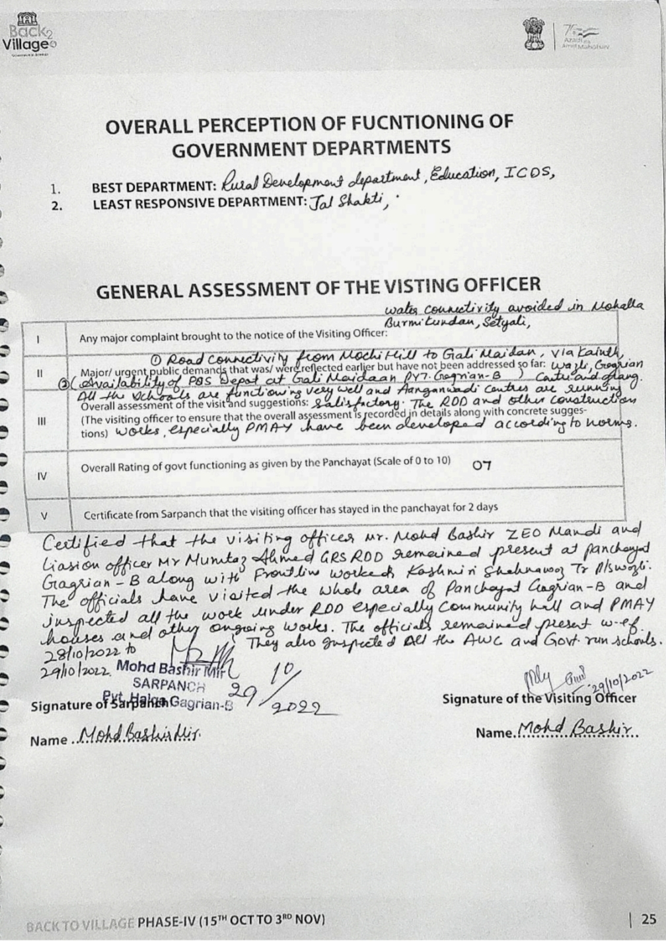

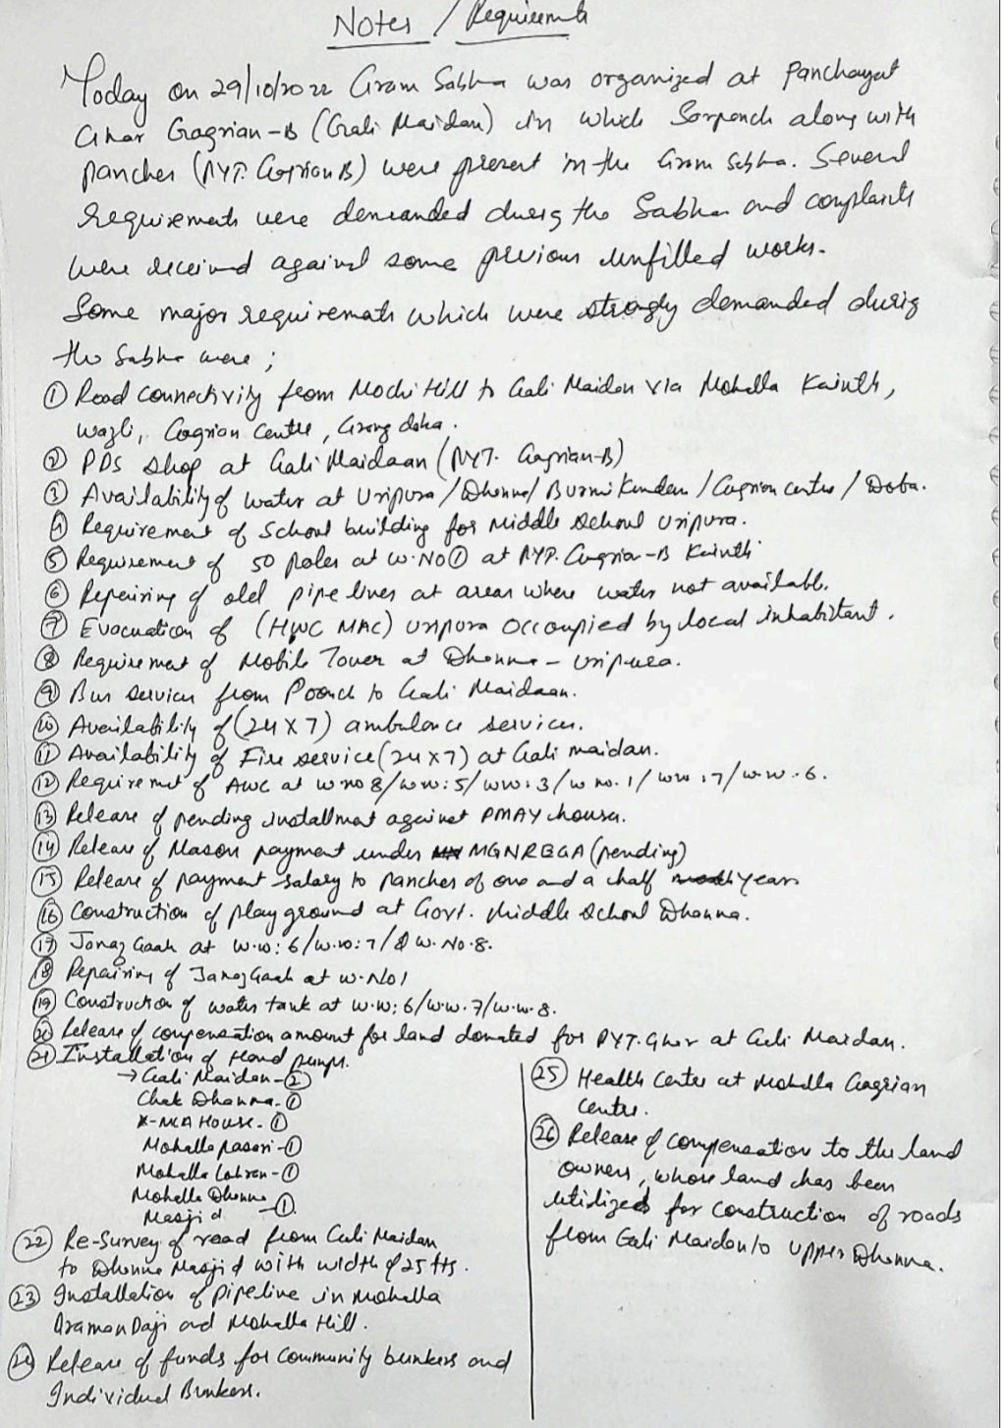

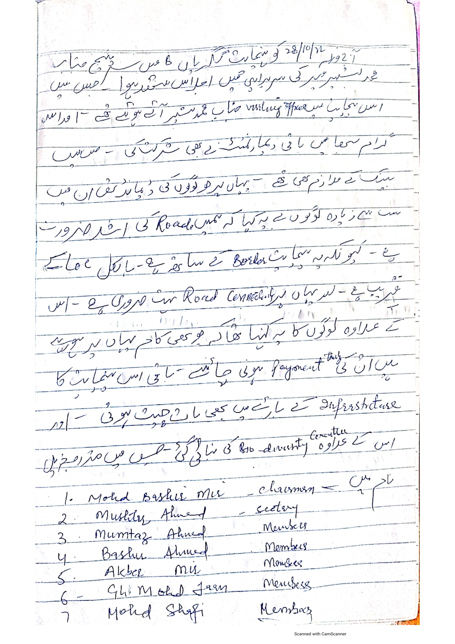

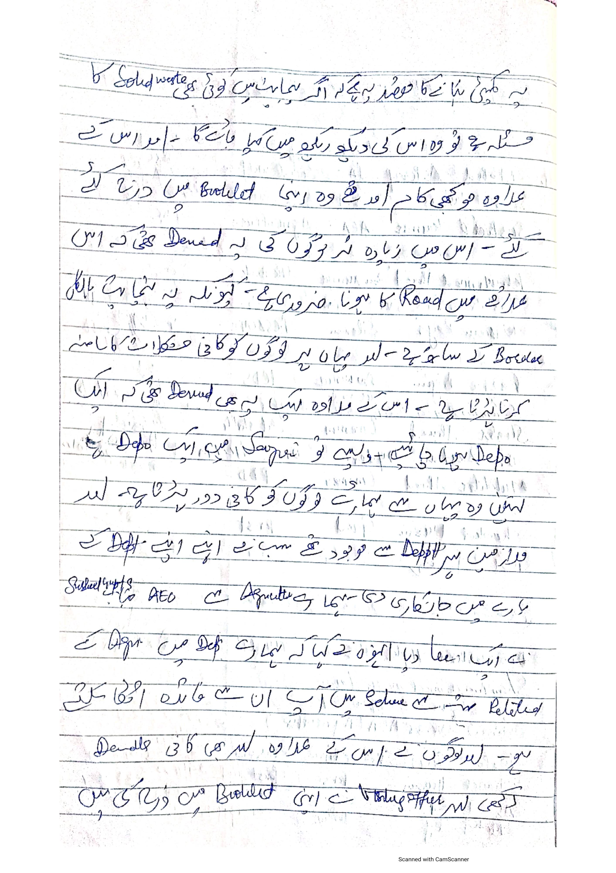

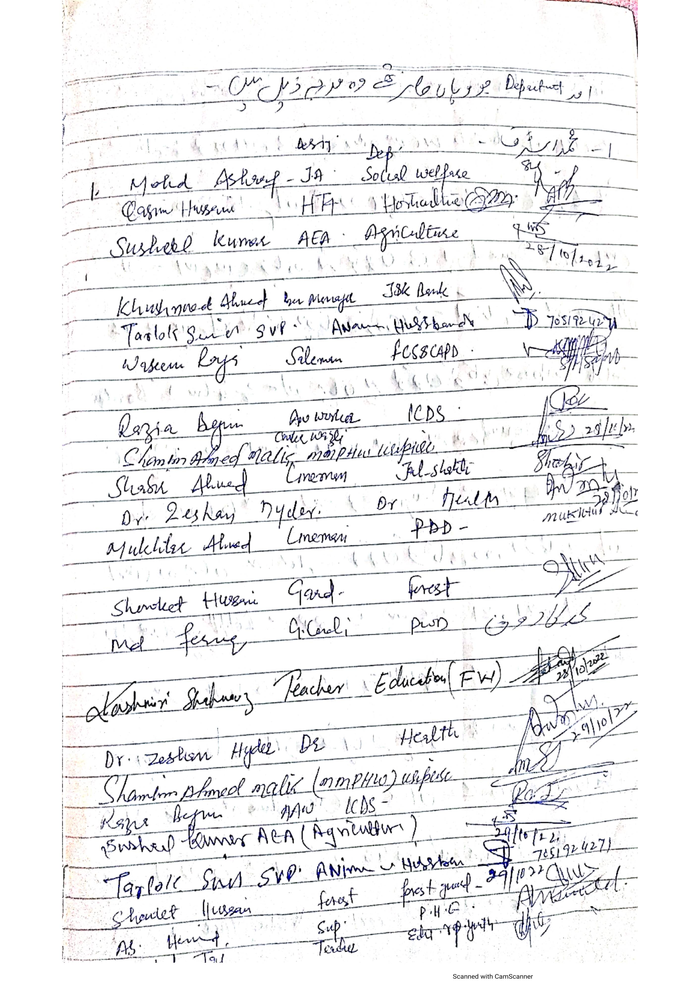

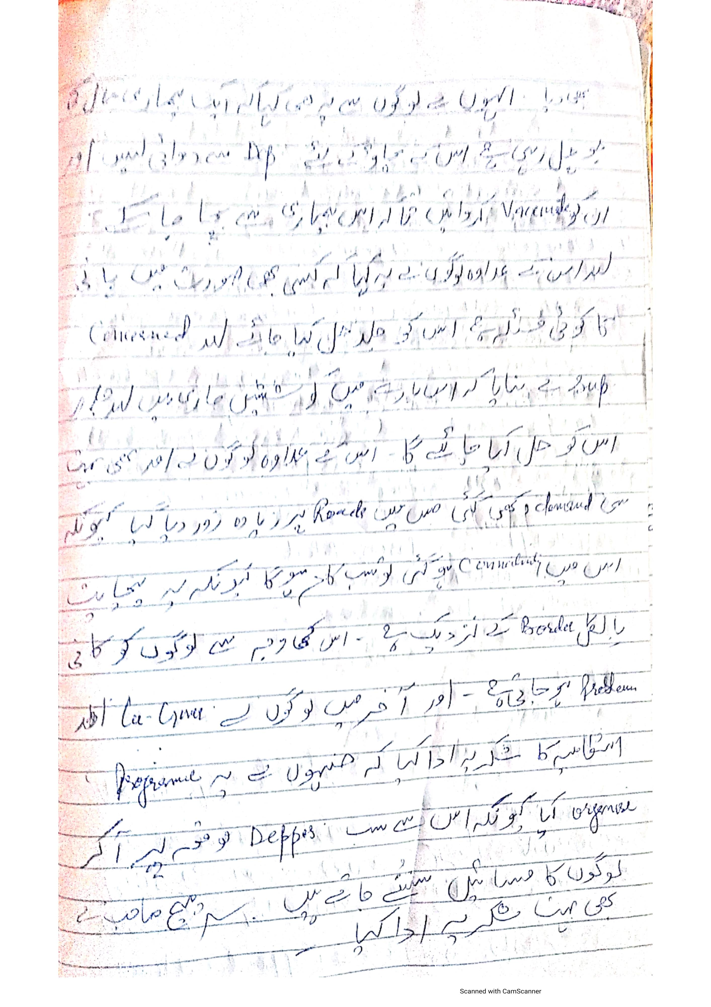

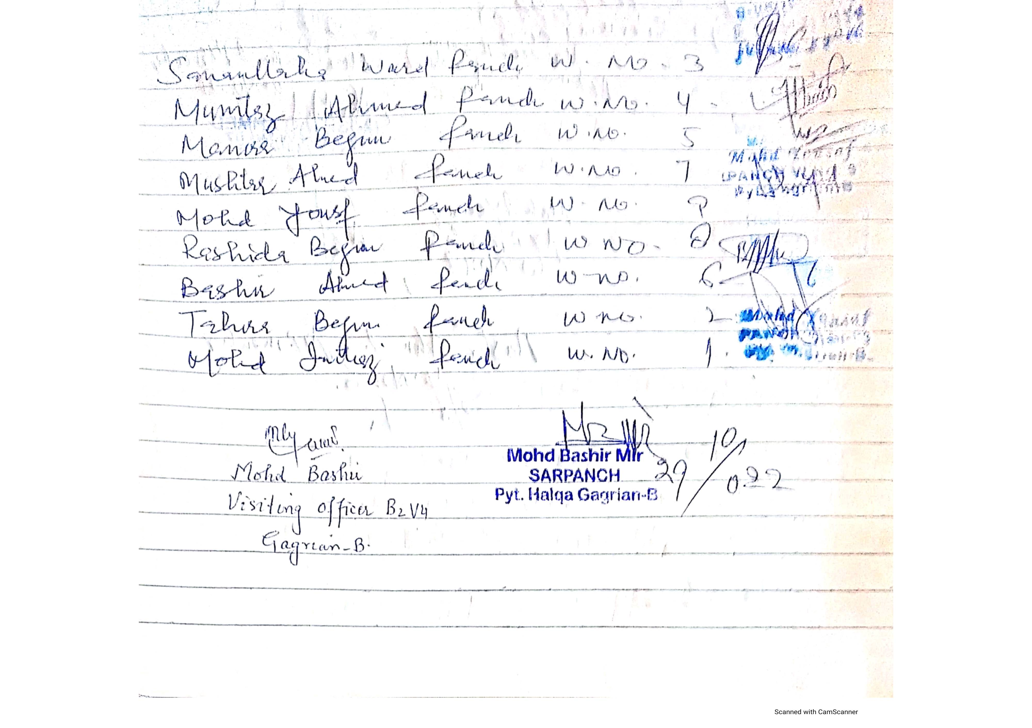



**DepartmentofRuralDevelompentandPanchayatiRaj**

**GovernmentofJammu &Kashmir**