4





**15TH OCT to 3RD NOV, 2022**

**KEY FEATURES**

• Deputy Commissioners to lead the initiative

• Rural development Department to be the nodal department

• Planning Development & Monitoring department and IT to be the support departments

**ACTIONS AND TIMELINES**

|  |  |  |  |
| --- | --- | --- | --- |
| **ACTION** | **RESPONSIBILITY** | **LATEST BY** | **REMARKS** |
| **Jan abhiyan** | All departments | Oct 15 -26th | Going on |
| **Deputation of Sectt staff/ HoDs** | GAD | Oct 14 | Done |
| **Deployment of Staff to Panchayats and serving of orders on deployed officers** | DCs | Oct 25 | DCs will deploy senior level staff from the districts. Strict action to be taken against abstentions. No exemptions to be given |
| **Training of district trainors on B2V4** | RDD | Oct 26 |  |
| **Training of visiting officers** | DCs | Oct 27 |  |
| **Field Visits to be completed by** | Visiting Officers | Nov 3 | DCs to supervise and ensure that each Panchayat is visited within the period specified |
| **Data of B2V4 to be uploaded by** | Visiting Officers | Nov 10 | DCs to supervise and ensure that data of all Panchayats is upload- ed by the visiting officer within the period specified |

**INSTRUCTIONS FOR THE VISITING OFFICER (DAY WISE)**

|  |  |  |
| --- | --- | --- |
| **DATE** | **INSTRUCTIONS** | **ACTION POINTS** |
| **Day 0** | Meeting with deputy commissioner and his/her team | a. Take print outs of filled booklets of B2V1, B2V2 and B2V3 from [www.jkpanchayat.in](http://www.jkpanchayat.in)  b. Also take print outs of the summarized excel sheets of the previous phases from [www.jkpanchayat.in](http://www.jkpanchayat.in)  c. Collect ATRs on issues raised during previous 3 phases from the office of Deputy Commissioner (Planning deptt)  d. Take prints of blank 2 booklets of B2V4 from [www.jkpanchayat.in](http://www.jkpanchayat.in) e. Take plans for 2 previous years and ATRs from the planning deptt f. Complete trainings on different components of B2V4 being  organized by respective Deputy Commissioners  g. Collect List of new works started/ ongoing/ completed during the previous and current Financial year under the following heads:  • PRI grants  • District Plan  • UT plan  • MGNREGA  • Other schemes of other departments  • Any other work  h. Plans/ beneficiary lists:  • MGNREGA draft plan document for the year 2022-23.  • List of Awaas+ beneficiaries alongwith IHHL Convergence  • List of pension beneficiaries.  • List of SHGs  • List of agriculture scheme beneficiaries  i. Lists of beneficiaries for:  • Various certificates/ benefits to be distributed by the visiting officer.  • Any other activities identified by different departments |

|  |  |  |  |
| --- | --- | --- | --- |
| **Day 1** | Reach the village | 1. | Ensure that all front line workers of different deptts are present. |
|  |  | 2. | Ensure exhibition by different depts. about individual beneficiary schemes |
|  |  | 3. | Inspect JKB/PSB counters/outlets |
|  |  | 4. | Participate/ensure organization of sports activity in playfield, talent hunt/cultural event/youth activity |
|  |  | 5. | Gandhi Katha (suggested details uploaded on jkpanchayat.in) |
|  |  | 6. | Visit atleast 2 amritsarovars and get its geo tagged photos |
|  |  | 7. | Inspect Khidmat (CSC) Centres and create Generate awareness on  225 schemes particularly G2C schemes like BEAMS, Janbhagidari, AapkiZaminAapkiNigrani, Digital J&K |
|  |  | 8. | Visiting officer shall also plan and conduct panchayat level conver- gence meeting of all departments |
|  |  | 9. | Check effectiveness of Centrally sponsored schemes |
|  |  | 10. | Visit and inspect all government establishments including PHE, AWC, FPS, schools, etc |
|  |  | 11. | Attempt saturation of deliverable so Jan Abhiyan and wherever deficiencies found, lead a drive to achieve all deliverables |
|  |  | 12. | Assess effectiveness of sanitation campaign in the panchayat |
|  |  | 13. | Ensure self employment activities for 15 youth per panchayat |
|  |  | 14. | Identify 20 potential candidates per panchayat for HIMAYAT training alongwith the trade on which they want training |
|  |  | 15. | Wherever possible, distribute employment letters for people select- ed under various government employments |
|  |  | 16. | In the evening, hold normal meeting with senior citizens, govt em- ployees including retired employees, ex servicemen, youth club, and any citizens of the village who are enrolled in college/university |
|  |  | 17. | Open discussion on Nasha Mukt Abhiyan |

Day2 Have a meeting with all stakeholders- deptt officials and panchayat members

1. Discussion on the and assess the progress of different schemes relating to the localized SDGs prioritized for that village as per the resolution passed by that Gram Panchayat on 21st April 22, on National Panchayti Raj Day.

2. Sensitize village residents about myScheme” portal (myscheme.in) which includes information about all the schemes being run by Cen- tral/ State/ UT govt across the country

3. Hold meeting of the Biodiversity Management Committees to deliber- ate on issues pertaining to conservation of biodiversity and sustaina- ble utilization of biological resources.

4. Prepare Village development plan, in consultancy with Gram panchayat, discuss it in gram sabha and get it approved.

5. Ensure saturation of soil health card and golden health card under Gold- en Health Card under Ayushman Bharat,

6. Ensure saturation of Old Age Pension Scheme

7. Ensure Domicile Saturation.

8. Ensure KCC Saturation

9. Ensure saturation of land pass books

10. Ensure registration of village vendors needed for any scheme, on GEM

portal

11. Ensure panchayat contractors registration

12. Encourage Panchayat members for importance of plantation drive in

Panchayat under Har Gaon Hariyali

13. Ensure painting on digital J&K in panchayat ghars

14. Ensure painting on panchayat activites and CSS in panchayat ghars

15. The visiting office shall check no of kindergarten and playfields present in the panchayat for kids and students, if the infrastructure present in these are good enough.

16. Hold meeting with panchayat members to discuss about corruption menace and steps required to make J&K corruption free

17. Obtain a candid assessment about performance of various deptts in- cluding fair feedback about discrepancies in functioning

18. Check the status of Nasha Mukt Abhiyan and reporting of drug ad- dicts to Deputy Commissioner.

19. Identify Tourist Destinations, Circuits, Theme Treks, Identify Homestays, provide support for tourism activities through Village Cooperative

20. Organize Talent Hunt at Panchayat Level

21. Conduct social audit of atleast 5 works under following schemes:

a. MGNREGA

b. PMAY

c. IHHL toilets and payments d. CSCs

e. AMRIT SAROVARS

22. Hold a mahilasabha and a balsabha and record proceedings in the for- mat given

23. Inaugurate village haat under JKSRLM

24. Check if youth clubs are formed in the panchayat and what activities they are engaged in

25. Organize a village level cultural event to engage panchayat members

26. Sensitize GP about E-kitab kosh an initiative of J&K Govt for empowering youths through online digital literacy

**GENERAL INSTRUCTIONS**

1. The visiting officer shall refrain himself/ herself giving or offering any commitment on behalf of the government and shall adopt an unbiased attitude in reporting issues. As far as possible, his/her observation should be based on a fair and analytical view emerging from his/her interaction in the village.

2. He is going to the village as planning officer, not for sanctioning any works or for making any com- mitments.

3. While preparing village development plan, he has to ensure that, demands are prioritized and re- flected under available schemes, wherever necessary the larger works are to be referred to adminis- trative deptt under CSS/UT plans under intimation to DCs and rest of the works to DCs for reflecting it under district/CSS plans

4. His work shall be hard core planning and audit and is not a PR exercise.

5. Every Deputy Commissioner has to ensure that atleast one RDD official (ideally Panchayat Secre- tary) is present in every panchayat with relevant panchayat records, to ensure conduct of all activi- ties as planned. Panchayat wise order needs to be issued in advance.

6. Visiting officer should ideally carry his/her laptop to complete the reports at the panchayat level itself and upload the final report, duly signed both by the sarpanch and by the visiting officer on [www.jkpanchayat.in](http://www.jkpanchayat.in) portal, before they leave panchayat.

7. Focus of visit are youth, skills, self-employment, nasha mukt, bhrashtrachar mukt, Rozgar yukt J&K, besides to carry forward the activities during Jan Abhiyan and saturate them.

8. In addition attention may be given to the following areas a. Make full use of Centrally Sponsored Schemes

b. Saturation of individual beneficiary schemes c. Self-employment schemes

d. Bank linked schemes- including departmental subsidy schemes e. Empowerment and transparency through digital initiatives

f. Effectiveness of grass roots machinery –

i. Patwari, VLW present and available

ii. Available funds utilized in public interest and as per Gram Sabha resolutions iii. Fairness in governance

iv. CSS/Individual beneficiary schemes etc v. BrashtacharMukt J&K

vi. Bhai Mukt J&K

vii. NashaMukt J&K

9. The PRI members (Sarpanchs, Panchs, BDC Chairperson) shall be at the forefront of all activities and given due importance and the approach should be to strengthen them and make them feel em- powered. He/she shall ensure that the BDC chairperson and Sarpanch/Panch are present at the time of inauguration and ceremonies.

10. Visiting officer shall not leave the district without uploading the report, duly signed on the **www. jkpanchayat.in** portal. Every Deputy Commissioner has to ensure that.

**A) Details of Reporting Officer:**

Name: Dr. Yougish Kumar Sharma

Designation: Assistant Professor

Department/ place of posting: HOD Philosophy/ Shri Krishan Chander Govt Degree College Poonch

Mobile No: 0-9622126888 / 0-7006469307

Email ID: yougish83@gmail.com

Home District: Poonch

Dates of visit: 2nd and 3rd of November 2022

**B) Locational details of Panchayat: (to be pre-filled, information to be taken from the previous phases booklets/summarized excel sheet uploaded on jkpanchayat.in/b2v4.php) (to be vali- dated by the visiting officer and missing details to be filled)**

Name of the Panchayat: Draba

Local Government Directory(LGD) code of the Panchayat: 7427

Name of CD Block: Buffliaz

Name of Tehsil: Surankote

Name of District: Poonch

**C) Panchayat Profile:**

No. of revenue villages in the Panchayat: 01

No. of hamlets in the Panchayat: 09

No. of households in the Panchayat: 595

Population (approx) of the Panchayat: 5400

**Part-II:**

(To be filled up by the Visiting Officer during his/her two day visit to the Panchayat. All Fields have to be

filled by the Visiting Officer before the booklet is handed over to the DC

**Frontline Officers/Officials who were assigned to the Panchayat for the programme:**

|  |  |  |
| --- | --- | --- |
| Department | Name | Designation |
| Agriculture | Ali Akber | JAEO |
| Horticulture | Shamsher Ahmed | HTG 2nd |
| Animal Husbandry | Dr. Ishtiaq Ahmed | VAS |
| Irrigation | Hadyat Khan | Junior Assistant |
| NRHM | Riya Verma | MLHP HWC Draba |
| Health | Zareena Begum | FMPHW HWC Draba |
| Health | Javaid Kouser | Asha HWC Draba |
| Anganwadi | Santosh Kumari | AWW Draba |
| AWW | Shamim Akhter |  |
|  |  |  |
|  |  |  |
|  |  |  |
|  |  |  |

**Details of absent employees vis-à-vis list furnished by the DC office:**

|  |  |  |
| --- | --- | --- |
| Department | Name | Designation |
|  |  |  |
|  |  |  |
|  |  |  |
|  |  |  |
|  |  |  |
|  |  |  |
|  |  |  |
|  |  |  |
|  |  |  |
|  |  |  |
|  |  |  |
|  |  |  |
|  |  |  |
|  |  |  |
|  |  |  |

**DAY 1- ACTIVITIES**

**AGENDA 1: PANCHAYAT ASSET REGISTER**

**Infrastructure:**

1. Panchayat Ghar Infrastructure a. Govt building/private - Govt. Building

b. New/needing repairs - New

2. Furniture (Y/N) - Yes

3. Computer/printer (Y/N) - No

4. Internet (Y/N) - No

5. Telephone (Y/N) - No

6. Toilet (CSC/part of panchayat ghar) (Y/N) - No

7. Water (Y/N) - No

8. Electricity (Y/N) - No

9. Bank branch (Y/N) - Yes

10. CSC (Y/N) - Yes

11. Patwarkhana (Y/N) - Yes

12. Village haat (Y/N) - No

13. Playground (Y/N) - No

14. School-

a. Kindergarten (Y/N) - Yes

b. Primary (Y/N) - Yes

c. Secondary (Y/N) - Yes

d. College (Y/N) -No

e. University (Y/N) - No

15. Anganwadi Centre (Y/N) - Yes

a. (govt/private) - Govt

b. Total children enrolled

15. Amrit Sarovars – details, location, condition : 33.6 * 74.31 near Tatta Pani , Well maintained

16. Government offices- details, whether functional or not : well functional

17. Ration shop (Y/N) _ Yes

18. Places of tourism importance – names, little details on historical/cultural importance : 1. Water fall near Tatta Pani 1 km from main road Draba 2. Seri Galla Panj Pandu Draba top

19. Village heritage sites/ treks- names, little details on historical/cultural importance : Govt MS Draba established by Maharaja Baldev Singh 1931

20. VLW Office (Y/N) -Yes

21. Primary Healthcare Centre (Y/N), - No

22. List of Incomplete Buildings- names, year of construction - PS Machakki, PS Bari Barian, PS Manda, PMAY houses under construction

23. List of Underutilized Buildings- names

- Nil

**DAY 1-ACTIVITIES**

**AGENDA 2:**

**DIFFERENT INSTITUTIONS/INFRASTRUCTURE PROJECTS TO BE VISITED**

|  |  |  |
| --- | --- | --- |
| **AMRIT SAROVARS** | **Visit, verify** | **COMMENTS** |
| Khidmat Centres | Create /Generate awareness on 225 schemes particularly G2C schems Aapki Zamin Aapki Nigrani, Beams, Janbhagidari, Digital J&K | Visited and discusssed the Govt sponsored schemes (as mentioned) |
| JKB/PSB counters/outlets | a) Status of counter b) Number of visitors | Branch of J&K Bank  250 |
| Incomplete buildings/pro- jects | Verify whether identification and redistribution done | Identified incomplete projects and informed the concerned authorities |
| PDS | Visit, evaluate, online status | Visited,working,biometric based |
| PHC | Visit- evaluate, status of staff, equipment and quality | Visited Health and wellness centre which is very far for the locality and not well equipped |
| Youth clubs | Meet, interact, seek suggestions | Conducted meeting and took note of their suggestion |
| SHG | Meet, identify problems, seek suggestions | Conducted meeting and took note of their demands |
| PMAY | Inspect, Inaugurate | Inspected and inaugurated many houses under PMAY |
| My school, my pride progress; schools- water, toilets, staff | Visit, check for water, electricity, sanitation, meet students and staff | Visited many schools- Lack of infrastructure-toilets, electricity, poor building conditions etc |
| Swachh SBM | Evaluate | Work in progress |
| Panchayat play ground, Sports kits distribution Village games | Ensure, verify. Participate in at least one game in the playground | No playground in the village. Demand for playground and children park |
| Har Gaon Hariyali, Planta- tion drive | Evaluate status, feedback | Natural forests are available in the village side. Trees alsoplanted under plantation drive |
| Village cultural event  Dangal/ Haat/Mela | Participate in; ensure that it is held | Cultural events are organised in the schools regularly |
| Exhibition of schemes | Ensure that every department participates and that it continues for the entire duration of B2V | All departments are advised to display their schemes before general public and create awaeeness |
| Jal Jeewan Mission verifica- tion- WSS/JSD  Electricity supply | Verify | Immediate requirement of repair and restoration of water pipeline/ demand for transformes 08 and poles |

**DAY 1 - ACTIVITIES**

**AGENDA 3: SATURATE JAN BHIYAN**

**DELIVERABLES AND RECORD DEFICIENCIES IF ANY (INSERT DELIVERABLES LIST HERE AS PER GAD FORMAT**

|  |  |  |  |
| --- | --- | --- | --- |
| Department | Daily deliverables | Achievements | Remarks |
| Social Welfare | Pension- Old age  Disabled  Widow | 91/161  11/20  5/15 | Re identification required |
| Revenue | Domicile issued  Land passbook isued  Inheritance mutation | 4000/5000  15/595  Data not available | Under process |
| School education | Total schools (9) | Impoverished condition | Require renovation, upgradation |
| Agriculture | KCC issued  PM Kisan  Soil Health Card | 436/436  281/281  320 people eligible | Under process |
| Health | Golden cards  PHC  Free checkups  Wellness centre | 3500/5400  Not present  Occassional  Functional | Under process  Urgent requirement  Not well equipped and poor infrastructure |
| RDD | MGNREGA  PMAY  Rural HAAT | Max works executed under this scheme  40/300  Not established | Exclusion error  No suitable site identified |

**DAY 1- ACTIVITIES**

**AGENDA 4:**

**SELF EMPLOYMENT ACTIVITIES**

Ensure Self-employment activities for youth, distribute employment letters for people selected under various social schemes (15 IS THE TARGET PER PANCHAYAT): Annexure 1

Annexure 7, Annexure 9 (Himayat)

**Number of cases in different categories : 27 sanctioned : Details of the bank sanctioning it : J&k Bank Draba**

**Total amount involved : 52 lacs**

**DAY 1 ACTIVITIES**

**AGENDA 5**

In the evening, hold informal meetings with senior citizens , govt employees, retd employees, youth club and other citizens who are enrolled on college/university and have discussion on Gandhi Katha, Nasha Mukt Abhiyan, corruption free governance, doubling farmers income and record the proceedings

**DAY 2**

a. No of Individual Compost Pits constructed : 07

b. No of Individual Soak Pits constructed :220

V. No.ofBiodiversity management committee meetingsheld: 1

VI. IsthenameofSarpanchdisplayedoncitizeninformationboardsofallRD&PRschemes:Yes/No - Yes

VII. AreSarpanchsbeinginvolvedinstart/inaugurationofactivities:Yes/No - Yes

VIII. Whethersubjectshavebeenassignedbythe Sarpanchtothe Panchs:Yes/No -Yes

IX. Whethergrievancesredressalboxisinstalled:Yes/No -Yes

X. NoofgrievancesreceivedpertainingtoPanchayatlevel: 15

XI. NoofgrievancesdisposedofatPanchayatlevel: 15

XII. Whetherthe Sarpanch/PanchayatSecretaryhavedigitalsignatures:Yes/No - Yes

XIII. Whether all MGNREGA/ 14th FC payments are being made by Sarpanch through Digital Signature

Certificate (DSC): Yes/ No

- No (still pending)

Meeting with youth club- Annexure 5, Meeting with ex serviceman - Annexure 6, Meeting with senior citizens- Annexure 8

**HUMAN RESOURCE AVAILABLE AT THE PANCHAYAT LEVEL:**

|  |  |  |  |  |
| --- | --- | --- | --- | --- |
| **SR NO.** | **DEPARTMENT WISE STAFF** | **NUMBERS** | | **NAMES** |
|  |  | SANCTIONED | ACTUAL |  |
|  | Rural development department: BDO  JE GRS TA | 01  01  01  01 | 01  01  01  01 | Mohd Ibrahim  Abdul Qayoom (Add. Charge)  Rafaqat Hussain  Abdul Qayoom |
|  | SCHOOL EDUCATION: TEACHER  HEAD MASTER ANY OTHER | 34  03  18 | 34  03  18 |  |
|  | JAL JEEVAN: | 09 | 06 | 01- Arun Bakshi  05- Contractual |
|  | PDD: LINEMAN JE  ANY OTHER | 06  01  01 | 06  01  01 | 01- Permanent Sadeeq Bhat  05-Contarctual  01-Mohd Isaq  01- Meter reader |
|  | FOOD & CIVIL SUPPLIES | 01 | 01 | Jameel Ahmed Khan |
|  | AGRICULTURE & ANIMAL HUS- BANDARY | 01 | 01 | Ali Akber |
|  | SOCIAL WELFARE | nil | nil | nil |
|  | HEALTH: ASHA ANM  AYUSH DOCTOR ALLOPATHIC DOCTOR | 05  04  02  01  nil | 04  04  02  01  nil |  |
|  | ANY OTHER DEPARTMENT | 01 | 01 | Dr Rahul sharma ( Sheep Husbandry) |

**DAY 2-ACTIVITIES**

**AGENDA NO.1**

Discussion on the and assess the progress of different schemes relating to the localized SDGs prior- itized for that village as per the resolution passed by that Gram Panchayat on 21st April 22, on National Panchayati Raj Day (Copy of the resolution to be taken from [www.jkpanchayat.in](http://www.jkpanchayat.in) portal under the link of Gram Swaraj Month)

1. SDGs AGREED FOR THAT VILLAGE, TO BE IMPLEMENTED BY MARCH2024:

2. STATUS OF WORKS UNDER THE FOLLOWING SCHEMES:

**1 Clean and green village**

i. Initiatives taken by the Panchayat for managing Solid and Liquid Waste Yes

ii. Initiatives taken by the Panchayat for using green sources of fuel like solar, biogas _ Yes

iii. Has mapping of land use, water bodies, forest, slopes, wet lands, degraded forest within the Gram

Panchayat been done? Yes/No. If No, reason, thereof Yes

iv. Has the Climate Resilience Plan been developed for the GP? Yes /No - No

v. Steps taken by the Gram Sabha about the climate change mitigation factors like reducing energy consumption, usage of fossil fuels, plastics, non-renewable building materials and also to promote measures like planting of trees, conserving forests, usage of good agricultural practices like drip irrigation, water conservation measures and conservation of wetlands. - Yes

vi. Whether schools have started segregating waste - Yes

vii. Whether schools have their own compost/soakage pits for solid/liquid waste management - No

**2 Healthy village**

i) Are meetings related to Village Health and Sanitation Committee being held regularly? Yes

ii) Do all the eligible individuals been provided the Golden Card? No

iii) Are all the Children being immunized as per the Schedule recommended by Govt. of India? Yes

iv) Are all the eligible individuals been vaccinated against COVID-19? Yes

v) Does Gram Panchayat ensure that all pregnant women are getting necessary prenatal checkups? - Yes

vi) Whether all the deliveries were Institutionalized or conducted by trained Midwives? - Yes

**3 Water sufficient village**

i) Do all the IHHs in the Gram Panchayat have water pipeline connections? Yes

ii) Whether Gram Panchayat has taken steps for grey water management. If Yes please specify - No

iii) Do all the IHHs in the Gram Panchayat have toilets? No

iv) Are all the IHHs toilets functional or not? Yes

v) Do all the Schools/Anganwadi centers have a toilet facility or not? Not

vi) Are all the toilets in the schools/Aaganwadi functional or not? Not

vii) Whether Gram Pachachayat Bhawan has separate toilets for women or not? Not

**4 Child Friendly village**

i) Do all the children under the age of 0-6 years been enrolled in the Anganwadi centers for pre- schooling? Yes/NO - Yes

ii) How many Bal Sabha’s were organized in the Gram Panchayat------03 (Three in two days)-------------

iii) Whether the issues raised by Bal Sabha are addressed during the Gram Sabha. Yes/NO -Yes

iv) Whether Gram Panchayat is tracking the data related to dropout children and children with irregular attendance? Yes/NO. - Yes

v) Do all the schools under the Gram Panchayat have separate toilets for girls and boys? Yes/No - No

**5 Village with good governance**

i) Is CSC located in the Gram Panchayat Bhawan or not? Yes

ii) Is the list of beneficiaries related to the Schemes/Programs displayed on the Gram panchayat wall or not? Yes

iii) Does the Gram Panchayat has its building or not? Yes

iv) Is the Gram Panchayat office functional or not? Yes

v) Are the activities approved under the Halqa Panchayat Development Plan displayed on the Gram

Panchayat wall or not? Yes

vi) Is Social Audit of earlier Schemes/Programs carried out or not? Yes

**6 Poverty free and enhanced livelihood village**

i) Has Gram Panchayat developed any criteria for the identification of the poor? Yes/No if yes specify - Yes socio-economic caste census

ii) Have all the eligible households registered in PDS or not? Yes

iii) Has Gram Panchayat provided space for Self-help Groups in PanchyatGhar for holding meetings or not? Yes

iv) Have all the eligible households been registered for Pension or not? No

v) Has Gram Panchayat facilitated Youth for Skill Enhancement Courses and Placement? Yes

vi) Has Job Cards been distributed to all the eligible individuals under MGNREGA? Yes

vii) Has Gram Panchayat facilitated SHGs for Bank Account Linkages? Yes

**7 Socially secured village**

i) Whether Gram Panchayat is maintaining data related to Differently Abled People? Yes

ii) Is Gram Panchayat Office Disabled Friendly or not? Yes

iii) Are provisions for a separate Budget under the Resource Envelope for Women and Children made or not? No

iv) Do all the Schools in the Gram Panchayat have facilities for Differently Abled Children like toilets, barrier-free access, etc., or not? No

v) Are all the eligible individuals are getting pensions, like old age pension, widow pension, etc? No

vi) Are all the eligible households getting benefits from IAY or not? No

**8 Engendered Development in Village**

i) How many Mahila Sabha’s were organized in the Gram Panchayat-----02 in two days--------------

ii) Whether SHGs federations have been provided space for meetings in the Panchayat Bhawan (Yes/ No) - Yes

iii) Whether GPs have taken steps for increasing women’s participation in Gram Sabha(Yes/No) - Yes

iv) Number of women beneficiaries headed households covered under PDS

system…………30……………

v) Number of beneficiaries (out of total eligible population) receiving social protection benefits under

Pradhan Mantri Matritva Vandana Yojana………42………….

9 Self-sufficient infrastructure in the village

i. Whether GP has a Community Hall with access to electricity, furniture, water supply, toilet………………Nil……….

ii. Whether the Disaster management plan is available at the GP Level (Yes/No) - No

iii. Whether child-friendly park with required facilities is available in GP (Yes/No) - No

iv. Whether the GP has easy access to Godown for storage (Yes/No) - No

v. Whether street lights are provided in public places for ensuring safety (Yes/No) - No

**DAY 2 ACTIVITIES**

**AGENDA NO.2**

Sensitize village residents about myScheme” portal (myscheme.in) which includes information about all the schemes being run by Central/ State/ UT govt across the country

*(Scheme Material available from https://jkpanchayat.in/b2v4.php)*

**DAY 2 ACTIVITIES**

**AGENDA NO.3**

Hold meeting of the Biodiversity Management Committees to deliberate on issues pertaining to conserva- tion of biodiversity and sustainable utilization of biological resources. He should check People Biodiversity register (PBR) of that panchayat and review if Biodiversity Management Committee constituted for that panchayat is holding minimum 4 meetings in a year and meeting once in every 3 months *(Role of BMC available at https://jkpanchayat.in/b2v4.php)*

COMMITTEE MEMBERS PRESENT

BIODIVERSITY REGISTER PHOTOS

PAST 4 MEETING DETAILS- DATES, MINUTES PHOTOS

**DAY 2 ACTIVITIES**

**AGENDA 4**

Visiting officer shall also plan and conduct panchayat level convergence meeting of all departments and prepare Village development plan for village, in consultancy with Gram panchayat, discuss it in gram sabha and get it approved. : GPDP has already prepared and submitted to higher authorities by Gram Panchayat. Some additional works are proposed in Annexure 2, 2 (a) (Attached)

(GPDP format available on https://jkpanchayat.in/b2v4.php)

**In addition GPDP plan shall also include :**

▪ Tourist places which need to be developed : Water fall, Panj Pandu top Draba, Savni top

▪ Specific product which needs to be developed : Walnuts, apricots

▪ Tourism- home stays : No

▪ 20 candidates for training under Himayat scheme alongwith trade in which training is to be given: Yes

**DAY 2 ACTIVITIES**

**AGENDA 5**

Ensure saturation of following schemes and give status:

|  |  |  |  |
| --- | --- | --- | --- |
| **NAME OF THE SCHEME** | **TOTAL ELIGIBLE BENEFICIARIES IN THE VILLAGE** | **TOTAL BENEFICIARIES WHO AVAILED THE BENEFITS OF THE SCHEME** | **REASONS FOR PENDENCY** |
| Golden Health Card under  Ayushman Bharat | 5400 | 3500 | work in progress |
| Janani suraksha yojana | 104 | 104 | - |
| OLD AGE pension | 160 | 91 | work in progress |
| Widow pension | 15 | 05 | Files submitted |
| Disability pension | 20 | 11 | - |
| Domicile certificate | 5400 | 4000 | - |
| Kisan credit card | 436 | 436 | - |
| PM kisan sammannidhi | 281 | 281 | - |

|  |  |  |  |
| --- | --- | --- | --- |
| Land pass book | 595 | 18 | work in progress |
| Registration of village ven- dors on GEM portal | nil | nil | nil |
| Registration of village con- tractors on jktenders portal | 13 | 13 | - |
| Registration of village con- tractors on PWD portal | 05 | 05 | - |
| Incomplete buildings/pro- jects | 12 | 12 | - |

**DAY 2 ACTIVITIES**

**AGENDA 6**

**NASHA MUKT ABHIYAN**

1. Whether gram sabha resolution passed - Yes

2. Details of activities conducted - Pledge/conducted awareness programmes

3. Whether all activities and GS resolution uploaded on jkpanchayats.in portal - Yes

4. How many drug addicts in the village - Nil

5. Whether reported to the Deputy Commissioner

6. How many registered for rehabilitation under government programme

- Nil

**DAY 2 ACTIVITIES**

**AGENDA 7**

**SOCIAL AUDIT**

Conduct social audit of atleast 5 works each under following schemes:

|  |  |  |  |  |  |  |
| --- | --- | --- | --- | --- | --- | --- |
| NAME OF THE SCHEME | DETAILS OF THE WORKS | YEAR OF WORK APPROVAL | AMOUNT APPROVED  FOR THE WORK | WHETHER  WORK EXECUTED SATISFACTORILY | GEO- TAGGED PHOTOS | ANY GRIEVANCE RECORDED RELATING TO THAT WORK |
| MGNREGA | Amrit sarovar | 2021-22 | 2.00 lacs | yes | yes | no |
| PMAY | Mohd. Aslam | 2021-22 | 1.50 lacs | yes | yes | no |
| IHHL  UNDER SBM-G | Mohd Zabir | 2022-23 | 12 thousand | yes | yes | no |
| CSC UNDER SBMG | N/A | N/A | N/A | N/a | N/A | N/A |
| AMRIT SAROVARS | Amrit Sarovar ward 8 | 2022-23 | 2.00 lacs | yes | yes | no |

**DAY 2 ACTIVITIES**

**AGENDA 8**

**MAHILA SABHA : Annexure 3**

Total women in the village above the age of 18 : approx 1800

Total attended : 45

Proceedings: Children park, seperate public transport for women, women higher education

*(Pl insert pointers to be discussed there – refer palli proceedings) Annexure 3 ( copy enclosed)*

**DAY 2 ACTIVITIES**

**AGENDA 9**

**BAL SABHA : Annexure 4**

Hold a balsabha and record proceedings : Yes

Total children in the village above the age of : Below 14 yrs = Approx 600

….. Total attended : 30

Proceedings: Playground, children park, music teacher Annexure 4 (copy enclosed)

*(Pl insert pointers to be discussed there – refer palli proceedings)*

**DAY 2 ACTIVITIES**

**AGENDA 10**

**INAUGURATIONS**

|  |  |  |  |
| --- | --- | --- | --- |
| **SR NO.** | **ASSETS /ACTIVITIES INAUGRATED** | **STATUS OF THE ASSET/AC- TIVITIES (NUMBER, OTHER DETAILS)** | **GEO-TAGGED PHOTOS** |
|  | VILLAGE HAAT under JKSRLM (SUN- DAY MARKET) | N/A | N/A |
|  | PMAY houses if any ready for inaugra- tion | Yes | Yes |
|  | Swachh gram projects- segregation sheds etc | No | No |
|  | Amrit sarovars | Yes well maintained | Yes |
|  | Sports kits | Yes  Distributed by Sarpanch & visiting officer |  |
|  | Village cultural events | Yes at GHS Draba | Yes |
|  | JJM assets/projects | Under tendering | N/A |
|  | Any other to be identified at district level ( Culvert near Tatta Pani Majid0 | Newly built inaugurated by Visiting officer and sarpanch | Yes |

**FOLLOW UP OF (B2V1, B2V2 & B2V3):**

*(Pre filled excel sheet to be taken from district level/ and also to be downloaded*

*from [www.jkpanchayat.in)](http://www.jkpanchayat.in)*

|  |  |  |  |
| --- | --- | --- | --- |
| S.NO. | Particulars | Action taken | Remarks # |
| I. Urgent Public Requirements/ Demands- B2V1 | | | |
| 1 | Demand for PHC-Wellness centre inaccessible | Nil |  |
| 2 | Demand for ambulance | Nil |  |
| 3 | Upgradation and renovation of BMS Draba | Nil |  |
| 4 | Upgradation of GHS to HSS | Nil |  |
| 5 |  |  |  |
| 6 |  |  |  |
| 7 |  |  |  |
| II. Urgent Public Requirements/ Demands- B2V2 | | | |
| 1 | Upgradation of GHS to Higher secondary | Nil |  |
| 2 | Transport inaccesibility especially for girls | nil |  |
| 3 | Road from Tatta Pani to Kala Phalayan | Nil |  |
| 4 | Road from Kala qureshiyan to Manjakote | Nil |  |
| 5 | Road from Malik market to Galyote | Nil |  |
| 6 | Demand for lift irrigation and portable water | Nil |  |
| 7 | Demand to get rid of menace of wild pigs and monkeys | Nil |  |
| S.NO. | Particulars | Action taken | Remarks # |
| III. Major Problems – B2V1 | | | |
| 1 | Unavailability of link roads | Nil |  |
| 2 | Way/path for cremation ground | nil |  |
| 3 | Irrigation facility and food control | nil |  |

Urgent demand under B2V3:

MGNREGA work liability still standing and work done during the year 2017-18, 2018-19, and the amount stands at Rs 15 lacs

Upgradation of medical centre in the panchayat

Requirement of transformer in ward no 3,6&9

Requirement of seperate electric panel for panchayat

Regularisation of GRS employyes

|  |  |  |  |
| --- | --- | --- | --- |
| 4 | Rusted and broken pipeline | nil |  |
| 5 | Main road from Draba to Jaranwali gali | nil |  |
| IV. Major Problems- B2V2 | | | |
| 1 | Public transport facility b/w Draba and Surankote | nil |  |
| 2 | No bustand  Need of transformer at ward no 2, 3 and 9 | nil |  |
| 3 | Demand foremployment in construction ward of local power projects | nil |  |
| 4 |  |  |  |
| 5 |  |  |  |
| V. Major Problems- B2V3 | | | |
| 1 | Issue of road connectivity | nil |  |
| 2 | Requirement of cremation ground | nil |  |
| 3 | Renovation of water pipeline | nil |  |
| 4 | Requirement of poles and transformers | nil |  |
| 5 | Requirement of electric panel for panchayat | nil |  |
| VI. Major Complaints- B2V1 | | | |
| 1 | Separate panel for Draba | Nil |  |
| 2 | Impoverished school building not renovated | nil |  |
| 3 |  |  |  |
| VII. Major Complaints- B2V2 | | | |
| 1 | Seperate panel at R/STN Draba not provided by PDD | nil |  |
| 2 | Public transport is virtually non existant | nil |  |
| 3 | A population of 3700 is served by only 1 health sub centre | nil |  |
| VIII. Major Complaints- B2V3 | | | |
| 1 | Unavailabilty of cremation ground/shamshan ghat | nil |  |
| 2 | Inadequate no. of transformers and poles | nil |  |
| 3 | Non existant transport facility b/w draba and surankote | nil |  |

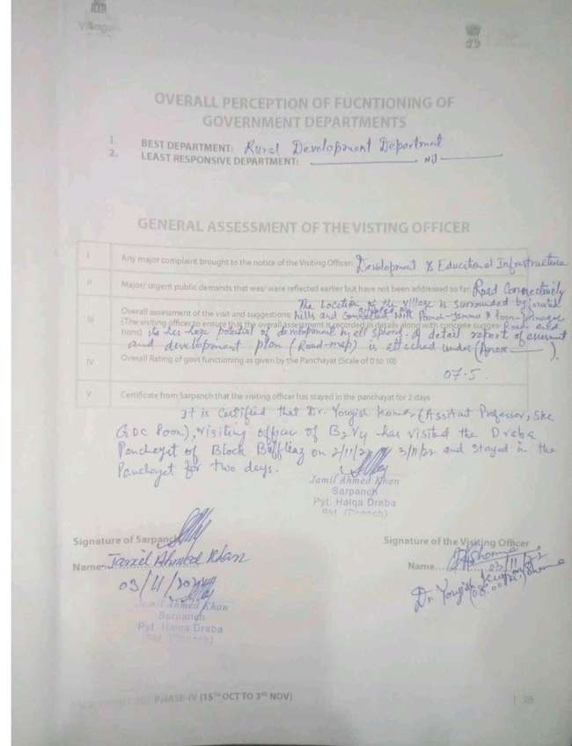

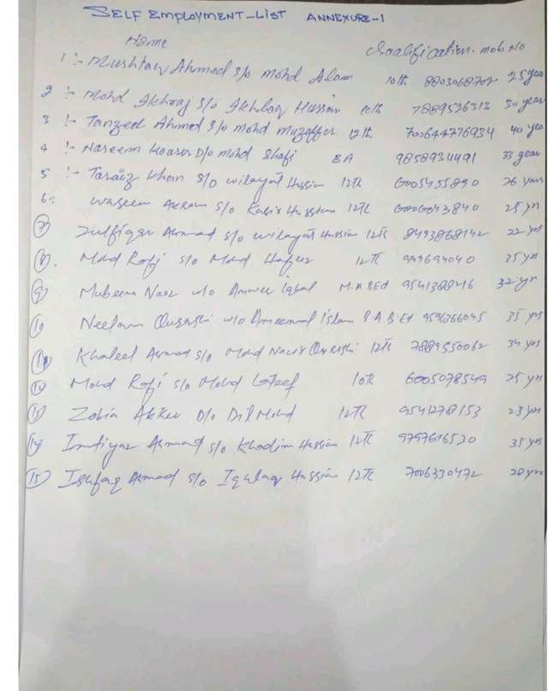

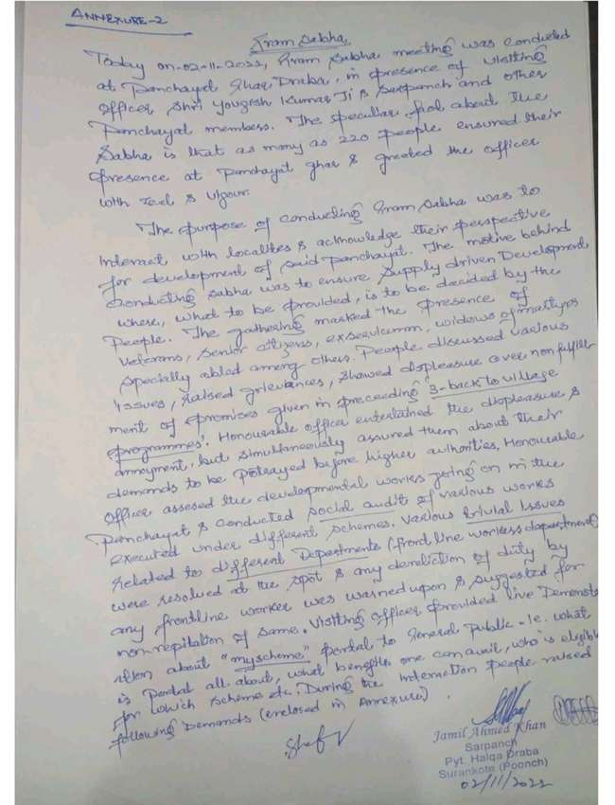



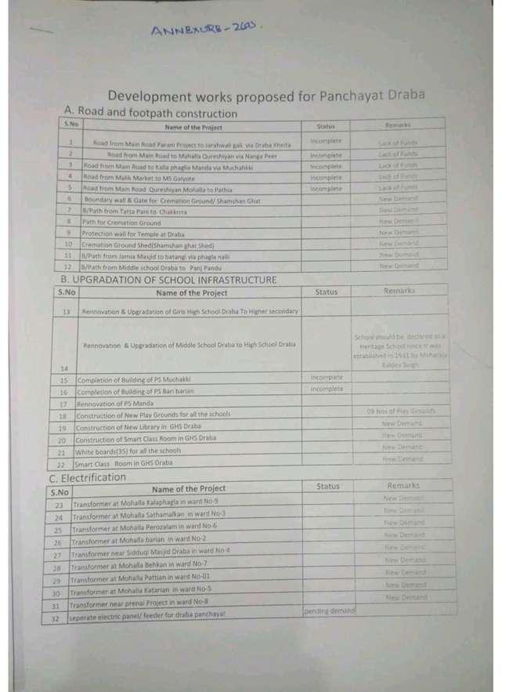

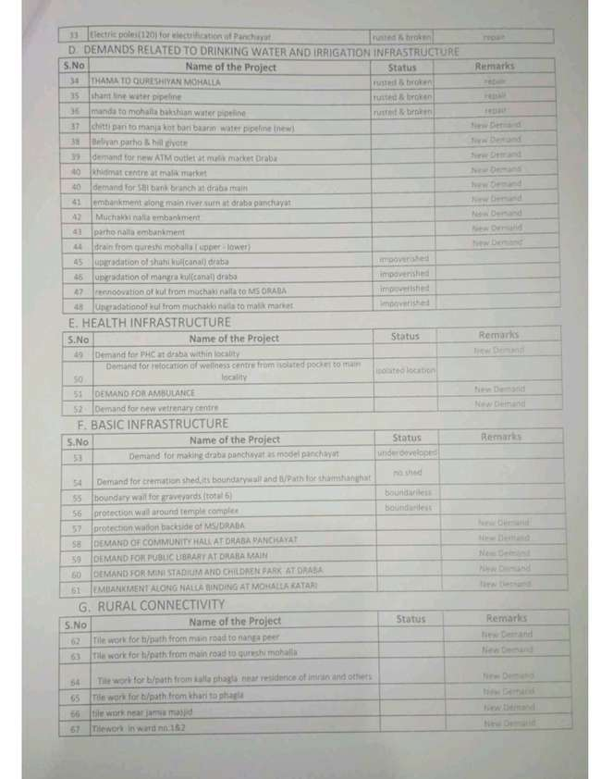

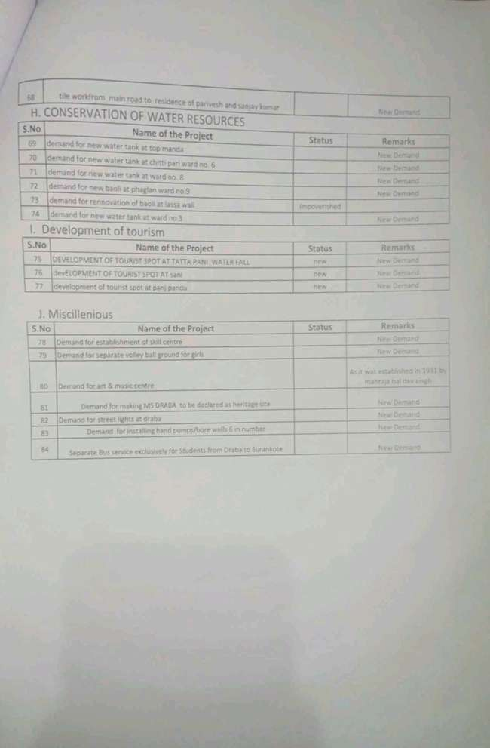

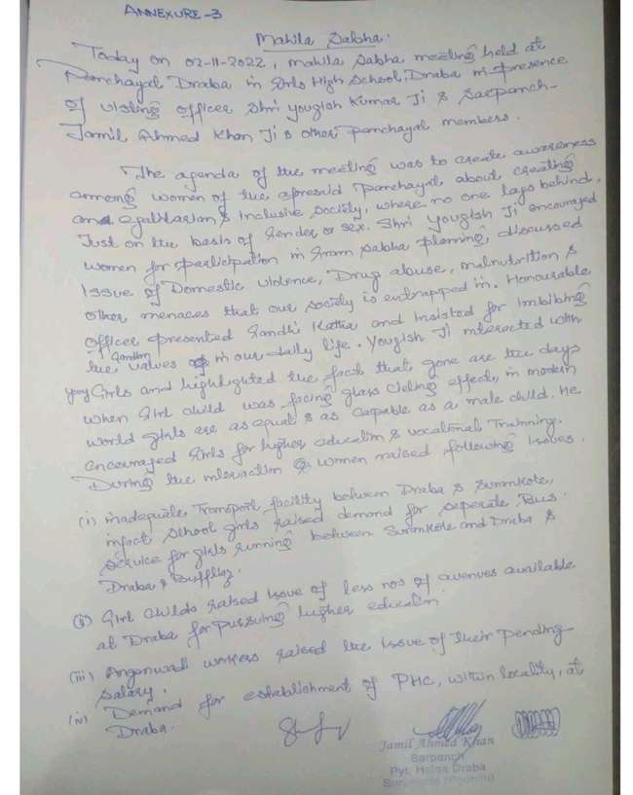

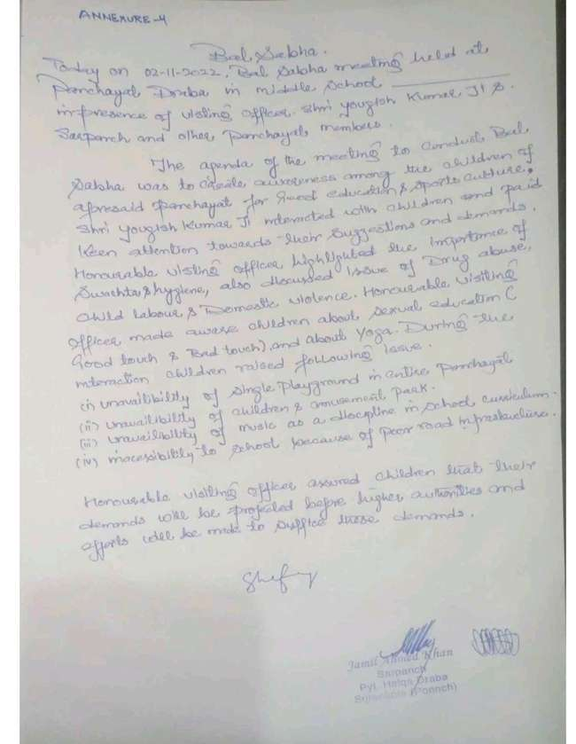

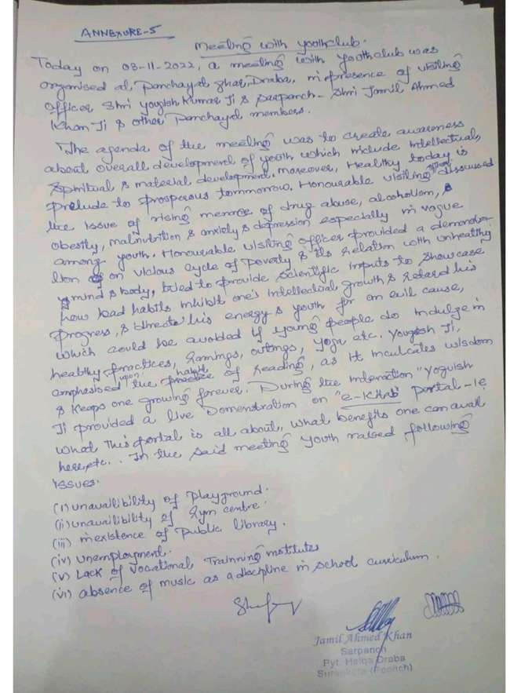

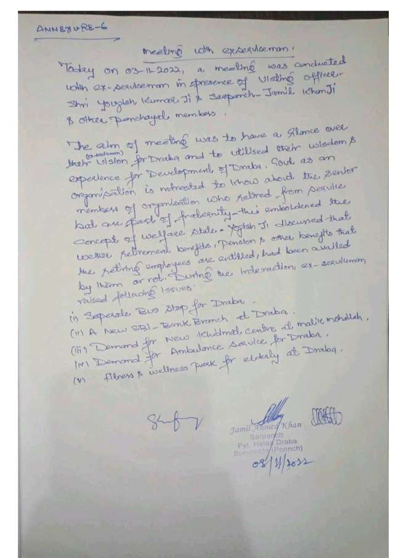

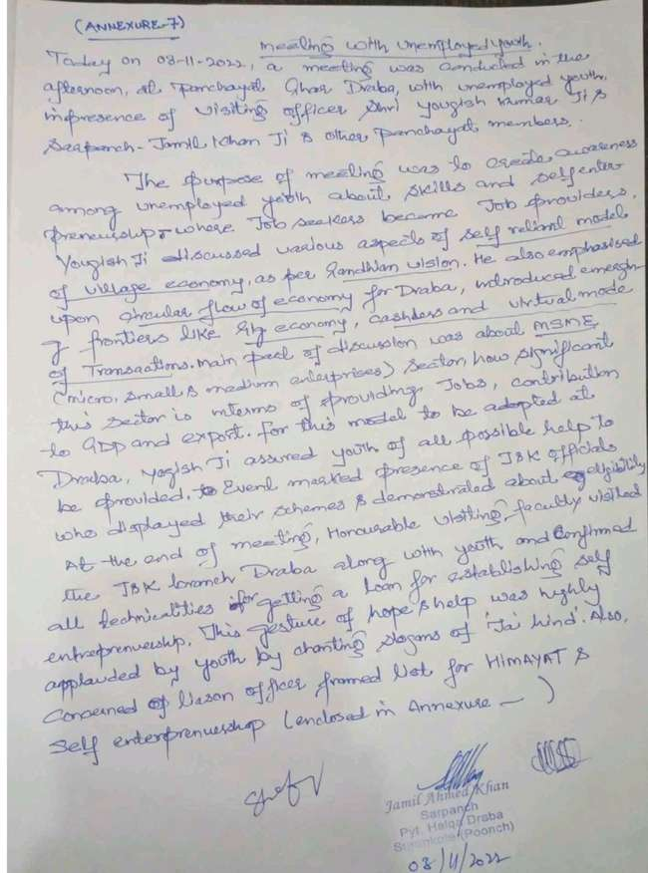

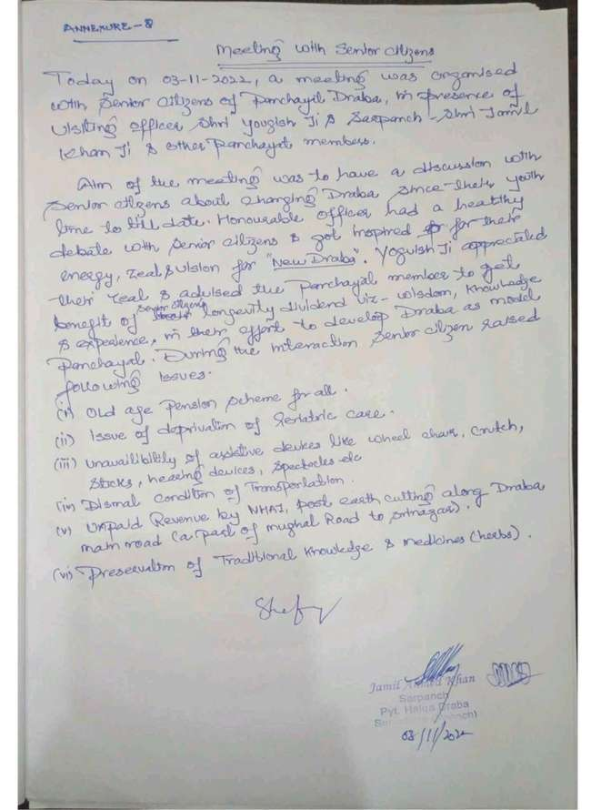

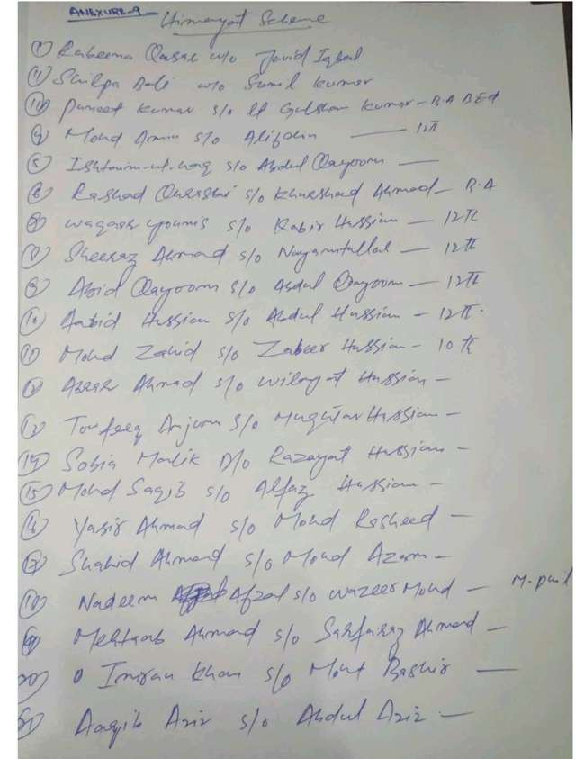



**Department of Rural Develompent and Panchayati Raj**

**Government of Jammu & Kashmir**