4





**15TH OCTto3RD NOV,2022**

**KEYFEATURES**

• DeputyCommissionerstoleadtheinitiative

• RuraldevelopmentDepartmenttobethenodaldepartment

• PlanningDevelopment&MonitoringdepartmentandITtobethesupportdepartments

**ACTIONSANDTIMELINES**

|  |  |  |  |
| --- | --- | --- | --- |
| **ACTION** | **RESPONSIBILITY** | **LATESTBY** | **REMARKS** |
| **Janabhiyan** | Alldepartments | Oct15-26th | Goingon |
| **DeputationofSecttstaff/ HoDs** | GAD | Oct14 | Done |
| **DeploymentofStaffto Panchayatsandservingof ordersondeployedofficers** | DCs | Oct25 | DCswilldeployseniorlevelstaff fromthedistricts.Strictactionto betakenagainstabstentions.No exemptionstobegiven |
| **TrainingofdistricttrainorsonB2V4** | RDD | Oct26 |  |
| **Trainingofvisitingofficers** | DCs | Oct27 |  |
| **FieldVisitstobecompletedby** | VisitingOfficers | Nov3 | DCstosuperviseandensurethat eachPanchayatisvisitedwithin theperiodspecified |
| **DataofB2V4tobe uploadedby** | VisitingOfficers | Nov10 | DCstosuperviseandensurethat dataofallPanchayatsisupload- edbythevisitingofficerwithin theperiodspecified |

**INSTRUCTIONSFORTHEVISITINGOFFICER(DAYWISE)**

|  |  |  |
| --- | --- | --- |
| **DATE** | **INSTRUCTIONS** | **ACTIONPOINTS** |
| **Day0** | Meetingwithdeputycommissionerandhis/her team | a. TakeprintoutsoffilledbookletsofB2V1,B2V2andB2V3from [www.jkpanchayat.in](http://www.jkpanchayat.in)  b.Alsotakeprintoutsofthesummarizedexcelsheetsofthepreviousphasesfrom[www.jkpanchayat.in](http://www.jkpanchayat.in)  c. CollectATRsonissuesraisedduringprevious3phasesfromthe officeofDeputyCommissioner(Planningdeptt)  d.Takeprintsofblank 2bookletsofB2V4from[www.jkpanchayat.in](http://www.jkpanchayat.in)e.Takeplansfor2previousyearsandATRsfromtheplanningdeptt f. CompletetrainingsondifferentcomponentsofB2V4being  organizedbyrespectiveDeputyCommissioners  g.CollectListofnewworksstarted/ongoing/completedduringthepreviousandcurrentFinancialyearunderthefollowingheads:  • PRIgrants  • DistrictPlan  • UTplan  • MGNREGA  • Otherschemesofotherdepartments  • Anyotherwork  h. Plans/beneficiarylists:  • MGNREGAdraftplandocumentfortheyear2022-23.  • ListofAwaas+beneficiariesalongwithIHHLConvergence  • Listofpensionbeneficiaries.  • ListofSHGs  • Listofagricultureschemebeneficiaries  i. Listsofbeneficiariesfor:  • Variouscertificates/benefitstobedistributedbythevisitingofficer.  • Anyotheractivitiesidentifiedbydifferentdepartments |

|  |  |  |  |
| --- | --- | --- | --- |
| **Day1** | Reachthevillage | 1. | Ensurethatallfrontlineworkersofdifferentdepttsarepresent. |
|  |  | 2. | Ensureexhibitionbydifferentdepts.aboutindividualbeneficiaryschemes |
|  |  | 3. | InspectJKB/PSBcounters/outlets |
|  |  | 4. | Participate/ensureorganizationofsportsactivityinplayfield,talenthunt/culturalevent/youthactivity |
|  |  | 5. | GandhiKatha(suggesteddetailsuploadedonjkpanchayat.in) |
|  |  | 6. | Visitatleast2amritsarovarsandgetitsgeotaggedphotos |
|  |  | 7. | InspectKhidmat(CSC)CentresandcreateGenerateawarenesson  225schemesparticularlyG2CschemeslikeBEAMS,Janbhagidari, AapkiZaminAapkiNigrani,DigitalJ&K |
|  |  | 8. | Visitingofficershallalsoplanandconductpanchayatlevelconver- gencemeetingofalldepartments |
|  |  | 9. | CheckeffectivenessofCentrallysponsoredschemes |
|  |  | 10. | VisitandinspectallgovernmentestablishmentsincludingPHE, AWC,FPS,schools,etc |
|  |  | 11. | AttemptsaturationofdeliverablesoJanAbhiyanandwhereverdeficienciesfound,leadadrivetoachievealldeliverables |
|  |  | 12. | Assesseffectivenessofsanitationcampaigninthepanchayat |
|  |  | 13. | Ensureselfemploymentactivitiesfor15youthperpanchayat |
|  |  | 14. | Identify20potentialcandidatesperpanchayatforHIMAYATtraining alongwiththetradeonwhichtheywanttraining |
|  |  | 15. | Whereverpossible,distributeemploymentlettersforpeopleselect- edundervariousgovernmentemployments |
|  |  | 16. | Intheevening,holdnormalmeetingwithseniorcitizens,govtem- ployeesincludingretiredemployees,exservicemen,youthclub,andany citizens ofthevillagewhoareenrolledincollege/university |
|  |  | 17. | OpendiscussiononNashaMuktAbhiyan |

Day2 Haveameetingwithall stakeholders-depttofficialsandpanchayatmembers

1. DiscussionontheandassesstheprogressofdifferentschemesrelatingtothelocalizedSDGsprioritizedforthatvillageaspertheresolutionpassedby thatGramPanchayaton21stApril22,onNationalPanchayti RajDay.

2. SensitizevillageresidentsaboutmyScheme”portal(myscheme.in) whichincludesinformationaboutalltheschemesbeingrunbyCen- tral/State/UTgovtacrossthecountry

3. Hold meeting of theBiodiversityManagementCommitteestodeliber- ateonissuespertainingtoconservationof biodiversityandsustaina- bleutilizationofbiologicalresources.

4. PrepareVillagedevelopmentplan,inconsultancywithGrampanchayat, discussitingramsabhaandgetitapproved.

5. EnsuresaturationofsoilhealthcardandgoldenhealthcardunderGold- enHealthCardunderAyushmanBharat,

6. Ensuresaturation of OldAgePensionScheme

7. EnsureDomicileSaturation.

8. EnsureKCCSaturation

9. Ensuresaturationoflandpassbooks

10. Ensureregistrationofvillagevendorsneededforanyscheme,onGEM

portal

11. Ensurepanchayatcontractorsregistration

12. EncouragePanchayatmembersforimportanceofplantationdrivein

PanchayatunderHarGaonHariyali

13. EnsurepaintingondigitalJ&Kinpanchayatghars

14. EnsurepaintingonpanchayatactivitesandCSSinpanchayatghars

15. Thevisitingofficeshallchecknoofkindergarten andplayfieldspresent inthepanchayatfor kidsandstudents,iftheinfrastructurepresent inthesearegoodenough.

16. HoldmeetingwithpanchayatmemberstodiscussaboutcorruptionmenaceandstepsrequiredtomakeJ&Kcorruptionfree

17. Obtainacandidassessmentaboutperformanceofvariousdepttsin- cludingfairfeedbackaboutdiscrepanciesinfunctioning

18. Check thestatusofNashaMuktAbhiyanandreportingof drugad- dictstoDeputyCommissioner.

19. IdentifyTouristDestinations,Circuits,ThemeTreks,IdentifyHomestays, providesupportfortourismactivitiesthroughVillageCooperative

20. OrganizeTalentHuntatPanchayatLevel

21. Conductsocialauditofatleast5worksunderfollowingschemes:

a. MGNREGA

b.PMAY

c. IHHLtoiletsandpaymentsd.CSCs

e.AMRITSAROVARS

22. Holdamahilasabhaandabalsabhaandrecordproceedingsinthefor- matgiven

23. InauguratevillagehaatunderJKSRLM

24. Checkifyouthclubsareformedinthepanchayatandwhatactivitiestheyareengagedin

25. Organizeavillagelevelculturaleventtoengagepanchayatmembers

26. SensitizeGPaboutE-kitabkoshaninitiativeofJ&KGovtforempoweringyouthsthroughonlinedigitalliteracy

**GENERALINSTRUCTIONS**

1. Thevisitingofficershallrefrainhimself/herselfgivingorofferinganycommitmentonbehalfofthe governmentandshalladoptanunbiasedattitudeinreportingissues.Asfaraspossible,his/her observation shouldbebasedonafairandanalyticalviewemergingfromhis/herinteractioninthevillage.

2. Heisgoingtothevillageasplanningofficer,notforsanctioninganyworksorformakinganycom- mitments.

3. Whilepreparingvillagedevelopmentplan,hehastoensurethat,demandsareprioritizedandre- flectedunderavailableschemes,wherevernecessarythelargerworksaretobereferredtoadminis- trativedepttunderCSS/UTplansunderintimationtoDCsandrestoftheworkstoDCsforreflecting itunderdistrict/CSS plans

4. His workshallbehardcoreplanningandauditandisnotaPRexercise.

5. EveryDeputyCommissionerhastoensurethatatleastoneRDDofficial(ideallyPanchayatSecre- tary)ispresent ineverypanchayatwithrelevantpanchayatrecords,toensureconductofallactivi- tiesasplanned.Panchayatwiseorderneedstobeissuedinadvance.

6. Visitingofficershouldideallycarryhis/herlaptoptocompletethereportsatthepanchayatlevel itselfanduploadthefinalreport,dulysignedbothbythesarpanchandbythevisitingofficeron[www.jkpanchayat.in](http://www.jkpanchayat.in)portal,beforetheyleavepanchayat.

7. Focus ofvisitareyouth,skills,self-employment,nashamukt,bhrashtracharmukt,Rozgaryukt J&K, besidestocarryforwardtheactivitiesduringJanAbhiyanandsaturatethem.

8. Inadditionattentionmaybegiventothefollowingareasa. MakefulluseofCentrallySponsoredSchemes

b.Saturationofindividualbeneficiaryschemesc. Self-employmentschemes

d.Banklinkedschemes-includingdepartmentalsubsidyschemese.Empowermentandtransparencythroughdigitalinitiatives

f. Effectivenessofgrassrootsmachinery–

i. Patwari,VLWpresentandavailable

ii. AvailablefundsutilizedinpublicinterestandasperGramSabharesolutions iii. Fairness ingovernance

iv. CSS/Individual beneficiaryschemesetcv. BrashtacharMuktJ&K

vi. BhaiMuktJ&K

vii. NashaMuktJ&K

9. ThePRImembers(Sarpanchs,Panchs,BDCChairperson)shallbeattheforefrontofallactivities and givendueimportanceandtheapproachshouldbetostrengthenthemandmakethemfeelem- powered.He/sheshallensurethattheBDCchairpersonandSarpanch/Pancharepresentatthetimeofinaugurationandceremonies.

10. Visitingofficershallnotleavethedistrictwithoutuploadingthereport,duly signedonthe**www. jkpanchayat.in**portal.EveryDeputyCommissionerhastoensurethat.

**A) DetailsofReportingOfficer:**

Name: Er. Shahid UL Bashir

Designation: Assistant Engineer

Department/placeof posting:Jal Shakti PHE Division/Division Awantipora

MobileNo:- 9419587251

EmailID: shahiidmir@gmail.com

HomeDistrict:- pulwama

Datesof visit: 28/10/2022 to 29/10/2022

**B) LocationaldetailsofPanchayat:(tobepre-filled,informationtobetakenfromtheprevious phasesbooklets/summarizedexcelsheetuploadedonjkpanchayat.in/b2v4.php)(tobevali- datedbythevisitingofficerandmissingdetailstobefilled)**

NameofthePanchayat:Rajpora A

LocalGovernmentDirectory(LGD)codeof thePanchayat: 245577

Nameof CDBlock:**Shadimarg**

NameofTehsil:**Rajpora**

Nameof District: PULWAMA

**C) PanchayatProfile:**

No.ofrevenuevillagesinthePanchayat:_________01.

No.ofhamletsinthePanchayat ______01_________

No.ofhouseholdsinthePanchayat:__________400__________

Population(approx)of thePanchayat:_______________2579____________

**Part-II:**

(TobefilledupbytheVisitingOfficerduringhis/hertwodayvisit tothePanchayat.AllFieldshavetobe

FilledbytheVisitingOfficerbeforethebookletishanded over totheDC

**FrontlineOfficers/OfficialswhowereassignedtothePanchayatfortheprogramme:**

|  |  |  |
| --- | --- | --- |
| Department | Name | Designation |
| RDD | Abdul Hamid Mir | Panchayat Sectt |
| Education | Bashir Ahmed Wani | Master |
| PMGSY | Zahid Ahmed Chat | A.E |
| PMGSY | Zahoor Ahmed Thokker | J.E. |
| Jal Shakti | Fayaz Ah Mir | J.E |
| R&B | ShahidFarwe | R/W |
| HEALTH | Farida | Asha Worker |
| Social Welfare | Mehnwda | A.W.W. |
| FOOD Supply | ALI MOHD AHANGER | STOKEEPER |
| Sheep and animal husbandry | K Majeed | Lab Boy |
| Social Welfare | Syed Feliwada | Asha Worker |

**Detailsofabsentemployeesvis-à-vislistfurnishedbytheDCoffice:**

|  |  |  |
| --- | --- | --- |
| Department | Name | Designation |
| Nil | Nil | Nil |

**DAY1-ACTIVITIES**

**AGENDA1:PANCHAYATASSETREGISTER**

**Infrastructure:**

1. PanchayatGharInfrastructure a. Govtbuilding

b. New Building

2. Furniture(No)

3. Computer/printer(No)

4. Internet(No)

5. Telephone(No)

6. Toilet(CSC/partofPanchayat ghar)(No)

7. Water(No)

8. Electricity(No)

9. Bankbranch(Yes)

10. CSC(Yes)

11. Patwarkhana(No)

12. Villagehaat(No)

13. Playground(No)

14. School-

a. Kindergarten(No)

b.Primary(No)

c. Secondary(Yes)

d. College (N)

e.University(N)

15. AnganwadiCentre(Yes) 04 Nos

a. (private Building)

b.Totalchildrenenrolled ( 292 )

15. AmritSarovars–details, 02 Nos at location KuttMohalla, MandMohalla, little KKrimere, not in good condition .

16. Governmentoffices-details,whether functionalornot; Tehsil office, PDD, Post Office, all functional.

17. Rationshop(Y)

18. Placesoftourismimportance–names,littledetailsonhistorical/culturalimportance .( NIL )

19. Villageheritagesites/treks-names,littledetailson historical/culturalimportance. ( NIL )

20. VLWOffice (Yes )

21. PrimaryHealthcareCentre(N )

22. ListofIncompleteBuildings-names,yearofconstruction ( Nil )

23. ListofUnderutilizedBuildings-names NIL

**DAY1-ACTIVITIES**

**AGENDA2:**

**DIFFERENTINSTITUTIONS/INFRASTRUCTUREPROJECTSTOBEVISITED**

|  |  |  |
| --- | --- | --- |
| **AMRITSAROVARS** | **Visit,verify** | **COMMENTS** |
| KhidmatCentres | Create/Generateawarenesson225schemes particularlyG2CschemsAapkiZaminAapkiNigrani, Beams,Janbhagidari,DigitalJ&K | Kidmatcentres was visited and verified, services provided by the centre fond satisfactory. |
| JKB/PSBcounters/outlets | a)Statusofcounter Functionalb)Numberofvisitors800 plus visitors | Functional |
| Incompletebuildings/pro- jects | Verify whetheridentificationandredistribution done | NIL |
| PDS | Visit,evaluate,onlinestatus | 100% Saturation |
| PHC | Visit-evaluate,statusofstaff,equipmentand quality | Not Available in GP. |
| Youthclubs | Meet,interact,seeksuggestions | NA |
| SHG | Meet,identifyproblems,seeksuggestions | NA |
| PMAY | Inspect,Inaugurate | 2 under construction  1 inagrated |
| Myschool,myprideprogress;schools-water, toilets,staff | Visit,checkforwater,electricity,sanitation,meet studentsandstaff | All basic facilities available. |
| SwachhSBM | Evaluate | Satisfactory |
| Panchayatplayground, Sportskitsdistribution Villagegames | Ensure,verify.Participateinatleastonegamein theplayground | N.A |
| HarGaonHariyali, Planta- tiondrive | Evaluatestatus,feedback | Plantation driver was done at GHR sec Rajpora |
| Villageculturalevent  Dangal/Haat/Mela | Participatein;ensurethatitisheld | NIL |
| Exhibitionofschemes | Ensurethateverydepartmentparticipatesand thatitcontinuesfortheentiredurationofB2V | Ensured |
| JalJeewanMission verifica- tion- WSS/JSD  Electricitysupply | Verify | No scheme under JJM |

**DAY1-ACTIVITIES**

**AGENDA3:SATURATEJANBHIYAN**

**DELIVERABLESANDRECORDDEFICIENCIESIFANY(INSERTDELIVERABLESLISTHEREASPERGADFORMAT**

**DAY1-ACTIVITIES**

**AGENDA4:**

**SELFEMPLOYMENTACTIVITIES**

EnsureSelf-employmentactivities foryouth,distributeemploymentlettersforpeopleselectedunder varioussocialschemes(15ISTHETARGETPERPANCHAYAT)

**Numberofcasesindifferentcategoriessanctioned:16**

**Detailsofthebanksanctioning it: Bank Ltd**

**Totalamountinvolved: RS 60 Lakh**

**DAY1ACTIVITIES**

**AGENDA5**

Intheevening,holdinformalmeetings withseniorcitizens,govtemployees,retdemployees,youthclub andothercitizenswhoareenrolledoncollege/universityandhavediscussiononGandhiKatha,NashaMuktAbhiyan,corruptionfreegovernance,doublingfarmersincomeandrecordtheproceedings

**DAY2**

1. No. ofIndividualCompostPitsconstructed- **Nil**
2. NoofIndividualSoakPitsconstructed**- 20**

V. No.ofBiodiversitymanagementcommitteemeetingsheld: **NIL**

VI. IsthenameofSarpanchdisplayedoncitizeninformationboardsofallRD&PRschemes:**No**

VII. AreSarpanchsbeinginvolvedinstart/inaugurationofactivities: ( No ) **There is no punch and surpanch in the Halqa .**

VIII. WhethersubjectshavebeenassignedbytheSarpanch tothePanchs:**No**

IX. Whethergrievancesredressalboxisinstalled:**Yes**

X. NoofgrievancesreceivedpertainingtoPanchayatlevel**:0**

XI. NoofgrievancesdisposedofatPanchayatlevel:**0**

XII. WhethertheSarpanch/PanchayatSecretaryhavedigitalsignatures:**Yes**

XIII. WhetherallMGNREGA/14thFCpayments arebeingmadebySarpanchthrough DigitalSignature

Certificate(DSC):No

**HUMAN RESOURCEAVAILABLEATTHEPANCHAYAT LEVEL:**

|  |  |  |  |  |
| --- | --- | --- | --- | --- |
| **SRNO.** | **DEPARTMENTWISESTAFF** | **NUMBERS** | | **NAMES** |
|  |  | SANCTIONED | ACTUAL |  |
|  | **RuralDev department:**  BDO  JEGRS TA | 0  01  01  01 | 0  01  01  01 | Bashir Ahmad Sheikh  Bilal Ahmed Qadri  Ghulam Jeelani |
|  | **SCHOOLEDUCATION:**TEACHER  HEADMASTER ANYOTHER | 26  01  12  REK,Cooks etc. | 23  01  12  03  0 |  |
|  | **JAL JEEVAN:** | ---- | 03 |  |
|  | **PDD:**LINEMAN JE  ANYOTHER | 01 MR | 01  01  06 |  |
|  | FOOD&CIVILSUPPLIES | 02 | 02 | Ali MohdAhenger  Farooq Ah Khan |
|  | AGRICULTURE&ANIMALHUS- BANDARY | NotExisting in the Halqa | NIL | NIL |
|  | SOCIALWELFARE | 4 | 4 | Mehmuda  Syed Fehmeeda |
|  | HEALTH: ASHA ANM  AYUSHDOCTOR ALLOPATHICDOCTOR | 02 | 02  0  0  0 | Fasida , Haseena |
|  | ANYOTHERDEPARTMENT | NIL | NIL | NIL |

**DAY2-ACTIVITIES**

**AGENDANO.1**

DiscussionontheandassesstheprogressofdifferentschemesrelatingtothelocalizedSDGsprior-itizedforthatvillageaspertheresolutionpassedbythatGramPanchayaton21stApril22,onNational PanchayatiRajDay(Copyoftheresolutiontobetakenfrom[www.jkpanchayat.in](http://www.jkpanchayat.in)portalunderthelinkof GramSwarajMonth)

1. SDGs AGREED FORTHATVILLAGE,TOBEIMPLEMENTED BYMARCH2024:

2. STATUSOFWORKSUNDERTHEFOLLOWINGSCHEMES:

**1 Cleanandgreenvillage**

i.InitiativestakenbythePanchayatformanagingSolidandLiquidWaste Yes **cont. of soak pits.**

ii. InitiatiestakenbythePanchayatforusinggreensourcesoffuellikesolar,biogas

**NA**

iii. Hasmappingoflanduse,waterbodies,forest,slopes,wetlands,degradedforestwithintheGram

Panchayatbeendone?Yes/No.IfNo,reason,thereof**NA**

iv. HastheClimateResiliencePlanbeendevelopedfortheGP?**No**

v. StepstakenbytheGramSabhaabouttheclimatechangemitigationfactorslikereducingenergy consumption,usageoffossilfuels,plastics,non-renewablebuildingmaterialsandalsotopromote measureslikeplantingoftrees,conservingforests,usageofgoodagriculturalpracticeslikedrip irrigation,waterconservationmeasuresandconservationofwetlands.**No**

vi. Whetherschoolshavestartedsegregatingwaste**No**

vii. Whetherschoolshavetheirowncompost/soakagepitsforsolid/liquidwastemanagement**NO**

**2 Healthyvillage**

i) AremeetingsrelatedtoVillageHealthandSanitationCommitteebeingheldregularly?**Yes**

ii) DoalltheeligibleindividualsbeenprovidedtheGoldenCard?**Yes**

iii) ArealltheChildrenbeingimmunizedaspertheSchedulerecommendedbyGovt.ofIndia?**YES**

iv) ArealltheeligibleindividualsbeenvaccinatedagainstCOVID-19?**Yes**

v) DoesGramPanchayatensurethatallpregnantwomenaregettingnecessaryprenatalcheckups?**YES**

vi) WhetherallthedeliverieswereInstitutionalizedorconductedbytrainedMidwives?**YES**

**3 Watersufficientvillage**

i) DoalltheIHHsintheGramPanchayathavewaterpipelineconnections?**Yes**

ii) WhetherGramPanchayathastakenstepsforgreywatermanagement.IfYespleasespecify**Yes, by way of constructed soak pits**

iii) DoalltheIHHsintheGramPanchayathavetoilets?**Yes**

iv) ArealltheIHHstoiletsfunctionalornot? **Yes**

v) DoalltheSchools/Anganwadicentershavea toiletfacilityornot?**Yes**

vi) Areallthetoiletsintheschools/Aaganwadifunctionalornot?**Yes**

vii) WhetherGramPachachayatBhawanhasseparate toiletsforwomenornot?**NO**

**4 ChildFriendlyvillage**

i) Doallthechildrenundertheageof0-6yearsbeenenrolledintheAnganwadicentersforpre- schooling?**Yes**

ii) HowmanyBalSabha’swereorganizedintheGramPanchayat----------------**02**

iii) WhethertheissuesraisedbyBalSabhaareaddressedduringtheGramSabha. **Yes**

iv) WhetherGramPanchayatistrackingthedatarelatedtodropoutchildrenandchildrenwithirregular attendance?**Yes**

v) DoalltheschoolsundertheGramPanchayathaveseparate toiletsforgirlsandboys?**Yes**

**5 Villagewithgoodgovernance**

1. i) IsCSClocatedintheGramPanchayatBhawanornot?**Yes**
2. IsthelistofbeneficiariesrelatedtotheSchemes/ProgramsdisplayedontheGrampanchayatwallor not?**YES**
3. DoestheGramPanchayathasitsbuildingornot?**YES**
4. IstheGramPanchayatofficefunctionalornot?**Yes**
5. Aretheactivities approved undertheHalqaPanchayatDevelopmentPlandisplayedontheGram
6. Panchayatwallornot ?**NO**
7. IsSocialAuditofearlierSchemes/Programscarriedoutornot?**Yes**

**6 Povertyfreeandenhancedlivelihoodvillage**

1. HasGramPanchayatdevelopedanycriteria fortheidentificationofthepoor?**YES – 1) income less than 40,000/ per year and 2) Home less**
2. HavealltheeligiblehouseholdsregisteredinPDSornot?**NO**

iii) HasGramPanchayatprovidedspaceforSelf-helpGroupsinPanchyatGharforholdingmeetings or not?**NO**

iv) HavealltheeligiblehouseholdsbeenregisteredforPensionornot?**Yes**

v) HasGramPanchayatfacilitatedYouthforSkillEnhancementCoursesandPlacement?**Yes**

vi) HasJobCardsbeendistributedtoalltheeligibleindividualsunderMGNREGA?**YES**

vii) HasGramPanchayatfacilitatedSHGsforBankAccountLinkages?**No**

**7 Sociallysecuredvillage**

i) WhetherGramPanchayatismaintainingdatarelatedtoDifferentlyAbledPeople? **No**

ii) IsGramPanchayatOfficeDisabledFriendlyornot?**YES**

iii) Areprovisionsfora separate BudgetundertheResourceEnvelopeforWomenandChildrenmadeornot? **NO**

iv) DoalltheSchools intheGramPanchayathavefacilitiesforDifferentlyAbledChildrenliketoilets, barrier-freeaccess,etc.,ornot?**Yes**

v) Arealltheeligibleindividualsaregettingpensions,likeoldagepension,widowpension,etc? **Yes, All rgistered and are receiving .**

vi) ArealltheeligiblehouseholdsgettingbenefitsfromIAYornot?

**YES , only deserving one.**

**8 EngenderedDevelopmentinVillage**

i) HowmanyMahilaSabha’swereorganizedintheGramPanchayat------------ **02**----

ii) WhetherSHGsfederationshavebeenprovidedspaceformeetingsinthePanchayatBhawan**No**

iii) WhetherGPshavetakenstepsforincreasingwomen’sparticipationinGramSabha Yes

iv) NumberofwomenbeneficiariesheadedhouseholdscoveredunderPDS

system………**100%**

v) Numberofbeneficiaries(outoftotaleligiblepopulation)receivingsocialprotectionbenefitsunder

PradhanMantriMatritvaVandanaYojana**15**

9 Self-sufficientinfrastructureinthevillage

i. WhetherGPhasaCommunityHallwithaccesstoelectricity,furniture,watersupply, toilet… **NO community hall available**

ii. WhethertheDisastermanagementplanisavailableattheGPLevel(**No**)

iii. Whetherchild-friendlyparkwithrequiredfacilitiesisavailableinGP(**No**)

iv. WhethertheGPhaseasyaccesstoGodownforstorage(**Yes**)

v. Whetherstreetlightsareprovidedinpublicplacesforensuringsafety(**Yes**)

**DAY2ACTIVITIES**

**AGENDANO.2**

SensitizevillageresidentsaboutmyScheme”portal(myscheme.in)whichincludesinformationaboutall theschemesbeingrunbyCentral/State/UT govtacrossthecountry (  **Sensitized and informed )**

*(SchemeMaterialavailablefromhttps://jkpanchayat.in/b2v4.php)*

**DAY2ACTIVITIES**

**AGENDANO.3**

HoldmeetingoftheBiodiversityManagementCommitteestodeliberateonissues pertainingtoconserva- tionofbiodiversityandsustainableutilizationofbiologicalresources.HeshouldcheckPeopleBiodiversity register(PBR)ofthatpanchayatandreviewifBiodiversityManagementCommittee constitutedforthatpanchayatis holdingminimum4meetings inayearandmeeting onceinevery3months *(RoleofBMCavailableathttps://jkpanchayat.in/b2v4.php)*

COMMITTEEMEMBERS PRESENT

BIODIVERSITYREGISTERPHOTOS

PAST 4MEETINGDETAILS-DATES,MINUTESPHOTOS

**DAY2ACTIVITIES**

**AGENDA4**

Visitingofficershallalsoplanandconductpanchayatlevelconvergencemeeting ofalldepartmentsandprepareVillagedevelopmentplanforvillage,inconsultancywithGrampanchayat,discussitingram sabhaandgetitapproved.

(GPDPformatavailableonhttps://jkpanchayat.in/b2v4.php)

**InadditionGPDPplanshallalsoinclude:**

▪ Touristplaceswhichneedtobedeveloped **NIL**

▪ Specificproductwhichneedstobedeveloped**Apple , walnut ,vegetable, fruit plant may be provide**

▪ Tourism-homestays**NIL**

▪ 20candidatesfortrainingunderHimayatschemealongwithtradeinwhich trainingistobegiven **10**

**DAY2ACTIVITIES**

**AGENDA5**

Ensuresaturationoffollowingschemesandgivestatus:

|  |  |  |  |
| --- | --- | --- | --- |
| **NAMEOFTHESCHEME** | **TOTALELIGIBLE BENEFICIARIESIN THE VILLAGE** | **TOTALBENEFICIARIESWHO AVAILEDTHEBENEFITSOFTHESCHEME** | **REASONSFOR PENDENCY** |
| GoldenHealthCardunder  AyushmanBharat | 2579 | 2505 | Unavailability of adhaar card of underage children |
| Jananisurakshayojana | 50 | 50 | Nil |
| OLDAGEpension | 91 | 91 |  |
| Widowpension | 32 | 32 | NIL |
| Disabilitypension | 35 | 35 | NIL |
| Domicilecertificate | 2579 | 750 | Not interested |
| Kisancreditcard | 457 | 453 | 100% saturation  Land mutation ownership |
| PMkisansammannidhi | 450 | 330 | Land mutation ownership |
|  |  |  |  |

|  |  |  |  |
| --- | --- | --- | --- |
| Landpassbook | - | - | - |
| Registrationofvillageven- dorsonGEMportal | 01 | 01 | NIL |
| Registrationofvillagecon- tractorsonjktendersportal | 13 | 13 | NIL |
| Registrationofvillagecon- tractorsonPWDportal | 13 | 13 | NIL |
| Incompletebuildings/pro- jects | NIL | NIL | NIL |
|  |  |  |  |

**DAY2ACTIVITIES**

**AGENDA6**

**NASHAMUKTABHIYAN**

1. Whethergramsabharesolutionpassed**YES**

2. Detailsofactivities conducted Awareness about **NASHA MUKT Abyan , corruption free society , green and clean village etc.**

3. Whetherallactivities andGSresolutionuploadedonjkpanchayats.inportal**YES**

4. Howmanydrugaddictsinthevillage**NIL**

5. WhetherreportedtotheDeputyCommissioner**NIL**

6. Howmanyregisteredforrehabilitationundergovernmentprogramme

**NIL**

**DAY2ACTIVITIES**

**AGENDA7**

**SOCIALAUDIT**

Conductsocialauditofatleast5workseachunderfollowingschemes:

|  |  |  |  |  |  |  |
| --- | --- | --- | --- | --- | --- | --- |
| **Name of the scheme** | **Detail of works** | **Year of work approval** | **Amount approved for work** | **whether work executed satisfactorily** | **geo tagged photos** | **any grievance recorded relating to that work** |
| MGNAREGA | C/o drain from H/o Mohd Hussain Shetan | 2022-23 | 2.84 | Yes | Yes | NA |
| PMAY | Manzoor Ali | 2021-22 | 1.32 | Yes | Yes | NA |
| IHHL Under SBM-G | Toilet - Ab Hamid Dal S/o Gh. Bhat | 2021-22 | 0.12 | Yes | Yes | NA |
| CSC under SBMG | c/o CSC | 2020-21 | 2.99 | Yes | Yes | NA |
| AmritSarovars | Development of spring 410 Nazir Ali Mir | 2022-23 | 1.39 | Yes | Yes | NA |

**DAY2ACTIVITIES**

**AGENDA8**

**MAHILASABHA**

Totalwomeninthevillageabovetheageof18

Totalattended

Proceedings:

*(Plinsertpointerstobediscussedthere–referpalliproceedings)*

**DAY2ACTIVITIES**

**AGENDA9**

**BALSABHA**

Holdabalsabhaandrecordproceedings**HELD**

Totalchildreninthevillageabovetheageof…**. ( 3-Years )**

Totalattended

Proceedings:

*(Plinsertpointerstobediscussedthere–referpalliproceedings)*

**DAY2ACTIVITIES**

**AGENDA10**

**INAUGURATIONS**

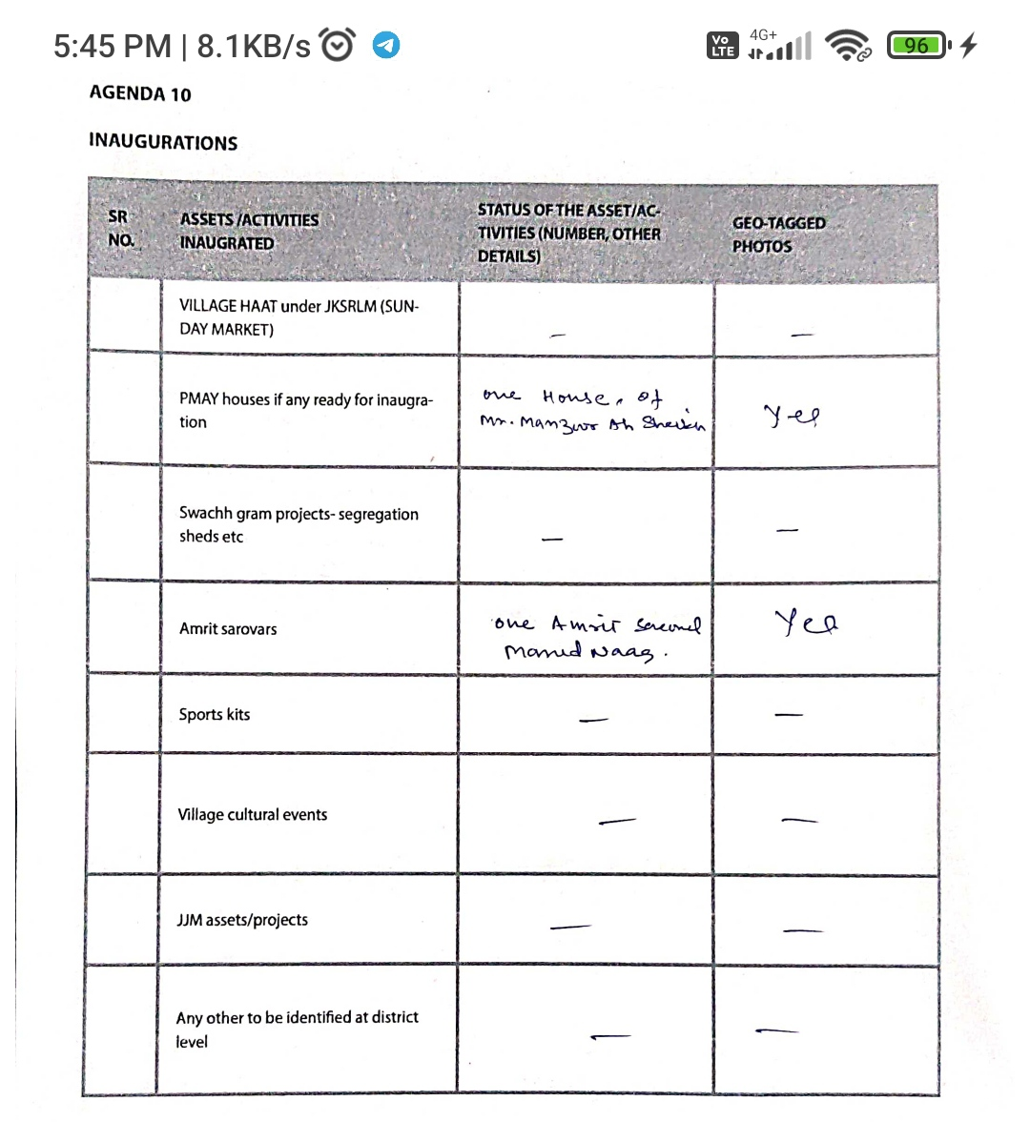

**FOLLOWUPOF(B2V1,B2V2&B2V3):**

*(Prefilledexcelsheettobetakenfromdistrictlevel/andalsotobedownloaded*

*from*[*www.jkpanchayat.in)*](http://www.jkpanchayat.in)

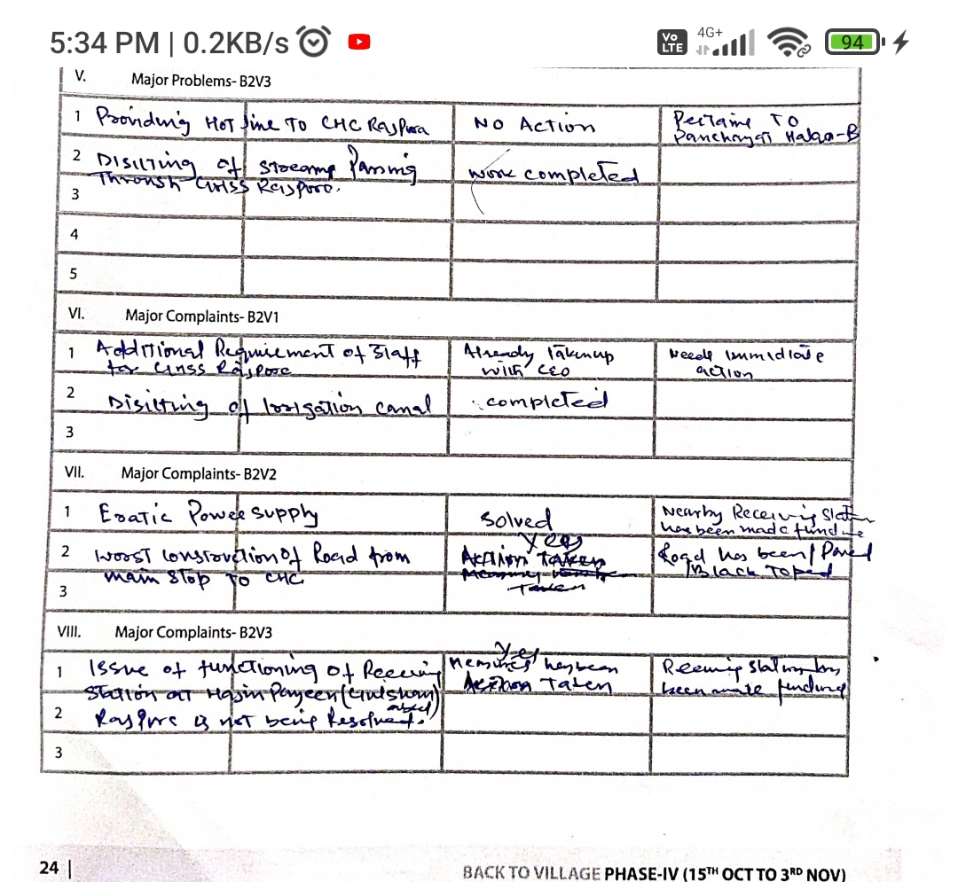

|  |  |  |  |
| --- | --- | --- | --- |
| **S.No.** | **Particulars** | **Action taken** | **Remarks** |
| 1 | Reqirement of tubewell in order to improve supply of portable water | No action taken |  |
| 2 | Constrction of additional classrooms for GHSS Rajpora | Work has been started |  |
| 3 | Constrction of new panchayat ghar | Primary school building has been allotted |  |
| 4 | Constrction of new rewnue complex | No action taken |  |
| 5 | Hot line to CHC Rajpora | No action taken |  |
| 6 | Replacement of HT/LT wires with inslators | work has been started | condctors not laid yet |
| 7 | Up gradation of road from Rajpora to Gulshanabad kuthpora | No action taken |  |
| **II** | **Urgent Public reqirements/Demands-B2V2** | | |
| 1 | Upgradation of BSNL exchange Rajpora so that Broadband services shall improve | No action taken |  |
| 2 | Panchayat Ghar Rajpora is fnctional from rental bilding | Primary school building has been allotted |  |
| 3 | Improvement of HT/LT in panchayat Halqa | Work has been started | condctors not laid yet |
| 4 | Demand for extra Ration in the pyt Halqa | Srvey has been done by CAPD but fond not feasible |  |
| 5 | Repairing of water pipes | No action taken |  |
| 6 | Project has been submitted for flood protection works | Not taken p |  |
| 7 | Disilting of stream passing through GHSS Rajpora | Work has been done |  |
| **III** | **Major Problems - B2V1** | | |
| 1 | Encroachment of irrigation canal passing through Gram Panchayat | No action taken | Encroachment must be stopped |
| 2 | Internal and external drainage system | No action taken |  |
| 3 | Road connectivity to the orchads | Almost done |  |
| 4 | Eratic power supply | Solved | Nearby receiving station made functional |
| 5 | Unemployment | No action taken |  |
| **IV** | **Major Problems - B2V2** | | |
| 1 | No destilling of canals/streams | some destilling of streams done | Need more action |
| 2 | Poor broadband service | No action taken |  |
| 3 | Additional accomodation for GHSS | Work has been started |  |
| 4 |  |  |  |
| 5 |  |  |  |
| **V** | **Major Problems - B2V3** | | |
| 1 | Providing hotline to CHC Rajpora | No action taken | Pertains to Halqa Rajpora -B |
| 2 | Disilting of stream passing through GHSS Rajpora | Work completed |  |
| 3 |  |  |  |
| 4 |  |  |  |
| 5 |  |  |  |
| **VI** | **Major Complaints - B2V1** | | |
| 1 | Additional requirement of staff for GHSS Rajpora | Already taken up with CEO | Needs immediate action |
| 2 | Desilting of irrigation canal | completed |  |
| 3 |  |  |  |
| **VII** | **Major Complaints - B2V2** | | |
| 1 | Eratic power supply | Solved | Nearby receiving station made functional |
| 2 | Worst construction of road from main stop to CHC | Solved | Road has been black topped |
| **VIII** | **Major Complaints - B2V3** | | |
| 1 | Issue of functioning of receiving station at Hanjeen Payeen(Gulshanabad) Rajpora B has not resolved | Yes, measures has been taken | Remaining station has been made functional |
| 2 |  |  |  |
| 3 |  |  |  |

**OVERALLPERCEPTIONOFFUCNTIONING OF GOVERNMENTDEPARTMENTS**

1. **BESTDEPARTMENT:**

**2. LEASTRESPONSIVEDEPARTMENT:**

**GENERALASSESSMENTOFTHEVISTINGOFFICER**

|  |  |
| --- | --- |
| I | Any major complaint brought to the notice of the Visiting Officer:   * -Conductor not laidover newly erected electricity poles. * Replacement of old wornout pipes laid some decadesback which are passing under the plinth of houses,walls etc and are 5 to 6 feet deep and additional tube well for water supply. * Subcentre not available in Gram Panchayat. * Supply of portable drinking water * New Anganwari centre for Khar Mohalla |
| II | Major/urgent public demands that was/were reflected earlier but have not been addressed so far:   * Repairing of water pipes. * Requirement of tubewell in order to improve supply of portable drinking water |
| III | Overall assessment of the visit and suggestions:  (The visiting officer to ensure that the overall assessment is recorded in details along with concrete sugges- tions)   * The back to village program is of great importance and beneficial to the people. It reports the grossroot issues of the people and awareness about varios employment generation schemes. * The panches and Sarpanches need to be elected at the earliest. * There is need of more departmental involvement of RDD, PHE, IT, Revenue, Skill development and also for women empowerment, there is need of tailoring units, Self help groups etc. * The major complaints enlisted above shall be redressed. |
| IV | Overall Rating of govt functioning as given by the Panchayat (Scale of 0 to  10)  07 (Seven) |
| V | Certificate from Sarpanch that the visiting officer has stayed in the panchayat for 2 days PRI not available. |

