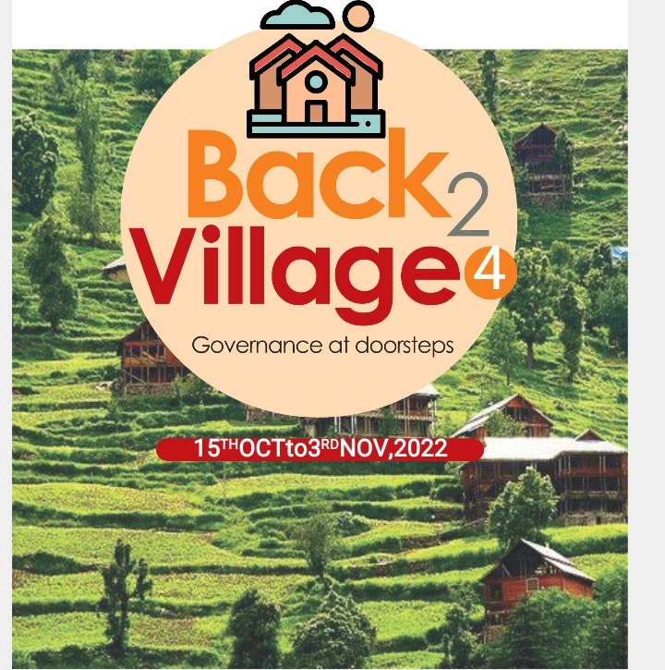

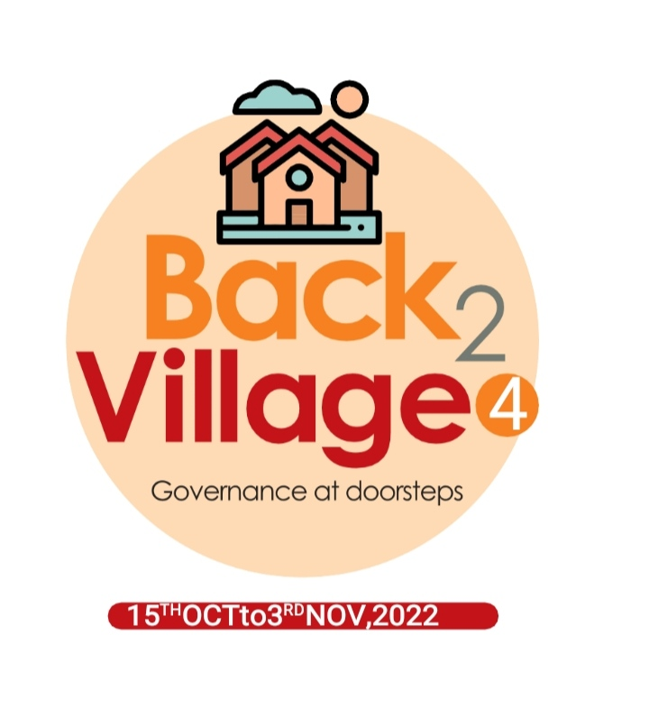

**Back To Village 4 Panchayat Halqa Mandoora**

**BACK TO VILLAGE- PHASE IV (15TH OCTOBER TO 3RD NOVEMBER )**

**KEY FEATURES**

* Deputy Commissioners to lead the initiative
* Rural development Department to be the nodal department
* Planning Development & Monitoring department and IT to be the support departments

**ACTIONS AND TIMELINES**

|  |  |  |  |
| --- | --- | --- | --- |
| **ACTION** | **RESPONSIBILITY** | **LATEST BY** | **REMARKS** |
| Jan abhiyan | All departments | Oct 15 -25th | Going on |
| Deputation of Sectt staff/HoDs | GAD | Oct 14 | Done |
| Deployment of Staff to Panchayats and serving of orders on deployed officers | DCs | Oct 25 | DCs will deploy senior level staff from the districts. Strict action to be taken against absentations. No exemptions to be given |
| Training of district trainors on B2V4 | RDD | Oct 26 |  |
| Training of visiting officers | DCs | Oct 27 |  |
| Field Visits to be completed by | Visiting Officers | Nov 3 | DCs to supervise and ensure that each Panchayat is visited within the period specified |
| Data of B2V4 to be uploaded by | Visiting Officers | Nov 10 | DCs to supervise and ensure that data of all Panchayats is uploaded by the visiting officer within the period specified |

**INSTRUCTIONS FOR THE VISITING OFFICER (DAY WISE)**

|  |  |  |
| --- | --- | --- |
| **DATE** | **INSTRUCTIONS** | **ACTION POINTS** |
| Day 0 | Meeting with deputy commissioner and his/her team | 1. Take print outs of filled booklets of B2V1, B2V2 and B2V3 from [www.jkpanchayat.in](http://www.jkpanchayat.in) 2. Also take print outs of the summarized excel sheets of the previous phases from [www.jkpanchayat.in](http://www.jkpanchayat.in) 3. Collect ATRs on issues raised during previous 3 phases from the office of Deputy Commissioner (Planning deptt) 4. Take prints of blank 2 booklets of B2V4 from [www.jkpanchayat.in](http://www.jkpanchayat.in) 5. Take plans for 2 previous years and ATRs from the planning deptt 6. Complete trainings on different components of B2V4 being organized by respective Deputy Commissioners 7. Collect List of new works started/ ongoing/ completed during the previous and current Financial year under the following heads:  * PRI grants * District Plan * UT plan * MGNREGA * Other schemes of other departments * Any other work  1. Plans/ beneficiary lists:  * MGNREGA draft plan document for the year 2022-23. * List of Awaas+ beneficiaries alongwith IHHL Convergence * List of pension beneficiaries. * List of SHGs * List of agriculture scheme beneficiaries  1. Lists of beneficiaries for:  * Various certificates/ benefits to be distributed by the visiting officer. * Any other activities identified by different departments |
| Day 1 | Reach the village | 1. Ensure that all front line workers of different deptts are present. 2. Ensure exhibition by different depts. about individual beneficiary schemes 3. Inspect JKB/PSB counters/outlets 4. Participate/ensure organization of sports activity in playfield, talent hunt/cultural event/youth activity 5. Visit atleast 2 amritsarovars and get its geo tagged photos 6. Inspect Khidmat (CSC) Centres and create Generate awareness on 225 schemes particularly G2C schemes like BEAMS, Janbhagidari, AapkiZaminAapkiNigrani, Digital J&K 7. Visiting officer shall also plan and conduct panchayat level convergence meeting of all departments 8. Check effectiveness of Centrally sponsored schemes 9. Visit and inspect all government establishments including PHE, AWC, FPS, schools, etc 10. Attempt saturation of deliverable so Janabhiyan and wherever deficiencies found, lead a drive to achieve all deliverables 11. Assess effectiveness of sanitation campaign in the panchayat 12. Ensure self employment activities for 15 youth per panchayat 13. Wherever possible, distribute employment letters for people selected under various government employments 14. In the evening, hold inormal meeting with senior citizens, govt employees including retired employees, ex servicemen, youth club, and any citizens of the village who are enrolled in college/university 15. Open discussion on Nasha Mukt Abhiyan |
| Day2 | Have a meeting with all stakeholders- deptt officials and panchayat members | 1. Discussion on the and assess the progress of different schemes relating to the localized SDGs prioritized for that village as per the resolution passed by that Gram Panchayat on 21st April 22, on National Panchayti Raj Day. 2. **Sensitize village residents about myScheme” portal (myscheme.in)** which includes information about all the schemes being run by Central/ State/ UT govt across the country 3. Hold meeting of the **Biodiversity Management Committees** to deliberate on issues pertaining to conservation of biodiversity and sustainable utilization of biological resources. 4. Prepare Village development plan, in consultancy with Gram panchayat, discuss it in gram sabha and get it approved. 5. Ensure saturation of soil health card and golden health card under **Golden Health Card under Ayushman Bharat**, 6. Ensure saturation of **Old Age Pension Scheme** 7. Ensure Domicile Saturation. 8. Ensure KCC Saturation 9. Ensure saturation of land pass books 10. Ensure registration of village vendors needed for any scheme, on GEM portal 11. Ensure panchayat contractors registration 12. Encourage Panchayat members for importance of plantation drive in Panchayat under Har Gaon Hariyali 13. Ensure painting on digital J&K in panchayat ghars 14. Ensure painting on panchayat activites and CSS in panchayat ghars 15. The visiting office shall check no of kindergarten and playfields present in the panchayat for kids and students, if the infrastructure present in these are good enough. 16. Hold meeting with panchayat members to discuss about corruption menace and steps required to make J&K corruption free 17. Obtain a candid assessment about performance of various deptts including fair feedback about discrepancies in functioning 18. Check the status of Nasha Mukt Abhiyan and reporting of drug addicts to Deputy Commissioner. 19. Identify Tourist Destinations, Circuits, Theme Treks, Identify Homestays, provide support for tourism activities through Village Cooperative 20. Organize Talent Hunt at Panchayat Level 21. Conduct social audit of atleast 5 works under following schemes:     1. MGNREGA     2. PMAY     3. IHHL toilets and payments     4. CSCs     5. AMRIT SAROVARS 22. Hold a mahilasabha and a balsabha and record proceedings in the format given 23. Inaugurate village haat under JKSRLM 24. Check if youth clubs are formed in the panchayat and what activities they are engaged in 25. Organize a village level cultural event to engage panchayat members 26. Sensitize GP about E-kitab kosh an initiative of J&K Govt for empowering youths through online digital literacy |

**GENERAL INSTRUUTIONS**

1. The visiting officer shall refrain himself/ herself giving or offering any commitment on behalf of the government and shall adopt an unbiased attitude in reporting issues. As far as possible, his/her observation should be based on a fair and analytical view emerging from his/her interaction in the village.
2. He is going to the village as planning officer, not for sanctioning any works or for making any commitments.
3. While preparing village development plan, he has to ensure that, demands are prioritized and reflected under available schemes, wherever necessary the larger works are to be referred to administrative deptt under CSS/UT plans under intimation to DCs and rest of the works to DCs for reflecting it under district/CSS plans
4. His work shall be hard core planning and audit and is not a PR exercise.
5. **Focus of visit are youth, skills, self-employment, nasha mukt, bhrashtrachar mukt, Rozgar yukt J&K, besides to carry forward the activities during Jan Abhiyan and saturate them.**
6. **In addition attention may be given to the following areas**
   1. Make full use of Centrally Sponsored Schemes
   2. Saturation of individual beneficiary schemes
   3. Self-employment schemes
   4. Bank linked schemes- including departmental subsidy schemes
   5. Empowerment and transparency through digital initiatives
   6. Effectiveness of grass roots machinery –
      1. Patwari, VLW present and available
      2. Available funds utilized in public interest and as per Gram Sabha resolutions
      3. Fairness in governance
      4. CSS/Individual beneficiary schemes etc
      5. BrashtacharMukt J&K
      6. Bhai Mukt J&K
      7. NashaMukt J&K
7. The PRI members (Sarpanchs, Panchs, BDC Chairperson) shall be kept at the forefront of all activities and given due importance and the approach should be to strengthen them and make them feel empowered. He/she shall ensure that the BDC chairperson and Sarpanch/Panch are present at the time of inauguration and ceremonies.
8. The visitingofficer shall ensure that COVID protocols are strictly followed during the visits.

**BACK TO VILLAGE (B2V4) October 27th to November 3rd**

**A) DetailsofReportingOfficer:**

Name: **Mr. Mohd Ramzan Mir**

Designation: **Lecturer**

Department/placeofposting: **Education/BHSS Tral**

Mobile No:- **9596142947**

Email ID: mirramzan699@gmail.com

Home District: Pulwama

Dates of visit: **30 & 31 October 2022**

**B)LocationaldetailsofPanchayat: (to be pre-filled, information to be taken from the previous phases booklets/summarized excel sheet uploaded on [jkpanchayat.in](http://www.jkpanchayat.in)/b2v4.php ) (to be validated by the visiting officer and missing details to be filled)**

Name of the Panchayat: **Mandoora**

Local Government Directory(LGD) code of the Panchayat: **242917_**

Name of CD Block: **Tral**

Name of Tehsil: **Tral**

Name of District: **Pulwama**

**C)PanchayatProfile:**

No. of revenue villages in the Panchayat: **01**

No. of hamlets in the Panchayat: **03**

No. of households in the Panchayat: **317**

Population (approx) of the Panchayat: **1798**

**PartII : (To be filled up by the Visiting Officer during his/her two day visit to the Panchayat. All Fields have to be filled by the Visiting Officer before the booklet is handed over to the DC**

**FrontlineOfficers/Officialswhowereassignedtothe Panchayatfortheprogramme:**

|  |  |  |  |
| --- | --- | --- | --- |
| **Department** | **Name** | **Designation** | **CONTACT NO.** |
| EDUCATION | MOHD RAMZAN MIR | LECTUTER(VO) | 9596142947 |
| RDD | AJAZ AHMAD NAIK | GRS(NODAL OFFICER) | 8491857166 |
| RDD | JUNAID AHMAD KHAN | GRS | 7889717519 |
| HANDICRAFT | NAZIR AHMAD KHAN | MA | 9622893938 |
| SHEEP HUSBANDARY | FAROOQ AHMAD SHAH | ASM | 9541073114 |
| R&B | ALI MOHD KHAN | ROAD WORKER | 9797790235 |
| FISHIRIES | MOHD ABDULLAH WANI | GUARD | 9697904727 |
| PHE | MOHD SHAFI BHAT | HELPER | 9906519093 |
| AGRICULTURE | SATPAL SINGH | HELPER | 9906448281 |
| SOCIAL FOREST | MOHD SHAFI BAIGH | JUNIOR MALI | 8494088484 |
| FLOOD CONTROL | RAVEES AHMAD SHEIKH | WORKS SUPERVISOR | 9906637795 |
| IRRIGATION | ISHTIYAQ AHMAD WANI | J.E | 9596067427 |
| ANIUMAL HUSBANDARY | MUZAFFAR AHMAD GANAI | VP | 9797228306 |
| PDD | FAROOQ AHMAD NAIK | TECHNICIAN | 7006898118 |
| SOCIAL WELFARE | TAHIR MAJEED | NYC | 9622686905 |
| FOREST | MOHD AYOUB BHAT | MALI | 9797414126 |
| FOOD SUPPLY | SHOWKAT AHMAD | ASK | 9797022942 |
| ICDS | FARIDA BANOO | AWW | 9541306092 |
| CERICULTURE | HAMID ULLAH RATHER | HELPER | 9541267112 |
| HEALTH | FATIMA | FMPHW | 9541734805 |
| HEALTH | DILSHADA | ASHA | 9596467554 |
| REVENUE | ASHIQ HUSSAIN | PATWARI | 9797112684 |
| IT | ISHFAQ BASHIR | VLE | 9541214727 |
| J & K BANK | MIR FAIZAN | BANK ASSOCIATE | 9797420110 |
| PMGSY | UMAR BASHIR | J.E | 9419655565 |
| EDUCATION | SHAHNAWAZ AHMAD | TEACHER | 6006129614 |
| ICDS | NAINA AKHTER | SUPERVISOR | 9541785518 |
| NRLM | MADIA BASHIR | CDEO | 6006417376 |
| NRLM | AROOJA BINTI HAMID | COM | 6005802745 |
| ICDS | SHAHZADA | HELPER | 9596538871 |
| ICDS | MISRA BANOO | WORKER | 9906003580 |
| HORTICULTURE | JAVID AHMAD SHAH | TECHNICIAN | 9596068631 |
| RDD | GH NABI DAR | HELPER | 9797272824 |

**Detailsofabsentemployeesvis-à-vislistfurnished bytheDC office:**

|  |  |  |
| --- | --- | --- |
| **Department** | **Name** | **Designation** |
| NIL |  |  |
|  |  |  |
|  |  |  |
|  |  |  |

**DAY 1 ACTIVITIES**

**AGENDA 1: PANCHAYAT ASSET REGISTER**

**Infrastructure:**

1. Panchayat Ghar Infrastructure

Govt building/private:- Govt Building

New/needing repairs:- Needing Repairs

1. Furniture (Y/N) :- Yes
2. Computer/printer (Y/N):- Yes
3. Internet (Y/N) :-Yes
4. Telephone (Y/N):- N0
5. Toilet (CSC/part of panchayat ghar) (Y/N) :-No
6. Water (Y/N) :-Yes
7. Electricity (Y/N) :-Yes
8. Bank branch (Y/N) :- No
9. CSC (Y/N) :-Yes
10. Patwarkhana (Y/N) :-No
11. Village haat (Y/N) :-Yes
12. Playground (Y/N) :-Yes
13. School-
14. Kindergarten (Y/N) :- Yes
15. Primary (Y/N) :- Yes
16. Secondary (Y/N) :- Yes
17. College (Y/N) :- No
18. University (Y/N) :-No
19. Anganwadi Centre (Y/N) :- Yes
    1. (govt/private) :-Private
    2. Total children enrolled:- 155

15. Amrit Sarovars – details, location, condition :- Spring near Jamia Masjid Under Construction

16. Government offices- details, whether functional or not:- Schools & Panchayat Ghar

17. Ration shop (Y/N):- Yes

18. Places of tourism importance – names, little details on historical/cultural importance :- Nil

19. Village heritage sites/ treks- names, little details on historical/cultural importance :- Nil

20.VLW Office (Y/N) :- Yes

21. Primary Healthcare Centre (Y/N), :- No

22. List of Incomplete Buildings- names, year of construction :- Nil

23. List of Underutilized Buildings- names :- Nil

**DAY 1 ACTIVITIES**

**AGENDA 2: DIFFERENT INSTITUTIONS/INFRASTRUCTURE PROJECTS TO BE VISITED**

|  |  |  |
| --- | --- | --- |
| AMRIT SAROVARS | Visit, verify |  |
| KhidmatCentres and 4. | create Generate awareness on 225 schemes particularly G2C schemsAapkiZaminAapkiNigrani, Beams, janbhagidari, digital J&K | Doing well ,but Banking & Adhaar facilities not available |
| CSC counters/JKB/PSB counters/outlets | a) Status of counter  b) Number of visitors | Nil |
| INCOMPLETE BUILDINGS/PROJECTS | Verify whether identification and redistribution done | Nil |
| PDS | Visit, evaluate, online status | Verified. The food store needs electricity |
| PHC | Visit- evaluate, status of staff, equipment and quality | Nil |
| YOUTH CLUBS | Meet, interact, seek suggestions | Need of Sports equipments 7 playground |
| SHG | Meet, identify problems, seek suggestions | Need accomudation |
| PMAY | Inspect, Inaugurate | Inaugrated |
| MY SCHOOL, MY PRIDE PROGRESS; SCHOOLS- WATER, TOILETS, STAFF | Visit, check for water, electricity, sanitation, meet students and staff | Satisfactory |
| SWACHH GRAM SBM | Evaluate | Verified |
| PANCHAYAT PLAY GROUND  SPORTS KITS DISTRIBUTION  VILLAGE GAMES | Ensure, verify. Participate in at least one game in the playground | Verified  Kabadi game played by youths of Mandura |
| HAR GAON HARIYALI , PLANTATION DRIVE | Evaluate status, feedback | Plantation drive done , need more plantation in future to save environment |
| VILLAGE CULTURAL EVENT  DANGAL/HAAT/MELA | Participate in; ensure that it is held | Students organized a cultural programme |
| EXHIBITION OF SCHEMES | Ensure that every department participates and that it continues for the entire duration of B2V | Stalla by different departments were being installed |
| JAL JIWAN MISSION VERIFICATION- WSS/JSD  ELECTRICITY SUPPLY | Verify | Over head tank under construction |

**DAY 1 ACTIVITIES**

**AGENDA 3: SATURATE JAN BHIYANDELIVERABLES AND RECORD DEFICIENCIES IF ANY**

|  |  |  |  |  |  |  |
| --- | --- | --- | --- | --- | --- | --- |
| **STATUS OF ACTIVITIES BEING CARRIED OUT DURING B2V4 PROGRAMME** | | | | | | |
|  |  | **Daily Report** | | |  |  |
|  |  |  |  |  |  |  |
| **District:-Pulwama Date30 and 31 October 2022** | | | | | | |
| **No. of Panchayats where visiting officers visited:- 01** | | | | | | |
| **Total No. of people who participated in B2V4 in the Panchayat today:- 80** | | | | | | |
| **S. No.** | **Deliverable** | **Department** | **Overall Target** | **District Target** | **Cumulative Achievements (15 Oct, 2022 - till today)** | **Today's Achievements** |
| 1 | Golden Health Cards | Health | 100,000 | Panchayat/District Targets to be fixed by the Department based on gap in figures of every Panchayat | 1526 | - |
| 2 | Land Passbooks | Revenue | 1,000,000 | Panchayat/District Targets to be fixed by the Department based on gap in figures of every Panchayat | - | 10 |
| 3 | Inheritance Mutations | Revenue | 7,000 | Panchayat/District Targets to be fixed by the Department based on survey of every Panchayat by the Patwaries | - | - |
| 4 | Self Employment Drive | J&K Bank & Industries | 65,000 | At least 15 persons per Panchayat | - | 15 |
| 5 | Identify candidates for skill training under HIMAYAT and other schemes | RDD | 100,000 | At least 20 per Panchayat | - | 20 |
| 6 | CSC/IT Camps in every Panchayat | IT | 4290 | One per Panchayat | 1 | 0 |
| 7 | Creating Awareness of Jan Bhagidari among PRIs and general public | IT | 100,000 | 25 additional hits/Panchayat | 1 | 1 |
| 8 | Painting of Digital J&K in every Panchayat | RDD | 4290 | One per Panchayat | 1 | 0 |
| 9 | *Pani Samitis* meetings to be held | Jal Shakti | 4290 | One per Panchayat | 0 | 1 |
| 10 | Field testing kits to be provided for all Panchayats and trainings given | Jal Shakti | 4290 | One per Panchayat | 1 | 0 |
| 11 | Certification of water sufficiency and quality of Panchayats | Jal Shakti | 451 | As per list decided by Department | 0 | 0 |
| 12 | Implement Swachh Gram Plans ·       Door to door collection and disposal- ensure ·       Management of grey water, black water and solid waste | RDD | 6,870 | To be implemented in every Village | 20 Soak Pits | 0 |
| 13 | UDID Cards to be converted to Digital Format | Social Welfare | 250,000 | Panchayat/District Targets to be fixed by the Department based on existing cards | 0 | 0 |
| 14 | E-shram Cards | Labour | 250,000 | Panchayat/District Targets to be fixed by the Department based on survey | 600 | 0 |
| 15 | Inspect Playfields and ensure that at least one sports event is held | YSS | 4290 | At least one per Panchayat | 0 | 01 |
| 16 | Inspect office of Patwari, VLW and ensure that name and phone number of the Patwari/VLW is painted on the wall of the office | Revenue, RDD | 8580 | 2 per Panchayat ( 1 patwari office + 1 VLW office) | 0 | 01 |
| 17 | Amrit Sarovars- Inspect quality | RDD | 1,500 | 75 per District | 0 | 01 |
| 18 | Youth Clubs Interact | Youth Mission | 4290 | At least one per Panchayat | 0 | 01 |
| 19 | Azadi Ka Amrit Mahotsav- Upload High Quality videos | Culture & DCs | 15,000 | At least 3 per Panchayat | 0 | 01 |
| 20 | Hold Gram Sabha meetings and assess quality and effectiveness of service delivery, performance and ranking of departments and perception of corruption | All visiting Officers | 4,290 | Every Panchayat | 0 | 01 |

**DAY 1 ACTIVITIES**

**AGENDA 4:**

**SELF EMPLOYMENT ACTIVITIES**

**Ensure Self-employment activities for youth, distribute employment letters for people selected under various social schemes:**

|  |  |  |
| --- | --- | --- |
| **S.No** | **Name of Candidate** | **Parentage** |
| **01** | **Mohd Amir Khan** | **Rafiq Ahmad Khan** |
| **02** | **Feroz Ahmad Bhat** | **Gh Nabi Bhat** |
| **03** | **Bilal Ahmad Bhat** | **Mohd Ramzan Bhat** |
| **04** | **Adil Muzaffar** | **Muzaffar Ahmad Bhat** |
| **05** | **Umair-ul Islam** | **Ab Rashid Lone** |
| **06** | **Najamus Saqib** | **Amin Arshid Ganie** |
| **07** | **Shabir Ahmad Gojer** | **Alamdin Gojer** |
| **08** | **Sidiq gojer** | **Ibrahim Gojer** |
| **09** | **Sidiq Gojer** | **Yousuf Gojer** |
| **10** | **Mohd Shahid Bhat** | **Ab Ahad Bhat** |
| **11** | **Parvaiz Ahmad Wani** | **Mohd Sultan Wani** |
| **12** | **Shahbaz Mohi ud din** | **Gh Mohi nud din Bhat** |
| **13** | **Younis Hassan Bhat** | **Gh Hassan Bhat** |
| **14** | **Mushtaq Ahmad Lone** | **Ab Samad Lone** |
| **15** | **Furqan Ayoub Bhat** | **Mohd Ayoub Bhat** |
| **16** | **Rizwan Syed Bhat** | **Mohd Syed Bhat** |

Number of cases in different categories sanctioned :- NA

Details of the bank sanctioning it :- NA

Total amount involved :- NA

**DAY 1 ACTIVITIES**

**AGENDA 5**

* In the evening, hold informal meetings with senior citizens , govt employees, retd employees , youth club and other citizens who are enrolled on college/university and have discussion on Nasha Mukt Abhiyan, corruption free governance, doubling farmers income and record their suggestions

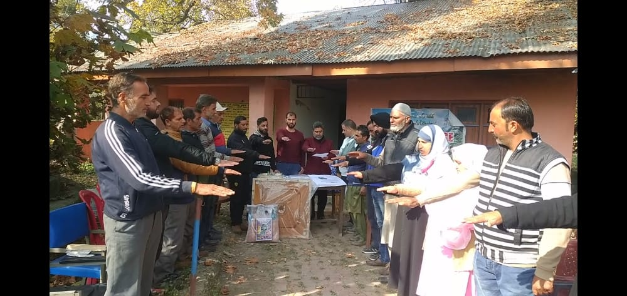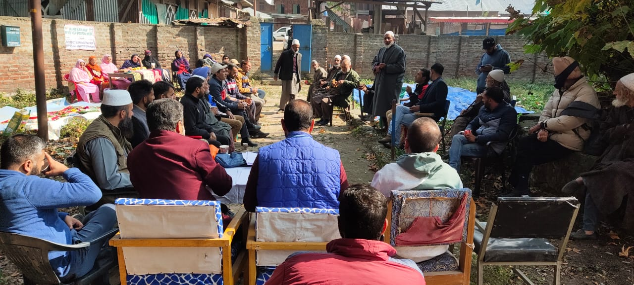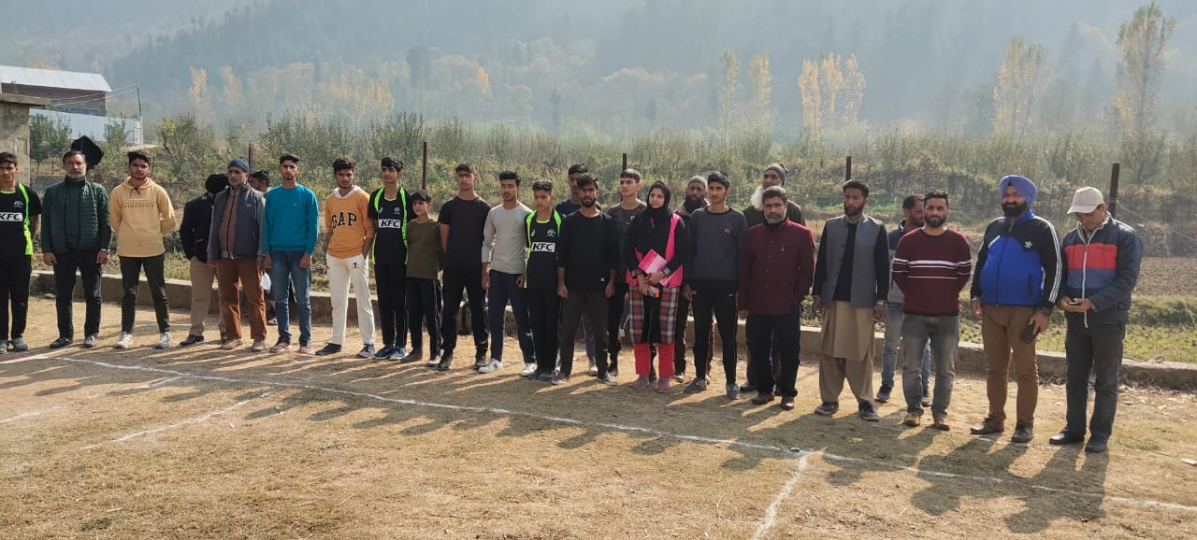

**PLEDGE ANTI CORRUPTION**

**YOUTH CLUB**

**INTERACTION WITH SENIOR CITIZENS**

**DAY 2**

**Check functionality of panchayats (data filled in the excel sheet and B2V1-3 reports to be validated and gaps to be filled) insert the link**

1. Maintenance of records: Gram Sabha registers
2. 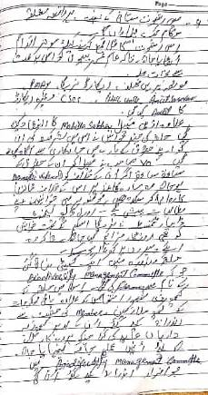Social Audit Committee details
3. Swachta Status – Village is ODF or ODF +
4. *MGNREGA/SBM convergence*
   1. *No of Individual Compost Pits constructed:- Nil*
   2. *No of Individual Soak Pits constructed :- 20*
5. No.ofBiodiversity management committee meetingsheld: 01
6. IsthenameofSarpanchdisplayedoncitizeninformationboardsofallRD&PRschemes:Yes/No :- Yes
7. AreSarpanchsbeinginvolvedinstart/inaugurationofactivities:Yes/No : Yes
8. Whethersubjectshavebeenassignedbythe Sarpanchtothe Panchs:Yes/No :- Yes
9. Whethergrievancesredressalboxisinstalled:Yes/No ;_ Yes
10. NoofgrievancesreceivedpertainingtoPanchayatlevel: Nil
11. NoofgrievancesdisposedofatPanchayatlevel: Nil
12. Whetherthe Sarpanch/PanchayatSecretaryhavedigitalsignatures:Yes/No:-Yes
13. Whether all MGNREGA/ 14th FC payments are being made by Sarpanch through Digital Signature Certificate (DSC): Yes/ No :-Yes

**HUMAN RESOURCE AVAILABLE AT THE PANCHAYAT LEVEL:**

|  |  |  |  |  |
| --- | --- | --- | --- | --- |
| SR NO. | DEPARTMENT WISE STAFF | NUMBERS | | NAMES |
|  |  | SANCTIONED | ACTUAL |  |
|  | Rural development department:  BDO  JE  GRS  TA | 1  1  1  1 | 1  0  1  1 | Shafiq Ahmad Wani  Junaid Ahmad Khan  Adil Manzoor |
|  | SCHOOL EDUCATION:  Teacher  Head master  Any other | Govt. UPS Mandura:7+1 | 8 | 1:Parvaiz Ahmad Bhat  2:Gh Nabi Janbaz  3:Muneera Akhter  4:Sameer Yousuf Khan  5:Javaid Ahmad Bhat  6:Mehraj ud din  7:Rakesh Kumar  8:Gh Nabi Dar |
| High School Mandura:24 | 7+1 | 1:Manzoor Ahmad  2:Showkat Ahmad Sheikh  3:Bashir Ahmad  4:Mudasir Ahmad Sheikh  5:Mohd Iqbal Khan  6:Shahnawaza Ahmad Bhat  7:Feroz bHussain Wani  8:Ab Qayoom Sheikh |
| Primary School Shitlan:2 | 2 | 1:Hilal Ahmad Bhat  2:Fahmeeda Akhter |
|  | JAL JEEVAN | 3 | 3 | 1:Mohd Shafi  2:Gh Hassan Dar  3:Nisar Ahmad Reshi |
| (PHE) |
| (IRRIGATION) | 3 | 3 | 1:Ishtiyaq Ahmad  2:Mohd Yousuf  3:Ali Mohd |
|  | PDD: |  |  |  |
| LINEMAN | 1 | 1 | Nazir Ahmad |
| JE | 1 | 1 | Harminder Singh |
|  | Any other | 2 | 2 | 1:Bashir Ahmad  2:Irshad Ahmad |
|  | FOOD & CIVIL SUPPLIES | 2 | 1 | Showkat Ahmad (ASK) |
|  | AGRICULTURE & ANIMAL HUSBANDARY | 2 | 2 | 1:Muzaffar Ahmad Ganie  2:Prithi Singh |
|  | SOCIAL WELFARE | - | - | - |
|  | HEALTH: |  |  |  |
| ASHA | 2 | 1 | Dilshada |
| ANM | 2 | 2 | 1:Fatima & 2: Farhat |
| AYUSH DOCTOR | 1 | 0 | - |
| ALLOPATHIC DOCTOR | - | - | - |

**DAY 2 ACTIVITIES**

**AGENDA NO.1** Discussion on the and assess the progress of different schemes relating to the localized SDGs prioritized for that village as per the resolution passed by that Gram Panchayat on 21st April 22, on National PanchayatiRaj Day **(Copy of the resolution to be taken from [www.jkpanchayat.in](http://www.jkpanchayat.in) portal under the link of Gram Swaraj Month)**

1. SDGs AGREED FOR THAT VILLAGE, TO BE IMPLEMENTED BY MARCH2024:
2. STATUS OF WORKS UNDER THE FOLLOWING SCHEMES:

1 **Clean and green village**

1. Initiatives taken by the Panchayat for managing Solid and Liquid Waste:- **Segregation Shed**
2. Initiatives taken by the Panchayat for using green sources of fuel like solar, biogas :-**NO**
3. Has mapping of land use, water bodies, forest, slopes, wet lands, degraded forest within the Gram Panchayat been done? Yes/No. If No, reason, thereof :-**Yes**
4. Has the Climate Resilience Plan been developed for the GP? Yes /No:- **No**
5. Steps taken by the Gram Sabha about the climate change mitigation factors like reducing energy consumption, usage of fossil fuels, plastics, non-renewable building materials and also to promote measures like planting of trees, conserving forests, usage of good agricultural practices like drip irrigation, water conservation measures and conservation of wetlands. :- **Plantation done, rest ones yet to take any action**
6. Whether schools have started segregating waste:-**No**
7. Whether schools have their own compost/soakage pits for solid/liquid waste management:-**No**
8. **Healthy village**
9. Are meetings related to Village Health and Sanitation Committee being held regularly?:-**Yes**
10. Do all the eligible individuals been provided the Golden Card?:-**80%**
11. Are all the Children being immunized as per the Schedule recommended by Govt. of India?:-Yes
12. Are all the eligible individuals been vaccinated against COVID-19?:-**Yes**
13. Does Gram Panchayat ensure that all pregnant women are getting necessary prenatal checkups? :-**Yes**
14. Whether all the deliveries were Institutionalized or conducted by trained Midwives? :-**Institutionalized**

**3 Water sufficient village**

1. Do all the IHHs in the Gram Panchayat have water pipeline connections?:-Yes
2. Whether Gram Panchayat has taken steps for grey water management. If Yes please specify:-**No**
3. Do all the IHHs in the Gram Panchayat have toilets?:-**Yes**
4. Are all the IHHs toilets functional or not?:-**Functional**
5. Do all the Schools/Anganwadi centers have a toilet facility or not? :-**Yes**
6. Are all the toilets in the schools/Aaganwadi functional or not?:-**Functional**
7. Whether Gram Pachachayat Bhawan has separate toilets for women or not? :-**No**

**4 Child Friendly village**

1. Do all the children under the age of 0-6 years been enrolled in the Anganwadi centers for pre-schooling? Yes/NO:-Yes
2. How many Bal Sabha’s were organized in the Gram Panchayat-:-1------------------
3. Whether the issues raised by Bal Sabha are addressed during the Gram Sabha. Yes/NO:-Yes
4. Whether Gram Panchayat is tracking the data related to dropout children and children with irregular attendance? Yes/NO. :-Yes
5. Do all the schools under the Gram Panchayat have separate toilets for girls and boys? Yes/No:-Yes

**5 Village with good governance**

1. Is CSC located in the Gram Panchayat Bhawan or not?:-Yes
2. Is the list of beneficiaries related to the Schemes/Programs displayed on the Gram panchayat wall or not?:-Yes
3. Does the Gram Panchayat has its building or not?:-Yes
4. Is the Gram Panchayat office functional or not?:-Yes
5. Are the activities approved under the Halqa Panchayat Development Plan displayed on the Gram Panchayat wall or not?:-Yes
6. Is Social Audit of earlier Schemes/Programs carried out or not?:-Yes

**6 Poverty free and enhanced livelihood village**

1. Has Gram Panchayat developed any criteria for the identification of the poor? Yes/No if yes specify:-Yes (Land less)
2. Have all the eligible households registered in PDS or not?:-No (10 Pending)
3. Has Gram Panchayat provided space for Self-help Groups in PanchyatGhar for holding meetings or not?:-No
4. Have all the eligible households been registered for Pension or not?:-Yes
5. Has Gram Panchayat facilitated Youth for Skill Enhancement Courses and Placement?:-NO
6. Has Job Cards been distributed to all the eligible individuals under MGNREGA?:-Yes
7. Has Gram Panchayat facilitated SHGs for Bank Account Linkages?:-Yes

**7 Socially secured village**

1. Whether Gram Panchayat is maintaining data related to Differently Abled People?:-Yes
2. Is Gram Panchayat Office Disabled Friendly or not?:-Friendly
3. Are provisions for a separate Budget under the Resource Envelope for Women and Children made or not?:-No
4. Do all the Schools in the Gram Panchayat have facilities for Differently Abled Children like toilets, barrier-free access, etc., or not?:-No
5. Are all the eligible individuals are getting pensions, like old age pension, widow pension, etc?:-Yes
6. Are all the eligible households getting benefits from IAY or not?:-No (Due to limited quoto all are not covered)

**DAY 2 ACTIVITIES**

**AGENDA NO.2**

**Sensitize village residents about myScheme” portal (myscheme.in) which includes information about all the schemes being run by Central/ State/ UT govt across the country**

**(Scheme Material available from https://jkpanchayat.in/b2v4.php)**

**DAY 2 ACTIVITIES**

**AGENDA NO.3**

**Hold meeting of the Biodiversity Management Committees to deliberate on issues pertaining to conservation of biodiversity and sustainable utilization of biological resources. He should check People Biodiversity register (PBR) of that panchayat and review if Biodiversity Management Committee constituted for that panchayat is holding minimum 4 meetings in a year and meeting once in every 3 months(Role of BMC available at https://jkpanchayat.in/b2v4.php)**

COMMITTEE MEMBERS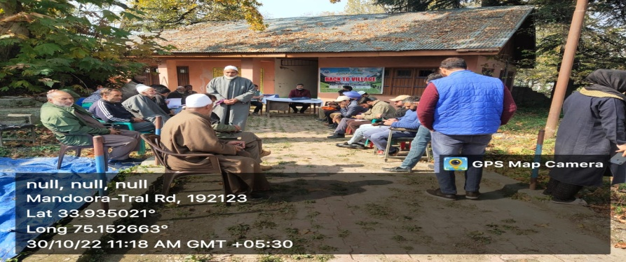

PRESENT

BIODIVERSITY REGISTER PHOTOS

PAST 4 MEETING DETAILS- DATES, MINUTES PHOTOS

**DAY 2 ACTIVITIES**

**AGENDA 4**

**Visiting officer shall also plan and conduct panchayat level convergence meeting of all departments and prepare Village development plan for village, in consultancy with Gram panchayat, discuss it in gram sabha and get it approved.**

**Village Development Plan**

|  |  |  |
| --- | --- | --- |
| **S.No** | **Name Of Work** | **Department** |
| **1** | **Mecdamization of High School Road from UPS Mandura to High School Via Dankard** | **R & B** |
| **2** | **Upgradation of electric infrastructure** | **PDD** |
| **3** | **Request/demand for establishment of PHC at Mandura** | **Health** |
| **4** | **School building for UPS Mandura** | **Education** |
| **5** | **Bore well tube well for irrigation** | **Irrigation** |
| **6** | **Mecdamization of road from Tulbagh to Badbagh** | **R & B** |
| **7** | **C/O drain near Zadinaag** | **RDD** |
| **8** | **J & k Bank branch for Mandura** | **Bank** |
| **9** | **C/O drain at Wani Mohalla Chopan Mohalla** | **RDD** |
| **10** | **C/O drain from Watal ara to chirmulla at reshi Mohalla Mandura** | **RDD** |
| **11** | **Mecdamization of road from chinaar tree to Gojar basti Shitlan** | **PMGSY** |
| **12** | **Fencing of Graveyard at Sheikh Mohalla** | **RDD** |
| **13** | **C/o P/ bund from culvert to graveyard via H/o Ab ahad Lone near Masjid Ibrahim at Mandura** | **Flood Control** |
| **14** | **C/o Lane from Mushtaq Medicate upto the entrance of Gh Jeelani Khan** | **RDD** |
| **15** | **Bore well at new colony near H/o Rayees ahmad Khan & others** | **Tube well** |
| **16** | **Levelling of High School Ground** | **RDD** |
| **17** | **Establishment of Animal/ Sheep husbandary** | **Animal/Sheep husbandary** |
| **18** | **Fencing of Primary school Shitlan** | **RDD** |
| **19** | **Establishment of Food centre Shitlan** | **CAPD** |
| **20** | **Establishment of Anganwadi centre at Shitlan Bala** | **ICDS** |
| **21** | **Fencing around graveyard near Jamia Masjid** | **RDD** |
| **22** | **Mecdamization of interior link from Jamia Masjid to Masjid Ibrahim** | **R & B** |

**(GPDP format available on** <https://jkpanchayat.in/b2v4.php>)

In addition GPDP plan shall also include :

**GPDP Plan**

|  |  |  |
| --- | --- | --- |
| S.No | Name Of Work | Estt. Cost |
| 1 | Imp. Of road from Shop of Ali Mohd Bhat to H/O Ab Ahad Chopan at Mandura | 1.50 |
| 2 | C/O road from H/o Mohd Anwar Bhat to onwards via drang at Mandura | 5.00 |
| 3 | Imp/ C/O road from Bathnoor road to Pahalpathri via Brimjinadji at Mandura | 8.00 |
| 4 | Imp of road from chandar to Banjar at Mandura | 1.00 |
| 5 | Disilting/ Imp of Chirmol Dhar at Mandura | 1.00 |
| 6 | Imp of road from Mandura bridge to Bathnoor road via Bangad mohalla at Mandura | 6.00 |
| 7 | C/o Fp bund on watal ara nea Bangad Mohalla | 4.00 |
| 8 | C/o FP bund on watal ara near Banjar at Mandura | 4.00 |
| 9 | C/o road from High School to Budnard at Mandura | 8.00 |
| 10 | Desilting of nallah Lugh at Mandura | 3.00 |
| 11 | Dev./ Land leveling at Budnard at Mandura | 3.00 |
| 12 | Constt./ land leveling at shitlan bala at Mandura | 4.00 |
| 13 | C/O p/bund on various spots near ST/IAY H/Hs at Gojar Basti Shitlan Bala | 2.00 |
| 14 | C/O p/bund on various spots near ST/IAY H/Hs at Gojar Basti Shitlan Payeen | 2.00 |
| 15 | C/O public park near Masjid Sharief Shitlan | 2.00 |
| 16 | C/O road from Masjid Ibrahim to Shilamnaag at Mandura | 8.00 |
| 17 | Upgradation of road from Shitlan Chinaar to Gojjar Basti Shitlan at Mandura | 10.00 |
| 18 | Approach filling of culvert near Reshi Mohalla Mandura | 3.00 |

* Tourist places which need to be developed
* Specific product which needs to be developed
* Tourism- home stays
* 20 candidates for training under Himayat Scheme along with trade in which training is to be given

**List of Youth for Himayat Training**

|  |  |  |
| --- | --- | --- |
| S.No | Name | Parentage |
| 1 | Uzair Feroz | Feroz Ahmad Bhat |
| 2 | Mohd Shahid Bhat | Mohd Ashraf Bhat |
| 3 | Mohd Farooq Bhat | Mohd Anwar Bhat |
| 4 | Amir Ashraf Bhat | Mohd Ashraf Bhat |
| 5 | Mohd Imran Khan | Gh Mohd Khan |
| 6 | Ubaid Manzoor | Manzoor Ahmad Reshi |
| 7 | Kamran Reyaz | Reyaz Ahmad Bhat |
| 8 | Gufran Bilal | Bilal Ahmad Bhat |
| 9 | Aqib Ahmad Wani | Muzaffar Ahmad Wani |
| 10 | Amir Ahad | Ab Ahad Bhat |
| 11 | Basit Ashraf | Mohd Ashraf Bhat |
| 12 | Mohd Sideeq Gojar | Mohd Yousuf Gojar |
| 13 | Imtiyaz Ahmad Gojar | Mushtaq Ahmad Gojar |
| 14 | Danish Manzoor | Manzoor Ahmad |
| 15 | Faisal Farooq | Farooq Ahmad Bhat |
| 16 | Kaisar Manzoor | Manzoor Ahmad Reshi |
| 17 | Arif Gojar | Mohd Yousuf Gojjar |
| 18 | Ishfaq Ahmad Ganai | Gh Mohi ud din Ganai |
| 19 | Shahbaz Ahmad Bhat | Ab Gani Bhat |
| 20 | Gh Nabi Bhat | Wali Mohd Bhat |

**DAY 2 ACTIVITIES**

**AGENDA 5**

**Ensure saturation of following schemes and give status:**

|  |  |  |  |
| --- | --- | --- | --- |
| **NAME OF THE SCHEME** | **TOTAL ELIGIBLE BENEFICIARIES IN THE VILLAGE** | **TOTAL BENEFICIARIES WHO AVAILED THE BENEFITS OF THE SCHEME** | **REASONS FOR PENDENCY** |
| **Golden Health Card under Ayushman Bharat** | **1691** | **1526** | **Non-Cooperative** |
| **Janani suraksha yojana** | **228** | **82** | **Prefer private institutions** |
| **OLD AGE pension** | **92** | **92** | **Nil** |
| **Widow pension** | **46** | **46** | **Nil** |
| **Disability pension** | **26** | **26** | **Nil** |
| **Domicile certificate** | **1798** | **1000** | **Not Applied yet** |
| **Kisan credit card** | **317** | **273** | **Not applied yet** |
| **PM kisan sammannidhi** | **200** | **200** | **-** |
| **Land pass book** | **500** | **10** | **In progress** |
| **Registration of village vendors on GEM portal** | **Nil** | **Nil** | **Nil** |
| **Registration of village contractors on jktenders portal** | **110** | **5** | **NA** |
| **Registration of village contractors on PWD portal** | **NA** | **NA** | **NA** |
| **Incomplete buildings/projects** | **Nil** | **Nil** | **Nil** |

**DAY 2 ACTIVITIES**

**AGENDA 6**

**NASHA MUKT ABHIYAN**

1. Whether gram sabha resolution passed:-Yes
2. Details of activities conducted:- A Seminaar /debate on Nasha mukt Abhiyan was organised
3. Whether all activities and GS resolution uploaded on jkpanchayats.in portal:- Yes
4. How many drug addicts in the village:- Nil
5. Whether reported to the Deputy Commissioner:-Nil
6. How many registered for rehabilitation under government programme:-Nil

**DAY 2 ACTIVITIES**

**AGENDA 7**

**SOCIAL AUDIT**

Conduct social audit of atleast 5 works under following schemes:



**DAY 2 ACTIVITIES**

**AGENDA 8**

**MAHILA SABHA**

Total women in the village above the age of 18:- 535

Total attended :-20

Proceedings::- 2

(Pl insert pointers to be discussed there – refer palli proceedings)

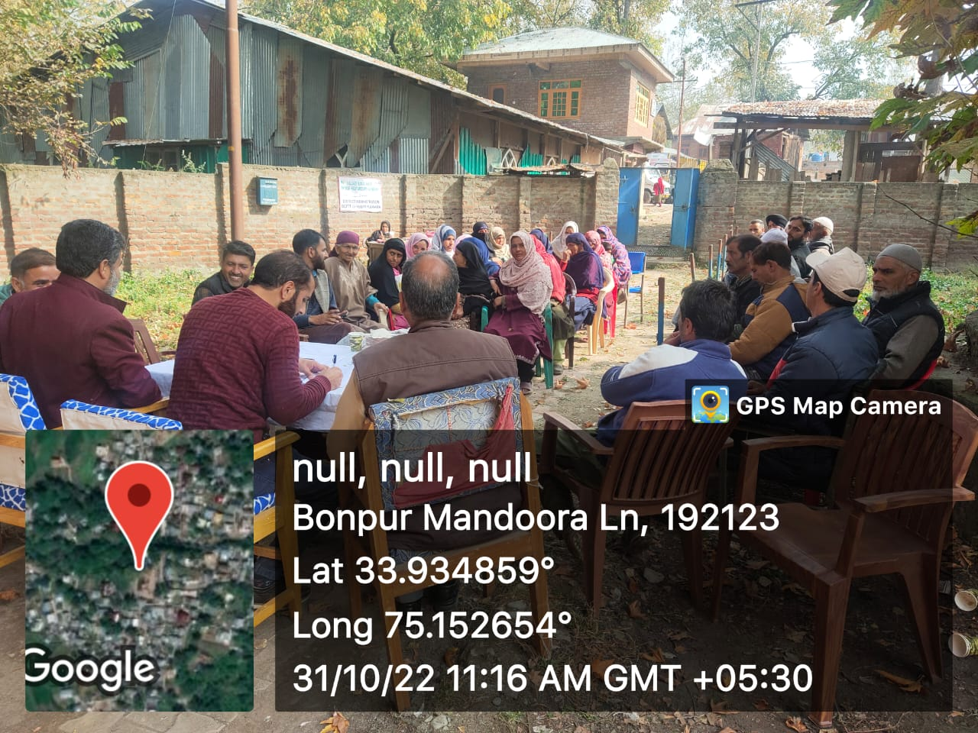

**DAY 2 ACTIVITIES**

**AGENDA 9**

**BAL SABHA**

Hold a balsabha and record proceedings

Total children in the village above the age of …..:- 463

Total attended :-72

Proceedings:_2

(Pl insert pointers to be discussed there – refer palli proceedings)

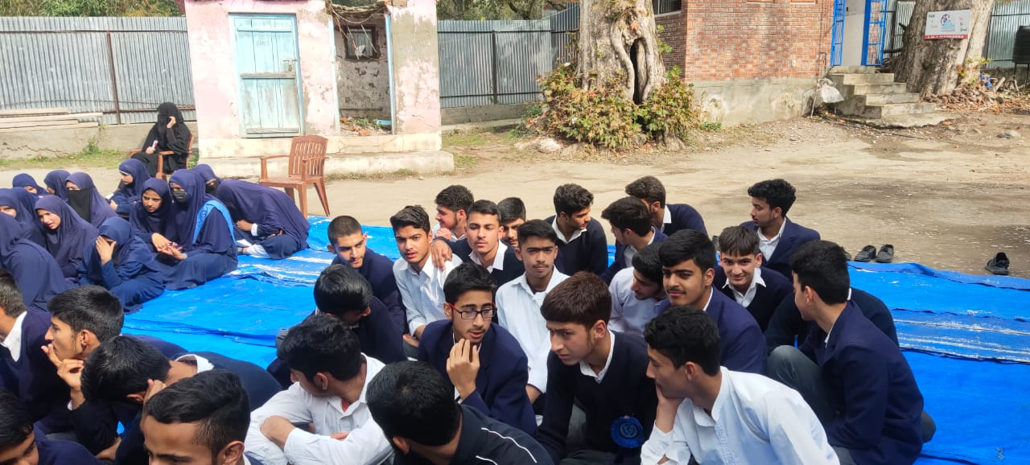

**DAY 2 ACTIVITIES**

**AGENDA 10**

**INAUGRATIONS**

|  |  |  |  |  |
| --- | --- | --- | --- | --- |
| **SR NO.** | **ASSETS /ACTIVITIES INAUGRATED** | **STATUS OF THE ASSET/ACTIVITIES (NUMBER, OTHER DETAILS)** | **GEO-TAGGED PHOTOS** |  |
|  | VILLAGE HAAT under JKSRLM (SUNDAY MARKET) | Stalls by different departments were being installed | Yes | C:\Users\Naikajaz\Desktop\PHOTOS B2V4\VILLAGE HAAT.jpg |
|  | PMAY houses if any ready for inaugration | Yes  H/O Ishfaq Ahmad Najar in good condition | Yes | C:\Users\Naikajaz\Desktop\PHOTOS B2V4\PMAY.jpg |
|  | Swachh gram projects- segregation sheds etc | Under Construction | Yes |  |
|  | Amrit sarovars | Mandura Naag under construction | Yes | C:\Users\Naikajaz\Desktop\PHOTOS B2V4\AMRIT SAROVAR.jpg |
|  | Sports kits | Carrom : 1 No.  Chess board:1 No. | Yes |  |
|  | Village cultural events | A drama serial was performed by students | Yes | C:\Users\Naikajaz\Desktop\PHOTOS B2V4\CULTURAL.jpg |
|  | JJM assets/projects | Over head tank under construction | Yes |  |
|  | Any other to be identified at district level | - | - |  |

**FOLLOW UP OF (B2V1, B2V2 & B2V3):(Pre filled excel sheet to be taken from district level/ and also to be downloaded from www.jkpanchayat.in)**

|  |  |  |  |
| --- | --- | --- | --- |
| S.NO. | Particulars | Action taken | Remarks # |
| 1. Urgent Public Requirements/ Demands- B2V1 | | | |
| 1: Approach road from village Mandura to High School Mandura via Dankard | | Yes | Completed |
| 2: Establishmment of khidmat centre for Mandura | | CSC established | Needs a Modal CSC |
| 3:Bore well with overhead tank for horticulture & drinking purpose | | Over head tank for drinking water under construction | For horticulture a deep borewell to be constructed yet |
| 4:Upgradation of High School to Hr. Sec. School | | No action taken |  |
| 5:Upgradation of sub centre to PHC | | No action taken |  |
| 6:C/O Govt. building for UPS Mandura | | No action taken |  |
| 7Establishment of food supply store at shitlan  8:C/o road from Chinar to Shitlan | | No action taken  Under Construction |  |
| 1. Urgent Public Requirements/ Demands- B2V2 | | | |
| 1: Borewell with overhead tank for irrigation of orchard & to full fill drinking facilities | | Work approved | But only for drinking purpose |
| 2: Regular power supply, replacement of faulty conductor providing transformers to Chukpora & Goriwan Mohalla | | No action taken |  |
| 3: C/O P bund on watal ara passing along side of village Mandura | | sanctioned | Completed |
| 4:Establishment of Govt. Mandi for better marketing of horticulture produce | | No action taken |  |
| 5:Utilization of Ground water for irrigation of orchard & agriculture land | | No action taken |  |
| S.NO. | Particulars | Action taken | Remarks # |
| 1. Major Problems – B2V1 | | | |
| 1:Water facility for horticulture | | No action taken |  |
| 2:C/O road from UPS Mandura to High School Mandura | | Executed in MGNREGA | Needs mecdamization |
| 3:Drinking water shortage | | Partially solved |  |
| 4: C/O irrigation canal running through the village leading to drinking water shortage | | No action taken |  |
| 1. Major Problems- B2V2 | | | |
| 1:Tap water facility not available to wani Mohalla No action taken | |  |  |
| 1. Major Problems- B2V3 | | | |
| 1Nil |  |  |  |
| 1. Major Complaints- B2V1 | | | |
| 1:Irritation electricity distribution at chukpora ,delaying in installation of new transformer at Badbagh & Junglepora | | Badbagh transformer installed |  |
| 1. Major Complaints- B2V2 | | | |
| 1:PDD & PHE departments not working to the expectations of general public | | Partially solved |  |
| 1. Major Complaints- B2V3 | | | |
| 1: Nil |  |  |  |

**OVERALL PERCEPTION OF FUCNTIONING OF GOVERNMENT DEPARTMENTS**

BEST DEPARTMENT:Rural development Department, Education, Social Welfare

LEAST RESPONSIVE:Nil

**GENERAL ASSESSMENT OF THE VISTING OFFICER**

|  |  |
| --- | --- |
| I | Any major complaint brought to the notice of the Visiting Officer: Material payment of various works pending till date |
|  |  |
| II | Major/ urgent public demands that was/ were reflected earlier but have not been addressed so far: |
|  |  |
| III | Overall assessment of the visit and suggestions:  (The visiting officer to ensure that the overall assessment is recorded in details along with concrete suggestions)  ***It is pertained to mention that among all frontline employees the work conduct & professionalism exhibited by the concerned Nodal Officer (GRS in RDD) is very good. The concerned nodal officer (GRS in RDD) is intelligent, efficient, experienced & dedicated . Therefore it is requested the service of contractual staff of MGNREGA should be regularized on priority basis &*** enhancement ***of monthly honorarium .Moreover mobility charges ,laptop should be provided them.***  ***A lot has been done at Pyt. Level , however massive budgetary provision needed to be made for various public works. It is suggested that the previos demands & commitments should be full filled on priority basis .***  ***The most departments have not executed the works which where reflected in earlier Back2 villages.***  ***Moreover higher grade of officials from different departments should be deputed , so that problems can be solved in Back2 Village programmes.***  Thanks |
| IV | Overall Rating of govt functioning as given by the Panchayat (Scale of 0 to 10): 7 |
| V | Certificate from Sarpanch that the visiting officer has stayed in the panchayat for 2 days |

Signature of Sarpanch Signature of the Visiting Officer

Name : Mukhtar Ahmad Gojjar Name: -Mohd Ramzan Mir

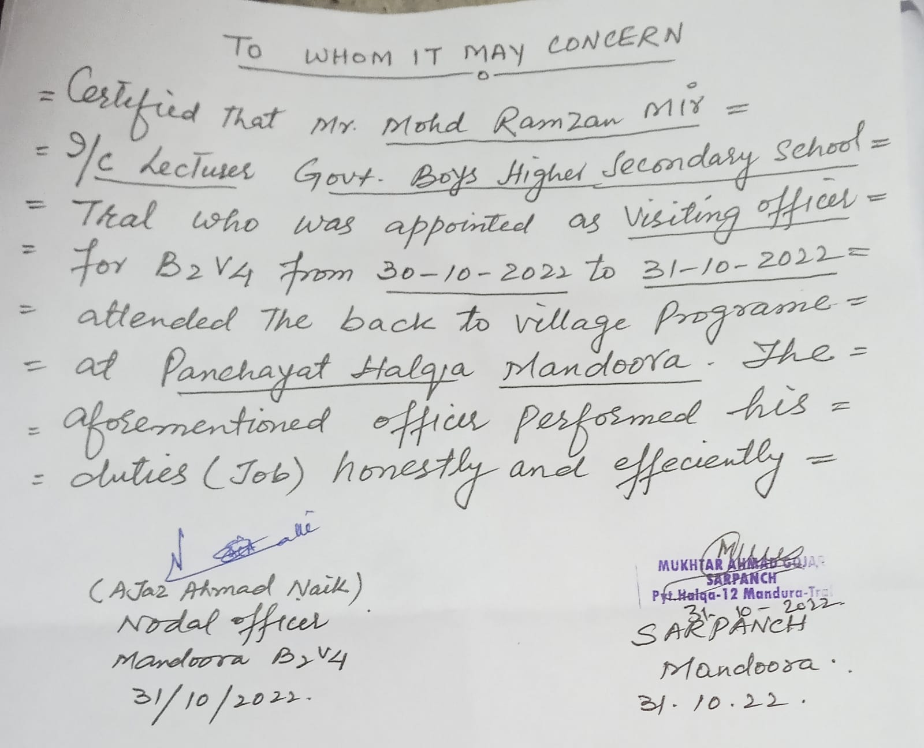

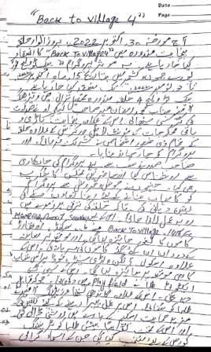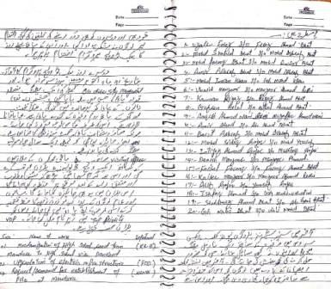

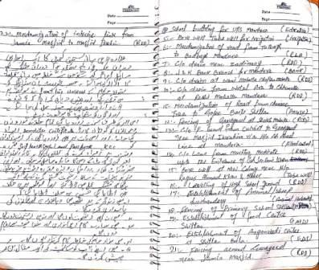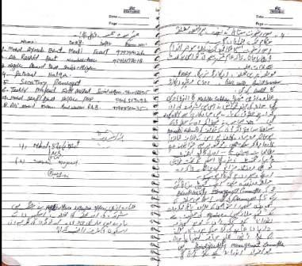

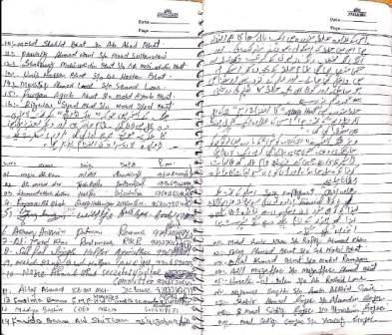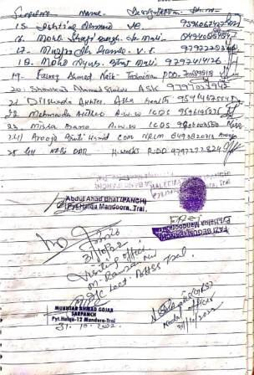

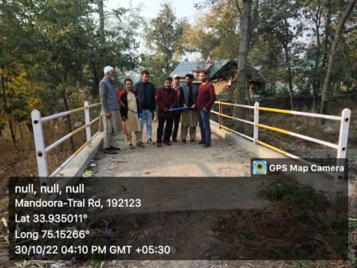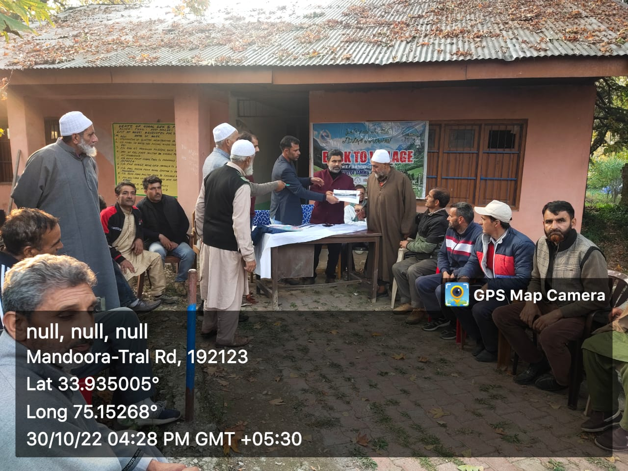

Distribution of land passbook

**Inauguration of culvert**

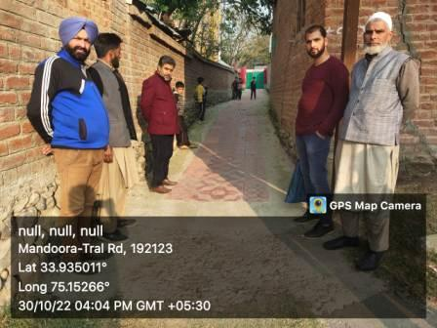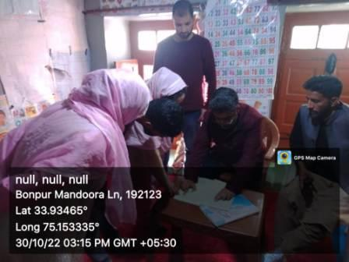

***B2V4 BOOKLET OF PANCHAYAT HALQA MANDURA PREPARED BY GRAM ROZGAR SAHAYAK (GRS) AJAZ AHMAD NAIK OF BLOCK TRAL***

Visit to anganwadi centre

**Inspection ofworkwork**