

4

**15TH OCT to 3RD NOV, 2022**

# KEY FEATURES

* Deputy Commissioners to lead the initiative
* Rural development Department to be the nodal department
* Planning Development & Monitoring department and IT to be the support departments

# ACTIONS AND TIMELINES

|  |  |  |  |
| --- | --- | --- | --- |
| **ACTION** | **RESPONSIBILITY** | **LATEST BY** | **REMARKS** |
| **Jan abhiyan** | All departments | Oct 15 -26th | Going on |
| **Deputation of Sectt staff/ HoDs** | GAD | Oct 14 | Done |
| **Deployment of Staff to Panchayats and serving of orders on deployed officers** | DCs | Oct 25 | DCs will deploy senior level staff from the districts. Strict action to be taken against abstentions. No exemptions to be given |
| **Training of district trainors on B2V4** | RDD | Oct 26 |  |
| **Training of visiting officers** | DCs | Oct 27 |  |
| **Field Visits to be completed by** | Visiting Officers | Nov 3 | DCs to supervise and ensure that each Panchayat is visited within the period specified |
| **Data of B2V4 to be uploaded by** | Visiting Officers | Nov 10 | DCs to supervise and ensure that data of all Panchayats is upload- ed by the visiting officer within the period specified |

**INSTRUCTIONS FOR THE VISITING OFFICER (DAY WISE)**

|  |  |  |
| --- | --- | --- |
| **DATE** | **INSTRUCTIONS** | **ACTION POINTS** |
| **Day 0** | Meeting with deputy commissioner and his/her team | 1. Take print outs of filled booklets of B2V1, B2V2 and B2V3 from [www.jkpanchayat.in](http://www.jkpanchayat.in/) 2. Also take print outs of the summarized excel sheets of the previous phases from [www.jkpanchayat.in](http://www.jkpanchayat.in/) 3. Collect ATRs on issues raised during previous 3 phases from the office of Deputy Commissioner (Planning deptt) 4. Take prints of blank 2 booklets of B2V4 from [www.jkpanchayat.in](http://www.jkpanchayat.in/) 5. Take plans for 2 previous years and ATRs from the planning deptt 6. Complete trainings on different components of B2V4 being organized by respective Deputy Commissioners 7. Collect List of new works started/ ongoing/ completed during the previous and current Financial year under the following heads:    * PRI grants    * District Plan    * UT plan    * MGNREGA    * Other schemes of other departments    * Any other work 8. Plans/ beneficiary lists:    * MGNREGA draft plan document for the year 2022-23.    * List of Awaas+ beneficiaries alongwith IHHL Convergence    * List of pension beneficiaries.    * List of SHGs    * List of agriculture scheme beneficiaries 9. Lists of beneficiaries for:    * Various certificates/ benefits to be distributed by the visiting officer.    * Any other activities identified by different departments |

|  |  |  |  |
| --- | --- | --- | --- |
| **Day 1** | Reach the village | 1. | Ensure that all front line workers of different deptts are present. |
| 2. | Ensure exhibition by different depts. about individual beneficiary schemes |
| 3. | Inspect JKB/PSB counters/outlets |
| 4. | Participate/ensure organization of sports activity in playfield, talent hunt/cultural event/youth activity |
| 5. | Gandhi Katha (suggested details uploaded on jkpanchayat.in) |
| 6. | Visit atleast 2 amritsarovars and get its geo tagged photos |
| 7. | Inspect Khidmat (CSC) Centres and create Generate awareness on 225 schemes particularly G2C schemes like BEAMS, Janbhagidari, AapkiZaminAapkiNigrani, Digital J&K |
| 8. | Visiting officer shall also plan and conduct panchayat level conver- gence meeting of all departments |
| 9. | Check effectiveness of Centrally sponsored schemes |
| 10. | Visit and inspect all government establishments including PHE, AWC, FPS, schools, etc |
| 11. | Attempt saturation of deliverable so Jan Abhiyan and wherever deficiencies found, lead a drive to achieve all deliverables |
| 12. | Assess effectiveness of sanitation campaign in the panchayat |
| 13. | Ensure self employment activities for 15 youth per panchayat |
| 14. | Identify 20 potential candidates per panchayat for HIMAYAT training alongwith the trade on which they want training |
| 15. | Wherever possible, distribute employment letters for people select- ed under various government employments |
| 16. | In the evening, hold normal meeting with senior citizens, govt em- ployees including retired employees, ex servicemen, youth club, and any citizens of the village who are enrolled in college/university |
| 17. | Open discussion on Nasha Mukt Abhiyan |

|  |  |  |
| --- | --- | --- |
| Day2 | Have a meeting with all stakeholders- deptt officials and panchayat members | 1. Discussion on the and assess the progress of different schemes relating to the localized SDGs prioritized for that village as per the resolution passed by that Gram Panchayat on 21st April 22, on National Panchayti Raj Day. 2. Sensitize village residents about myScheme” portal (myscheme.in) which includes information about all the schemes being run by Cen- tral/ State/ UT govt across the country 3. Hold meeting of the Biodiversity Management Committees to deliber- ate on issues pertaining to conservation of biodiversity and sustaina- ble utilization of biological resources. 4. Prepare Village development plan, in consultancy with Gram panchayat, discuss it in gram sabha and get it approved. 5. Ensure saturation of soil health card and golden health card under Gold- en Health Card under Ayushman Bharat, 6. Ensure saturation of Old Age Pension Scheme 7. Ensure Domicile Saturation. 8. Ensure KCC Saturation 9. Ensure saturation of land pass books 10. Ensure registration of village vendors needed for any scheme, on GEM portal 11. Ensure panchayat contractors registration 12. Encourage Panchayat members for importance of plantation drive in Panchayat under Har Gaon Hariyali 13. Ensure painting on digital J&K in panchayat ghars 14. Ensure painting on panchayat activites and CSS in panchayat ghars 15. The visiting office shall check no of kindergarten and playfields present in the panchayat for kids and students, if the infrastructure present in these are good enough. 16. Hold meeting with panchayat members to discuss about corruption menace and steps required to make J&K corruption free 17. Obtain a candid assessment about performance of various deptts in- cluding fair feedback about discrepancies in functioning 18. Check the status of Nasha Mukt Abhiyan and reporting of drug ad- dicts to Deputy Commissioner. 19. Identify Tourist Destinations, Circuits, Theme Treks, Identify Homestays, provide support for tourism activities through Village Cooperative 20. Organize Talent Hunt at Panchayat Level 21. Conduct social audit of atleast 5 works under following schemes:     1. MGNREGA     2. PMAY     3. IHHL toilets and payments     4. CSCs     5. AMRIT SAROVARS 22. Hold a mahilasabha and a balsabha and record proceedings in the for- mat given 23. Inaugurate village haat under JKSRLM 24. Check if youth clubs are formed in the panchayat and what activities they are engaged in 25. Organize a village level cultural event to engage panchayat members 26. Sensitize GP about E-kitab kosh an initiative of J&K Govt for empowering youths through online digital literacy |

# GENERAL INSTRUCTIONS

1. The visiting officer shall refrain himself/ herself giving or offering any commitment on behalf of the government and shall adopt an unbiased attitude in reporting issues. As far as possible, his/her observation should be based on a fair and analytical view emerging from his/her interaction in the village.
2. He is going to the village as planning officer, not for sanctioning any works or for making any com- mitments.
3. While preparing village development plan, he has to ensure that, demands are prioritized and re- flected under available schemes, wherever necessary the larger works are to be referred to adminis- trative deptt under CSS/UT plans under intimation to DCs and rest of the works to DCs for reflecting it under district/CSS plans
4. His work shall be hard core planning and audit and is not a PR exercise.
5. Every Deputy Commissioner has to ensure that atleast one RDD official (ideally Panchayat Secre- tary) is present in every panchayat with relevant panchayat records, to ensure conduct of all activi- ties as planned. Panchayat wise order needs to be issued in advance.
6. Visiting officer should ideally carry his/her laptop to complete the reports at the panchayat level itself and upload the final report, duly signed both by the sarpanch and by the visiting officer on [www.jkpanchayat.in](http://www.jkpanchayat.in/) portal, before they leave panchayat.
7. Focus of visit are youth, skills, self-employment, nasha mukt, bhrashtrachar mukt, Rozgar yukt J&K, besides to carry forward the activities during Jan Abhiyan and saturate them.
8. In addition attention may be given to the following areas
   1. Make full use of Centrally Sponsored Schemes
   2. Saturation of individual beneficiary schemes
   3. Self-employment schemes
   4. Bank linked schemes- including departmental subsidy schemes
   5. Empowerment and transparency through digital initiatives
   6. Effectiveness of grass roots machinery –
      1. Patwari, VLW present and available
      2. Available funds utilized in public interest and as per Gram Sabha resolutions
      3. Fairness in governance
      4. CSS/Individual beneficiary schemes etc
      5. BrashtacharMukt J&K
      6. Bhai Mukt J&K
      7. NashaMukt J&K
9. The PRI members (Sarpanchs, Panchs, BDC Chairperson) shall be at the forefront of all activities and given due importance and the approach should be to strengthen them and make them feel em- powered. He/she shall ensure that the BDC chairperson and Sarpanch/Panch are present at the time of inauguration and ceremonies.
10. Visiting officer shall not leave the district without uploading the report, duly signed on the [**www.**](http://www/) **jkpanchayat.in** portal. Every Deputy Commissioner has to ensure that.

## Details of Reporting Officer:

Name: RAJAN GUPTA

Designation: Chief Engineer

Department/ place of posting: PDD/CVPPPL

Mobile No: 9419141094

Email ID: [rajan65@gmail.com](mailto:rajan65@gmail.com)

Home District: Jammu

Dates of visit: 28th and 29th of Oct’22

## Locational details of Panchayat: (to be pre-filled, information to be taken from the previous phases booklets/summarized excel sheet uploaded on jkpanchayat.in/b2v4.php) (to be vali- dated by the visiting officer and missing details to be filled)

Name of the Panchayat: Azamabad

Local Government Directory(LGD) code of the Panchayat: 7437

Name of CD Block: Mandi

Name of Tehsil: Mandi

Name of District: Mandi

## Panchayat Profile:

No. of revenue villages in the Panchayat: 1

No. of hamlets in the Panchayat: 11

No. of households in the Panchayat: 860

Population (approx) of the Panchayat: 4245

# Part-II:

(To be filled up by the Visiting Officer during his/her two day visit to the Panchayat. All Fields have to be filled by the Visiting Officer before the booklet is handed over to the DC

## Frontline Officers/Officials who were assigned to the Panchayat for the programme:

|  |  |  |
| --- | --- | --- |
|  | Name | Designation |
|  | Sh. Manzoor Hussain | Sarpanch |
|  | Ms. Suraya Sartaj | Naib Sarpanch |
| RDD | Sh. Ashraq Hussain | Pvt Sec. |
| RDD | Sh. Shakoor Hussain | APP |
| RDD | Sh.Shakeel Ahmed | GRS |
| RDD | Sh. Mohd Rashid | Tech Asst. |
|  | Sh. Gulam Nabi | Numberdar |
|  | Sh.Zaheer Ahmed Khan | Patwari |
|  | Sh. Mohd Din | Headmaster |
|  | Sh. Azam Rather | TSWO |
| PDD | Sh. Javaid Iqbal Malik | JE |
| PDD | Sh. Ghulam Mohd | L/M |
| Jal Shakti | Sh. Mohd Hanief | JE |
| Agri. Deptt | Sh. Devinder Sharma | JAA |
| Horticulture Deptt. | Sh. Mohd. Farid | Tech |
|  | Dr. Shazia Zafar |  |
|  | Dr. Ishtiaq Ahmed Dar | Vet Asst. Surgeon |
|  | Sh. Adil Shabir |  |
|  | Ms Rubia Kouser | Asha worker |
|  | Dr. Qayoom Mandi | MO |
|  | Sh, Mohd. Afzal Malik | Dealer |
| PHE | Sh. Mohd, Akram | L/M |
|  | Sh. Attaullah Niyazi | Forest Gaurd |
|  | JKB Mandi |  |
|  | Sh, Shagun Hearty | Bank Official |
|  | Sh. Mohd Younis | CSC VLE |
|  |  |  |

**Details of absent employees vis-à-vis list furnished by the DC office:**

|  |  |  |
| --- | --- | --- |
| Department | Name | Designation |
| RDD | Sh. Mohd Rashid | Tech Asst. |
|  | Sh.Zaheer Ahmed Khan | Patwari |
|  | Sh. Azam Rather | TSWO |
| Agri. Deptt | Sh. Devinder Sharma | JAA |
| Horticulture Deptt. | Sh. Mohd. Farid | Tech |
|  | Dr. Ishtiaq Ahmed Dar | Vet Asst. Surgeon |
|  | Sh. Adil Shabir |  |
|  | Sh. Attaullah Niyazi | Forest Gaurd |
|  |  |  |
|  |  |  |
|  |  |  |
|  |  |  |
|  |  |  |
|  |  |  |
|  |  |  |
|  |  |  |

# DAY 1- ACTIVITIES

## AGENDA 1: PANCHAYAT ASSET REGISTER

**Infrastructure:**

|  |  |  |
| --- | --- | --- |
| 1. | Panchayat Ghar Infrastructure   1. Govt building/~~private~~ 2. ~~New~~/needing repairs | Needing Repairs |
| 2. | Furniture (Y/~~N~~) | Yes |
| 3. | Computer/printer (~~Y~~/N) | No |
| 4. | Internet (Y/N) | No |
| 5. | Telephone (Y/N) | No |
| 6. | Toilet (CSC/part of panchayat ghar) (Y/N) | Non Functional |
| 7. | Water (Y/N) | No |
| 8. | Electricity (Y/N) | Yes |
| 9. | Bank branch (Y/N) | No |
| 10. | CSC (Y/N) | Yes |
| 11. | Patwarkhana (Y/N) | No |
| 12. | Village haat (Y/N) | No |
| 13. | Playground (Y/N) | No |
| 14. | School- |  |
|  | a. Kindergarten (Y/N) | No |
|  | b. Primary (Y/N) | 05 +03 Middle |
|  | c. Secondary (Y/N) | No |
|  | d. College (Y/N) | No |
|  | e. University (Y/N) | No |
| 15. | Anganwadi Centre (Y/N) | Yes 16 Nos |
|  | a. (govt/private) | Private |
|  | b. Total children enrolled | 742 |
| 15. | Amrit Sarovars – details, location, condition | No |

1. Government offices- details, whether functional or not Yes
2. Ration shop (Y/N) Yes (Private)
3. Places oftourism importance– names, little details on historical/cultural importance- NoorPur, Nehrian
4. Village heritage sites/ treks- names, little details on historical/cultural importance - Datti Baba, Baba Abdullah Baghdadi, Zairat Shastaar
5. VLW Office (Y/N) Yes
6. Primary Healthcare Centre (Y/N) Yes
7. List of Incomplete Buildings- names, year of construction -
8. List of Underutilized Buildings- names Nil

# DAY 1-ACTIVITIES

## AGENDA 2:

**DIFFERENT INSTITUTIONS/INFRASTRUCTURE PROJECTS TO BE VISITED**

|  |  |  |
| --- | --- | --- |
| **AMRIT SAROVARS** | **Visit, verify** | **COMMENTS** |
| Khidmat Centres /CSC Centre | Create /Generate awareness on 225 schemes particularly G2C schems Aapki Zamin Aapki Nigrani, Beams, Janbhagidari, Digital J&K | All the services are provided by Model CSC VLE but peoples of said village need awareness of online schemes. |
| JKB/PSB counters/outlets | 1. Status of counter 2. Number of visitors 1800-2000 Per Day | JK Bank is in Mandi Panchayat There are 09 Counters |
| Incomplete buildings/pro- jects | Verify whether identification and redistribution done | Mandi Byepass Bridge and Indoor Stadium. |
| PDS | Visit, evaluate, online status | Yes 03 Nos ( Private) |
| PHC | Visit- evaluate, status of staff, equipment and quality | NTPHC Azamabad. Shortage of staff,equipment and without electricity and run by 4th class employees and without MO |
| Youth clubs | Meet, interact, seek suggestions | Nil |
| SHG | Meet, identify problems, seek suggestions | 55 Members. Need Building |
| PMAY | Inspect, Inaugurate | Total 414 and completed 110 |
| My school, my pride progress; schools- water, toilets, staff | Visit, check for water, electricity, sanitation, meet students and staff | Most of the school buildings are in bad condition. Toilet and water facility not available / defunct wherever available. Shortage of staff in most of the schools, 1-2 teachers teaching all subjects.  Without Headmaster |
| Swachh SBM | Evaluate | 768 Created |
| Panchayat play  ground, Sports kits distribution Village | Ensure, verify. Participate in at least one game in the playground | Play ground not available in pancayat Azamabad. |



4

|  |  |  |
| --- | --- | --- |
| Har Gaon Hariyali, Plantation drive | Evaluate status, feedback | Yes, Some plantation done by forest department. |
| Village cultural event Dangal/ Haat/Mela | Participate in; ensure that it is held | Play ground not available. One cultural event held today |
| Exhibition of schemes | Ensure that every department participates and that it continues for the entire duration of B2V | Products made by Self-help group were displayed. |
| Jal Jeewan Mission verifica- tion- WSS/JSD  Electricity supply | Verify | Under tendering process.  Electricity supply is satisfactory |

# DAY 1 - ACTIVITIES

## AGENDA 3: SATURATE JAN BHIYAN DELIVERABLES AND RECORD DEFICIENCIES IF ANY (INSERT

**DELIVERABLES LIST HERE AS PER GAD FORMAT**

# DAY 1- ACTIVITIES



4

## AGENDA 4:

**SELF EMPLOYMENT ACTIVITIES**

Ensure Self-employment activities for youth, distribute employment letters for people selected under various social schemes (15 IS THE TARGET PER PANCHAYAT)

## Number of cases in different categories sanctioned :

14 Accounts

## Details of the bank sanctioning it : JKB Mandi

**Total amount involved :** 35 Lacs

# DAY 1 ACTIVITIES

## AGENDA 5

In the evening, hold informal meetings with senior citizens , govt employees, retd employees, youth club and other citizens who are enrolled on college/university and have discussion on Gandhi Katha, Nasha Mukt Abhiyan, corruption free governance, doubling farmers income and record the proceedings

## DAY 2

1. No of Individual Compost Pits constructed Nil
2. No of Individual Soak Pits constructed 649
3. No. of Biodiversity management committee meetings held: Nil
4. IsthenameofSarpanchdisplayedoncitizeninformationboardsofallRD&PRschemes:Yes/No- Yes
5. Are Sarpanch being involved in start/inauguration of activities: Yes/No Yes
6. Whether subjects have been assigned by the Sarpanch to the Panch: Yes/No Yes
7. Whether grievances redressal box is installed: Yes/No Yes
8. No of grievances received pertaining to Panchayat level: NIL
9. No of grievances disposed of at Panchayat level: Nil
10. Whether the Sarpanch/Panchayat Secretary have digital signatures: Yes/No Yes
11. Whether all MGNREGA/ 14th FC payments are being made by Sarpanch through Digital Signature Certificate (DSC): Yes/ No - Yes

# HUMAN RESOURCE AVAILABLE AT THE PANCHAYAT LEVEL:

|  |  |  |  |  |
| --- | --- | --- | --- | --- |
| **SR NO.** | **DEPARTMENT WISE STAFF** | **NUMBERS** | | **NAMES** |
|  |  | SANCTIONED | ACTUAL |  |
| Rural development department: |  | 01  02  01  01 | Akansha Gupta Rohit Sharma Shakeel Ahmed Mohd Rashid |
| BDO |
| JE |
| GRS |
| TA |
| SCHOOL EDUCATION: TEACHER  HEAD MASTER ANY OTHER | Record not available | 30  03  01 | Sajad Ahmed Rehbar E Khel |
| JAL JEEVAN: |  | 02 | Amar Din |
|  |  | Mohd Hanief |
| PDD: LINEMAN JE  ANY OTHER |  | 01  01  01  02 | Arshad Hussain Shah Javed Iqbal Bahar Mohd Rafiq Manzoor Hussain |
| FOOD & CIVIL SUPPLIES |  | Private 01 | Mohd Afzal Khan |
| AGRICULTURE & ANIMAL HUS- BANDARY |  | 06 | Vishal Gupta JAEO, Mohd Rashid JAEO, Aunis Suhail AEA, Susheel Kumar AEA, Nazir Hussain FA, Amar Pal Singh AEA. |
| SOCIAL WELFARE |  |  | *No record available* |
| HEALTH: |  |  |  |
| ASHA ANM  AYUSH DOCTOR | 01  01  01 | Nagina Akhter  Zenuka Gupta ,Shamas Din Pharmasist ,Shenaz Akhter PTC |
| ALLOPATHIC DOCTOR | Nil |  |



ANY OTHER DEPARTMENT

4

**DAY 2-ACTIVITIES**

## AGENDA NO.1

Discussion on the and assess the progress of different schemes relating to the localized SDGs prior- itized for that village as per the resolution passed by that Gram Panchayat on 21st April 22, on National Panchayati Raj Day (Copy of the resolution to be taken from [www.jkpanchayat.in](http://www.jkpanchayat.in/) portal under the link of Gram Swaraj Month)

* 1. SDGs AGREED FOR THAT VILLAGE, TO BE IMPLEMENTED BY MARCH2024: No Record available
  2. STATUS OF WORKS UNDER THE FOLLOWING SCHEMES:

1. **Clean and green village**
2. Initiatives taken by the Panchayat for managing Solid and Liquid Waste Soak Pits are being constructed and compost pits are under estimation
3. Initiatives taken by the Panchayat for using green sources of fuel like solar, biogas Nil
4. Has mapping of land use, water bodies, forest, slopes, wet lands, degraded forest within the Gram Panchayat been done? Yes/No. If No, reason, thereof No, Not started in Mandi block yet.
5. Has the Climate Resilience Plan been developed for the GP? Yes /No NO
6. Steps taken by the Gram Sabha about the climate change mitigation factors like reducing energy consumption, usage of fossil fuels, plastics, non-renewable building materials and also to promote measures like planting of trees, conserving forests, usage of good agricultural practices like drip irrigation, water conservation measures and conservation of wetlands NIL
7. Whether schools have started segregating waste NO
8. Whether schools have their own compost/soakage pits for solid/liquid waste management NO
9. **Healthy village**
10. Are meetings related to Village Health and Sanitation Committee being held regularly? NO
11. Do all the eligible individuals been provided the Golden Card? Under Progress
12. Are all the Children being immunized as per the Schedule recommended by Govt. of India? Yes
13. Are all the eligible individuals been vaccinated against COVID-19? Yes
14. Does Gram Panchayat ensure that all pregnant women are getting necessary prenatal checkups? Yes
15. Whether all the deliveries were Institutionalized or conducted by trained Midwives? Yes
16. **Water sufficient village**
17. Do all the IHHs in the Gram Panchayat have water pipeline connections? No
18. Whether Gram Panchayat has taken steps for grey water management. If Yes please specify

NO

1. Do all the IHHs in the Gram Panchayat have toilets? NO
2. Are all the IHHs toilets functional or not? NO Partially
3. Do all the Schools/Anganwadi centers have a toilet facility or not? NO
4. Are all the toilets in the schools/Aaganwadi functional or not? Partially
5. Whether Gram Pachachayat Bhawan has separate toilets for women or not?
6. **Child Friendly village**
7. Do all the children under the age of 0-6 years been enrolled in the Anganwadi centers for pre- schooling? Yes/NO YES
8. How many Bal Sabha’s were organized in the Gram Panchayat NIL
9. Whether the issues raised by Bal Sabha are addressed during the Gram Sabha. Yes/NO NIL
10. Whether Gram Panchayat is tracking the data related to dropout children and children with irregular attendance? Yes/NO NO
11. Do all the schools under the Gram Panchayat have separate toilets for girls and boys? Yes/No NO
12. **Village with good governance**
13. Is CSC located in the Gram Panchayat Bhawan or not? Yes
14. Is the list of beneficiaries related to the Schemes/Programs displayed on the Gram panchayat wall or not? Yes
15. Does the Gram Panchayat has its building or not? Yes
16. Is the Gram Panchayat office functional or not? Yes
17. Are the activities approved under the Halqa Panchayat Development Plan displayed on the Gram Panchayat wall or not?-

- - -NO

1. Is Social Audit of earlier Schemes/Programs carried out or not? NO
2. **Poverty free and enhanced livelihood village**
3. Has Gram Panchayat developed any criteria for the identification of the poor? Yes/No if yes specify NO
4. ii) Have all the eligible households registered in PDS or not? No
5. Has Gram Panchayat provided space for Self-help Groups in PanchyatGhar for holding meetings or not?- No
6. Have all the eligible households been registered for Pension or not? Record not available
7. Has Gram Panchayat facilitated Youth for Skill Enhancement Courses and Placement? No
8. Has Job Cards been distributed to all the eligible individuals under MGNREGA? Yes Total 805 , Issued

799 and active 697 Pending 200 for verification.

1. Has Gram Panchayat facilitated SHGs for Bank Account Linkages? Yes 55 Members
2. **Socially secured village**
3. Whether Gram Panchayat is maintaining data related to Differently Abled People? No
4. Is Gram Panchayat Office Disabled Friendly or not? No
5. Are provisions for a separate Budget under the Resource Envelope for Women and Children made or not?- No
6. Do all the Schools in the Gram Panchayat have facilities for Differently Abled Children like toilets, barrier-free access, etc., or not? No
7. Are all the eligible individuals are getting pensions, like old age pension, widow pension, etc? Yes
8. Are all the eligible households getting benefits from IAY or not?
9. **Engendered Development in Village**
10. How many Mahila Sabha’s were organized in the Gram Panchayat Nil. One No

Today.

1. Whether SHGs federations have been provided space for meetings in the Panchayat Bhawan (Yes/ No) No
2. Whether GPs have taken steps for increasing women’s participation in Gram Sabha(Yes/No)-

-No

1. Number of women beneficiaries headed households covered under PDS-

Nil system………………………

1. Number of beneficiaries (out of total eligible population) receiving social protection benefits under Pradhan Mantri Matritva Vandana Yojana Nil
2. Self-sufficient infrastructure in the village
3. Whether GP has a Community Hall with access to electricity, furniture, water supply, toilet No
4. Whether the Disaster management plan is available at the GP Level (Yes/No) -

--NO

1. Whether child-friendly park with required facilities is available in GP (Yes/No) -

---NO

1. Whether the GP has easy access to Godown for storage (Yes/No) NO
2. Whether street lights are provided in public places for ensuring safety (Yes/No)-

---NO

# DAY 2 ACTIVITIES

## AGENDA NO.2

Sensitize village residents about myScheme” portal (myscheme.in) which includes information about all the schemes being run by Central/ State/ UT govt across the country

*(Scheme Material available from https://jkpanchayat.in/b2v4.php)*

# DAY 2 ACTIVITIES

## AGENDA NO.3

Hold meeting of the Biodiversity Management Committees to deliberate on issues pertaining to conserva- tion of biodiversity and sustainable utilization of biological resources. He should check People Biodiversity register (PBR) of that panchayat and review if Biodiversity Management Committee constituted for that panchayat is holding minimum 4 meetings in a year and meeting once in every 3 months *(Role of BMC available at https://jkpanchayat.in/b2v4.php)*

COMMITTEE MEMBERS PRESENT

BIODIVERSITY REGISTER PHOTOS

PAST 4 MEETING DETAILS- DATES, MINUTES PHOTOS

No record available

# DAY 2 ACTIVITIES

## AGENDA 4

Visiting officer shall also plan and conduct panchayat level convergence meeting of all departments and prepare Village development plan for village, in consultancy with Gram panchayat, discuss it in gram sabha and get it approved.

(GPDP format available on https://jkpanchayat.in/b2v4.php)

Attached as Annexure 1

## In addition GPDP plan shall also include :

Tourist places which need to be developed Nehrian Noorpur(road required from main road

Azamabad Karran to noorpur Via Peeruwala to connect Budda Amarnath with Noorpur. Road Connectivity to Mughal Dab Park.

Specific product which needs to be developed … Apple , Walnut and Potato.



Tourism- home stays… Tourist Hut Ziarat Shastaar , Mughal Dab Park Jallian, Tourist hut at Karran Nakka. 20 candidates for training under Himayat scheme alongwith trade in which

training is to be given Yet to be identified by RDD as no candidate

came forward during the visit.

# DAY 2 ACTIVITIES

## AGENDA 5

Ensure saturation of following schemes and give status:

|  |  |  |  |
| --- | --- | --- | --- |
| **NAME OF THE SCHEME** | **TOTAL ELIGIBLE BENEFICIARIES IN THE VILLAGE** | **TOTAL BENEFICIARIES WHO AVAILED THE BENEFITS OF THE SCHEME** | **REASONS FOR PENDENCY** |
| Golden Health Card under Ayushman Bharat | Record not available | Record not available | 115 pending Aadhaar card and Mobile number Issue |
| Janani suraksha yojana | Record not available | Record not available |  |
| OLD AGE pension | 220 | 170 | Departmental Issue |
| Widow pension | 50 | 39 | Do |
| Disability pension | 60 | 49 | Do |
| Domicile certificate | Record not available | Record not available |  |



4

|  |  |  |
| --- | --- | --- |
| Kisan credit card |  | 04 Accounts (35 Lacs) |
| PM kisan samman nidhi | 342 | 342 |

|  |  |  |  |
| --- | --- | --- | --- |
| Land pass book | 783 | 03 issued today | Land passbooks are under process. |
| Registration of village vendors on GEM | Record not available | |  |
| Registration of village contractors on | Record not available | |  |
| Registration of village contractors on PWD | 15 | 12 |  |
| Incomplete buildings/pro- jects | Indoor Stadium and Mandi byepass Bridge | |  |

# DAY 2 ACTIVITIES

## AGENDA 6

**NASHA MUKT ABHIYAN**

* 1. Whether gram sabha resolution passed Yes
  2. Details of activities conducted Door to door visit for awareness of Nasha Mukhti by

Sarpanch and his team in village Azamabad at Auto Stand Mohalla Karran and Jallian.

* 1. Whether all activities and GS resolution uploaded on jkpanchayats.in portal No
  2. How many drug addicts in the village Not known
  3. Whether reported to the Deputy Commissioner No
  4. How many registered for rehabilitation under government programme Nil

# DAY 2 ACTIVITIES

## AGENDA 7 SOCIAL AUDIT

Conduct social audit of atleast 5 works each under following schemes:

|  |  |  |  |  |  |  |
| --- | --- | --- | --- | --- | --- | --- |
| NAME OF THE SCHEME | DETAILS OF THE WORKS | YEAR OF WORK APPROVAL | AMOUNT APPROVED FOR THE WORK | WHETHER  WORK EXECUTED SATISFACTORILY | GEO- TAGGED PHOTOS | ANY GRIEVANCE RECORDED RELATING TO THAT WORK |
| MGNREGA | 1-Soak Pit Faqeer Mohd 2-Soak Pit Nafa Makhdoomi 3- Soak Pit Wali Mohd  4-Soak Pit Mohd Rashid 5-Soak Pit Abdul Kabir | 2022-23 | 2270 Each | Yes | Yes | No |
| PMAY | 1 -Bashir Ahmed   1. Ghulam Mohd 2. Abdul Ahmed 3. Ghulam Mohd 4. Mohd Latief | 2020-21 | 1.30 Lacs Each | Yes | Yes | No |
| IHHL  UNDER SBM-G | Nazir Hussain Mohd Rashid Asif Latief Sharifa Begum | 2019-20 | 12000 Each | Yes | Yes | No |
| CSC UNDER SBMG | Nil | Nil |  |  |  |  |

|  |  |  |  |  |  |  |
| --- | --- | --- | --- | --- | --- | --- |
| 4 |  |  |  |  |  |  |
| AMRIT SAROVARS | Nil |  |  |  |  |  |

# DAY 2 ACTIVITIES

## AGENDA 8 MAHILA SABHA

Total women in the village above the age of 18 Record not available/ provided

Total attended 25

Proceedings:

BDO Ms. Akanksha Gupta had an interaction with women present. Made them aware about various schemes and how to utilize them. Gave them information about ‘Umeed’ scheme and how to participate in various Self Help Groups. Information was provided regarding Gov. Flagship Programme ‘Beti

Bachao Beti Padhao’

*(Pl insert pointers to be discussed there – refer palli proceedings)*

# DAY 2 ACTIVITIES

## AGENDA 9 BAL SABHA

Hold a balsabha and record proceedings Nil

Total children in the village above the age of Total attended-------

Proceedings:

Children didn’t turn up for participation

*(Pl insert pointers to be discussed there – refer palli proceedings)*

# DAY 2 ACTIVITIES

**AGENDA 10 INAUGURATIONS**

|  |  |  |  |
| --- | --- | --- | --- |
| **SR NO.** | **ASSETS /ACTIVITIES INAUGRATED** | **STATUS OF THE ASSET/AC- TIVITIES (NUMBER, OTHER DETAILS)** | **GEO-TAGGED PHOTOS** |
|  | VILLAGE HAAT under JKSRLM (SUN- DAY MARKET) | 0 |  |
| PMAY houses if any ready for inaugra- tion | NIL |  |
| Swachh gram projects- segregation sheds etc | 0 |  |
| Amrit sarovars | - | - |
| Sports kits | - | - |
| Village cultural events | No. One no held today | - |
| JJM assets/projects | - | - |
| Any other to be identified at district level | Development work of one Children Park in Ward No. 01 started | Yes |

# FOLLOW UP OF (B2V1, B2V2 & B2V3):



4

*(Pre filled excel sheet to be taken from district level/ and also to be downloaded from* [*www.jkpanchayat.in)*](http://www.jkpanchayat.in/)

|  |  |  |  |
| --- | --- | --- | --- |
| S.NO. | Particulars | Action taken | Remarks # |
| I. Urgent Public Requirements/ Demands- B2V1 | | | |
| 1 | Construction of road from karran to peeruwala. | Not Constructed yet | Funds not available |
| 2 | Water lift scheme from jallian to irrinar. | Pending | Funds not available |
| 3 | Upgradation of MS Azamabad to High School Level | Pending | Funds not available |
|  | Not Constructed yet |  |
| 4 | Road from Sib to Jallian |
| 5 | Water lift scheme Mohalla Tarkhana To Shala pathar | Pending | Funds not available |
| 6 | Road from azamabad to khyber | Not Constructed yet | Funds not available |
|  | Pending | Funds not available |
| 7 |  |
| Supply / Sanctioning 200 electric poles. |  |  |
| II. Urgent Public Requirements/ Demands- B2V2 | |  |  |
| 1 |  |  | Record not available  /uploaded on portal |
| 2 |
| 3 |
| 4 |
| 5 |
| 6 |
| 7 |
| S.NO. | Particulars | Action taken | Remarks # |
| III. Major Problems – B2V1 | | | |

|  |  |  |  |  |
| --- | --- | --- | --- | --- |
| 1 |  | MGNREGA funds not provided as per projection of GP |  | 4  Not provided as per projection. |
| 2 |  | Land compension of Azamabad Tarkhana to Gali Azmabad patch of road not provided. | Pending | Funds Awaited |
| 3 |  | Black topping of above road awaited, people creaing problems due to non payment of compensation. | Pending | Funds Awaited |



4

|  |  |  |
| --- | --- | --- |
| 4 | Non availability of fruit processing/preservation units in GP | Pending |
| 5 | Illogical distribution of educational zones and inclusion of schools in Sathra zone M/S Makru in Mandi Zone | No action taken yet. |
| IV. Major Problems- B2V2 | | |
| 1 |  | Record not available  /uploaded on portal |
| 2 |
| 3 |  |  |
| 4 |  |  |
| 5 |  |  |
| V. Major Problems- B2V3 | | |
| 1 |  | Record not available  /uploaded on portal |
| 2 |  |  |
| 3 |  |  |
| 4 |  |  |
| 5 |  |  |
| VI. Major Complaints- B2V1 | | |
| 1 | 100 days gurantee employment under MGNREGA scheme is not provided. | 40 % received during last two years |
| 2 | Minimum income support to poor farmers under pmkissan samman nidhi yojna, | Partially Received and is ongoing process |
| 3 |  |  |
| VII. Major Complaints- B2V2 | | |
| 1 |  | Record not available  /uploaded on portal |
| 2 |  |  |
| **BA**3**CK TO VILLAGE PHASE** | **-IV (15TH OCT TO 3RD NOV)** | | **25** |



4

|  |  |  |  |
| --- | --- | --- | --- |
| VIII. Major Complaints- B | 2V3 |  |  |
| 1 |  |  | Record not available  /uploaded on portal |
| 2 |  |  |  |
| 3 |  |  |  |

**BACK TO VILLAGE PHASE-IV (15TH OCT TO 3RD NOV)**

| **25**

# OVERALL PERCEPTION OF FUCNTIONING OF GOVERNMENT DEPARTMENTS



4

## BEST DEPARTMENT: RDD and PDD

1. **LEAST RESPONSIVE DEPARTMENT: Irrigation and Flood Control**

# GENERAL ASSESSMENT OF THE VISTING OFFICER

|  |  |
| --- | --- |
| I | Any major complaint brought to the notice of the Visiting Officer:   1. Demarcation of forest land is urgently required. 2. Registration of left out beneficiaries under PMAY-G is required for which portal may be made active. |
| II | Major/ urgent public demands that was/ were reflected earlier but have not been addressed so far:  All the demands reflected in B2V1 have not been addressed yet. |
| III | Overall assessment of the visit and suggestions:  (The visiting officer to ensure that the overall assessment is recorded in details along with concrete suggestions)  The u/s visited various schools ( PS & MS), Sub centre, NTPHC, wards of Azamabad Panchayat along with Sarpanch, his team and local public and found that most of the schools are in pathetic condition especially PS which also seems very unsafe for small children. Boundary wall is required in most of the schools. Besides there is acute shortage of staff in school. As a result only 1 teacher is found teaching all subjects. Toilet wherever available in schools are found non – functional.  NTPHC is without internal wiring and electricity. Besides at present it is run by one 4th class employee and two and is without MO.  All the govt. departments operating in the village are trying their best to provide their services within available limited resources. Free Ayush medicines were also distributed among Azamabad villagers during the visit.  Awareness of various schemes for general masses is required in more effective manner with |
| IV | Overall Rating of govt functioning as given by the Panchayat (Scale of 0 to 10)…..08 |



4

|  |  |
| --- | --- |
| V | Certificate from Sarpanch that the visiting officer has stayed in the panchayat for 2 days  It is certified that visiting officer Sh. Rajan Gupta, CE, PDD/CVPPPL has stayed in Panchayat Azamabad, Block Mandi on 28th, 29th. and 30th of Oct’22 during his B2V4 visit. |

Panchayat Azamabad ,Block Mandi is very vast in area having eleven wards and population of 4245 .There is a major demand from PRIs and general public that it should be bifurcated into 2-3 panchayats.

## Signature of Sarpanch Signature of the Visiting Officer

**Name – Manzoor Hussain Name – Rajan Gupta Chief Engineer PDD/CVPPPL**

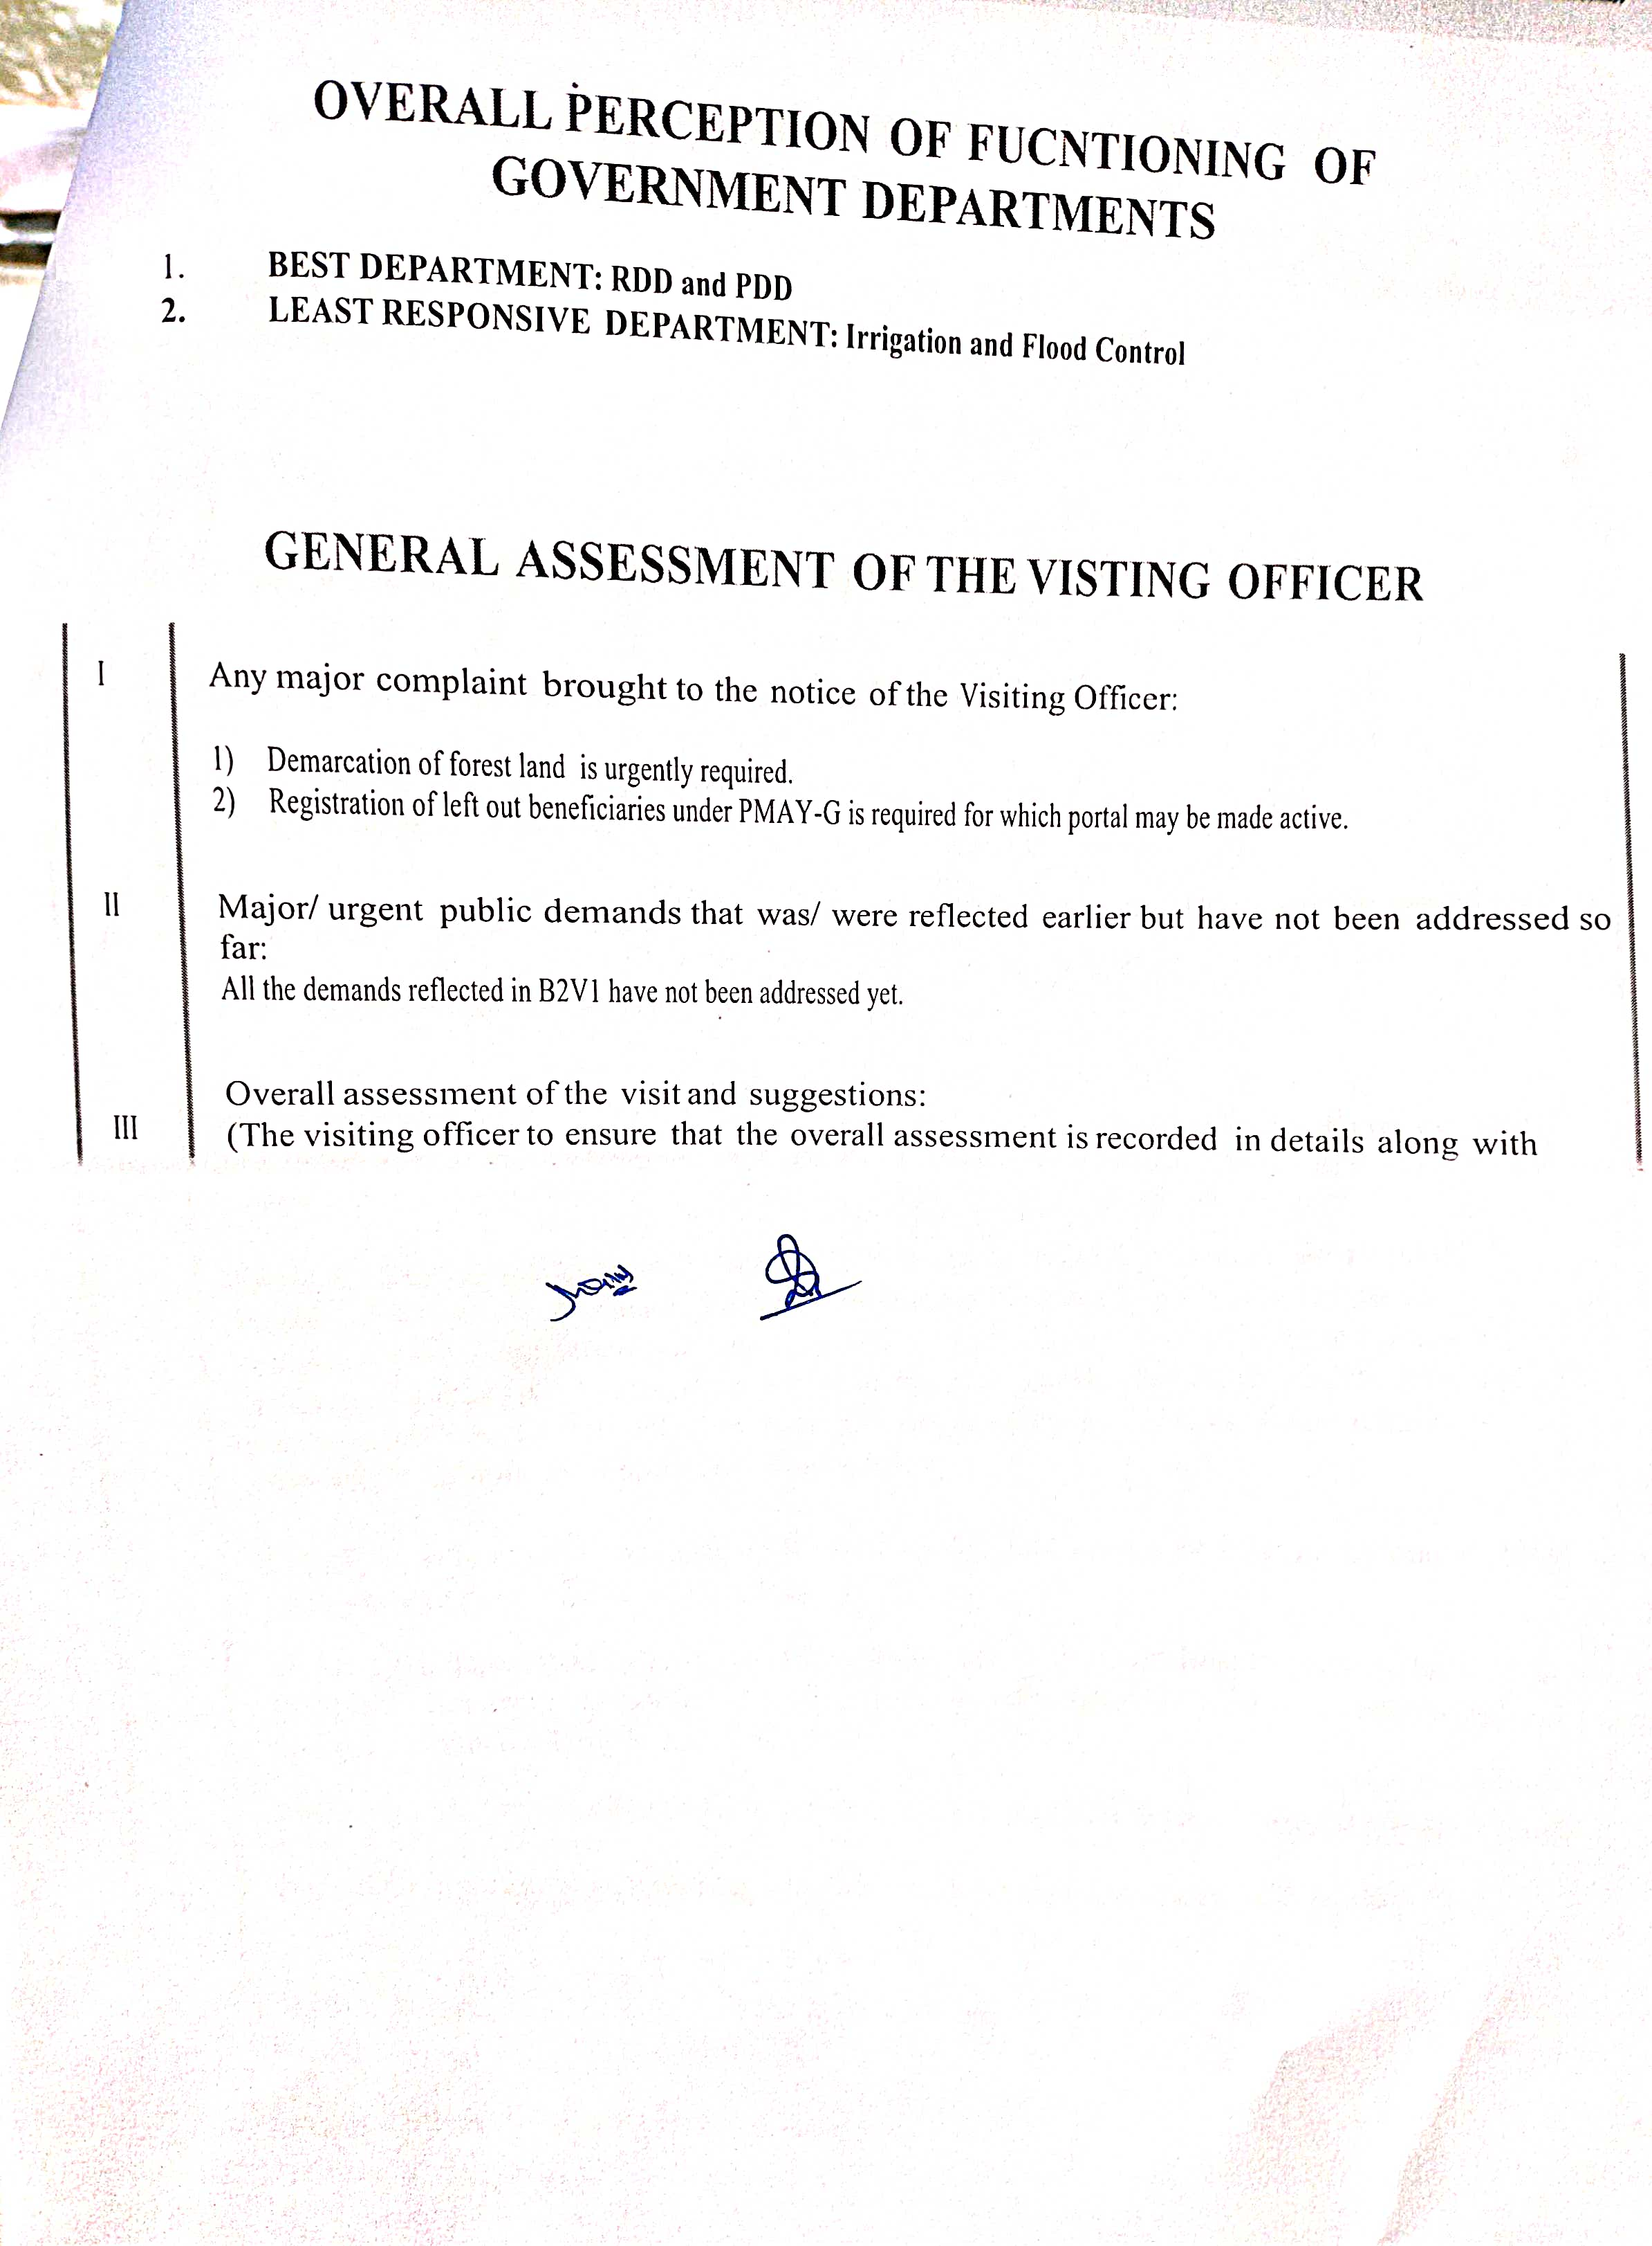

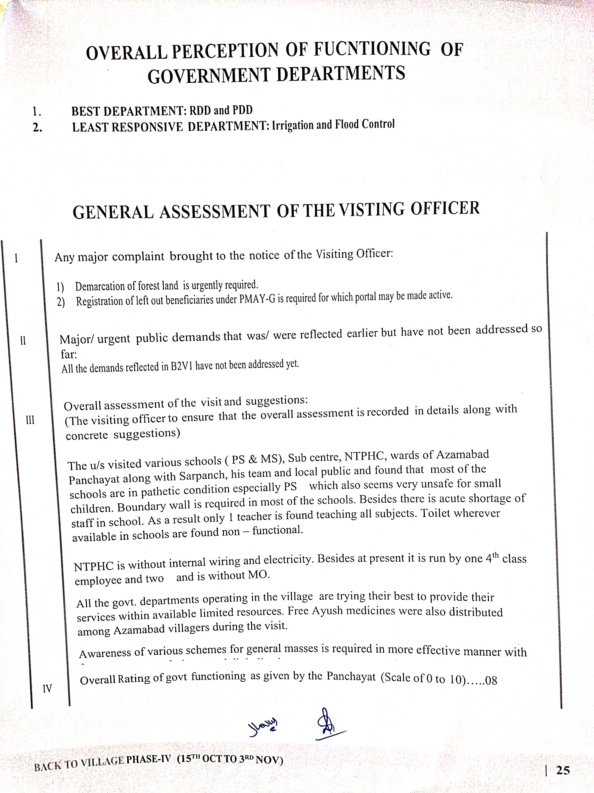

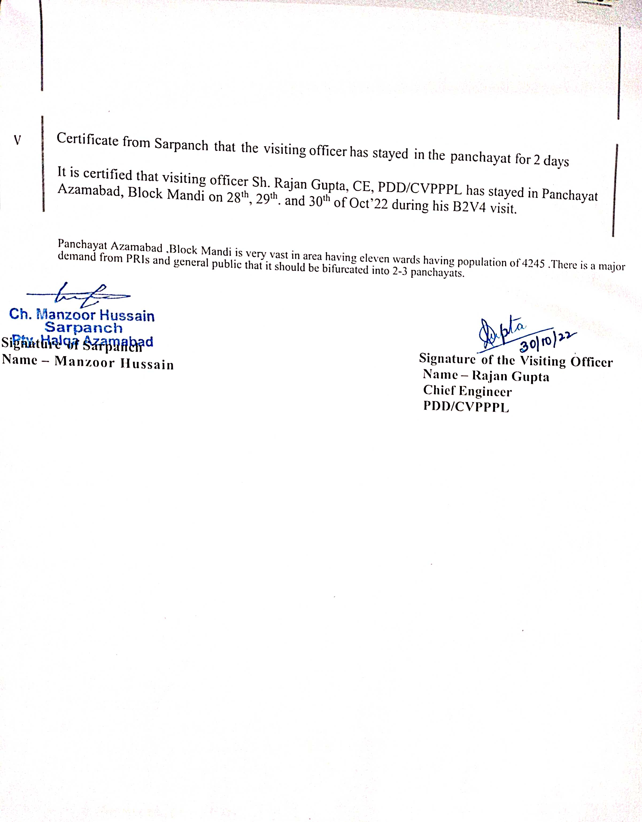

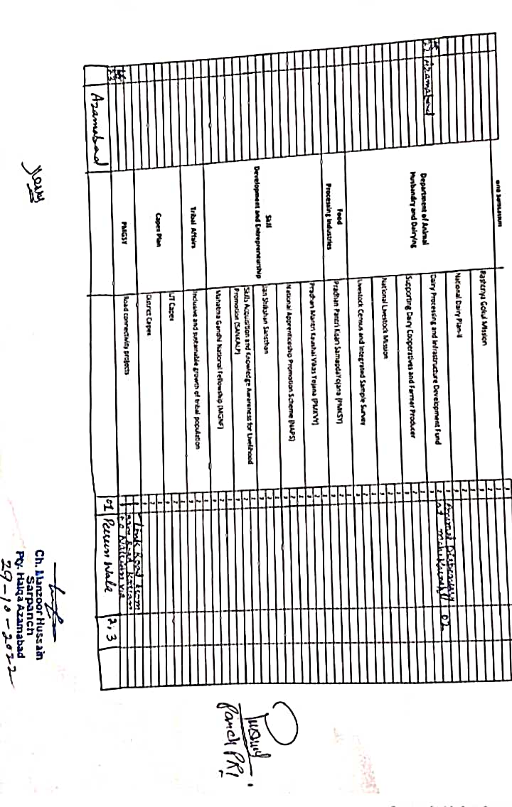

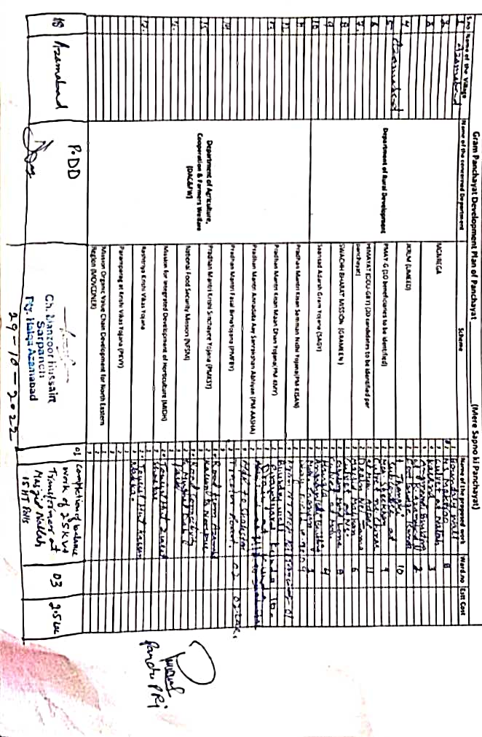

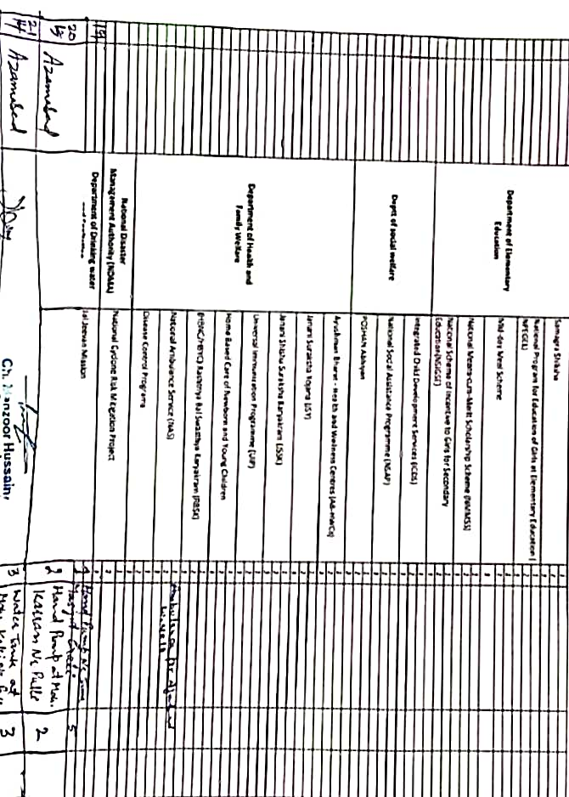



**Department of Rural Develompent and Panchayati Raj Government of Jammu & Kashmir**