4





**15TH OCTto3RD NOV,2022**

**KEYFEATURES**

• DeputyCommissionerstoleadtheinitiative

• RuraldevelopmentDepartmenttobethenodaldepartment

• PlanningDevelopment&MonitoringdepartmentandITtobethesupport departments

**ACTIONSANDTIMELINES**

|  |  |  |  |
| --- | --- | --- | --- |
| **ACTION** | **RESPONSIBILITY** | **LATESTBY** | **REMARKS** |
| **Janabhiyan** | Alldepartments | Oct15-26th | Goingon |
| **DeputationofSecttstaff/ HoDs** | GAD | Oct14 | Done |
| **DeploymentofStaffto Panchayatsandservingof ordersondeployedofficers** | DCs | Oct25 | DCswilldeployseniorlevelstaff fromthedistricts.Strictactionto betakenagainstabstentions.No exemptionstobegiven |
| **Trainingofdistricttrainors onB2V4** | RDD | Oct26 |  |
| **Trainingofvisitingofficers** | DCs | Oct27 |  |
| **FieldVisitstobecompleted by** | VisitingOfficers | Nov3 | DCstosuperviseandensurethat eachPanchayatisvisitedwithin theperiodspecified |
| **DataofB2V4tobe uploadedby** | VisitingOfficers | Nov10 | DCstosuperviseandensurethat dataofallPanchayatsisupload- edbythevisitingofficerwithin theperiodspecified |

**INSTRUCTIONSFORTHEVISITINGOFFICER(DAYWISE)**

|  |  |  |
| --- | --- | --- |
| **DATE** | **INSTRUCTIONS** | **ACTIONPOINTS** |
| **Day0** | Meetingwithdeputy commissionerandhis/her team | a. TakeprintoutsoffilledbookletsofB2V1,B2V2andB2V3from [www.jkpanchayat.in](http://www.jkpanchayat.in)  b.Alsotakeprintoutsofthesummarizedexcelsheetsofthe previousphasesfrom[www.jkpanchayat.in](http://www.jkpanchayat.in)  c. CollectATRsonissuesraisedduringprevious3phasesfromthe officeofDeputyCommissioner(Planningdeptt)  d.Takeprintsofblank 2bookletsofB2V4from[www.jkpanchayat.in](http://www.jkpanchayat.in)e.Takeplansfor2previousyearsandATRsfromtheplanningdeptt f. CompletetrainingsondifferentcomponentsofB2V4being  organizedbyrespectiveDeputyCommissioners  g.CollectListofnewworksstarted/ongoing/completedduringthe previousandcurrentFinancialyearunderthefollowingheads:  • PRIgrants  • DistrictPlan  • UTplan  • MGNREGA  • Otherschemesofotherdepartments  • Anyotherwork  h. Plans/beneficiarylists:  • MGNREGAdraftplandocumentfortheyear2022-23.  • ListofAwaas+beneficiariesalongwithIHHL Convergence  • Listofpensionbeneficiaries.  • ListofSHGs  • Listofagricultureschemebeneficiaries  i. Listsofbeneficiariesfor:  • Variouscertificates/benefitstobedistributedbythe visitingofficer.  • Anyotheractivitiesidentifiedbydifferentdepartments |

|  |  |  |  |
| --- | --- | --- | --- |
| **Day1** | Reachthevillage | 1. | Ensurethatallfrontlineworkersofdifferentdepttsarepresent. |
|  |  | 2. | Ensureexhibitionbydifferentdepts.aboutindividualbeneficiary schemes |
|  |  | 3. | InspectJKB/PSBcounters/outlets |
|  |  | 4. | Participate/ensureorganizationofsportsactivityinplayfield,talent hunt/culturalevent/youthactivity |
|  |  | 5. | GandhiKatha(suggesteddetailsuploadedonjkpanchayat.in) |
|  |  | 6. | Visitatleast2amritsarovarsandgetitsgeotaggedphotos |
|  |  | 7. | InspectKhidmat(CSC)CentresandcreateGenerateawarenesson  225schemesparticularlyG2CschemeslikeBEAMS,Janbhagidari, AapkiZaminAapkiNigrani,DigitalJ&K |
|  |  | 8. | Visitingofficershallalsoplanandconductpanchayatlevelconver- gencemeetingofalldepartments |
|  |  | 9. | CheckeffectivenessofCentrallysponsoredschemes |
|  |  | 10. | VisitandinspectallgovernmentestablishmentsincludingPHE, AWC,FPS,schools,etc |
|  |  | 11. | Attemptsaturationofdeliverableso JanAbhiyanandwherever deficienciesfound,leadadrivetoachievealldeliverables |
|  |  | 12. | Assesseffectivenessofsanitationcampaigninthepanchayat |
|  |  | 13. | Ensureselfemploymentactivitiesfor15youthperpanchayat |
|  |  | 14. | Identify20potentialcandidatesperpanchayatforHIMAYATtraining alongwiththetradeonwhichtheywanttraining |
|  |  | 15. | Whereverpossible,distributeemploymentlettersforpeopleselect- edundervariousgovernmentemployments |
|  |  | 16. | Intheevening,holdnormalmeetingwith seniorcitizens,govtem- ployeesincludingretiredemployees,exservicemen,youthclub,and any citizens ofthevillagewhoareenrolledincollege/university |
|  |  | 17. | OpendiscussiononNashaMuktAbhiyan |

Day2 Haveameetingwithall stakeholders-depttofficials andpanchayatmembers

1. Discussionontheandassesstheprogressofdifferentschemesrelating tothelocalizedSDGsprioritizedforthatvillageaspertheresolution passedby thatGramPanchayaton21st April22,onNationalPanchayti RajDay.

2. Sensitizevillage residentsaboutmyScheme”portal(myscheme.in) whichincludesinformationaboutalltheschemesbeingrunbyCen- tral/State/UTgovtacrossthecountry

3. Hold meeting of theBiodiversityManagementCommitteestodeliber- ateonissuespertaining toconservation of biodiversityandsustaina- bleutilizationof biologicalresources.

4. PrepareVillagedevelopmentplan,inconsultancywithGrampanchayat, discussitingramsabhaandgetitapproved.

5. Ensure saturationofsoilhealthcardandgoldenhealthcardunderGold- enHealthCardunderAyushmanBharat,

6. Ensuresaturation of OldAge PensionScheme

7. EnsureDomicileSaturation.

8. EnsureKCCSaturation

9. Ensure saturationoflandpassbooks

10. Ensureregistrationofvillagevendorsneededforanyscheme,onGEM

portal

11. Ensurepanchayatcontractors registration

12. EncouragePanchayatmembers forimportanceofplantationdrivein

PanchayatunderHarGaonHariyali

13. Ensure paintingondigitalJ&Kinpanchayatghars

14. Ensure paintingonpanchayatactivitesandCSSinpanchayatghars

15. Thevisiting officeshallchecknoof kindergarten andplayfields present inthepanchayat for kidsandstudents,iftheinfrastructure present inthesearegoodenough.

16. Holdmeeting withpanchayatmembers todiscussaboutcorruption menaceandstepsrequiredtomakeJ&Kcorruptionfree

17. Obtaina candidassessmentaboutperformanceofvariousdeptts in- cludingfairfeedbackaboutdiscrepanciesinfunctioning

18. Check thestatusof NashaMuktAbhiyanandreporting of drugad- dictstoDeputyCommissioner.

19. IdentifyTouristDestinations,Circuits,ThemeTreks,IdentifyHomestays, providesupportfortourismactivities throughVillageCooperative

20. OrganizeTalentHuntatPanchayatLevel

21. Conductsocialauditofatleast5worksunderfollowingschemes:

a. MGNREGA

b.PMAY

c. IHHLtoiletsandpayments d.CSCs

e.AMRITSAROVARS

22. Holda mahilasabha anda balsabhaandrecordproceedingsinthefor- matgiven

23. InauguratevillagehaatunderJKSRLM

24. Checkifyouthclubsareformedinthepanchayatandwhatactivities theyareengagedin

25. Organizea villagelevelculturaleventtoengagepanchayatmembers

26. SensitizeGPaboutE-kitabkoshaninitiativeofJ&KGovtforempowering youthsthrough onlinedigitalliteracy

**GENERALINSTRUCTIONS**

1. Thevisitingofficershallrefrainhimself/herselfgivingorofferinganycommitmentonbehalfofthe governmentandshalladoptanunbiasedattitudeinreportingissues.As faraspossible,his/her observation shouldbebasedona fairandanalytical viewemergingfromhis/herinteractioninthe village.

2. Heisgoingtothevillageasplanningofficer,notforsanctioninganyworksorformakinganycom- mitments.

3. Whilepreparingvillagedevelopmentplan,hehastoensurethat,demandsareprioritizedandre- flectedunderavailableschemes,wherevernecessarythelargerworksaretobereferredtoadminis- trativedepttunderCSS/UTplansunderintimationtoDCsandrestoftheworkstoDCsforreflecting itunderdistrict/CSS plans

4. His workshallbehardcoreplanningandauditandisnota PRexercise.

5. EveryDeputyCommissionerhastoensurethatatleastoneRDDofficial(ideallyPanchayatSecre- tary)ispresent ineverypanchayatwithrelevantpanchayatrecords,toensureconductofallactivi- tiesasplanned.Panchayatwiseorderneedstobeissuedinadvance.

6. Visitingofficershouldideallycarryhis/herlaptoptocompletethereportsatthepanchayatlevel itselfanduploadthefinalreport,duly signedbothbythesarpanchandbythevisitingofficeron [www.jkpanchayat.in](http://www.jkpanchayat.in)portal,beforetheyleavepanchayat.

7. Focus ofvisitareyouth,skills,self-employment,nashamukt,bhrashtracharmukt,Rozgaryukt J&K, besidestocarryforwardtheactivities duringJanAbhiyanandsaturatethem.

8. Inadditionattentionmaybegiventothefollowingareas a. MakefulluseofCentrallySponsoredSchemes

b.Saturationofindividualbeneficiaryschemes c. Self-employmentschemes

d.Banklinkedschemes-includingdepartmentalsubsidyschemes e.Empowermentandtransparencythrough digitalinitiatives

f. Effectivenessofgrassrootsmachinery–

i. Patwari,VLWpresent andavailable

ii. AvailablefundsutilizedinpublicinterestandasperGramSabharesolutions iii. Fairness ingovernance

iv. CSS/Individual beneficiaryschemesetc v. BrashtacharMuktJ&K

vi. BhaiMuktJ&K

vii. NashaMuktJ&K

9. ThePRImembers (Sarpanchs,Panchs,BDCChairperson)shallbeattheforefrontofallactivities and givendueimportanceandtheapproach shouldbetostrengthenthemandmakethemfeelem- powered.He/sheshallensurethattheBDCchairpersonandSarpanch/Panch arepresent atthetime ofinaugurationandceremonies.

10. Visitingofficershallnotleavethedistrictwithoutuploadingthereport,duly signedonthe**www. jkpanchayat.in**portal.EveryDeputyCommissionerhastoensurethat.

**A) Details of ReportingOfficer:**

Name: Mushtaq Ahmad Bhat

Designation: Sr. Lecturer

Department/placeof posting: GHSS Kakapora (Education Deptt.)

MobileNo: 7006032719

EmailID: mushtaqahmadbhat2719@gmail.com

HomeDistrict: Pulwama

Datesof visit: 30th and 31th of Oct. 2022

**B) LocationaldetailsofPanchayat:(tobepre-filled,informationtobetakenfromtheprevious phasesbooklets/summarizedexcelsheetuploadedonjkpanchayat.in/b2v4.php)(tobevali- datedbythevisitingofficerandmissingdetailstobefilled)**

NameofthePanchayat; PATHAN PAHLOO

LocalGovernmentDirectory(LGD)codeof thePanchayat: 242881

Nameof CDBlock: PULWAMA

NameofTehsil: PULWAMA

Nameof District: PULWAMA

**C) PanchayatProfile:**

No.ofrevenuevillagesinthePanchayat: 01

No.ofhamletsinthePanchayat: 01

No.ofhouseholdsinthePanchayat: 258

Population(approx)of thePanchayat: 1625

**Part-II:**

(TobefilledupbytheVisitingOfficerduringhis/hertwodayvisittothePanchayat.AllFieldshavetobe

filledbytheVisitingOfficerbeforethebookletishandedovertotheDC

**FrontlineOfficers/OfficialswhowereassignedtothePanchayatfortheprogramme**

|  |  |  |
| --- | --- | --- |
| Department | Name | Designation |
| RDD | RUBEENA SULTAN | PANCHAYT SECRETARY |
| PHE | MOHAMMAD SHAFI | ASST HEAD LINEMAN |
| FOOD DISTRIBUTION | MUSHTAQ AH. GANIE | STORE KEEPER |
| PDD | GULZAR AHMAD | LINE MAN |
| REVENUE | SHAH MOHAMMAD | PATWARI |
| SPORTS | AB RASHID BHAT | PEM |
| HEALTH | REHANA RASHID | FMPHW |
| SOCIAL WELFARE | HALIMA BHAT | SUPERVISOR |
| AGRICULTURE | FAROOQ AHMAD BHAT | HELPER |
| FOREST DEPT. | KHURSHEED AH.MUJU | HELPER |
| SHEEP DEPT. | FAYAZ AHMAD DAR | SAT |
| HORTICULTUE | MOHAMMAD AFZAL | TEGIVE |
| FISHRIES | TOWSEEF YOUSUF | F/G |
| SERICULTURE | MOHD SHAFI BHAT | N/MAN |
| ICDS | MUBEENA &NASREENAS | AWW |
| FDC | AB HAMID BHAT | O/H |
| PANCHAYAT | SHAMEEMA AKHTER | SURPUNCH |

**Detailsofabsentemployeesvis-à-vislistfurnishedbytheDCoffice:**

|  |  |  |
| --- | --- | --- |
| Department | Name | Designation |
| NIL | NIL | NIL |
|  |  |  |
|  |  |  |
|  |  |  |
|  |  |  |
|  |  |  |
|  |  |  |
|  |  |  |
|  |  |  |
|  |  |  |
|  |  |  |
|  |  |  |
|  |  |  |
|  |  |  |
|  |  |  |

**DAY1-ACTIVITIES**

**AGENDA1:PANCHAYATASSETREGISTER**

**Infrastructure:**

1. PanchayatGharInfrastructure a. Govtbuilding/private

GOVT. BUILDING

b. New/needingrepairs: NEW

2. Furniture(Y/N): INSUFFICIENT FURNITURE

3. Computer/printer(Y/N): NO

4. Internet(Y/N): NO

5. Telephone(Y/N):NO

6. Toilet(CSC/partofpanchayatghar)(Y/N):YES (UNDER COSTRUCTION)

7. Water(Y/N):YES

8. Electricity(Y/N):YES

9. Bankbranch(Y/N):NO

10. CSC(Y/N):NO

11. Patwarkhana(Y/N):NO

12. Villagehaat(Y/N): NO

13. Playground(Y/N): NO

14. School-

a. Kindergarten(Y/N): NO

b.Primary(Y/N): YES

c. Secondary(Y/N): NO

d. College (Y/N):NO

e.University(Y/N):NO

15. AnganwadiCentre(Y/N): YES (02 No.)

a. (govt/private): ONE IN PRIVATE ACCOMODATION &ONE IN GOVT.BUILDING.

b.Totalchildrenenrolled: 73

15. AmritSarovars–details,location,condition:NO

16. Governmentoffices-details,whetherfunctionalornot YES

17. Rationshop(Y/N) : YES

18. Placesoftourismimportance–names,littledetailsonhistorical/culturalimportance:NIL

19. Villageheritagesites/treks-names,littledetailson historical/culturalimportance:NIL

20. VLWOffice (Y/N): YES

21. PrimaryHealthcareCentre(Y/N),: NO

22. ListofIncompleteBuildings-names,yearofconstruction: NIL

23. ListofUnderutilizedBuildings-names: NIL

**DAY1-ACTIVITIES**

**AGENDA2:**

**DIFFERENTINSTITUTIONS/INFRASTRUCTUREPROJECTSTOBEVISITED**

|  |  |  |
| --- | --- | --- |
| **AMRITSAROVARS** | **Visit,verify** | **COMMENTS** |
| KhidmatCentres | Create/Generateawarenesson225schemes particularlyG2CschemsAapkiZaminAapkiNigrani, Beams,Janbhagidari,DigitalJ&K | AVAILABLE AND FUNCTIONAL |
| JKB/PSBcounters/outlets | a)Statusofcounter b)Numberofvisitors | NIL |
| Incompletebuildings/pro- jects | Verify whetheridentificationandredistribution done | NIL |
| PDS | Visit,evaluate,onlinestatus | AVIALBLE |
| PHC | Visit-evaluate,statusofstaff,equipmentand quality | NOT AVAILABLE. |
| Youthclubs | Meet,interact,seeksuggestions | INTERACTED WITH VILLAGE YOUTH AND THEY DEMANDED A PLATFIELD. |
| SHG | Meet,identifyproblems,seeksuggestions | NOT AVAILABLE |
| PMAY | Inspect,Inaugurate | INSPECTED=1; INAUGRATED=1 |
| Myschool,mypride progress;schools-water, toilets,staff | Visit,checkforwater,electricity,sanitation,meet studentsandstaff | WATER QUALITY IS GOOD;ELECTRICITY IS AVAILABLE;SANITATION WAS SATISFACTORY;ICT LAB REQUIRED;SCHOOL GROUNG NEEDS LAND FILLING AND CONSTRUCTION OF A FOOT PATH. |
| SwachhSBM | Evaluate | VARIOUS SBM POINTS SANCTIONED;SOAKAGE PITS CONSTRUCTED |
| Panchayatplayground, Sportskitsdistribution Villagegames | Ensure,verify.Participateinatleastonegamein theplayground | CARROM AND CHESS BOARD DIATRIBUTRD,PARTICIPATED IN SCHOOL ACTIVITIES |
| HarGaonHariyali, Planta- tiondrive | Evaluatestatus,feedback | PLANTATION DRIVE CARRIED OUT IN SCHOOL PREMESIS |
| Villageculturalevent  Dangal/Haat/Mela | Participatein;ensurethatitisheld | NIL |
| Exhibitionofschemes | Ensurethateverydepartmentparticipatesand thatitcontinuesfortheentiredurationofB2V | ICDS CENTERS CARRIED OUT EXHIBITION OF SCHEMES FOR ENTIRE DURATION OF B2V4 |
| JalJeewanMission verifica- tion- WSS/JSD  Electricitysupply | Verify | MOST OF THE HOUSEHOLDS HAVE BEEN COVERED UNDER THESE SCHEMES. |

**DAY1-ACTIVITIES**

**AGENDA3:SATURATEJANBHIYAN**

**DELIVERABLES AND RECORD DEFICIENCIES IF ANY (INSERT DELIVERABLES LIST HERE AS PER GAD FORMAT**

|  |  |  |  |
| --- | --- | --- | --- |
| **S.NO** | **DELIVERABLES** | **ASSESSMENT** | **DEPARTMENT** |
| 1 | PLANTATION DRIVE | HELD IN THE PREMISES OF H/S PATHAN | FOREST DEPTT. |
| 2 | GOLDEN CARDS | 1169 ISSUED/1362 ELIGIBLE | HEALTH |
| 3 | LAND PASS BOOKS |  | REVENUE |
| 4 | CONSTRUCTION OF SOAKAGE PITS | 14 | RDD |
| 5 | E-SHRAM CARDS |  | LABOUR DEPTT. |
| 6 | KISAN CREDIT CARDS/PM KISAN SAMANIDHI | 158 /63  100% TARGET ACHIEVED. | AGRICULTURE |
| 7 | OLD AGE PENSION/DISABILITY/WIDOW PENSIONS | 50/32/37  100% TARGET ACHIEVED | SOCIAL WELFARE |
| 8 | GHANDHI KATHA | LECTURE DELIVERED | VISITING OFFICER |

**DAY1-ACTIVITIES**

**AGENDA4:**

**SELFEMPLOYMENTACTIVITIES**

EnsureSelf-employmentactivities foryouth,distributeemploymentlettersforpeopleselectedunder varioussocialschemes(15ISTHETARGETPERPANCHAYAT)

**Number of cases indifferent categories sanctioned:**

**Details of the bank sanctioning it:**

**Total amount involved: NOT APPLICABLE**

**DAY1ACTIVITIES**

**AGENDA5**

In the evening,hold informal meetings with senior citizens, govt employees ,retdemployees,youthclub andothercitizenswhoareenrolledoncollege/universityandhavediscussiononGandhiKatha,Nasha MuktAbhiyan,corruptionfreegovernance,doublingfarmersincomeandrecordtheproceedings

**DAY2**

a. No of Individual Compost Pits constructed: NIL

b.NoofIndividualSoakPitsconstructed: 14

V. No.of Biodiversity management committee meetings held: NIL

VI. Is the name of Sarpanch displayed on citizen information boards of all RD&PR schemes: Yes/No: YES

VII. AreSarpanchsbeinginvolvedinstart/inaugurationofactivities:Yes/No: YES

VIII. WhethersubjectshavebeenassignedbytheSarpanchtothePanchs:Yes/No: NO (NON AVAILABILITY OF PANCHES)

IX. Whethergrievancesredressalboxisinstalled:Yes/No: NO

X NoofgrievancesreceivedpertainingtoPanchayatlevel:02  
 XI. NoofgrievancesdisposedofatPanchayatlevel: 02

XII. WhethertheSarpanch/PanchayatSecretaryhavedigitalsignatures:Yes/No;YES

XIII. WhetherallMGNREGA/14thFCpayments arebeingmadebySarpanchthrough DigitalSignature

Certificate(DSC):Yes/No: YES

**HUMAN RESOURCEAVAILABLEATTHEPANCHAYAT LEVEL:**

|  |  |  |  |  |
| --- | --- | --- | --- | --- |
| **SRNO.** | **DEPARTMENTWISESTAFF** | **NUMBERS** | | **NAMES** |
|  |  | SANCTIONED | ACTUAL |  |
| 01 | Ruraldevelopmentdepartment: BDO  JE  GRS TA | 0  0  1  1 | 0  0  1  1 | SHOIB MOHD GANI |
| 02 | SCHOOLEDUCATION: TEACHER  HEADMASTER ANYOTHER | 09  1 | 07  1 | SHAHZADA MUZZAFAR(H.M) AND OTHERS |
| 03 | JAL JEEVAN:  JE  ASST.LINE MAN | 04  00 | 03  00  1 |  |
| 04 | PDD: LINEMAN  JE  ANYOTHER | 02  1  1 | 02  1  1 | GULZAR AHMAD WAGAY & FEROZ AHMAD DAR  FAYAZ AHMAD MIR  SALEEMA GULL M.R. |
| 05 | FOOD&CIVILSUPPLIES | 1 | 1 | MUSHTAQ AHMAD GANIE ( STORE KEEPER) |
| 06 | AGRICULTURE&ANIMALHUS- BANDARY | N.A | N.A |  |
| 07 | SOCIALWELFARE: FIELD ASSISTANT | 02 | 02 | SHAKEELA (HELPER) & NASREENA (WORKER) |
| 08 | HEALTH: ASHA ANM  AYUSHDOCTOR   ALLOPATHICDOCTOR | 02  02  0 | 02  02  0 | RAFIQA AKHTER & MUNEERA  REHANA RASHID & ZAMROODA AKHTER |
| 09 | ANYOTHERDEPARTMENT | 0  NIL | 0 |  |

**DAY2-ACTIVITIES**

**AGENDANO.1**

DiscussionontheandassesstheprogressofdifferentschemesrelatingtothelocalizedSDGsprior-itizedforthatvillageaspertheresolutionpassedbythatGramPanchayaton21stApril22,onNational PanchayatiRajDay(Copyoftheresolutiontobetakenfrom[www.jkpanchayat.in](http://www.jkpanchayat.in)portalunderthelinkof GramSwarajMonth)

1. SDGs AGREED FORTHATVILLAGE,TOBEIMPLEMENTED BYMARCH2024:

2. STATUSOFWORKSUNDERTHEFOLLOWINGSCHEMES:

**1 Cleanandgreenvillage**

i.InitiativestakenbythePanchayatformanagingSolidandLiquidWaste YES(IN THE FORM OF SOAKAGE PITS)

ii. InitiativestakenbythePanchayatforusinggreensourcesoffuellikesolar,biogas NIL

iii. Hasmappingoflanduse,waterbodies,forest,slopes,wetlands,degradedforestwithintheGram

Panchayatbeendone?Yes/No.IfNo,reason,thereof YES

iv. HastheClimateResiliencePlanbeendevelopedfortheGP?Yes/No NO

v. StepstakenbytheGramSabhaabouttheclimatechangemitigationfactorslikereducingenergy consumption,usageoffossilfuels,plastics,non-renewablebuildingmaterialsandalsotopromote measureslikeplantingoftrees,conservingforests,usageofgoodagriculturalpracticeslikedrip irrigation,waterconservationmeasuresandconservationofwetlands. YES ( BY WAY OF IMPARTING AWEARNESS)

vi. Whetherschoolshavestartedsegregatingwaste YES

vii. Whetherschoolshavetheirowncompost/soakagepitsforsolid/liquidwastemanagement : NO

**2 Healthyvillage**

i) Aremeetings relatedtoVillageHealthandSanitationCommitteebeingheldregularly?YES

ii) DoalltheeligibleindividualsbeenprovidedtheGoldenCard? NO

iii) ArealltheChildrenbeingimmunizedaspertheSchedulerecommendedbyGovt.ofIndia? YES

iv) ArealltheeligibleindividualsbeenvaccinatedagainstCOVID-19? YES

v) DoesGramPanchayatensurethatallpregnantwomenaregettingnecessaryprenatalcheckups?YES

vi) WhetherallthedeliverieswereInstitutionalizedorconductedbytrainedMidwives? YES

**3 Watersufficientvillage**

i) DoalltheIHHsintheGramPanchayathavewaterpipelineconnections? 97% COMPLETED

ii) WhetherGramPanchayathastakenstepsforgreywatermanagement.IfYespleasespecify YES( IN FORM OF SOAKAGE PITS)

iii) DoalltheIHHsintheGramPanchayathavetoilets? YES

iv) ArealltheIHHstoiletsfunctionalornot? YES

v) DoalltheSchools/Anganwadicentershavea toiletfacilityornot? YES

vi) Areallthetoiletsintheschools/Aaganwadifunctionalornot? YES.

vii) WhetherGramPachachayatBhawanhasseparate toiletsforwomenornot? YES

**4 ChildFriendlyvillage**

i) Doallthechildrenundertheageof0-6yearsbeenenrolledintheAnganwadicentersforpre- schooling?Yes/NO : YES

ii) HowmanyBalSabha’swereorganizedintheGramPanchayat? 2

iii) WhethertheissuesraisedbyBalSabhaareaddressedduringtheGramSabha. Yes/NO YES

iv) WhetherGramPanchayatistrackingthedatarelatedtodropoutchildrenandchildrenwithirregular attendance?Yes/NO. NO

v) DoalltheschoolsundertheGramPanchayathaveseparate toiletsforgirlsandboys?Yes/No YES

**5 Villagewithgoodgovernance**

i) IsCSClocatedintheGramPanchayatBhawanornot? NO.

ii) IsthelistofbeneficiariesrelatedtotheSchemes/ProgramsdisplayedontheGrampanchayatwallor not?YES

iii) DoestheGramPanchayathasitsbuildingornot? YES

iv) IstheGramPanchayatofficefunctionalornot? YES.

v) Aretheactivities approved undertheHalqaPanchayatDevelopmentPlandisplayedontheGram

Panchayatwallornot?  
YES

vi) IsSocialAuditofearlierSchemes/Programscarriedoutornot? YES

**6 Povertyfreeandenhancedlivelihoodvillage**

i) HasGramPanchayatdevelopedanycriteria fortheidentificationofthepoor?Yes/Noifyesspecify YES( AAY/APL/BPL)  
 ii) HavealltheeligiblehouseholdsregisteredinPDSornot? YES

iii) HasGramPanchayatprovidedspaceforSelf-helpGroupsinPanchyatGharforholdingmeetings or not? NO

iv) HavealltheeligiblehouseholdsbeenregisteredforPensionornot? YES

v) HasGramPanchayatfacilitatedYouthforSkillEnhancementCoursesandPlacement? YES

vi) HasJobCardsbeendistributedtoalltheeligibleindividualsunderMGNREGA? YES

vii) HasGramPanchayatfacilitatedSHGsforBankAccountLinkages? NO

**7 Sociallysecuredvillage**

i) WhetherGramPanchayatismaintainingdatarelatedtoDifferentlyAbledPeople? NO

ii) IsGramPanchayatOffice DisabledFriendlyornot? NO

iii) Areprovisionsfora separate BudgetundertheResourceEnvelopeforWomenandChildrenmadeor not? NO

iv) DoalltheSchools intheGramPanchayathavefacilitiesforDifferentlyAbledChildrenliketoilets, barrier-freeaccess,etc.,ornot? NO

v) Arealltheeligibleindividualsaregettingpensions,likeoldagepension,widowpension,etc? YES

vi) ArealltheeligiblehouseholdsgettingbenefitsfromIAYornot?

YES

**8 EngenderedDevelopmentinVillage**

i) HowmanyMahilaSabha’swereorganizedintheGramPanchayat? 02

ii) WhetherSHGsfederationshavebeenprovidedspaceformeetings inthePanchayatBhawan(Yes/ No) NO.

iii) WhetherGPshavetakenstepsforincreasingwomen’sparticipationinGramSabha(Yes/No) YES

iv) NumberofwomenbeneficiariesheadedhouseholdscoveredunderPDS

system NA

v) Numberofbeneficiaries(outoftotaleligiblepopulation)receivingsocialprotectionbenefitsunder

PradhanMantriMatritvaVandanaYojana 25

9 Self-sufficientinfrastructureinthevillage

i. WhetherGPhasa CommunityHallwithaccesstoelectricity,furniture,watersupply, toilet NO

ii\ WhethertheDisastermanagementplanisavailableattheGPLevel(Yes/No) YES

iii. Whetherchild-friendlyparkwithrequiredfacilitiesisavailableinGP(Yes/No) NO

iv. WhethertheGPhaseasyaccesstoGodownforstorage(Yes/No) NO

v. Whetherstreetlightsareprovidedinpublicplacesforensuringsafety(Yes/No) NO

**DAY2ACTIVITIES**

**AGENDANO.2**

SensitizevillageresidentsaboutmyScheme”portal(myscheme.in)whichincludesinformationaboutall theschemesbeingrunbyCentral/State/UT govtacrossthecountry

*(SchemeMaterialavailablefromhttps://jkpanchayat.in/b2v4.php)*

**DAY2ACTIVITIES**

**AGENDANO.3**

HoldmeetingoftheBiodiversityManagementCommitteestodeliberateonissues pertainingtoconserva- tionofbiodiversityandsustainableutilizationofbiologicalresources.HeshouldcheckPeopleBiodiversity register(PBR)ofthatpanchayatandreviewifBiodiversityManagementCommittee constitutedforthat panchayatis holdingminimum4meetings inayearandmeeting onceinevery3months *(RoleofBMC availableathttps://jkpanchayat.in/b2v4.php)*

COMMITTEEMEMBERS

PRESENT

BIODIVERSITYREGISTERPHOTOS

PAST 4MEETINGDETAILS-DATES,MINUTESPHOTOS: NA

**DAY2ACTIVITIES**

**AGENDA4**

Visitingofficershallalsoplanandconductpanchayatlevelconvergencemeeting ofalldepartmentsand prepareVillagedevelopmentplanforvillage,inconsultancywithGrampanchayat,discussitingram sabhaandgetitapproved.

(GPDPformatavailableonhttps://jkpanchayat.in/b2v4.php)

**InadditionGPDPplanshallalsoinclude:**

▪ Touristplaceswhichneedtobedeveloped

▪ Specificproductwhichneedstobedeveloped

▪ Tourism-homestays

▪ 20candidatesfortrainingunderHimayatschemealongwithtradeinwhich trainingistobegiven

TAILORING:10

KNETTING:05

EMBROEDARY:05

**DAY2ACTIVITIES**

**AGENDA5**

Ensuresaturationoffollowingschemesandgivestatus:

|  |  |  |  |
| --- | --- | --- | --- |
| **NAMEOFTHESCHEME** | **TOTALELIGIBLE BENEFICIARIESIN THE VILLAGE** | **TOTALBENEFICIARIESWHO AVAILEDTHEBENEFITSOFTHESCHEME** | **REASONSFOR PENDENCY** |
| GoldenHealthCardunder  AyushmanBharat | 1362 | 1169 | PENDING VERIFICATION |
| Jananisurakshayojana | 13 | 10 | LACK OF FUNDS |
| OLDAGEpension | 50 | 50 | NIL |
| Widowpension | 32 | 32 | NIL |
| Disabilitypension | 37 | 37 | NIL |
| Domicilecertificate | NA | NA | NO SEPARATE DETAILS AVAILABLE FOR THE GP |
| Kisancreditcard | 158 | 158 | NIL |
| PMkisansammannidhi | 63 | 63 | NIL |

|  |  |  |  |
| --- | --- | --- | --- |
| Landpassbook | NA | ___ | PASSBOOK GENERATION UNDER PROGRESS |
| Registrationofvillageven- dorsonGEMportal | 02 | 02 | NIL |
| Registrationofvillagecon- tractorsonjktendersportal | NA | NA |  |
| Registrationofvillagecon- tractorsonPWDportal | NA | NA | NO CONTRACTORS REGISTERED ON PWD PORTAL |
| Incompletebuildings/pro- jects | NA | NA |  |

**DAY2ACTIVITIES**

**AGENDA6**

**NASHAMUKTABHIYAN**

1. Whethergramsabharesolutionpassed YES

2. Detailsofactivities conducted:PLEDGE CERIMONY HELD AND AWARENESS COMPAIGN CONDUCTED TO MAKE PEOPLE AWARE OF DRUG MENANCE

3. Whetherallactivities andGSresolutionuploadedonjkpanchayats.inportal YES

4. Howmanydrugaddictsinthevillage NIL

5. WhetherreportedtotheDeputyCommissioner :YES

6. Howmanyregisteredforrehabilitationundergovernmentprogramme

NIL

**DAY2ACTIVITIES**

**AGENDA7**

**SOCIALAUDIT**

Conductsocialauditofatleast5workseachunderfollowingschemes: SEPARATE SHEET ATTACHED AT THE END OF BOOKLET

|  |  |  |  |  |  |  |
| --- | --- | --- | --- | --- | --- | --- |
| NAMEOFTHE SCHEME | DETAILSOFTHE WORKS | YEAROFWORK APPROVAL | AMOUNT APPROVED  FORTHEWORK | WHETHER  WORKEXECUTED SATISFACTORILY | GEO- TAGGED PHOTOS | ANY GRIEVANCE RECORDED RELATINGTOTHAT WORK |
| MGNREGA | Const.of road | 2017 | 1.5 lakh | yes | yes | no |
| PMAY | Const,of hous |  | 74 thousand | yes | yes | No |
| IHHL  UNDERSBM-G | Const of toilet |  | 12 thousand | yes | yes | No |
| CSCUNDER SBMG | Nil |  |  |  |  |  |
| AMRIT SAROVARS | Nil |  |  |  |  |  |

**DAY2ACTIVITIES**

**AGENDA8**

**MAHILASABHA**(MINUTES ATTACHED AT THE END OF BOOKLET)

Totalwomeninthevillageabovetheageof18= 170

Totalattended=12

Proceedings: ISSUES LIKE DOMESTIC VOILENCE, CHILD CARE;SELF EMPLOYMENT SCHEMES AND DEMAND FOR KNITTING AND HANDICRAFTS CENTER FOR WOMEN EMPOWERMENT WERE DISCUSSED.

*(Plinsertpointerstobediscussedthere–referpalliproceedings)*

**DAY2ACTIVITIES**

**AGENDA9**

**BALSABHA**(MINUTES ATTACHED AT THE END OF BOOKLET)

Holda balsabhaandrecordproceedings

Totalchildreninthevillageabovetheageof 6yrs= 200 Totalattended=20

Proceedings: ISSUES LIKE QUALITY EDUCATION,CLEANLINESS, THEIR GOALS AND SPORTS WERE DISCUSSED.

*(Plinsertpointerstobediscussedthere–referpalliproceedings)*

**DAY2ACTIVITIES**

**AGENDA10**

**INAUGURATIONS**

|  |  |  |  |
| --- | --- | --- | --- |
| **SR NO.** | **ASSETS/ACTIVITIES INAUGRATED** | **STATUSOFTHEASSET/AC- TIVITIES(NUMBER,OTHER DETAILS)** | **GEO-TAGGED PHOTOS** |
| 01 | VILLAGEHAATunderJKSRLM (SUN- DAYMARKET) | NA |  |
| 02 | PMAYhousesifanyreadyforinaugra- tion | INSPECTED 05 INCLUDING INAUGRATION OF 01 PMAY HOUSE | YES |
| 03 | Swachhgramprojects-segregation shedsetc | IHHL UNITS  SOAKAGE PITS | YES |
| 04 | Amritsarovars | NA |  |
| 05 | Sportskits | CARROM AND CHESS BOARDS DISTRIBUTED | YES |
| 06 | Villageculturalevents | A WARM WELCOME WAS ORGANISED BY VILLAGERS OF GP | YES |
| 07 | JJMassets/projects | NA |  |
| 08 | Anyothertobeidentifiedatdistrict level | NA |  |

**FOLLOWUPOF(B2V1,B2V2&B2V3):**

*(Prefilledexcelsheet tobetakenfromdistrictlevel/andalsotobedownloaded*

*from*[*www.jkpanchayat.in)*](http://www.jkpanchayat.in)

|  |  |  |  |
| --- | --- | --- | --- |
| S.NO. | Particulars | Actiontaken | Remarks# |
| I. UrgentPublicRequirements/Demands-B2V1 | | | |
| 1 | REPAIRMENT OF ELECTRIC WIRES AND POLES AND PROVIIDING ADDITIONAL TRANSFORMER | 07 NO. POLES GIVEN AND ONE TRANSFORMER INSTALLED | NEEDS IMPROVEMENT |
| 2 | NON AVALABILITY OF WATER SUPPLY TO A SIZABLE POPULATION | NO ACTION TAKEN |  |
| 3 | NON AVAILABILITY OF A DOCTOR AND MALE STAFF AT HEALTH CENTER | NO ACTION TAKEN |  |
| 4 | POOR MOBILE CONNECTIVITY | NO ACTION TAKEN |  |
| 5 | NON FUNCTIONAL BSNL CABEL | NO ACTION TAKEN |  |
| 6 | NON AVAILABILITY OF A PLAY GROUND | NO ACTION TAKEN |  |
|  |  |  |  |
| II. UrgentPublicRequirements/Demands-B2V2 | | | |
| 1 | 04 CASES OF PMAY REGISTERED | NOT A SINGLE ALLOTED |  |
| 2 | INSTALLATION OF TRANSFORMERS AT ASTAN MOHALA & GOUSIA COLONY  RESTORATION OF WATER SUPPLY LINE OF MAQDAM MOHALLA AND NEW COLONY | ONE TRANSFORMER INSTALLED |  |
| 3 |  | PARTIAL WORK DONE. |  |
| 4 | CONSTRUCTION OF COMPOST PIT NEAR MASJID AND PANCHAYAT | NO ACTION TAKEN |  |
| 5 |  |  |  |
| 6 | REPLACEMENT OF BROKEN ELECTRICITY POLES | NO ACTION TAKEN |  |
| 7 | CONST.OF DRAIN NEAR H/S PATHAN | NO ACTION TAKEN |  |
| S.NO. | Particulars | Actiontaken | Remarks# |
| III. MajorProblems–B2V1 | | | |
| 1 | CONSTRUCTION OF CULVERT AT SASRA ARA | NO ACTION |  |
| 2 | CONSTRUCTION OF CULVERT AT MEI PATHAN | NO ACTION TAKEN |  |
| 3 | CONSTRUCTION OF A CULVERT AT GURWAN KOHELNEAR L/O GH MOHIDIN GANIE | NO ACTION TAKEN |  |

|  |  |  |  |
| --- | --- | --- | --- |
| 4 | PROVISION OF TAPPED WATER TO MAQDAM MAHALA AND NAYEE BASTI | NO ACTION TAKEN |  |
| 5 |  |  |  |
| IV. MajorProblems-B2V2 | | | |
| 1 | REPLACEMENT OF DAMAGED POLES | ONLY 07/113 POLES REPLACED | NEEDS IMPROVEMENT |
| 2 | WATER SUPPLY TO MAQDAM MAHALA | NO ACTION TAKEN |  |
| 3 | DEVELOPMENT OF ROAD FROM L/O GH QADIR MAILK TO L/OALI MOHD BHAT | NO ACTION TAKEN |  |
| 4 | CONSTRUCTYION OF FLOOD PROTECTION WALL ON SASRA ARA | NO ACTION TAKEN |  |
| 5 | CONSTRUCTION OF DRAIN NEAR H/S PATHAN | NO ACTION TAKEN |  |
| V. MajorProblems-B2V3 | | | |
| 1 | BUNDING OF ROAD ON B/S FROM ASTAN MOHALLA TO AHANGER MOHALA | NO ACTION |  |
| 2 | SHIFTING OF NAYABAT FROM LAJURAH TO PULWAMA | NO ACTION |  |
| 3 | UPGRADATION OF HEATH AND WELLNESS CENTER | NO ACTION TAKEN |  |
| 4 | WIDENING AND UPGRADATION OF TENGPUNA PINGLANA ROAD | NO ACTION TAKEN |  |
| 5 | ESTABLISMENT OF VETENARY UNIT AT PATHAN | NO ACTION TAKEN |  |
| VI. MajorComplaints-B2V1 | | | |
| 1 | UPGRADATION OF HEALTH CENTER | NO ACTION TAKEN |  |
| 2 | ESTABLISHMENT OF A BANK BRANCH | NO ACTION TAKEN |  |
| 3 | CONSTRUCTION OF HOUSES UNDER PMAY | NO ACTION TAKEN |  |
| VII. MajorComplaints-B2V2 | | | |
| 1 | CONSTRUCTION OF DRAIN NEAR H/O GULZAR AHMAD TO L/O GH AHMAD MIR | NO ACTION TAKEN |  |
| 2 | PERAIRMENT OF PANCHAYAT GHAR | NO ACTION |  |
| 3 | PROVISION OF A PLAYGROUND | NO ACTION TAKEN |  |
| VIII. MajorComplaints-B2V3 | | | |
| 1 | UPGRADATION OF HEATH CENTER | NO ACTION TAKEN |  |
| 2 | REPAIRMENT OF WATER SUPPLY PIPE LINES | NO ACTION |  |
| 3 | DEVELOPMENT OF INTERNAL LINK ROADS | NO ACTION |  |

**OVERALLPERCEPTIONOFFUCNTIONING OF GOVERNMENTDEPARTMENTS**

1. **BESTDEPARTMENT: RURAL DEVELOPMENT DEPARTMENT**

**2. LEASTRESPONSIVEDEPARTMENT: NONE.**

**GENERALASSESSMENTOFTHEVISTINGOFFICER**

|  |  |
| --- | --- |
| I | AnymajorcomplaintbroughttothenoticeoftheVisitingOfficer: NON AVAILABILITY OF PLAY GROUND;UPGRADATION OF HEALTH CENTER, WATER AND ELECTRICITY INFRASTRUCTURE AND SHIOFFTING OF NAYABAT. |
| II | Major/urgentpublicdemandsthatwas/werereflectedearlierbuthavenotbeenaddressedsofar:REPLACEMENT OF WATER SUPPLY PIPE LINES ,DAMAGED POLES ,LAND FILLING OF SCHOOL GROUND AND THREE GRAVEYARDS. |
| III | Overallassessmentofthevisitandsuggestions:  (Thevisitingofficertoensurethattheoverallassessmentisrecordedindetailsalongwithconcretesugges- tions)(1) ICT LAB AT HIGH SCHOOL (2)ROADS NEEDS IMPROVEMENT(3) INTRODUCTION OF VOCATIONAL SUBJECTS IN GOVT HIGH SCHOO ETC. |
| IV | OverallRatingofgovtfunctioningas givenbythePanchayat(Scaleof0to10)= 07 |
| V | CertificatefromSarpanchthatthevisitingofficerhasstayedinthepanchayatfor2days |

**Signature of Sarpanch Name: Shameema Akhter**

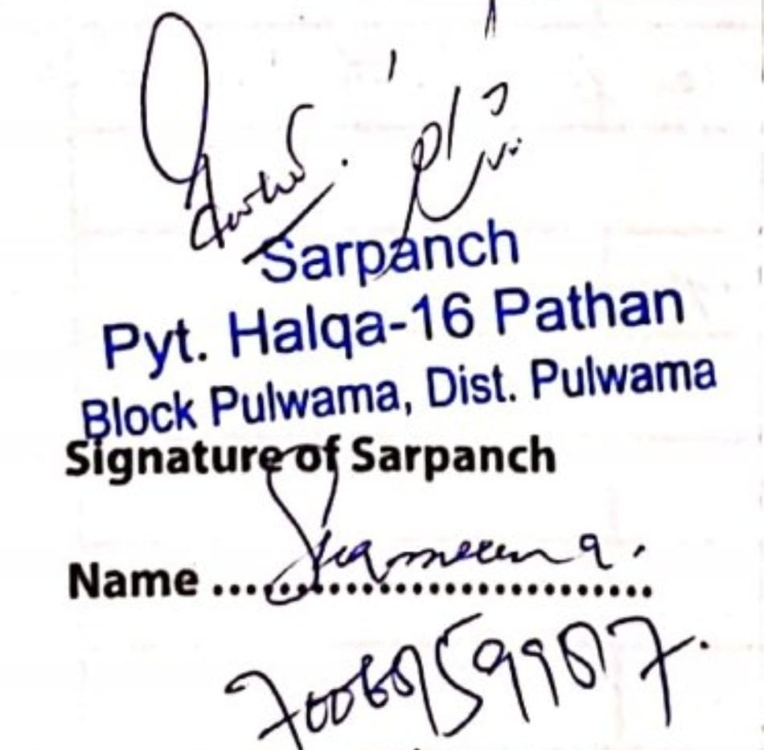

**SignatureoftheVisitingOfficer**

**Name : MUSHTAQ AHMAD BHAT**

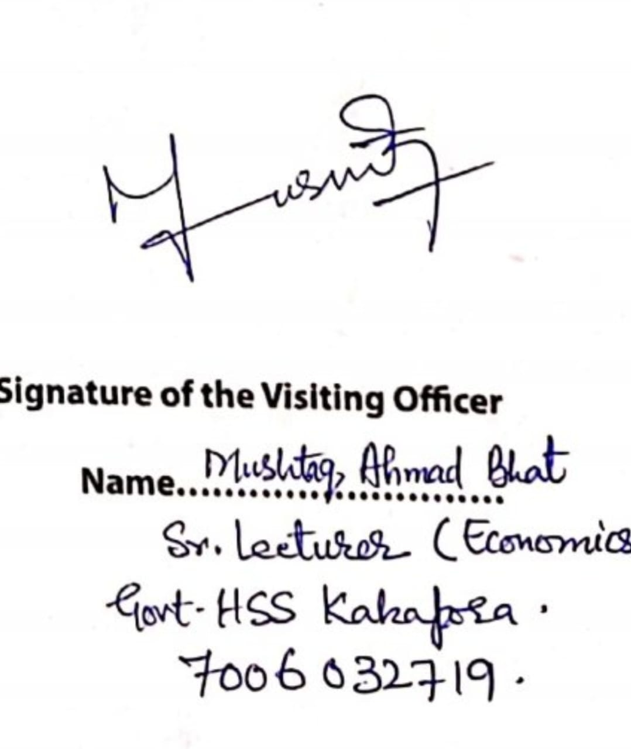

ATTENDANCE SHEET OF FRONT-LINE WORKERS:

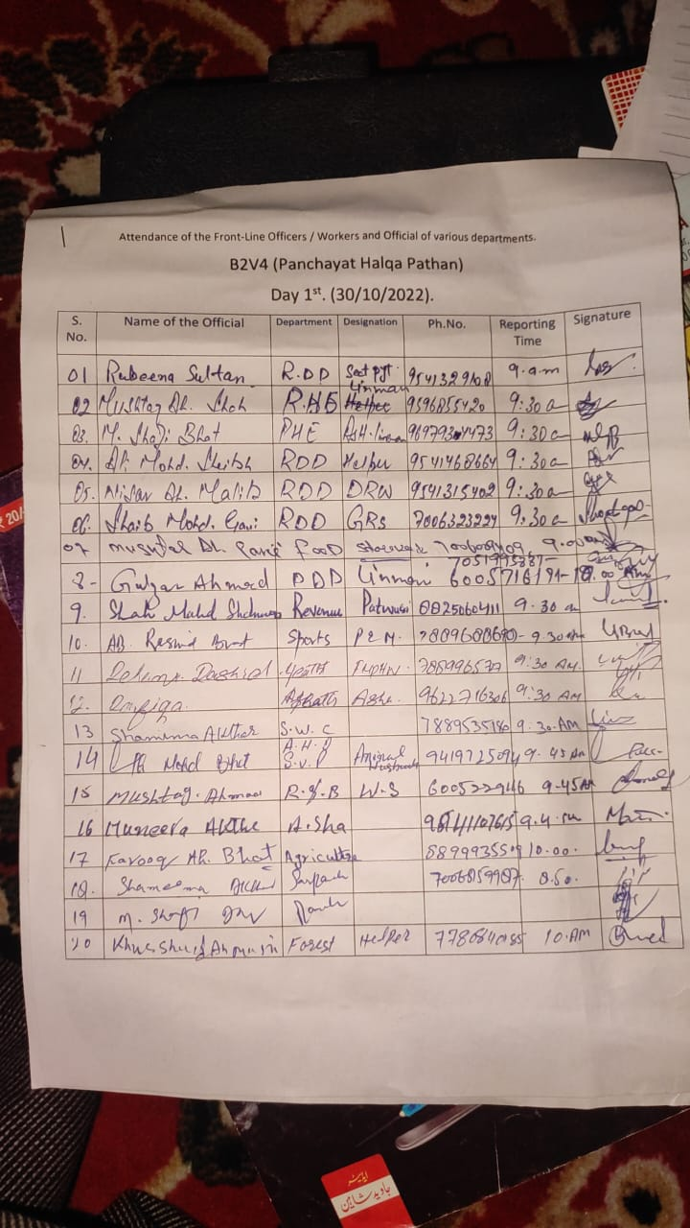

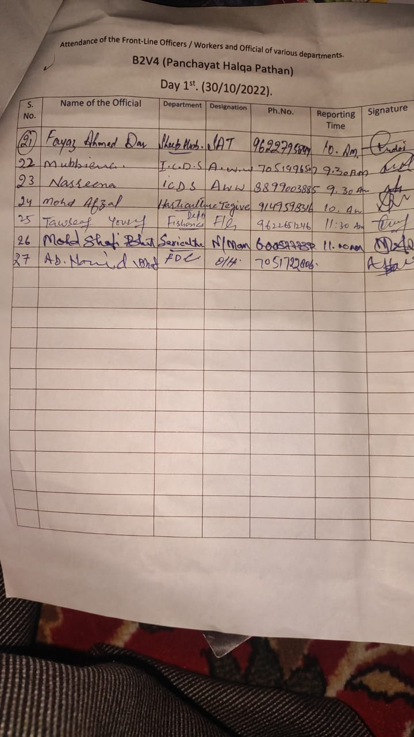

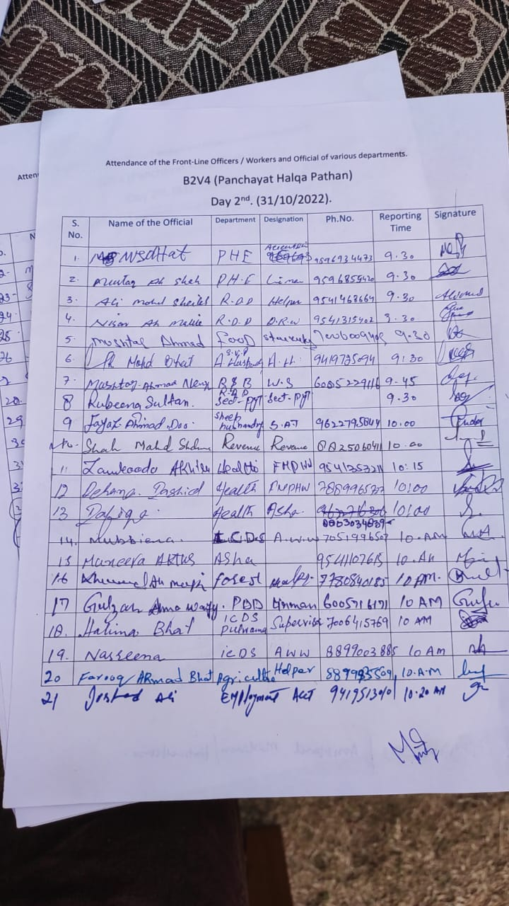

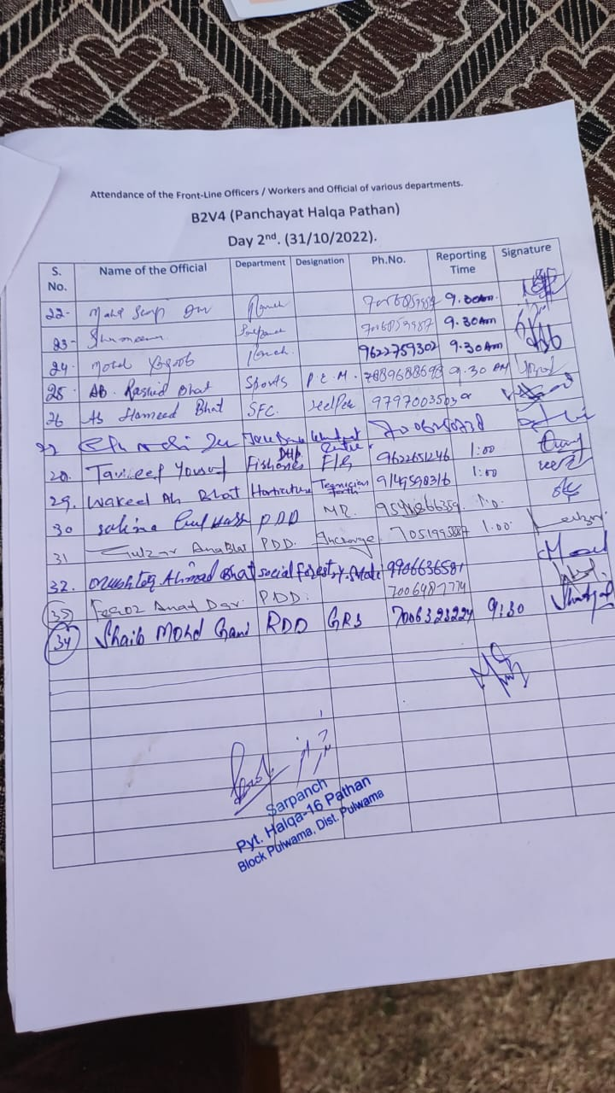

VILLAGE DEVELOPMENT PLAN:

**Major demands put forth by the villagers in B2V4 held at**

**GP Pathan Pahloo**

**(From 30-10-2022 to 31-10-2022).**

**General Demands:**

1.Identification of land by Revenue department for a playground.

2.Updradation of the Immunization center to Primary Health Centre.

3.Allotment of an additional ICDS center.

4.Replacement of Age-Old Water Supply pipe line as it has submerged deep into the ground.

5.Allotment of a Craft Center for educated and skilled girls (preferably a tailoring center)

6.Earth filling of Jinaza Gah.

7. Earth filling of Govt. High School ground.

8.Shifting of Nayabat from Lajoorah to Pulwama.

9.Seperate Patwar Halqa for the Village.

10.Allotment of an Agriculture outlet/ Horticulture Outlet/Animal Husbandry Center / Sheep Center and a Bank brank at the village.

11.Allotment of a Forest Sale Depo at the village.

**Constructional works demanded:**

1.Development of 3 No. Amrit Sarovers in the village.

2.Bunding of and land filling of 3 graveyards.

3.Construction of a foot path at the Govt. High School Pathan.

4.Construction of lining wall from main road to Sasra Stream.

5. Construction of lining wall from H/O: Abdul Rashid Dar to L/O: Assadullah Wani.

6.Construction of a drain from L/O: Mushtaq Ahmad Sheikh toL/O: Ab.Rashid Dar.

7.Construction of a drain from L/O: Mudasir Nazir via L/O: Mohammad Ramzan Bhat, Mushtaq Ahmad Sheikh and Javid Ahmad Pandith.

8.Development of link road from Masjid Shareef (Dar Masjid) to main road.

9.Construction of retaining wall from L/O: Abdul Ahad Wani to L/O: Manzoor Ahmad Ganie.

10.Construction of a drain near Heath center Pathan.

11.Construction of a bund on both sides of the road approaching to agriculture fields from the house of Hakeem Nazir Ahmad.

12.Construction of a bund around the water body near H/O: Mohammad Ashraf Wani.

13.Macdamization and widening of main road from Pinglana to Tanangam via Pathan.

14.Development of link road from main road to H/O: Ali Mohammad Lone.

15.Construction of bund on both sides of Asthan Streem.

16.Construction of bund from on both sides of the stream from H/O: Mushtaq Ahmad Ganie to Gh. Mohidin Kuchay.

17.Development of link road from the shop of Fayaz Ahmad Wani to L/O: Reyaz Ahmad Dar.

18.Construction of a house under PMAY for Mushtaq Ahmad Wagay S/O: Gh Hassan Wagay.

19.Construction of a Community compost pit.

20.Construction of a platform for transformer at Maqdam Mahalla.

21.Construction of a bridge over Gourwan streem near IMI public school.

22.Construction of a soakage pit at H/O : Nisar Ahmad.

23.Construction of a protection wall on both sides of the newly developed road from Asthan to L/O: Mohammad Ramzan Bhat.

24.Construction of left out drain from H/O: Nazir Ahmad H/O: Shabir Ahmad Mir

25.Macdamization oh link road (1/2 KM) from Maqdam Mohala to Mainroad.

**Other Demands:**

1.Installation of 100 KV transformer near the house of Ali Mohammad Bhat.

2.Compensation demanded by village apple grows for losses they occurred this year.

3.Compensation demanded by victims of snow storm of 2020-21 particularly by:

Ab. Rashid Bhat; Gh. Mohammad Sheikh and Mohamad Shafi Wani.

4.Provision of sports equipment to Govt. High School

5. Compensation to fire incident victim Irshad Ahmad Ganie.

**Visiting officer**

**Mushtaq Ahmad Bhat**

**Senior Lecturer Economics**

**GHSS Kakapora(Pulwama.)**



**DepartmentofRuralDevelompentandPanchayatiRaj**

**GovernmentofJammu &Kashmir**