

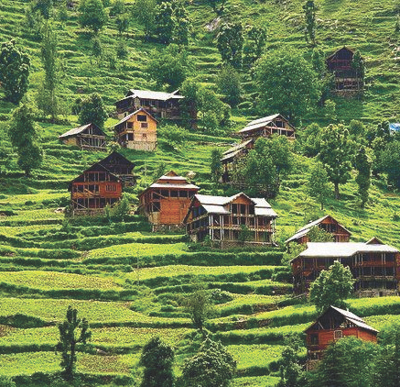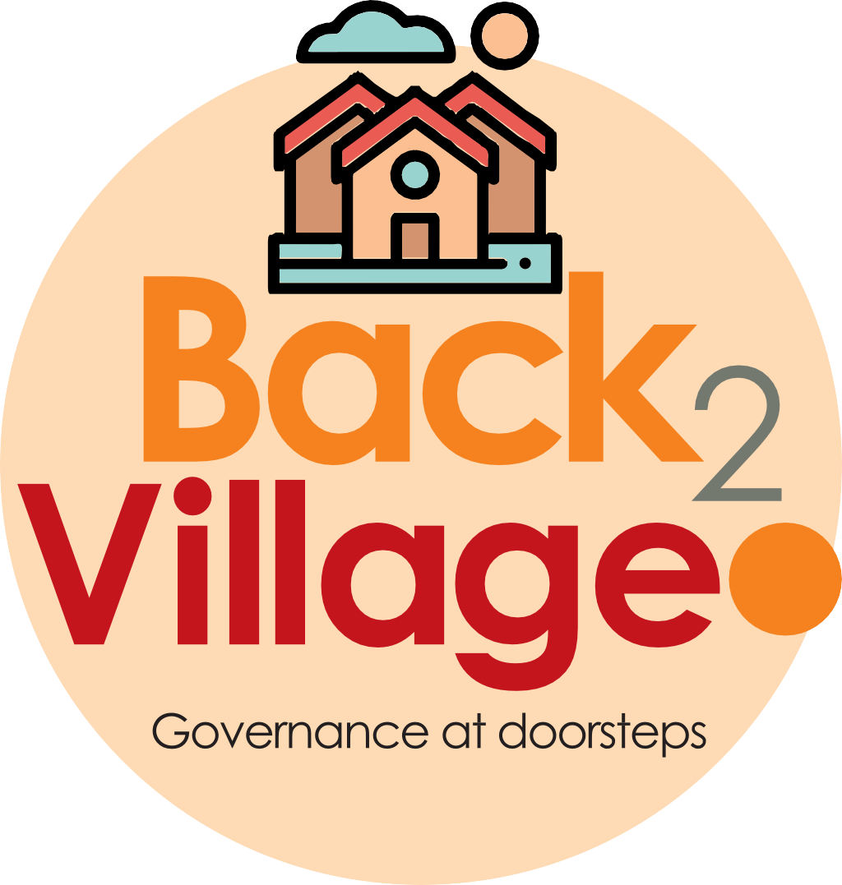

4

**15THOCTto3RDNOV,2022**

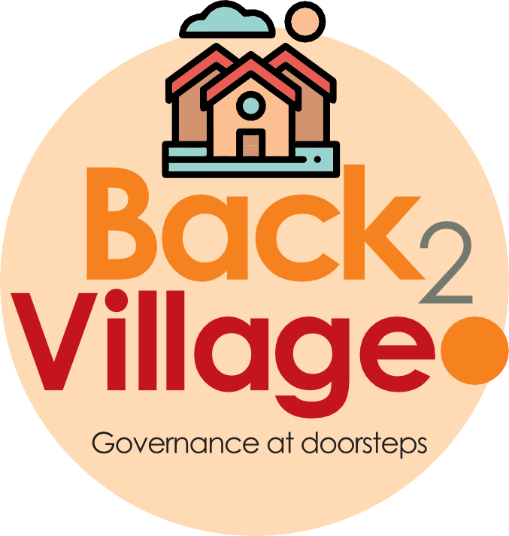

4

**15THOCTto3RDNOV,2022**

# KEYFEATURES

* DeputyCommissionerstoleadtheinitiative
* RuraldevelopmentDepartmenttobethenodaldepartment
* PlanningDevelopment&MonitoringdepartmentandITtobethesupportdepartments

# ACTIONSANDTIMELINES

|  |  |  |  |
| --- | --- | --- | --- |
| **ACTION** | **RESPONSIBILITY** | **LATESTBY** | **REMARKS** |
| **Janabhiyan** | Alldepartments | Oct15-26th | Goingon |
| **DeputationofSecttstaff/HoDs** | GAD | Oct14 | Done |
| **Deployment of Staff toPanchayats and serving ofordersondeployedofficers** | DCs | Oct25 | DCs will deploy senior level stafffromthedistricts.Strictactiontobe taken against abstentions. Noexemptionstobegiven |
| **TrainingofdistricttrainorsonB2V4** | RDD | Oct26 |  |
| **Trainingofvisitingofficers** | DCs | Oct27 |  |
| **FieldVisitstobecompletedby** | VisitingOfficers | Nov3 | DCstosuperviseandensurethateach Panchayatis visitedwithintheperiodspecified |
| **DataofB2V4tobeuploadedby** | VisitingOfficers | Nov10 | DCstosuperviseandensurethatdata of all Panchayats is upload-ed by the visiting officer withintheperiodspecified |

**INSTRUCTIONSFORTHEVISITINGOFFICER(DAYWISE)**

|  |  |  |
| --- | --- | --- |
| **DATE** | **INSTRUCTIONS** | **ACTIONPOINTS** |
| **Day0** | Meeting with deputycommissionerandhis/herteam | 1. TakeprintoutsoffilledbookletsofB2V1,B2V2andB2V3from[www.jkpanchayat.in](http://www.jkpanchayat.in/) 2. Alsotakeprintoutsofthesummarizedexcelsheetsofthepreviousphasesfrom[www.jkpanchayat.in](http://www.jkpanchayat.in/) 3. CollectATRsonissuesraisedduringprevious3phasesfromtheofficeofDeputyCommissioner(Planningdeptt) 4. Takeprintsofblank2bookletsofB2V4from[www.jkpanchayat.in](http://www.jkpanchayat.in/) 5. Takeplansfor2previousyearsandATRsfromtheplanningdeptt 6. CompletetrainingsondifferentcomponentsofB2V4beingorganizedbyrespectiveDeputyCommissioners 7. CollectListofnewworksstarted/ongoing/completedduringthepreviousandcurrentFinancialyearunderthefollowingheads:    * PRIgrants    * DistrictPlan    * UTplan    * MGNREGA    * Otherschemesofotherdepartments    * Anyotherwork 8. Plans/beneficiarylists:    * MGNREGAdraftplandocumentfortheyear2022-23.    * ListofAwaas+beneficiariesalongwithIHHLConvergence    * Listofpensionbeneficiaries.    * List of SHGs    * Listofagricultureschemebeneficiaries 9. Listsofbeneficiariesfor:    * Various certificates/ benefits to be distributed by thevisitingofficer.    * Anyotheractivitiesidentifiedbydifferentdepartments |

|  |  |  |
| --- | --- | --- |
| **Day1** | Reach thevillage | 1. Ensurethatallfrontlineworkersofdifferentdepttsarepresent. 2. Ensureexhibitionbydifferentdepts.aboutindividualbeneficiaryschemes 3. InspectJKB/PSBcounters/outlets 4. Participate/ensureorganizationofsportsactivityinplayfield,talenthunt/culturalevent/youthactivity 5. GandhiKatha(suggesteddetailsuploadedonjkpanchayat.in) 6. Visitatleast2amritsarovarsandgetitsgeotaggedphotos 7. InspectKhidmat(CSC)CentresandcreateGenerateawarenesson225schemesparticularlyG2CschemeslikeBEAMS,Janbhagidari,AapkiZaminAapkiNigrani,DigitalJ&K 8. Visitingofficershallalsoplanandconductpanchayatlevelconver-gencemeetingofalldepartments 9. CheckeffectivenessofCentrallysponsoredschemes 10. VisitandinspectallgovernmentestablishmentsincludingPHE,AWC,FPS,schools,etc 11. AttemptsaturationofdeliverablesoJanAbhiyanandwhereverdeficienciesfound,leadadrivetoachievealldeliverables 12. Assesseffectivenessofsanitationcampaigninthepanchayat 13. Ensureselfemploymentactivitiesfor15youthperpanchayat 14. Identify20potentialcandidatesperpanchayatforHIMAYATtrainingalongwiththetradeonwhichtheywanttraining 15. Whereverpossible,distributeemploymentlettersforpeopleselect-edundervariousgovernmentemployments 16. In the evening, hold normal meeting with senior citizens, govtem-ployeesincludingretiredemployees,exservicemen,youthclub,andanycitizensofthevillagewhoareenrolledincollege/university 17. OpendiscussiononNashaMuktAbhiyan |

|  |  |  |
| --- | --- | --- |
| Day2 | Have a meeting with allstakeholders- deptt officialsandpanchayatmembers | 1. Discussionontheandassesstheprogressofdifferentschemesrelatingto the localized SDGs prioritized for that village as per the resolutionpassedbythatGramPanchayaton21stApril22,onNationalPanchaytiRajDay. 2. SensitizevillageresidentsaboutmyScheme” portal(myscheme.in)whichincludesinformationaboutalltheschemesbeingrunbyCen-tral/State/UTgovtacrossthecountry 3. HoldmeetingoftheBiodiversityManagementCommitteestodeliber-ateonissuespertainingtoconservationofbiodiversityandsustaina-bleutilizationofbiologicalresources. 4. PrepareVillagedevelopmentplan,inconsultancywithGrampanchayat,discussitingramsabhaandgetitapproved. 5. EnsuresaturationofsoilhealthcardandgoldenhealthcardunderGold-enHealthCardunderAyushmanBharat, 6. EnsuresaturationofOldAgePensionScheme 7. EnsureDomicileSaturation. 8. EnsureKCCSaturation 9. Ensuresaturationoflandpassbooks 10. Ensureregistrationofvillagevendorsneededforanyscheme,onGEMportal 11. Ensurepanchayatcontractorsregistration 12. EncouragePanchayatmembersforimportanceofplantationdriveinPanchayatunderHarGaonHariyali 13. EnsurepaintingondigitalJ&Kinpanchayatghars 14. EnsurepaintingonpanchayatactivitesandCSSinpanchayatghars 15. The visiting office shall check no of kindergarten and playfieldspresentinthepanchayatforkidsandstudents,iftheinfrastructurepresentinthesearegoodenough. 16. HoldmeetingwithpanchayatmemberstodiscussaboutcorruptionmenaceandstepsrequiredtomakeJ&Kcorruptionfree 17. Obtainacandidassessmentaboutperformanceofvariousdepttsin-cludingfairfeedbackaboutdiscrepanciesinfunctioning 18. CheckthestatusofNashaMuktAbhiyanandreportingofdrugad-dictstoDeputyCommissioner. 19. Identify Tourist Destinations, Circuits, Theme Treks, Identify Homestays,providesupportfortourismactivitiesthroughVillageCooperative 20. OrganizeTalentHuntatPanchayatLevel 21. Conductsocialauditofatleast5worksunderfollowingschemes:     1. MGNREGA     2. PMAY     3. IHHLtoiletsandpayments     4. CSCs     5. AMRITSAROVARS 22. Holdamahilasabhaandabalsabhaandrecordproceedingsinthefor-matgiven 23. InauguratevillagehaatunderJKSRLM 24. Checkifyouthclubsareformedinthepanchayatandwhatactivitiestheyareengagedin 25. Organizeavillagelevelculturaleventtoengagepanchayatmembers 26. SensitizeGPaboutE-kitabkoshaninitiativeofJ&KGovtforempoweringyouthsthroughonlinedigitalliteracy |

# GENERALINSTRUCTIONS

1. Thevisitingofficershallrefrainhimself/herselfgivingorofferinganycommitmentonbehalfofthegovernmentandshalladoptanunbiasedattitudeinreportingissues.Asfaraspossible,his/herobservationshouldbebasedonafairandanalyticalviewemergingfromhis/herinteractioninthevillage.
2. Heisgoingtothevillageasplanningofficer,notforsanctioninganyworksorformakinganycom-mitments.
3. Whilepreparingvillagedevelopmentplan,hehastoensurethat,demandsareprioritizedandre-flectedunderavailableschemes,wherevernecessarythelargerworksaretobereferredtoadminis-trativedepttunderCSS/UTplansunderintimationtoDCsandrestoftheworkstoDCsforreflectingitunderdistrict/CSSplans
4. HisworkshallbehardcoreplanningandauditandisnotaPRexercise.
5. EveryDeputyCommissionerhastoensurethatatleastoneRDDofficial(ideallyPanchayatSecre-tary)ispresentineverypanchayatwithrelevantpanchayatrecords,toensureconductofallactivi-tiesasplanned.Panchayatwiseorderneedstobeissuedinadvance.
6. Visiting officer should ideally carry his/her laptop to complete the reports at the panchayat levelitself and upload the final report, duly signed both by the sarpanch and by the visiting officer on[www.jkpanchayat.in](http://www.jkpanchayat.in/)portal,beforetheyleavepanchayat.
7. Focus of visit are youth, skills, self-employment, nashamukt, bhrashtracharmukt, Rozgaryukt J&K,besidestocarryforwardtheactivitiesduringJanAbhiyanandsaturatethem.
8. Inadditionattentionmaybegiventothefollowingareas
   1. MakefulluseofCentrallySponsoredSchemes
   2. Saturationofindividualbeneficiaryschemes
   3. Self-employmentschemes
   4. Banklinkedschemes-includingdepartmentalsubsidyschemes
   5. Empowermentandtransparencythroughdigitalinitiatives
   6. Effectivenessofgrassrootsmachinery–
      1. Patwari,VLWpresentandavailable
      2. AvailablefundsutilizedinpublicinterestandasperGramSabharesolutions
      3. Fairnessingovernance
      4. CSS/Individualbeneficiaryschemesetc
      5. BrashtacharMuktJ&K
      6. Bhai MuktJ&K
      7. NashaMuktJ&K
9. ThePRImembers(Sarpanchs,Panchs,BDCChairperson)shallbeattheforefrontofallactivitiesandgiven due importance and the approach should be to strengthen them and make them feel em-powered.He/sheshallensurethattheBDCchairpersonandSarpanch/Pancharepresentatthetimeofinaugurationandceremonies.
10. Visitingofficershallnotleavethedistrictwithoutuploadingthereport,dulysignedonthe**[www.](http://www/)jkpanchayat.in**portal.EveryDeputyCommissionerhastoensurethat.

## DetailsofReportingOfficer:

Name: **Paramjeet Singh**

Designation: **Secretary**

Department/placeofposting: **GAD/ Social welfare Deptt./ S&E BCC**

MobileNo: **9419261755**

EmailID:**pjsraina@gmail.com** HomeDistrict:**JAMMU** Datesofvisit:**02-11-2022 to 03-11-2022**

## LocationaldetailsofPanchayat:(tobepre-filled,informationtobetakenfromtheprevious

**phasesbooklets/summarizedexcelsheetuploadedonjkpanchayat.in/b2v4.php)(tobevali-datedbythevisitingofficerandmissingdetailstobefilled)**

NameofthePanchayat:**Surankote Upper**

LocalGovernmentDirectory (LGD)codeofthePanchayat:**1256** NameofCDBlock: **Surankote** NameofTehsil: **Surankote** Name of District: **Poonch**

## PanchayatProfile:

No.ofrevenuevillagesinthePanchayat:**01** No.ofhamletsinthePanchayat:**09** No.ofhouseholdsinthePanchayat:**702**

Population(approx)ofthePanchayat:**3065**

# Part-II:

(TobefilledupbytheVisitingOfficerduringhis/hertwodayvisittothePanchayat.AllFieldshavetobefilledbytheVisitingOfficerbeforethebookletishandedovertotheDC

## FrontlineOfficers/OfficialswhowereassignedtothePanchayatfortheprogramme:

|  |  |  |
| --- | --- | --- |
| **Department** | **Name** | **Designation** |
| **RDD** | **Tariq Hussain** | **GRS** |
| **Revenue** | **Vishav Karmal** | **Patwari** |
| **Education** | **Bilal Hussain** | **Teacher** |
| **PWD** | **Nusrat Jabeen** | **TSWO** |
| **PDD** | **Puneet Kumar** | **JE** |
| **PHE** | **Kiffaat Hussain** | **JE** |
| **PMGSY** | **Mohd Kabir** | **Frontline worker** |
| **Agriculture** | **Mohd Sameer** | **JAEO** |
| **AH** | **Dr. Syed Koser** | **AS** |
| **ICDS** | **Narseen Akhter** | **AW** |
| **Forest** | **Mohd Tazeen** | **Guard** |
| **Food and Supply** | **Badder Nissar** | **Dealer** |

**Detailsofabsentemployeesvis-à-vislistfurnishedbytheDCoffice:**

|  |  |  |
| --- | --- | --- |
| Department | Name | Designation |
|  |  |  |
|  |  |  |
|  |  |  |
|  |  |  |
|  |  |  |
|  |  |  |
|  | NIL |  |
|  |  |  |
|  |  |  |
|  |  |  |
|  |  |  |
|  |  |  |
|  |  |  |
|  |  |  |
|  |  |  |

# DAY1-ACTIVITIES

## AGENDA1:PANCHAYATASSETREGISTER

**Infrastructure:**

* 1. PanchayatGharInfrastructure
     1. **Govtbuilding**/private: **Govt. Building**
     2. **New**/needingrepairs:
  2. Furniture(Y/N): **Yes**
  3. Computer/printer(Y/N)**Yes**
  4. Internet(Y/N)**Yes**
  5. Telephone(Y/N)**No**
  6. Toilet(CSC/partofpanchayatghar)(Y/N): **Yes**
  7. Water(Y/N): **Yes**
  8. Electricity(Y/N): **Yes**
  9. Bank branch (Y/N): **No**
  10. CSC(Y/N): **Yes**
  11. Patwarkhana(Y/N)**No**
  12. Villagehaat(Y/N): **No**
  13. Playground(Y/N): **No**
  14. School-
      1. Kindergarten(Y/N): **Yes**
      2. Primary(Y/N)**Yes**
      3. Secondary(Y/N)**No**
      4. College(Y/N)**No**
      5. University(Y/N)**No**
  15. AnganwadiCentre(Y/N): **Yes**
      1. (govt/private): **private**
      2. Totalchildrenenrolled: **97**

1. Amrit Sarovars–details,location,condition: **under construction**
2. Governmentoffices-details,whetherfunctionalornot: **functional**
3. Rationshop(Y/N): **No**
4. Placesoftourismimportance–names,littledetailsonhistorical/culturalimportance: **Nil**
5. Villageheritagesites/treks-names,littledetailsonhistorical/culturalimportance: **No**
6. VLWOffice(Y/N): **Yes**
7. PrimaryHealthcareCentre(Y/N): **No**
8. ListofIncompleteBuildings-names,yearofconstruction: **Nil**
9. ListofUnderutilizedBuildings-names: **Nil**

# DAY1-ACTIVITIES

## AGENDA2:

**DIFFERENTINSTITUTIONS/INFRASTRUCTUREPROJECTSTOBEVISITED**

|  |  |  |
| --- | --- | --- |
| **AMRITSAROVARS** | **Visit,verify** | **COMMENTS** |
| KhidmatCentres | Create /Generate awareness on 225 schemesparticularlyG2CschemsAapkiZaminAapkiNigrani,Beams,Janbhagidari,DigitalJ&K | **Public besides PRI’s were aware about all the schemes** |
| JKB/PSBcounters/outlets | 1. Statusofcounter 2. Numberofvisitors | **No counter was established however manager J&K Grameen Bank was called who make awareness about scheme** |
| Incomplete buildings/pro-jects | Verifywhetheridentificationandredistributiondone | **Nil** |
| PDS | Visit,evaluate,onlinestatus | **No center is available** |
| PHC | Visit-evaluate,statusofstaff,equipmentandquality | **No PHC is available** |
| Youthclubs | Meet,interact,seeksuggestions | **Youth club have been formed** |
| SHG | Meet,identifyproblems,seeksuggestions | **group was formed** |
| PMAY | Inspect,Inaugurate | **02 x Iinaugurated** |
| My school, my prideprogress; schools- water,toilets,staff | Visit,checkforwater,electricity,sanitation,meetstudentsandstaff | **v. poor condition of all the schools, moreover majority of staff posted have stay of more than 10 years** |
| SwachhSBM | Evaluate | **01** |
| Panchayatplayground,SportskitsdistributionVillagegames | Ensure,verify.Participateinatleastonegameintheplayground | **Sports kit distributed tug of war game displayed** |
| HarGaonHariyali,Planta-tiondrive | Evaluatestatus,feedback | **Plantation drive conducted** |
| Village cultural eventDangal/Haat/Mela | Participatein;ensurethatitisheld | **Tug of war, bad mention match conducted** |
| Exhibitionofschemes | Ensurethateverydepartmentparticipatesandthatitcontinuesforthe entiredurationofB2V | **Ensured** |
| Jal Jeewan Mission verifica-tion-WSS/JSD  Electricitysupply | Verify | **Schemes are under process** |

# DAY1-ACTIVITIES

## AGENDA 3: SATURATE JAN BHIYANDELIVERABLESANDRECORDDEFICIENCIESIFANY

**(INSERTDELIVERABLES LIST HEREAS PER GAD FORMAT**

|  |  |  |
| --- | --- | --- |
| **S/No** | **Deliverables** | **Remarks** |
| 01 | Land Passbook | 25 No’s Distributed |
| 02 | Golden health cards | Already issued |
| 03 | Self-employed drive | 15 |
| 04 | Himayat scheme | 20 |
| 05 | Awareness on Jan Abhiyan | Undertaken |
| 06 | Nasha Mukth | Pledge taken |
| 07 | Sports kit to senior citizen | Distributed |
| 08 | Bal sabha + mahila sabha | Done |
| 09 | Sports event (tug of war) | Done |

|  |  |  |
| --- | --- | --- |
| **S/No** | **Deficiencies** | **Remarks** |
| 01 | PDS | Required |
| 02 | PHC’s | Required |
| 03 | Tap water to each household | Required |

# DAY1-ACTIVITIES

## AGENDA4:

**SELFEMPLOYMENTACTIVITIES**

EnsureSelf-employmentactivitiesforyouth,distributeemploymentlettersforpeopleselectedundervarioussocialschemes(15ISTHETARGETPERPANCHAYAT)

## Numberofcasesindifferentcategoriessanctioned:

**Detailsofthebanksanctioningit:**

**Totalamountinvolved: No employment letter have been distributed, however 15 person have been motivated for the purpose.**

# DAY1ACTIVITIES

## AGENDA5

Intheevening,holdinformalmeetingswithseniorcitizens,govtemployees,retdemployees,youthclubandothercitizenswhoareenrolledoncollege/universityandhavediscussiononGandhiKatha,NashaMuktAbhiyan,corruptionfreegovernance,doublingfarmersincomeandrecordtheproceedings

## DAY2

1. NoofIndividualCompostPitsconstructed: **20**
2. NoofIndividualSoakPitsconstructed: **270**
3. No.ofBiodiversitymanagementcommitteemeetingsheld:**05**
4. IsthenameofSarpanchdisplayedoncitizeninformationboardsofallRD&PRschemes:Yes/No: **Yes**
5. AreSarpanchsbeinginvolvedinstart/inaugurationofactivities:Yes/No: **Yes**
6. WhethersubjectshavebeenassignedbytheSarpanchtothePanchs:Yes/No: **Yes**
7. Whethergrievancesredressalboxisinstalled:Yes/No: **Yes**
8. NoofgrievancesreceivedpertainingtoPanchayatlevel:**Nil**
9. NoofgrievancesdisposedofatPanchayatlevel:**Nil**
10. WhethertheSarpanch/PanchayatSecretaryhavedigitalsignatures:Yes/No: **Yes**
11. WhetherallMGNREGA/14thFCpaymentsarebeingmadebySarpanchthroughDigitalSignatureCertificate(DSC):Yes/No: **Yes**

# HUMANRESOURCEAVAILABLEATTHEPANCHAYATLEVEL:

|  |  |  |  |  |
| --- | --- | --- | --- | --- |
| **SRNO.** | **DEPARTMENTWISESTAFF** | **NUMBERS** | | **NAMES** |
|  |  | SANCTIONED | ACTUAL |  |
|  | Ruraldevelopmentdepartment:BDO/BDO  JE  GRS  TA | **0**  **01**  **01**  **01** | **0**  **Nil**  **01**  **01** | **Tariq Hussain**  **Showket Ali** |
|  | SCHOOL EDUCATION:TEACHER  HEADMASTER  ANYOTHER | **16**  **01** | **15**  **Nil** |  |
|  | JALJEEVAN: | **04** | **04** | **Mohd Rashid, Mohd Iqhlaq, Mohd Yousef, Mohd Riaz** |
|  | PDD:  LINEMANJE  ANYOTHER MeterReader | **02**  **01**  **01** | **02**  **01**  **01** | **Zulifkar Ali, Khalil Amed**  **Puneet Kumar**  **Jaffar Iqbal** |
|  | FOOD&CIVILSUPPLIES |  |  | **No depot is available** |
|  | AGRICULTURE&ANIMALHUS-BANDARY  VS VP attendant | **01, 01,02** | **0,01,01** | **Jameel Ahmed, Parveen Akhter** |
|  | SOCIALWELFARE | **Nil** | **Nil** | **Nil** |
|  | HEALTH:  ASHAANM  AYUSHDOCTOR  ALLOPATHICDOCTOR | **05**  **02**  **Nil**  **Nil** | **05**  **02**  **Nil**  **Nil** | **Naseem Akhter, Saheen Akhter, Farmita Akhter, Khatoon Begum, Robina Akhter** |
|  | ANYOTHERDEPARTMENT  ICDS 4 AH  4 AW | **04**  **04** | **04**  **04** | Nasreen Akhter, Zarina Begum, Sahin Akhter, Begum Noor, Rakhmat Jaan, Shamin Akhter, zanit Bi, Sakina Begum |

**DAY2-ACTIVITIES**

## AGENDANO.1

DiscussionontheandassesstheprogressofdifferentschemesrelatingtothelocalizedSDGsprior-itizedforthatvillageaspertheresolutionpassedbythatGramPanchayaton21stApril22,onNationalPanchayatiRajDay(Copyoftheresolutiontobetakenfromjammu[www.jkpanchayat.in](http://www.jkpanchayat.in)portalunderthelinkofGramSwarajMonth)

* 1. SDGsAGREEDFORTHATVILLAGE,TOBEIMPLEMENTEDBYMARCH2024:**Clean and Green Village**
  2. STATUSOFWORKSUNDERTHEFOLLOWINGSCHEMES: **Village with good governance**

## Cleanandgreenvillage

1. InitiativestakenbythePanchayatformanagingSolidandLiquidWaste **Composit pit and soak Pit**
2. InitiativestakenbythePanchayatforusinggreensourcesoffuellikesolar,biogas: **Nil**
3. Hasmappingoflanduse,waterbodies,forest,slopes,wetlands,degradedforestwithintheGramPanchayatbeendone?Yes/No.IfNo,reason,thereof **No**
4. HastheClimateResiliencePlanbeendevelopedfortheGP?Yes/No:
5. StepstakenbytheGramSabhaabouttheclimatechangemitigationfactorslikereducingenergyconsumption,usageoffossilfuels,plastics,non-

renewablebuildingmaterialsandalsotopromotemeasureslikeplantingoftrees,conservingforests,usageof goodagriculturalpracticeslikedripirrigation,waterconservationmeasuresandconservationofwetlands:

1. Whetherschoolshavestartedsegregatingwaste: **Yes**
2. Whetherschoolshavetheirowncompost/soakagepitsforsolid/liquidwastemanagement: **Yes**

## Healthyvillage

1. Aremeetingsrelatedto VillageHealthandSanitationCommitteebeingheldregularly?: **Yes**
2. DoalltheeligibleindividualsbeenprovidedtheGoldenCard?: **Yes**
3. ArealltheChildrenbeingimmunizedaspertheSchedulerecommendedbyGovt.ofIndia?: **Yes**
4. ArealltheeligibleindividualsbeenvaccinatedagainstCOVID-19?**No**
5. DoesGramPanchayatensurethatallpregnantwomenaregettingnecessaryprenatalcheckups?**Yes**
6. WhetherallthedeliverieswereInstitutionalizedorconductedbytrainedMidwives?**Yes**

## Watersufficientvillage

1. DoalltheIHHsintheGramPanchayathavewaterpipelineconnections?**No**
2. WhetherGramPanchayathastakenstepsforgreywatermanagement.IfYespleasespecify: **No**
3. DoalltheIHHsintheGramPanchayathavetoilets?**No**
4. ArealltheIHHstoiletsfunctionalornot?**No**
5. DoalltheSchools/Anganwadicentershaveatoiletfacilityornot?**Yes**
6. Areallthetoiletsintheschools/Aaganwadifunctionalornot?**Yes**
7. WhetherGramPachachayatBhawanhasseparatetoiletsforwomenornot?**No**

## ChildFriendlyvillage

1. Doallthechildrenundertheageof0-6yearsbeenenrolledintheAnganwadicentersforpre-schooling?Yes/NO: **Yes**
2. HowmanyBalSabha’swereorganizedintheGramPanchayat--------**02**-----------
3. WhethertheissuesraisedbyBalSabhaareaddressedduringtheGramSabha.Yes/NO: **No**
4. WhetherGramPanchayatistrackingthedatarelatedtodropoutchildrenandchildrenwithirregularattendance?Yes/NO: **No**
5. DoalltheschoolsundertheGramPanchayathaveseparatetoiletsforgirlsandboys?Yes/No: **No**

## Villagewithgoodgovernance

1. IsCSClocatedintheGramPanchayatBhawanornot? **Yes**
2. IsthelistofbeneficiariesrelatedtotheSchemes/ProgramsdisplayedontheGrampanchayatwallornot? **Yes**
3. DoestheGramPanchayathasitsbuildingornot? **Yes**
4. IstheGramPanchayatofficefunctionalornot?**Yes**
5. AretheactivitiesapprovedundertheHalqaPanchayatDevelopmentPlandisplayedontheGramPanchayatwallornot?**No**
6. IsSocialAuditofearlierSchemes/Programscarriedoutornot?**Yes**

## Povertyfreeandenhancedlivelihoodvillage

1. HasGramPanchayatdevelopedanycriteriafortheidentificationofthepoor?Yes/Noifyesspecify: **No**
2. HavealltheeligiblehouseholdsregisteredinPDSornot?**Yes**
3. HasGramPanchayatprovidedspaceforSelf-helpGroupsinPanchyatGharforholdingmeetingsornot? **Yes**
4. HavealltheeligiblehouseholdsbeenregisteredforPensionornot?**Yes**
5. HasGramPanchayatfacilitatedYouthforSkillEnhancementCoursesandPlacement? **Yes**
6. HasJobCardsbeendistributedtoalltheeligibleindividualsunderMGNREGA?**Yes**
7. HasGramPanchayatfacilitatedSHGsforBankAccountLinkages?**Yes**

## Sociallysecuredvillage

1. WhetherGramPanchayatismaintainingdatarelatedtoDifferentlyAbledPeople? **Yes**
2. IsGramPanchayatOfficeDisabledFriendlyornot?**Yes**
3. AreprovisionsforaseparateBudgetundertheResourceEnvelopeforWomenandChildrenmadeornot? **No**
4. Do all the Schools in the Gram Panchayat have facilities for Differently Abled Children like toilets,barrier-freeaccess,etc.,ornot? **No**
5. Arealltheeligibleindividualsaregettingpensions,likeoldagepension,widowpension,etc? **Yes**
6. ArealltheeligiblehouseholdsgettingbenefitsfromIAYornot?**Yes**

## EngenderedDevelopmentinVillage

1. HowmanyMahilaSabha’swereorganizedintheGramPanchayat-------**05**------------
2. WhetherSHGsfederationshavebeenprovidedspaceformeetingsinthePanchayatBhawan(Yes/No) **Yes**
3. WhetherGPshavetakenstepsforincreasingwomen’sparticipationinGramSabha(Yes/No)**No**
4. NumberofwomenbeneficiariesheadedhouseholdscoveredunderPDSsystem………………………
5. Numberofbeneficiaries(outoftotaleligiblepopulation)receivingsocialprotectionbenefitsunderPradhanMantriMatritvaVandanaYojana………**49**………….
6. Self-sufficientinfrastructureinthevillage
7. Whether GP has a Community Hall with access to electricity, furniture, water supply,toilet…………**No**…………….
8. WhethertheDisastermanagementplanisavailableattheGPLevel(Yes/No)**Yes**
9. Whetherchild-friendlyparkwithrequiredfacilitiesisavailableinGP(Yes/No)**No**
10. WhethertheGPhaseasyaccesstoGodownforstorage(Yes/No)**No**
11. Whetherstreetlightsareprovidedinpublicplacesforensuringsafety(Yes/No)**Yes**

# DAY2ACTIVITIES

## AGENDANO.2

SensitizevillageresidentsaboutmyScheme”portal(myscheme.in)whichincludesinformationaboutalltheschemesbeingrunbyCentral/State/UTgovtacrossthecountry

*(SchemeMaterialavailablefromhttps://jkpanchayat.in/b2v4.php)*

# DAY2ACTIVITIES

## AGENDANO.3

HoldmeetingoftheBiodiversityManagementCommitteestodeliberateonissuespertainingtoconserva-tion of biodiversity and sustainable utilization of biological resources. He should check People Biodiversityregister(PBR)ofthatpanchayatandreviewifBiodiversityManagementCommitteeconstitutedforthatpanchayat is holding minimum 4 meetings in a year and meeting once in every 3 months *(Role of BMCavailableathttps://jkpanchayat.in/b2v4.php)*

COMMITTEEMEMBERS: **07**

PRESENT:**04**

BIODIVERSITYREGISTERPHOTOS:

PAST4MEETINGDETAILS-DATES,MINUTESPHOTOS:

# DAY2ACTIVITIES

## AGENDA4

VisitingofficershallalsoplanandconductpanchayatlevelconvergencemeetingofalldepartmentsandprepareVillagedevelopmentplanforvillage,inconsultancywithGrampanchayat,discussitingramsabhaandgetitapproved.

(GPDPformatavailableonhttps://jkpanchayat.in/b2v4.php)

## InadditionGPDPplanshallalsoinclude:

Tourist places which need to be developed:**Not Available**

Specificproductwhichneedstobedeveloped:**Walnut**

Tourism-homestays**:Nil**

20candidatesfortrainingunderHimayatschemealongwithtradeinwhich:trainingistobegiven:**Copy enclosed**

# DAY2ACTIVITIES

## AGENDA5

Ensuresaturationoffollowingschemesandgivestatus:

|  |  |  |  |
| --- | --- | --- | --- |
| **NAMEOFTHESCHEME** | **TOTAL ELIGIBLEBENEFICIARIESIN THEVILLAGE** | **TOTALBENEFICIARIESWHO**  **AVAILED THE BENEFITS OFTHESCHEME** | **REASONSFORPENDENCY** |
| GoldenHealthCardunderAyushmanBharat | **2289** | **1805** | **under process** |
| Jananisurakshayojana | **22** | **22** | **-** |
| OLDAGEpension | **190** | **179** | **under process** |
| Widowpension | **62** | **57** | **Docu def** |
| Disabilitypension | **105** | **102** | **-do-** |
| Domicilecertificate | **3065** | **2365** | **On going process** |
| Kisancreditcard | **220** | **215** | **Under process** |
| PMkisansammannidhi | **170** | **140** | **Docu defi** |

|  |  |  |  |
| --- | --- | --- | --- |
| Landpassbook | **504** | **200** | **Under Process** |
| Registrationofvillageven-dorsonGEMportal | **Nil** | **Nil** |  |
| Registrationofvillagecon-tractorsonjktenders portal | **05** | **05** |  |
| Registrationofvillagecon-tractorsonPWDportal | **03** | **03** |  |
| Incomplete buildings/pro-jects | **-** | **-** | **-** |

# DAY2ACTIVITIES

## AGENDA6

**NASHAMUKTABHIYAN**

1. Whethergramsabharesolutionpassed: **Yes resolution by the GP that there is no person with addiction in the village and whole village is nasha mukt**
2. Detailsofactivitiesconducted: **-**
3. WhetherallactivitiesandGSresolutionuploadedonjkpanchayats.inportal: **Yes**
4. Howmanydrugaddictsinthevillage:**Not reported**
5. WhetherreportedtotheDeputyCommissioner: **-**
6. Howmanyregisteredforrehabilitationundergovernmentprogramme: **-**

# DAY2ACTIVITIES

## AGENDA 7SOCIALAUDIT

Conductsocialauditofatleast5workseachunderfollowingschemes:

|  |  |  |  |  |  |  |
| --- | --- | --- | --- | --- | --- | --- |
| NAMEOFTHE  SCHEME | DETAILSOFTHE  WORKS | YEAROFWORK  APPROVAL | AMOUNT  APPROVEDFORTHEWORK | WHETHER  WORK EXECUTEDSATISFACTORILY | GEO-  TAGGEDPHOTOS | ANYGRIEVANCE  RECORDEDRELATINGTOTHATWORK |
| MGNREGA | **03** | **2020-21** | **3.90 lakh** | **Yes** | **Yes** | **No** |
| PMAY | **02** | **2019-20** | **2.6 lakh** | **Yes** | **Yes** | **No** |
| IHHL  UNDERSBM-G | **01** | **2020-21** | **0.12 lakh** | **Yes** | **Yes** | **No** |
| CSC UNDERSBMG |  |  |  |  |  |  |
| AMRITSAROVARS | **01** |  |  |  |  | **Under const** |

# DAY2ACTIVITIES

## AGENDA 8

## MAHILASABHA

Totalwomeninthevillageabovetheageof18: **973**

Totalattended :**17**

Proceedings:**Awareness created about immunization health and hygiene anemia defi, discourage about marriage below 18 of female child and all scheme of Govt of india related to female and women.**

*(Plinsertpointerstobediscussedthere–referpalliproceedings)*

# DAY2ACTIVITIES

## AGENDA 9

## BALSABHA

Holdabalsabhaandrecordproceedings

Totalchildreninthevillageabovetheageof…**6 years and below 16 years**.

Totalattended: **20**

Proceedings:

*(Plinsertpointerstobediscussedthere–referpalliproceedings)*

# DAY2ACTIVITIES

**AGENDA 10INAUGURATIONS**

|  |  |  |  |
| --- | --- | --- | --- |
| **SRNO.** | **ASSETS /ACTIVITIESINAUGRATED** | **STATUSOFTHEASSET/AC-TIVITIES (NUMBER, OTHERDETAILS)** | **GEO-TAGGEDPHOTOS** |
|  | VILLAGEHAATunderJKSRLM(SUN-DAYMARKET) | **No** | **No** |
|  | PMAYhousesifanyreadyforinaugra-tion | **02** | **Yes** |
|  | Swachhgramprojects-segregationshedsetc | **-** | **-** |
|  | Amritsarovars | **01** | **UNDER CONTT** |
|  | Sportskits | **01** | **Yes** |
|  | Villageculturalevents | **Yes** | **Yes** |
|  | JJMassets/projects | **-** | **-** |
|  | Any other to be identified at districtlevel | **-** | **-** |

# FOLLOWUPOF(B2V1,B2V2&B2V3):

*(Prefilledexcelsheettobetakenfromdistrictlevel/andalsotobedownloadedfromwww.jkpanchayat.in)*

|  |  |  |  |
| --- | --- | --- | --- |
| S.NO. | Particulars | Actiontaken | Remarks# |
| I. UrgentPublicRequirements/Demands-B2V1 | | | |
| 1. **Link road to panchayat ghar and water taken** | |  | Nil |
| 1. **Road from college to kamri wala and link road to each hamlet** | |  | Nil |
| 1. **Upgradation of MS to HS basti dra** | |  | Nil |
| 1. **Panchayat be promoted as model town** | |  | Nil |
|  | |  |  |
|  | |  |  |
|  | |  |  |
| II. UrgentPublicRequirements/Demands-B2V2 | | | |
| 1. **Water supply system** | | Nil | However plan approved as stated by AEE, PHE |
| 1. **Lack of Anganwari center** | | Nil |  |
|  | |  |  |
|  | |  |  |
|  | |  |  |
|  | |  |  |
|  | |  |  |
| S.NO. | Particulars | Actiontaken | Remarks# |
| III. MajorProblems–B2V1 | | | |
| 1. Drinking water supply | | Nil |  |
| 1. Lack of health S.C | | Nil |  |
|  | |  |  |

|  |  |  |  |  |  |  |  |  |  |  |  |  |  |
| --- | --- | --- | --- | --- | --- | --- | --- | --- | --- | --- | --- | --- | --- |
|  | | | |  | | | | | | |  | | |
|  | | | |  | | | | | | |  | | |
| IV. MajorProblems-B2V2 | | | | | | | | | | | | | |
| 1. **Lack of Angadwari building** | | | | | | Nil | | |  | | | | |
| 1. **Worst condition of road JWG to basti dra** | | | | | | Nil | | |  | | | | |
|  | | | | | |  | | |  | | | | |
|  | | | | | |  | | |  | | | | |
|  | | | | | |  | | |  | | | | |
| V. MajorProblems-B2V3 | | | | | | | | | | | | | |
| 1. **Lack of water supply system in whole village** | | | | | Nil | | However plan approved as stated by AEE, PHE | | | | | | |
|  | | | | |  | |  | | | | | | |
|  | | | | |  | |  | | | | | | |
|  | | | | |  | |  | | | | | | |
|  | | | | |  | |  | | | | | | |
| VI. MajorComplaints-B2V1 | | | | | | | | | | | | | |
| 1. **Non-availability of Hr Sec School** | | | Nil | | | | |  | | | | | |
| 1. **Road connectivity to hamlet** | | | Nil | | | | |  | | | | | |
| 1. **Non availability of tab water** | | | Nil | | | | |  | | | | | |
| VII. MajorComplaints-B2V2 | | | | | | | | | | | | | |
|  | | Nil | | | | | | | |  | | | |
|  | | Nil | | | | | | | |  | | | |
|  | |  | | | | | | | |  | | | |
| VIII. MajorComplaints-B2V3 | | | | | | | | | | | | | |
| 1. **Lack of water supply system in whole village** | Nil | | | | | | | | | | | | However plan approved as stated by AEE, PHE |
|  |  | | | | | | | | | | | | - |
|  |  | | | | | | | | | | |  | |

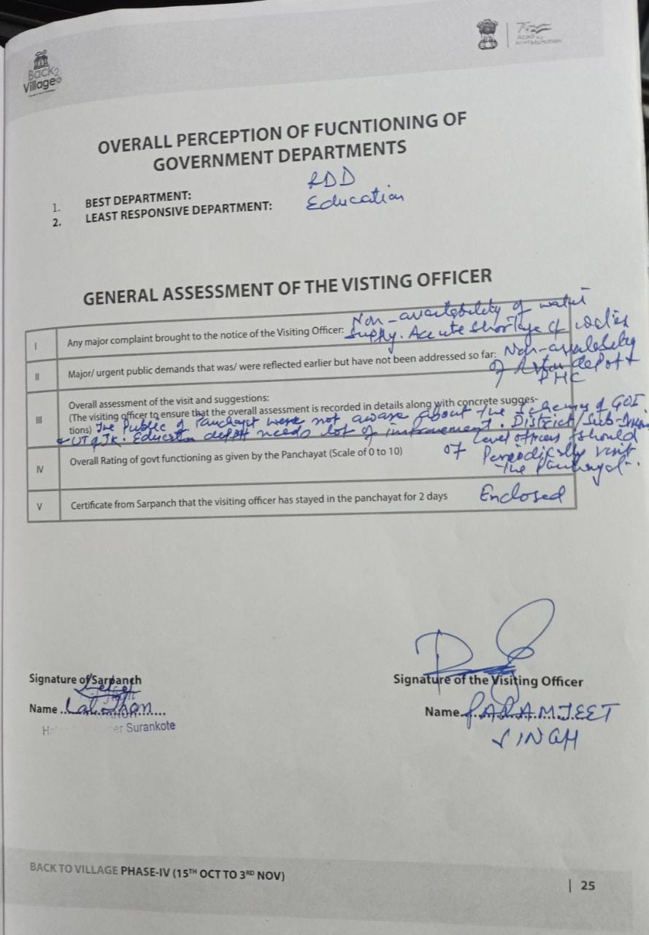

**DepartmentofRuralDevelompentandPanchayatiRajGovernmentofJammu&Kashmir**