4





**15TH OCTto3RD NOV,2022**

**KEYFEATURES**

• DeputyCommissionerstoleadtheinitiative

• RuraldevelopmentDepartmenttobethenodaldepartment

• PlanningDevelopment&MonitoringdepartmentandITtobethesupport departments

**ACTIONSANDTIMELINES**

|  |  |  |  |
| --- | --- | --- | --- |
| **ACTION** | **RESPONSIBILITY** | **LATESTBY** | **REMARKS** |
| **Janabhiyan** | Alldepartments | Oct15-26th | Goingon |
| **DeputationofSecttstaff/ HoDs** | GAD | Oct14 | Done |
| **DeploymentofStaffto Panchayatsandservingof ordersondeployedofficers** | DCs | Oct25 | DCswilldeployseniorlevelstaff fromthedistricts.Strictactionto betakenagainstabstentions.No exemptionstobegiven |
| **Trainingofdistricttrainors onB2V4** | RDD | Oct26 |  |
| **Trainingofvisitingofficers** | DCs | Oct27 |  |
| **FieldVisitstobecompleted by** | VisitingOfficers | Nov3 | DCstosuperviseandensurethat eachPanchayatisvisitedwithin theperiodspecified |
| **DataofB2V4tobe uploadedby** | VisitingOfficers | Nov10 | DCstosuperviseandensurethat dataofallPanchayatsisupload- edbythevisitingofficerwithin theperiodspecified |

**INSTRUCTIONSFORTHEVISITINGOFFICER(DAYWISE)**

|  |  |  |
| --- | --- | --- |
| **DATE** | **INSTRUCTIONS** | **ACTIONPOINTS** |
| **Day0** | Meetingwithdeputy commissionerandhis/her team | a. TakeprintoutsoffilledbookletsofB2V1,B2V2andB2V3from [www.jkpanchayat.in](http://www.jkpanchayat.in)  b.Alsotakeprintoutsofthesummarizedexcelsheetsofthe previousphasesfrom[www.jkpanchayat.in](http://www.jkpanchayat.in)  c. CollectATRsonissuesraisedduringprevious3phasesfromthe officeofDeputyCommissioner(Planningdeptt)  d.Takeprintsofblank 2bookletsofB2V4from[www.jkpanchayat.in](http://www.jkpanchayat.in)e.Takeplansfor2previousyearsandATRsfromtheplanningdeptt f. CompletetrainingsondifferentcomponentsofB2V4being  organizedbyrespectiveDeputyCommissioners  g.CollectListofnewworksstarted/ongoing/completedduringthe previousandcurrentFinancialyearunderthefollowingheads:  • PRIgrants  • DistrictPlan  • UTplan  • MGNREGA  • Otherschemesofotherdepartments  • Anyotherwork  h. Plans/beneficiarylists:  • MGNREGAdraftplandocumentfortheyear2022-23.  • ListofAwaas+beneficiariesalongwithIHHL Convergence  • Listofpensionbeneficiaries.  • ListofSHGs  • Listofagricultureschemebeneficiaries  i. Listsofbeneficiariesfor:  • Variouscertificates/benefitstobedistributedbythe visitingofficer.  • Anyotheractivitiesidentifiedbydifferentdepartments |

|  |  |  |  |
| --- | --- | --- | --- |
| **Day1** | Reachthevillage | 1. | Ensurethatallfrontlineworkersofdifferentdepttsarepresent. |
|  |  | 2. | Ensureexhibitionbydifferentdepts.aboutindividualbeneficiary schemes |
|  |  | 3. | InspectJKB/PSBcounters/outlets |
|  |  | 4. | Participate/ensureorganizationofsportsactivityinplayfield,talent hunt/culturalevent/youthactivity |
|  |  | 5. | GandhiKatha(suggesteddetailsuploadedonjkpanchayat.in) |
|  |  | 6. | Visitatleast2amritsarovarsandgetitsgeotaggedphotos |
|  |  | 7. | InspectKhidmat(CSC)CentresandcreateGenerateawarenesson  225schemesparticularlyG2CschemeslikeBEAMS,Janbhagidari, AapkiZaminAapkiNigrani,DigitalJ&K |
|  |  | 8. | Visitingofficershallalsoplanandconductpanchayatlevelconver- gencemeetingofalldepartments |
|  |  | 9. | CheckeffectivenessofCentrallysponsoredschemes |
|  |  | 10. | VisitandinspectallgovernmentestablishmentsincludingPHE, AWC,FPS,schools,etc |
|  |  | 11. | Attemptsaturationofdeliverableso JanAbhiyanandwherever deficienciesfound,leadadrivetoachievealldeliverables |
|  |  | 12. | Assesseffectivenessofsanitationcampaigninthepanchayat |
|  |  | 13. | Ensureselfemploymentactivitiesfor15youthperpanchayat |
|  |  | 14. | Identify20potentialcandidatesperpanchayatforHIMAYATtraining alongwiththetradeonwhichtheywanttraining |
|  |  | 15. | Whereverpossible,distributeemploymentlettersforpeopleselect- edundervariousgovernmentemployments |
|  |  | 16. | Intheevening,holdnormalmeetingwith seniorcitizens,govtem- ployeesincludingretiredemployees,exservicemen,youthclub,and any citizens ofthevillagewhoareenrolledincollege/university |
|  |  | 17. | OpendiscussiononNashaMuktAbhiyan |

Day2 Haveameetingwithall stakeholders-depttofficials andpanchayatmembers

1. Discussionontheandassesstheprogressofdifferentschemesrelating tothelocalizedSDGsprioritizedforthatvillageaspertheresolution passedby thatGramPanchayaton21st April22,onNationalPanchayti RajDay.

2. Sensitizevillage residentsaboutmyScheme”portal(myscheme.in) whichincludesinformationaboutalltheschemesbeingrunbyCen- tral/State/UTgovtacrossthecountry

3. Hold meeting of theBiodiversityManagementCommitteestodeliber- ateonissuespertaining toconservation of biodiversityandsustaina- bleutilizationof biologicalresources.

4. PrepareVillagedevelopmentplan,inconsultancywithGrampanchayat, discussitingramsabhaandgetitapproved.

5. Ensure saturationofsoilhealthcardandgoldenhealthcardunderGold- enHealthCardunderAyushmanBharat,

6. Ensuresaturation of OldAge PensionScheme

7. EnsureDomicileSaturation.

8. EnsureKCCSaturation

9. Ensure saturationoflandpassbooks

10. Ensureregistrationofvillagevendorsneededforanyscheme,onGEM

portal

11. Ensurepanchayatcontractors registration

12. EncouragePanchayatmembers forimportanceofplantationdrivein

PanchayatunderHarGaonHariyali

13. Ensure paintingondigitalJ&Kinpanchayatghars

14. Ensure paintingonpanchayatactivitesandCSSinpanchayatghars

15. Thevisiting officeshallchecknoof kindergarten andplayfields present inthepanchayat for kidsandstudents,iftheinfrastructure present inthesearegoodenough.

16. Holdmeeting withpanchayatmembers todiscussaboutcorruption menaceandstepsrequiredtomakeJ&Kcorruptionfree

17. Obtaina candidassessmentaboutperformanceofvariousdeptts in- cludingfairfeedbackaboutdiscrepanciesinfunctioning

18. Check thestatusof NashaMuktAbhiyanandreporting of drugad- dictstoDeputyCommissioner.

19. IdentifyTouristDestinations,Circuits,ThemeTreks,IdentifyHomestays, providesupportfortourismactivities throughVillageCooperative

20. OrganizeTalentHuntatPanchayatLevel

21. Conductsocialauditofatleast5worksunderfollowingschemes:

a. MGNREGA

b.PMAY

c. IHHLtoiletsandpayments d.CSCs

e.AMRITSAROVARS

22. Holda mahilasabha anda balsabhaandrecordproceedingsinthefor- matgiven

23. InauguratevillagehaatunderJKSRLM

24. Checkifyouthclubsareformedinthepanchayatandwhatactivities theyareengagedin

25. Organizea villagelevelculturaleventtoengagepanchayatmembers

26. SensitizeGPaboutE-kitabkoshaninitiativeofJ&KGovtforempowering youthsthrough onlinedigitalliteracy

**GENERALINSTRUCTIONS**

1. Thevisitingofficershallrefrainhimself/herselfgivingorofferinganycommitmentonbehalfofthe governmentandshalladoptanunbiasedattitudeinreportingissues.As faraspossible,his/her observation shouldbebasedona fairandanalytical viewemergingfromhis/herinteractioninthe village.

2. Heisgoingtothevillageasplanningofficer,notforsanctioninganyworksorformakinganycom- mitments.

3. Whilepreparingvillagedevelopmentplan,hehastoensurethat,demandsareprioritizedandre- flectedunderavailableschemes,wherevernecessarythelargerworksaretobereferredtoadminis- trativedepttunderCSS/UTplansunderintimationtoDCsandrestoftheworkstoDCsforreflecting itunderdistrict/CSS plans

4. His workshallbehardcoreplanningandauditandisnota PRexercise.

5. EveryDeputyCommissionerhastoensurethatatleastoneRDDofficial(ideallyPanchayatSecre- tary)ispresent ineverypanchayatwithrelevantpanchayatrecords,toensureconductofallactivi- tiesasplanned.Panchayatwiseorderneedstobeissuedinadvance.

6. Visitingofficershouldideallycarryhis/herlaptoptocompletethereportsatthepanchayatlevel itselfanduploadthefinalreport,duly signedbothbythesarpanchandbythevisitingofficeron [www.jkpanchayat.in](http://www.jkpanchayat.in)portal,beforetheyleavepanchayat.

7. Focus ofvisitareyouth,skills,self-employment,nashamukt,bhrashtracharmukt,Rozgaryukt J&K, besidestocarryforwardtheactivities duringJanAbhiyanandsaturatethem.

8. Inadditionattentionmaybegiventothefollowingareas a. MakefulluseofCentrallySponsoredSchemes

b.Saturationofindividualbeneficiaryschemes c. Self-employmentschemes

d.Banklinkedschemes-includingdepartmentalsubsidyschemes e.Empowermentandtransparencythrough digitalinitiatives

f. Effectivenessofgrassrootsmachinery–

i. Patwari,VLWpresent andavailable

ii. AvailablefundsutilizedinpublicinterestandasperGramSabharesolutions iii. Fairness ingovernance

iv. CSS/Individual beneficiaryschemesetc v. BrashtacharMuktJ&K

vi. BhaiMuktJ&K

vii. NashaMuktJ&K

9. ThePRImembers (Sarpanchs,Panchs,BDCChairperson)shallbeattheforefrontofallactivities and givendueimportanceandtheapproach shouldbetostrengthenthemandmakethemfeelem- powered.He/sheshallensurethattheBDCchairpersonandSarpanch/Panch arepresent atthetime ofinaugurationandceremonies.

10. Visitingofficershallnotleavethedistrictwithoutuploadingthereport,duly signedonthe**www. jkpanchayat.in**portal.EveryDeputyCommissionerhastoensurethat.

**A) DetailsofReportingOfficer:**

Name: **Mohd Shafi Dar**

Designation:**Agriculture Extension Officer**

Department/place of posting: **Department of Agriculture/ Sub Division Kakapora**

MobileNo: **7006287763**

EmailID: [**mohdshafishafi05@gmail.com**](mailto:mohdshafishafi05@gmail.com)

Home District: **Pulwama**

Datesof visit: **28-10-2022 to 29-10-2022**

**B) Locational details of Panchayat:(tobepre-filled,informationtobetakenfromtheprevious phasesbooklets/summarizedexcelsheetuploadedonjkpanchayat.in/b2v4.php)(tobevali- datedbythevisitingofficerandmissingdetailstobefilled)**

NameofthePanchayat: **Amlar**

LocalGovernmentDirectory(LGD)codeof thePanchayat:**242889**

Nameof CD Block: **Dadsara**

NameofTehsil: **Tral**

Nameof District: **Pulwama**

**C) Panchayat Profile:**

No.of revenue villages in the Panchayat: **01**

No. of hamlets in the Panchayat: **02**

No.of households in the Panchayat: **613**

Population(approx)of the Panchayat: **3255**

**Part-II:**

(TobefilledupbytheVisitingOfficerduringhis/hertwodayvisittothePanchayat.AllFieldshavetobe

Filled by the Visiting Officer before the booklet is handed over to the DC

**FrontlineOfficers/OfficialswhowereassignedtothePanchayatfortheprogramme:**

|  |  |  |
| --- | --- | --- |
| Department | Name | Designation |
| Rural Dev Department | Ali Mohd Wani | VLW |
| PDD | Mushtaq Ahmad | Sec Incharge |
| Agriculture | Bilal Ahmad Bhat | AEA |
| Forest | Manzoor Ahmad | Forester |
| Horticulture | Mohd Ashraf Reshi | HTG II |
| Irrigation | Shabir Ahmad | EG |
| Social Forestry | Farooq Ahmad | Jr Malli |
| Health | Rayeesa Bano | FMPHW/ANM |
| Youth Services and Sports | Mir Raies Ahmad | Phy Education teacher |
| Food and Civil Supplies | Wakeel Ahmad Dar | Store Keeper |
| Sheep Husbandry | Rukaya Rafiq | Assistant Stockman |
| PHE | Rafiq Ahmad | Helper |
| Revenue | Bashir Ah Dar | Patwari |

**Details of absent employees vis-à-vis list furnished by the DC office:**

|  |  |  |
| --- | --- | --- |
| Department | Name | Designation |
| Bank |  |  |
|  |  |  |
|  |  |  |
|  |  |  |
|  |  |  |
|  |  |  |
|  |  |  |
|  |  |  |
|  |  |  |
|  |  |  |
|  |  |  |
|  |  |  |
|  |  |  |
|  |  |  |
|  |  |  |

**DAY1-ACTIVITIES**

**AGENDA1:PANCHAYATASSETREGISTER**

**Infrastructure:**

1. Panchayat Ghar Infrastructure a. Govtbuilding/private

b. New/needingrepairs… **New**

2. Furniture(Y/N)--- **Y**

3. Computer/printer(Y/N)--- **N**

4. Internet(Y/N)--- **N**

5. Telephone(Y/N)--- **N**

6. Toilet(CSC/partofpanchayatghar)(Y/N)--- **Y**

7. Water(Y/N)--- **Y**

8. Electricity(Y/N)--**Y**

9. Bankbranch(Y/N)--- **N**

10. CSC(Y/N)--- **Y**

11. Patwarkhana(Y/N)--- **Y**

12. Village haat(Y/N)--- **N**

13. Playground(Y/N)--- **N**

14. School-

a. Kindergarten(Y/N)-- **N**

b.Primary(Y/N)-- **Y**

c. Secondary(Y/N)--- **Y**

d. College (Y/N)-- **N**

e.University(Y/N)--- **N**

15. Anganwadi Centre(Y/N)-- **Y**

a. (govt/private)--- **Private rented**

b. Total children enrolled--- **217**

15. Amrit Sarovars–details,location,condition… **Reshi Mohalla (Good condition)**

16. Governmentoffices-details,whetherfunctionalornot---- **Nil**

17. Rationshop(Y/N)--- **Y**

18. Placesoftourismimportance–names,littledetailsonhistorical/culturalimportance--- **Not available**

19. Village heritage sites/treks-names ,little details on historical/cultural importance--- **Not available**

20. VLWOffice (Y/N)-- **Y**

21. Primary Health care Centre(Y/N)-- **Y**

22. List of Incomplete Buildings-names, year of construction—**Health Centre and Middle School**

23. List of Underutilized Buildings-names--- **Not available**

**DAY1-ACTIVITIES**

**AGENDA2:**

**DIFFERENTINSTITUTIONS/INFRASTRUCTUREPROJECTSTOBEVISITED**

|  |  |  |
| --- | --- | --- |
| **AMRITSAROVARS** | **Visit,verify** | **COMMENTS** |
| KhidmatCentres | Create/Generateawarenesson225schemes particularlyG2CschemsAapkiZaminAapkiNigrani, Beams,Janbhagidari,DigitalJ&K | CSC centre at Amlar. All services being provided |
| JKB/PSBcounters/outlets | a)Statusofcounter b)Numberofvisitors | No branch at GP |
| Incompletebuildings/pro- jects | Verify whetheridentificationandredistribution done | School and Health Centre |
| PDS | Visit,evaluate,onlinestatus | Visited and found satisfactory |
| PHC | Visit-evaluate,statusofstaff,equipmentand quality | Satisfactory |
| Youthclubs | Meet,interact,seeksuggestions | Did not participate |
| SHG | Meet,identifyproblems,seeksuggestions | Met SHGs. Lack of awareness |
| PMAY | Inspect,Inaugurate | Inaugurated |
| Myschool,mypride progress;schools-water, toilets,staff | Visit,checkforwater,electricity,sanitation,meet studentsandstaff | Facility wise found satisfactory but staff dearth noticed |
| Swachh SBM | Evaluate | Evaluated |
| Panchayatplayground, Sportskitsdistribution Villagegames | Ensure,verify.Participateinatleastonegamein theplayground | Play ground Not available. Sports kits distributed among old age club |
| HarGaonHariyali, Planta- tiondrive | Evaluatestatus,feedback | Plantation drive inaugurated |
| Village cultural event  Dangal/Haat/Mela | Participatein;ensurethatitisheld | Held |
| Exhibitionofschemes | Ensurethateverydepartmentparticipatesand thatitcontinuesfortheentiredurationofB2V | Done by all Departments |
| JalJeewanMission verifica- tion- WSS/JSD  Electricitysupply | Verify | Verified JJM. Electricity Supply satisfactory |

**DAY1-ACTIVITIES**

**AGENDA3: SATURATE JAN BHIYAN**

**DELIVERABLES AND RECORD DEFICIENCIES IF ANY (INSERT DELIVERABLES LIST HEREAS PER GAD FORMAT**

All the frontline departments assured that the Jan Abhiyan deliverables have been achieved to a considerable extent. However, the achievements are not 100% due to poor public participation and interest. Saturation of PMKISAN and PMKMY schemes have been achieved to a great extent by Deptt of Agriculture

**DAY1-ACTIVITIES**

**AGENDA4:**

**SELFEMPLOYMENTACTIVITIES--- No official from any bank was present to provide the data.**

Ensure Self-employment activities for youth, distribute employment letters for peoples elected under various social schemes(15ISTHETARGETPERPANCHAYAT)

**Number of cases in different categories sanctioned: Details of the bank sanctioning it:**

**Total amount involved:**

**DAY1ACTIVITIES**

**AGENDA5**

Intheevening,holdinformalmeetings withseniorcitizens,govtemployees,retdemployees,youthclub andothercitizenswhoareenrolledoncollege/universityandhavediscussiononGandhiKatha,Nasha MuktAbhiyan,corruptionfreegovernance,doublingfarmersincomeandrecordtheproceedings

**DAY2**

a. No of Individual Compost Pits constructed--- **Under process**

-b.No of Individual Soak Pits constructed--- **25**

V. No. of Biodiversity management committee meetings held: **01**

VI. Is the name of Sarpanch displayed on citizen information boards of all RD&PR schemes:Yes/No-- **No**

VII. Are Sarpanchs being involved in start/inauguration of activities: Yes/No--- **No**

VIII. Whether subjects have been assigned by the Sarpanch to the Panchs: Yes/No--- **No**

IX. Whether grievances redressal box is installed: Yes/N--- **Yes**

X. NoofgrievancesreceivedpertainingtoPanchayatlevel: **Nil**

XI. NoofgrievancesdisposedofatPanchayatlevel: **Nil**

XII. WhethertheSarpanch/PanchayatSecretaryhavedigitalsignatures:Yes/No--- **Yes**

XIII. WhetherallMGNREGA/14thFCpayments arebeingmadebySarpanchthrough DigitalSignature

Certificate(DSC):Yes/No--- **No Sarpanch exists in the Panchayat**

.

**HUMAN RESOURCEAVAILABLEATTHEPANCHAYAT LEVEL:**

|  |  |  |  |  |
| --- | --- | --- | --- | --- |
| **SRNO.** | **DEPARTMENTWISESTAFF** | **NUMBERS** | | **NAMES** |
|  |  | SANCTIONED | ACTUAL |  |
|  | Rural development department: BDO  JE GRS TA | 01  01  01  01 | 01  01  01  01 | Shafiq Ahmad Wani  Mohd Shafi Wani  Nisar Ah Tantray  Farhat Agha |
|  | SCHOOLEDUCATION: (high/middle/pry schools  TEACHER  HEADMASTER ANYOTHER | 31  03 | 22  03 | Nazir Khanday, Farooq Parray |
|  | JAL JEEVAN:  Helper  Casual Labour | 02  01 | 02  01 | Rafiq Ah Mir, Mohd Maqbool  Javaid Ah Sheikh |
|  | PDD: LINEMAN JE  ANYOTHER | 01  01  01 | 01  01  01 | Mushtaq Ah Khanday  Jalal udin Bhat  Zahoor Ahmad |
|  | FOOD&CIVILSUPPLIES | 01 | 01 | Wakeel Ahmad Dar (SK) |
|  | AGRICULTURE&ANIMALHUS- BANDARY | 01 | 01 | Kauseena (JAEO Agriculture)  Ab Rashid Larik (Animal Husbandry) |
|  | SOCIALWELFARE | 01 | 01 | Ishfaq Bashir |
|  | HEALTH: ASHA ANM  AYUSHDOCTOR ALLOPATHICDOCTOR | 03  02  01  Nil | 03  02  01  - | Gulshana, Mehbooba, Fehmeeda  Jitendar Kour, Raiesa Bano  Sumaya Hassan |
|  | ANYOTHERDEPARTMENT  **Youth Services and Sports**  **Revenue** | 02  01 | 02  01 | Bilal Bhat, Shina Akhter  Bashir Ah Dar |

**DAY2-ACTIVITIES**

**AGENDANO.1**

DiscussionontheandassesstheprogressofdifferentschemesrelatingtothelocalizedSDGsprior-itizedforthatvillageaspertheresolutionpassedbythatGramPanchayaton21stApril22,onNational PanchayatiRajDay(Copyoftheresolutiontobetakenfrom[www.jkpanchayat.in](http://www.jkpanchayat.in)portalunderthelinkof GramSwarajMonth)

1. SDGs AGREED FORTHATVILLAGE,TO BE IMPLEMENTED BY MARCH 2024: **Clean and Green Village**

2. STATUS OF WORKS UNDER THE FOLLOWING SCHEMES:

**1 Cleanandgreenvillage**

1. Initiatives taken by the Panchayat for managing Solid and Liquid Waste--- **Yes**
2. Initiatives taken by the Panchayat for using green sources of fuel like solar, biogas-- **Nil**
3. Hasmappingoflanduse,waterbodies,forest,slopes,wetlands,degradedforestwithintheGram
4. Panchayat been done? Yes/No. If No, reason,thereof--- **yes**

iv. Has the Climate Resilience Plan been developed for the GP? Yes/No--- **No**

v. StepstakenbytheGramSabhaabouttheclimatechangemitigationfactorslikereducingenergy consumption,usageoffossilfuels,plastics,non-renewablebuildingmaterialsandalsotopromote measureslikeplantingoftrees,conservingforests,usageofgoodagriculturalpracticeslikedrip irrigation, water conservation measures and conservation of wetlands.--- **No**

vi. Whether schools have started segregating waste--- **No**

vii. Whetherschoolshavetheirowncompost/soakagepitsforsolid/liquidwastemanagement--- **No**

**2 Healthyvillage**

i) Are meetings related to Village Health and Sanitation Committee being held regularly?-- **Yes**

ii) Do all the eligible individuals been provided the Golden Card?-- **Yes**

iii) ArealltheChildrenbeingimmunizedaspertheSchedulerecommendedbyGovt.ofIndia?--- **Yes**

iv) ArealltheeligibleindividualsbeenvaccinatedagainstCOVID-19?-- **Yes**

v) DoesGramPanchayatensurethatallpregnantwomenaregettingnecessaryprenatalcheckups?-- **Yes**

vi) WhetherallthedeliverieswereInstitutionalizedorconductedbytrainedMidwives?-- **Yes**

**3 Watersufficientvillage**

i) Do all the IHHs in the GramPanchayat have water pipeline connections?-- **No**

ii) WhetherGramPanchayathastakenstepsforgreywatermanagement.IfYespleasespecify--- **Yes**

iii) DoalltheIHHsintheGramPanchayathavetoilets?—**Yes**

iv) ArealltheIHHstoiletsfunctionalornot?--- **Yes**

v) DoalltheSchools/Anganwadicentershavea toiletfacilityornot?--- **Yes**

vi) Areallthetoiletsintheschools/Aaganwadifunctionalornot?--- **Yes**

vii) WhetherGramPachachayatBhawanhasseparate toiletsforwomenornot?-- **No**

**4 ChildFriendlyvillage**

i) Doallthechildrenundertheageof0-6yearsbeenenrolledintheAnganwadicentersforpre- schooling?Yes/NO--- **Yes**

ii) How many BalSabha’s were organized in the GramPanchayat-------------------**01**

iii) Whether the issues raised by Bal Sabha are addressed during the GramSabha. Yes/NO-- **Yes**

iv) WhetherGramPanchayatistrackingthedatarelatedtodropoutchildrenandchildrenwithirregular attendance? Yes/NO.--- **Yes**

v) Do all the schools under the Gram Panchayat have separate toilets for girls and boys?Yes/No---- **Yes**

**5 Villagewithgoodgovernance**

i) Is CSC located in the GramPanchayat Bhawan or not?-- **Yes**

ii)IsthelistofbeneficiariesrelatedtotheSchemes/ProgramsdisplayedontheGrampanchayatwallor not?-- **Yes**

iii) Does the GramPanchayat has its building or not?-- **Yes**

iv) IstheGramPanchayatofficefunctionalornot?-- **No**

v) Aretheactivities approved undertheHalqaPanchayatDevelopmentPlandisplayedontheGram

Panchayatwallornot?-- **Yes**

vi) IsSocialAuditofearlierSchemes/Programscarriedoutornot?-- **Yes**

**6 Povertyfreeandenhancedlivelihoodvillage**

1. HasGramPanchayatdevelopedanycriteria fortheidentificationofthepoor?Yes/Noifyesspecify-- **Yes**
2. HavealltheeligiblehouseholdsregisteredinPDSornot?-- **Yes**

iii) HasGramPanchayatprovidedspaceforSelf-helpGroupsinPanchyatGharforholdingmeetings or not?-- **yes**

iv) HavealltheeligiblehouseholdsbeenregisteredforPensionornot?-- **Yes**

v) HasGramPanchayatfacilitatedYouthforSkillEnhancementCoursesandPlacement?-- **No**

vi) HasJobCardsbeendistributedtoalltheeligibleindividualsunderMGNREGA?-- **Yes**

vii) HasGramPanchayatfacilitatedSHGsforBankAccountLinkages?--- **Yes**

**7 Sociallysecuredvillage**

i) WhetherGramPanchayatismaintainingdatarelatedtoDifferentlyAbledPeople?-- **Yes**

ii) IsGramPanchayatOffice DisabledFriendlyornot?--- **Yes**

iii) Areprovisionsfora separate BudgetundertheResourceEnvelopeforWomenandChildrenmadeor not?-- **No**

iv) DoalltheSchools intheGramPanchayathavefacilitiesforDifferentlyAbledChildrenliketoilets, barrier-freeaccess,etc.,ornot?--- **Yes**

v) Arealltheeligibleindividualsaregettingpensions,likeoldagepension,widowpension,etc?--- **Yes**

vi) ArealltheeligiblehouseholdsgettingbenefitsfromIAYornot?--- **Yes**

**8 EngenderedDevelopmentinVillage**

i) HowmanyMahilaSabha’swereorganizedintheGramPanchayat-------------------**02**

ii) WhetherSHGsfederationshavebeenprovidedspaceformeetings inthePanchayatBhawan(Yes/ No)-- **Yes**

iii) WhetherGPshavetakenstepsforincreasingwomen’sparticipationinGramSabha(Yes/No)—**Yes**

iv) NumberofwomenbeneficiariesheadedhouseholdscoveredunderPDS system………………………**15**

v) Numberofbeneficiaries(outoftotaleligiblepopulation)receivingsocialprotectionbenefitsunder

PradhanMantriMatritvaVandanaYojana………………….**12**

9 Self-sufficientinfrastructureinthevillage

i. WhetherGPhasa CommunityHallwithaccesstoelectricity,furniture,watersupply, toilet………………………. **No**

ii. WhethertheDisastermanagementplanisavailableattheGPLevel(Yes/No)--- **Yes**

iii. Whetherchild-friendlyparkwithrequiredfacilitiesisavailableinGP(Yes/No) -- **No**

iv. WhethertheGPhaseasyaccesstoGodownforstorage(Yes/No)-- **No**

v. Whetherstreetlightsareprovidedinpublicplacesforensuringsafety(Yes/No)--- **Yes**

**DAY2ACTIVITIES**

**AGENDANO.2**

SensitizevillageresidentsaboutmyScheme”portal(myscheme.in)whichincludesinformationaboutall theschemesbeingrunbyCentral/State/UT govtacrossthecountry

*(SchemeMaterialavailablefromhttps://jkpanchayat.in/b2v4.php)*

**DAY2ACTIVITIES**

**AGENDANO.3**

HoldmeetingoftheBiodiversityManagementCommitteestodeliberateonissues pertaining to conserva- tionofbiodiversityandsustainableutilizationofbiologicalresources.HeshouldcheckPeopleBiodiversity register(PBR)ofthatpanchayatandreviewifBiodiversityManagementCommittee constitutedforthat panchayatis holdingminimum4meetings in a year and meeting onceinevery3months *(RoleofBMC availableathttps://jkpanchayat.in/b2v4.php)*

COMMITTEEMEMBERS—**Farooq Ah Bhat (VLW), Jitendar Kaur (Health), Mehbooba (Asha)**

PRESENT--- **All the members were not present except few**

BIODIVERSITYREGISTERPHOTOS--- **Not available**

PAST 4MEETINGDETAILS-DATES,MINUTESPHOTOS---- **28.08.2020 and 29.10.2022**

**DAY2ACTIVITIES**

**AGENDA4**

Visiting officer shall also plan and conduct panchayat level convergence meeting of all departments and prepareVillagedevelopmentplanforvillage,inconsultancywithGrampanchayat,discussitingram sabha and get it approved.—**Convergence meeting of all the departments held and GPDP prepared which was later passed under Gram Sabha (GPDP annexed at I)**

(GPDPformatavailableonhttps://jkpanchayat.in/b2v4.php)

**In addition GPDP plan shall also include:**

▪ Tourist places which need to be developed

▪ Specific product which needs to be developed

▪ Tourism-homestays

▪ 20candidatesfortrainingunderHimayatschemealongwithtradeinwhich training is to be given

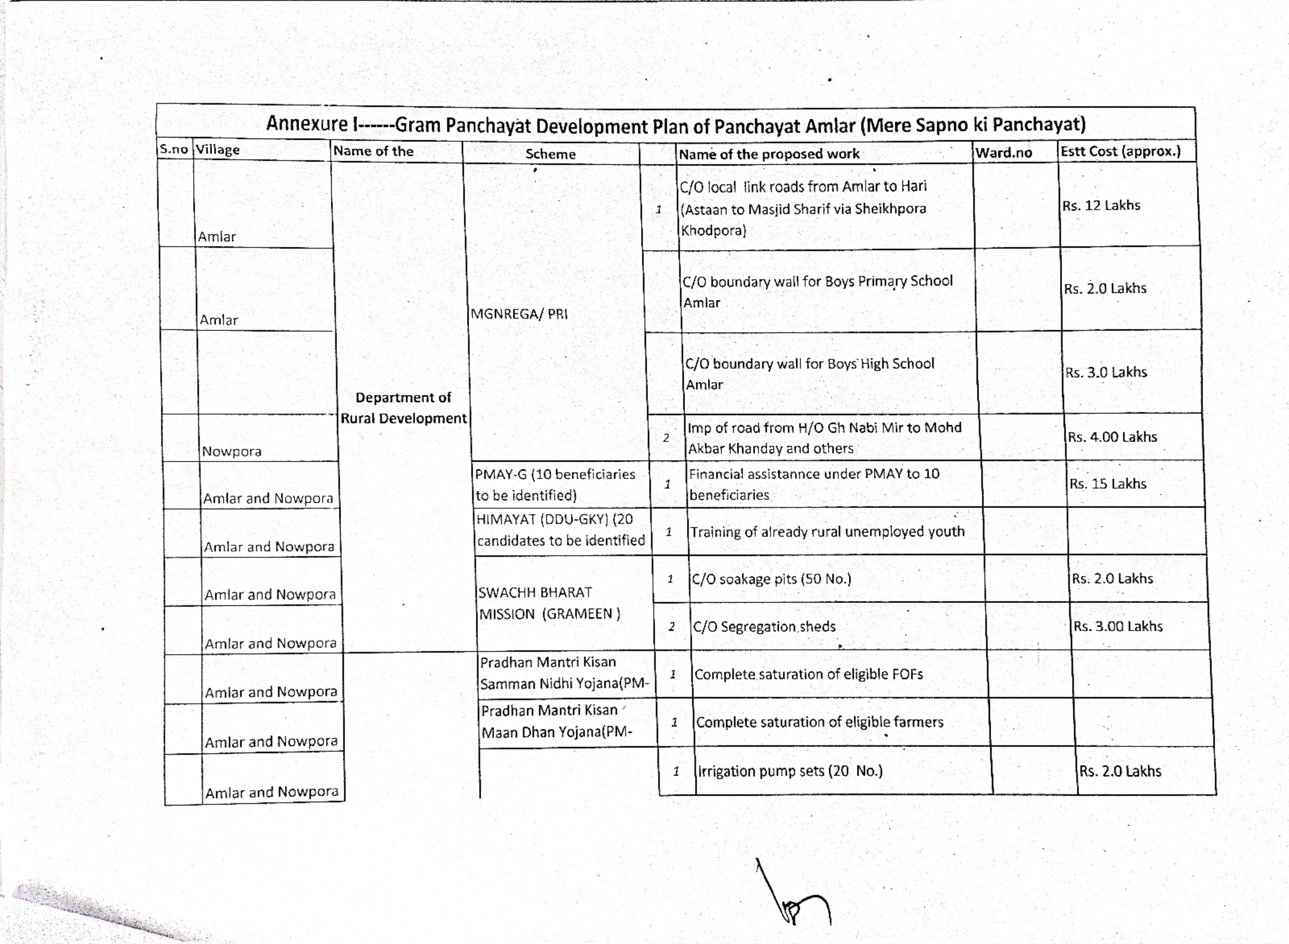



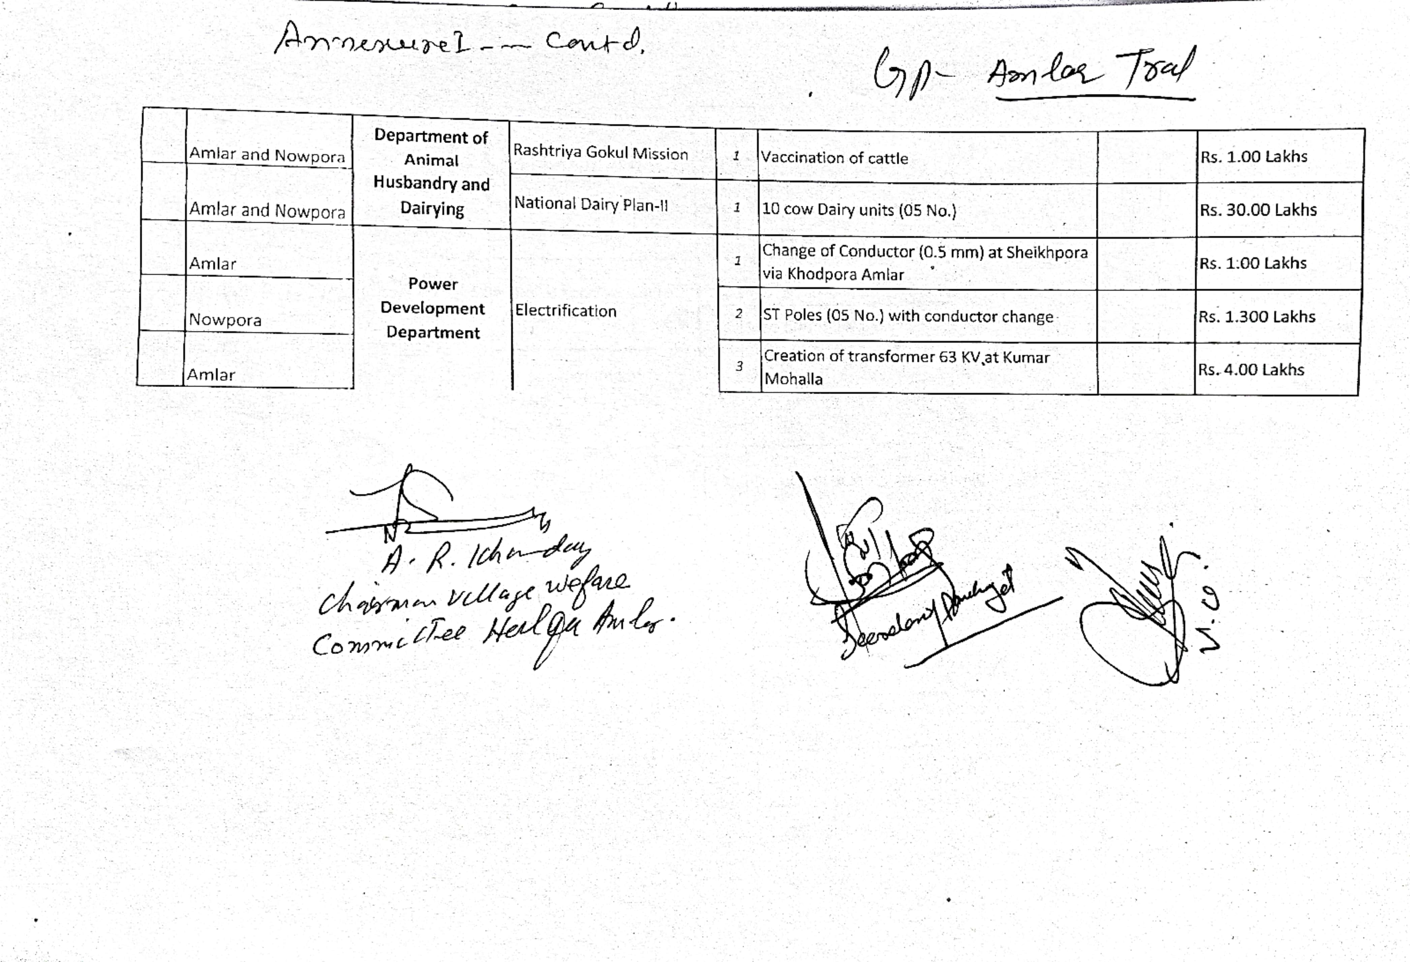

**DAY2ACTIVITIES**

**AGENDA5**

Ensuresaturationoffollowingschemesandgivestatus:

|  |  |  |  |
| --- | --- | --- | --- |
| **NAMEOFTHESCHEME** | **TOTALELIGIBLE BENEFICIARIESIN THE VILLAGE** | **TOTALBENEFICIARIESWHO AVAILEDTHEBENEFITSOFTHESCHEME** | **REASONSFOR PENDENCY** |
| Golden Health Card under  Ayushman Bharat | 2676 | 2599 | Correction in aadhar |
| Janani suraksha yojana | 15  111 | 15 | Nil |
| OLD AGE pension | 111  61 | 111 | Nil |
| Widow pension | 61  45 | 61 | Nil |
| Disability pension | 45 | 45 | Nil |
| Domicile certificate | 613 | 490 | Need based applications are received |
| Kisan credit card | 494 | 494 | Nil |
| PM kisan samman nidhi | 310 | 310 | Nil |

|  |  |  |  |
| --- | --- | --- | --- |
| Land passbook | 550 | 50 | Remaining are under process |
| Registration of village ven- dors on GEM portal | - | - | - |
| Registration of village con- tractors on jktenders portal | 08 | 06 | Under process |
| Registration of village con- tractors on PWD portal | 08 | 06 | Under process |
| Incomplete buildings/ projects | 02 | 02 | Health centre and School |

**DAY2ACTIVITIES**

**AGENDA6**

**NASHAMUKTABHIYAN**

1. Whether gram sabha resolution passed--- **Yes**

2. Details of activities conducted—Nasha Mukht related speeches delivered

3. Whether all activities and GS resolution uploaded on jkpanchayats.in portal--- **Yes**

4. How many drug addicts in the village--- Data Not available

5. Whether reported to the Deputy Commissioner… No

6. How many registered for rehabilitation under government programme-- Nil

**DAY2ACTIVITIES**

**AGENDA7**

**SOCIALAUDIT**

Conductsocialauditofatleast5workseachunderfollowingschemes:

|  |  |  |  |  |  |  |
| --- | --- | --- | --- | --- | --- | --- |
| NAMEOFTHE SCHEME | DETAILSOFTHE WORKS | YEAROFWORK APPROVAL | AMOUNT APPROVED  FORTHEWORK | WHETHER  WORKEXECUTED SATISFACTORILY | GEO- TAGGED PHOTOS | ANY GRIEVANCE RECORDED RELATINGTOTHAT WORK |
| MGNREGA | 1. C/O protection bund from H/O Gh Mohidin Sheikh at Nowpora Amlar  2. Development of grave yard and Pyt Ghar by way of earthfilling at Amlar  3. C/O drain/protection bund near L/O Habibullah Mir at Nowpora Amlar  4. C/O drain/bund from Badi Kull near foot bridge near L/O Altaf Ah Shah  5. C/O protection bund and desilting of badi kull from H/O Nazir Ah Ganie at Amlar | 2021-22  2021-22  2021-22  2021-22  2021-22 | 1.09 Lakhs  2.81 Lakhs  0.98 Lakhs  1.79 Lakhs  1.99 Lakhs | Yes  Yes  Yes  Yes  Yes | Yes  Yes  Yes  Yes  Yes | - |
| PMAY | 1.C/O house of Rouf Rashid Mir  2. C/O PMAY house of Mohd Amin Shah  3. C/O PMAY house of Mohd Ashraf Rather  4. C/O PMAY house of Javid Ah Khanday | 2021-22  2021-22  2021-22  2021-22 | 1.30 Lakhs  1.30 Lakhs  1.30 Lakhs  1.30 Lakhs | Yes  Yes  Yes  Yes | Yes  Yes  Yes  Yes |  |
| IHHL  UNDERSBM-G | 1.Mohd Afzal Reshi  2. Mushtaq Ah Mir  3. Gh Mohd Mir  4. Maqsood Ah Khanday  5. Shabir Ah Ganie | 2021-22  2021-22  2021-22  2021-22  2021-22 | 0.12 Lakhs  0.12 Lakhs  0.12 Lakhs  0.12 Lakhs  0.12 Lakhs | Yes  Yes  Yes  Yes  Yes | Yes  Yes  Yes  Yes  Yes |  |
| CSCUNDER SBMG |  |  |  |  |  |  |
| AMRIT SAROVARS |  |  |  |  |  |  |

**DAY2ACTIVITIES**

**AGENDA8**

**MAHILASABHA**

Totalwomeninthevillageabovetheageof18--- **961**

Total attended--- **09**

Proceedings:

*(Plinsertpointerstobediscussedthere–referpalliproceedings)*

***Women empowerment***

***Employment generation***

***Education***

***Save the girl child***

**DAY2ACTIVITIES**

**AGENDA9**

**BALSABHA**

Hold a balsabha and record proceedings---

Total children in the village above the age of **06 years --- 217**

Total attended--- **07**

Proceedings:

**Cleanliness, save environment, child education, avoid child labour, physical exercise ect.**

*(Plinsertpointerstobediscussedthere–referpalliproceedings)*

**DAY2ACTIVITIES**

**AGENDA10**

**INAUGURATIONS**

|  |  |  |  |
| --- | --- | --- | --- |
| **SR NO.** | **ASSETS/ACTIVITIES INAUGRATED** | **STATUSOFTHEASSET/AC- TIVITIES(NUMBER,OTHER DETAILS)** | **GEO-TAGGED PHOTOS** |
|  | VILLAGE HAAT under JKSRLM (SUN- DAYMARKET) | Not available |  |
|  | PMAY houses if any ready for inaugra- tion | One house of M. Amin Shah at Kanli Mohala inaugurated | Yes uploaded on portal by Nodal Officer |
|  | Swachh gram projects-segregation sheds etc | - | - |
|  | Amrit sarovars | Reshi Mohalla Spring at Nowpora | Yes |
|  | Sports kits | 01 | Yes |
|  | Village cultural events |  |  |
|  | JJMassets/projects |  |  |
|  | Anyothertobeidentifiedatdistrict level |  |  |

**FOLLOWUPOF(B2V1,B2V2&B2V3):**

*(Prefilledexcelsheet tobetakenfromdistrictlevel/andalsotobedownloaded*

*from*[*www.jkpanchayat.in)*](http://www.jkpanchayat.in)

|  |  |  |  |  |
| --- | --- | --- | --- | --- |
| S.NO. | Particulars | Action taken | Remarks# | |
| I. Urgent Public Requirements/Demands-B2V1 | | | | |
| 1 | C/O road from Amlar to Hari | Approved under B2V2  Pro | | Under execution |
| 2 | Digging of borewell and water treatment with upgradation of existing reservoir Propo | Proposed under JJM WSS | |  |
| 3 |  |  | |  |
| 4 |  |  | |  |
| 5 |  |  | |  |
| 6 |  |  | |  |
| 7 |  |  | |  |
| II. UrgentPublicRequirements/Demands-B2V2 | | | | |
| 1 | C/O flood protection bund along the banks of flood channel | DPR stands submitted | |  |
| 2 | C/O bathrooms at Masjid Ibrahim  Nowpora | To be executed under SBM (G)  during  ( (G) | |  |
| 3 |  |  | |  |
| 4 |  |  | |  |
| 5 |  |  | |  |
| 6 |  |  | |  |
| 7 |  |  | |  |
| S.NO. | Particulars | Actiontaken | | Remarks# |
| III. MajorProblems–B2V1 | | | | |
| 1 |  |  |  | |
| 2 |  |  |  | |
| 3 |  |  |  | |

|  |  |  |  |
| --- | --- | --- | --- |
| 4 |  |  |  |
| 5 |  |  |  |
| IV. MajorProblems-B2V2 | | | |
| 1 |  |  |  |
| 2 |  |  |  |
| 3 |  |  |  |
| 4 |  |  |  |
| 5 |  |  |  |
| V. MajorProblems-B2V3 | | | |
| 1 |  |  |  |
| 2 |  |  |  |
| 3 |  |  |  |
| 4 |  |  |  |
| 5 |  |  |  |
| VI. MajorComplaints-B2V1 | | | |
| 1 |  |  |  |
| 2 |  |  |  |
| 3 |  |  |  |
| VII. MajorComplaints-B2V2 | | | |
| 1 |  |  |  |
| 2 |  |  |  |
| 3 |  |  |  |
| VIII. MajorComplaints-B2V3 | | | |
| 1 |  |  |  |
| 2 |  |  |  |
| 3 |  |  |  |

**OVERALLPERCEPTIONOFFUCNTIONING OF GOVERNMENTDEPARTMENTS**

1. **BEST DEPARTMENT: RDD**

**2. LEAST RESPONSIVE DEPARTMENT: Bank**

**GENERALASSESSMENTOFTHEVISTINGOFFICER**

|  |  |
| --- | --- |
| I | Any major complaint brought to the notice of the Visiting Officer:  **Old School Building at Amlar Tral is unsafe fro general public and school going children. It shall be dismantled at an earlies** |
| II | Major/urgentpublicdemandsthatwas/werereflectedearlierbuthavenotbeenaddressedsofar:  **C/O link roads from Amlar to Hari via Sheikhpora Khodpora** |
| III | Overall assessment of the visit and suggestions:  (Thevisitingofficertoensurethattheoverallassessmentisrecordedindetailsalongwithconcretesugges- tions)  **Lack of awareness about different schemes of various Departments. All the frontline departments must conduct awareness camps in the GP** |
| IV | Overall Rating of govt functioning as given by the Panchayat (Scale of 0 to10)--- **06** |
| V | Certificate from Sarpanch that the visiting officer has stayed in the panchayat for 2days |

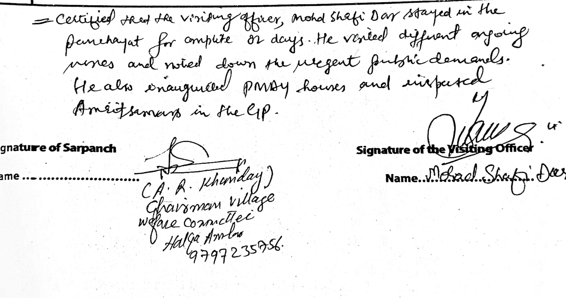

**SignatureofSarpanch SignatureoftheVisitingOfficer**

**Name……………………… Name………………………**



**Department of Rural Development and Panchayati Raj**

**Government of Jammu & Kashmir**