

4

**15TH OCT to 3RD NOV, 2022**

# KEY FEATURES

* Deputy Commissioners to lead the initiative
* Rural development Department to be the nodal department
* Planning Development & Monitoring department and IT to be the support departments

# ACTIONS AND TIMELINES

|  |  |  |  |
| --- | --- | --- | --- |
| **ACTION** | **RESPONSIBILITY** | **LATEST BY** | **REMARKS** |
| **Jan abhiyan** | All departments | Oct 15 -26th | Going on |
| **Deputation of Sectt staff/ HoDs** | GAD | Oct 14 | Done |
| **Deployment of Staff to Panchayats and serving of orders on deployed officers** | DCs | Oct 25 | DCs will deploy senior level staff from the districts. Strict action to be taken against abstentions. No exemptions to be given |
| **Training of district trainors on B2V4** | RDD | Oct 26 |  |
| **Training of visiting officers** | DCs | Oct 27 |  |
| **Field Visits to be completed by** | Visiting Officers | Nov 3 | DCs to supervise and ensure that each Panchayat is visited within the period specified |
| **Data of B2V4 to be uploaded by** | Visiting Officers | Nov 10 | DCs to supervise and ensure that data of all Panchayats is upload- ed by the visiting officer within the period specified |

**INSTRUCTIONS FOR THE VISITING OFFICER (DAY WISE)**

|  |  |  |
| --- | --- | --- |
| **DATE** | **INSTRUCTIONS** | **ACTION POINTS** |
| **Day 0** | Meeting with deputy commissioner and his/her team | a. Take print outs of filled booklets of B2V1, B2V2 and B2V3 from [www.jkpanchayat.in](http://www.jkpanchayat.in/) |
|  |  | b. Also take print outs of the summarized excel sheets of the previous phases from [www.jkpanchayat.in](http://www.jkpanchayat.in/) |
|  |  | c. Collect ATRs on issues raised during previous 3 phases from the office of Deputy Commissioner (Planning deptt) |
|  |  | d. Take prints of blank 2 booklets of B2V4 from [www.jkpanchayat.in](http://www.jkpanchayat.in/) |
|  |  | e. Take plans for 2 previous years and ATRs from the planning deptt |
|  |  | f. Complete trainings on different components of B2V4 being organized by respective Deputy Commissioners |
|  |  | 1. Collect List ofnew works started/ ongoing/ completed during the previous and current Financial year under the following heads:    * PRI grants    * District Plan    * UT plan    * MGNREGA    * Other schemes of other departments    * Any other work |
|  |  | 1. Plans/ beneficiary lists:    * MGNREGA draft plan document for the year 2022-23.    * List of Awaas+ beneficiaries alongwith IHHL Convergence    * List of pension beneficiaries.    * List of SHGs    * List of agriculture scheme beneficiaries |
|  |  | 1. Lists of beneficiaries for:    * Various certificates/ benefits to be distributed by the visiting officer.    * Any other activities identified by different departments |

|  |  |  |
| --- | --- | --- |
| **Day 1** | Reach the village | 1. Ensure that all front line workers of different deptts are present. 2. Ensure exhibition by different depts. about individual beneficiary schemes 3. Inspect JKB/PSB counters/outlets 4. Participate/ensure organization of sports activity in playfield, talent hunt/cultural event/youth activity 5. Gandhi Katha (suggested details uploaded on jkpanchayat.in) 6. Visit atleast 2 amritsarovars and get its geo tagged photos 7. Inspect Khidmat (CSC) Centres and create Generate awareness on 225 schemes particularly G2C schemes like BEAMS, Janbhagidari, AapkiZaminAapkiNigrani, Digital J&K 8. Visiting officer shall also plan and conduct panchayat level conver- gence meeting of all departments 9. Check effectiveness of Centrally sponsored schemes 10. Visit and inspect all government establishments including PHE, AWC, FPS, schools, etc 11. Attempt saturation of deliverable so Jan Abhiyan and wherever deficiencies found, lead a drive to achieve all deliverables 12. Assess effectiveness of sanitation campaign in the panchayat 13. Ensure self employment activities for 15 youth per panchayat 14. Identify 20 potential candidates per panchayat for HIMAYAT training alongwith the trade on which they want training 15. Wherever possible, distribute employment letters for people select- ed under various government employments 16. In the evening, hold normal meeting with senior citizens, govt em- ployees including retired employees, ex servicemen, youth club, and any citizens of the village who are enrolled in college/university 17. Open discussion on Nasha Mukt Abhiyan |

|  |  |  |
| --- | --- | --- |
| Day2 | Have a meeting with all stakeholders- deptt officials and panchayat members | 1. Discussion on the and assess the progress of different schemes relating to the localized SDGs prioritized for that village as per the resolution passed by that Gram Panchayat on 21st April 22, on National Panchayti Raj Day. 2. Sensitize village residents about myScheme” portal (myscheme.in) which includes information about all the schemes being run by Cen- tral/ State/ UT govt across the country 3. Hold meeting of the Biodiversity Management Committees to deliber- ate on issues pertaining to conservation of biodiversity and sustaina- ble utilization of biological resources. 4. Prepare Village development plan, in consultancy with Gram panchayat, discuss it in gram sabha and get it approved. 5. Ensure saturation of soil health card and golden health card under Gold- en Health Card under Ayushman Bharat, 6. Ensure saturation of Old Age Pension Scheme 7. Ensure Domicile Saturation. 8. Ensure KCC Saturation 9. Ensure saturation of land pass books 10. Ensure registration of village vendors needed for any scheme, on GEM portal 11. Ensure panchayat contractors registration 12. Encourage Panchayat members for importance of plantation drive in Panchayat under Har Gaon Hariyali 13. Ensure painting on digital J&K in panchayat ghars 14. Ensure painting on panchayat activites and CSS in panchayat ghars 15. The visiting office shall check no of kindergarten and playfields present in the panchayat for kids and students, if the infrastructure present in these are good enough. 16. Hold meeting with panchayat members to discuss about corruption menace and steps required to make J&K corruption free 17. Obtain a candid assessment about performance of various deptts in- cluding fair feedback about discrepancies in functioning 18. Check the status of Nasha Mukt Abhiyan and reporting of drug ad- dicts to Deputy Commissioner. 19. Identify Tourist Destinations, Circuits, Theme Treks, Identify Homestays, provide support for tourism activities through Village Cooperative 20. Organize Talent Hunt at Panchayat Level 21. Conduct social audit of atleast 5 works under following schemes:     1. MGNREGA     2. PMAY     3. IHHL toilets and payments     4. CSCs     5. AMRIT SAROVARS 22. Hold a mahilasabha and a balsabha and record proceedings in the for- mat given 23. Inaugurate village haat under JKSRLM 24. Check if youth clubs are formed in the panchayat and what activities they are engaged in 25. Organize a village level cultural event to engage panchayat members 26. Sensitize GP about E-kitab kosh an initiative of J&K Govt for empowering youths through online digital literacy |

# GENERAL INSTRUCTIONS

1. The visiting officer shall refrain himself/ herself giving or offering any commitment on behalf of the government and shall adopt an unbiased attitude in reporting issues. As far as possible, his/her observation should be based on a fair and analytical view emerging from his/her interaction in the village.
2. He is going to the village as planning officer, not for sanctioning any works or for making any com- mitments.
3. While preparing village development plan, he has to ensure that, demands are prioritized and re- flected under available schemes, wherever necessary the larger works are to be referred to adminis- trative deptt under CSS/UT plans under intimation to DCs and rest of the works to DCs for reflecting it under district/CSS plans
4. His work shall be hard core planning and audit and is not a PR exercise.
5. Every Deputy Commissioner has to ensure that atleast one RDD official (ideally Panchayat Secre- tary) is present in every panchayat with relevant panchayat records, to ensure conduct of all activi- ties as planned. Panchayat wise order needs to be issued in advance.
6. Visiting officer should ideally carry his/her laptop to complete the reports at the panchayat level itself and upload the final report, duly signed both by the sarpanch and by the visiting officer on [www.jkpanchayat.in](http://www.jkpanchayat.in/) portal, before they leave panchayat.
7. Focus of visit are youth, skills, self-employment, nasha mukt, bhrashtrachar mukt, Rozgar yukt J&K, besides to carry forward the activities during Jan Abhiyan and saturate them.
8. In addition attention may be given to the following areas
   1. Make full use of Centrally Sponsored Schemes
   2. Saturation of individual beneficiary schemes
   3. Self-employment schemes
   4. Bank linked schemes- including departmental subsidy schemes
   5. Empowerment and transparency through digital initiatives
   6. Effectiveness of grass roots machinery –
      1. Patwari, VLW present and available
      2. Available funds utilized in public interest and as per Gram Sabha resolutions
      3. Fairness in governance
      4. CSS/Individual beneficiary schemes etc
      5. BrashtacharMukt J&K
      6. Bhai Mukt J&K
      7. NashaMukt J&K
9. The PRI members (Sarpanchs, Panchs, BDC Chairperson) shall be at the forefront of all activities and given due importance and the approach should be to strengthen them and make them feel em- powered. He/she shall ensure that the BDC chairperson and Sarpanch/Panch are present at the time of inauguration and ceremonies.
10. Visiting officer shall not leave the district without uploading the report, duly signed on the [**www.**](http://www/) **jkpanchayat.in** portal. Every Deputy Commissioner has to ensure that.

## Details of Reporting Officer:

Name: **NISSAR AHMAD WANI**

Designation**: ASSISTANT ENGINEER**

Department/ place of posting: **PWD(R&B) SUB-DIVISION RAJPORA**

Mobile No: **7006247592**

Email ID: [**ERNISSARWANI111@GMAIL.COM**](mailto:ERNISSARWANI111@GMAIL.COM)

Home District: **SHOPIAN**

Dates of visit: **30TH AND 31ST OF OCT. 2022**

## Locational details of Panchayat: (to be pre-filled, information to be taken from the previous phases booklets/summarized excel sheet uploaded on jkpanchayat.in/b2v4.php) (to be vali- dated by the visiting officer and missing details to be filled)

Name of the Panchayat**: PUTRIGAM A**

Local Government Directory(LGD) code of the Panchayat: **242851**

Name of CD Block: **PULWAMA**

Name of Tehsil**: RAJPORA**

Name of District: **PULWAMA**

## Panchayat Profile:

No. of revenue villages in the Panchayat: df **02**

No. of hamlets in the Panchayat: **02 (SHALTAKIYA AND BONTAKIYA**)

No. of households in the Panchayat: **333**

Population (approx) of the Panchayat: **2304**

# Part-II:

(To be filled up by the Visiting Officer during his/her two day visit to the Panchayat. All Fields have to be filled by the Visiting Officer before the booklet is handed over to the DC

## Frontline Officers/Officials who were assigned to the Panchayat for the programme:

|  |  |  |
| --- | --- | --- |
| Department | Name | Designation |
| **SHEEP/H** | **AKTHER RASHID** | **ASM** |
| **HEALTH** | **NUSRAT FAROOQ** | **MLHP** |
| **PDD** | **M.MAQBOOL** | **LINE MAIN** |
| **PHE** | **NAZIR AHMAD BHAT** | **HELPER** |
| **R&B** | **GH AHMAD DHOBI** | **J.E** |
| **ICDS** | **SABZA AKTHER** | **Supervisor** |
| **EDUCATION** | **BILAL AHMAD** | **P.E.T** |
| **AGRICULTURE** | **M.YOUSIF LONE** | **G.C.O** |
| **R.D.D** | **FAROOQ AH** | **V.L.W** |
| **FISHRIES** | **BASHIR AHMAD** | **F.G** |
| **JKB** | **GULZAR AHMAD WANI** | **B.A** |
| **HORTICULTURE** | **VAKEEL AHMAD** | **CALSS IV** |
| **F&S(CAPD)** | **M.MAQBOOL** | **F.P DEALER** |
| **REVENUE** | **M.ASHRAF YATOO** | **PATWARI** |

**Details of absent employees vis-à-vis list furnished by the DC office:**

|  |  |  |
| --- | --- | --- |
| Department | Name | Designation |
|  |  |  |
|  |  |  |
|  |  |  |
|  |  |  |
|  |  |  |
|  |  |  |
|  |  |  |
|  |  |  |
|  |  |  |
|  |  |  |
|  |  |  |
|  |  |  |
|  |  |  |
|  |  |  |
|  |  |  |

# DAY 1- ACTIVITIES

## AGENDA 1: PANCHAYAT ASSET REGISTER

**Infrastructure:**

1 Panchayat Ghar Infrastructure

1. Govt building/private **yes** ( **housed in GPS shaltakiya)**
2. New/needing repairs **NOT EXISTING**
3. Furniture (Y/N) **NO**
4. Computer/printer (Y/N) **NO**
5. Internet (Y/N**) NO**
6. Telephone (Y/N) **NO**
7. Toilet (CSC/part of panchayat ghar) (Y/N) **NO**
8. Water (Y/N) **YES**
9. Electricity (Y/N) **YES**
10. Bank branch (Y/N**) NO**
11. CSC (Y/N) **YES(LINKED WITH HDFC ONLY)**
12. Patwarkhana (Y/N) **NO(RESIDING IN PRIVATE ACCOMIDATION)**
13. Village haat (Y/N) **YES**
14. Playground (Y/N) **Y**
15. School-
    1. Kindergarten (Y/N) **N**
    2. Primary (Y/N) **S**
    3. Secondary (Y/N) **Y**
    4. College (Y/N) **N**
    5. University(Y/N**) N**
16. Anganwadi Centre (Y/N) **Y 05 NO.S**
    1. (govt/private) **PRIVATE**
    2. Total children enrolled **142**
17. Amrit Sarovars – details, location, condition **NIL**
18. Government offices- details, whether functional or not **FUNCTIONAL**
19. Ration shop (Y/N) **YES**
20. Places oftourism importance– names, little details on historical/cultural importance **NIL**
21. Village heritage sites/ treks- names, little details on historical/cultural importance **NIL**
22. VLW Office (Y/N) **Y**
23. Primary Healthcare Centre (Y/N), **Y (WELLNESS CENTRE)**
24. List of Incomplete Buildings- names, year of construction **NIL**
25. List of Underutilized Buildings- names **NIL**

# DAY 1-ACTIVITIES

## AGENDA2:

**DIFFERENT INSTITUTIONS/INFRASTRUCTURE PROJECTS TO BE VISITED**

**AMRIT SAROVARS**

**Visit, verify**

**COMMENTS**

Khidmat Centres

Create /Generate awareness on 225 schemes particularly G2C schems Aapki Zamin Aapki Nigrani, Beams, Janbhagidari, Digital J&K

Satisfactory services delivered (csc linked with HDFC banking, need to be linked with J&K bank facilities

JKB/PSB counters/outlets

Incomplete buildings/pro- jects

PDS PHC

Youth clubs SHG

PMAY

My school, my pride progress; schools- water, toilets, staff

Swachh SBM

Panchayat play ground, Sports kits distribution Village games

Har Gaon Hariyali, Planta- tion drive

Village cultural event Dangal/ Haat/Mela

Exhibition of schemes

Jal Jeewan Mission verifica- tion- WSS/JSD

Electricity supply

1. Status of counter
2. Number of visitors

Verify whether identification and redistribution done

Visit, evaluate, online status

Visit- evaluate, status of staff, equipment and quality

Meet, interact, seek suggestions

Meet, identify problems, seek suggestions Inspect, Inaugurate

Visit, check for water, electricity, sanitation, meet students and staff

Evaluate

Ensure, verify. Participate in at least one game in the playground

Evaluate status, feedback

Participate in; ensure that it is held

Ensure that every department participates and that it continues for the entire duration of B2V

Verify

Not existing, demanding for JKB outlet/ ATM facilities

NONE

satisfactory

Wellness center exists found satisfactory

Existing interacted

Existing more public participation needed

01 inspected and inaugurated

Satisfactory. GPS needs walling and P.S at shaltakiya needs cc drain

satisfactory

Cultural and sports events organized at GHS putrigam and sport kits distributed

Satisfactory, plantation drive carried out.

Event Held

Organized and F.L Workers were present throughout the B2V program

Stands tendered out

# DAY 1 - ACTIVITIES

## AGENDA3: SATURATE JAN BHIYAN DELIVERABLES AND RECORD DEFICIENCIES IF ANY (INSERT DELIVERABLES LIST HERE AS PER GAD FORMAT

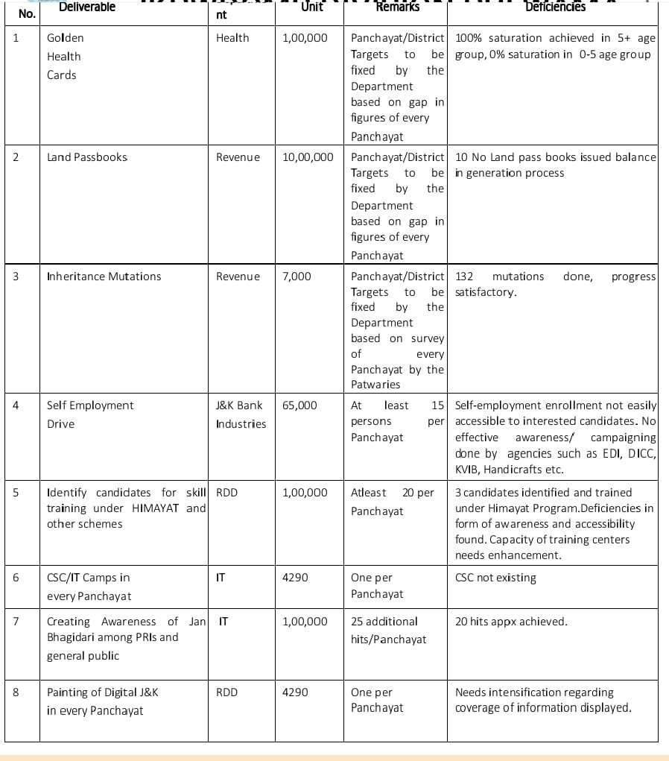

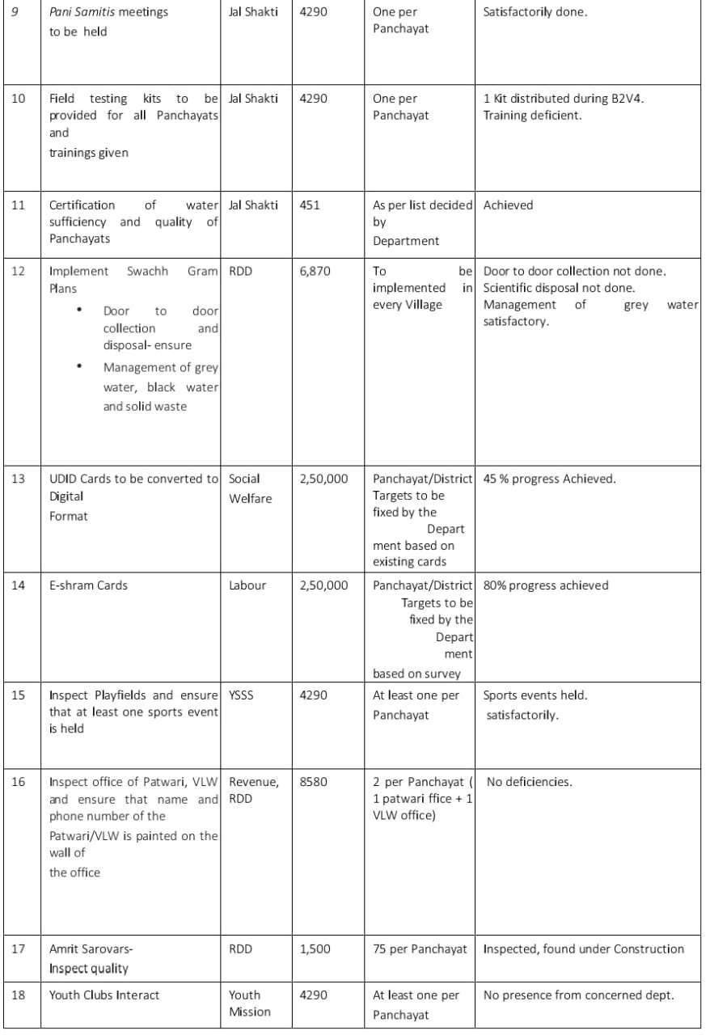

**14 (15TH 3RD NOV)**

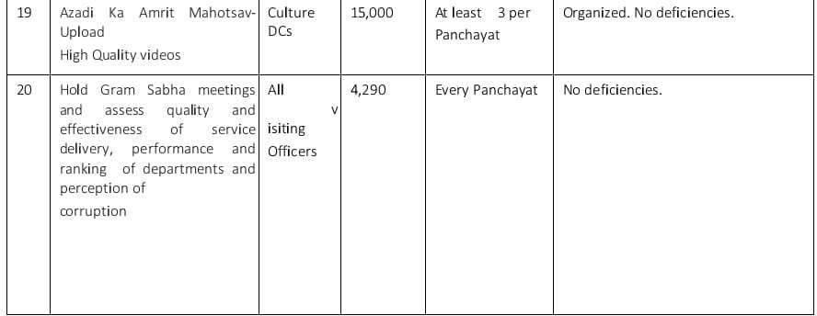

## AGENDA 4:

**SELF EMPLOYMENT ACTIVITIES**

Ensure Self-employment activities for youth, distribute employment letters for people selected under various social schemes (15 IS THE TARGET PER PANCHAYAT)

**Number of cases in different categories sanctioned Details of the bank sanctioning it : 02(JKB under mumken) Total amount involved : 20 lacs**

# DAY 1 ACTIVITIES

## AGENDA 5

In the evening, hold informal meetings with senior citizens , govt employees, retd employees, youth club and other citizens who are enrolled on college/university and have discussion on Gandhi Katha, Nasha Mukt Abhiyan, corruption free governance, doubling farmers income and record the proceedings

## DAY 2

1. No of Individual Compost Pits constructed **NIL**
2. No of Individual Soak Pits constructed **22**
3. No. of Biodiversity management committee meetings held: **NIL**
4. Is the name of SarpanchdisplayedoncitizeninformationboardsofallRD&PRschemes:Yes/No **NO**
5. AreSarpanchsbeinginvolvedinstart/inaugurationofactivities:Yes/NO **PRI NOT EXISTING**
6. Whether subjectshavebeenassignedbythe Sarpanchtothe Panchs:Yes/No **NO**
7. Whether grievances redressal boxisinstalled:Yes/No **YES**
8. NoofgrievancesreceivedpertainingtoPanchayatlevel: **02**
9. NoofgrievancesdisposedofatPanchayatlevel: **02**
10. Whetherthe Sarpanch/PanchayatSecretaryhavedigitalsignatures:Yes/No **YES**
11. Whether all MGNREGA/ 14th FC payments are being made by Sarpanch through Digital Signature Certificate (DSC): Yes/ No **YES**

# HUMAN RESOURCE AVAILABLE AT THE PANCHAYAT LEVEL:

|  |  |  |  |  |
| --- | --- | --- | --- | --- |
| **SR NO.** | **DEPARTMENT WISE STAFF** | **NUMBERS** | | **NAMES** |
|  | Rural development department: | SANCTIONED  01  01  01  01  14  01  04  05  02  02  02  0  02  01  01  0 | ACTUAL  01  01  01  01  10  01  04  05  O2 01  02  0  02  01  Nil 0 |  |
| BDO JE GRS TA | Gulzar Bin Rehman Nazir Ahmad Alie Nazir Ahmad Yatoo Farooq Ahmad |
| SCHOOL EDUCATION: |  |
| TEACHER  HEAD MASTER | H.M Neelofar Jan |
| ANY OTHER |  |
| JAL JEEVAN: | J.E G.M Bhat, W/S GH . Hassan  M. Abdullah(ITI) and M. |
|  | Maqbool( Line man) |
| PDD: |  |
| LINEMAN |  |
| JE |  |
| ANY OTHER |  |
| FOOD & CIVIL SUPPLIES | Mohd Maqbool mir F.P.S |
| AGRICULTURE & ANIMAL HUS- BANDARY | GH. Rasool (VET Stock Assistant), Ab Rashid Attendant |
| SOCIAL WELFARE |  |
| HEALTH: |  |
| ASHA |  |
| ANM |  |
| AYUSH DOCTOR |  |
| ALLOPATHIC DOCTOR |  |
| ANY OTHER DEPARTMENT |  |

## AGENDA NO.1

Discussion on the and assess the progress of different schemes relating to the localized SDGs prior- itized for that village as per the resolution passed by that Gram Panchayat on 21st April 22, on National Panchayati Raj Day(Copyof the resolution to be taken from [www.jkpanchayat.in](http://www.jkpanchayat.in/) portal under the link of Gram Swaraj Month)

* 1. SDGs AGREED FOR THAT VILLAGE, TO BE IMPLEMENTED BY MARCH2024:
  2. STATUS OF WORKS UNDER THE FOLLOWING SCHEMES:

## Clean and green village

1. Initiatives taken by the Panchayat for managing Solid and Liquid Waste **SWM SHED Approved**
2. Initiatives taken by the Panchayat for using green sources of fuel like solar, biogas

**NO**

1. Has mapping of land use, water bodies, forest, slopes, wet lands, degraded forest within the Gram Panchayat been done? Yes/No. If No, reason, thereof **YES**
2. Has the Climate Resilience Plan been developed for the GP? Yes /No **NO**
3. Steps taken by the Gram Sabha about the climate change mitigation factors like reducing energy consumption, usage of fossil fuels, plastics, non-renewable building materials and also to promote measures like planting of trees, conserving forests, usage of good agricultural practices like drip irrigation, water conservation measures and conservation of wetlands. **YES**
4. Whether schools have started segregating waste **YES**
5. Whether schools have their own compost/soakage pits for solid/liquid waste management **NO**

## Healthy village

1. Are meetings related to Village Health and Sanitation Committee being held regularly? **YES**
2. Do all the eligible individuals been provided the Golden Card? **YES**
3. Are all the Children being immunized as per the Schedule recommended by Govt. of India? **YES**
4. Are all the eligible individuals been vaccinated against COVID-19? **YES**
5. Does Gram Panchayat ensure that all pregnant women are getting necessary prenatal checkups? **YES**
6. Whether all the deliveries were Institutionalized or conducted by trained Midwives? **YES**

## Water sufficient village

1. Do all the IHHs in the Gram Panchayat have water pipeline connections? **90%**
2. Whether Gram Panchayat has taken steps for grey water management. If Yes please specify **s/pits const**
3. Do all the IHHs in the Gram Panchayat have toilets? **YES**
4. Are all the IHHs toilets functional or not? **95%**
5. Do all the Schools/Anganwadi centers have a toilet facility or not? **YES**
6. Are all the toilets in the schools/Aaganwadi functional or not? **YES**
7. Whether Gram Pachachayat Bhawan has separate toilets for women or not? **Not Available**

## Child Friendly village

1. Do all the children under the age of 0-6 years been enrolled in the Anganwadi centers for pre- schooling? Yes/NO **YES**
2. How many Bal Sabha’s were organized in the Gram Panchayat------**02**-------------
3. Whether the issues raised by Bal Sabha are addressed during the Gram Sabha. Yes/NO **YES**
4. Whether Gram Panchayat is tracking the data related to dropout children and children with irregular attendance? Yes/NO. **YES**
5. Do all the schools under the Gram Panchayat have separate toilets for girls and boys? Yes/No **YES**

## Village with good governance

1. Is CSC located in the Gram Panchayat Bhawan or not? **NO**
2. Is the list of beneficiaries related to the Schemes/Programs displayed on the Gram panchayat wall or not? **YES**
3. Does the Gram Panchayat has its building or not? **NO(Housed in GPS Shaltakiya)**
4. Is the Gram Panchayat office functional or not? **yes**
5. Are the activities approved under the Halqa Panchayat Development Plan displayed on the Gram Panchayat wall or not? **yes**
6. Is Social Audit of earlier Schemes/Programs carried out or not? **yes**

## Poverty free and enhanced livelihood village

1. Has Gram Panchayat developed any criteria for the identification of the poor? Yes/No if yes specify **yes**
2. Have all the eligible households registered in PDS or not? **YES**
3. Has Gram Panchayat provided space for Self-help Groups in PanchyatGhar for holding meetings or not? **YES**
4. Have all the eligible households been registered for Pension or not? **YES**
5. Has Gram Panchayat facilitated Youth for Skill Enhancement Courses and Placement?**NO**
6. Has Job Cards been distributed to all the eligible individuals under MGNREGA? **YES**
7. Has Gram Panchayat facilitated SHGs for Bank Account Linkages? **YES**

## Socially secured village

1. Whether Gram Panchayat is maintaining data related to Differently Abled People? **YES**
2. Is Gram Panchayat Office Disabled Friendly or not? **YES**
3. Are provisions for a separate Budget under the Resource Envelope for Women and Children made or not? **NO**
4. Do all the Schools in the Gram Panchayat have facilities for Differently Abled Children like toilets, barrier-free access, etc., or not? **YES**
5. Are all the eligible individuals are getting pensions, like old age pension, widow pension, etc? **YES**
6. Are all the eligible households getting benefits from IAY or not? **YES**

## Engendered Development in Village

1. How many Mahila Sabha’s were organized in the Gram Panchayat------**O2**---------
2. Whether SHGs federations have been provided space for meetings in the Panchayat Bhawan (Yes/ No) **YES**
3. Whether GPs have taken steps for increasing women’s participation in Gram Sabha(Yes/No) **YES**
4. Number of women beneficiaries headed households covered under PDS system……**10**…………………
5. Number of beneficiaries (out of total eligible population) receiving social protection benefits under Pradhan Mantri Matritva Vandana Yojana…**12**……………….
6. Self-sufficient infrastructure in the village
7. Whether GP has a Community Hall with access to electricity, furniture, water supply, toilet……-----

**NOT EXISTING**………………….

1. Whether the Disaster management plan is available at the GP Level (Yes/No) **NO**
2. Whether child-friendly park with required facilities is available in GP (Yes/No) **NO**
3. Whether the GP has easy access to Godown for storage (Yes/No) **NO**
4. Whether street lights are provided in public places for ensuring safety (Yes/No) **Partially**

# DAY 2 ACTIVITIES

## AGENDA NO.2

Sensitize village residents about my Scheme” portal (myscheme.in) which includes information about all the schemes being run by Central/ State/ UT govt across the country

*(Scheme Material available from https://jkpanchayat.in/b2v4.php)*

# DAY 2 ACTIVITIES

## AGENDA NO.3

Hold meeting of the Biodiversity Management Committees to deliberate on issues pertaining to conserva- tion of biodiversity and sustainable utilization of biological resources. He should check People Biodiversity register (PBR) of that panchayat and review if Biodiversity Management Committee constituted for that panchayat is holding minimum 4 meetings in a year and meeting once in every 3 months *(Role of BMC available at https://jkpanchayat.in/b2v4.php)*

COMMITTEE MEMBERS: **04 MEMBERS**

PRESENT : **NIL**

BIODIVERSITY REGISTER PHOTOS

PAST 4 MEETING DETAILS- DATES, MINUTES PHOTOS **nil**

# DAY 2 ACTIVITIES

## AGENDA 4

Visiting officer shall also plan and conduct panchayat level convergence meeting of all departments and prepare Village development plan for village, in consultancy with Gram panchayat, discuss it in gram sabha and get it approved. **Conducted and developmental plan proposed through Gram Sabha**

(GPDP format available on https://jkpanchayat.in/b2v4.php)

## In addition GPDP plan shall also include :

Tourist places which need to be developed **NOT Available**



Specific product which needs to be developed **nil**

Tourism- home stays **NO**

20 candidates for training under Himayat scheme alongwith trade in which training is to be given **LIST ENCLOSED**

# DAY 2 ACTIVITIES

## AGENDA 5

Ensure saturation of following schemes and give status:

|  |  |  |  |
| --- | --- | --- | --- |
| **NAME OF THE SCHEME** | **TOTAL ELIGIBLE BENEFICIARIES IN THE VILLAGE** | **TOTAL BENEFICIARIES WHO AVAILED THE BENEFITS OF THE SCHEME** | **REASONS FOR PENDENCY** |
| Golden Health Card under | **2304** | **1500** | **UNDER PROCESS** |
| Ayushman Bharat |  |  |  |
| Janani suraksha yojana | **30** | **30** | **100%** |
| OLD AGE pension | **92** | **92** | **100%** |
| Widow pension | **26** | **26** | **100%** |
| Disability pension | **17** | **17** | **100%** |
| Domicile certificate | **2100** | **1150** | **Document Checking** |
| Kisan credit card | **603** | **550** | **NEEDS Awareness** |
| PM kisan sammannidhi | **208** | **208** | **100%** |

Land pass book

Registration of village ven- dors on GEM portal

**603**

## nil

**207**

## nil

**U/Process**

Registration of village con- **02 02**

tractors on jktenders portal

Registration of village con- tractors on PWD portal

**nil**

**nil**

Incomplete buildings/pro- jects

# DAY 2 ACTIVITIES

## AGENDA 6

**NASHA MUKT ABHIYAN**

1. Whether gram sabha resolution passed **yes**
2. Details of activities conducted **Nasha Mukht Awareness program, pledge campaign, motivation and discussion held**
3. Whether all activities and GS resolution uploaded on jkpanchayats.in portal **YES**
4. How many drug addicts in the village **NO**
5. Whether reported to the Deputy Commissioner
6. How many registered for rehabilitation under government programme **NO**

# DAY 2 ACTIVITIES

## AGENDA 7 SOCIAL AUDIT

Conduct social audit of atleast 5 works each under following schemes:

|  |  |  |  |  |  |  |
| --- | --- | --- | --- | --- | --- | --- |
| NAME OF THE SCHEME | DETAILS OF THE WORKS | YEAR OF WORK APPROVAL | AMOUNT APPROVED FOR THE WORK | WHETHER  WORK EXECUTED SATISFACTORILY | GEO- TAGGED PHOTOS | ANY GRIEVANCE RECORDED RELATING TO THAT  WORK |
| MGNREGA | **03** | **21-22** | **6.68 lacs** | **Y** | **Y** | **N** |
| PMAY | **03** | **21-22** | **4.5** | **Y** | **Y** | **N** |
| IHHL  UNDER SBM-G | **12** | **21-22** | **1.44** | **Y** | **Y** | **N** |
| CSC UNDER SBMG | **NIL** |  |  |  |  |  |
| AMRIT SAROVARS | **NIL** |  |  |  |  |  |

# DAY 2 ACTIVITIES

## AGENDA 8 MAHILA SABHA

Total women in the village above the age of 18 **694**

Total attended **25**

Proceedings: **Suggestions taken and Given.**

*(Pl insert pointers to be discussed there – refer palli proceedings)*

# DAY 2 ACTIVITIES

## AGENDA 9 BAL SABHA

Hold a balsabha and record proceedings

Total children in the village above the age of 5-18 **250**

Total attended **30**

Proceedings: **Suggestions taken and Given.**

*(Pl insert pointers to be discussed there – refer palli proceedings)*

# DAY 2 ACTIVITIES

**AGENDA 10 INAUGURATIONS**

|  |  |  |  |
| --- | --- | --- | --- |
| **SR NO.** | **ASSETS /ACTIVITIES INAUGRATED** | **STATUS OF THE ASSET/AC- TIVITIES (NUMBER, OTHER DETAILS)** | **GEO-TAGGED PHOTOS** |
|  | VILLAGE HAAT under JKSRLM (SUN- DAY MARKET) | **Organized by social welfare** | **attached** |
| PMAY houses if any ready for inaugra- tion | **O1 inspected and inaugurated** | **attached** |
| Swachh gram projects- segregation sheds etc | **Segregation sheds approved for construction but requires** |  |
|  | **land identification and** |  |
|  | **demarcation by revenue** |  |
|  | **department.** |  |
| Amrit sarovars | **nil** |  |
| Sports kits | **Distributed** | **attached** |
| Village cultural events | **Organized at GHS putrigam** | **attached** |
| JJM assets/projects | **Works stands tendered** | **attached** |
| Any other to be identified at district level | **DEMAND FOR C/O COLD STORAGE UNITS**  **AND JUICE FACTORY** |  |
|  | **UNITS AT G.P LEVEL** |  |

# FOLLOW UP OF (B2V1, B2V2 & B2V3):

*(Pre filled excel sheet to be taken from district level/ and also to be downloaded from* [*www.jkpanchayat.in)*](http://www.jkpanchayat.in/)

|  |  |  |  |
| --- | --- | --- | --- |
| S.NO. | Particulars | Action taken | Remarks # |
| I. Urgent Public Requirements/ Demands- B2V1   1. Drinking water 2. Sumo service from Rahmoo to Rajpora to and fro 3. Dismantling of unsafe panchayat ghar in school premises 4. Establishment of P.H.C 5. Improvement of LT/HT network 6. c/o of 132kva,33kva grid   7  II. Urgent Public Requirements/ Demands- B2V2 | | DPR approved under JJM | Tendered out |
| No action taken | Need to be attended on priority |
| cleared | Done |
| No action taken | Wellness center available |
| Partially done | Needs serious attention |
| No action taken | Pay serious attention |
| 1  2 | Improvement of LT/HT network and transformers  c/o bridge from Zagiam to Rahmoo | Partially done  Done | Needs serious attention |
| 3  4 | Compensiation of fruit bearing trees during snowfall  Establishment of vetenary hospital | Done  No action taken | O1 no. vetenary dispensary existing in zaigam |
| 5 | Filtration plant at zagigam | No action taken | Serious attention needed |
| 6  7 | Improvement of internal roads  Bore well at putrigam with overhead tank | 75% done  Done | Macadamisation of 0.75km carried out in 22-23 |
| S.NO. | Particulars | Action taken | Remarks # |
| III. Major Problems – B2V1 | |  |  |
| 1 Drinking water | | Work in progress | Under JJM |
| 2 Less availability of power supply | | Improved | Needs further improvement |
|  | |  | by way of electric infra |
| 3 Inadequate health facility | | Wellness center already | network  Needs to be upgraded |
|  | | exists |  |

* 1. pathetic condition of internal and external roads
  2. Lack of awareness among people regarding horticulture

Macadamisation of 0.75 km carried out in 22-23

Availed different schemes/ forming equipments, motors tillers brush cutters

DPR under Nabard XVIII submitted for remaining internal links

Further awareness required

1. Major Problems- B2V2
2. Filtration plant at Zagigam No action taken Needs serious attention
3. Improvement of LT/HT network and augmentation of transformer at zagigam
4. Establishment of vetenary hospital at putrigam

Partially done

No action taken

Augmentation of transformer is yet to be carried out

01 no. available at zagigam

4

5

1. Major Problems- B2V3
2. JKB facility at putrigam No action taken Needs attention
3. High school upgradation No action taken Needs attention
4. Dismantling of unsafe panchayat Ghar in school premises at putrigam
5. Vetenary dispensary at putrigam
6. Electric poles plus wires required in all the hamlet

Done

No action taken Partially done

Nearest available at zagigam

Needs improvement

1. Major Complaints- B2V1
2. Drinking water scarcity in all the hamlets JJM scheme Tendered out
3. Electric poles and wire Partially Needs attention
4. Dismantling of p/ghar in school premises Done
5. Major Complaints- B2V2
6. Drinking water issue JJM scheme Tendered out
7. Internal roads of halqa zagigam, shaltakiya and putrigam

3

0.75km macadamisation carried out in 22-23

DPR under NABARD framed and submitted



1. Major Complaints- B2V3

1 Drinking water issue JJM scheme Tendered out

**24 (15TH 3RD NOV)**



2

3

Electric poles and electric wires

Vetenary dispensary at putrigam

partially

No action taken

Needs attention

One existing at zagigam

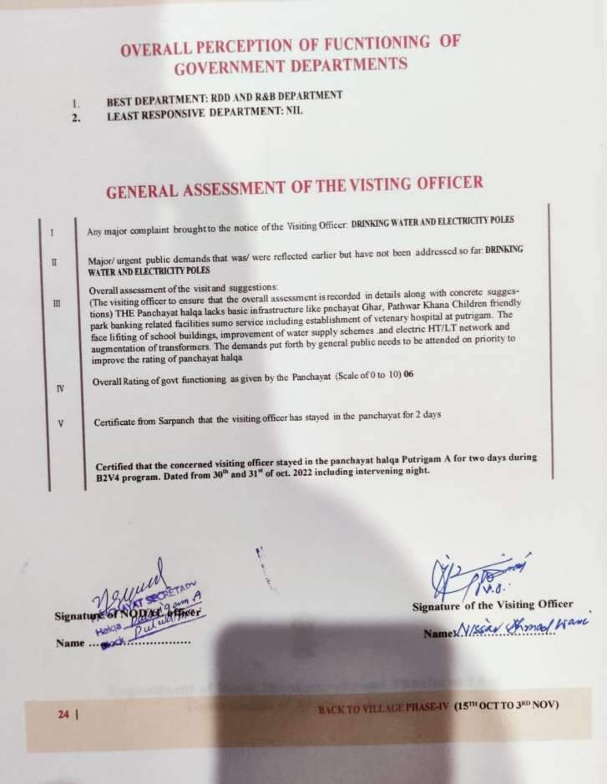



**24**

**(15TH**

**3RD NOV)**



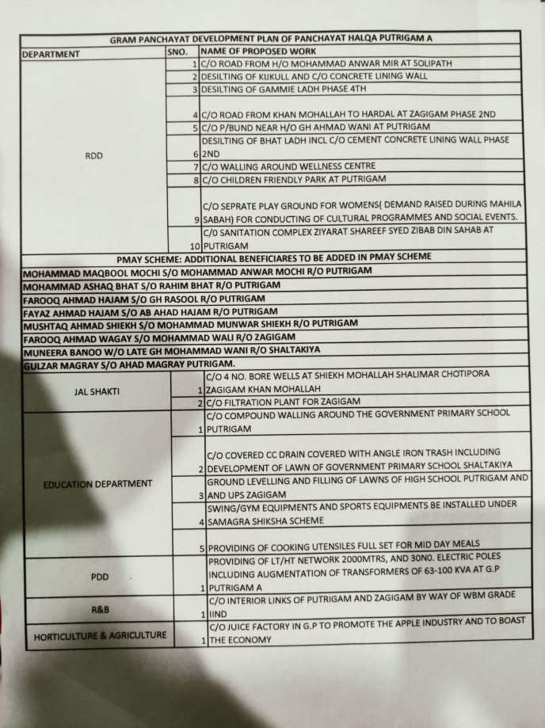

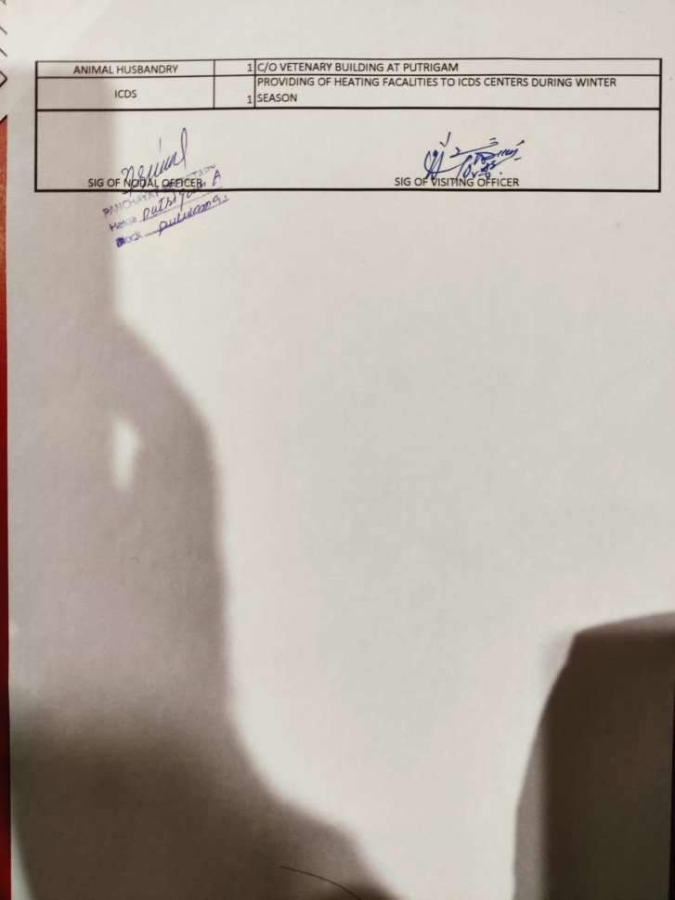

**24 (15TH 3RD NOV)**



**Department of Rural Develompent and Panchayati Raj Government of Jammu & Kashmir**