

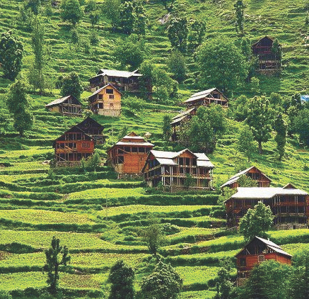

4

**15THOCTto3RDNOV,2022**

***Panchayat Halqa CHATTROGAM Block TRAL***



4

**15THOCTto3RDNOV,2022**

# KEYFEATURES

* DeputyCommissionerstoleadtheinitiative
* RuraldevelopmentDepartmenttobethenodaldepartment
* PlanningDevelopment&MonitoringdepartmentandITtobethesupportdepartments

# ACTIONSANDTIMELINES

**ACTION**

**RESPONSIBILITY**

**LATESTBY**

**REMARKS**

**Janabhiyan**

Alldepartments

Oct15-26th

Goingon

**Deputation ofSectt staff/**

**HoDs**

GAD

Oct14

Done

**Deployment of Staff toPanchayatsandservingof**

**ordersondeployedofficers**

DCs

Oct25

DCs will deploy senior level stafffromthedistricts.Strictactiontobetakenagainstabstentions.No

exemptionstobegiven

**Trainingofdistricttrainors**

**onB2V4**

RDD

Oct26

**Trainingofvisitingofficers**

DCs

Oct27

**FieldVisitstobecompleted**

**by**

VisitingOfficers

Nov3

DCstosuperviseandensurethateach Panchayatis visitedwithin

theperiodspecified

**Data ofB2V4tobe**

**uploadedby**

VisitingOfficers

Nov10

DCstosuperviseandensurethatdata of all Panchayats is upload-edbythevisitingofficerwithin

theperiodspecified

**INSTRUCTIONSFORTHEVISITINGOFFICER(DAYWISE)**

**DATE**

**INSTRUCTIONS**

**ACTIONPOINTS**

**Day0**

Meeting with deputycommissionerandhis/herteam

1. TakeprintoutsoffilledbookletsofB2V1,B2V2andB2V3from[www.jkpanchayat.in](http://www.jkpanchayat.in/)
2. Alsotakeprintoutsofthesummarizedexcelsheetsofthepreviousphasesfrom[www.jkpanchayat.in](http://www.jkpanchayat.in/)
3. CollectATRsonissuesraisedduringprevious3phasesfromtheofficeofDeputyCommissioner(Planningdeptt)
4. Takeprintsofblank2bookletsofB2V4from[www.jkpanchayat.in](http://www.jkpanchayat.in/)
5. Takeplansfor2previousyearsandATRsfromtheplanningdeptt
6. CompletetrainingsondifferentcomponentsofB2V4beingorganizedbyrespectiveDeputyCommissioners
7. CollectListofnewworksstarted/ongoing/completedduringthepreviousandcurrentFinancialyearunderthefollowingheads:
   * PRIgrants
   * DistrictPlan
   * UTplan
   * MGNREGA
   * Otherschemesofotherdepartments
   * Anyotherwork
8. Plans/beneficiarylists:
   * MGNREGAdraftplandocumentfortheyear2022-23.
   * ListofAwaas+beneficiariesalongwithIHHLConvergence
   * Listofpensionbeneficiaries.
   * List of SHGs
   * Listofagricultureschemebeneficiaries
9. Listsofbeneficiariesfor:
   * Various certificates/ benefits to be distributed by thevisitingofficer.
   * Anyotheractivitiesidentifiedbydifferentdepartments

**Day1**

Reachthevillage

1. Ensurethatallfrontlineworkersofdifferentdepttsarepresent.
2. Ensureexhibitionbydifferentdepts.aboutindividualbeneficiaryschemes
3. InspectJKB/PSBcounters/outlets
4. Participate/ensureorganizationofsportsactivityinplayfield,talenthunt/culturalevent/youthactivity
5. GandhiKatha(suggesteddetailsuploadedonjkpanchayat.in)
6. Visitatleast2amritsarovarsandgetitsgeotaggedphotos
7. InspectKhidmat(CSC)CentresandcreateGenerateawarenesson225 schemes particularly G2C schemes like BEAMS, Janbhagidari,AapkiZaminAapkiNigrani,DigitalJ&K
8. Visitingofficershallalsoplanandconductpanchayatlevelconver-gencemeetingofalldepartments
9. CheckeffectivenessofCentrallysponsoredschemes
10. VisitandinspectallgovernmentestablishmentsincludingPHE,AWC,FPS,schools,etc
11. AttemptsaturationofdeliverablesoJanAbhiyanandwhereverdeficienciesfound,leadadrivetoachievealldeliverables
12. Assesseffectivenessofsanitationcampaigninthepanchayat
13. Ensureselfemploymentactivitiesfor15youthperpanchayat
14. Identify20potentialcandidatesperpanchayatforHIMAYATtrainingalongwiththetradeonwhichtheywanttraining
15. Whereverpossible,distributeemploymentlettersforpeopleselect-edundervariousgovernmentemployments
16. In the evening, hold normal meeting with senior citizens, govtem-ployeesincludingretiredemployees,exservicemen,youthclub,andanycitizensofthevillagewhoareenrolledincollege/university
17. OpendiscussiononNashaMuktAbhiyan

Day2

Have a meeting with allstakeholders- deptt officialsandpanchayatmembers

1. Discussionontheandassesstheprogressofdifferentschemesrelatingto the localized SDGs prioritized for that village as per the resolutionpassedbythatGramPanchayaton21stApril22,onNationalPanchaytiRajDay.
2. SensitizevillageresidentsaboutmyScheme” portal(myscheme.in)whichincludesinformationaboutalltheschemesbeingrunbyCen-tral/State/UTgovtacrossthecountry
3. HoldmeetingoftheBiodiversityManagementCommitteestodeliber-ateonissuespertainingtoconservationofbiodiversityandsustaina-bleutilizationofbiologicalresources.
4. PrepareVillagedevelopmentplan,inconsultancywithGrampanchayat,discussitingramsabhaandgetitapproved.
5. EnsuresaturationofsoilhealthcardandgoldenhealthcardunderGold-enHealthCardunderAyushmanBharat,
6. EnsuresaturationofOldAgePensionScheme
7. EnsureDomicileSaturation.
8. EnsureKCCSaturation
9. Ensuresaturationoflandpassbooks
10. Ensureregistrationofvillagevendorsneededforanyscheme,onGEMportal
11. Ensurepanchayatcontractorsregistration
12. EncouragePanchayatmembersforimportanceofplantationdriveinPanchayatunderHarGaonHariyali
13. EnsurepaintingondigitalJ&Kinpanchayatghars
14. EnsurepaintingonpanchayatactivitesandCSSinpanchayatghars
15. The visiting office shall check no of kindergarten and playfieldspresentinthepanchayatforkidsandstudents,iftheinfrastructurepresentinthesearegoodenough.
16. HoldmeetingwithpanchayatmemberstodiscussaboutcorruptionmenaceandstepsrequiredtomakeJ&Kcorruptionfree
17. Obtainacandidassessmentaboutperformanceofvariousdepttsin-cludingfairfeedbackaboutdiscrepanciesinfunctioning
18. CheckthestatusofNashaMuktAbhiyanandreportingofdrugad-dictstoDeputyCommissioner.
19. Identify Tourist Destinations, Circuits, Theme Treks, Identify Homestays,providesupportfortourismactivitiesthroughVillageCooperative
20. OrganizeTalentHuntatPanchayatLevel
21. Conductsocialauditofatleast5worksunderfollowingschemes:
    1. MGNREGA
    2. PMAY
    3. IHHLtoiletsandpayments
    4. CSCs
    5. AMRITSAROVARS
22. Holdamahilasabhaandabalsabhaandrecordproceedingsinthefor-matgiven
23. InauguratevillagehaatunderJKSRLM
24. Checkifyouthclubsareformedinthepanchayatandwhatactivitiestheyareengagedin
25. Organizeavillagelevelculturaleventtoengagepanchayatmembers
26. SensitizeGPaboutE-kitabkoshaninitiativeofJ&KGovtforempoweringyouthsthroughonlinedigitalliteracy

# GENERALINSTRUCTIONS

1. Thevisitingofficershallrefrainhimself/herselfgivingorofferinganycommitmentonbehalfofthegovernmentandshalladoptanunbiasedattitudeinreportingissues.Asfaraspossible,his/herobservationshouldbebasedonafairandanalyticalviewemergingfromhis/herinteractioninthevillage.
2. Heisgoingtothevillageasplanningofficer,notforsanctioninganyworksorformakinganycom-mitments.
3. Whilepreparingvillagedevelopmentplan,hehastoensurethat,demandsareprioritizedandre-flectedunderavailableschemes,wherevernecessarythelargerworksaretobereferredtoadminis-trativedepttunderCSS/UTplansunderintimationtoDCsandrestoftheworkstoDCsforreflectingitunderdistrict/CSSplans
4. HisworkshallbehardcoreplanningandauditandisnotaPRexercise.
5. EveryDeputyCommissionerhastoensurethatatleastoneRDDofficial(ideallyPanchayatSecre-tary)ispresentineverypanchayatwithrelevantpanchayatrecords,toensureconductofallactivi-tiesasplanned.Panchayatwiseorderneedstobeissuedinadvance.
6. Visiting officer should ideally carry his/her laptop to complete the reports at the panchayat levelitself and upload the final report, duly signed both by the sarpanch and by the visiting officer on[www.jkpanchayat.in](http://www.jkpanchayat.in/)portal,beforetheyleavepanchayat.
7. Focus of visit are youth, skills, self-employment, nashamukt, bhrashtracharmukt, Rozgaryukt J&K,besidestocarryforwardtheactivitiesduringJanAbhiyanandsaturatethem.
8. Inadditionattentionmaybegiventothefollowingareas
   1. MakefulluseofCentrallySponsoredSchemes
   2. Saturationofindividualbeneficiaryschemes
   3. Self-employmentschemes
   4. Banklinkedschemes-includingdepartmentalsubsidyschemes
   5. Empowermentandtransparencythroughdigitalinitiatives
   6. Effectivenessofgrassrootsmachinery–
      1. Patwari,VLWpresentandavailable
      2. AvailablefundsutilizedinpublicinterestandasperGramSabharesolutions
      3. Fairnessingovernance
      4. CSS/Individualbeneficiaryschemesetc
      5. BrashtacharMuktJ&K
      6. BhaiMuktJ&K
      7. NashaMuktJ&K
9. ThePRImembers(Sarpanchs,Panchs,BDCChairperson)shallbeattheforefrontofallactivitiesandgiven due importance and the approach should be to strengthen them and make them feel em-powered.He/sheshallensurethattheBDCchairpersonandSarpanch/Pancharepresentatthetimeofinaugurationandceremonies.
10. Visitingofficershallnotleavethedistrictwithoutuploadingthereport,dulysignedonthe[**www.**](http://www/)**jkpanchayat.in**portal.EveryDeputyCommissionerhastoensurethat.

### DetailsofReportingOfficer:

JavidAhmadDar

Name: Designation: Department/placeofposting: MobileNo: EmailID:irjavid501@gmail.com HomeDistrict:  Datesofvisit:

28-10-2022

Seniorlecturer

Education/GHSSAchan

9596110009

### LocationaldetailsofPanchayat:(tobepre-filled,informationtobetakenfromthepreviousphasesbooklets/summarizedexcelsheetuploadedonjkpanchayat.in/b2v4.php)(tobevali-datedbythevisitingofficerandmissingdetailstobefilled)

NameofthePanchayat: LocalGovernmentDirectory(LGD)codeofthePanchayat: NameofCDBlock: NameofTehsil: Name of District:

Tral

Tral

242945

Chatrtrogam

Chatrtrogam

### PanchayatProfile:

One

No.ofrevenuevillagesinthePanchayat: No.ofhamletsinthePanchayat: 3 No.ofhouseholdsinthePanchayat:

260

1300

1.KhasdiGojerBasti 2.Shaladraman,3.sikhcheckBajwani

Population(approx)ofthePanchayat:

# Part-II:

(TobefilledupbytheVisitingOfficerduringhis/hertwodayvisittothePanchayat.AllFieldshavetobe

filledbytheVisitingOfficerbeforethebookletishandedovertotheDC

**FrontlineOfficers/OfficialswhowereassignedtothePanchayatfortheprogramme:**

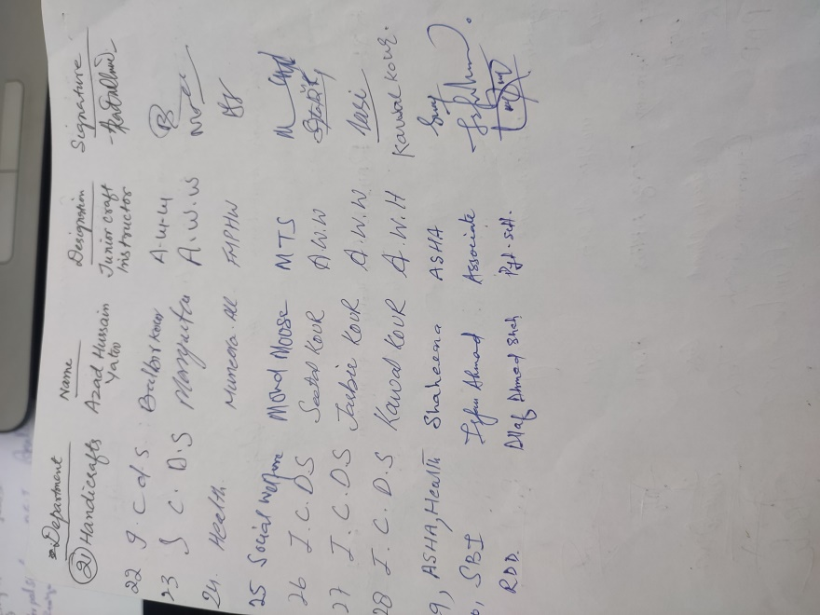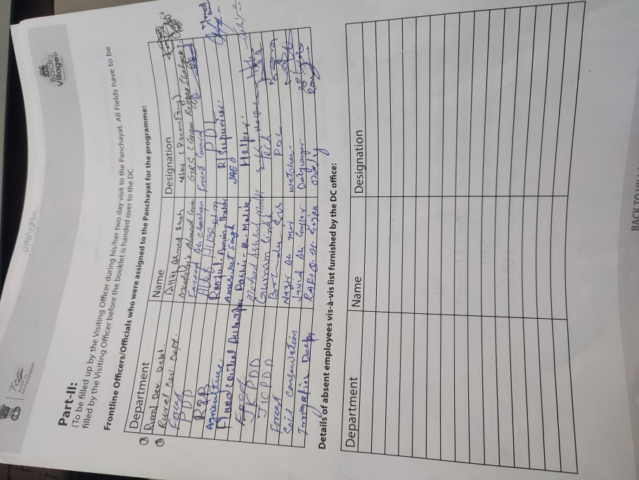

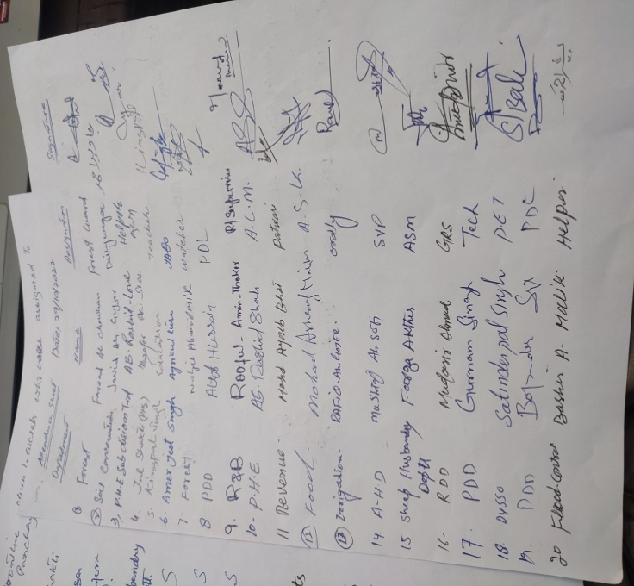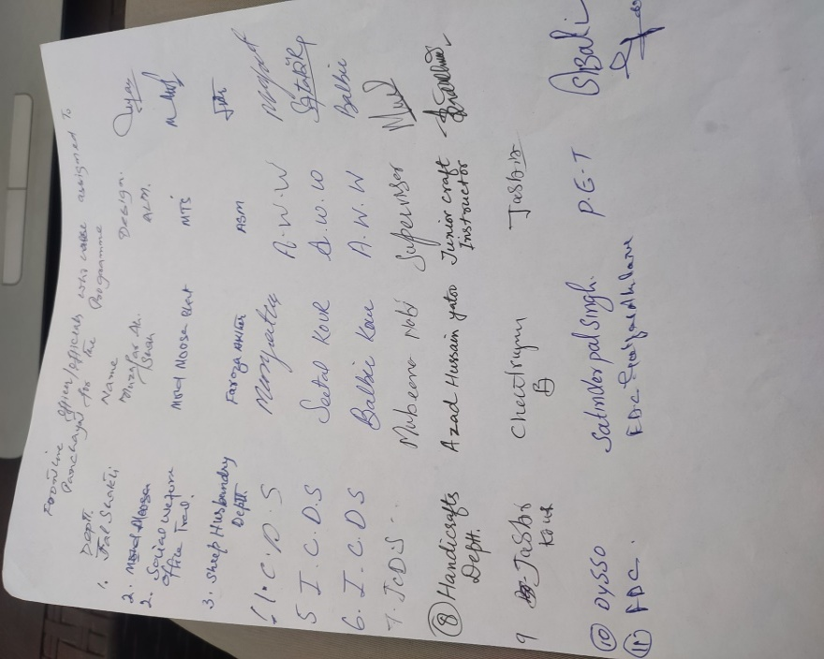

# DAY1-ACTIVITIES

## AGENDA1:PANCHAYATASSETREGISTER

### Infrastructure:

* 1. PanchayatGharInfrastructure
     1. Govtbuilding/private Private
     2. New/needingrepairs No
  2. Furniture(Y/N) No
  3. Computer/printer(Y/N) Yes
  4. Internet(Y/N) No
  5. Telephone(Y/N) No
  6. Toilet(CSC/partofpanchayatghar)(Y/N) No
  7. Water(Y/N) Yes
  8. Electricity(Y/N) Yes
  9. Bank branch (Y/N) No
  10. CSC(Y/N) No
  11. Patwarkhana(Y/N) NO
  12. Villagehaat(Y/N) Yes
  13. Playground(Y/N) Yes
  14. School-
      1. Kindergarten(Y/N) No
      2. Primary(Y/N) Yes 2no
      3. Middle School Yes 1no
      4. Secondary(Y/N) No
      5. College(Y/N) No
      6. University(Y/N) No
  15. AnganwadiCentre(Y/N) Yes 4no
      1. (govt/private) Private
      2. Totalchildrenenrolled 77 in 4 Anganwadis

1. AmritSarovars–details,location,condition No
2. Governmentoffices-details,whetherfunctionalornot All Govt offices functional
3. Rationshop(Y/N) Yes
4. Placesoftourismimportance–names,littledetailsonhistorical/culturalimportance No
5. Villageheritagesites/treks-names,littledetailsonhistorical/culturalimportance No
6. VLWOffice(Y/N) Yes
7. PrimaryHealthcareCentre(Y/N), Yes
8. ListofIncompleteBuildings-names,yearofconstruction No
9. ListofUnderutilizedBuildings-names NO

**DAY1-ACTIVITIES**

**AGENDA2:**

**DIFFERENTINSTITUTIONS/INFRASTRUCTUREPROJECTSTOBEVISITED**

|  |  |  |
| --- | --- | --- |
| **AMRITSAROVARS** | **Visit,verify** | **COMMENTS** |
| KhidmatCentres | Create/Generateawarenesson225schemes particularlyG2CschemsAapkiZaminAapkiNigrani, Beams,Janbhagidari,DigitalJ&K | NOT AVAILABE |
| JKB/PSBcounters/outlets | a)Statusofcounter b)Numberofvisitors | NOT AVAILABLE |
| Incompletebuildings/pro- jects | Verify whetheridentificationandredistribution done | NIL |
| PDS | Visit,evaluate,onlinestatus | VISITED AND FOUND FUNCTIONAL |
| PHC | Visit-evaluate,statusofstaff,equipmentand quality | VISITED AND FOUND UP TO DATE |
| Youthclubs | Meet,interact,seeksuggestions | INTERACTED |
| SHG | Meet,identifyproblems,seeksuggestions | NOT AVAILABLE |
| PMAY | Inspect,Inaugurate | INSPECTED |
| Myschool,mypride progress;schools-water, toilets,staff | Visit,checkforwater,electricity,sanitation,meet studentsandstaff | VISITED, CHECKED, SATISFIED |
| SwachhSBM | Evaluate | ACHIEVED AND ONGOING |
| Panchayatplayground, Sportskitsdistribution Villagegames | Ensure,verify.Participateinatleastonegamein theplayground | EXISTING, PARTICIPATED IN MANY GAMES |
| HarGaonHariyali, Planta- tiondrive | Evaluatestatus,feedback | INITIATED PLANTATION DRIVES |
| Villageculturalevent  Dangal/Haat/Mela | Participatein;ensurethatitisheld | RURAL HAAT INAGURATED AT GMS GROUND |
| Exhibitionofschemes | Ensurethateverydepartmentparticipatesand thatitcontinuesfortheentiredurationofB2V | EXHIBITION DONE ON PRIORITY |
| JalJeewanMission verifica- tion- WSS/JSD  Electricitysupply | Verify | 100% TAP WATER SATURATED. MAINTENANCE OF ELECTRICITY UNDER PROGRESS |

# DAY1-ACTIVITIES

**AGENDA 3: SATURATE JAN BHIYANDELIVERABLESANDRECORDDEFICIENCIESIFANY**

**(INSERTDELIVERABLESLISTHEREASPERGADFORMAT**

|  |  |  |  |  |  |  |
| --- | --- | --- | --- | --- | --- | --- |
| **S. No.** | **Deliverable** | **Department** | **Overall Target** | **District Target** | **Cumulative Achievements (15 Oct, 2022 - till today)** | **Today's Achievements** |
| 1 | **Golden Health Cards** | Health | 100,000 | Panchayat/District Targets to be fixed by the Department based on gap in figures of every Panchayat | 1210 | 84 |
| 2 | **Land Passbooks** | Revenue | 1,000,000 | Panchayat/District Targets to be fixed by the Department based on gap in figures of every Panchayat | Under Digitalization | Nil |
| 3 | **Inheritance Mutations** | Revenue | 7,000 | Panchayat/District Targets to be fixed by the Department based on survey of every Panchayat by the Patwaries | - | Nil |
| 4 | **Self Employment Drive** | J&K Bank & Industries | 65,000 | At least 15 persons per Panchayat | Under Process | Nil |
| 5 | **Identify candidates for skill training under HIMAYAT and other schemes** | RDD | 100,000 | At least 20 per Panchayat | 20 | Nil |
| 6 | **CSC/IT Camps in every Panchayat** | IT | 4290 | One per Panchayat | Nil | Nil |
| 7 | **Creating Awareness of Jan Bhagidari among PRIs and general public** | IT | 100,000 | 25 additional hits/Panchayat | Nil | Nil |
| 8 | **Painting of Digital J&K in every Panchayat** | RDD | 4290 | One per Panchayat | Achieved | - |
| 9 | ***PaniSamitis* meetings to be held** | Jal Shakti | 4290 | One per Panchayat | Achieved | - |
| 10 | **Field testing kits to be provided for all Panchayats and trainings given** | Jal Shakti | 4290 | One per Panchayat | Nil | Nil |
| 11 | **Certification of water sufficiency and quality of Panchayats** | Jal Shakti | 451 | As per list decided by Department | 251 | Acheived |
| 12 | **Implement Swachh Gram Plans ·       Door to door collection and disposal- ensure ·       Management of grey water, black water and solid waste** | RDD | 6,870 | To be implemented in every Village | 260 IHHL 100 % Achievements   260 Soakage pits | -    25 % Achievements |
| 13 | **UDID Cards to be converted to Digital Format** | Social Welfare | 250,000 | Panchayat/District Targets to be fixed by the Department based on existing cards | 700 | - |
| 14 | **E-shram Cards** | Labour | 250,000 | Panchayat/District Targets to be fixed by the Department based on survey | 200 | Nil |
| 15 | **Inspect Playfields and ensure that at least one sports event is held** | YSS | 4290 | At least one per Panchayat | Achieved | Conducted Soprts event |
| 16 | **Inspect office of Patwari, VLW and ensure that name and phone number of the Patwari/VLW is painted on the wall of the office** | Revenue, RDD | 8580 | 2 per Panchayat ( 1 patwari office + 1 VLW office) | VLW Office Existing | Inspection Conducted |
| 17 | **AmritSarovars- Inspect quality** | RDD | 1,500 | 75 per District | Nil | Nil |
| 18 | **Youth Clubs Interact** | Youth Mission | 4290 | At least one per Panchayat | - | Interacted With Youth Club Members |
| 19 | **AzadiKaAmritMahotsav- Upload High Quality videos** | Culture & DCs | 15,000 | At least 3 per Panchayat | Achieved | Inspected |
| 20 | **Hold Gram Sabha meetings and assess quality and effectiveness of service delivery, performance and ranking of departments and perception of corruption** | All visiting Officers | 4,290 | Every Panchayat | Achieved | Inspected/Achieved |

# DAY1-ACTIVITIES

## AGENDA4:

**SELFEMPLOYMENTACTIVITIES**

EnsureSelf-employmentactivitiesforyouth,distributeemploymentlettersforpeopleselectedundervarioussocialschemes(15ISTHETARGETPERPANCHAYAT)

**Numberofcasesindifferentcategoriessanctioned: NOT AVAILABLE**

**Detailsofthebanksanctioningit:**

**Totalamountinvolved:**

# DAY1ACTIVITIES

## AGENDA5

Intheevening,holdinformalmeetingswithseniorcitizens,govtemployees,retdemployees,youthclubandothercitizenswhoareenrolledoncollege/universityandhavediscussiononGandhiKatha,NashaMuktAbhiyan,corruptionfreegovernance,doublingfarmersincomeandrecordtheproceedings

## DAY2

1. NoofIndividualCompostPitsconstructed Nil
2. NoofIndividualSoakPitsconstructed 50
3. No.ofBiodiversitymanagementcommitteemeetingsheld: 3
4. IsthenameofSarpanchdisplayedoncitizeninformationboardsofallRD&PRschemes:Yes/No No
5. AreSarpanchsbeinginvolvedinstart/inaugurationofactivities:Yes/No Yes
6. WhethersubjectshavebeenassignedbytheSarpanchtothePanchs:Yes/No Yes
7. Whethergrievancesredressalboxisinstalled:Yes/No YES
8. NoofgrievancesreceivedpertainingtoPanchayatlevel: 16
9. NoofgrievancesdisposedofatPanchayatlevel: 11
10. WhethertheSarpanch/PanchayatSecretaryhavedigitalsignatures:Yes/No Yes
11. WhetherallMGNREGA/14thFCpaymentsarebeingmadebySarpanchthroughDigitalSignatureCertificate(DSC):Yes/No Yes

**HUMAN RESOURCEAVAILABLEATTHEPANCHAYAT LEVEL:**

|  |  |  |  |  |
| --- | --- | --- | --- | --- |
| **SRNO.** | **DEPARTMENTWISESTAFF** | **NUMBERS** | | **NAMES** |
|  |  | SANCTIONED | ACTUAL |  |
|  | Ruraldevelopmentdepartment: BDO  Panchayat secretary  JE GRS TA | 1  1  1  1 | 1  1  1  1 | SHAFIQ AH WANI  ALTF AHMAD SHAH  GH AASAN SHAIDE  MUDASIR AHMAD LONE  AADIL MANZOOR |
|  | SCHOOLEDUCATION: TEACHER  HEADMASTER ANYOTHER | 6  1 | 6  1 |  |
|  | JAL JEEVAN:  ASSTT. LINE MAN  HELPER | 1 | 1  2 | MUZAFFAR AH SHAH  AB RASHEED LONE & AB RASHEED SHAH |
|  | PDD: LINEMAN JE  ANYOTHER |  | 2  1 | NAZIR AHMAD BHAT & ALI MOHD BABA  HARBINDER SINGH (JE) |
|  | FOOD&CIVILSUPPLIES | 1 | 1 | MOHD ASHRAF MALIK |
|  | AGRICULTURE&ANIMALHUS- BANDARY | 1 | 1 | MUSHTAQ AHMAD SOFI |
|  | SOCIALWELFARE |  |  |  |
|  | HEALTH: ASHA ANM  AYUSHDOCTOR ALLOPATHICDOCTOR | 2  1  1  0 | 2  1  1  0 | SHAHEENA AKHTER & GUDDY KOUR  MUNEERA AKHTER  DR. SARWAR IQBAL |
|  | ANYOTHERDEPARTMENT |  |  |  |

# DAY2-ACTIVITIES

## AGENDANO.1

DiscussionontheandassesstheprogressofdifferentschemesrelatingtothelocalizedSDGsprior-itizedforthatvillageaspertheresolutionpassedbythatGramPanchayaton21stApril22,onNationalPanchayatiRajDay(Copyoftheresolutiontobetakenfrom[www.jkpanchayat.in](http://www.jkpanchayat.in/)portalunderthelinkofGramSwarajMonth)

* 1. SDGsAGREEDFORTHATVILLAGE,TOBEIMPLEMENTEDBYMARCH2024:
  2. STATUSOFWORKSUNDERTHEFOLLOWINGSCHEMES:

### Cleanandgreenvillage

1. InitiativestakenbythePanchayatformanagingSolidandLiquidWasteyes
2. InitiativestakenbythePanchayatforusinggreensourcesoffuellikesolar,biogas

No

1. Hasmappingoflanduse,waterbodies,forest,slopes,wetlands,degradedforestwithintheGramPanchayatbeendone?Yes/No.IfNo,reason,thereof YES
2. HastheClimateResiliencePlanbeendevelopedfortheGP?Yes/No YES
3. StepstakenbytheGramSabhaabouttheclimatechangemitigationfactorslikereducingenergyconsumption,usageoffossilfuels,plastics,non-renewablebuildingmaterialsandalsotopromotemeasureslikeplantingoftrees,conservingforests,usageofgoodagriculturalpracticeslikedripirrigation,waterconservationmeasuresandconservationofwetlands. YES
4. Whetherschoolshavestartedsegregatingwaste YES
5. Whetherschoolshavetheirowncompost/soakagepitsforsolid/liquidwastemanagement YES

### Healthyvillage

1. Aremeetingsrelatedto VillageHealthandSanitationCommitteebeingheldregularly? Yes
2. DoalltheeligibleindividualsbeenprovidedtheGoldenCard? YES
3. ArealltheChildrenbeingimmunizedaspertheSchedulerecommendedbyGovt.ofIndia? YES
4. ArealltheeligibleindividualsbeenvaccinatedagainstCOVID-19? YES
5. DoesGramPanchayatensurethatallpregnantwomenaregettingnecessaryprenatalcheckups? YES
6. WhetherallthedeliverieswereInstitutionalizedorconductedbytrainedMidwives? INSTITUTIONALIZED

### Watersufficient village

1. DoalltheIHHsintheGramPanchayathavewaterpipelineconnections? Yes
2. WhetherGramPanchayathastakenstepsforgreywatermanagement.IfYespleasespecify Yes initiated Construction of soakage pits to every IHH
3. DoalltheIHHsintheGramPanchayathavetoilets? Yes
4. ArealltheIHHstoiletsfunctionalornot? Yes
5. DoalltheSchools/Anganwadicentershaveatoiletfacilityornot? Yes
6. Areallthetoiletsintheschools/Aaganwadifunctionalornot? Yes
7. WhetherGramPachachayatBhawanhasseparatetoiletsforwomenornot? No

### ChildFriendlyvillage

1. Doallthechildrenundertheageof0-6yearsbeenenrolledintheAnganwadicentersforpre-schooling?Yes/NO Yes
2. HowmanyBalSabha’swereorganizedintheGramPanchayat-------03 No------------
3. WhethertheissuesraisedbyBalSabhaareaddressedduringtheGramSabha.Yes/NO Yes
4. WhetherGramPanchayatistrackingthedatarelatedtodropoutchildrenandchildrenwithirregularattendance?Yes/NO. Yes
5. DoalltheschoolsundertheGramPanchayathaveseparatetoiletsforgirlsandboys?Yes/No Yes

### Villagewithgoodgovernance

1. IsCSClocatedintheGramPanchayatBhawanornot? No
2. IsthelistofbeneficiariesrelatedtotheSchemes/ProgramsdisplayedontheGrampanchayatwallornot? Yes
3. DoestheGramPanchayathasitsbuildingornot? Not
4. IstheGramPanchayatofficefunctionalornot? Yes
5. AretheactivitiesapprovedundertheHalqaPanchayatDevelopmentPlandisplayedontheGramPanchayatwallornot? Yes
6. IsSocialAuditofearlierSchemes/Programscarriedoutornot? Yes

### Povertyfreeandenhancedlivelihoodvillage

1. HasGramPanchayatdevelopedanycriteriafortheidentificationofthepoor?Yes/Noifyesspecify Yes, the Gram Panchayat fallows the directions and guidelines issued by Government time to time.
2. HavealltheeligiblehouseholdsregisteredinPDSornot? Yes
3. HasGramPanchayatprovidedspaceforSelf-helpGroupsinPanchyatGharforholdingmeetingsornot? Yes
4. HavealltheeligiblehouseholdsbeenregisteredforPensionornot? Yes
5. HasGramPanchayatfacilitatedYouthforSkillEnhancementCoursesandPlacement? Yes
6. HasJobCardsbeendistributedtoalltheeligibleindividualsunderMGNREGA? Yes
7. HasGramPanchayatfacilitatedSHGsforBankAccountLinkages? No SHG till date

### Sociallysecuredvillage

1. WhetherGramPanchayatismaintainingdatarelatedtoDifferentlyAbledPeople? Yes
2. IsGramPanchayatOfficeDisabledFriendlyornot? Yes
3. AreprovisionsforaseparateBudgetundertheResourceEnvelopeforWomenandChildrenmadeornot? Yes
4. Do all the Schools in the Gram Panchayat have facilities for Differently Abled Children like toilets,barrier-freeaccess,etc.,ornot? Yes
5. Arealltheeligibleindividualsaregettingpensions,likeoldagepension,widowpension,etc? Yes
6. ArealltheeligiblehouseholdsgettingbenefitsfromIAYornot? Yes

### EngenderedDevelopmentinVillage

1. HowmanyMahilaSabha’swereorganizedintheGramPanchayat-------03------------
2. WhetherSHGsfederationshavebeenprovidedspaceformeetingsinthePanchayatBhawan(Yes/No) Yes
3. WhetherGPshavetakenstepsforincreasingwomen’sparticipationinGramSabha(Yes/No) Yes
4. NumberofwomenbeneficiariesheadedhouseholdscoveredunderPDSsystem 24
5. Number of beneficiaries (out of total eligible population) receiving social protection benefits under PradhanMantriMatritvaVandanaYojana…………………. YES
6. Self-sufficientinfrastructureinthevillage
7. Whether GP has a Community Hall with access to electricity, furniture, water supply,toilet…………………No…….
8. WhethertheDisastermanagementplanisavailableattheGPLevel(Yes/No) Yes
9. Whetherchild-friendlyparkwithrequiredfacilitiesisavailableinGP(Yes/No) No
10. WhethertheGPhaseasyaccesstoGodownforstorage(Yes/No) No
11. Whetherstreetlightsareprovidedinpublicplacesforensuringsafety(Yes/No) Yes

# DAY2ACTIVITIES

## AGENDANO.2

SensitizevillageresidentsaboutmyScheme”portal(myscheme.in)whichincludesinformationaboutalltheschemesbeingrunbyCentral/State/UTgovtacrossthecountry

*(SchemeMaterialavailablefromhttps://jkpanchayat.in/b2v4.php)*

# DAY2ACTIVITIES

## AGENDANO.3

HoldmeetingoftheBiodiversityManagementCommitteestodeliberateonissuespertainingtoconserva-tion of biodiversity and sustainable utilization of biological resources. He should check People Biodiversityregister(PBR)ofthatpanchayatandreviewifBiodiversityManagementCommitteeconstitutedforthatpanchayat is holding minimum 4 meetings in a year and meeting once in every 3 months *(Role of BMCavailableathttps://jkpanchayat.in/b2v4.php)*

COMMITTEEMEMBERS

PRESENT

BIODIVERSITYREGISTERPHOTOS

PAST4MEETINGDETAILS-DATES, MINUTESPHOTOS

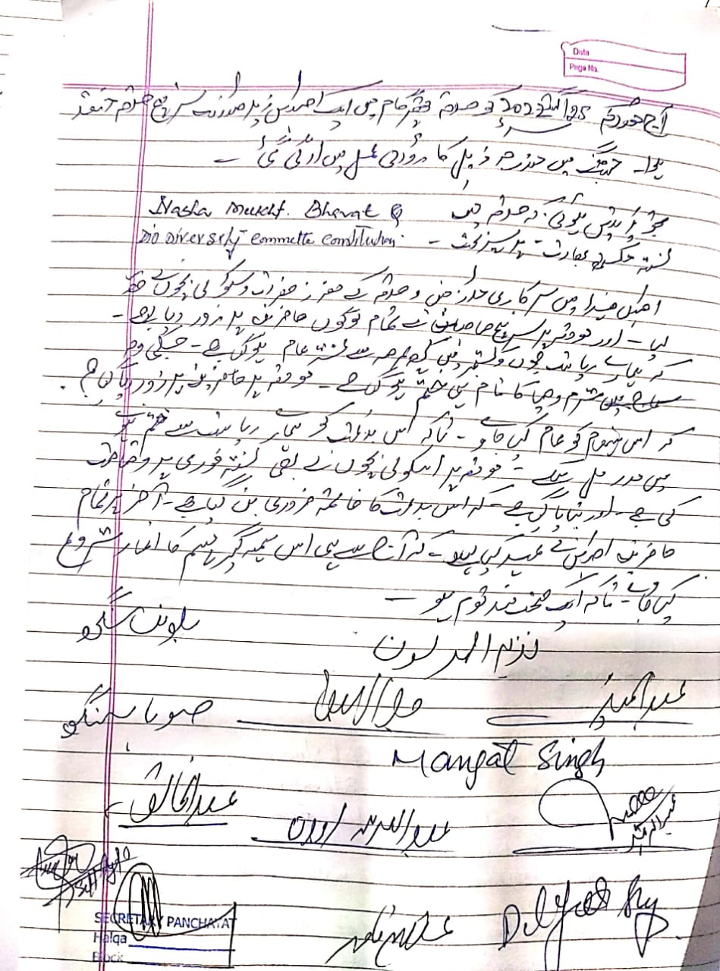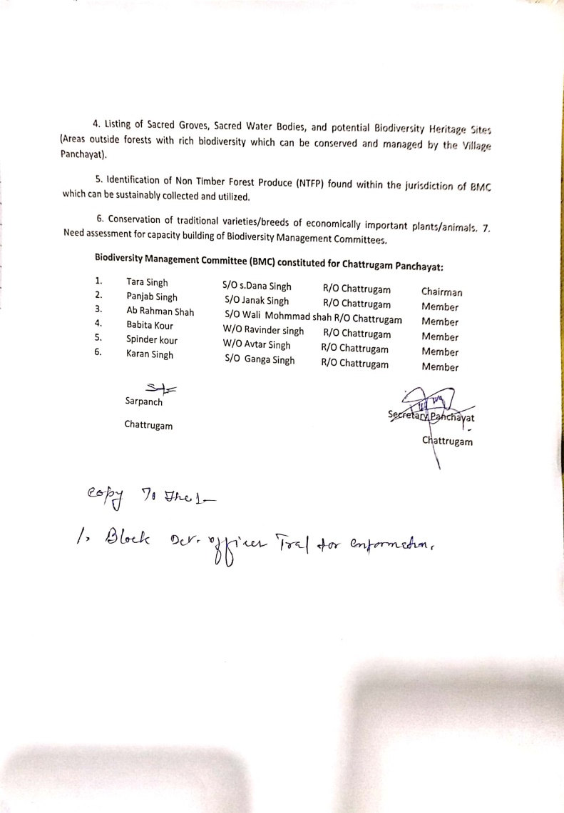

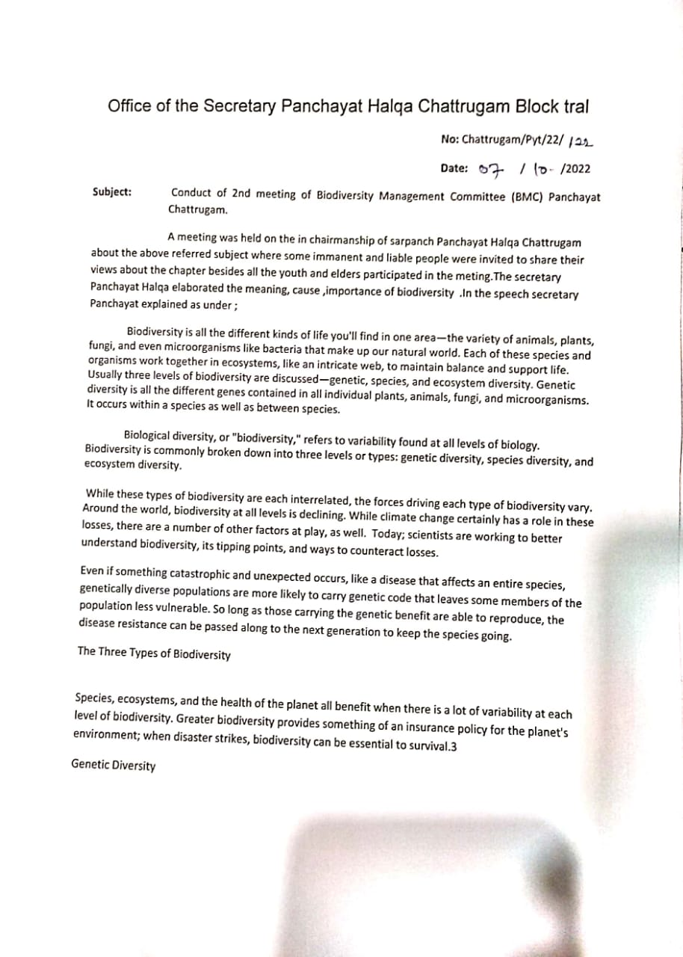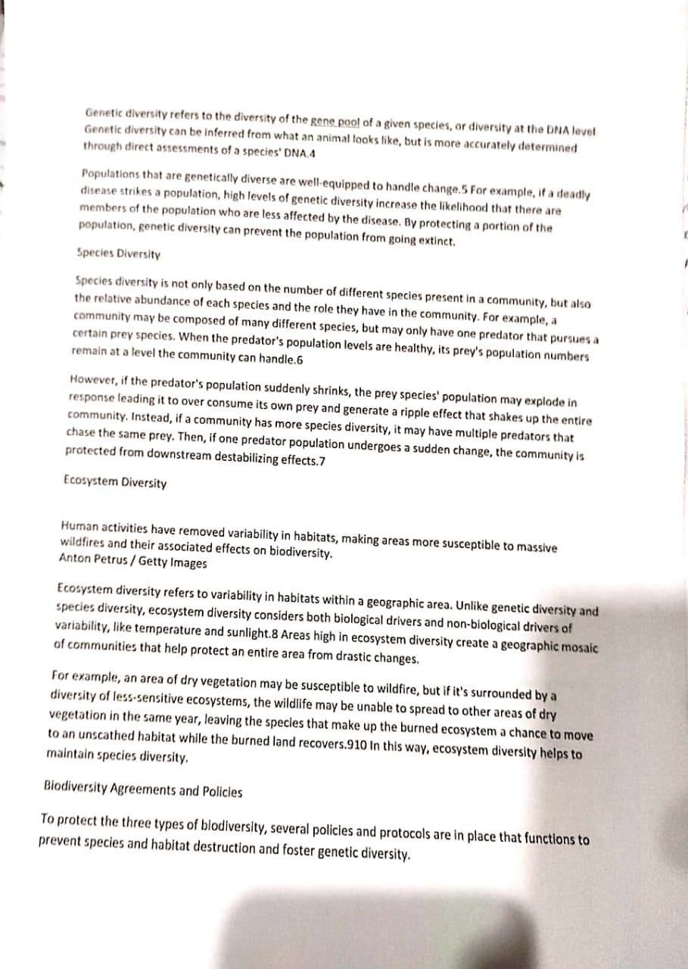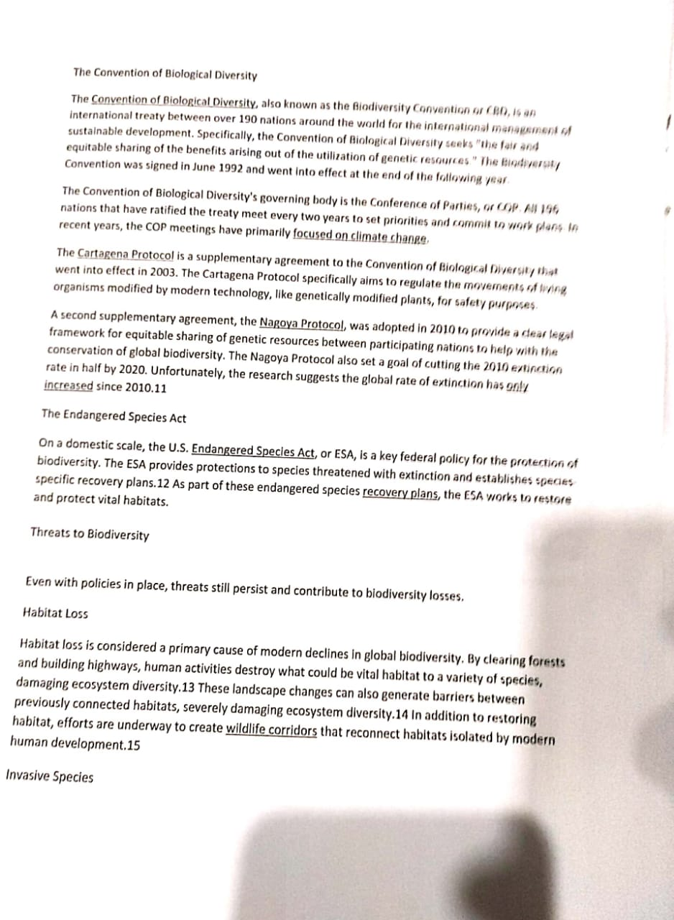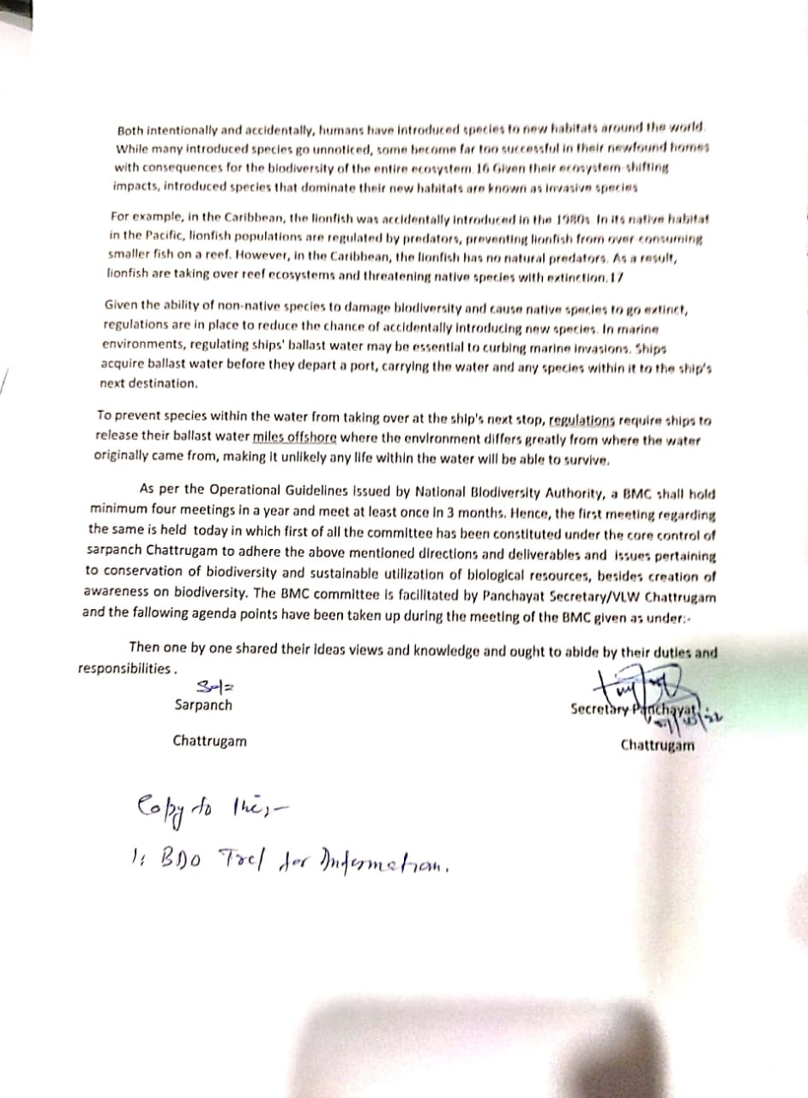

|  |  |
| --- | --- |
|  | **2023-24** |
|  | GPDP OF PANCHAYAT CHATTRUGAM  BLOCK TRAL |

|  |
| --- |
| **Rural development Department UT of J&K Block Tral District Pulwama** |
|  |



**RURAL DEVELOPMENT DEPARTMENT UT OF J&K**

**GramPanchayatDevelopmentPlan HalqaChattrugam**

**Block Tral District Pulwama**

**GRAM PanchayatDevelopmentPlan(BPDP)ForthePeriodof2021-2022**

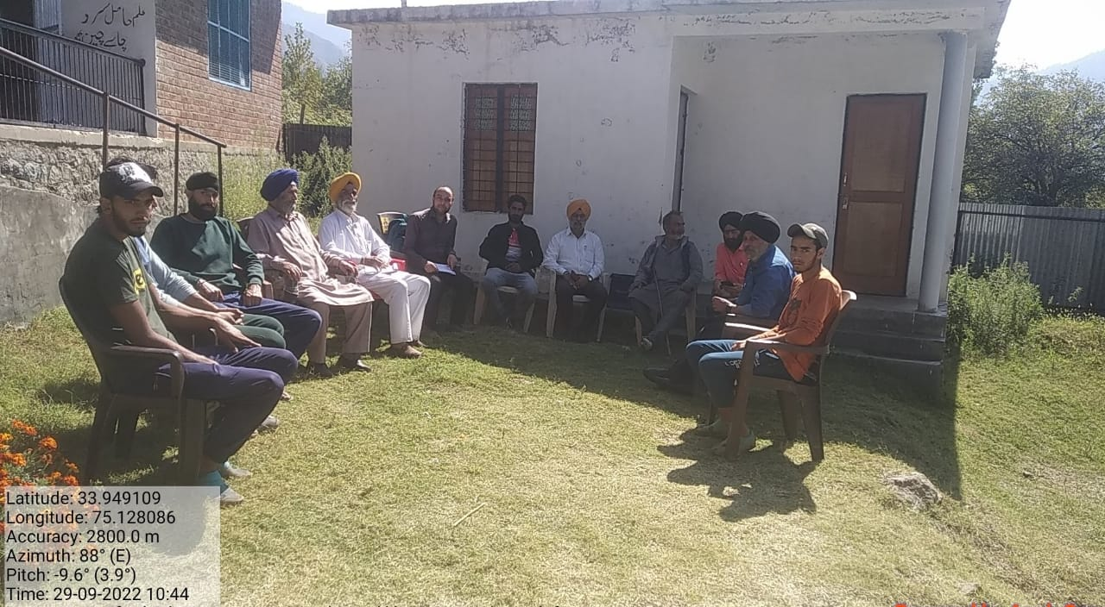

**Photograph of Gram Sabha held at Halqa PanchayatCHATTRUGAM**

Introduction

Preparation of Gram Panchayat Development Plan by Panchayat of the Constitution of IndiamandatestheIntermediatePanchayattopreparetheGram PanchayatDevelopmentPlan(GPDP)foreconomicdevelopmentandsocialjusticebyconvergingandintegratingallsuchprogrammes/schemesofthePanchayat,StateandCentretobeimplementedintheirgeographicalarea.Further,aslocalgovernment,theIntermediate Panchayat are also responsible for ensuring delivery of basic servicestolocalcitizensandaddressingvulnerabilitiesofthepoorandmarginalizedsectionsofthepopulationintheirarea.Thiscanonlybeachievedthroughimplementationofacomprehensiveplanthroughefficientandresponsibleutilizationofavailableresourcesand expandingtheresources tocatertotheirneeds. Further, it has to be ensured that there should not be duplication of theirworkswiththoseundertaken/tobeundertakenbytheGramPanchayatandDistrict Panchayat and line departments in their respective area. Over the last twoandhalfdecades,severalinitiativeshavebeentakenbytheStateandCentralGovernmentstoencourageparticipatoryplanningprocessattheleveloftheIntermediatePanchayat.However,variouschallengessuchasinadequateresources, low people’s participation, low capacity etc. have hindered the pace offormulationofcomprehensiveandvisionary PanchayatDevelopmentPlan(PDP).

However,theplanningofthePDPwouldgetboostwithproactivedrivebytheGovernmentofIndiaandtheStateGovernmentsthroughthegrantsrecommendedbyFifteenthFinanceCommission.Therefore,timehascometopreparetheGPDPinacomprehensivemannerwithincorporationofequityandinclusiveness.ThepreparationoftheBlockDevelopmentPlanisa time-bound process. It is part ofchainofplanstobepreparedincascadingmode.Itshouldbeprepared aftercompletion of Gram Panchayat Development Plans (GPDPs) by Gram Panchayatsintheir respective area. However, the Intermediate Panchayat should not wait till thecompletionofallGPDPsintheirarea.

They should provide the building blocks for the District Development Plan. ThePanchayatDevelopmentPlanshouldideallycatertopeople’sneeds,providebasicservicesandmeettheiraspirationswithoptimalutilizationoftheavailableresources. It should be prepared through a participatory, inclusive and transparentprocess. The plan should be long-term (perspective plan) in nature (ideally for fiveyears) and operational plan, which is implementable in a year, based on prioritiesarrived at Panchayat Sabah. The Intermediate Panchayat with their moderate status intermsofmanpower,infrastructureandinstitutionalcapacitycanplanforandimplementmediumtypesofactivitieswhicharepossibleontheirparttoimplementandmonitor.Besides,itmaybenecessaryonthepartofeachIntermediatePanchayat to plan for and implement those plan activities which territorially covertwo or more GPs because, in such cases, the Intermediate Panchayat would be in abetterpositiontotakechargeofsuchactivities.OnlyinanexceptionalsituationtheymayundertakeoneparticularPanchayat.

**Data CollectionPrimaryData**

Thedatacollecteddirectlyfromtherespondents:

* 1. ParticipatoryRuralAppraisal(SocialMap,NaturalresourceMap,TransectWalk)
  2. FocusGroupDiscussions
  3. HouseholdSurvey

1. **SecondaryData**

Thedataalreadycollectedandavailablefromtherecords/reports:

* 1. SocioEconomicandCastCensusdata2011(SECC)
  2. Line departmentdata(Agricultural/Educational/Housing/Health)
  3. MissionAntyodayaSurveyData
  4. Datafromindependentstudies/reports
  5. BasicprofileoftheGramPanchayat
  6. GPleveldemographydata
  7. GPlevelexistinginfrastructure
  8. PHC/sub-centreleveldata
  9. Public DistributionSystem(PDS)data
  10. DatainAnganwadis
  11. DatainPrimarySchool
  12. SHG/SHGfederationdataetc.
  13. SBMsurveydata.

**SituationAnalysisforIdentifiedProblemsandDevelopmentalOptions:**

|  |  |  |  |
| --- | --- | --- | --- |
| **Sl.**  **No.** | **ProblemIdentified** | **SituationAnalyzed** | **PossibleDevelopmentOptions** |
| 1 | Poorsanitationinpublicplaces | 1. Poordrainagefacility 2. Community toiletsdefunctduetolackofmaintenance 3. Openexcretion 4. Lackofawarenessabouthygiene practices 5. VHSCnotconstituted | 1. Construction of new drainageline 2. Constructionofimprovedcommunitytoilets 3. Creating awareness onconsequences of open defecationandpoorhygienicpractices. 4. Activating Village Health and   SanitationCommittee |
| 2 | Low CropProductivity | 1. Lackofawarenessabouthighbreedvarieties. 2. Poor adoption ofmodern agriculturetechnologies 3. Poorcropprotectionmeasures | 1. Creating awareness on improvedagriculturalpractices. 2. Introductionofhighbreedvarietiesofcereals,pulsesandvegetables. 3. Exposurevisitstoimprovedagri   -farms/KrishiVigyanKendra.   1. Periodicalinteractionwithagriculture department about thesepractices |
| 3 | Malnutritionin SC  children | 1. Lack of balanced diet topregnantwomenandchildren. 2. Poorlivelihoodsleadingpoor expenditurepatternonnutritionalfood 3. Nopractices of kitchen   gardening | 1. Creatingawarenessaboutneedofbalanceddietaryfood. 2. VHSCtobestrengthened. 3. Encourage kitchen garden assourceofnutritionalvegetables   /fruits. |
| 4 | Lack of  QualityEducation | 1. Lackofqualityteachingmethodsandmaterials. 2. No monitoring of   teachers by villageeducationcommittee | 1. SMC to be strengthened tomonitorqualityofteaching. 2. Supplyofteachingaids 3. Newequipmenttobeprocuredforsciencelaboratory. |

**1.Panchayat**

* + 1. **BasicDetailsof Gram PanchayatChattrugam**

|  |  |  |
| --- | --- | --- |
| **Sl.No.** | **Particulars** | **Details** |
| 1 | NameofPanchayat | Chattrugam |
| 2 | NameofBlock | Tral |
| 3 | NameofDistrict | Pulwama |
| 4 | NameofState | U T of J&K |
| 5 | NearestPoliceStation withContactNo. | Tral 1933250240 |
| 6 | NearestTehsiloffice | Tral |
| 7 | Postoffice | Chattrugam |
| 8 | PinCode | 192123 |
| 9 | LokSabah Constituency | Anantnag |
| 10 | AssemblySeats | Tral |
| 12 | NumberofVillageCommittees | 4 |
| 13 | Numberof Panchayat Constituencies | 7 |
| 15 | TotalareaofPanchayat (km2) | 6 km2 |
| 16 | TotalElectorsofthePanchayat | 700 |
| 17 | NumberofRationCards | 260 |
| 18 | NumberofHouseHold | 260 |
| 19 | TotalPopulation | 1300 |
| 20 | NumberofMale | 700 |
| 21 | Numberof Female | 600 |
| 22 | Temperature(Max/Min) | -2⁰ to 30⁰ |
| 23 | AverageRain fallin 2020 | 40mm |

* + 1. **DetailsofelectedRepresentatives**

|  |  |  |  |  |  |
| --- | --- | --- | --- | --- | --- |
| **Sl.**  **No** | **Name of**  **ERs** | **Designation** | **Caste** | **Gender** | **Contact**  **No** |
|  | Tara singh | Sarpanch | Sikh | Male | 9906624909 |
|  | Hakoomat Singh | Panch | Sikh | Male | 9906636084 |
|  | AjeetKour | Panch | Sikh | Female | 9797535784 |
|  | Amlok Singh | Panch | Sikh | Male | 9906431613 |
|  | Soba Singh | Panch | Sikh | Male | 9906153529 |
|  | Balwant Singh | Panch | Sikh | Male | 9541210487 |
|  | Rajindra Singh | Panch | Sikh | Male | 9697957808 |
|  | GurvinderKour | Panch | Sikh | Female | 7051585634 |

* + 1. **DemographyofPS/BAC**

|  |  |  |  |  |  |
| --- | --- | --- | --- | --- | --- |
| **Sl.No** | **Particulars** | **TotalHHs** | **Totalpopulation** | **Male** | **Female** |
| 1 | TotalHHs | 260 | 1300 | 700 | 600 |
| 2 | OBCHHs | 260 | 1300 | 700 | 600 |
| 3 | SCHHs | 0 | 0 | 0 | 0 |
| 4 | STHHs | 9 | 54 | 29 | 25 |
| 5 | Minority HHs | 230 | 1246 | 470 | 450 |
| **Total** |  |  |  |  |  |

**SocioEconomic(RationCard)details**

|  |  |  |
| --- | --- | --- |
| **Sl.No** | **Economicstatus** | **Nooffamily** |
| 1 | APL | 186 |
| 2 | BPL | 59 |
| 3 | Annapurna | - |
| 4 | Antyodaya | 15 |
| **Total** | | 260 |

* + 1. **Landdetails**

|  |  |  |
| --- | --- | --- |
| **Sl.No** | **Particular** | **Area** |
| 1 | CropLand | 250 hector |
| 2 | Plantation | 18.75 hector |
| 3 | Forest | 1.25 hector |
| 4 | Lakes | 0 |
| 5 | Ponds | 0 |
| 7 | Reservoir/tanks | 0 |
| 8 | River/Stream/Drain | 0/2/25 |

* + 1. **Economicactivity wisepopulation details**

|  |  |  |  |  |
| --- | --- | --- | --- | --- |
| **Sl.No** | **Category** | **Total** | **Male** | **Female** |
| 1 | GovernmentEmployee | 134 | 124 | 10 |
| 2 | PrivatesectorEmployee | 21 | 21 | 0 |
| 3 | Self-Employee | 9 | 8 | 1 |
| 4 | AgriculturalFarmer | 371 | 221 | 100 |
| 5 | Horticultural Farmer | 52 | 30 | 22 |
| 6 | Commercialfarmer(Apple) |  |  |  |
| 7 | Fishery | 0 | 0 | 0 |
| 8 | Fisherman | 0 | 0 | 0 |
| 9 | Meson | 6 | 6 | 0 |
| 10 | Potter | 0 | 0 | 0 |
| 11 | Cobbler | 0 | 0 | 0 |
| 12 | Houseservant | 0 | 0 | 0 |
| 13 | ConstructionLabour | 22 | 22 | 0 |
| 14 | Carpenter | 0 | 0 | 0 |
| 15 | WageLabour | 185 | 130 | 55 |
| 16 | Servant | 0 | 0 | 0 |
| 17 | HouseholdIndustry | 0 | 0 | 0 |
| 18 | Electrician | 3 | 3 | 0 |
| 19 | Plumber | 0 | 0 | 0 |
| 20 | SkillLabour | 6 | 6 | 0 |
| 21 | DailyLabour | 18 | 15 | 3 |
| 22 | Beggar | 0 | 0 | 0 |
| 23 | Other | 12 | 8 | 4 |
|  |  |  |  |  |
| **Total** | |  |  |  |

* + 1. **AmenitiesDetails**

|  |  |  |  |  |  |
| --- | --- | --- | --- | --- | --- |
| **Sl.No** | **InfrastructureFacilities**  **/Services** | **Locatedwithin thePS/BACYes(Y)/**  **No(N)** | **No.** | **If locatedelsewhere (N),distancefromthePS/BAC**  **Office** | **No.** |
| 1 | ANM/HealthSubCentre | Yes | 1 |  |  |
| 2 | Nearest Primary Health  Centre(PHC) | No | - | tral3 km | 1 |
| 3 | Nearest Community  HealthCentre(CHC) | Chattrugam CHC | - | - | - |
| 4 | Nearest Post Office with  Pincode | Chattrugam | - | - | - |
| 5 | Nearest Bank Branch  (Any) | no | - | 3 km | 1 |
| 6 | NearestBank with CBS  Facility | no | - | 3 km | 1 |
| 7 | NearestATM | no |  | 3 km | 1 |
| 8 | NearestPrimarySchool | Yes | 2 | - | - |
| 9 | NearestMSSchool | Yes | 1 | - | - |
| 10 | NearestSecondarySchool | No | - | 3 km | 2 |
| 11 | NearestHigherSecondary  School | No | - | 3 km | 2 |
| 12 | NearestDegreeCollege | No |  | 3 km | - |
| 13 | Nearest ITI /  NIT/TIT/PolytechnicCentre | no | - | No | - |
| 14 | KisanSevaKendra | No | - | - | - |
| 15 | NearestAWC | Yes | 4 | - | - |
| 16 | Nearest electriccallcentre | No | - | - | - |
| 17 | Agriculture Credit  CooperativeSociety | No | - | - | - |
| 18 | AgriRegulatedMarket(s) | No | - | - | - |
| 19 | KCC(KrishanCreditCard) | Yes | - | - | - |
| 20 | LAMPS/PACS |  | - | - | - |
| 21 | Nearest Agro Service  Centre | No | - | - | - |
| 22 | MSP based Government  ProcurementCentre | No | - | - | - |
| 23 | Milk Cooperative  /CollectionCentre | No | - | - | - |
| 24 | VeterinaryCareCentre | Yes | 1 | - | - |
| 25 | Ayurvedic  Centre/Homeo/Ayush | No | - | - | - |
| 26 | E-SevaKendra | No | - | - | - |
| 27 | BusStop | No | - | - | - |
| 28 | RailwayStation | No | - | - | - |
| 29 | Library | No | - | - | - |

|  |  |  |  |  |  |
| --- | --- | --- | --- | --- | --- |
| **Sl.No** | **InfrastructureFacilities**  **/Services** | **Locatedwithin thePanchayat Yes/**  **No** | **No.** | **If locatedelsewhere,distancefromthe Panchayat**  **Office** | **No.** |
| 30 | CommonServiceCentre | No |  | Tral 3km | 1 |
| 31 | FamilycounselingCentre | No |  | Tral 3km | 1 |
| 32 | Nearest shelter during  Disaster | No |  | No | - |

* + 1. **Infrastructureandotherdetails**

|  |  |  |
| --- | --- | --- |
| **SL.No** | **Particulars** | **Total** |
| 1 | TotalMGNREGAJobCard | 246 ACTIVE 185 |
| 2 | NumberofHHsusingLPG | 260 |
| 3 | NumberofHHshavingelectricconnection | 260 |
| 4 | NumberofHHsusingLEDbulbs | 260 |
| 5 | ActiveSHGs | 0 |
| 6 | Domestictappedwaterconnection | 260 |
| 7 | Totallengthofirrigationcannel | 6 km |
| 10 | NumberofAWC | 4 |
| 11 | Numberofpersonsreceiving oldage pension | Not available |
| 12 | Numberofpersonsreceivingwidowpension | Not available |
| 13 | Numberof personsreceivingdisabilitypension | Not available |
| 14 | NumberofactiveSHGs | 0 |
| 15 | NumberofwomeninvolvedSHG | 0 |
| 16 | Totalpersonattendskilldevelopmentprogramme | 10 |
| 17 | Totallengthof GPRoad(km) | 3 km |
| 18 | TotallengthofBlacktopRoad | 3 km |
| 19 | TotallengthofBrickRoad | 0 km |
| 20 | TotallengthofCCRoad | 0 km |
| 21 | Totallengthofdrain | 6 km |
| 22 | TotalCulverts | 8 |

* + 1. **FormationofIntermediatePanchayatPlanningCommittee**

|  |  |  |  |  |
| --- | --- | --- | --- | --- |
| **Sl.**  **No.** | **NameoftheTeam**  **Member** | **Designation** | **ContactNo.** | **Department** |
| 1. 8 | Altaf Ahmad Shah | Panchayat secretary | 7006781453 | RDD(Panchayat) |
| 1. 9 | Ajaz Ahmad Shah  Gowhar Ahmad dar | Field officer | Unavailable  9797843509 | Agriculture |
| 1. 10 | Sartaj Ahmad Bhat |  | 9797980231 | Horticulture |
| 1. 11 | - | - | - | Fisheries |
| 1. 12 | GulamQadir |  | 8493069902 | Social forestry |
| 1. 13 | MuneeraAkhter  ShahenaAkthar  GuddyKour | Asha worker  Asha worker  Asha worker | 9541775253  9797779833  8082315472 | Health |
| 1. 14 | Fareed Ahmad Chohwan |  | 9596429533 | Forest |
| 1. 15 | Mohd Ashraf Zargar |  | 8899048138 | Jal Shakti |
| 1. 16 | Shakeel Ahmad | GhatMunshi | 9797243012 | Food&CivilSupply |
| 1. 17 | S Dilgeet Singh | Teacher | 9906630763 | Education |
| 1. 18 | Hilal Ahmad Naik  SheetalKour  JasbeerKour  BalbeerKour | Anganwade worker  Anganwade worker  Anganwade worker | 9622899287  9596265266  6005947406  9797909845 | SocialWelfare |
| 1. 19 | MohdIlyasKar |  | 9906950904 | PWD |
|  | Ali MohdGanai |  | 8899024942 | Flood Control |
| 1. 25 | - | - | - | SkillDevelopment |
|  | Abdul HameedDalal |  | 9797495875 | Sericulture Department |
|  | Farooq Ahmad Shah |  | 9541073114 | Sheep Husbandry |
|  | Fayaz Ahmad Dar |  | 9906640910 | Animal Husbandry |
|  | Rajinder Singh |  | 9797237280 | P D department |
| 1. 27 | - | - | - | Industries |
| 1. 28 | - | - | - | KhadiBoard |
|  | - | - | - | Government  t Financial institutions |
| 1. 29 | All |  | All | Villager |

**FormationofPanchayat levelDisasterManagementCommittee**

* + - 1. BlockDevelopmentOfficer(Chairman)
      2. Sarpanch ofGramPanchayat.
      3. Medical official InChargeof Panchayat Level Hospitals.
      4. RepresentativesofPanchayatlevelEducationDepartment.
      5. RepresentativesofPanchayatlevelFood&CivilSuppliesDepartment
      6. RepresentativesofPanchayatlevelTransportDepartment
      7. RepresentativesofPanchayatlevelotherlineDepartment
      8. JuniorEngineer(PanchayatLevel)
      9. RepresentativesofSHGs.
      10. RetiredGovt.Employees.
      11. YouthrepresentativesfromNYKS,NCC,NSS
      12. RepresentativesofNGOs.

### TypesofDisasterexperiencedinthePanchayatsincelast(10-20)years-

|  |  |  |  |
| --- | --- | --- | --- |
| **TypeofDisasters** | | **PleaseTick**  **Or Cross** | **YearofOccurrence** |
| **Meteorological** | Cyclone | $$×$$ |  |
| Coldwave | $$√$$ | 2020 |
| Cloudburst | $$×$$ |  |
| Hail-storm | $$√$$ | 2017 |
| Flash-Flood | $$×$$ |  |
| Thunder-Storm | $$√$$ | 2017 |
| Droughts | $$×$$ |  |
| Forestfire | $$×$$ |  |
| **Geological** | Earthquake | $$×$$ |  |
| Landslide | $$×$$ |  |
| Erosion | $$×$$ |  |
| SoilSubsidence | $$×$$ |  |
| **Bio-logical** | EpidemicHumanDisease | $$√$$ | 2019-10 |
| AnimalandPlantDisease |  |  |

|  |  |  |  |
| --- | --- | --- | --- |
| **TypeofDisasters** | | **PleaseTick** | **YearofOccurrence** |
|  | Insect and VerminDisease | $$×$$ |  |
| FoodCropDisease | $$×$$ |  |
| Emerging CatastrophicDisease | $$×$$ |  |
| **HumanCausedDisaster** | CivilDisturbance/riot | $$√$$ | 2016 |
| Extremism | $$×$$ |  |
| Sabotage of essentialservices | $$×$$ |  |
| ITvirusetc. | $$×$$ |  |
| **Technologicalorigin** | BridgeCollapse | $$×$$ |  |
| FailureinCriticalInfrastructure | $$×$$ |  |
| TransportAccident |  |  |
| **Other** |  |  |  |
|  |  |  |

* 1. **GPDPPlanforpreviousyear(2021-22)**

**Gram Panchayat Chattrugam,Block tral**

|  |  |  |  |  |  |  |  |  |  |
| --- | --- | --- | --- | --- | --- | --- | --- | --- | --- |
| **ListofActivitieswithBudget** | | | | | | | | | |
| **Sl.**  **No.** | **Departments**  (Based on  29subjectsasper the11  Schedule) | **Description of schemes of Schemes** | **PhysicalTarget**(No/Length  /Areaetc.) | **BudgetEstimatedAmount**  {Totalof(f)and(g)}Rs.Lakh} | **MainSourceofFund** | **OtherSource ofFund**(ifinconvergencewith other  source) | **Timeline**  (Date of  Start and  date ofCompletion) | **Outcome**(Noofpeople benefitted ) | **Remarks** |
|  | RD | MG Narega  PMAY  SBM  14th FCA | 3no  1no  7no  2no | 5.80  1.50  0.84  2.30 | Center share  Center share  Center share  Center share  Center share | -  -  -  -  - | 1year  1year  1year  1year  1 year | 600  100  6  42  140 | Finalized  Finalized  Finalized  Finalized  Finalized |
|  | Agriculture |  | - | - | - | - | - | - | Not availiable |
|  | Horticulture | - | - | - | - | - | - | - | Not availiable |
|  | Fisheries | - | - | - | - | - | - | - | Not availiable |
|  | Health | - | - | - | - | - | - | - | Not availiable |
| 1. - | Forest | - | - | - | - | - | - | - | Not availiable |
|  | Food&CivilSupply | - | - | - | - | - | - | - | Not available |
|  | Education | - | - | - | - | - | - | - | Not available |
|  | SocialWelfare | - | - | - | - | - | - | - | Not available |
|  | Jal Shakti | - | - | - | - | - | - | - | Not available |
|  | PWD(R&B) | - | - | - | - | - | - | - | Not available |
|  | SkillDevelopment | - | - | - | - | - | - | - | Not available |
|  | Industries | - | - | - | - | - | - | - | Not available |
|  | KhadiBoard | - | - | - | - | - | - | - | Not available |
|  |  |  |  |  |  |  |  |  |  |

**Proposed GPDPPlanforyear(2022-23)**

**Gram Panchayat Chattrugam,Block tral**

|  |  |  |  |  |  |  |  |  |  |
| --- | --- | --- | --- | --- | --- | --- | --- | --- | --- |
| **ListofActivitieswithBudget** | | | | | | | | | |
| **Sl.**  **No.** | **Sector**  (Based on  29subjectsas per the11Schedule) | **Description of proposedschemes** | **PhysicalTarget**(No/Length  /Areaetc.) | **BudgetEst. Amt** | **MainSourceofFund** | **OtherSource Fund** | **Timeline for**  completion | Noofpeoplebenefited | **Remarks** |
|  | RDD | 1. MahatmaGandhiNationalRuralEmploymentGuaranteeAct(MGNREGA) 2. PradhanMantriAwaasYojana-Gramin(PMAY-G) 3. swach Bharat Mission SBM-ii 4. 15th FCA 5. RuralSelf Employment TrainingInstitutes(RSETI)NationalSocialAssistanceProgramme(NSAP) 6. community area development fund (Capex budget) | 23 works  04 houses  4 works  20 works  15 works | 37.60  6.00  10.00  15.00  23.00 | CS  CS  CS  CS  SS | Nil | Fiscal year | Gram Panchayat |  |
|  | Agriculture | 1. pradhanMantriKisanSammanNidhiYojana(PM-KISAN) 2. PradhanMantriKisanMaanDhanYojana(PM-KMY) 3. 3.PradhanMantriAnnadataAaySanrakshanAbhiyan(PM-AASHA)PradhanMantriFasalBimaYojana(PMFBY) 4. 4.PradhanMantriKrishiSinchayeeYojana(PMKSY) 5. 5.NationalFoodSecurityMission(NFSM) 6. 6.MissionforIntegratedDevelopmentofHorticulture(MIDH) 7. RashtriyaKrishiVikasYojana |  | 5.00 | CS/SS | Nil | Fiscal year |  |  |
|  | Horticulture |  |  | 5.00 | CS/SS | Nil | Fiscal year |  |  |
|  | Fisheries |  |  | 3.00 | CS/SS | Nil | Fiscal year |  |  |
|  | Health | 1. AyushmanBharat-HealthandWellnessCentres(AB-HWCs) 2. JananiSurakshaYojana(JSY) 3. JananiShishuSurakshaKaryakram(JSSK) 4. UniversalImmunizationProgramme(UIP) 5. Home Based Care of Newborn and Young Children(HBNC/HBYC)RashtriyaBalSwasthyaKaryakram(RBSK) 6. NationalAmbulanceService(NAS) 7. DiseaseControlPrograms 8. DirectBenefitTransfer(DBT) 9. NationalHealthPolicy |  | 5.00 | CS/SS | Nil | Fiscal year |  |  |
|  | Forest |  |  | 4.00 | CS/SS | Nil | Fiscal year |  |  |
|  | Food&CivilSupply | 1. PradhanPantriKisanSamapdaYojana(PMKSY), |  | 6.00 | CS/SS | Nil | Fiscal year |  |  |
|  | Animal Husbandry | 1. RashtriyaGokulMission 2. NationalDairyPlan-II 3. DairyProcessingandInfrastructureDevelopmentFund 4. SupportingDairyCooperativesandFarmerProducer 5. NationalLivestockMission 6. LivestockCensusandIntegratedSampleSurvey |  | 4.00 | CS/SS | Nil | Fiscal year |  |  |
|  | Jal Shakti | 1. JalJeevanMission |  | 8.00 | CS/SS | Nil | Fiscal year |  |  |
|  | Education | 1. SamagraShiksha 2. 2.NationalProgramforEducationofGirlsatElementaryEducation(NPEGEL) 3. 3.Mid-dayMealScheme 4. 4.NationalMeans-cum-MeritScholarshipScheme(NMMSS) 5. NationalSchemeofIncentivetoGirlsforSecondaryEducation(NSIGSE) |  | - | CS/SS | Nil | Fiscal year |  |  |
|  | SocialWelfare | 1. IntegratedChildDevelopmentServices(*ICDS)* 2. POSHANAbhiyan |  | 5.00 | CS/SS | Nil | Fiscal year |  |  |
|  | PWD(R&B) |  |  | 20.00 | CS/SS | Nil | Fiscal year |  |  |
|  | SkillDevelopment | 1. PradhanMantriKaushalVikasYojana(PMKVY) 2. NationalApprenticeshipPromotionScheme(NAPS) |  | 5.00 | CS/SS | Nil | Fiscal year |  |  |
|  | Industries | 1. JanShikshanSansthan 2. Skills Acquisition andKnowledge Awareness forLivelihoodPromotion(SANKALP) 3. MahatmaGandhiNationalFellowship(MGNF) |  | 30.00 | CS/SS | Nil | Fiscal year |  |  |
|  | KhadiBoard |  |  | 15.00 | CS/SS | Nil | Fiscal year |  |  |
|  | Sriculture |  |  | 3.00 | CS/SS | Nil | Fiscal year |  |  |
|  | Department of TribalAffairs | 1. Inclusiveandsustainablegrowthoftribalpopulation |  | 5.00 | CS/SS | Nil | Fiscal year |  |  |
|  | Total |  |  |  |  |  |  |  |  |

Copy of karwayi reflected on sport at the time of formulating GPDP in the Panchayat Chattrugam

**The proposed works plan under MG-NREGA Year 2022-23**

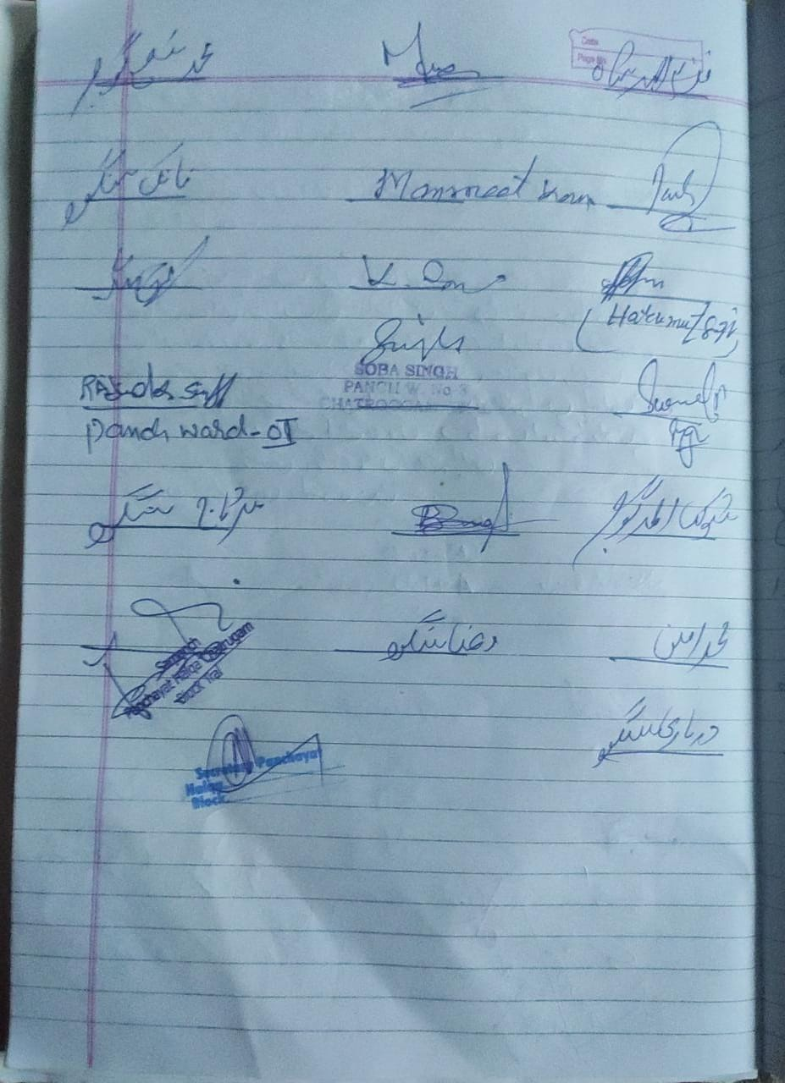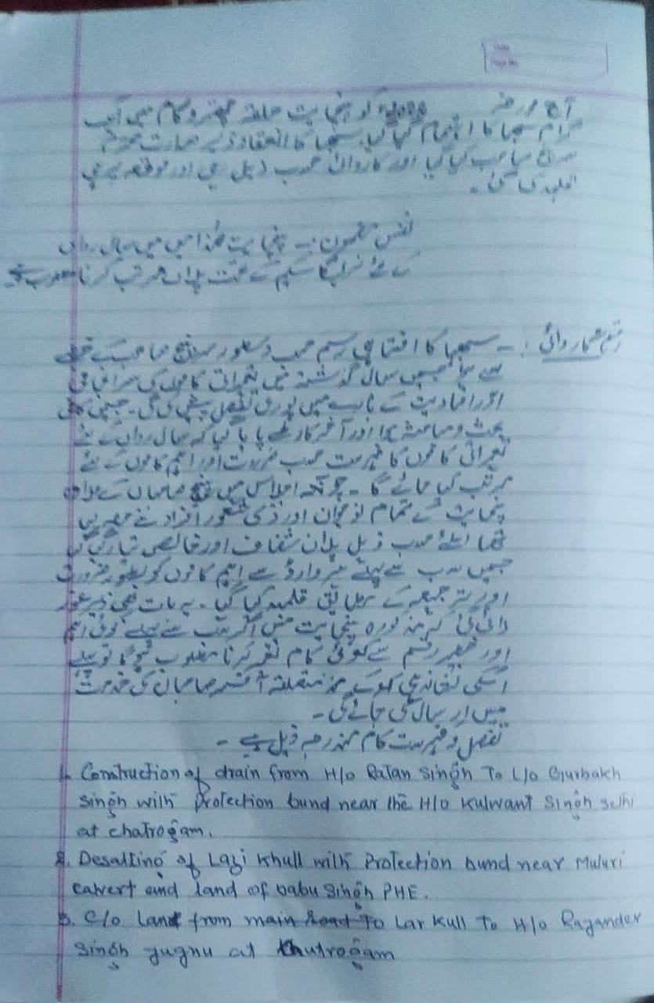

|  |  |  |
| --- | --- | --- |
| **Annual Action Plan Under MG Nrega 2022-23 P/H CHATRUGAM** | | |
| S.No. | Name of WORK | Amount in lacs |
|  | C/o drain from h/o Ratansingh to land of Gurbakh Singh with p/b near the h/o KulwantsinghSethi at chatrugam | 2.00 |
|  | D/o Lazikul with p/b near muluri culvert and land of Babusingh PHE | 1.50 |
|  | C/o lane from larkul to h/o Rajindersinghjugnu at chattrugam | 1.50 |
|  | C/o of lane from main road to h/o Mashoor Singh at chatrugam | 1.50 |
|  | C/o lane from h/o Jeetsinghbali to h/o Master Jasbeersingh at chatrugam | 1.00 |
|  | C/o create bund at Panzwothdandi at chatrugam | 0.50 |
|  | C/o lane from h/o narindersingh to h/o Khemsingh and others at chatrugam | 1.00 |
|  | Upgration of lane/road from main road to grave yard at shaldramanchatrugam | 1.50 |
|  | C/o drain from h/o Hamidgani to land of hamiddar with p/b at shaldramanchatrugam | 1.20 |
|  | C/o children park near Middle school chatroogam | 1.00 |
|  | D/o of public park at chatrugam | 2.50 |
|  | D/o of lane from h/o khemsingh to zenkuli culvert with p/b at chatrugam | 2.00 |
|  | D/o road from h/o Sudagarsingh to Muluri culvert at chatrugam | 2.00 |
|  | Repairment of lane from main road to h/o Mokhamsingh at chatrugam | 0.50 |
|  | D/o lane/raod from water pump to mulurinallah along with p/b on some places at chatrugam | 2.50 |
|  | C/o Cow shed at Manganpal at chatrugam | 2.50 |
|  | C/o 5no. Water tanks on apple orcheds at chatrugam | 3.00 |
|  | C/o P/bunds at different spots near bulbul at chatrugam | 2.90 |
|  | C/o lane from muludicalvert to h/o nanaksingh and to h/o sukhdevsingh at chatrugam | 2.00 |
|  | C/o p/bunds at different spots on muludinala at shaldramanchatrugam | 2.00 |
|  | C/o drain from primary school to h/o mangatsingh at bajwanichatrugam | 2.00 |
|  | P/bunds near the new h/o budhsingh and land of jadeshsingh at diver darchatrugam | 1.00 |

Tourist places which need to be developedSpecificproductwhichneedstobedevelopedTourism-homestays

20candidatesfortrainingunderHimayatschemealongwithtradeinwhichtrainingistobegiven

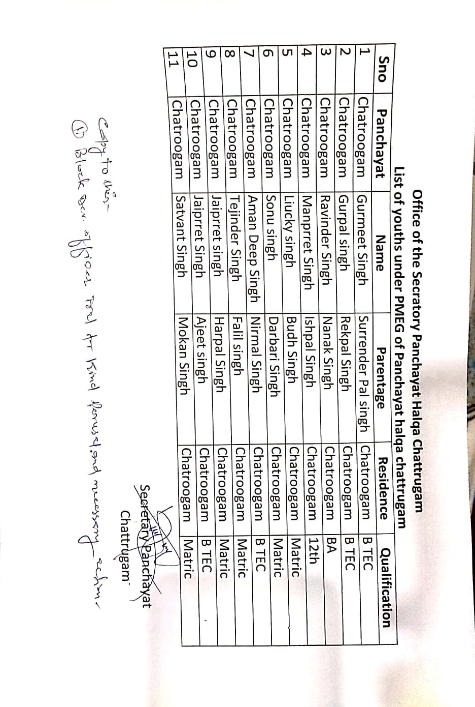

# DAY2ACTIVITIES

## AGENDA5

Ensuresaturationoffollowingschemesandgivestatus:

|  |  |  |  |
| --- | --- | --- | --- |
| **NAMEOFTHESCHEME** | **TOTALELIGIBLE BENEFICIARIESIN THE VILLAGE** | **TOTALBENEFICIARIESWHO AVAILEDTHEBENEFITSOFTHESCHEME** | **REASONSFOR PENDENCY** |
| GoldenHealthCardunder  AyushmanBharat | 1323 | 1294 | 29 UNDER PROCESS |
| Jananisurakshayojana | 21 | 0 | REST NOT ELIGIBLE TO AVAIL ASSISTANCE YET |
| OLDAGEpension | 71 | 71 | NIL |
| Widowpension | 24 | 24 | NIL |
| Disabilitypension | 19 | 19 | NIL |
| Domicilecertificate | 1323 | 945 | 378 UNDER PROCESS |
| Kisancreditcard | 218 | 157 | 61(UNDER PROCESS) |
| PMkisansammannidhi | 218 | 93 | 125 (NOT ELIGIBLE) |

|  |  |  |  |
| --- | --- | --- | --- |
| Landpassbook | 563 | NIL | 563 (UNDER DIGITIZATION) |
| Registrationofvillageven- dorsonGEMportal | NIL | NIL | - |
| Registrationofvillagecon- tractorsonjktendersportal | 5 | 5 | NIL |
| Registrationofvillagecon- tractorsonPWDportal | - | - | - |
| Incompletebuildings/pro- jects | NIL | NIL | - |

# DAY2ACTIVITIES

## AGENDA6

**NASHAMUKT ABHIYAN**

1. Whethergramsabharesolutionpassed : Yes
2. Detailsofactivitiesconducted : Mentioned above
3. WhetherallactivitiesandGSresolutionuploadedonjkpanchayats.inportal :Yes
4. Howmanydrugaddictsinthevillage: Nil
5. WhetherreportedtotheDeputyCommissioner: No
6. Howmanyregisteredforrehabilitationundergovernmentprogramme: Nil

# DAY2ACTIVITIES

## AGENDA 7SOCIALAUDIT

Conductsocialauditofatleast5workseachunderfollowingschemes:

|  |  |  |  |  |  |  |
| --- | --- | --- | --- | --- | --- | --- |
| NAMEOFTHE SCHEME | DETAILSOFTHE WORKS | YEAROFWORK APPROVAL | AMOUNT APPROVED  FORTHEWORK | WHETHER  WORKEXECUTED SATISFACTORILY | GEO- TAGGED PHOTOS | ANY GRIEVANCE RECORDED RELATINGTOTHAT WORK |
| MGNREGA |  |  |  |  |  |  |
| PMAY |  |  |  |  |  |  |
| IHHL  UNDERSBM-G |  |  |  |  |  |  |
| CSCUNDER SBMG |  |  |  |  |  |  |
| AMRIT SAROVARS |  |  |  |  |  |  |

MGNREGA

|  |  |  |  |  |  |  |  |  |  |  |
| --- | --- | --- | --- | --- | --- | --- | --- | --- | --- | --- |
| 1 | Chatroogam | Completed | 1405003059/RC/8808582403 | Const. of Lane / Steps from Khardandi Culvert to H/O Popinder Singh an others at Chatrogam | 0.68 | 0.1284 | 60 | YES | 18/05/2021 | 11/06/2021 |
| 2 | Chatroogam | Completed | 1405003059/FP/8808561323 | C/O P/Bund at Shamshanghat and R/Wall at Various sites at Chattrogam | 4 | 0.993 | 464 | YES | 23/12/2021 | 21/03/2022 |
| 3 | Chatroogam | Physically Completed | 1405003059/RC/8808577465 | Construction. of road from main road to Wagama at Chatroogam | 1.7955 | 0.774 | 266 | NO | 12/05/2021 | 13/11/2021 |
| 4 | Chatroogam | Ongoing | 1405003059/RC/8808598381 | C/O Link road from H/O Daleepsingh to H/O AbGaniWani at Chatrogam | 2.7584 | 1.827 | 618 | NO | 25/01/2022 |  |
| 5 | Chatroogam | Ongoing | 1405003059/RC/8808598383 | C/O Link road from M/Road to Play field at Chatrogam | 0.843 | 0.6613 | 309 | NO | 28/12/2021 |  |
|  |  |  |  |  |  |  |  |  |  |  |

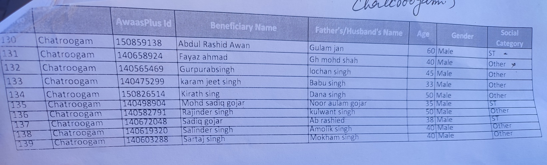PMAY

IHHL UNDER SBM-G-----260-------(100 PERCENT ACHIEVED)

CSC UNDER SBMG-------------- NIL

AMRIT SAROVARS--------------- NIL

# DAY2ACTIVITIES

## AGENDA 8MAHILASABHA

Totalwomeninthevillageabovetheageof18 :600

Total attended

30

=Proceedings:

*(Plinsertpointerstobediscussedthere–referpalliproceedings)*

# DAY2

# ACTIVITIES

## AGENDA 9BALSABHA

Holdabalsabhaandrecordproceedings

Totalchildreninthevillageabovetheageof…40..Totalattended

Proceedings:

*(Plinsertpointerstobediscussedthere–referpalliproceedings)*

# 

# 

# WhatsApp Image 2022-10-29 at 2.50.59 AM.jpegWhatsApp Image 2022-10-29 at 2.50.16 AM.jpeg

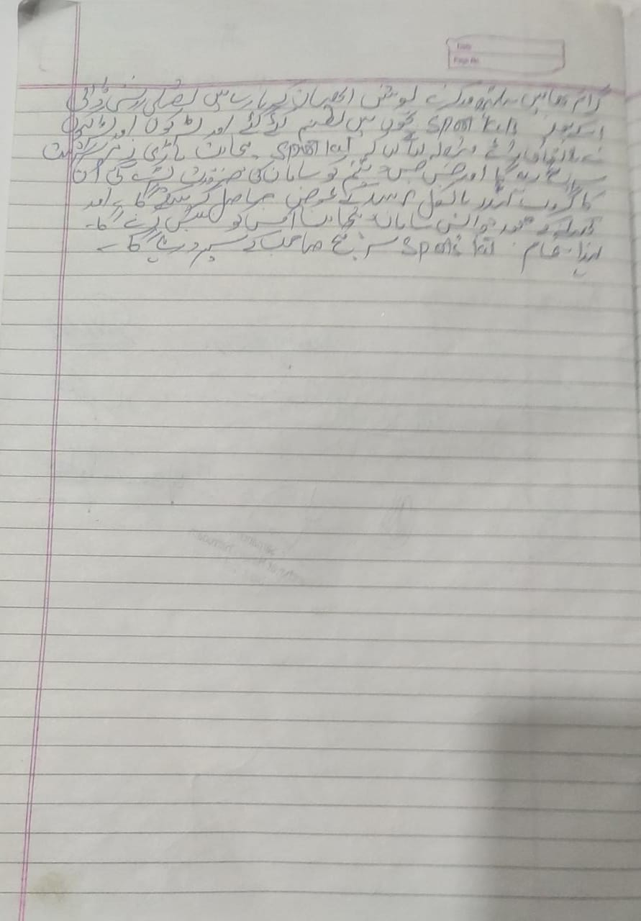

# DAY2ACTIVITIES

## AGENDA 10INAUGURATIONS

|  |  |  |  |
| --- | --- | --- | --- |
| **SR NO.** | **ASSETS/ACTIVITIES INAUGRATED** | **STATUSOFTHEASSET/AC- TIVITIES(NUMBER,OTHER DETAILS)** | **GEO-TAGGED PHOTOS** |
|  | VILLAGEHAATunderJKSRLM (SUN- DAYMARKET) | ESTABLISHED AND INAGURATED TODAY ON 29-10-2022 | UPLOADED |
|  | PMAYhousesifanyreadyforinaugra- tion | NO SUCH WORK UNDER PMAY |  |
|  | Swachhgramprojects-segregation shedsetc | NIL |  |
|  | Amritsarovars | NIL |  |
|  | Sportskits | DISTRIBUTED | UPLOADED |
|  | Villageculturalevents | NIL |  |
|  | JJMassets/projects | NIL |  |
|  | Anyothertobeidentifiedatdistrict level |  |  |

# FOLLOWUPOF(B2V1,B2V2&B2V3):

*(Prefilledexcelsheettobetakenfromdistrictlevel/andalsotobedownloaded*

*fromwww.jkpanchayat.in)*

|  |  |  |  |
| --- | --- | --- | --- |
| S.NO. | Particulars | Actiontaken | Remarks# |
| I. UrgentPublicRequirements/Demands-B2V1 | | | |
| 1 | Most of the grievances and works redressed/completed. |  | Good contribution by RDD |
| 2 |  |  |  |
| 3 |  |  |  |
| 4 |  |  |  |
| 5 |  |  |  |
| 6 |  |  |  |
| 7 |  |  |  |
| II. UrgentPublicRequirements/Demands-B2V2 | | | |
| 1 | About 60% of demands raised during B2V2 have been examined and checked on spot and found executed. Most of the works were related to PDD. | The funds earmarked for execution of works, erecting of electric poles and maintenance has been incurred from PRI (capex budget. | Some of the works related to PDD are under execution. |
| 2 |  |  |  |
| 3 |  |  |  |
| 4 |  |  |  |
| 5 |  |  |  |
| 6 |  |  |  |
| 7 |  |  |  |
| S.NO. | Particulars | Actiontaken | Remarks# |
| III. MajorProblems–B2V1 | | | |
| 1 |  |  |  |
| 2 |  |  |  |
| 3 |  |  |  |

|  |  |  |  |
| --- | --- | --- | --- |
| 4 |  |  |  |
| 5 |  |  |  |
| IV. MajorProblems-B2V2 | | | |
| 1 |  |  |  |
| 2 |  |  |  |
| 3 |  |  |  |
| 4 |  |  |  |
| 5 |  |  |  |
| V. MajorProblems-B2V3 | | | |
| 1 | Common Service Centre | Still not available |  |
| 2 | Macadamization of Road | Not initiated |  |
| 3 | Construction of Culvert/ Bridge | Not done |  |
| 4 |  |  |  |
| 5 |  |  |  |
| VI. MajorComplaints-B2V1 | | | |
| 1 |  |  |  |
| 2 |  |  |  |
| 3 |  |  |  |
| VII. MajorComplaints-B2V2 | | | |
| 1 |  |  |  |
| 2 |  |  |  |
| 3 |  |  |  |
| VIII. MajorComplaints-B2V3 | | | |
| 1 | Work of Road, Bridge and establishment of CSC still pending. |  |  |
| 2 |  |  |  |
| 3 |  |  |  |

# OVERALLPERCEPTIONOFFUCNTIONINGOFGOVERNMENTDEPARTMENTS

* 1. **BESTDEPARTMENT: RDD**
  2. **LEASTRESPONSIVEDEPARTMENT: DIC**

# GENERALASSESSMENTOFTHEVISTINGOFFICER

# Note: A genuine and most important demand of the general public is related to irrigation of agricultural land. Some farmers have not been able to cultivate paddy this year because they were unable to supply water to their land.

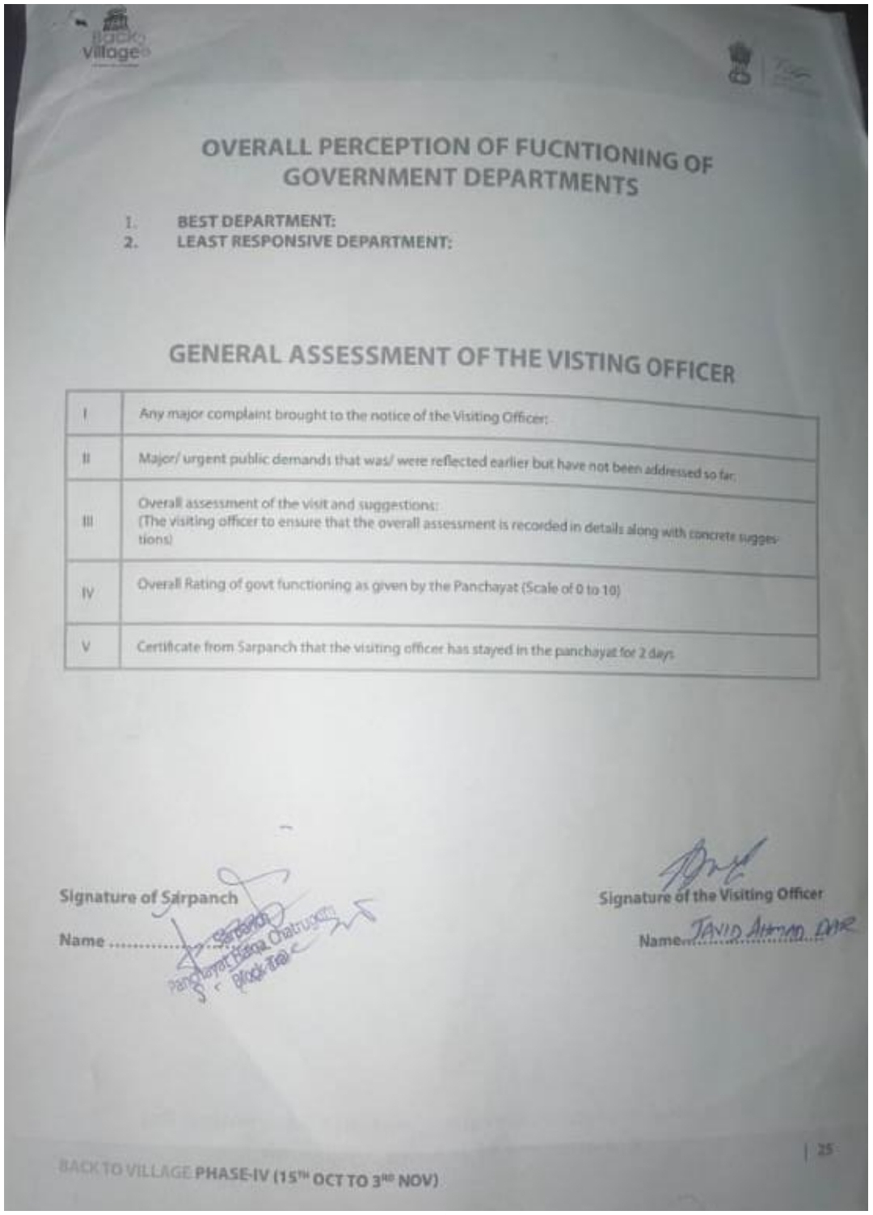

**DepartmentofRuralDevelopmentandPanchayatiRajGovernmentofJammu&Kashmir**