4





**15TH OCTto3RD NOV,2022**

**KEYFEATURES**

• DeputyCommissionerstoleadtheinitiative

• RuraldevelopmentDepartmenttobethenodaldepartment

• PlanningDevelopment&MonitoringdepartmentandITtobethesupport departments

**ACTIONSANDTIMELINES**

|  |  |  |  |
| --- | --- | --- | --- |
| **ACTION** | **RESPONSIBILITY** | **LATESTBY** | **REMARKS** |
| **Jan abhiyan** | All departments | Oct15-26th | Going on |
| **Deputation of Sectt staff/ HoDs** | GAD | Oct14 | Done |
| **Deployment o fStaff to Panchayats and serving of orders on deployed officers** | DCs | Oct25 | DCs will deploy senior level staff from the districts. Strict action to be taken against abstentions. No exemptions to be given |
| **Training of district trainors onB2V4** | RDD | Oct26 |  |
| **Training of visiting officers** | DCs | Oct27 |  |
| **Field Visits to be completed by** | Visiting Officers | Nov3 | DCs to supervise and ensure that each Panchayat is visited within the period specified |
| **Data ofB2V4tobe uploaded by** | Visiting Officers | Nov10 | DCs to supervise and ensure that data of all Panchayats is upload- ed by the visiting officer within the period specified |

**INSTRUCTIONSFORTHEVISITINGOFFICER(DAYWISE)**

|  |  |  |
| --- | --- | --- |
| **DATE** | **INSTRUCTIONS** | **ACTIONPOINTS** |
| **Day0** | Meeting with deputy commissioner and his/her team | a. TakeprintoutsoffilledbookletsofB2V1,B2V2andB2V3from [www.jkpanchayat.in](http://www.jkpanchayat.in)  b.Also take print outs of the summarizedexcelsheetsofthe previousphasesfrom[www.jkpanchayat.in](http://www.jkpanchayat.in)  c. CollectATRsonissuesraisedduringprevious3phasesfromthe officeofDeputyCommissioner(Planningdeptt)  d.Takeprintsofblank 2bookletsofB2V4from[www.jkpanchayat.in](http://www.jkpanchayat.in)e.Takeplansfor2previousyearsandATRsfromtheplanningdeptt f. CompletetrainingsondifferentcomponentsofB2V4being  organizedbyrespectiveDeputyCommissioners  g.CollectListofnewworksstarted/ongoing/completedduringthe previousandcurrentFinancialyearunderthefollowingheads:  • PRIgrants  • DistrictPlan  • UTplan  • MGNREGA  • Otherschemesofotherdepartments  • Anyotherwork  h. Plans/beneficiarylists:  • MGNREGAdraftplandocumentfortheyear2022-23.  • ListofAwaas+beneficiariesalongwithIHHL Convergence  • Listofpensionbeneficiaries.  • ListofSHGs  • Listofagricultureschemebeneficiaries  i. Listsofbeneficiariesfor:  • Variouscertificates/benefitstobedistributedbythe visitingofficer.  • Anyotheractivitiesidentifiedbydifferentdepartments |

|  |  |  |  |
| --- | --- | --- | --- |
| **Day1** | Reachthevillage | 1. | Ensurethatallfrontlineworkersofdifferentdepttsarepresent. |
|  |  | 2. | Ensureexhibitionbydifferentdepts.aboutindividualbeneficiary schemes |
|  |  | 3. | InspectJKB/PSBcounters/outlets |
|  |  | 4. | Participate/ensureorganizationofsportsactivityinplayfield,talent hunt/culturalevent/youthactivity |
|  |  | 5. | GandhiKatha(suggesteddetailsuploadedonjkpanchayat.in) |
|  |  | 6. | Visitatleast2amritsarovarsandgetitsgeotaggedphotos |
|  |  | 7. | InspectKhidmat(CSC)CentresandcreateGenerateawarenesson  225schemesparticularlyG2CschemeslikeBEAMS,Janbhagidari, AapkiZaminAapkiNigrani,DigitalJ&K |
|  |  | 8. | Visitingofficershallalsoplanandconductpanchayatlevelconver- gencemeetingofalldepartments |
|  |  | 9. | CheckeffectivenessofCentrallysponsoredschemes |
|  |  | 10. | VisitandinspectallgovernmentestablishmentsincludingPHE, AWC,FPS,schools,etc |
|  |  | 11. | Attemptsaturationofdeliverableso JanAbhiyanandwherever deficienciesfound,leadadrivetoachievealldeliverables |
|  |  | 12. | Assesseffectivenessofsanitationcampaigninthepanchayat |
|  |  | 13. | Ensureselfemploymentactivitiesfor15youthperpanchayat |
|  |  | 14. | Identify20potentialcandidatesperpanchayatforHIMAYATtraining alongwiththetradeonwhichtheywanttraining |
|  |  | 15. | Whereverpossible,distributeemploymentlettersforpeopleselect- edundervariousgovernmentemployments |
|  |  | 16. | Intheevening,holdnormalmeetingwith seniorcitizens,govtem- ployeesincludingretiredemployees,exservicemen,youthclub,and any citizens ofthevillagewhoareenrolledincollege/university |
|  |  | 17. | OpendiscussiononNashaMuktAbhiyan |

Day2 Haveameetingwithall stakeholders-depttofficials andpanchayatmembers

1. Discussionontheandassesstheprogressofdifferentschemesrelating tothelocalizedSDGsprioritizedforthatvillageaspertheresolution passedby thatGramPanchayaton21st April22,onNationalPanchayti RajDay.

2. Sensitizevillage residentsaboutmyScheme”portal(myscheme.in) whichincludesinformationaboutalltheschemesbeingrunbyCen- tral/State/UTgovtacrossthecountry

3. Hold meeting of theBiodiversityManagementCommitteestodeliber- ateonissuespertaining toconservation of biodiversityandsustaina- bleutilizationof biologicalresources.

4. PrepareVillagedevelopmentplan,inconsultancywithGrampanchayat, discussitingramsabhaandgetitapproved.

5. Ensure saturationofsoilhealthcardandgoldenhealthcardunderGold- enHealthCardunderAyushmanBharat,

6. Ensuresaturation of OldAge PensionScheme

7. EnsureDomicileSaturation.

8. EnsureKCCSaturation

9. Ensure saturationoflandpassbooks

10. Ensureregistrationofvillagevendorsneededforanyscheme,onGEM

portal

11. Ensurepanchayatcontractors registration

12. EncouragePanchayatmembers forimportanceofplantationdrivein

PanchayatunderHarGaonHariyali

13. Ensure paintingondigitalJ&Kinpanchayatghars

14. Ensure paintingonpanchayatactivitesandCSSinpanchayatghars

15. Thevisiting officeshallchecknoof kindergarten andplayfields present inthepanchayat for kidsandstudents,iftheinfrastructure present inthesearegoodenough.

16. Holdmeeting withpanchayatmembers todiscussaboutcorruption menaceandstepsrequiredtomakeJ&Kcorruptionfree

17. Obtaina candidassessmentaboutperformanceofvariousdeptts in- cludingfairfeedbackaboutdiscrepanciesinfunctioning

18. Check thestatusof NashaMuktAbhiyanandreporting of drugad- dictstoDeputyCommissioner.

19. IdentifyTouristDestinations,Circuits,ThemeTreks,IdentifyHomestays, providesupportfortourismactivities throughVillageCooperative

20. OrganizeTalentHuntatPanchayatLevel

21. Conductsocialauditofatleast5worksunderfollowingschemes:

a. MGNREGA

b.PMAY

c. IHHLtoiletsandpayments d.CSCs

e.AMRITSAROVARS

22. Holda mahilasabha anda balsabhaandrecordproceedingsinthefor- matgiven

23. InauguratevillagehaatunderJKSRLM

24. Checkifyouthclubsareformedinthepanchayatandwhatactivities theyareengagedin

25. Organizea villagelevelculturaleventtoengagepanchayatmembers

26. SensitizeGPaboutE-kitabkoshaninitiativeofJ&KGovtforempowering youthsthrough onlinedigitalliteracy

**GENERALINSTRUCTIONS**

1. Thevisitingofficershallrefrainhimself/herselfgivingorofferinganycommitmentonbehalfofthe governmentandshalladoptanunbiasedattitudeinreportingissues.As faraspossible,his/her observation shouldbebasedona fairandanalytical viewemergingfromhis/herinteractioninthe village.

2. Heisgoingtothevillageasplanningofficer,notforsanctioninganyworksorformakinganycom- mitments.

3. Whilepreparingvillagedevelopmentplan,hehastoensurethat,demandsareprioritizedandre- flectedunderavailableschemes,wherevernecessarythelargerworksaretobereferredtoadminis- trativedepttunderCSS/UTplansunderintimationtoDCsandrestoftheworkstoDCsforreflecting itunderdistrict/CSS plans

4. His workshallbehardcoreplanningandauditandisnota PRexercise.

5. EveryDeputyCommissionerhastoensurethatatleastoneRDDofficial(ideallyPanchayatSecre- tary)ispresent ineverypanchayatwithrelevantpanchayatrecords,toensureconductofallactivi- tiesasplanned.Panchayatwiseorderneedstobeissuedinadvance.

6. Visitingofficershouldideallycarryhis/herlaptoptocompletethereportsatthepanchayatlevel itselfanduploadthefinalreport,duly signedbothbythesarpanchandbythevisitingofficeron [www.jkpanchayat.in](http://www.jkpanchayat.in)portal,beforetheyleavepanchayat.

7. Focus ofvisitareyouth,skills,self-employment,nashamukt,bhrashtracharmukt,Rozgaryukt J&K, besidestocarryforwardtheactivities duringJanAbhiyanandsaturatethem.

8. Inadditionattentionmaybegiventothefollowingareas a. MakefulluseofCentrallySponsoredSchemes

b.Saturationofindividualbeneficiaryschemes c. Self-employmentschemes

d.Banklinkedschemes-includingdepartmentalsubsidyschemes e.Empowermentandtransparencythrough digitalinitiatives

f. Effectivenessofgrassrootsmachinery–

i. Patwari,VLWpresent andavailable

ii. AvailablefundsutilizedinpublicinterestandasperGramSabharesolutions iii. Fairness ingovernance

iv. CSS/Individual beneficiaryschemesetc v. BrashtacharMuktJ&K

vi. BhaiMuktJ&K

vii. NashaMuktJ&K

9. ThePRImembers (Sarpanchs,Panchs,BDCChairperson)shallbeattheforefrontofallactivities and givendueimportanceandtheapproach shouldbetostrengthenthemandmakethemfeelem- powered.He/sheshallensurethattheBDCchairpersonandSarpanch/Panch arepresent atthetime ofinaugurationandceremonies.

10. Visitingofficershallnotleavethedistrictwithoutuploadingthereport,duly signedonthe**www. jkpanchayat.in**portal.EveryDeputyCommissionerhastoensurethat.

**A) Details of Reporting Officer:**

Name: Waseem Ahmad Lone

Designation: Deputy Legal Remembrancer (DLR)

Department/place of posting: General Administration Department, Civil Secretariat, Srinagar.

Mobile No: 9797494712

Email ID: waseemahmadlaw@gmail.com

Home District: Baramulla

Dates of visit:31st October – 01st November 2022

**B) Locational details of Panchayat :(to be pre-filled, information to be taken from the previous phasesbooklets/summarizedexcelsheetuploadedonjkpanchayat.in/b2v4.php)(tobevali- dated by the visiting officer and missing details to be filled)**

Name of the Panchayat: BALHAMA-A

Local Government Directory (LGD) code of the Panchayat: 04

Name of CD Block: KHANMOH

Name of Tehsil: PANTHACHOWK

Name of District: SRINAGAR

**C) Panchayat Profile:**

No .of revenue villages in the Panchayat :05

No. of hamlets in the Panchayat: 57

No.of house holds in the Panchayat: 500

Population (approx)of the Panchayat: 2459

**Part-II:**

(To be filled up by the Visiting Officer during his/her two day visit to the Panchayat.All Fields have to be

Filled by the Visiting Officer before the booklets handed over to the DC

**Frontline Officers/Officials who were assigned to the Panchayat for the programme:**

|  |  |  |
| --- | --- | --- |
| Department | Name | Designation |
| ALL THE OFFICIALS FROM CONCERNED DEPARTMENTS, VIZ, CAPD, PDD, JAL SHAKTI, SOCIAL WELFARE, REVENUE ETC. WERE PRESENT. |  |  |
|  |  |  |
|  |  |  |
|  |  |  |
|  |  |  |
|  |  |  |
|  |  |  |
|  |  |  |
|  |  |  |
|  |  |  |
|  |  |  |
|  |  |  |
|  |  |  |

**Details of absent employees vis-à-vis list furnished by the DC office:**

|  |  |  |
| --- | --- | --- |
| Department | Name | Designation |
| NONE OF THE ASSIGNED OFFICIALS ABSENT. |  |  |
|  |  |  |
|  |  |  |
|  |  |  |
|  |  |  |
|  |  |  |
|  |  |  |
|  |  |  |
|  |  |  |
|  |  |  |
|  |  |  |
|  |  |  |
|  |  |  |
|  |  |  |
|  |  |  |

**DAY1-ACTIVITIES**

**AGENDA1:PANCHAYAT ASSET REGISTER**

**Infrastructure:**

1. Panchayat Ghar Infrastructure NO PANCHAYAT GHAR

a. Govt building/private

b. New/needing repairs

2. Furniture(Y/N) NO

3. Computer/printer(Y/N) YES

4. Internet(Y/N) NO

5. Telephone(Y/N) NO

6. Toilet(CSC/part of panchayat ghar)(Y/N) NO

7. Water(Y/N) NO

8. Electricity(Y/N) NO

9. Bank branch(Y/N) YES

10. CSC(Y/N) UES

11. Patwarkhana (Y/N) NO

12. Village haat(Y/N) YES

13. Playground(Y/N) LAND IDENTIFIED, UNDER DEVELOPMENT

14. School-

a. Kindergarten(Y/N) YES

b.Primary(Y/N) YES

c. Secondary(Y/N) YES

d. College (Y/N) NO

e.University(Y/N)

15. Anganwadi Centre(Y/N) YES

a. (govt/private) PRIVATE

b.Total children enrolled: 100

15. Amrit Sarovars–details,location,condition One tube-well constructed but not handed over so far. Work not initiated in 02 other tube-wells.

16. Government offices-details, whether functional o rnot

17. Rationshop (Y/N) YES

18. Placesoftourismimportance–names,little details on historical/culturalimportance

19. Village heritage sites/treks-names, little details on historical/cultural importance BALA DEVI TEMPLE

20. VLWOffice (Y/N) NO

21. Primary Health care Centre(Y/N), YES

22. List of Incomplete Buildings-names, year of construction Operating in a private building in adjacent Panchayat.

23. List of Underutilized Buildings-names

Rural Hut

**DAY1-ACTIVITIES**

**AGENDA2:**

**DIFFERENTINSTITUTIONS/INFRASTRUCTUREPROJECTSTOBEVISITED**

|  |  |  |
| --- | --- | --- |
| **AMRITSAROVARS** | **Visit,verify** | **COMMENTS** |
| Khidmat Centres | Create/Generateawarenesson225schemes particularlyG2CschemsAapkiZaminAapkiNigrani, Beams, Janbhagidari, Digital J&K | People being made aware. |
| JKB/PSB counters/outlets | a)Status of counter b)Number of visitors | J&K Bank operating satisfactorily. |
| Incomplete buildings/pro- jects | Verify whether identification and redistribution done | Rural Hut. |
| PDS | Visit, evaluate, online status | Ration quota needs enhancement. |
| PHC | Visit-evaluate, status of staff, equipment and quality | Potable water needs improvement. |
| Youth clubs | Meet, interact, seek suggestions | Youth clubs established. |
| SHG | Meet, identify problems, seek suggestions | Guidance/counseling needed, some SHGs functional. |
| PMAY | Inspect, Inaugurate | 09 houses constructed/sanctioned. |
| My school, my pride progress; schools-water, toilets, staff | Visit, check for water, electricity, sanitation, meet students and staff | Needs up gradation. |
| Swachh SBM | Evaluate | Waste Disposal Site needed. |
| Panchayat playground, Sports kits distribution Village games | Ensure, verify. Participate in atleast one game in the playground | Land identified for playfield, sports kits being distributed. |
| Har Gaon Hariyali, Planta- tion drive | Evaluate status, feedback | Carried out during B2V4. |
| Village cultural event  Dangal/Haat/Mela | Participate in;ensure that it is held | Organized during B2V4. |
| Exhibition of schemes | Ensure that every department participates and that it continues for the entire duration of B2V | Various schemes put to exhibition. |
| Jal Jeewan Mission verifica- tion- WSS/JSD  Electricity supply | Verify | Needs improvement. |

**DAY1-ACTIVITIES**

**AGENDA3:SATURATEJANBHIYAN**

**DELIVERABLESANDRECORDDEFICIENCIESIFANY(INSERTDELIVERABLESLISTHEREASPERGADFORMAT**

**MAJOR GRIEVANCE OF BALHAMA-A**

**1.** The main grievance of Panchayat Halqa, Balhama-A is that the roads and inner link roads are neither being addressed by R&B Department nor by the local Municipality. The R&B officials including AEE and JE have stated that these roads have been handed over to Municipality but the locals and their representatives including Sarpanch, Panch and DDC/BDC members present in B2V4 stated that local roads are to be constructed by R&B. They also showed a communication of Field Functionaries which says that these roads are liability of R&B Department.

Hence, this conflict as to who will construct the roads/inner link roads was the main area of concern for all the people present during B2V4 including local representatives, viz, DDC,BDC. Sarpanch, Panch. The issue needs to be addressed on priority.

1. Up gradation of Govt. Boys High School (Land identified-state land)

**DAY1-ACTIVITIES**

**AGENDA4:**

**SELFEMPLOYMENTACTIVITIES**

Ensure Self-employment activities for youth, distribute employment letters for people selected under various social schemes (15 IS THE TARGET PER PANCHAYAT)

**Number of cases in different categories sanctioned: 15**

**Details of the bank sanctioning it: J&K Bank Ltd**. And Elaqai Dehati Bank

**Total amount involved: Rs 55 Lac sanctioned/distributed among beneficiaries .**

**(15 Artisan Cards, Rs 1**.80 Lac each, J&K Bank Loan amounting to Rs 27 Lac and some to other SHG loans)

**DAY1ACTIVITIES**

**AGENDA 5:**

In the evening, hold informal meetings with senior citizens, govt employees, retd employees, youth club and other citizens who are enrolled on

college/university and have discussion on Gandhi Katha, Nasha Mukt Abhiyan,corruption free governance,doubling farmers income and record the proceedings

**DAY2**

a. No of Individual Compost Pits constructed b.No of Individual Soak Pits constructed

V. No. of Biodiversity management committee meetings held: 02

VI. Is the name of Sarpanch displayed on citizen information boards of all RD&PR schemes: Yes/No Yes

VII. Are Sarpanchs being involved in start/inauguration of activities: Yes/No Yes

VIII. Whether subjects have been assigned by the Sarpanch to the Panchs: Yes/No Yes

IX. Whether grievances redressal box is installed:Yes/No Yes

X. No of grievances received pertaining to Panchayat level: 12

XI. No of grievances disposed of at Panchayat level: 06

XII. Whether the Sarpanch/Panchayat Secretary have digital signatures: Yes/No No

XIII. Whether all MGNREGA/14th FC payments are being made by Sarpanch through Digital Signature

Certificate (DSC):Yes/No

No

**HUMAN RESOURCEAVAILABLEATTHEPANCHAYAT LEVEL:**

|  |  |  |  |  |
| --- | --- | --- | --- | --- |
| **SRNO.** | **DEPARTMENTWISESTAFF** | **NUMBERS** | | **NAMES** |
|  |  | SANCTIONED | ACTUAL |  |
|  | Rural development department: BDO  JE GRS TA | 01  02 | 01  02 |  |
|  | SCHOOLEDUCATION: TEACHER  HEADMASTER ANYOTHER | 19  01  05 | 10  01  04 |  |
|  | JAL JEEVAN: | 01 | 01 |  |
|  | PDD: LINEMAN JE  ANYOTHER | 02  01  01 | 02  01  01 |  |
|  | FOOD&CIVILSUPPLIES  TSO | 01  01 | 01  01 |  |
|  | AGRICULTURE&ANIMALHUS- BANDARY | 01 | 01 |  |
|  | SOCIALWELFARE | 05 | 05 |  |
|  | HEALTH: ASHA ANM  AYUSHDOCTOR ALLOPATHICDOCTOR | 01  02  01 | 01  02  01 |  |
|  | ANY OTHER DEPARTMENT(soil and water conservation Department) | 02 | 02 |  |

**DAY2-ACTIVITIES**

**AGENDANO.1**

Discussion on the and assess the progress of different schemes relating to the localized SDGs prior-itized for that village as per the resolution passed by that Gram Panchayat on 21stApril 22,on National Panchayati Raj Day(Copy of the resolution to be taken from [www.jkpanchayat.in](http://www.jkpanchayat.in) portal under the link of Gram Swaraj Month)

1. SDGs AGREED FORTHATVILLAGE,TO BE IMPLEMENTED BYMARCH2024: YES

2. STATUSOFWORKSUNDERTHEFOLLOWINGSCHEMES:

**1 Clean and green village**

i.Initiatives taken by the Panchayat for managing Solid and Liquid Waste: Disposal site needed

ii. Initiatives taken by the Panchayat for using green sources of fuel like solar, biogas Infrastructure to be developed.

iii. Has mapping of land use,waterbodies,forest,slopes,wetlands,degraded forest within the Gram

Panchayat been done?Yes/No.If No, reason, there of YES

iv. Has the Climate Resilience Plan been developed for the GP?Yes/No: No

v. Steps taken by the Gram Sabha about the climate change mitigation factors like reducing energy consumption,usage of fossil fuels,plastics,non-renewable building materials and also to promote measures like planting of trees,conserving forests,usage of good agricultural practices like drip irrigation, water conservation measures and conservation of wetlands. Steps being taken.

vi. Whethers chools have started segregating waste YES

vii. Whether schools have their own compost/soakage pits for solid/liquid waste management NO

**2 Healthyvillage**

i) Are meetings related to Village Health and Sanitation Committee being held regularly? Yes, occasionally.

ii) Do all the eligible individuals been provided the Golden Card? 90%

iii) Are all the Children being immunized as per the Schedule recommended by Govt.of India? Yes

iv) Are all the eligible individuals been vaccinated against COVID-19? Yes

v) Does Gram Panchayat ensure that all pregnant women are getting necessary prenatal checkups? Yes

vi) Whether all the deliveries were Institutionalized or conducted by trained Midwives? 90%

**3 Water sufficient village**

i) Do all the IHHs in the Gram Panchayat have water pipeline connections? Yes, except new houses.

ii) Whether Gram Panchayat has taken steps for grey water management. If Yes please specify No.

iii) Do all the IHHs in the Gram Panchayat have toilets? Yes

iv) Are all the IHHs toilets functional or not? Functional

v) Do all the Schools/Anganwadi centers have a toilet facility or not? Yes.

vi) Are all the toilets in the schools/Aaganwadi functional or not? Yes

vii) Whether Gram Pachachayat Bhawan has separate toilets for women or not? No Gram Panchayat Building available.

**4 Child Friendly village**

i) Do all the children under the age of 0-6years been enrolled in the Anganwadi centers for pre- schooling ?Yes /NO Yes.

ii) How many Bal Sabha’s were organized in the Gram Panchayat 05 ( 01 during B2V4)

ii) Whether the issues raised by Bal Sabha are addressed in the Gram Sabha. Yes/NO Yes

iv) Whether Gram Panchayat is tracking the data related to dropout children and children with irregular attendance ?Yes/NO. No

v) Do all the schools under the Gram Panchayat have separate toilets for girls and boys ?Yes/No Yes.

**5 Village with good governance**

i) Is CSC located in the Gram Panchayat Bhawan or not? No.

ii) Is the list of beneficiaries related to the Schemes/Programs displayed on the Gram panchayat wall or not? No

iii) Does the Gram Panchayat has its building or not? No

iv) Is the Gram Panchayat office functional or not? Yes

v) Are the activities approved under the Halqa Panchayat Development Plan displayed on the Gram

Panchayat wall or not? No

vi) Is Social Audit of earlier Schemes/Programs carried out or not? Yes

**6 Poverty free and enhanced livelihood village**

1. Has Gram Panchayat developed any criteria for the identification of the poor ?Y es/No if yes specify Yes, low income and less marginal land holders

ii) Have all the eligible households registered in PDS or not? Yes

iii) Has Gram Panchayat provided space for Self-help Groups in Panchyat Ghar for holding meetings or not? No

iv) Have all the eligible households been registered for Pension or not? Yes

v) Has Gram Panchayat facilitated Youth for Skill Enhancement Courses and Placement? Yes

vi) Has Job Cards been distributed to all the eligible individuals under MGNREGA? Yes

vii) Has Gram Panchayat facilitated SHGs for Bank Account Linkages? Yes

**7 Socially secured village**

i) Whether Gram Panchayat is maintaining data related to Differently Abled People? Yes

ii) Is Gram Panchayat Office Disabled Friendly or not? Yes

iii) Are provisions for a separate Budget under the Resource Envelope forWomen and Children made or not? Yes

iv) Do all the Schools in the Gram Panchayat have facilities for Differently Abled Children like toilets, barrier-free access,etc.,or not? Yes

v) Are all the eligible individuals are getting pensions,like old age pension,widow pension,etc? Yes

vi) Are all the eligible households getting benefits from IAY or not?

Yes

**8 Engendered Development inVillage**

i) How many Mahila Sabha’s were organized in the Gram Panchayat 07

ii) Whether SHGs federations have been provided space for meetings in the Panchayat Bhawan(Yes/ No) No

iii) Whether GPs have taken steps for increasing women’s participation in Gram Sabha (Yes/No) Yes

iv) Number of women beneficiaries headed households covered under PDS

system 15

v) Number of beneficiaries (out of total eligible population) receiving social protection benefits under

Pradhan Mantri Matritva Vandana Yojana Not abailable.

9 Self-sufficient in frastructure in the village

i. Whether GP has a Community Hall with access to electricity, furniture, water supply, toilet: No community hall available.

ii Whether the Disaster management plan is available at the GP Level (Yes/No) Yes

iii.Whether child-friendly park with required facilities is available in GP(Yes/No) No

iv. Whether the GP has easy access to God own for storage (Yes/No) No

v. Whether street lights are provided in public places for ensuring safety (Yes/No) Yes

**DAY 2 ACTIVITIES**

**AGENDA NO.2**

Sensitize village residents about my Scheme”portal (my scheme.in) which includes information about all the schemes being run by Central/State/UT govt across the country

*(SchemeMaterialavailablefromhttps://jkpanchayat.in/b2v4.php)*

**DAY 2 ACTIVITIES**

**AGENDA NO.3**

Hold meeting of the Biodiversity Management Committees to deliberate on issues pertaining to conserva- tion of biodiversity and sustainable utilization of biological resources. He should check People Biodiversity register (PBR) of that panchayat and review if Biodiversity Management Committee constituted for that panchayat is holding minimum 4 meetings in a year and meeting once in every 3 months *(Role of BMC availableathttps://jkpanchayat.in/b2v4.php)*

COMMITTEE MEMBERS PRESENT

BIODIVERSITY REGISTER PHOTOS

PAST 4 MEETINGDETAILS-DATES, MINUTES PHOTOS

**DAY 2 ACTIVITIES**

**AGENDA 4**

Visiting officer shall also plan and conduct panchayat level convergence meeting of all departments and prepare Village development plan for village, inconsultancy with Gram panchayat,discuss it in gram sabha and get it approved.

(GPDPformatavailableonhttps://jkpanchayat.in/b2v4.php)

**In addition GPDP plan shall also include:**

▪ Tourist places which need to be developed

▪ Specific product which needs to be developed

▪ Tourism-home stays

▪ 20 candidates for training under Himayat scheme along with trade in which trainings to be given

**DAY2ACTIVITIES**

**AGENDA5**

Ensuresaturationoffollowingschemesandgivestatus:

|  |  |  |  |
| --- | --- | --- | --- |
| **NAMEOFTHESCHEME** | **TOTALELIGIBLE BENEFICIARIESIN THE VILLAGE** | **TOTALBENEFICIARIESWHO AVAILEDTHEBENEFITSOFTHESCHEME** | **REASONSFOR PENDENCY** |
| Golden Health Card under  Ayushman Bharat | 2459 | 2213 | Pendency due to new borns. |
| Janani suraksha yojana | 92 | 83 | Registration at private nursing homes. |
| OLD AGE pension | 85 | 85 | Nil |
| Widow pension | 120 | 120 | Nil |
| Disability pension |  |  |  |
| Domicile certificate | 2459 | 2213 | Continuous process, on demand. |
| Kisan credit card | 189 | 189 | Nil |
| PM kisan samman nidhi | 140 | 140 | Nil |

|  |  |  |  |
| --- | --- | --- | --- |
| Land passbook | 754 | 358 | Distribution under process. |
| Registration of village ven- dors on GEMportal | NA |  |  |
| Registration of village con- tractors on jktendersportal | NA |  |  |
| Registration of village con- tractors on PWDportal | NA |  |  |
| Incomplete buildings/pro- jects |  |  |  |

**DAY2ACTIVITIES**

**AGENDA6**

**NASHAMUKTABHIYAN**

1. Whether gram sabha resolution passed YES

2. Details of activities conducted

3. Whether all activities and GS resolution uploaded on jkpanchayats.in portal

4. How many drug addicts in the village

5. Whether reported to the Deputy Commissioner

6. How many registered for rehabilitation under government programme

**DAY 2 ACTIVITIES**

**AGENDA 7**

**SOCIAL AUDIT**

Conduct social audit of at least 5 works each under following schemes:

|  |  |  |  |  |  |  |
| --- | --- | --- | --- | --- | --- | --- |
| NAMEOFTHE SCHEME | DETAILSOFTHE WORKS | YEAROFWORK APPROVAL | AMOUNT APPROVED  FORTHEWORK | WHETHER  WORKEXECUTED SATISFACTORILY | GEO- TAGGED PHOTOS | ANY GRIEVANCE RECORDED RELATINGTOTHAT WORK |
| MGNREGA | Earth filling of graveyard  Tree Plantation  Besides, many other works. | 2021-22  2021-22 | 1,45,438 Rs  47,224 Rs | Yes  Yes | Yes  Yes | No  No |
| PMAY |  |  |  |  |  |  |
| IHHL  UNDERSBM-G |  |  |  |  |  |  |
| CSCUNDER SBMG |  |  |  |  |  |  |
| AMRIT SAROVARS |  |  |  |  |  |  |

**DAY 2 ACTIVITIES**

**AGENDA 8**

**MAHILA SABHA**

Total women in the village above the age of 18: 650

Total attended 80

Proceedings: Awareness and participation in various Govt. run schemes for non-organised sector facilitated by J&K Bank and JKEDI, etc.

*(Plinsertpointerstobediscussedthere–referpalliproceedings)*

**DAY 2 ACTIVITIES**

**AGENDA9**

**BALSABHA**

Hold a bal sabha and record proceedings Yes, held.

Total children in the village above the age of 05 yrs 320

Total attended 45

Proceedings: Instructions imparted related to Nasha Mukht Abhiyan, sayings of Mahatma Gandhi, etc.

*(Plinsertpointerstobediscussedthere–referpalliproceedings)*

**DAY2ACTIVITIES**

**AGENDA10**

**INAUGURATIONS**

|  |  |  |  |
| --- | --- | --- | --- |
| **SR NO.** | **ASSETS/ACTIVITIES INAUGRATED** | **STATUSOFTHEASSET/AC- TIVITIES(NUMBER,OTHER DETAILS)** | **GEO-TAGGED PHOTOS** |
|  | VILLAGE HAAT under JKSRLM (SUN- DAYMARKET) | Various stalls installed during B2V4 for exhibition of products. |  |
|  | PMAY houses if any ready fori naugra- tion | 09 houses constructed/sanctioned. |  |
|  | Swachh gram projects-segregation sheds etc |  |  |
|  | Amrit sarovars | 01 tube well constructed 02 others being constructed. |  |
|  | Sports kits | Various sports items distributed among beneficiaries. |  |
|  | Village cultural events | Cultural events being organized frequently. |  |
|  | JJM assets/projects | De-silting of water stream. |  |
|  | Anyother to be identified at district level | Land passbooks distributed.  Incentives for Handicraft Artisans.  Various loan sanctions by J&K Bank |  |

**FOLLOWUPOF(B2V1,B2V2&B2V3):**

*(Prefilledexcelsheet tobetakenfromdistrictlevel/andalsotobedownloaded*

*from*[*www.jkpanchayat.in)*](http://www.jkpanchayat.in)

|  |  |  |  |  |
| --- | --- | --- | --- | --- |
| S.NO. | Particulars | | Actiontaken | Remarks# |
| I. Urgent Public Requirements/Demands-B2V1 | | | | |
| 1 Road connectivity to place of cremation. | |  |  | Work done. |
| 2 Transmission wiring (1000mtrs) | |  |  | Partially done. |
| 3 Water supply pipes (800 mtrs) | |  |  | Partially done. |
| 4 Primary Health Centre | |  |  | Demand for separate PHC. |
| 5 Up gradation of Govt. Schools | |  |  | School up gradation needs to be addressed. |
| 6 | |  |  |  |
| 7 | |  |  |  |
| II. Urgent Public Requirements /Demands-B2V2 | | | | |
| 1 Restoration of transport facility | |  |  | Poor transportation. |
| 2 Primary Health Centre | |  |  | Demand for separate PHC. |
| 3 Play ground | |  |  | Land identified. |
| 4 Creation of 100kva sub station | |  |  | Installed but connections not given. |
| 5 Up gradation of schools | |  |  | Needs up gradation. |
| 6 ATM at Main Chowk | |  |  | Available only in Bank |
| 7 Settlement of land records | |  |  | Under Process. |
| S.NO. | | Particulars | Actiontaken | Remarks# |
| III. Major Problems–B2V1 | | | | |
| 1 Widening and repair of roads | |  |  | Sempora -Wuyan still in demand. |
| 2 Damaged Water pipes | |  |  | Repaired partially. |
| 3 | |  |  |  |

|  |  |  |  |  |
| --- | --- | --- | --- | --- |
| 4 | |  |  |  |
| 5 | |  |  |  |
| IV. Major Problems-B2V2 | | | | |
| 1 Road widening |  | |  | Partially done. |
| 2 Water supply not potable |  | |  | Needs improvement. |
| 3 Electricity transmission lines |  | |  | Partially done. |
| 4 |  | |  |  |
| 5 |  | |  |  |
| V. Major Problems-B2V3 | | | | |
| 1 Water and electricity connectivity | |  |  | Partially done. |
| 2 Land for sewage disposal | |  |  | Required. |
| 3 | |  |  |  |
| 4 | |  |  |  |
| 5 | |  |  |  |
| VI. Major Complaints-B2V1 | | | | |
| 1 Firdous and Shah Abbas colony without tap water | |  |  | New houses not covered. |
| 2 Water stream filthy | |  |  | De-silting underway. |
| 3 Mode of transport for patients | |  |  | Urgently required. |
| VII. Major Complaints-B2V2 | | | | |
| 1 Encroachment of Govt. land | |  |  | To be addressed. |
| 2 Water supply not potable | |  |  | Needs improvement. |
| 3 | |  |  |  |
| VIII. Major Complaints-B2V3 | | | | |
| 1 Ration not given as per stipulated amount. | |  |  | Provided as per schedule. |
| 2 Punctuality concern of non-local AWW | |  |  | Addressed. |
| 3 | |  |  |  |

**OVERALLPERCEPTIONOFFUCNTIONING OF GOVERNMENTDEPARTMENTS**

1. **BEST DEPARTMENT:**

**2. LEAST RESPONSIVE DEPARTMENT:**

**GENERAL ASSESSMENT OF THE VISTING OFFICER**

|  |  |
| --- | --- |
| I | Any major complaint brought to the notice of the Visiting Officer: |
| II | Major/urgent public demands that was /were reflected earlier but have not been addressed so far: |
| III | Overall assessment of the visit and suggestions:  (The visiting officer to ensure that the overall assessment is recorded in details along with concrete sugges- tions) |
| IV | Overall Rating of govt functioning as given by the Panchayat(Scale of 0to10) |
| V | Certificate from Sarpanch that the visiting officer has stayed in the panchayat for 2days |

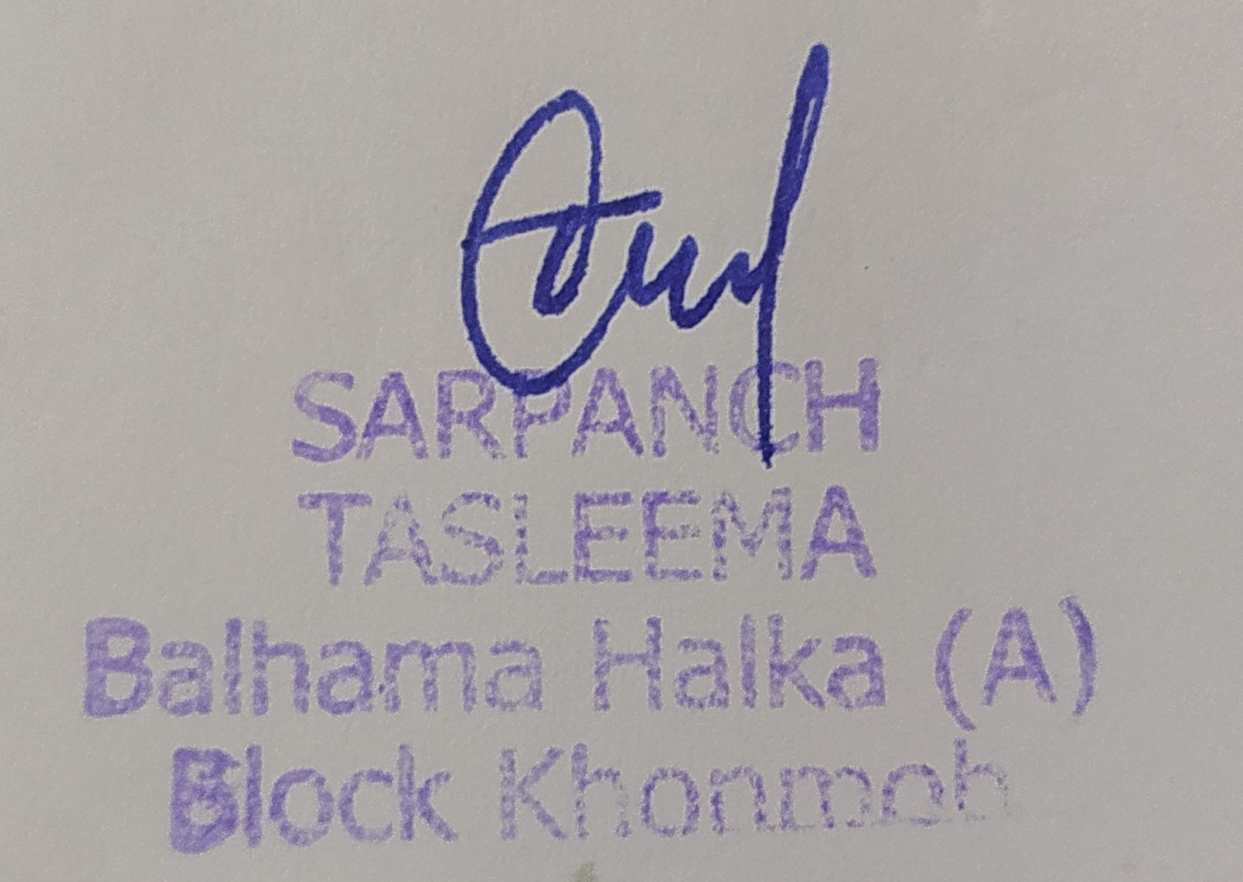 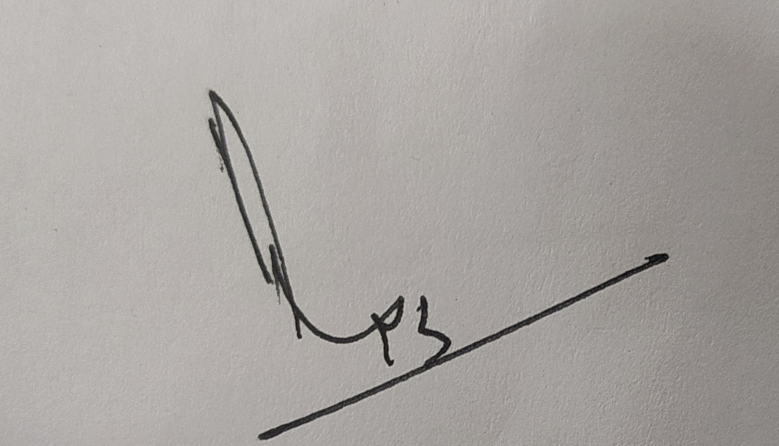

**Signature of Sarpanch Signature of the Visiting Officer**

\

**Name: Tasleema Maqbool Name: Waseem Ahmad Lone**



**Department of Rural Develompent and Panchayati Raj**

**Government of Jammu &Kashmir**