4





**15TH OCTto3RD NOV,2022**

**KEYFEATURES**

• DeputyCommissionerstoleadtheinitiative

• RuraldevelopmentDepartmenttobethenodaldepartment

• PlanningDevelopment&MonitoringdepartmentandITtobethesupport departments

**ACTIONSANDTIMELINES**

|  |  |  |  |
| --- | --- | --- | --- |
| **ACTION** | **RESPONSIBILITY** | **LATESTBY** | **REMARKS** |
| **Janabhiyan** | Alldepartments | Oct15-26th | Goingon |
| **DeputationofSecttstaff/ HoDs** | GAD | Oct14 | Done |
| **DeploymentofStaffto Panchayatsandservingof ordersondeployedofficers** | DCs | Oct25 | DCswilldeployseniorlevelstaff fromthedistricts.Strictactionto betakenagainstabstentions.No exemptionstobegiven |
| **Trainingofdistricttrainors onB2V4** | RDD | Oct26 |  |
| **Trainingofvisitingofficers** | DCs | Oct27 |  |
| **FieldVisitstobecompleted by** | VisitingOfficers | Nov3 | DCstosuperviseandensurethat eachPanchayatisvisitedwithin theperiodspecified |
| **DataofB2V4tobe uploadedby** | VisitingOfficers | Nov10 | DCstosuperviseandensurethat dataofallPanchayatsisupload- edbythevisitingofficerwithin theperiodspecified |

**INSTRUCTIONSFORTHEVISITINGOFFICER(DAYWISE)**

|  |  |  |
| --- | --- | --- |
| **DATE** | **INSTRUCTIONS** | **ACTIONPOINTS** |
| **Day0** | Meetingwithdeputy commissionerandhis/her team | a. TakeprintoutsoffilledbookletsofB2V1,B2V2andB2V3from [www.jkpanchayat.in](http://www.jkpanchayat.in)  b.Alsotakeprintoutsofthesummarizedexcelsheetsofthe previousphasesfrom[www.jkpanchayat.in](http://www.jkpanchayat.in)  c. CollectATRsonissuesraisedduringprevious3phasesfromthe officeofDeputyCommissioner(Planningdeptt)  d.Takeprintsofblank 2bookletsofB2V4from[www.jkpanchayat.in](http://www.jkpanchayat.in)e.Takeplansfor2previousyearsandATRsfromtheplanningdeptt f. CompletetrainingsondifferentcomponentsofB2V4being  organizedbyrespectiveDeputyCommissioners  g.CollectListofnewworksstarted/ongoing/completedduringthe previousandcurrentFinancialyearunderthefollowingheads:  • PRIgrants  • DistrictPlan  • UTplan  • MGNREGA  • Otherschemesofotherdepartments  • Anyotherwork  h. Plans/beneficiarylists:  • MGNREGAdraftplandocumentfortheyear2022-23.  • ListofAwaas+beneficiariesalongwithIHHL Convergence  • Listofpensionbeneficiaries.  • ListofSHGs  • Listofagricultureschemebeneficiaries  i. Listsofbeneficiariesfor:  • Variouscertificates/benefitstobedistributedbythe visitingofficer.  • Anyotheractivitiesidentifiedbydifferentdepartments |

|  |  |  |  |
| --- | --- | --- | --- |
| **Day1** | Reachthevillage | 1. | Ensurethatallfrontlineworkersofdifferentdepttsarepresent. |
|  |  | 2. | Ensureexhibitionbydifferentdepts.aboutindividualbeneficiary schemes |
|  |  | 3. | InspectJKB/PSBcounters/outlets |
|  |  | 4. | Participate/ensureorganizationofsportsactivityinplayfield,talent hunt/culturalevent/youthactivity |
|  |  | 5. | GandhiKatha(suggesteddetailsuploadedonjkpanchayat.in) |
|  |  | 6. | Visitatleast2amritsarovarsandgetitsgeotaggedphotos |
|  |  | 7. | InspectKhidmat(CSC)CentresandcreateGenerateawarenesson  225schemesparticularlyG2CschemeslikeBEAMS,Janbhagidari, AapkiZaminAapkiNigrani,DigitalJ&K |
|  |  | 8. | Visitingofficershallalsoplanandconductpanchayatlevelconver- gencemeetingofalldepartments |
|  |  | 9. | CheckeffectivenessofCentrallysponsoredschemes |
|  |  | 10. | VisitandinspectallgovernmentestablishmentsincludingPHE, AWC,FPS,schools,etc |
|  |  | 11. | Attemptsaturationofdeliverableso JanAbhiyanandwherever deficienciesfound,leadadrivetoachievealldeliverables |
|  |  | 12. | Assesseffectivenessofsanitationcampaigninthepanchayat |
|  |  | 13. | Ensureselfemploymentactivitiesfor15youthperpanchayat |
|  |  | 14. | Identify20potentialcandidatesperpanchayatforHIMAYATtraining alongwiththetradeonwhichtheywanttraining |
|  |  | 15. | Whereverpossible,distributeemploymentlettersforpeopleselect- edundervariousgovernmentemployments |
|  |  | 16. | Intheevening,holdnormalmeetingwith seniorcitizens,govtem- ployeesincludingretiredemployees,exservicemen,youthclub,and any citizens ofthevillagewhoareenrolledincollege/university |
|  |  | 17. | OpendiscussiononNashaMuktAbhiyan |

Day2 Haveameetingwithall stakeholders-depttofficials andpanchayatmembers

1. Discussionontheandassesstheprogressofdifferentschemesrelating tothelocalizedSDGsprioritizedforthatvillageaspertheresolution passedby thatGramPanchayaton21st April22,onNationalPanchayti RajDay.

2. Sensitizevillage residentsaboutmyScheme”portal(myscheme.in) whichincludesinformationaboutalltheschemesbeingrunbyCen- tral/State/UTgovtacrossthecountry

3. Hold meeting of theBiodiversityManagementCommitteestodeliber- ateonissuespertaining toconservation of biodiversityandsustaina- bleutilizationof biologicalresources.

4. PrepareVillagedevelopmentplan,inconsultancywithGrampanchayat, discussitingramsabhaandgetitapproved.

5. Ensure saturationofsoilhealthcardandgoldenhealthcardunderGold- enHealthCardunderAyushmanBharat,

6. Ensuresaturation of OldAge PensionScheme

7. EnsureDomicileSaturation.

8. EnsureKCCSaturation

9. Ensure saturationoflandpassbooks

10. Ensureregistrationofvillagevendorsneededforanyscheme,onGEM

portal

11. Ensurepanchayatcontractors registration

12. EncouragePanchayatmembers forimportanceofplantationdrivein

PanchayatunderHarGaonHariyali

13. Ensure paintingondigitalJ&Kinpanchayatghars

14. Ensure paintingonpanchayatactivitesandCSSinpanchayatghars

15. Thevisiting officeshallchecknoof kindergarten andplayfields present inthepanchayat for kidsandstudents,iftheinfrastructure present inthesearegoodenough.

16. Holdmeeting withpanchayatmembers todiscussaboutcorruption menaceandstepsrequiredtomakeJ&Kcorruptionfree

17. Obtaina candidassessmentaboutperformanceofvariousdeptts in- cludingfairfeedbackaboutdiscrepanciesinfunctioning

18. Check thestatusof NashaMuktAbhiyanandreporting of drugad- dictstoDeputyCommissioner.

19. IdentifyTouristDestinations,Circuits,ThemeTreks,IdentifyHomestays, providesupportfortourismactivities throughVillageCooperative

20. OrganizeTalentHuntatPanchayatLevel

21. Conductsocialauditofatleast5worksunderfollowingschemes:

a. MGNREGA

b.PMAY

c. IHHLtoiletsandpayments d.CSCs

e.AMRITSAROVARS

22. Holda mahilasabha anda balsabhaandrecordproceedingsinthefor- matgiven

23. InauguratevillagehaatunderJKSRLM

24. Checkifyouthclubsareformedinthepanchayatandwhatactivities theyareengagedin

25. Organizea villagelevelculturaleventtoengagepanchayatmembers

26. SensitizeGPaboutE-kitabkoshaninitiativeofJ&KGovtforempowering youthsthrough onlinedigitalliteracy

**GENERALINSTRUCTIONS**

1. Thevisitingofficershallrefrainhimself/herselfgivingorofferinganycommitmentonbehalfofthe governmentandshalladoptanunbiasedattitudeinreportingissues.As faraspossible,his/her observation shouldbebasedona fairandanalytical viewemergingfromhis/herinteractioninthe village.

2. Heisgoingtothevillageasplanningofficer,notforsanctioninganyworksorformakinganycom- mitments.

3. Whilepreparingvillagedevelopmentplan,hehastoensurethat,demandsareprioritizedandre- flectedunderavailableschemes,wherevernecessarythelargerworksaretobereferredtoadminis- trativedepttunderCSS/UTplansunderintimationtoDCsandrestoftheworkstoDCsforreflecting itunderdistrict/CSS plans

4. His workshallbehardcoreplanningandauditandisnota PRexercise.

5. EveryDeputyCommissionerhastoensurethatatleastoneRDDofficial(ideallyPanchayatSecre- tary)ispresent ineverypanchayatwithrelevantpanchayatrecords,toensureconductofallactivi- tiesasplanned.Panchayatwiseorderneedstobeissuedinadvance.

6. Visitingofficershouldideallycarryhis/herlaptoptocompletethereportsatthepanchayatlevel itselfanduploadthefinalreport,duly signedbothbythesarpanchandbythevisitingofficeron [www.jkpanchayat.in](http://www.jkpanchayat.in)portal,beforetheyleavepanchayat.

7. Focus ofvisitareyouth,skills,self-employment,nashamukt,bhrashtracharmukt,Rozgaryukt J&K, besidestocarryforwardtheactivities duringJanAbhiyanandsaturatethem.

8. Inadditionattentionmaybegiventothefollowingareas a. MakefulluseofCentrallySponsoredSchemes

b.Saturationofindividualbeneficiaryschemes c. Self-employmentschemes

d.Banklinkedschemes-includingdepartmentalsubsidyschemes e.Empowermentandtransparencythrough digitalinitiatives

f. Effectivenessofgrassrootsmachinery–

i. Patwari,VLWpresent andavailable

ii. AvailablefundsutilizedinpublicinterestandasperGramSabharesolutions

iii. Fairness ingovernance

iv. CSS/Individual beneficiaryschemesetc

v. BrashtacharMuktJ&K

vi. BhaiMuktJ&K

vii. NashaMuktJ&K

9. ThePRImembers (Sarpanchs,Panchs,BDCChairperson)shallbeattheforefrontofallactivities and givendueimportanceandtheapproach shouldbetostrengthenthemandmakethemfeelem- powered.He/sheshallensurethattheBDCchairpersonandSarpanch/Panch arepresent atthetime ofinaugurationandceremonies.

10. Visitingofficershallnotleavethedistrictwithoutuploadingthereport,duly signedonthe**www. jkpanchayat.in**portal.EveryDeputyCommissionerhastoensurethat.

**A) DetailsofReportingOfficer:**

Name: Dr. Syed Altaf Gilani

Designation: Poultry Development Officer, Srinagar.

Department/placeof posting: Animal Huspandry Department, Srinagar.

MobileNo: **9419008623**

EmailID: **gilanismaltaf@gmail.com**

HomeDistrict: **Srinagar**

Dates of visit: **2nd and 3rd Nov. 2022**

**B) LocationaldetailsofPanchayat:(tobepre-filled,informationtobetakenfromtheprevious phasesbooklets/summarizedexcelsheetuploadedonjkpanchayat.in/b2v4.php)(tobevali- datedbythevisitingofficerandmissingdetailstobefilled)**

NameofthePanchayat: **Faqir Gujree - B**

Local Government Directory (LGD)code of the Panchayat: **274482**

Nameof CDBlock: **Harwan**

NameofTehsil: **Srinagar North**

Nameof District: **Srinagar**

**C) PanchayatProfile:**

No.of revenue villages in the Panchayat: **01**

No. of hamlets in the Panchayat: **01**

No .of households in the Panchayat: **217**

Population(approx)of the Panchayat: **2066**

**Part-II:**

(TobefilledupbytheVisitingOfficerduringhis/hertwodayvisittothePanchayat.AllFieldshavetobe

filledbytheVisitingOfficerbeforethebookletishandedovertotheDC

**FrontlineOfficers/OfficialswhowereassignedtothePanchayatfortheprogramme:**

|  |  |  |
| --- | --- | --- |
| Department | Name | Designation |
| J&k BANK | Ishtiyaq Ahmad | Branch Head |
| Floriculture | M. Hussain Parray | AFO |
| Sheep Husbandry | Dr. Sumiyah | VAS |
| Fisheries | Masood Ah Dar | F/S |
| Industries | Syed Zeeshan | IPO |
| Mission Shakti | Rehana Qadir | Gender Specialist |
| Labour Department | Abdul Hamid | Labour Inspector |
| Animal Husbandry | M. Saleem Bhat | SVP |
| Apiculture | Sajad Ahmad Wani | Lab. Assistant. |
| DIC | Ishfaq Ah. Wani | Employment Officer |
| Agriculture | Ajaz Ah. Bhat | Ic/ DAEO |
| PHE | Mukhtar Ahmad | Astt. Lineman |
| PDD | Bilal Ah. Bhat | Orderly |

***Other Departments present: ICDS, Revenue, Youth Services & Sports, Social forestry, Urban Forestry, PWD, JKSRLM, Sericulture, Apiculture, I&FC Deptt, CAPD, Geology and Mining***

**Details of absent employees vis-à-vis list furnished by the DC office:**

|  |  |  |
| --- | --- | --- |
| Department | Name | Designation |
| PMGSY |  |  |
| Tribal Affaires |  |  |
| Skill Dev.& Entrepreneurship |  |  |
| Food Processing industries. |  |  |
| National Disaster Man. Authority |  |  |
|  |  |  |
|  |  |  |
|  |  |  |
|  |  |  |
|  |  |  |
|  |  |  |
|  |  |  |

**DAY1-ACTIVITIES**

**AGENDA1:PANCHAYATASSETREGISTER**

**Infrastructure:**

1. PanchayatGharInfrastructure ***Not Available***

a. Govtbuilding/private

b. New/needingrepairs

2. Furniture(Y/N) ***Yes***

3. Computer/printer(Y/N) ***No***

4. Internet(Y/N) ***No***

5. Telephone(Y/N) ***No***

6. Toilet(CSC/part of panchayat ghar)(Y/N )  ***No***

7. Water(Y/N) ***No***

8. Electricity(Y/N) ***No***

9. Bank branch(Y/N) ***No***

10. CSC(Y/N) ***No***

11. Patwarkhana(Y/N) ***No***

12. Villagehaat(Y/N) ***No***

13. Playground(Y/N) ***Yes***

14. School-

a. Kindergarten(Y/N) ***Yes***

b. Primary(Y/N) ***Yes***

c. Secondary(Y/N) ***No***

d. College (Y/N) ***No***

e.University(Y/N) ***No***

15. AnganwadiCentre(Y/N) ***Yes***

a. (govt/private) ***Private***

b. Totalchildrenenrolled ***171***

15. Amrit Sarovars–details, location, condition ***01 No at Padshapal Dardkhover in Good Condition.***

16. Government offices-details , whether functional or not ***NO***

17. Rationshop(Y/N)  ***Yes***

18. Placesoftourismimportance–names,littledetailsonhistorical/culturalimportance:

***Paragliding at Astanmarg.***

19. Village heritage sites/treks-names ,little details on historical/cultural importance:

***Mammat, Ladivas and Mahadev.***

20. VLWOffice (Y/N)  ***Yes***

21. PrimaryHealthcareCentre(Y/N), ***NO***

22. List of Incomplete Buildings-names, year of construction  ***Nil***

23. ListofUnderutilizedBuildings-names ***Nil***

**DAY1-ACTIVITIES**

**AGENDA2:**

**DIFFERENTINSTITUTIONS/INFRASTRUCTUREPROJECTSTOBEVISITED**

|  |  |  |
| --- | --- | --- |
| **AMRITSAROVARS** | **Visit,verify** | **COMMENTS** |
| Khidmat Centres | Create/Generateawarenesson225schemes particularlyG2CschemsAapkiZaminAapkiNigrani, Beams,Janbhagidari,DigitalJ&K | ***Not Available*** |
| JKB/PSBcounters/outlets | a)Statusofcounter b)Numberofvisitors | ***Functional At Site***  ***50*** |
| Incompletebuildings/pro- jects | Verify whetheridentificationandredistribution done | ***Not Applicable*** |
| PDS | Visit,evaluate,onlinestatus | ***Requires Additions*** |
| PHC | Visit-evaluate,statusofstaff,equipmentand quality | ***Not Available*** |
| Youthclubs | Meet,interact,seeksuggestions | Interacted, Need Employment |
| SHG | Meet,identifyproblems,seeksuggestions | Interacted Seeks Market |
| PMAY | Inspect,Inaugurate | Only first installment released |
| Myschool,mypride progress;schools-water, toilets,staff | Visit,checkforwater,electricity,sanitation,meet studentsandstaff | Need Kitchen Sheds |
| Swachh SBM | Evaluate | Need more CSC and IHHL units. |
| Panchayatplayground, Sportskitsdistribution Villagegames | Ensure, verify. Participate in at least one game in the playground | Participated in Cricket. |
| Har Gaon Hariyali, Plantation drive | Evaluate status, feedback | Plantation drive held. |
| Village cultural event  Dangal/Haat/Mela | Participatein;ensurethatitisheld | Inaugurated. |
| Exhibition of schemes | Ensure that every department participates and that it continues for the entire duration of B2V |  |
| JalJeewanMission verifica- tion- WSS/JSD  Electricitysupply | Verify | Panchayat having tap water.  Requires more electric poles. |

**DAY1-ACTIVITIES**

**AGENDA3:SATURATEJANBHIYAN**

**DELIVERABLESANDRECORDDEFICIENCIESIFANY(INSERTDELIVERABLESLISTHEREASPERGADFORMAT**

|  |  |  |  |  |
| --- | --- | --- | --- | --- |
| **S.No** | **DEPARTMENT** | **WORK/DELIVERABLE** | **ASSISTED BY** | **REMARKS** |
| 1. | RDD | ALL B2V WORKS- Document,  *Verify, Complete* | DC | 100%  (as reported by field functionaries present)  Accomplished |
|  |  | All GPDPs to be prepared and |  |
|  |  | finalised under convergence |
|  |  | mode |
|  |  | Panchayat Awards to be finalised |  |
|  |  | VILLAGE HAATS –*Establish* | NRLM |
| 2. | IT | 1. CSC CAMPS- ONE PER PANCHAYAT 2. ALL 225 ONLINE SERVICES- Popularise, Inform 3. Beams, *Jan Bhagidari*- Assist in Access, Demonstrate, Educate, Inform, 4. Hoardings, Wall Paintings in all Panchayats about Digital J&K and services 5. Assist in enrollment of user services- Golden Cards, Domiciles, UDID etc | CSC | Accomplished |
| 3. | FINANCE | 1. SELF EMPLOYMENT TO AT LEAST 15 PERSONS/Panchayat 2. All INDIVIDUAL SUBSIDY SCHEMES- *Counter to be set up by banks at Panchayat level to verify, Sanction, disburse cases and also accept fresh applications* 3. ADHAAR SEEDING OF ALL INDIVIDUAL BENEFICIARY SCHEMES | J&K BANK EDI LABOUR | --  -- |
|  |  |  | 100% (As reported by field functionaries present) |

|  |  |  |  |  |  |
| --- | --- | --- | --- | --- | --- |
| 4. |  | REVENUE | 1. APKI ZAMIN APKI NIGRANI-   *Inform, popularise*   1. PATWAR KHANA- *Verify, Establish, Paint information and timings* 2. INHERITANCE MUTATIONS-   *Complete*   1. LAND PASSBOOKS-generate and Issue for undisputed entries | DC IT CSC | --  --  --  100%  (as reported by Field Staff Present) |
| 5. |  | HEALTH | 1)PMJAY GOLDEN CARDS-  *Saturate* | NHM | 100%  (as reported by Field Staff Present) |
| 2) *Swachh* hospitals- *clean*  *toilets, junk free premises* |
| 6. |  | SOCIAL WELFARE | 1. DIVYANG CAMPS- *Hold Camps, ensure fittings* 2. DISABILITY CARDS (UDID) –   *All existing 2.5 lakhs UDID Cards to be made digital*   1. NOAPS/ISSS PENSIONS- Audit, *Saturation of wall paintings of pension beneficiaries* 2. *POSHAN VATIKA*-*ensure 100% plantation* 3. 500 ANEMIA CHECK UP CAMPS-*Conduct* 4. AADHAR SEEDING- *Ladli Beti* beneficiaries, *Aanganwadi* beneficiaries 5. BBBP events, at least 5 in every district 6. Formation of Senior Citizens club in every Panchayat | Health | NIL  NIL |
|  |  |  |  | -- |
| Available |
| Done on monthly basis |
| Done  NA  NA |
| 7. |  | FOREST | 1) GREEN J&K CAMAPAIGN  –  *Jan Abhiyan*   1. One Village One Beat Guard 2. Forest for Fodder and livelihood   -*Complete all preparatory plantation activities in winter Plantation areas*  *- Audit of summer plantation in non summer plantation areas*  -*Saturate* |  | Started |
|  |  |  |  | ----- |



|  |  |  |  |  |
| --- | --- | --- | --- | --- |
| 4  8. | TOURISM | 1. TOURIST DESTINATIONS/CIRCUITS/THE MES TREKS/- *Identify, Delineate, Demarcate* 2. HOMESTAYS- *Identify* 3. VILLAGE COOPERATIVE-   Provide Support for Tourism activities | JKTDC | -- |
| 9. | CULTURE | 1) TALENT HUNT AT PANCHAYAT LEVEL *- Organise* | JKAACL | -- |
| 10. | LABOUR | 1) e- SHRAM- *Saturate* | CSC | 90% approx. (as reported by field functionaries  present) |
| 11. | SCHOOL EDUCATION | 1. Bringing back all out of school children 2. MY SCHOOL MY PRIDE- 3. PARENT TEACHER MEETING |  | 90 %  100%  NA |
| 12. | HIGHER EDUCATION | 1) INTRODUCE AND START  30  CREDIT SKILL COURSE IN 50 DEGREE COLLEGES   1. INTRODUCE RESEARCH UNDER NEP in 30 GDCs 2. COMPLETE AND Launch HRM MODULE UNDER e-Samarth Gov suite 3. FEEEDBACK OF 1,00,000 STUDENTS OF GDCs across J&K 4. MY COLLEGE MY PRIDE- ClEANLINESS Drive in every GDC |  | **NA**  **NA**  **NA**  **NA**  **NA** |
| 13. | YOUTH AFFAIRS | 1) Games in every  *Panchayat*- *Organise* |  | Done  (as reported by field functionaries present) |
| 14. | TRANSPORT | 1. COMPLETE SURVEY OF ALL UNDERSERVED AREAS IN THE UT 2. 100 cases under MUMKIN scheme |  | -- |



|  |  |  |  |  |  |
| --- | --- | --- | --- | --- | --- |
| 15  . | | TRIBAL | 1. ALL SCHOLARSHIP SCHEMES-   *Saturate*   1. PLAN FORMULATION OF ALL VILLAGES UNDER PMAAGY (ADARSH GRAM SCHEME) –   *Complete* | CSC | 4  NA |
| 16. |  | PDD | 1) DISTRIBUTION TRANSFORMERS-   1. *Check unique no,* 2. *identify DTS with low oil and top up,* 3. *identify DTs with load imbalance,* 4. *replace non standard fuses with standard fuses,* 5. *identify DTs without earthing and ensure proper earthing* 6. *remove foliage around DTs*   2) All cases of electrical accident claims pending to be resolved and put up for disbursement |  | **100 % achieve**  **NIL**  **NIL**  **NIL**  **NIL**  **NA** |
|  |  |  |  |
| 17. |  | CAPD | 1. SHIFT TO RATION CARD MANGEMENT SYSTEM (*RCMS*) 2. 100% GRIEVANCE REDRESSAL | IT | 100%  (as reported by field functionaries present)  NA |
| 18. |  | SKILL DEVELOPMENT | 1) SKILL TRAINING OF 13000 HEALTH STAFF AND ACCREDITATION TO NSDC/MSDE  2) COMPLETE ALL ADMISSIONS TO POLYTECHNICS |  | **NA**    **NA** |
|  |  |
| 19. |  | COOPERATIVES | 1) 25000 COOPERATIVE MEMBERS TO BE TRAINED |  | -- |
| 20. |  | SCIENCE & TECHNOLOGY | 1) Reach out to 10000 farmers for PM KUSUM SCHEME |  | -- |
| 21. |  | PWD | 1. 100% ONLINE PAYMENTS WITH NO MANUAL INTERFACE- *Implement* 2. COMPLETE JKPCC MERGER PROCESS |  | -- |
| 22. |  | ARI &TRAININGS | 1) INSPECTION OF 100 OFFICES AT BLOCK LEVEL- *Evaluate quality of work and grievance disposal, record keeping, inventory*  *management* |  | - - |



|  |  |  |  |  |
| --- | --- | --- | --- | --- |
| 23. | MINING | 1) 100% IMPLEMENTTAION OF E- CHALLAN WITH ZERO MANUAL  INTERFACE |  | -- |
| 24. | DMRR | 1. DISPOSE OFF ALL PENDING GRIEVANCES on relief commissioner grievances portal 2. TRAIN 250 APDA MITRAs |  | -- |
| 25. | GAD | 1. 100% BIOMETRIC ATTENDANCE ENSURE 2. ENSURE EPM BY ALL EMPLOYEES 3. 100% PROPERTY RETURNS FILED IN 4. 100% ONLINE APRs 5. HRMS IMPLEMENTATION |  | -- |
| 26. | JAL SHAKTI | 1. ACTIVATE ALL *PANI SAMITIS sensitise the local community/Gram Panchayats/Pani Samitis of their role and responsibilities in Planning,Implementation and Monitoring of JJM* 2. Awareness generation regarding mechanism for Water Quality and testing of   Water quality using Field  Testing Kits (FTKs) as per JJM guidelines. |  | 100% done  (as reported by field functionaries  present)  100 % done  (as reported by  field functionaries  present) |
| 27. | LAW | 1) 250 Awareness and Assistance camps through Legal Service Authority |  | -- |
| 28. | ESTATES | 1) Identify unauthorized  occupants of government accommodation |  | -- |
| 29. | PUBLIC  GRIEVANCES | 1) PERCEPTION OF  DEPARTMENTS AMONG PUBLIC  2) 50 KEY ISSUES OF CONCERN  LEADING TO GRIEVANCES-  *Identify* |  | --  -- |
| 30. | HOSPITALITY | 1) Training of all |  |  |
|  | AND PROTOCOL | employees of the department  2) Introduce and Implement | -- |
|  |  | Quality policy for the | -- |
|  |  | department |  |

|  |  |  |  |  |  |
| --- | --- | --- | --- | --- | --- |
| 31. |  | AGRICULTURE AND ALLIED SECTORS | 1. Individual beneficiary schemes including bank loan schemesSoil Health Cards 2. 5 KISAN MELAS- *Organise* | CSC  J&K BANK | 100% coverage  -- |
| 32. |  | FLORICULTURE | 1) TRAINING AND AWARENESS CAMPS FOR 1000 FARMERS IN COMMERCIAL FLORICULTURE-  *Organise* |  | -- |
| 33. |  | INDUSTRIES | 1. LAND ALLOTTMENT FOR PROJECTS WORTH Rs. 6000 crores 2. 100% PMEGP TARGETS TO BE ACHIEVED 3. PREPARATION AND SUBMISSION OF ALL 352 BRAP EVIDENCE POINTS UNDER EODB 4. CENTRAL INSPECTION SYSTEM TO BE MADE LIVE   ONLINE |  |  |
|  |  | Accomplished |



**DAY1-ACTIVITIES**

**AGENDA4:**

**SELFEMPLOYMENTACTIVITIES**

EnsureSelf-employmentactivities foryouth,distributeemploymentlettersforpeopleselectedunder varioussocialschemes(15ISTHETARGETPERPANCHAYAT)

**Numberofcasesindifferentcategoriessanctioned: *18 Cases* Detailsofthebanksanctioningit: *J&K Bank New Theed, Shalimar Branch***

**Total amount involved: *40.10 lac***

**DAY1 ACTIVITIES**

**AGENDA5**

Intheevening,holdinformalmeetings withseniorcitizens,govtemployees,retdemployees,youthclub andothercitizenswhoareenrolledoncollege/universityandhavediscussiononGandhiKatha,Nasha MuktAbhiyan,corruptionfreegovernance,doublingfarmersincomeandrecordtheproceedings

**DAY2**

a. NoofIndividualCompostPitsconstructed ***04*** b. No of Individual Soak Pits constructed ***04***

V. No.ofBiodiversitymanagementcommitteemeetingsheld: ***NA***

VI. IsthenameofSarpanchdisplayedoncitizeninformationboardsofallRD&PRschemes:Yes/No ***Yes***

VII. AreSarpanchsbeinginvolvedinstart/inaugurationofactivities:Yes/No ***Yes***

VIII. WhethersubjectshavebeenassignedbytheSarpanchtothePanchs:Yes/No ***Yes***

IX. Whethergrievancesredressalboxisinstalled:Yes/No ***Yes***

X. No of grievancesreceivedpertainingtoPanchayatlevel: ***NIL***

XI. No of grievances disposed of at Panchayat level: ***NIL***

XII. WhethertheSarpanch/PanchayatSecretaryhavedigitalsignatures:Yes/No ***Yes***

XIII. WhetherallMGNREGA/14thFCpayments arebeingmadebySarpanchthrough DigitalSignature

Certificate(DSC):Yes/No ***Yes***

**HUMAN RESOURCEAVAILABLEATTHEPANCHAYAT LEVEL:**

|  |  |  |  |  |
| --- | --- | --- | --- | --- |
| **SRNO.** | **DEPARTMENTWISESTAFF** | **NUMBERS** | | **NAMES** |
|  |  | SANCTIONED | ACTUAL |  |
|  | Ruraldevelopmentdepartment: BDO  JE GRS TA | 1  1  1  1 | 1  1  0  1 | Raja Majid Iqbal  Mudasir Shafi  Amir Haroon |
|  | SCHOOLEDUCATION: TEACHER  HEADMASTER ANYOTHER | 16 | 16 | M Altaf Koli, Sgakeela Bano, Manzoor Ah Phanbra, Liyaqat Ah Phambra,Ashiq Hussain Khan, Amina Akhtar, Bashir Ah Khan, Riyaz Ah Khatana, Mehraj u Din Ganai, Snobar Aalin, Liyaqat Ali Khan, Bilal Ah. Lone, Showkat Ah Ganai, Dilawar Ah Bajran, Ruksana Qadir,Nusrat Akhtar.  Razia Akhtar, ( on leave)  Mubeena Akhtar (Deputed) |
|  | JAL JEEVAN:  Asstt. Lineman  Daily Wager | 2  3 | 2  3 | 1.Gami Bajran,  2.Zubair Ah Bajran  1.Javid Ah Phamda  2.Farooq Ah Bajran  3.M Aslam Bajran |
|  | PDD: LINEMAN JE  ANYOTHER/M. R . | 3  1  1 | 3  1  1 | 1. Gh. Hassan Rather  2. M Lateef Khan  3.Bilal Ah Bhat  1.Ms. Kousar Shafi.  1. Gulzar Ah Ganai |
|  | FOOD&CIVILSUPPLIES  T.S.O.  S.K | 1  1 | 1  1 | Ab Hamid Kutoo  Ab Gani Rather |
|  | **AGRICULTURE&ANIMALHUSBANDARY**:  Agriculture: JAEO & GCO  Animal Husbandry  Sheep Husbandry: In charge and ASM  Hoticulture : Tech. IV | 1+1  1  1+2  2 | 2  1  3  2 | 1.Aijaz Ah Bhat  2.Asadullah  1. M Saleem  1. Gulzar Ah Bhat  2. Mudasir Ah  3. Manzoor Ah. Baba.  1. Mohammad Amin  2. Shameem Ahmad. |
|  | SOCIALWELFARE | 0 | 0 | -- |
|  | HEALTH: ASHA ANM/ BHW  AYUSHDOCTOR ALLOPATHICDOCTOR | 3  1  -  - | 3  1  -  - | 1. Naseema Ji (ASHA)  2. Shareefa Ji (ASHA)  3. Shameema Ji (ASHA)  1.Muhammad Hussain. (BHW) |
|  | ANYOTHERDEPARTMENT | 4 | 4 | 1. Syed Yasir Masood (BFO)  2. Shabir Ah Mir  3. Gh. Mohiu Din  4. Riyan Ah Bhat |

**DAY2-ACTIVITIES**

**AGENDANO.1**

DiscussionontheandassesstheprogressofdifferentschemesrelatingtothelocalizedSDGsprior-itizedforthatvillageaspertheresolutionpassedbythatGramPanchayaton21stApril22,onNational PanchayatiRajDay(Copyoftheresolutiontobetakenfrom[www.jkpanchayat.in](http://www.jkpanchayat.in)portalunderthelinkof GramSwarajMonth)

1. SDGs AGREED FORTHATVILLAGE,TOBEIMPLEMENTED BYMARCH2024:

2. STATUSOFWORKSUNDERTHEFOLLOWINGSCHEMES:

**1 Cleanandgreenvillage**

i.InitiativestakenbythePanchayatformanagingSolidandLiquidWaste ***Soakage Pit and Compost Pit.***

ii. Initiatives taken by the Panchayat for using green sources of fuel like solar,biogas ***Solar streat lights installed***

iii. Hasmappingoflanduse,waterbodies,forest,slopes,wetlands,degradedforestwithintheGram

Panchayatbeendone?Yes/No.IfNo,reason,thereof ***YES***

iv. Has the Climate Resilience Plan been developed for the GP? Yes/No ***NO***

v. StepstakenbytheGramSabhaabouttheclimatechangemitigationfactorslikereducingenergy consumption,usageoffossilfuels,plastics,non-renewablebuildingmaterialsandalsotopromote measureslikeplantingoftrees,conservingforests,usageofgoodagriculturalpracticeslikedrip irrigation,waterconservationmeasuresandconservationofwetlands.

vi. Whether schools have started segregating waste ***YES***

vii. Whether schools have their own compost/soakage pitsforsolid/liquidwastemanagement ***YES***

**2 Healthyvillage**

i) Aremeetings relatedtoVillageHealthandSanitationCommitteebeingheldregularly? ***YES***

ii) DoalltheeligibleindividualsbeenprovidedtheGoldenCard? ***YES***

iii) ArealltheChildrenbeingimmunizedaspertheSchedulerecommendedbyGovt.ofIndia? ***YES***

iv) ArealltheeligibleindividualsbeenvaccinatedagainstCOVID-19? ***YES***

v) DoesGramPanchayatensurethatallpregnantwomenaregettingnecessaryprenatalcheckups? ***YES***

vi) WhetherallthedeliverieswereInstitutionalizedorconductedbytrainedMidwives? ***Institutionalized.***

**3 Watersufficientvillage**

i) DoalltheIHHsintheGramPanchayathavewaterpipelineconnections? ***YES***

ii) WhetherGramPanchayathastakenstepsforgreywatermanagement.IfYespleasespecify ***Soakage Pits Constructed***

iii) DoalltheIHHsintheGramPanchayathavetoilets? ***NA***

iv) ArealltheIHHstoiletsfunctionalornot? ***YES***

v) DoalltheSchools/Anganwadicentershavea toiletfacilityornot? ***YES***

vi) Areallthetoiletsintheschools/Aaganwadifunctionalornot? ***YES***

vii) WhetherGramPachachayatBhawanhasseparate toiletsforwomenornot? ***NA***

**4 ChildFriendlyvillage**

i) Doallthechildrenundertheageof0-6yearsbeenenrolledintheAnganwadicentersforpre- schooling?Yes/NO ***YES***

ii) HowmanyBalSabha’swereorganizedintheGramPanchayat 12----------------

iii) WhethertheissuesraisedbyBalSabhaareaddressedduringtheGramSabha. Yes/NO ***YES***

iv) WhetherGramPanchayatistrackingthedatarelatedtodropoutchildrenandchildrenwithirregular attendance?Yes/NO. ***YES***

v) DoalltheschoolsundertheGramPanchayathaveseparate toiletsforgirlsandboys?Yes/No ***NA***

**5 Villagewithgoodgovernance**

i) IsCSClocatedintheGramPanchayatBhawanornot? ***NA***

ii) IsthelistofbeneficiariesrelatedtotheSchemes/ProgramsdisplayedontheGrampanchayatwallor not? ***YES***

iii) DoestheGramPanchayathasitsbuildingornot? ***NO***

iv) IstheGramPanchayatofficefunctionalornot? ***YES***

v) Aretheactivities approved undertheHalqaPanchayatDevelopmentPlandisplayedontheGram

Panchayatwallornot? ***YES***

vi) IsSocialAuditofearlierSchemes/Programscarriedoutornot? ***YES***

**6 Povertyfreeandenhancedlivelihoodvillage**

i) HasGramPanchayatdevelopedanycriteria fortheidentificationofthepoor?Yes/Noifyesspecify ***YES***

***Land Less and Low Income***

ii) HavealltheeligiblehouseholdsregisteredinPDSornot? ***YES***

iii) HasGramPanchayatprovidedspaceforSelf-helpGroupsinPanchyatGharforholdingmeetings or not?***NA***

iv) HavealltheeligiblehouseholdsbeenregisteredforPensionornot? ***YES***

v) HasGramPanchayatfacilitatedYouthforSkillEnhancementCoursesandPlacement? ***NO***

vi) HasJobCardsbeendistributedtoalltheeligibleindividualsunderMGNREGA? ***YES***

vii) HasGramPanchayatfacilitatedSHGsforBankAccountLinkages? ***YES***

**7 Socially secured village**

i) WhetherGramPanchayatismaintainingdatarelatedtoDifferentlyAbledPeople? ***YES***

ii) IsGramPanchayatOffice DisabledFriendlyornot? ***YES***

iii) Areprovisionsfora separate BudgetundertheResourceEnvelopeforWomenandChildrenmadeor not? ***NO***

iv) DoalltheSchools intheGramPanchayathavefacilitiesforDifferentlyAbledChildrenliketoilets, barrier-freeaccess,etc.,ornot? ***NO***

v) Arealltheeligibleindividualsaregettingpensions,likeoldagepension,widowpension,etc? ***YES***

vi) ArealltheeligiblehouseholdsgettingbenefitsfromIAYornot? ***YES***

**8 EngenderedDevelopmentinVillage**

i) HowmanyMahilaSabha’swereorganizedintheGramPanchayat ______**4_____**

ii) WhetherSHGsfederationshavebeenprovidedspaceformeetings inthePanchayatBhawan(Yes/ No) ***NA***

iii) WhetherGPshavetakenstepsforincreasingwomen’sparticipationinGramSabha(Yes/No) ***YES***

iv) NumberofwomenbeneficiariesheadedhouseholdscoveredunderPDS

system……**30**…………………

v) Numberofbeneficiaries(outoftotaleligiblepopulation)receivingsocialprotectionbenefitsunder

PradhanMantriMatritvaVandanaYojana………**35**………….

9 Self-sufficientinfrastructureinthevillage

i. Whether GP has a Community Hall with access to electricity, furniture, water supply, toilet……***NA***………………….

ii. Whether the Disaster management plan is available at the GP Level(Yes/No) ***NO***

iii. Whetherchild-friendlyparkwithrequiredfacilitiesisavailableinGP(Yes/No) ***NO***

iv. WhethertheGPhaseasyaccesstoGodownforstorage(Yes/No) ***NO***

v. Whetherstreetlightsareprovidedinpublicplacesforensuringsafety(Yes/No) ***YES***

**DAY 2 ACTIVITIES**

**AGENDANO.2**

SensitizevillageresidentsaboutmyScheme”portal(myscheme.in)whichincludesinformationaboutall theschemesbeingrunbyCentral/State/UT govtacrossthecountry

*(SchemeMaterialavailablefromhttps://jkpanchayat.in/b2v4.php)*

**DAY2ACTIVITIES**

**AGENDANO.3**

HoldmeetingoftheBiodiversityManagementCommitteestodeliberateonissues pertainingtoconserva- tionofbiodiversityandsustainableutilizationofbiologicalresources.HeshouldcheckPeopleBiodiversity register(PBR)ofthatpanchayatandreviewifBiodiversityManagementCommittee constitutedforthat panchayatis holdingminimum4meetings inayearandmeeting onceinevery3months *(RoleofBMC availableathttps://jkpanchayat.in/b2v4.php)*

COMMITTEEMEMBERS ***NA*** PRESENT

BIODIVERSITYREGISTERPHOTOS

PAST 4MEETINGDETAILS-DATES,MINUTESPHOTOS

**DAY2ACTIVITIES**

**AGENDA 4**

Visitingofficershallalsoplanandconductpanchayatlevelconvergencemeeting ofalldepartmentsand prepareVillagedevelopmentplanforvillage,inconsultancywithGrampanchayat,discussitingram sabhaandgetitapproved.

(GPDPformatavailableonhttps://jkpanchayat.in/b2v4.php)

**InadditionGPDPplanshallalsoinclude:**

▪ Tourist places which need to be developed ***Paragliding at Astanmarg.***

▪ Specificproductwhichneedstobedeveloped

▪ Tourism-home stays ***Need to be initiated.***

▪ 20 candidatesfortrainingunderHimayatschemealongwithtradeinwhich training is to be given ***Tourism department requires list of 10 youth as tourist guides for trecking.***

**DAY2ACTIVITIES**

**AGENDA5**

Ensuresaturationoffollowingschemesandgivestatus:

|  |  |  |  |
| --- | --- | --- | --- |
| **NAMEOFTHESCHEME** | **TOTALELIGIBLE BENEFICIARIESIN THE VILLAGE** | **TOTALBENEFICIARIESWHO AVAILEDTHEBENEFITSOFTHESCHEME** | **REASONSFOR PENDENCY** |
| GoldenHealthCardunder  AyushmanBharat | 585 | 585 | 100% coverage |
| Jananisurakshayojana | 24 since April | 24 | 100% |
| OLDAGEpension | 120 | 100% | NIL |
| Widowpension | 15 | 100% | NIL |
| Disabilitypension | 25 | 100% | NIL |
| Domicilecertificate | 650 | 650 | NIL |
| Kisancreditcard | 210 | 62 | Due to less scale of finance in agriculture. |
| PM kisan sammannidhi | 210 | 210 | NIL |

|  |  |  |  |
| --- | --- | --- | --- |
| Landpassbook | 1200 | 1150 | Online generated |
| Registrationofvillageven- dorsonGEMportal | NA | NA | NA |
| Registrationofvillagecon- tractorsonjktendersportal | NA | NA | NA |
| Registrationofvillagecon- tractorsonPWDportal | NA | NA | NA |
| Incompletebuildings/pro- jects | NA | NA | NA |

**DAY2ACTIVITIES**

**AGENDA6**

**NASHAMUKTABHIYAN**

1. Whether gram sabha resolution passed ***YES***

2. Detailsofactivities conducted ***Awareness, Pledge ceremony***

3. Whether all activities and GS resolution uploaded on jkpanchayats.in portal ***YES***

4. Howmanydrugaddictsinthevillage ***NIL***

5. WhetherreportedtotheDeputyCommissioner ***NA***

6. Howmanyregisteredforrehabilitationundergovernmentprogramme ***NA***

**DAY2ACTIVITIES**

**AGENDA7**

**SOCIALAUDIT**

Conductsocialauditofatleast5workseachunderfollowingschemes:

|  |  |  |  |  |  |  |
| --- | --- | --- | --- | --- | --- | --- |
| NAMEOFTHE SCHEME | DETAILSOFTHE WORKS | YEAROFWORK APPROVAL | AMOUNT APPROVED  FORTHEWORK | WHETHER  WORKEXECUTED SATISFACTORILY | GEO- TAGGED PHOTOS | ANY GRIEVANCE RECORDED RELATINGTOTHAT WORK |
| MGNREGA | Development of graveyard at faqir Gujri B | 2021-22 | 4.165 Lac | YES | YES | NO |
| PMAY | - | - | - | - | - | - |
| IHHL  UNDERSBM-G | Construction of IHHL unit | 2021-22 | 12000 | YES | YES | NO |
| CSCUNDER SBMG | Construction of CSC at Astanmarg | 2021-22 | 3 Lac | YES | YES | NO |
| AMRIT SAROVARS | Restoration of Spring at Chirandara | 2022-23 | 1.44Lac | YES | YES | NO |

**DAY2ACTIVITIES**

**AGENDA8**

**MAHILASABHA**

Totalwomeninthevillageabovetheageof18

Total attended : ***40***

Proceedings: ***Enclosed***

*(Plinsertpointerstobediscussedthere–referpalliproceedings)*

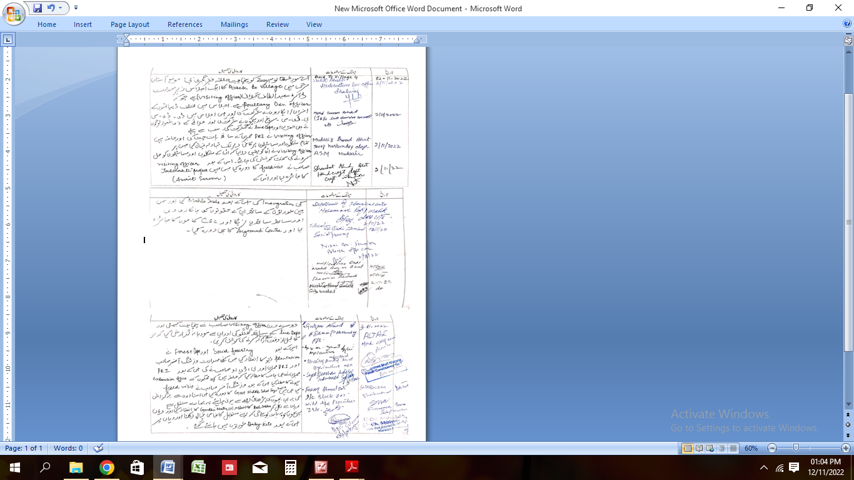

**DAY2ACTIVITIES**

**AGENDA9**

**BALSABHA**

Holda balsabhaandrecordproceedings

Totalchildreninthevillageabovetheageof….. Totalattended : ***30***

Proceedings: ***Enclosed***

*(Plinsertpointerstobediscussedthere–referpalliproceedings)*

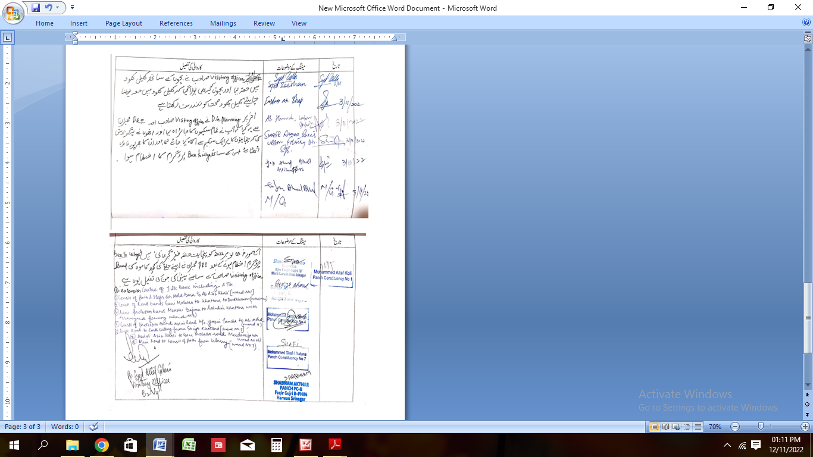

**DAY2ACTIVITIES**

**AGENDA10**

**INAUGURATIONS**

|  |  |  |  |
| --- | --- | --- | --- |
| **SR NO.** | **ASSETS/ACTIVITIES INAUGRATED** | **STATUSOFTHEASSET/AC- TIVITIES(NUMBER,OTHER DETAILS)** | **GEO-TAGGED PHOTOS** |
|  | VILLAGEHAATunderJKSRLM (SUN- DAYMARKET) | ***Existing*** | ***Done*** |
|  | PMAYhousesifanyreadyforinaugration | ***Under Construction*** | ***--*** |
|  | Swachhgramprojects-segregation shedsetc | ***NA*** | -- |
|  | Amritsarovars | ***Inaugrated*** | ***Done*** |
|  | Sportskits | ***Nil*** | ***--*** |
|  | Village cultural events | ***Nil*** | ***--*** |
|  | JJMassets/projects | ***Need RCC Slab of PHE Scheme near Scholar School for cover up*** | ***Done*** |
|  | Anyothertobeidentifiedatdistrict level | -- | -- |

**FOLLOW UP OF (B2V1,B2V2&B2V3):**

*(Prefilledexcelsheet tobetakenfromdistrictlevel/andalsotobedownloaded*

*from*[*www.jkpanchayat.in)*](http://www.jkpanchayat.in)

|  |  |  |  |
| --- | --- | --- | --- |
| S.NO. | Particulars | Actiontaken | Remarks# |
| I. **UrgentPublicRequirements/Demands-B2V1** | | | |
| 1 | *General Public Toilet / Installation of lights at graveyard* | Not Available |  |
| 2 | *Transport facility regularly* | Not Available |  |
| 3 | *Free Agriculture (availability inputs)* | Not Available |  |
| 4 | *Health centre with free medicines.* | Not Available |  |
| 5 | *Panchayatghar / playground / library* | Not Available |  |
| 6 | *Cow sheds under MGNREGA scheme* | Not Available |  |
| 7 | *Provision of financial assistance to SHG as the population is mostly BPL category.* | Not Available |  |
| II**. UrgentPublicRequirements/Demands-B2V2** | | | |
| 1 |  |  |  |
| 2 |  |  |  |
| 3 |  |  |  |
| 4 |  |  |  |
| 5 |  |  |  |
| 6 |  |  |  |
| 7 |  |  |  |
| S.NO. | Particulars | Actiontaken | Remarks# |
| III. **MajorProblems–B2V1** | | | |
| 1 | *Wild Animals* | Not Available |  |
| 2 | *Unemployment* | Not Available |  |
| 3 | *Dogs* | Not Available |  |

|  |  |  |  |
| --- | --- | --- | --- |
| 4 | *Polen (popular Trees)* | Not Available |  |
| 5 |  |  |  |
| IV. MajorProblems-B2V2 | | | |
| 1 | *Shifting of transformer to Dardkhover* | Not Available |  |
| 2 | *Providing of lights to graveyard at Masha Pajan.* | Not Available |  |
| 3 | *Earth filling of graveyard at Mashe Pajan* | Not Available |  |
| 4 | *Improvement of roads.* | Not Available |  |
| 5 |  |  |  |
| V. MajorProblems-B2V3 | | | |
| 1 | NIL |  |  |
| 2 | NIL |  |  |
| 3 | NIL |  |  |
| 4 | NIL |  |  |
| 5 | NIL |  |  |
| VI. MajorComplaints-B2V1 | | | |
| 1 | *Unemployment and lack of health centre, bank , ATM Panchayat and Transport facility*. | Not Available |  |
| 2 |  |  |  |
| 3 |  |  |  |
| VII. MajorComplaints-B2V2 | | | |
| 1 | *Drainage Roads and retaining wall for heavy snowfall* | Not Available |  |
| 2 | *Problem faced by concerned Pathwari* | Not Available |  |
| 3 |  |  |  |
| VIII. MajorComplaints-B2V3 | | | |
| 1 | *Lack of cooperation from the bank branch* | Not Available |  |
| 2 | *Lack of adequate staff at PSM Dispensary* | Not Available |  |
| 3 | *A bulk of labour class are figuring in APL category of FCS and CA department.* | Not Available |  |
| 4 | *Pendency of SRO43 cases* | Not Available |  |

**OVERALLPERCEPTIONOFFUCNTIONING OF GOVERNMENTDEPARTMENTS**

1. **BEST DEPARTMENT: *RDD***

**2. LEASTRESPONSIVEDEPARTMENT: *Tribal Affaires***

**GENERALASSESSMENTOFTHEVISTINGOFFICER**

|  |  |
| --- | --- |
| I | AnymajorcomplaintbroughttothenoticeoftheVisitingOfficer: ***Home Delivery of LPG Gas Cylinders*** |
| II | Major/urgentpublicdemandsthatwas/werereflectedearlierbuthavenotbeenaddressedsofar: ***ATM/Extention office of J&K bank*** |
| III | Overallassessmentofthevisitandsuggestions: ***Verymuch beneficial if followed up***  (Thevisitingofficertoensurethattheoverallassessmentisrecordedindetailsalongwithconcretesugges- tions) |
| IV | OverallRatingofgovtfunctioningas givenbythePanchayat(Scaleof0to10)  ***07*** |
| V | CertificatefromSarpanchthatthevisitingofficerhasstayedinthepanchayatfor2days ***YES*** |

**SignatureofSarpanch SignatureoftheVisitingOfficer**

**Name……………………… Name………………………**

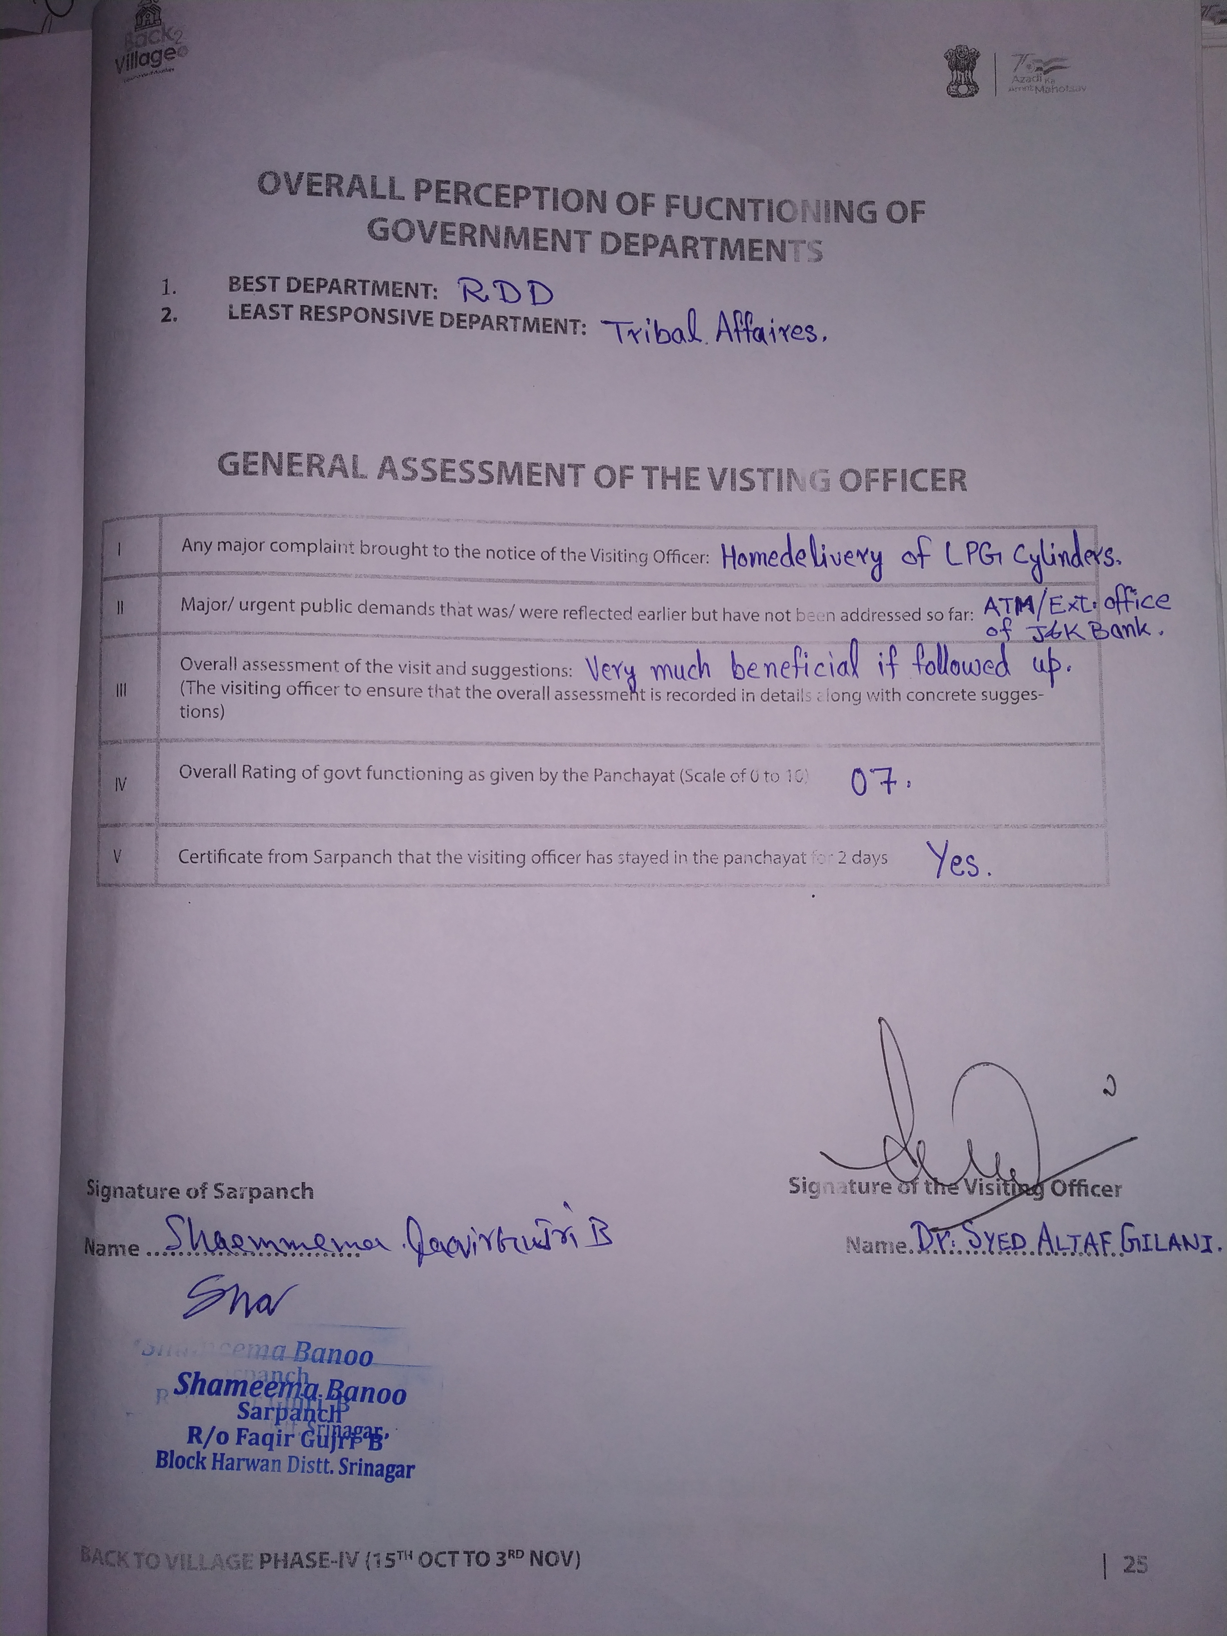



**DepartmentofRuralDevelompentandPanchayatiRaj**

**GovernmentofJammu &Kashmir**