4





**15TH OCTto3RD NOV,2022**

**KEYFEATURES**

• DeputyCommissionerstoleadtheinitiative

• RuraldevelopmentDepartmenttobethenodaldepartment

• PlanningDevelopment&MonitoringdepartmentandITtobethesupport departments

**ACTIONSANDTIMELINES**

|  |  |  |  |
| --- | --- | --- | --- |
| **ACTION** | **RESPONSIBILITY** | **LATESTBY** | **REMARKS** |
| **Janabhiyan** | Alldepartments | Oct15-26th | Goingon |
| **DeputationofSecttstaff/ HoDs** | GAD | Oct14 | Done |
| **DeploymentofStaffto Panchayatsandservingof ordersondeployedofficers** | DCs | Oct25 | DCswilldeployseniorlevelstaff fromthedistricts.Strictactionto betakenagainstabstentions.No exemptionstobegiven |
| **Trainingofdistricttrainors onB2V4** | RDD | Oct26 |  |
| **Trainingofvisitingofficers** | DCs | Oct27 |  |
| **FieldVisitstobecompleted by** | VisitingOfficers | Nov3 | DCstosuperviseandensurethat eachPanchayatisvisitedwithin theperiodspecified |
| **DataofB2V4tobe uploadedby** | VisitingOfficers | Nov10 | DCstosuperviseandensurethat dataofallPanchayatsisupload- edbythevisitingofficerwithin theperiodspecified |

**INSTRUCTIONSFORTHEVISITINGOFFICER(DAYWISE)**

|  |  |  |
| --- | --- | --- |
| **DATE** | **INSTRUCTIONS** | **ACTIONPOINTS** |
| **Day0** | Meetingwithdeputy commissionerandhis/her team | a. TakeprintoutsoffilledbookletsofB2V1,B2V2andB2V3from [www.jkpanchayat.in](http://www.jkpanchayat.in)  b.Alsotakeprintoutsofthesummarizedexcelsheetsofthe previousphasesfrom[www.jkpanchayat.in](http://www.jkpanchayat.in)  c. CollectATRsonissuesraisedduringprevious3phasesfromthe officeofDeputyCommissioner(Planningdeptt)  d.Takeprintsofblank 2bookletsofB2V4from[www.jkpanchayat.in](http://www.jkpanchayat.in)e.Takeplansfor2previousyearsandATRsfromtheplanningdeptt f. CompletetrainingsondifferentcomponentsofB2V4being  organizedbyrespectiveDeputyCommissioners  g.CollectListofnewworksstarted/ongoing/completedduringthe previousandcurrentFinancialyearunderthefollowingheads:  • PRIgrants  • DistrictPlan  • UTplan  • MGNREGA  • Otherschemesofotherdepartments  • Anyotherwork  h. Plans/beneficiarylists:  • MGNREGAdraftplandocumentfortheyear2022-23.  • ListofAwaas+beneficiariesalongwithIHHL Convergence  • Listofpensionbeneficiaries.  • ListofSHGs  • Listofagricultureschemebeneficiaries  i. Listsofbeneficiariesfor:  • Variouscertificates/benefitstobedistributedbythe visitingofficer.  • Anyotheractivitiesidentifiedbydifferentdepartments |

|  |  |  |  |
| --- | --- | --- | --- |
| **Day1** | Reachthevillage | 1. | Ensurethatallfrontlineworkersofdifferentdepttsarepresent. |
|  |  | 2. | Ensureexhibitionbydifferentdepts.aboutindividualbeneficiary schemes |
|  |  | 3. | InspectJKB/PSBcounters/outlets |
|  |  | 4. | Participate/ensureorganizationofsportsactivityinplayfield,talent hunt/culturalevent/youthactivity |
|  |  | 5. | GandhiKatha(suggesteddetailsuploadedonjkpanchayat.in) |
|  |  | 6. | Visitatleast2amritsarovarsandgetitsgeotaggedphotos |
|  |  | 7. | InspectKhidmat(CSC)CentresandcreateGenerateawarenesson  225schemesparticularlyG2CschemeslikeBEAMS,Janbhagidari, AapkiZaminAapkiNigrani,DigitalJ&K |
|  |  | 8. | Visitingofficershallalsoplanandconductpanchayatlevelconver- gencemeetingofalldepartments |
|  |  | 9. | CheckeffectivenessofCentrallysponsoredschemes |
|  |  | 10. | VisitandinspectallgovernmentestablishmentsincludingPHE, AWC,FPS,schools,etc |
|  |  | 11. | Attemptsaturationofdeliverableso JanAbhiyanandwherever deficienciesfound,leadadrivetoachievealldeliverables |
|  |  | 12. | Assesseffectivenessofsanitationcampaigninthepanchayat |
|  |  | 13. | Ensureselfemploymentactivitiesfor15youthperpanchayat |
|  |  | 14. | Identify20potentialcandidatesperpanchayatforHIMAYATtraining alongwiththetradeonwhichtheywanttraining |
|  |  | 15. | Whereverpossible,distributeemploymentlettersforpeopleselect- edundervariousgovernmentemployments |
|  |  | 16. | Intheevening,holdnormalmeetingwith seniorcitizens,govtem- ployeesincludingretiredemployees,exservicemen,youthclub,and any citizens ofthevillagewhoareenrolledincollege/university |
|  |  | 17. | OpendiscussiononNashaMuktAbhiyan |

Day2 Haveameetingwithall stakeholders-depttofficials andpanchayatmembers

1. Discussionontheandassesstheprogressofdifferentschemesrelating tothelocalizedSDGsprioritizedforthatvillageaspertheresolution passedby thatGramPanchayaton21st April22,onNationalPanchayti RajDay.

2. Sensitizevillage residentsaboutmyScheme”portal(myscheme.in) whichincludesinformationaboutalltheschemesbeingrunbyCen- tral/State/UTgovtacrossthecountry

3. Hold meeting of theBiodiversityManagementCommitteestodeliber- ateonissuespertaining toconservation of biodiversityandsustaina- bleutilizationof biologicalresources.

4. PrepareVillagedevelopmentplan,inconsultancywithGrampanchayat, discussitingramsabhaandgetitapproved.

5. Ensure saturationofsoilhealthcardandgoldenhealthcardunderGold- enHealthCardunderAyushmanBharat,

6. Ensuresaturation of OldAge PensionScheme

7. EnsureDomicileSaturation.

8. EnsureKCCSaturation

9. Ensure saturationoflandpassbooks

10. Ensureregistrationofvillagevendorsneededforanyscheme,onGEM

portal

11. Ensurepanchayatcontractors registration

12. EncouragePanchayatmembers forimportanceofplantationdrivein

PanchayatunderHarGaonHariyali

13. Ensure paintingondigitalJ&Kinpanchayatghars

14. Ensure paintingonpanchayatactivitesandCSSinpanchayatghars

15. Thevisiting officeshallchecknoof kindergarten andplayfields present inthepanchayat for kidsandstudents,iftheinfrastructure present inthesearegoodenough.

16. Holdmeeting withpanchayatmembers todiscussaboutcorruption menaceandstepsrequiredtomakeJ&Kcorruptionfree

17. Obtaina candidassessmentaboutperformanceofvariousdeptts in- cludingfairfeedbackaboutdiscrepanciesinfunctioning

18. Check thestatusof NashaMuktAbhiyanandreporting of drugad- dictstoDeputyCommissioner.

19. IdentifyTouristDestinations,Circuits,ThemeTreks,IdentifyHomestays, providesupportfortourismactivities throughVillageCooperative

20. OrganizeTalentHuntatPanchayatLevel

21. Conductsocialauditofatleast5worksunderfollowingschemes:

a. MGNREGA

b.PMAY

c. IHHLtoiletsandpayments d.CSCs

e.AMRITSAROVARS

22. Holda mahilasabha anda balsabhaandrecordproceedingsinthefor- matgiven

23. InauguratevillagehaatunderJKSRLM

24. Checkifyouthclubsareformedinthepanchayatandwhatactivities theyareengagedin

25. Organizea villagelevelculturaleventtoengagepanchayatmembers

26. SensitizeGPaboutE-kitabkoshaninitiativeofJ&KGovtforempowering youthsthrough onlinedigitalliteracy

**GENERALINSTRUCTIONS**

1. Thevisitingofficershallrefrainhimself/herselfgivingorofferinganycommitmentonbehalfofthe governmentandshalladoptanunbiasedattitudeinreportingissues.As faraspossible,his/her observation shouldbebasedona fairandanalytical viewemergingfromhis/herinteractioninthe village.

2. Heisgoingtothevillageasplanningofficer,notforsanctioninganyworksorformakinganycom- mitments.

3. Whilepreparingvillagedevelopmentplan,hehastoensurethat,demandsareprioritizedandre- flectedunderavailableschemes,wherevernecessarythelargerworksaretobereferredtoadminis- trativedepttunderCSS/UTplansunderintimationtoDCsandrestoftheworkstoDCsforreflecting itunderdistrict/CSS plans

4. His workshallbehardcoreplanningandauditandisnota PRexercise.

5. EveryDeputyCommissionerhastoensurethatatleastoneRDDofficial(ideallyPanchayatSecre- tary)ispresent ineverypanchayatwithrelevantpanchayatrecords,toensureconductofallactivi- tiesasplanned.Panchayatwiseorderneedstobeissuedinadvance.

6. Visitingofficershouldideallycarryhis/herlaptoptocompletethereportsatthepanchayatlevel itselfanduploadthefinalreport,duly signedbothbythesarpanchandbythevisitingofficeron [www.jkpanchayat.in](http://www.jkpanchayat.in)portal,beforetheyleavepanchayat.

7. Focus ofvisitareyouth,skills,self-employment,nashamukt,bhrashtracharmukt,Rozgaryukt J&K, besidestocarryforwardtheactivities duringJanAbhiyanandsaturatethem.

8. Inadditionattentionmaybegiventothefollowingareas a. MakefulluseofCentrallySponsoredSchemes

b.Saturationofindividualbeneficiaryschemes c. Self-employmentschemes

d.Banklinkedschemes-includingdepartmentalsubsidyschemes e.Empowermentandtransparencythrough digitalinitiatives

f. Effectivenessofgrassrootsmachinery–

i. Patwari,VLWpresent andavailable

ii. AvailablefundsutilizedinpublicinterestandasperGramSabharesolutions iii. Fairness ingovernance

iv. CSS/Individual beneficiaryschemesetc v. BrashtacharMuktJ&K

vi. BhaiMuktJ&K

vii. NashaMuktJ&K

9. ThePRImembers (Sarpanchs,Panchs,BDCChairperson)shallbeattheforefrontofallactivities and givendueimportanceandtheapproach shouldbetostrengthenthemandmakethemfeelem- powered.He/sheshallensurethattheBDCchairpersonandSarpanch/Panch arepresent atthetime ofinaugurationandceremonies.

10. Visitingofficershallnotleavethedistrictwithoutuploadingthereport,duly signedonthe**www. jkpanchayat.in**portal.EveryDeputyCommissionerhastoensurethat.

**A) DetailsofReportingOfficer:**

Name: **Sh. RAJINDER KUMAR**

Designation: **CHIEF HORTICULTURE OFFICER**

Department/placeof posting**: HORTICULTURE/ UDHAMPUR**

MobileNo: **7298126158**

EmailID: **rajinder.lochnn@yahoo.com**

HomeDistrict**: JAMMU**

Datesof visit: **1-11-2022 & 2-11-2022**

**B) LocationaldetailsofPanchayat:(tobepre-filled,informationtobetakenfromtheprevious phasesbooklets/summarizedexcelsheetuploadedonjkpanchayat.in/b2v4.php)(tobevali- datedbythevisitingofficerandmissingdetailstobefilled)**

NameofthePanchayat: **SUMWAL**

LocalGovernmentDirectory(LGD)codeof thePanchayat:  **289065**

Nameof CDBlock: **MAJALTA**

NameofTehsil: **MAJALTA**

Nameof District**: UDHAMPUR**

**C) PanchayatProfile:**

No.ofrevenuevillagesinthePanchayat:df **02**

No.ofhamletsinthePanchayat:  **10**

No.ofhouseholdsinthePanchayat:  **231**

Population(approx)of thePanchayat: **1282 (APPROX)**

**Part-II:**

(TobefilledupbytheVisitingOfficerduringhis/hertwodayvisittothePanchayat.AllFieldshavetobe

filledbytheVisitingOfficerbeforethebookletishandedovertotheDC

**FrontlineOfficers/OfficialswhowereassignedtothePanchayatfortheprogramme:**

|  |  |  |  |
| --- | --- | --- | --- |
| S.NO. | Department | Name | Designation |
| 1 | PDD | KUNDAN LAL | CASUAL LABOUR |
| 2 | ANIMAL HUSBANDRY | SAROTA RAM |  |
| 3 | IRRIGATION FLOOD CONTROL | NEERAJ SHARMA | SUPERVISOR |
| 4 | AGRICULTURE | AMIT BALOTRA | JAEO |
| 5 | FISHERY | PAWAN SHARMA | GUARD |
| 6 | HEALTH | SHILPA GULERIA | MLHP |
| 7 | HEALTH | DR FARAH CHOUDHARY | DENTAL SURGEON MANSAR |
| 8 | YOUTH SERVICES & SPORTS | RAHUL GUPTA | PHYSICAL TEACHER |
| 9 | KHADI & VILLAGE INDUSTRY | DEEWALKAR SINGH | JR. ASSISTANT |
| 10 | REVENUE | WASEEM AHMED | PATWARI |
| 11 | EDU. DEPTT. | RAKESH KUMAR | TEACHER |
| 12 | FOREST | MOHAN LAL | GUARD |
| 13 | PWD | VIJAY KUMAR | DAILY WAGER |
| 14 | PMGSY | AMIT ABROL | AEE |

**Detailsofabsentemployeesvis-à-vislistfurnishedbytheDCoffice:**

|  |  |  |
| --- | --- | --- |
| Department | Name | Designation |
| PHE | - | - |
| SOCIAL WELFARE | - | - |
|  |  |  |
|  |  |  |
|  |  |  |
|  |  |  |
|  |  |  |
|  |  |  |
|  |  |  |
|  |  |  |

**DAY1-ACTIVITIES**

**AGENDA1:PANCHAYATASSETREGISTER**

**Infrastructure:**

1. PanchayatGharInfrastructure

a. Govtbuilding/private PRIVATE (NEWLY CREATED PANCHAYAT. NO PANCHAYAT GHAR

b. New/needingrepairs

2. Furniture(Y/N) NO

3. Computer/printer(Y/N) YES

4. Internet(Y/N) NO

5. Telephone(Y/N) NO

6. Toilet(CSC/partofpanchayatghar)(Y/N) NO

7. Water(Y/N) NO

8. Electricity(Y/N) NO

9. Bankbranch(Y/N) NO

10. CSC(Y/N) YES

11. Patwarkhana(Y/N) YES

12. Villagehaat(Y/N) YES

13. Playground(Y/N) NO

14. School-

a. Kindergarten(Y/N) NO

b.Primary(Y/N) YES

c. Secondary(Y/N) NO

d. College (Y/N) NO

e.University(Y/N) NO

15. AnganwadiCentre(Y/N) YES

a. (govt/private) PRIVATE

b.Totalchildrenenrolled 114

15. AmritSarovars–details,location,condition NIL

16. Governmentoffices-details,whetherfunctionalornot 4 SCHOOL, 1 POWER STATION

17. Rationshop(Y/N) AVAILABLE IN BATTAL

18. Placesoftourismimportance–names,littledetailsonhistorical/culturalimportance NO

19. Villageheritagesites/treks-names,littledetailson historical/culturalimportance NO

20. VLWOffice (Y/N) NO

21. PrimaryHealthcareCentre(Y/N), NO

22. ListofIncompleteBuildings-names,yearofconstruction NO

23. ListofUnderutilizedBuildings-names NIL

**DAY1-ACTIVITIES**

**AGENDA2:**

**DIFFERENTINSTITUTIONS/INFRASTRUCTUREPROJECTSTOBEVISITED**

|  |  |  |
| --- | --- | --- |
| **AMRITSAROVARS** | **Visit,verify** | **COMMENTS** |
| KhidmatCentres | Create/Generateawarenesson225schemes particularlyG2CschemsAapkiZaminAapkiNigrani, Beams,Janbhagidari,DigitalJ&K | NO |
| JKB/PSBcounters/outlets | a)Statusofcounter b)Numberofvisitors | NO |
| Incompletebuildings/pro- jects | Verify whetheridentificationandredistribution done | INCOMPLETE ROAD |
| PDS | Visit,evaluate,onlinestatus | NIL |
| PHC | Visit-evaluate,statusofstaff,equipmentand quality | NIL |
| Youthclubs | Meet,interact,seeksuggestions | NIL |
| SHG | Meet,identifyproblems,seeksuggestions | NIL |
| PMAY | Inspect,Inaugurate | INSPECTED PMAY HOUSES |
| Myschool,mypride progress;schools-water, toilets,staff | Visit,checkforwater,electricity,sanitation,meet studentsandstaff | SCHOOL VISIT WAS DONE WHERE STAFF TOLD ABOUT WATER SUPPLY PROBLEM IN MS CHAWA& Road connectivity problem in pvt school srail |
| SwachhSBM | Evaluate | Toilets are functional in pyt |
| Panchayatplayground, Sportskitsdistribution Villagegames | Ensure,verify.Participateinatleastonegamein theplayground | Sports kit distribution. Games held at Middle School Chowa |
| HarGaonHariyali, Planta- tiondrive | Evaluatestatus,feedback | Going on smoothly |
| Villageculturalevent  Dangal/Haat/Mela | Participatein;ensurethatitisheld | RURAL HAAT INAUGRATED DURING B2V4 EVENT |
| Exhibitionofschemes | Ensurethateverydepartmentparticipatesand thatitcontinuesfortheentiredurationofB2V | AGRI Deptt exhibit their Scheme & Health deptt also participated |
| JalJeewanMission verifica- tion- WSS/JSD  Electricitysupply | Verify | NIL |

**DAY1-ACTIVITIES**

**AGENDA3:SATURATEJANBHIYAN**

**DELIVERABLESANDRECORDDEFICIENCIESIFANY(INSERTDELIVERABLESLISTHEREASPERGADFORMAT**

|  |
| --- |
| **DELIVERABLES** |
| **SATURATION OF AYUSHMAN HEALTH CARD** |
| **SATURATION OF SOIL HEALTH CARD** |
| **SATURATION OF KCC CARDS** |
| **SPORTS- KHO-KHO AND MIND GAMES ARE BEING DONE** |
| **CILTURAL ACTIVITIES- CULTURAL DANCE DONE BY SCHOOL STUDENTS** |
| **SATURATION OF LAND PASS BOOK ARE BEING ISSUED** |
|  |
|  |
|  |
|  |

**DAY1-ACTIVITIES**

**AGENDA4:**

**SELFEMPLOYMENTACTIVITIES**

EnsureSelf-employmentactivities foryouth,distributeemploymentlettersforpeopleselectedunder varioussocialschemes(15ISTHETARGETPERPANCHAYAT) _

**Numberofcasesindifferentcategoriessanctioned**

**Detailsofthebanksanctioningit:**

**Totalamountinvolved:**

**DAY1ACTIVITIES**

**AGENDA5**

Intheevening,holdinformalmeetings withseniorcitizens,govtemployees,retdemployees,youthclub andothercitizenswhoareenrolledoncollege/universityandhavediscussiononGandhiKatha,Nasha MuktAbhiyan,corruptionfreegovernance,doublingfarmersincomeandrecordtheproceedings

**DAY2**

a. NoofIndividualCompostPitsconstructed **10**

b.NoofIndividualSoakPitsconstructed **35**

V. No.ofBiodiversitymanagementcommitteemeetingsheld: NIL

VI. IsthenameofSarpanchdisplayedoncitizeninformationboardsofallRD&PRschemes:Yes/No YES

VII. AreSarpanchsbeinginvolvedinstart/inaugurationofactivities:Yes/No YES

VIII. WhethersubjectshavebeenassignedbytheSarpanchtothePanchs:Yes/No NO

IX. Whethergrievancesredressalboxisinstalled:Yes/No NO

X. NoofgrievancesreceivedpertainingtoPanchayatlevel;0

XI. NoofgrievancesdisposedofatPanchayatlevel: 0

XII. WhethertheSarpanch/PanchayatSecretaryhavedigitalsignatures:Yes/No YES

XIII. WhetherallMGNREGA/14thFCpayments arebeingmadebySarpanchthrough DigitalSignature

Certificate(DSC):Yes/No YES

**HUMAN RESOURCEAVAILABLEATTHEPANCHAYAT LEVEL:**

|  |  |  |  |  |
| --- | --- | --- | --- | --- |
| **SRNO.** | **DEPARTMENTWISESTAFF** | **NUMBERS** | | **NAMES** |
|  |  | SANCTIONED | ACTUAL |  |
|  | Ruraldevelopmentdepartment: BDO  JE GRS TA | 1  1  1  2 | 1  1  1  2 | VISHAL KUMAR SADHOTRA  RAVI KUMAR  DHEERAJ KESAR  SACHIN GUPTA&ANKUSH GUPTA |
|  | SCHOOLEDUCATION: TEACHER  HEADMASTER ANYOTHER | 16  1 | 15  0 | Om Parkash, Rashpal Singh,rokesh kumar, jaswant singh |
|  | JAL JEEVAN: | Nil | Nil |  |
|  | PDD: LINEMAN JE  ANYOTHER | 2  1 | 2  1 | 1 JE AT BLOCK LEVEL |
|  | FOOD&CIVILSUPPLIES | 1 | 1 | AT battal pyt not in sumwal |
|  | AGRICULTURE&  ANIMALHUS- BANDARY | 1  1  1(horticulture) | 1  1  1 | DARSHAN KUMAR, AMIT BALOTRA,KULDEEP SINGH, TOLA RAM, SAGAN SINGH, SUBASH SINGH |
|  | SOCIALWELFARE | - | - | - |
|  | HEALTH: ASHA ANM  AYUSHDOCTOR ALLOPATHICDOCTOR | 2  7  -  - | 2  7  -  - | Health centre is at battal( Kakrai) not at panchayat |
|  | ANYOTHERDEPARTMENT |  |  |  |

**DAY2-ACTIVITIES**

**AGENDANO.1**

DiscussionontheandassesstheprogressofdifferentschemesrelatingtothelocalizedSDGsprior-itizedforthatvillageaspertheresolutionpassedbythatGramPanchayaton21stApril22,onNational PanchayatiRajDay(Copyoftheresolutiontobetakenfrom[www.jkpanchayat.in](http://www.jkpanchayat.in)portalunderthelinkof GramSwarajMonth)

1. SDGs AGREED FORTHATVILLAGE,TOBEIMPLEMENTED BYMARCH2024:

2. STATUSOFWORKSUNDERTHEFOLLOWINGSCHEMES:

**1 Cleanandgreenvillage**

i.InitiativestakenbythePanchayatformanagingSolidandLiquidWaste -

ii. InitiativestakenbythePanchayatforusinggreensourcesoffuellikesolar,biogas

**-**

iii. Hasmappingoflanduse,waterbodies,forest,slopes,wetlands,degradedforestwithintheGram

Panchayatbeendone?Yes/No.IfNo,reason,thereof Yes ( in Abadideh area)

iv. HastheClimateResiliencePlanbeendevelopedfortheGP?Yes/No NO

v. StepstakenbytheGramSabhaabouttheclimatechangemitigationfactorslikereducingenergy consumption,usageoffossilfuels,plastics,non-renewablebuildingmaterialsandalsotopromote measureslikeplantingoftrees,conservingforests,usageofgoodagriculturalpracticeslikedrip irrigation,waterconservationmeasuresandconservationofwetlands. NIL

vi. Whetherschoolshavestartedsegregatingwaste NO

vii. Whetherschoolshavetheirowncompost/soakagepitsforsolid/liquidwastemanagement NO

**2 Healthyvillage**

i) Aremeetings relatedtoVillageHealthandSanitationCommitteebeingheldregularly?**NO**

ii) DoalltheeligibleindividualsbeenprovidedtheGoldenCard?**YES**

iii) ArealltheChildrenbeingimmunizedaspertheSchedulerecommendedbyGovt.ofIndia?**YES**

iv) ArealltheeligibleindividualsbeenvaccinatedagainstCOVID-19?**YES**

v) DoesGramPanchayatensurethatallpregnantwomenaregettingnecessaryprenatalcheckups?**YES**

vi) WhetherallthedeliverieswereInstitutionalizedorconductedbytrainedMidwives?**YES**

**3 Watersufficientvillage**

i) DoalltheIHHsintheGramPanchayathavewaterpipelineconnections? NO

ii) WhetherGramPanchayathastakenstepsforgreywatermanagement. NO

IfYespleasespecify

iii) DoalltheIHHsintheGramPanchayathavetoilets? YES

iv) ArealltheIHHstoiletsfunctionalornot? **YES**

v) DoalltheSchools/Anganwadicentershavea toiletfacilityornot? YES

vi) Areallthetoiletsintheschools/Aaganwadifunctionalornot? YES

vii) WhetherGramPachachayatBhawanhasseparate toiletsforwomenornot?NO

**4 ChildFriendlyvillage**

i) Doallthechildrenundertheageof0-6yearsbeenenrolledintheAnganwadicentersforpre- schooling?Yes/NO**YES**

ii) HowmanyBalSabha’swereorganizedintheGramPanchayat------**ONE**-------------

iii) WhethertheissuesraisedbyBalSabhaareaddressedduringtheGramSabha. Yes/NO**YES**

iv) WhetherGramPanchayatistrackingthedatarelatedtodropoutchildrenandchildrenwithirregular attendance?Yes/NO. **YES**

v) DoalltheschoolsundertheGramPanchayathaveseparate toiletsforgirlsandboys?Yes/No**YES**

**5 Villagewithgoodgovernance**

i) IsCSClocatedintheGramPanchayatBhawanornot? NO

ii) IsthelistofbeneficiariesrelatedtotheSchemes/ProgramsdisplayedontheGrampanchayatwallor not? NO

iii) DoestheGramPanchayathasitsbuildingornot? NO

iv) IstheGramPanchayatofficefunctionalornot? YES

v) Aretheactivities approved undertheHalqaPanchayatDevelopmentPlandisplayedontheGram

Panchayatwallornot? YES

vi) IsSocialAuditofearlierSchemes/Programscarriedoutornot? YES

**6 Povertyfreeandenhancedlivelihoodvillage**

i) HasGramPanchayatdevelopedanycriteria fortheidentificationofthepoor?Yes/Noifyesspecify **YES(PYT HAS MADE REWARD)**

ii) HavealltheeligiblehouseholdsregisteredinPDSornot?**YES**

iii) HasGramPanchayatprovidedspaceforSelf-helpGroupsinPanchyatGharforholdingmeetings or not?**NO**

iv) HavealltheeligiblehouseholdsbeenregisteredforPensionornot?**YES**

v) HasGramPanchayatfacilitatedYouthforSkillEnhancementCoursesandPlacement?**NO**

vi) HasJobCardsbeendistributedtoalltheeligibleindividualsunderMGNREGA?**YES**

vii) HasGramPanchayatfacilitatedSHGsforBankAccountLinkages?**NO**

**7 Sociallysecuredvillage**

i) WhetherGramPanchayatismaintainingdatarelatedtoDifferentlyAbledPeople? YES

ii) IsGramPanchayatOffice DisabledFriendlyornot? FRIENDLY

iii) Areprovisionsfora separate BudgetundertheResourceEnvelopeforWomenandChildrenmadeor not? NO

iv) DoalltheSchools intheGramPanchayathavefacilitiesforDifferentlyAbledChildrenliketoilets, barrier-freeaccess,etc.,ornot? YES

v) Arealltheeligibleindividualsaregettingpensions,likeoldagepension,widowpension,etc? YES

vi) ArealltheeligiblehouseholdsgettingbenefitsfromIAYornot YES

**8 EngenderedDevelopmentinVillage**

i) HowmanyMahilaSabha’swereorganizedintheGramPanchayat-----1------

ii) WhetherSHGsfederationshavebeenprovidedspaceformeetings inthePanchayatBhawan(Yes/ No) NO

iii) WhetherGPshavetakenstepsforincreasingwomen’sparticipationinGramSabha(Yes/No) YES

iv) NumberofwomenbeneficiariesheadedhouseholdscoveredunderPDS

system……12…………………

v) Numberofbeneficiaries(outoftotaleligiblepopulation)receivingsocialprotectionbenefitsunder

PradhanMantriMatritvaVandanaYojana……20…………….

9 Self-sufficientinfrastructureinthevillage

i. WhetherGPhasa CommunityHallwithaccesstoelectricity,furniture,watersupply, toilet……NO………………….

ii. WhethertheDisastermanagementplanisavailableattheGPLevel(Yes/No) NO

iii. Whetherchild-friendlyparkwithrequiredfacilitiesisavailableinGP(Yes/No) NO

iv. WhethertheGPhaseasyaccesstoGodownforstorage(Yes/No) NO

v. Whetherstreetlightsareprovidedinpublicplacesforensuringsafety(Yes/No) NO

**DAY2ACTIVITIES**

**AGENDANO.2**

SensitizevillageresidentsaboutmyScheme”portal(myscheme.in)whichincludesinformationaboutall theschemesbeingrunbyCentral/State/UT govtacrossthe**c**ountry

*(SchemeMaterialavailablefrom*[*https://jkpanchayat.in/b2v4.php*](https://jkpanchayat.in/b2v4.php)*)*

**DAY2ACTIVITIES**

**AGENDANO.3**

HoldmeetingoftheBiodiversityManagementCommitteestodeliberateonissues pertainingtoconserva- tionofbiodiversityandsustainableutilizationofbiologicalresources.HeshouldcheckPeopleBiodiversity register(PBR)ofthatpanchayatandreviewifBiodiversityManagementCommittee constitutedforthat panchayatis holdingminimum4meetings inayearandmeeting onceinevery3months *(RoleofBMC availableathttps://jkpanchayat.in/b2v4.php)*

COMMITTEEMEMBERS

PRESENT

BIODIVERSITYREGISTERPHOTOS

PAST 4MEETINGDETAILS-DATES,MINUTESPHOTOS NO MEETING HELD EARLIER

**DAY2ACTIVITIES**

**AGENDA4**

Visitingofficershallalsoplanandconductpanchayatlevelconvergencemeeting ofalldepartmentsand prepareVillagedevelopmentplanforvillage,inconsultancywithGrampanchayat,discussitingram sabhaandgetitapproved.

(GPDPformatavailableonhttps://jkpanchayat.in/b2v4.php)

**InadditionGPDPplanshallalsoinclude:**

▪ Touristplaceswhichneedtobedeveloped **NO**

▪ Specificproductwhichneedstobedeveloped NIL

▪ Tourism-homestays NO

▪ 20candidatesfortrainingunderHimayatschemealongwithtradeinwhich trainingistobegiven 13 CANDIDATES IDENTIFIED

**DAY2ACTIVITIES**

**AGENDA5**

Ensuresaturationoffollowingschemesandgivestatus:

S

|  |  |  |  |
| --- | --- | --- | --- |
| **NAMEOFTHESCHEME** | **TOTALELIGIBLE BENEFICIARIESIN THE VILLAGE** | **TOTALBENEFICIARIESWHO AVAILEDTHEBENEFITSOFTHESCHEME** | **REASONSFOR PENDENCY** |
| GoldenHealthCardunder  AyushmanBharat | 1434 | 1389 | Pending 45 |
| Jananisurakshayojana | 7 | 7 |  |
| OLDAGEpension | 67 | 40 | Pending due to incomplete document |
| Widowpension | 16 | 5 | Pending due to incomplete document |
| Disabilitypension | 8 | 2 | Pending due to incomplete document |
| Domicilecertificate | 2100 | 1600 | 500 PENDING |
| Kisancreditcard | 184 | 162 | Pending due to overage |
| PMkisansammannidhi | 102 | 102 | - |

|  |  |  |  |
| --- | --- | --- | --- |
| Landpassbook | 577 | 577 | 10 distributed today |
| Registrationofvillageven- dorsonGEMportal | NIL | NIL | - |
| Registrationofvillagecon- tractorsonjktendersportal | 5 | 5 |  |
| Registrationofvillagecon- tractorsonPWDportal | 5 | 5 |  |
| Incompletebuildings/pro- jects | 1 | 1 | ROAD PHASE I LARAY TO SUMWAL 3.3KM  SUMWAL TO SRAIL 3.7KM UNDER PMGSY |

**DAY2ACTIVITIES**

**AGENDA6**

**NASHAMUKTABHIYAN**

1. Whethergramsabharesolutionpassed YES

2. Detailsofactivities conducted SHAPATH THAKEN, PLEDGE, AWEARENESS

3. Whetherallactivities andGSresolutionuploadedonjkpanchayats.inportal YES

4. Howmanydrugaddictsinthevillage NIL

5. WhetherreportedtotheDeputyCommissioner NO

6. Howmanyregisteredforrehabilitationundergovernmentprogramme NO

**DAY2ACTIVITIES**

**AGENDA7**

**SOCIALAUDIT**

Conductsocialauditofatleast5workseachunderfollowingschemes:

|  |  |  |  |  |  |  |
| --- | --- | --- | --- | --- | --- | --- |
| NAMEOFTHE SCHEME | DETAILSOFTHE WORKS | YEAROFWORK APPROVAL | AMOUNT APPROVED  FORTHEWORK | WHETHER  WORKEXECUTED SATISFACTORILY | GEO- TAGGED PHOTOS | ANY GRIEVANCE RECORDED RELATINGTOTHAT WORK |
| MGNREGA | ENCOSED | - |  | YES | YES | NIL |
| PMAY | ENCLOSED |  |  | YES | YES | NIL |
| IHHL  UNDERSBM-G | ENCLOSED |  |  | YES | YES | NIL |
| CSCUNDER SBMG |  |  |  | YES | YES | NIL |
| AMRIT SAROVARS | - | - | - | - | - | - |

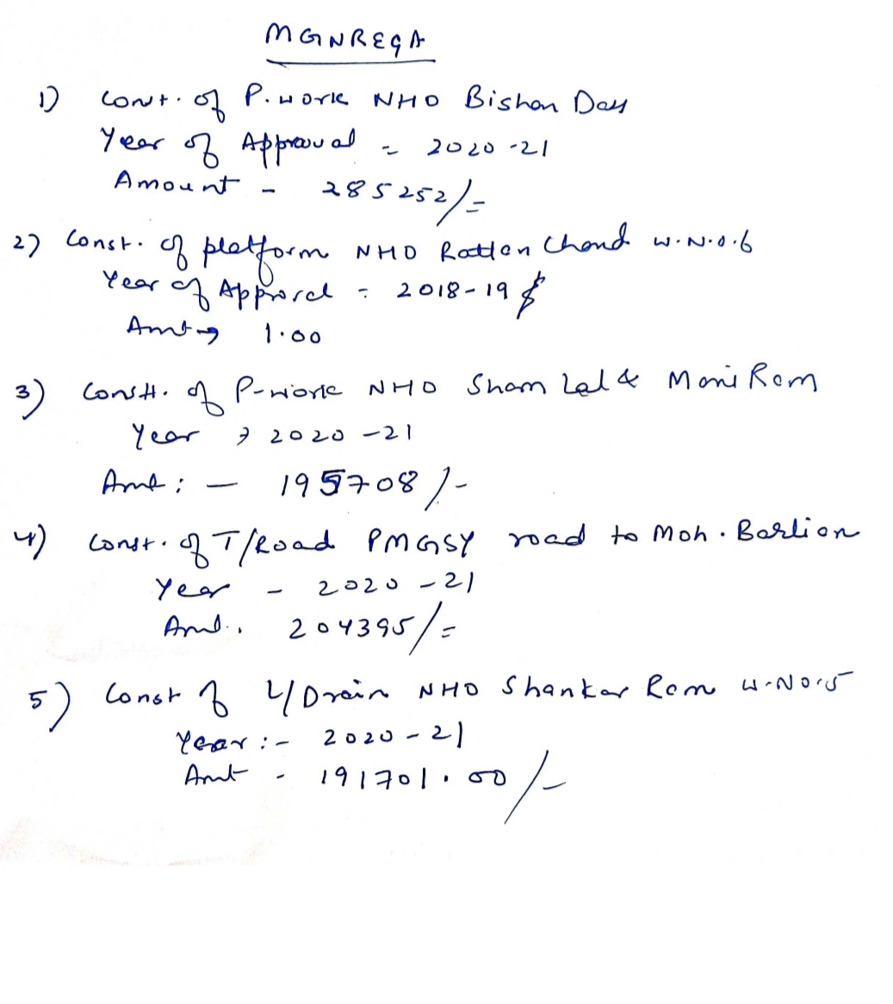

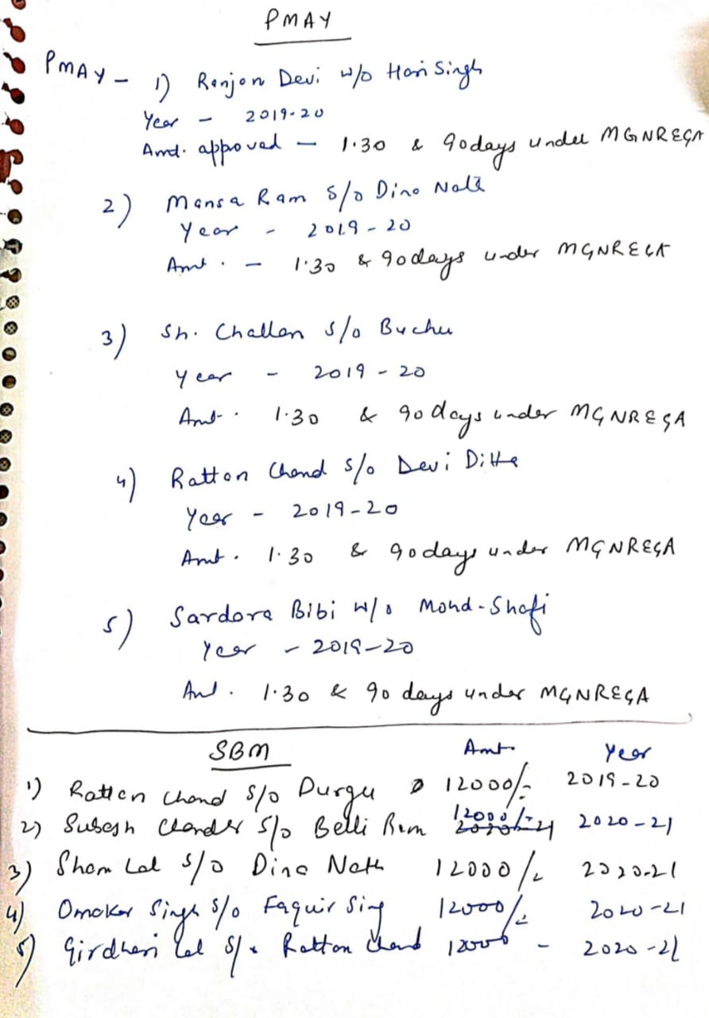

**DAY2ACTIVITIES**

**AGENDA8**

**MAHILASABHA**

Totalwomeninthevillageabovetheageof18 : **300 (APPROX)**

Totalattended: **20**

Proceedings: **Need skill development centres like silai centre, demanded SHGs**.

*(Plinsertpointerstobediscussedthere–referpalliproceedings)*

**DAY2ACTIVITIES**

**AGENDA9**

**BALSABHA**

Holda balsabhaandrecordproceedings

Totalchildreninthevillageabovetheageof 0-16: **114( aprox), 6-18: 110(approx)**

Totalattended **15**

Proceedings: **children told about the problem of road connectivity& electricity problem due to which they face problem due to which they face problems in studies. Due to bad condition of roads, they don’t able to reach school diring rains.**

*(Plinsertpointerstobediscussedthere–referpalliproceedings)*

**DAY2ACTIVITIES**

**AGENDA10**

**INAUGURATIONS**

|  |  |  |  |
| --- | --- | --- | --- |
| **SR NO.** | **ASSETS/ACTIVITIES INAUGRATED** | **STATUSOFTHEASSET/AC- TIVITIES(NUMBER,OTHER DETAILS)** | **GEO-TAGGED PHOTOS** |
|  | VILLAGEHAATunderJKSRLM (SUN- DAYMARKET) | Village hut inaugrated | YES |
|  | PMAYhousesifanyreadyforinaugra- tion | One PMAY house inaugrated | YES |
|  | Swachhgramprojects-segregation shedsetc | - | - |
|  | Amritsarovars | - | - |
|  | Sportskits | DONE | - |
|  | Villageculturalevents | YES | - |
|  | JJMassets/projects | - | - |
|  | Anyothertobeidentifiedatdistrict level | - | - |

**FOLLOWUPOF(B2V1,B2V2&B2V3):**

*(Prefilledexcelsheet tobetakenfromdistrictlevel/andalsotobedownloaded*

*from*[*www.jkpanchayat.in)*](http://www.jkpanchayat.in)

|  |  |  |  |  |  |  |
| --- | --- | --- | --- | --- | --- | --- |
| S.NO. | | Particulars | Action taken | | Remarks# | |
| I. UrgentPublicRequirements/Demands-B2V1 | | | | | | |
| 1 | Electriv voltage shall be improved | | | No action | |  |
| 2 | Requirement of PHC in panchayat | | | No action | |  |
| 3 | Some village which do not have foot path& culverts | | | No action | |  |
| 4 | Each hemlet is required to be connected with main road.  . | | | No action | |  |
| 5 | Requiremenet of sufficient water for drinking | | | No action | |  |
| 6 | Dispensary- animal husbandry | | | No action | |  |
| 7 |  | | | No action | |  |
| II. UrgentPublicRequirements/Demands-B2V2 | | | | | | |
| 1 | PMGSY Road from Dhar Road to Sumwal required | | |  | |  |
| 2 | Black topping on road required | | |  | |  |
| 3 | Panchayat Ghar for Panchayat | | |  | |  |
| 4 | Requirement of checkdams, borewells(at Chowa, Srail) | | |  | |  |
| 5 | CFC centre, Tractor Road from main road to SC Bhagat | | |  | |  |
| 6 | Dispensary Animal Husbandry | | |  | |  |
| 7 | Requirement of electrical poles | | |  | |  |
| S.NO. | Particulars | | | Actiontaken | | Remarks# |
| III. MajorProblems–B2V1 | | | | | | |
| 1 | water supply | | | No action | |  |
| 2 | Electricity problem | | | No action | |  |
| 3 | Condition of road id very bad | | | No action | |  |

|  |  |  |  |
| --- | --- | --- | --- |
| 4 |  |  |  |
| 5 |  |  |  |
| IV. MajorProblems-B2V2 | | | |
| 1 | No Panchayat Ghar | No action |  |
| 2 | Condition of Road is not good | No action |  |
| 3 | Water supply problem | No action |  |
| 4 | NO CFC |  |  |
| 5 |  |  |  |
| V. MajorProblems-B2V3 | | | |
| 1 | No CFC is there | No action |  |
| 2 | Road condition bad | No action |  |
| 3 | Water supply problem | No action |  |
| 4 | Electric problem | No action |  |
| 5 |  |  |  |
| VI. MajorComplaints-B2V1 | | | |
| 1 | No major Complaints |  |  |
| 2 |  |  |  |
| 3 |  |  |  |
| VII. MajorComplaints-B2V2 | | | |
| 1 | No major Complaints |  |  |
| 2 |  |  |  |
| 3 |  |  |  |
| VIII. MajorComplaints-B2V3 | | | |
| 1 | No major Complaints |  |  |
| 2 |  |  |  |
| 3 |  |  |  |

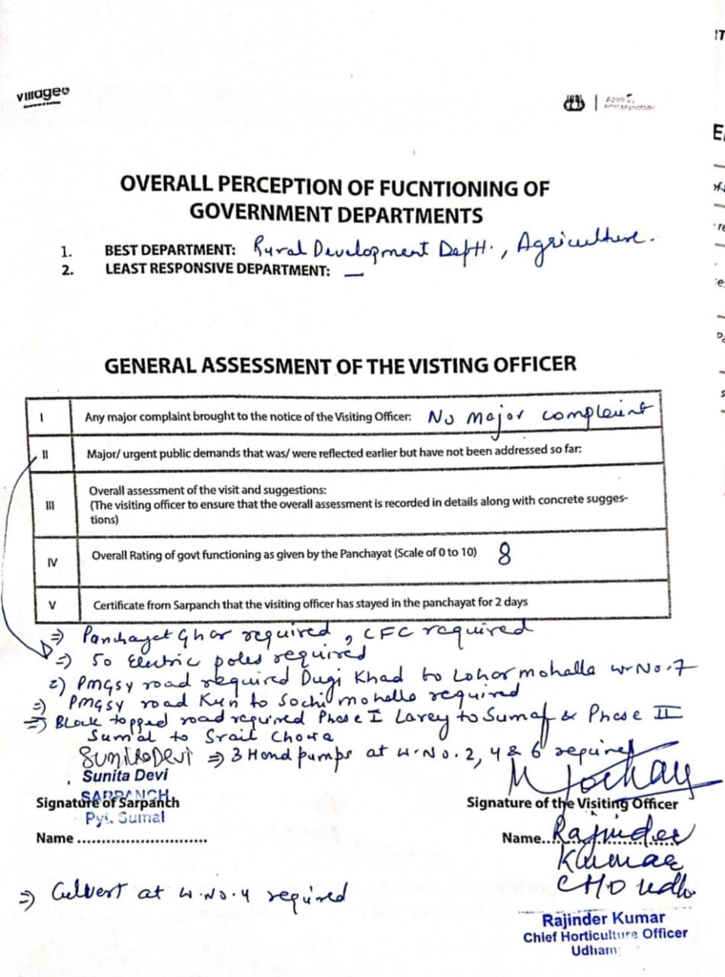



**DepartmentofRuralDevelompentandPanchayatiRaj**

**GovernmentofJammu &Kashmi**