4





**15TH OCT to 3RD NOV, 2022**

**KEY FEATURES**

• Deputy Commissioners to lead the initiative

• Rural development Department to be the nodal department

• Planning Development & Monitoring department and IT to be the support departments

**ACTIONS AND TIMELINES**

|  |  |  |  |
| --- | --- | --- | --- |
| **ACTION** | **RESPONSIBILITY** | **LATEST BY** | **REMARKS** |
| **Jan abhiyan** | All departments | Oct 15 -26th | Going on |
| **Deputation of Sectt staff/ HoDs** | GAD | Oct 14 | Done |
| **Deployment of Staff to Panchayats and serving of orders on deployed officers** | DCs | Oct 25 | DCs will deploy senior level staff from the districts. Strict action to be taken against abstentions. No exemptions to be given |
| **Training of district trainors on B2V4** | RDD | Oct 26 |  |
| **Training of visiting officers** | DCs | Oct 27 |  |
| **Field Visits to be completed by** | Visiting Officers | Nov 3 | DCs to supervise and ensure that each Panchayat is visited within the period specified |
| **Data of B2V4 to be uploaded by** | Visiting Officers | Nov 10 | DCs to supervise and ensure that data of all Panchayats is upload- ed by the visiting officer within the period specified |

**INSTRUCTIONS FOR THE VISITING OFFICER (DAY WISE)**

|  |  |  |
| --- | --- | --- |
| **DATE** | **INSTRUCTIONS** | **ACTION POINTS** |
| **Day 0** | Meeting with deputy commissioner and his/her team | a. Take print outs of filled booklets of B2V1, B2V2 and B2V3 from [www.jkpanchayat.in](http://www.jkpanchayat.in)  b. Also take print outs of the summarized excel sheets of the previous phases from [www.jkpanchayat.in](http://www.jkpanchayat.in)  c. Collect ATRs on issues raised during previous 3 phases from the office of Deputy Commissioner (Planning deptt)  d. Take prints of blank 2 booklets of B2V4 from [www.jkpanchayat.in](http://www.jkpanchayat.in) e. Take plans for 2 previous years and ATRs from the planning deptt f. Complete trainings on different components of B2V4 being  organized by respective Deputy Commissioners  g. Collect List of new works started/ ongoing/ completed during the previous and current Financial year under the following heads:  • PRI grants  • District Plan  • UT plan  • MGNREGA  • Other schemes of other departments  • Any other work  h. Plans/ beneficiary lists:  • MGNREGA draft plan document for the year 2022-23.  • List of Awaas+ beneficiaries alongwith IHHL Convergence  • List of pension beneficiaries.  • List of SHGs  • List of agriculture scheme beneficiaries  i. Lists of beneficiaries for:  • Various certificates/ benefits to be distributed by the visiting officer.  • Any other activities identified by different departments |

|  |  |  |  |
| --- | --- | --- | --- |
| **Day 1** | Reach the village | 1. | Ensure that all front line workers of different deptts are present. |
|  |  | 2. | Ensure exhibition by different depts. about individual beneficiary schemes |
|  |  | 3. | Inspect JKB/PSB counters/outlets |
|  |  | 4. | Participate/ensure organization of sports activity in playfield, talent hunt/cultural event/youth activity |
|  |  | 5. | Gandhi Katha (suggested details uploaded on jkpanchayat.in) |
|  |  | 6. | Visit atleast 2 amritsarovars and get its geo tagged photos |
|  |  | 7. | Inspect Khidmat (CSC) Centres and create Generate awareness on  225 schemes particularly G2C schemes like BEAMS, Janbhagidari, AapkiZaminAapkiNigrani, Digital J&K |
|  |  | 8. | Visiting officer shall also plan and conduct panchayat level conver- gence meeting of all departments |
|  |  | 9. | Check effectiveness of Centrally sponsored schemes |
|  |  | 10. | Visit and inspect all government establishments including PHE, AWC, FPS, schools, etc |
|  |  | 11. | Attempt saturation of deliverable so Jan Abhiyan and wherever deficiencies found, lead a drive to achieve all deliverables |
|  |  | 12. | Assess effectiveness of sanitation campaign in the panchayat |
|  |  | 13. | Ensure self employment activities for 15 youth per panchayat |
|  |  | 14. | Identify 20 potential candidates per panchayat for HIMAYAT training alongwith the trade on which they want training |
|  |  | 15. | Wherever possible, distribute employment letters for people select- ed under various government employments |
|  |  | 16. | In the evening, hold normal meeting with senior citizens, govt em- ployees including retired employees, ex servicemen, youth club, and any citizens of the village who are enrolled in college/university |
|  |  | 17. | Open discussion on Nasha Mukt Abhiyan |

Day2 Have a meeting with all stakeholders- deptt officials and panchayat members

1. Discussion on the and assess the progress of different schemes relating to the localized SDGs prioritized for that village as per the resolution passed by that Gram Panchayat on 21st April 22, on National Panchayti Raj Day.

2. Sensitize village residents about myScheme” portal (myscheme.in) which includes information about all the schemes being run by Cen- tral/ State/ UT govt across the country

3. Hold meeting of the Biodiversity Management Committees to deliber- ate on issues pertaining to conservation of biodiversity and sustaina- ble utilization of biological resources.

4. Prepare Village development plan, in consultancy with Gram panchayat, discuss it in gram sabha and get it approved.

5. Ensure saturation of soil health card and golden health card under Gold- en Health Card under Ayushman Bharat,

6. Ensure saturation of Old Age Pension Scheme

7. Ensure Domicile Saturation.

8. Ensure KCC Saturation

9. Ensure saturation of land pass books

10. Ensure registration of village vendors needed for any scheme, on GEM

portal

11. Ensure panchayat contractors registration

12. Encourage Panchayat members for importance of plantation drive in

Panchayat under Har Gaon Hariyali

13. Ensure painting on digital J&K in panchayat ghars

14. Ensure painting on panchayat activites and CSS in panchayat ghars

15. The visiting office shall check no of kindergarten and playfields present in the panchayat for kids and students, if the infrastructure present in these are good enough.

16. Hold meeting with panchayat members to discuss about corruption menace and steps required to make J&K corruption free

17. Obtain a candid assessment about performance of various deptts in- cluding fair feedback about discrepancies in functioning

18. Check the status of Nasha Mukt Abhiyan and reporting of drug ad- dicts to Deputy Commissioner.

19. Identify Tourist Destinations, Circuits, Theme Treks, Identify Homestays, provide support for tourism activities through Village Cooperative

20. Organize Talent Hunt at Panchayat Level

21. Conduct social audit of atleast 5 works under following schemes:

a. MGNREGA

b. PMAY

c. IHHL toilets and payments d. CSCs

e. AMRIT SAROVARS

22. Hold a mahilasabha and a balsabha and record proceedings in the for- mat given

23. Inaugurate village haat under JKSRLM

24. Check if youth clubs are formed in the panchayat and what activities they are engaged in

25. Organize a village level cultural event to engage panchayat members

26. Sensitize GP about E-kitab kosh an initiative of J&K Govt for empowering youths through online digital literacy

**GENERAL INSTRUCTIONS**

1. The visiting officer shall refrain himself/ herself giving or offering any commitment on behalf of the government and shall adopt an unbiased attitude in reporting issues. As far as possible, his/her observation should be based on a fair and analytical view emerging from his/her interaction in the village.

2. He is going to the village as planning officer, not for sanctioning any works or for making any com- mitments.

3. While preparing village development plan, he has to ensure that, demands are prioritized and re- flected under available schemes, wherever necessary the larger works are to be referred to adminis- trative deptt under CSS/UT plans under intimation to DCs and rest of the works to DCs for reflecting it under district/CSS plans

4. His work shall be hard core planning and audit and is not a PR exercise.

5. Every Deputy Commissioner has to ensure that atleast one RDD official (ideally Panchayat Secre- tary) is present in every panchayat with relevant panchayat records, to ensure conduct of all activi- ties as planned. Panchayat wise order needs to be issued in advance.

6. Visiting officer should ideally carry his/her laptop to complete the reports at the panchayat level itself and upload the final report, duly signed both by the sarpanch and by the visiting officer on [www.jkpanchayat.in](http://www.jkpanchayat.in) portal, before they leave panchayat.

7. Focus of visit are youth, skills, self-employment, nasha mukt, bhrashtrachar mukt, Rozgar yukt J&K, besides to carry forward the activities during Jan Abhiyan and saturate them.

8. In addition attention may be given to the following areas a. Make full use of Centrally Sponsored Schemes

b. Saturation of individual beneficiary schemes c. Self-employment schemes

d. Bank linked schemes- including departmental subsidy schemes e. Empowerment and transparency through digital initiatives

f. Effectiveness of grass roots machinery –

i. Patwari, VLW present and available

ii. Available funds utilized in public interest and as per Gram Sabha resolutions iii. Fairness in governance

iv. CSS/Individual beneficiary schemes etc v. BrashtacharMukt J&K

vi. Bhai Mukt J&K

vii. NashaMukt J&K

9. The PRI members (Sarpanchs, Panchs, BDC Chairperson) shall be at the forefront of all activities and given due importance and the approach should be to strengthen them and make them feel em- powered. He/she shall ensure that the BDC chairperson and Sarpanch/Panch are present at the time of inauguration and ceremonies.

10. Visiting officer shall not leave the district without uploading the report, duly signed on the **www. jkpanchayat.in** portal. Every Deputy Commissioner has to ensure that.

**A) Details of Reporting Officer:**

Name: **Dr Murtaza Rashid (JKAS)**

Designation: **Undersecretary to the Government**

Department/place of posting:  **Mission Youth, J&K, Civil Secretariat, Srinagar.**

Mobile No: **7006707400, 9419302337**

Email ID: [**meermurtaza365@gmail.com**](mailto:meermurtaza365@gmail.com)**, meer.murtaza365@jk.gov.in**

Home District: **Bandipora**

Dates of visit: **2nd and 3rd November, 2022**

**B) Locational details of Panchayat: (to be pre-filled, information to be taken from the previous phases booklets/summarized excel sheet uploaded on jkpanchayat.in/b2v4.php) (to be vali- dated by the visiting officer and missing details to be filled)**

Name of the Panchayat: **Konan**

Local Government Directory(LGD) code of the Panchayat: **242186**

Name of CD Block: **Arin**

Name of Tehsil: **Bandipora**

Name of District: **Bandipora**

**C) Panchayat Profile:**

No. of revenue villages in the Panchayat: **01**

No. of hamlets in the Panchayat: **15**

No. of households in the Panchayat: **522**

Population (approx) of the Panchayat: **2400**

**Part-II:**

(To be filled up by the Visiting Officer during his/her two day visit to the Panchayat. All Fields have to be

filled by the Visiting Officer before the booklet is handed over to the DC

**Frontline Officers/Officials who were assigned to the Panchayat for the programme:**

|  |  |  |
| --- | --- | --- |
| Department | Name | Designation |
| Social Welfare/ICDS | Jabeena | CCO |
| Power Dev. Department | Rafiq ud din Khawaja | Inspector |
| PHE/Jal Shakti Deptt. | Gh Ahmad Malla | Works Supervisor |
| PWD (R&B) | Gulzar Ahmad Zargar | JE |
| Education Deptt. | Nasrullah Mohi ud din | Teacher |
| Forest Deptt. | Mohd Ashraf Dar | Forest Guard |
| I&FC Deptt. | Mod Yousf Baba | Works Supervisor |
| Fisheries Deptt. | Imtiyaz Ahmad Mir | Fisheries Guard |
| Sericulture Deptt. | Nazir Ahmad Malik | Field Incharge |
| Agriculture | Shams ud din Mir | AEA |
| Animal & Sheep Husbandry Dept | Mohd Khushal Bani | VAS |
| Revenue Deptt. | Irshad Ahmad Mir | Patwari |
| Horticulture Deptt. | Tariq Ahmad Sheikh | Hortculture Assistant |

**Details of absent employees vis-à-vis list furnished by the DC office:**

|  |  |  |
| --- | --- | --- |
| Department | Name | Designation |
| Rest of the line Departments were not present |  |  |
|  |  |  |
|  |  |  |
|  |  |  |
|  |  |  |
|  |  |  |
|  |  |  |
|  |  |  |
|  |  |  |
|  |  |  |
|  |  |  |
|  |  |  |
|  |  |  |
|  |  |  |
|  |  |  |

**DAY 1- ACTIVITIES**

**AGENDA 1: PANCHAYAT ASSET REGISTER**

**Infrastructure:**

1. Panchayat Ghar Infrastructure a. Govt. building

b. Needing repairs

2. Furniture (N)

3. Computer/printer (Y)

4. Internet (N)

5. Telephone (N)

6. Toilet (CSC/part of panchayat ghar) (N)

7. Water (N)

8. Electricity (N)

9. Bank branch (N)

10. CSC (Y)

11. Patwarkhana (N)

12. Village haat (Y);- **Identified at Panchayat Ghar**

13. Playground (Y)

14. School-

a. Kindergarten (Y)

b. Primary (Y);- **PS, MS Boys & MS Girls working in single location, lacks infrastructure**

c. Secondary (N)

d. College (N)

e. University (N)

15. Anganwadi Centre (Y)

a. (Private);- **03 no. of Anganwari Centres and all working in private accomodation**

b. Total children enrolled;- **87 at all three centres**

15. Amrit Sarovars – details, location, condition;- 02 No.’s- **At Hakeem Mohalla and Playground**

16. Government offices- details, whether functional;-**Small Ruminants Office & Functional**

17. Ration shop (Y);- **But functional in a rented private store and needs additional store.**

18. Places of tourism importance – names, little details on historical/cultural importance;- **Local folk Music**

19. Village treks- names, little details on historical/cultural importance;- **Trek to Ded Mouj Buthoo**

20. VLW Office (Y);- **Panchayat Ghar but not functional due to need of repairmen.**

21. Primary Healthcare Centre (N);- **Need of NTPHC/ISM Dispensary as per feasibility**

22. List of Incomplete Buildings- names, year of construction;- **Community Hall, Panchayat Ghar**

23. List of Underutilized Buildings- names;- **No such Building existing.**

**DAY 1-ACTIVITIES**

**AGENDA 2:**

**DIFFERENT INSTITUTIONS/INFRASTRUCTURE PROJECTS TO BE VISITED**

|  |  |  |
| --- | --- | --- |
| **AMRIT SAROVARS** | **Visit, verify** | **COMMENTS** |
| Khidmat Centres | Create /Generate awareness on 225 schemes particularly G2C schems Aapki Zamin Aapki Nigrani, Beams, Janbhagidari, Digital J&K | **Working Smoothly. Wide scale awareness also given about schemes and online demo was also given.** |
| JKB/PSB counters/outlets | a) Status of counter b) Number of visitors | **No such outlet.** |
| Incomplete buildings/pro- jects | Verify whether identification and redistribution done | **Community Hall & Panchayat Ghar.** |
| PDS | Visit, evaluate, online status | **Working smoothly, but in a private rented store.** |
| PHC | Visit- evaluate, status of staff, equipment and quality | **N.A** |
| Youth clubs | Meet, interact, seek suggestions | **Youth clubs were not present, even Sarpanch was asked to intimate them** |
| SHG | Meet, identify problems, seek suggestions | **Met with SHG’s dealing with Handicrafts and they desired to open centres for them in Panchayat.** |
| PMAY | Inspect, Inaugurate | **Inspected 02 PMAY houses which were at plinth level.** |
| My school, my pride progress; schools- water, toilets, staff | Visit, check for water, electricity, sanitation, meet students and staff | **Lack of Infrastructure and congested. Additional building under-construction.** |
| Swachh SBM | Evaluate | **Satisfactory.** |
| Panchayat play ground, Sports kits distribution Village games | Ensure, verify. Participate in at least one game in the playground | **Participated in Cricket, Chess and Carrom and distributed the same.** |
| Har Gaon Hariyali, Planta- tion drive | Evaluate status, feedback | **Planted two saplings of conifers at MS Boys/Girls konan.** |
| Village cultural event  Dangal/ Haat/Mela | Participate in; ensure that it is held | **Cultural event regarding Nasha Mukht Bharat/SBM was conducted.** |
| Exhibition of schemes | Ensure that every department participates and that it continues for the entire duration of B2V | **Done.** |
| Jal Jeewan Mission verifica- tion- WSS/JSD  Electricity supply | Verify | **JJM under tendering process.** |

**DAY 1 - ACTIVITIES**

**AGENDA 3: SATURATE JAN BHIYAN**

**DELIVERABLES AND RECORD DEFICIENCIES IF ANY (INSERT DELIVERABLES LIST HERE AS PER GAD FORMAT**

**DAY 1- ACTIVITIES**

**AGENDA 4:**

**SELF EMPLOYMENT ACTIVITIES**

Ensure Self-employment activities for youth, distribute employment letters for people selected under various social schemes (15 IS THE TARGET PER PANCHAYAT)

**Number of cases in different categories sanctioned; (The list is enclosed)**

**Details of the bank sanctioning it :**

**Total amount involved :**

**DAY 1 ACTIVITIES**

**AGENDA 5**

In the evening, hold informal meetings with senior citizens, Govt employees, retired employees, youth club and other citizens who are enrolled on college/university and have discussion on Gandhi Katha, Nasha Mukt Abhiyan, corruption free governance, doubling farmers income and record the proceedings;- **The detailed informal meetings were held, which was productive as being the local of this Panchayat.**

**DAY 2**

a. No of Individual Compost Pits constructed;- **02**

b. No of Individual Soak Pits constructed;- **12**

V. No.of Biodiversity management committee meetings held: **no such meetings held**

VI. Is the name of Sarpanch displayed on citizen information boards of all RD&PRschemes: **Yes**

VII. Are Sarpanchs being involved in start/inauguration of activities: **Yes**

VIII. Whether subjects have been assigned by the Sarpanch to the Panchs: **Yes**

IX. Whether grievances Redressal box is installed: **Yes**

X. No of grievances received pertaining to Panchayatlevel: **The Compliant box was empty.**

XI. No of grievances disposed of at Panchayat level: **Nil**

XII. Whether the Sarpanch/Panchayat Secretary have digital signatures: **Yes**

XIII. Whether all MGNREGA/ 14th FC payments are being made by Sarpanch through Digital Signature Certificate (DSC): **Yes**

**HUMAN RESOURCE AVAILABLE AT THE PANCHAYAT LEVEL:**

|  |  |  |  |  |
| --- | --- | --- | --- | --- |
| **SR NO.** | **DEPARTMENT WISE STAFF** | **NUMBERS** | | **NAMES** |
|  |  | SANCTIONED | ACTUAL |  |
|  | Rural development department: BDO  JE GRS TA | 01  01  01  01 | 01  01  01  01 | Dr Shariq Iqbal  Aushial Hussian Sheikh  Aashaq Hussain  Nadeem Pintoo |
|  | SCHOOL EDUCATION: TEACHER  HEAD MASTER ANY OTHER | 11  01  01 | 17  01  01 | List Enclosed |
|  | JAL JEEVAN: | 03 | 03 | Javaid Ahmad  Mushtaq Ahmad  Showkat Ahmad |
|  | PDD: LINEMAN JE  ANY OTHER | 01  01  01 | 01  01  01 | Zahoor Ahmad  Fayaz Mohd Dar  M. Rafiq Khawaja |
|  | FOOD & CIVIL SUPPLIES | 02 | 01 | Mudasir Bashir |
|  | AGRICULTURE & ANIMAL HUS- BANDARY | 01  01 | 01  01 | Shams ud Din Mir  Dr Andleeb |
|  | SOCIAL WELFARE | 03 | 03 | Sameera Mushtaq  Khalida Naziki  Mehmood ul Nisa |
|  | HEALTH: ASHA ANM  AYUSH DOCTOR ALLOPATHIC DOCTOR | 03  01  01 | 03  01  01 | Mymoona  Syeda  Hilala  Mansoor Ahmad Shah  Haseena  Manso |
|  | ANY OTHER DEPARTMENT (Forest) | 01 | 01 | Mohd Ashraf Dar |

**DAY 2-ACTIVITIES**

**AGENDA NO.1**

Discussion on the and assess the progress of different schemes relating to the localized SDGs prior-itized for that village as per the resolution passed by that Gram Panchayat on 21st April 22, on National Panchayati Raj Day (Copy of the resolution to be taken from [www.jkpanchayat.in](http://www.jkpanchayat.in) portal under the link of Gram Swaraj Month)

1. SDGs AGREED FOR THAT VILLAGE, TO BE IMPLEMENTED BY MARCH2024:

2. STATUS OF WORKS UNDER THE FOLLOWING SCHEMES:

**1 Clean and green village**

i. Initiatives taken by the Panchayat for managing Solid and Liquid Waste **Composite pits & Soakage Pits.**

ii. Initiatives taken by the Panchayat for using green sources of fuel like solar, biogas

**Promoting solar plant as alternate electricity source.**

iii. Has mapping of land use, water bodies, forest, slopes, wet lands, degraded forest within the Gram

Panchayat been done? **No**. If No, reason, thereof **BMC not working properly.**

iv. Has the Climate Resilience Plan been developed for the GP? **No**

v. Steps taken by the Gram Sabha about the climate change mitigation factors like reducing energy consumption, usage of fossil fuels, plastics, non-renewable building materials and also to promote measures like planting of trees, conserving forests, usage of good agricultural practices like drip irrigation, water conservation measures and conservation of wetlands. **Awareness Programme done.**

vi. Whether schools have started segregating waste;-**Not found, but have been apprised.**

vii. Whether schools have their own compost/soakage pits for solid/liquid waste management.**NA**

**2 Healthy village**

i) Are meetings related to Village Health and Sanitation Committee being held regularly? **Yes**

ii) Do all the eligible individuals been provided the Golden Card? **Some Left**

iii) Are all the Children being immunized as per the Schedule recommended by Govt. of India? **Yes**

iv) Are all the eligible individuals been vaccinated against COVID-19? **Yes**

v) Does Gram Panchayat ensure that all pregnant women are getting necessary prenatal checkups? **Yes**

vi) Whether all the deliveries were Institutionalized or conducted by trained Midwives? **Yes**

**3 Water sufficient village**

i) Do all the IHHs in the Gram Panchayat have water pipeline connections? **Yes**

ii) Whether Gram Panchayat has taken steps for grey water management. If Yes please specify

**Soakage Pits have been constructed.**

iii) Do all the IHHs in the Gram Panchayat have toilets? **Yes**

iv) Are all the IHHs toilets functional or not? **Yes**

v) Do all the Schools/Anganwadi centers have a toilet facility or not? **Yes**

vi) Are all the toilets in the schools/Aaganwadi functional or not? **Yes**

vii) Whether Gram Pachachayat Bhawan has separate toilets for women or not? **No**

**4 Child Friendly village**

i) Do all the children under the age of 0-6 years been enrolled in the Anganwadi centers for pre- schooling? **Yes**

ii) How many Bal Sabha’s were organized in the Gram Panchayat;- **One (01)**

iii) Whether the issues raised by Bal Sabha are addressed during the Gram Sabha. **Yes**

iv) Whether Gram Panchayat is tracking the data related to dropout children and children with irregular attendance? **Yes**

v) Do all the schools under the Gram Panchayat have separate toilets for girls and boys? **Yes**

**5 Village with good governance**

i) Is CSC located in the Gram Panchayat Bhawan or not? **Yes**

ii) Is the list of beneficiaries related to the Schemes/Programs displayed on the Gram panchayat wall or not? **Yes**

iii) Does the Gram Panchayat has its building or not? **Yes**

iv) Is the Gram Panchayat office functional or not? **Yes**

v) Are the activities approved under the Halqa Panchayat Development Plan displayed on the Gram

Panchayat wall or not?

vi) Is Social Audit of earlier Schemes/Programs carried out or not?

**6 Poverty free and enhanced livelihood village**

i) Has Gram Panchayat developed any criteria for the identification of the poor? Yes/No if yes specify ii) Have all the eligible households registered in PDS or not?

iii) Has Gram Panchayat provided space for Self-help Groups in Panchyat Ghar for holding meetings or not? **No**

iv) Have all the eligible households been registered for Pension or not? **Yes**

v) Has Gram Panchayat facilitated Youth for Skill Enhancement Courses and Placement? **Yes**

vi) Has Job Cards been distributed to all the eligible individuals under MGNREGA? **Yes**

vii) Has Gram Panchayat facilitated SHGs for Bank Account Linkages? **Yes**

**7 Socially secured village**

i) Whether Gram Panchayat is maintaining data related to Differently Abled People? **Yes**

ii) Is Gram Panchayat Office Disabled Friendly or not? **Yes**

iii) Are provisions for a separate Budget under the Resource Envelope for Women and Children made or not? **Yes**

iv) Do all the Schools in the Gram Panchayat have facilities for Differently Abled Children like toilets, barrier-free access, etc., or not? **No**

v) Are all the eligible individuals are getting pensions, like old age pension, widow pension, etc? **Yes**

vi) Are all the eligible households getting benefits from IAY or not? **Yes**

**8 Engendered Development in Village**

i) How many Mahila Sabha’s were organized in the Gram Panchayat;- **One (01)**

ii) Whether SHGs federations have been provided space for meetings in the Panchayat Bhawan **No**

iii) Whether GPs have taken steps for increasing women’s participation in Gram Sabha **Yes**

iv) Number of women beneficiaries headed households covered under PDS system;- **41**

v) Number of beneficiaries (out of total eligible population) receiving social protection benefits under

Pradhan Mantri Matritva Vandana Yojana;- **15**

9 Self-sufficient infrastructure in the village

i. Whether GP has a Community Hall with access to electricity, furniture, water supply, toilet;- **No. The building is Under Construction**

ii. Whether the Disaster management plan is available at the GP Level **(No)**

iii. Whether child-friendly park with required facilities is available in GP **(No)**

iv. Whether the GP has easy access to Godown for storage **(No)**

v. Whether street lights are provided in public places for ensuring safety **(No)**

**DAY 2 ACTIVITIES**

**AGENDA NO.2**

Sensitize village residents about myScheme” portal (myscheme.in) which includes information about all the schemes being run by Central/ State/ UT govt across the country

*(Scheme Material available from* [*https://jkpanchayat.in/b2v4.php);-*](https://jkpanchayat.in/b2v4.php);-)

**The Gram Panchayat has been sensitized about the “myscheme” portal and live demos were also given during this B2V programme.**

**DAY 2 ACTIVITIES**

**AGENDA NO.3**

Hold meeting of the Biodiversity Management Committees to deliberate on issues pertaining to conserva- tion of biodiversity and sustainable utilization of biological resources. He should check People Biodiversity register (PBR) of that panchayat and review if Biodiversity Management Committee constituted for that panchayat is holding minimum 4 meetings in a year and meeting once in every 3 months *(Role of BMC available at https://jkpanchayat.in/b2v4.php)*

COMMITTEE MEMBERS;= **Not present/constituted as such the meeting could not been convened**

PRESENT

BIODIVERSITY REGISTER PHOTOS

PAST 4 MEETING DETAILS- DATES, MINUTES PHOTOS

**DAY 2 ACTIVITIES**

**AGENDA 4**

Visiting officer shall also plan and conduct panchayat level convergence meeting of all departments and prepare Village development plan for village, in consultancy with Gram panchayat, discuss it in gram sabha and get it approved.

(GPDP format available on <https://jkpanchayat.in/b2v4.php>)

**The GPDP plan was planned, formulated, discussed and approved in the Gram Sabha, which is enclosed**

**In addition GPDP plan shall also include :**

▪ Tourist places which need to be developed

▪ Specific product which needs to be developed

▪ Tourism- home stays

▪ 20 candidates for training under Himayat scheme alongwith trade in which training is to be given

**The Scope of Animal & Sheep Husbandry is encouraging here and the Panchayat has abundant Milk Production but lacks the marketing initiatives, which needs to be addressed.**

**DAY 2 ACTIVITIES**

**AGENDA 5**

Ensure saturation of following schemes and give status:

|  |  |  |  |
| --- | --- | --- | --- |
| **NAME OF THE SCHEME** | **TOTAL ELIGIBLE BENEFICIARIES IN THE VILLAGE** | **TOTAL BENEFICIARIES WHO AVAILED THE BENEFITS OF THE SCHEME** | **REASONS FOR PENDENCY** |
| Golden Health Card under  Ayushman Bharat | 1957 | 694 | Non Availaiblity of Aadhar Number. |
| Janani suraksha yojana | 24 | 18 | Lack of Funds |
| OLD AGE pension | 86 | 83 | Under process |
| Widow pension | 38 | 38 | Complete |
| Disability pension | 14 | 13 | Under process |
| Domicile certificate | 2350 | 2295 | Under process |
| Kisan credit card | 322 | 322 | Complete |
| PM kisan sammannidhi | 322 | 322 | Complete |

|  |  |  |  |
| --- | --- | --- | --- |
| Land pass book | 547 | 250 | Under process |
| Registration of village ven- dors on GEM portal | Nil | Nil | Under Process |
| Registration of village con- tractors on jktenders portal | Mushtaq Ahmad  Irfan Ahmad  Gh Mohd | All | Completed |
| Registration of village con- tractors on PWD portal | Mushtaq Ahmad  Irfan Ahmad  Gh Mohd | All | Completed |
| Incomplete buildings/pro- jects | NA | NA | NA |

**DAY 2 ACTIVITIES**

**AGENDA 6**

**NASHA MUKT ABHIYAN**

1. Whether gram sabha resolution passed **Yes**

2. Details of activities conducted;- **List Enclosed**

3. Whether all activities and GS resolution uploaded on jkpanchayats.in portal;- **Yes**

4. How many drug addicts in the village;- **List will be submitted confidentially.**

5. Whether reported to the Deputy Commissioner;- **Not Yet.**

6. How many registered for rehabilitation under government programme;- **Nil.**

**DAY 2 ACTIVITIES**

**AGENDA 7**

**SOCIAL AUDIT**

Conduct social audit of atleast 5 works each under following schemes:

|  |  |  |  |  |  |  |
| --- | --- | --- | --- | --- | --- | --- |
| NAME OF THE SCHEME | DETAILS OF THE WORKS | YEAR OF WORK APPROVAL | AMOUNT APPROVED  FOR THE WORK | WHETHER  WORK EXECUTED SATISFACTORILY | GEO- TAGGED PHOTOS | ANY GRIEVANCE RECORDED RELATING TO THAT WORK |
| MGNREGA | Dev. Of Public Park | 2022-23 | 4.73 lacs | Under execution | Yes | No |
| PMAY | Ab Majeed Ganie | 2022-23 | 1.65 lacs | Satisfactory | Yes | No |
| IHHL  UNDER SBM-G | - | - | - | - | - | - |
| CSC UNDER SBMG | - | - | - | - | - | - |
| AMRIT SAROVARS | 1. Near Playground  2. Near Hakeem Mohalla | 2022-23  2022-23 | 3.00 lacs | Satisfactory  Satisfactory | Yes  Yes | Nil  Nil |

**DAY 2 ACTIVITIES**

**AGENDA 8**

**MAHILA SABHA**

Total women in the village above the age of 18;- **650**

Total attended;- **50**

Proceedings: **(Enclosed)**

*(Pl insert pointers to be discussed there – refer palli proceedings)*

**DAY 2 ACTIVITIES**

**AGENDA 9**

**BAL SABHA**

Hold a balsabha and record proceedings;-

Total children in the village above the age of **Six;- 800**

Total attended;- **100**

Proceedings: **(Enclosed)**

*(Pl insert pointers to be discussed there – refer palli proceedings)*

**DAY 2 ACTIVITIES**

**AGENDA 10**

**INAUGURATIONS**

|  |  |  |  |
| --- | --- | --- | --- |
| **SR NO.** | **ASSETS /ACTIVITIES INAUGRATED** | **STATUS OF THE ASSET/AC- TIVITIES (NUMBER, OTHER DETAILS)** | **GEO-TAGGED PHOTOS** |
| 1 | VILLAGE HAAT under JKSRLM (SUN- DAY MARKET) | Identified at Panchayat Ghar | Uploaded |
| 2 | PMAY houses if any ready for inauguration | Plinth Level | Uploaded |
| 3 | Swachh gram projects- segregation sheds etc | Soakage Pits Only | Uploaded |
| 4 | Amrit sarovars | Completed (02) | Uploaded |
| 5 | Sports kits | Cricket Kit | Uploaded |
| 6 | Village cultural events | Nasha Mukt Bharat/SBM | Uploaded |
| 7 | JJM assets/projects | FiltrationPlant/Resorvior | Uploaded |
| 8 | Any other to be identified at district level | Handicraft Shawls by SHG’s | Uploaded |

**FOLLOW UP OF (B2V1, B2V2 & B2V3):**

*(Pre filled excel sheet to be taken from district level/ and also to be downloaded*

*from* [*www.jkpanchayat.in)*](http://www.jkpanchayat.in)

|  |  |  |  |
| --- | --- | --- | --- |
| S.NO. | Particulars | Action taken | Remarks # |
| I. Urgent Public Requirements/ Demands- B2V1 | | | |
| 1 PHC | - | Not Done | - |
| 2 Filtration Plant | - | Completed | But no electric supply |
| 3 Bank Branch | - | Not Done | - |
| 4 Macdamization | - | Almost Completed | Gundiqaiser-konan, Bhat Mohalla, Chopan Mohalla & New Colony link Pending. |
| 5 Community Centre | - | Under Construction | No Funds Available |
| 6 Protection Bund Arin Nallah | - | Not Done | - |
| 7 Transmission Line Water Station | - | Pending | Needs Immediately to be done |
| II. Urgent Public Requirements/ Demands- B2V2 | | | |
| 1 ISM Dispensary | - | Pending | Required |
| 2 Filtration Plant | - | Completed | But no electric supply |
| 3 Macdamization | - | Almost Completed | Gundiqaiser-konan, Bhat Mohalla, Chopan Mohalla & New Colony link Pending. |
| 4New Anganwari Centres | - | Pending | - |
| 5 Protection Bund Arin Nallah | - | Pending | - |
| 6 Double Story MS Konan | - | Almost Completed | Internal Work |
| 7 Cooperative Store | - | Pending | - |
| S.NO. | Particulars | Action taken | Remarks # |
| III. Major Problems – B2V1 | | | |
| 1 Inner Link Roads | - | Almost Completed | Gundiqaiser-konan, Bhat Mohalla, Chopan Mohalla & New Colony link Pending. |
| 2 Health | - | Not Done | Kindly Check Feasability |
| 3 Water Filtration Plant | - | Completed | But no electric supply |

|  |  |  |  |
| --- | --- | --- | --- |
| 4 Receiving Station | - | Pending | Required for augmentation |
| 5 Bank | - | Pending | Required due to good economic condition. |
| IV. Major Problems- B2V2 | | | |
| 1 Macdamization | - | Almost Completed | Gundiqaiser-konan, Bhat Mohalla, Chopan Mohalla & New Colony link Pending. |
| 2 ISM Dispensary | - | Pending | Required |
| 3 Double Story MS Konan | - | Almost Completed | Internal Work |
| V. Major Problems- B2V3 | | | |
| 1 Macdamization | - | Almost Completed | Gundiqaiser-konan, Bhat Mohalla, Chopan Mohalla & New Colony link Pending. |
| 2 Water Filtration Plant | - | Completed | But no electric supply |
| 3 Bank Branch | - | Not Done | - |
| 4 ISM Dispensary | - | Pending | Required |
| 5 Double Story MS Konan | - | Almost Completed | Internal Work |
| VI. Major Complaints- B2V1 | | | |
| 1Execution of work not upto the mark due to non cooperation of General Public | The General Public have been sensitized to check the quality and progress of work both physically as well as use of mobile based application | - | - |
| VII. Major Complaints- B2V2 | | | |
| 1 PHE & I&FC Non Cooperative | Regular Visit shall be made to change attitude of public towards these departments | - | - |
| 2 Health not organizing Awareness Camps | A must and shall be conducted regularly. | - | - |
| 3 Social Forestry needs Plantation Drive | Shall be done on all Barren land | - | - |
| VIII. Major Complaints- B2V3 | | | |
| 1 Illegal Occupation of 1400 kanals of Khacharie Land | Shall be evicted by Revenue Deptt from encroachers by conducting special drives. | - | - |

**OVERALL PERCEPTION OF FUCNTIONING OF GOVERNMENT DEPARTMENTS**

1. **BEST DEPARTMENT: RDD, Education and PDD**

**2. LEAST RESPONSIVE DEPARTMENT: Health & PHE.**

**GENERAL ASSESSMENT OF THE VISTING OFFICER**

|  |  |
| --- | --- |
| I | Any major complaint brought to the notice of the Visiting Officer: **(Enclosed)** |
| II | Major/ urgent public demands that was/ were reflected earlier but have not been addressed so far: **(Enclosed)** |
| III | Overall assessment of the visit and suggestions:  (The visiting officer to ensure that the overall assessment is recorded in details along with concrete suggestions)  **(The detailed list Enclosed)** |
| IV | Overall Rating of govt functioning as given by the Panchayat (Scale of 0 to 10);- **08** |
| V | Certificate from Sarpanch that the visiting officer has stayed in the panchayat for 2 days;- **Certificate enclosed** |

Certified that the visiting Officer has stayed in the Panchayat on 2nd & 3rd November including night stay.

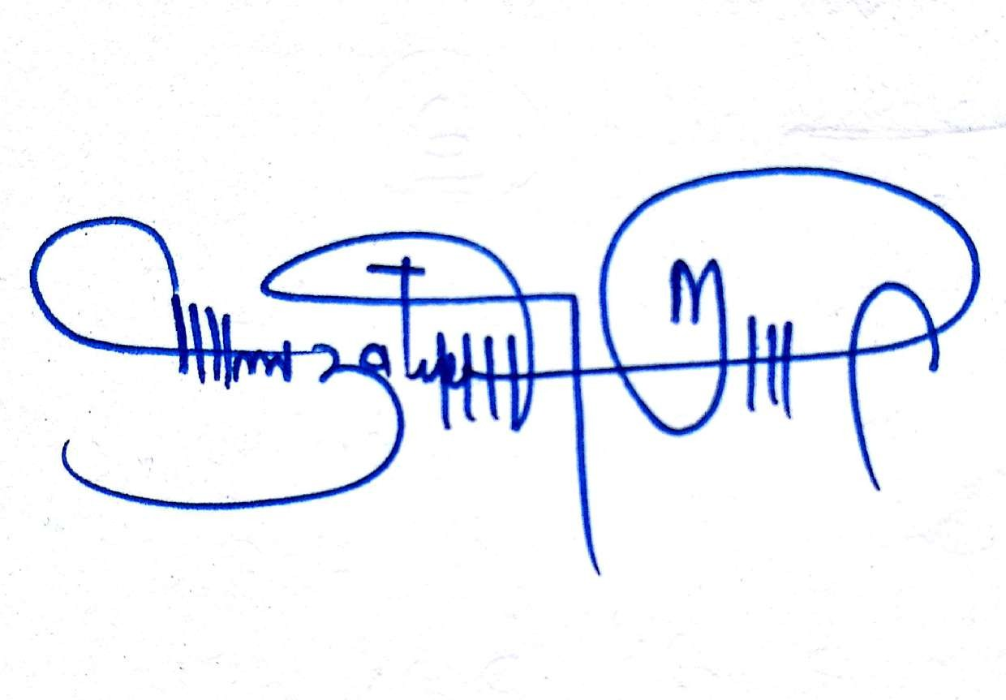

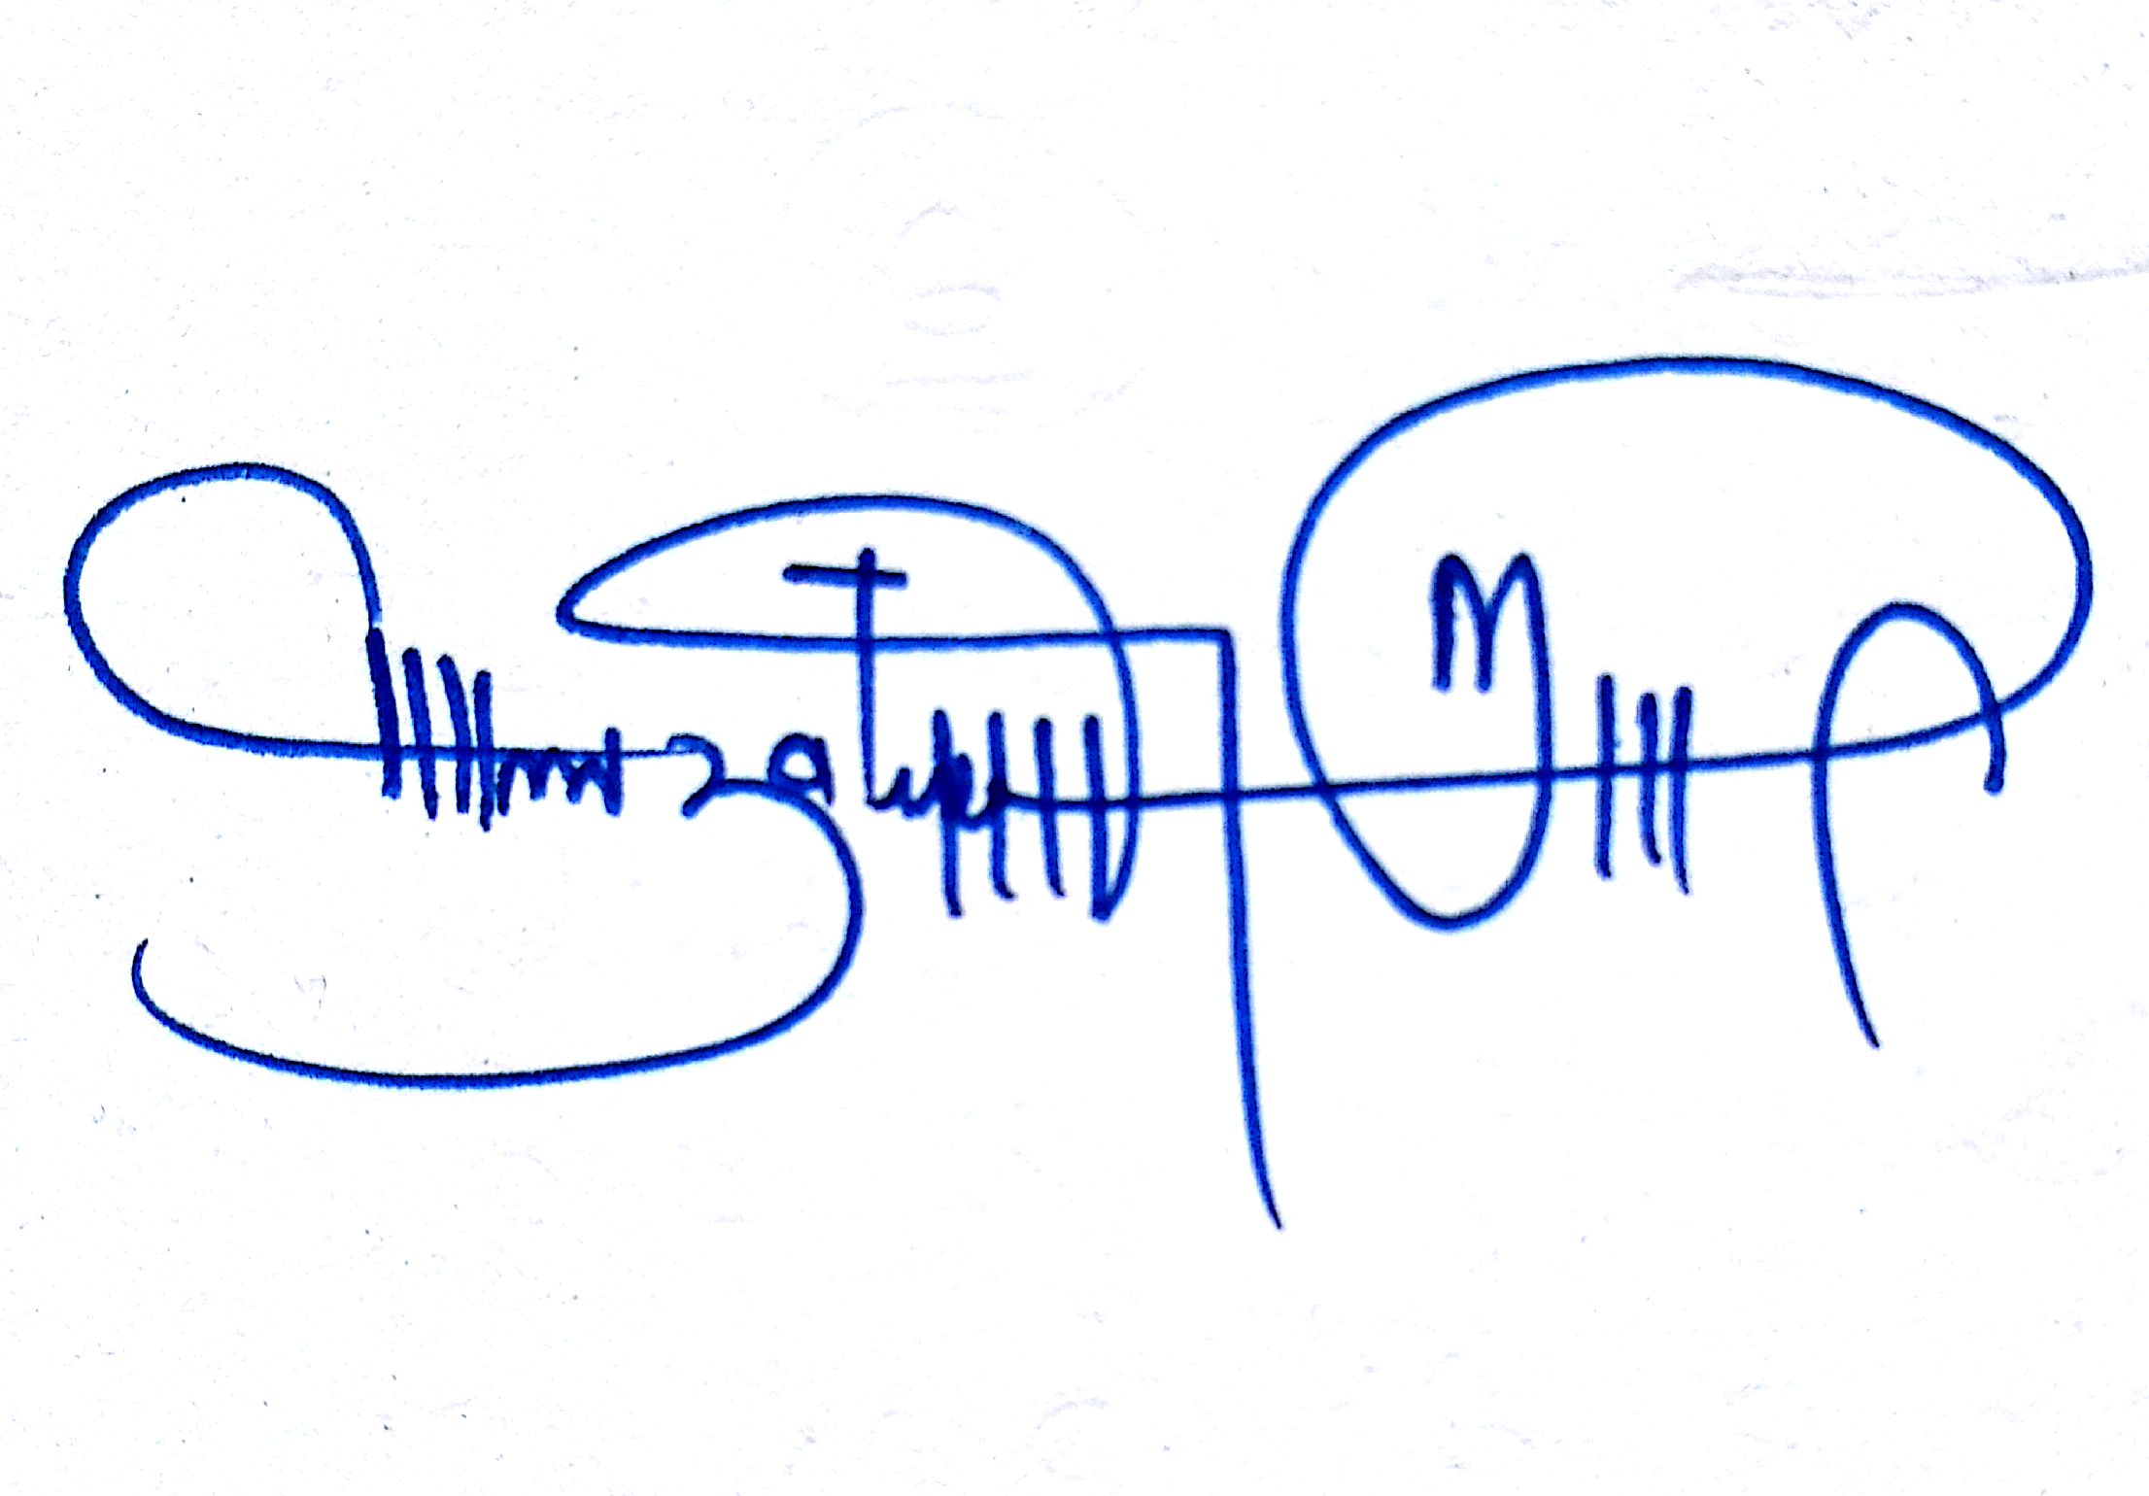





**Signature of Sarpanch Signature of the Visiting Officer**

**Name ……………………… Name;- Dr Murtaza Rashid (JKAS)**

**Undersecretary to the Government**

**Mission Youth, J&K.**

**The urgent public requirements, demands and complaints raised in early B2V programmes have been largely fulfilled with some pendency’s and also some new demands raised during B2V4 programmes which needs immediate attention and Redressal are listed below.**

1. The Electric Supply to the Filtration Plant/Reservoir shall be ensured to make it functional at an earliest (PHE/PDD).
2. The Macdamization of remaining links shall be done in the next fiscal year. (PWD R&B)
3. Bank branch/ATM facility shall be made available at konan in view of the good economic activities done in the Halqa having large employment ratio and ex-servicemen’s (Bank).
4. NTPHC/ISM dispensary shall be established after checking feasibility (Health).
5. Establishment of Public Library as the Halqa is known for high literacy rate (Education/RDD).
6. Development of Warpora Playground into mini-sports stadium (RDD/YSS).
7. Development of Narbothu into all weather roads by construction of Bridge (PWD/RDD).
8. Installation of Street lights in whole Panchayat. (RDD/EDA/Sci & Tech.)







**Name;- Dr Murtaza Rashid (JKAS)**

**Undersecretary to the Government**

**Mission Youth, J&K.**

**Department of Rural Develompent and Panchayati Raj**

**Government of Jammu & Kashmir**

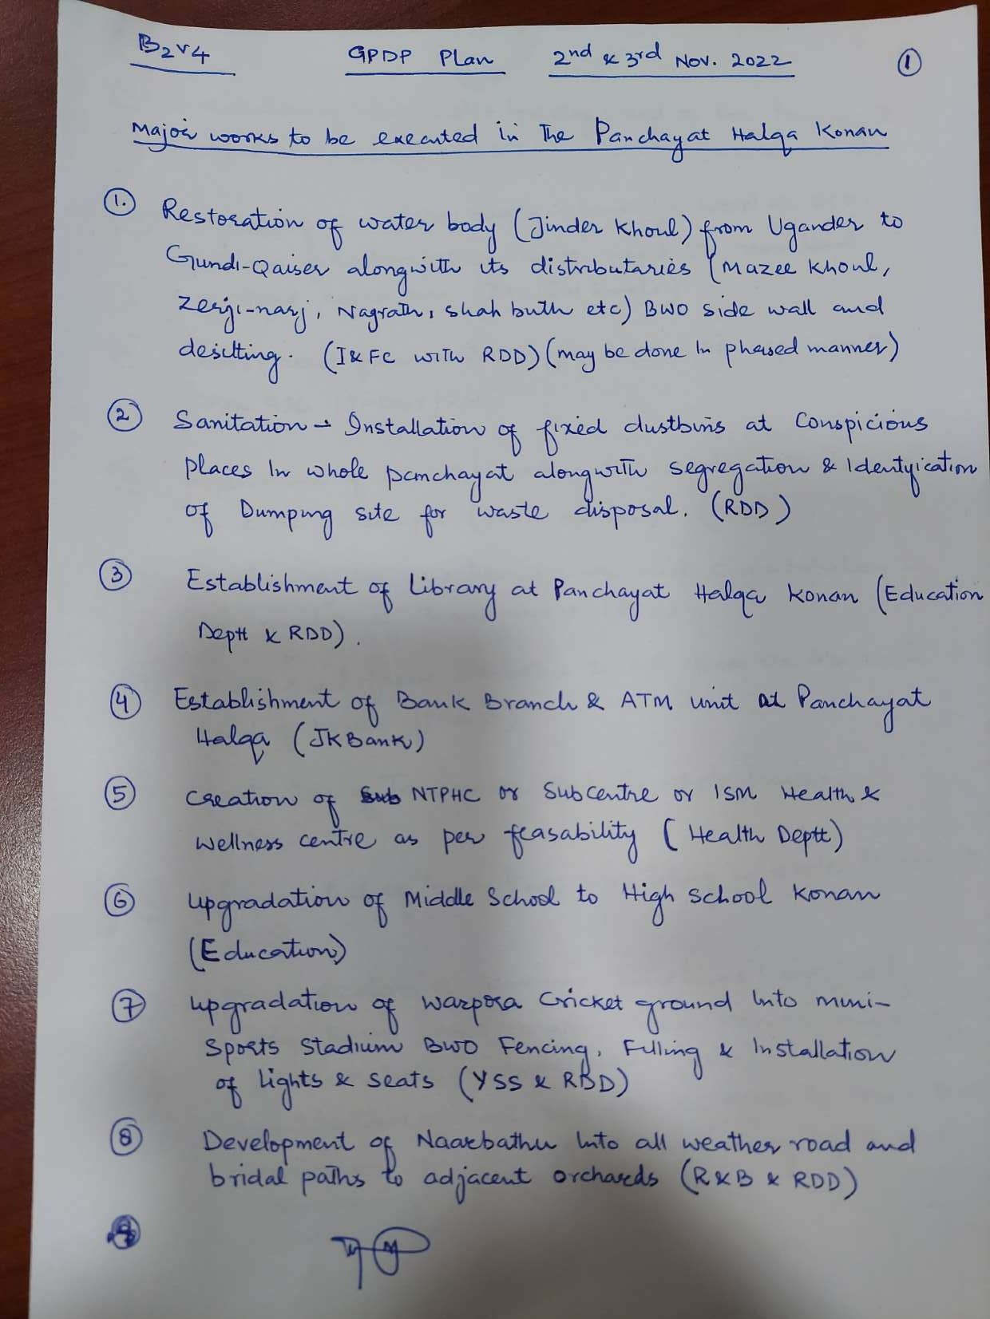

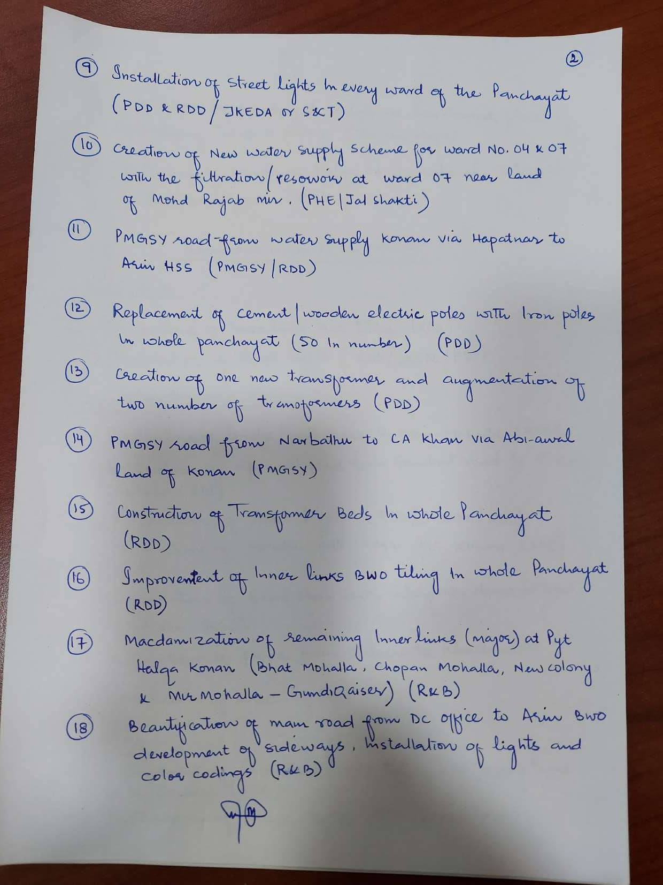



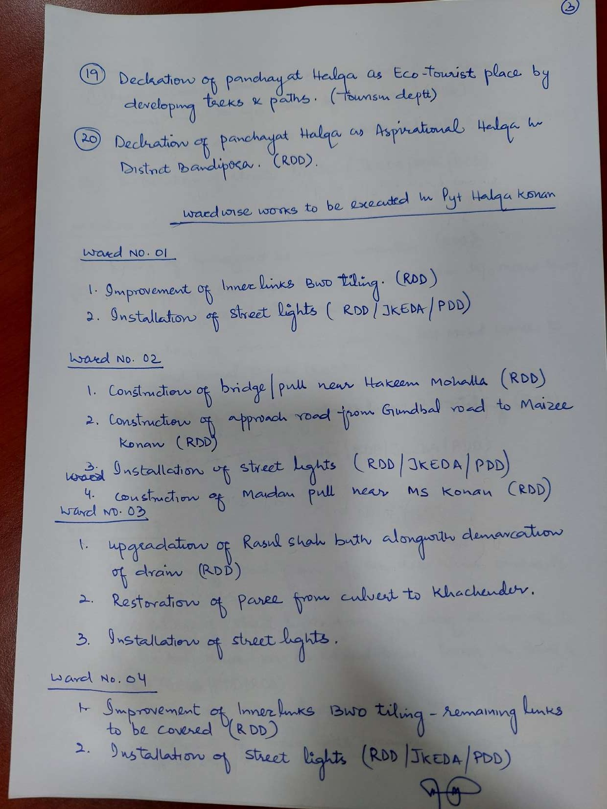

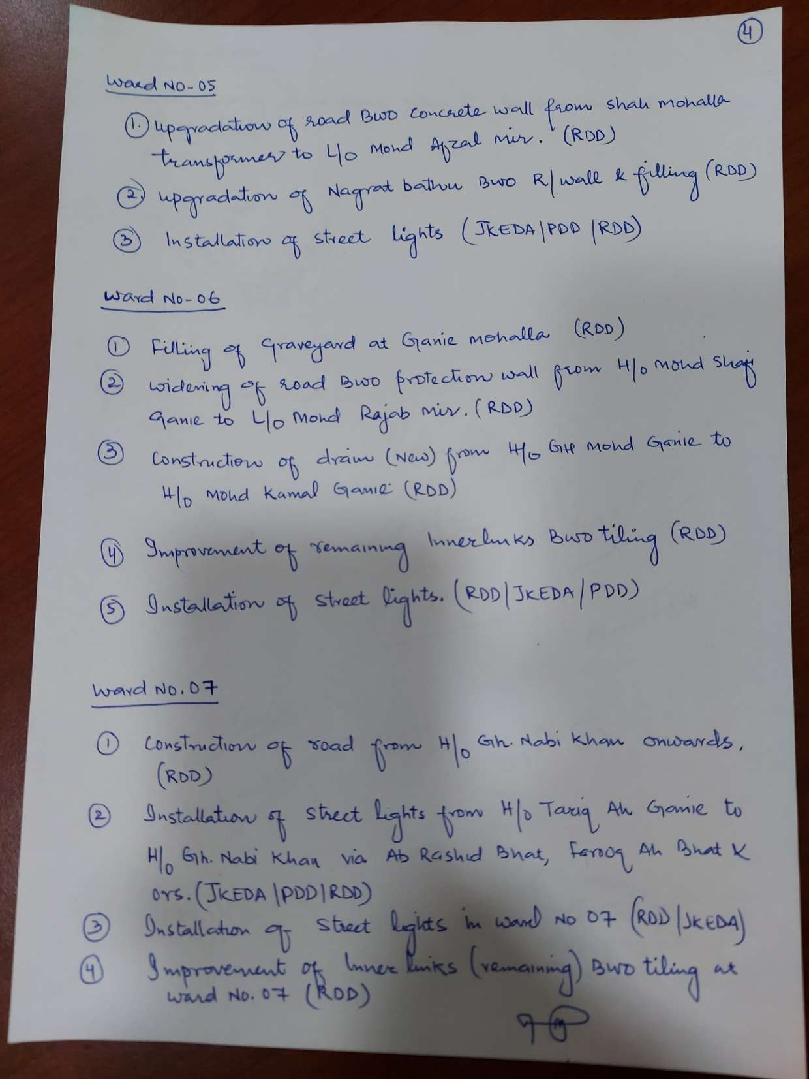

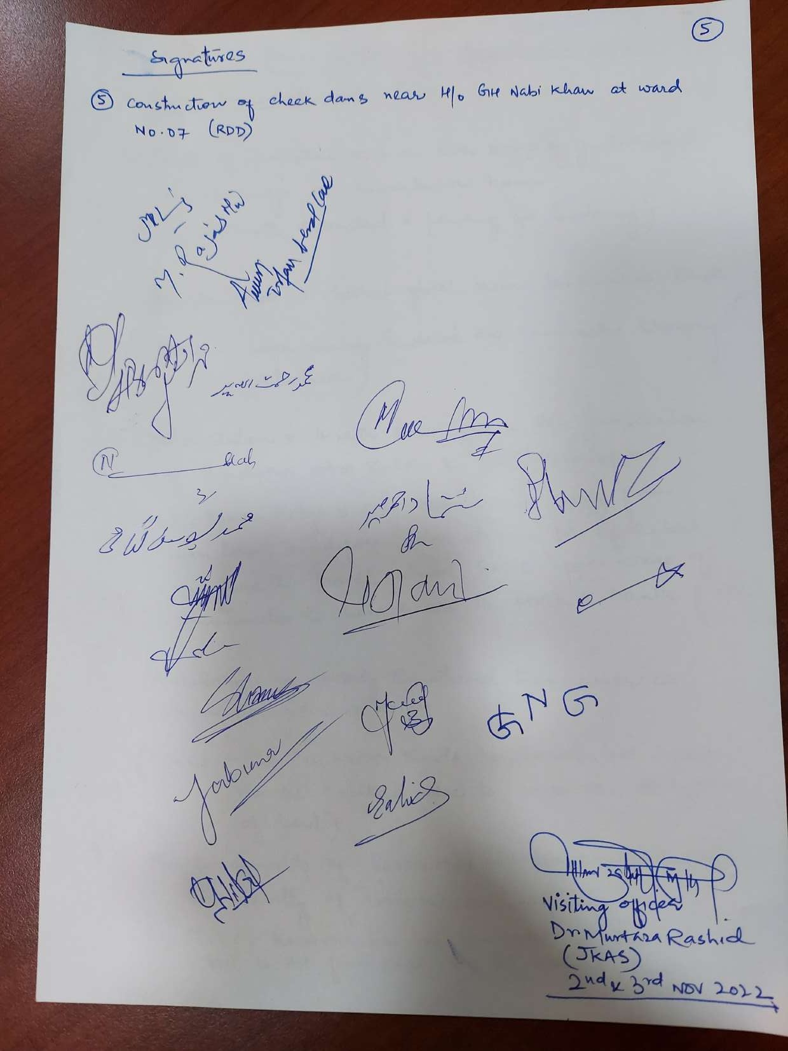

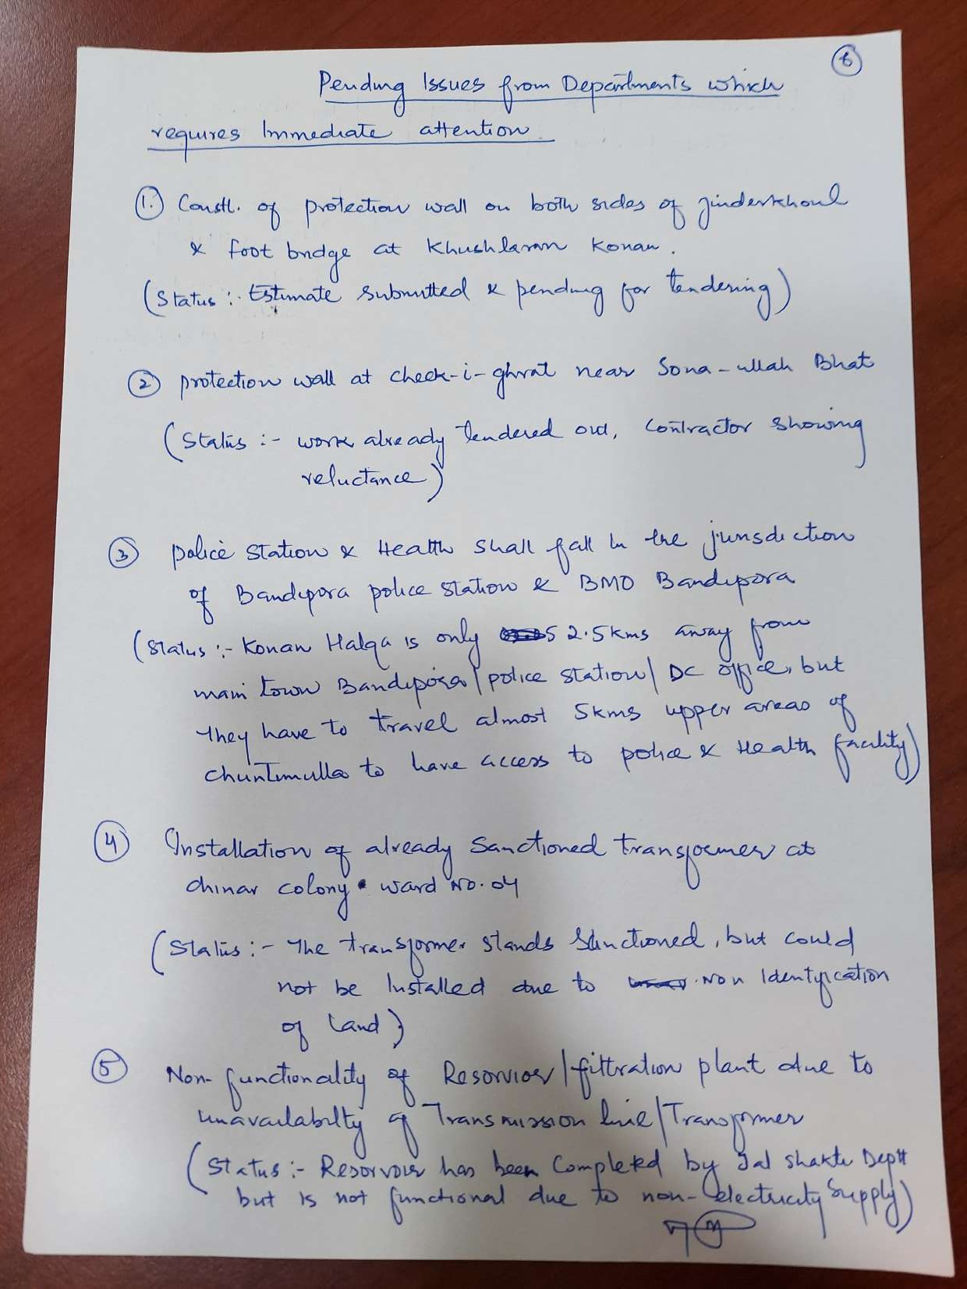

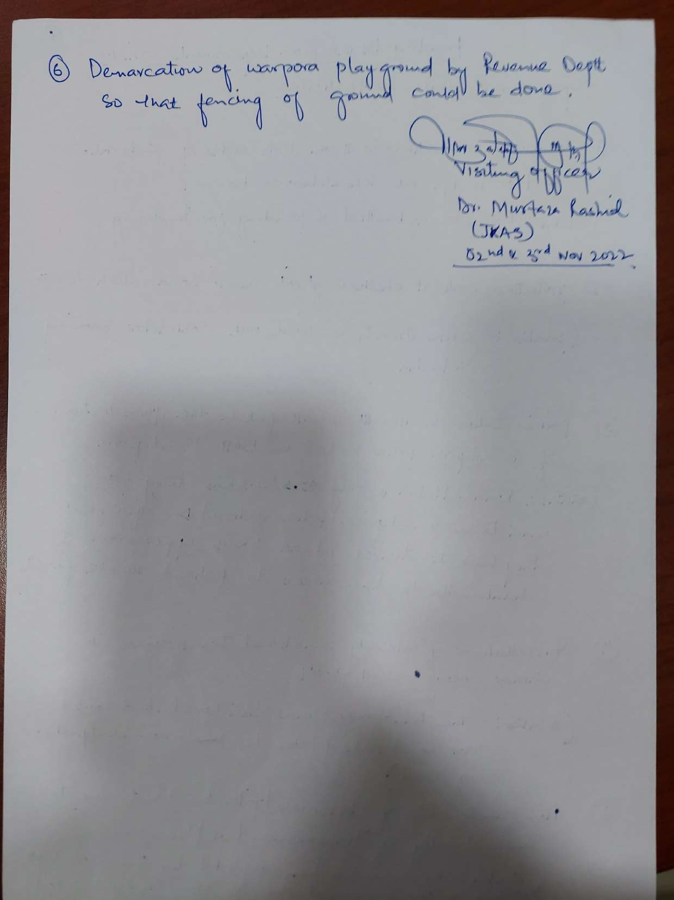





**Name;- Dr Murtaza Rashid (JKAS)**

**Undersecretary to the Government**

**Mission Youth, J&K**

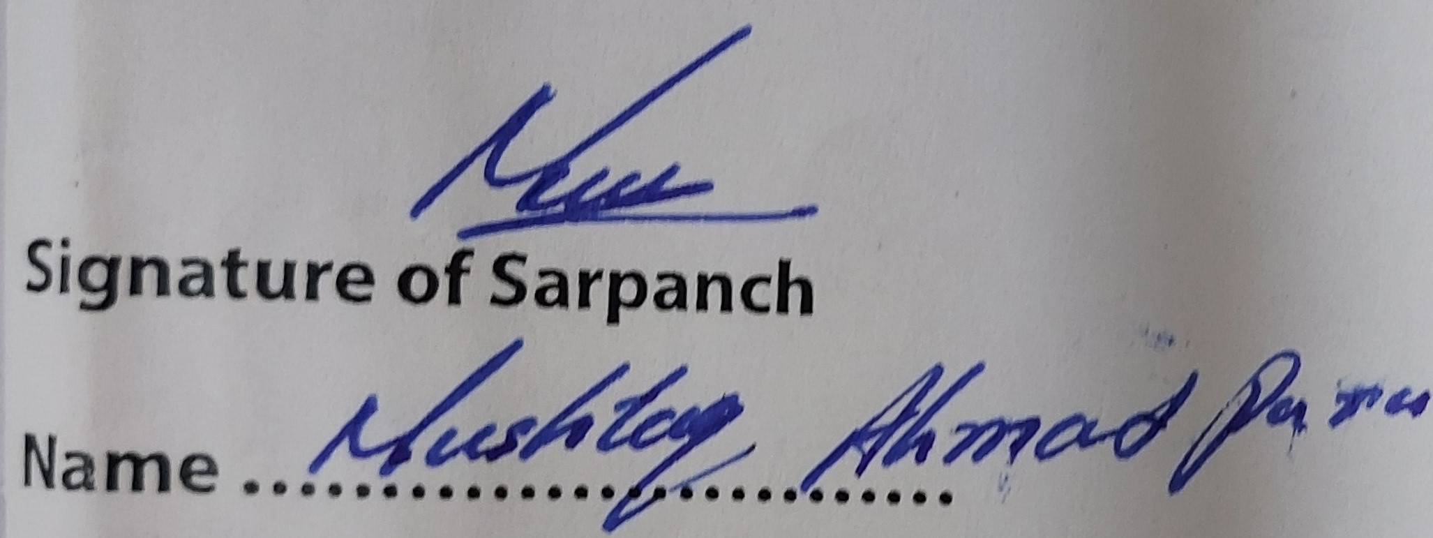

**Department of Rural Develompent and Panchayati Raj**

**Government of Jammu & Kashmir**