4





**15TH OCTto3RD NOV,2022**

**KEYFEATURES**

• DeputyCommissionerstoleadtheinitiative

• RuraldevelopmentDepartmenttobethenodaldepartment

• PlanningDevelopment&MonitoringdepartmentandITtobethesupport departments

**ACTIONSANDTIMELINES**

|  |  |  |  |
| --- | --- | --- | --- |
| **ACTION** | **RESPONSIBILITY** | **LATESTBY** | **REMARKS** |
| **Janabhiyan** | Alldepartments | Oct15-26th | Goingon |
| **DeputationofSecttstaff/ HoDs** | GAD | Oct14 | Done |
| **DeploymentofStaffto Panchayatsandservingof ordersondeployedofficers** | DCs | Oct25 | DCswilldeployseniorlevelstaff fromthedistricts.Strictactionto betakenagainstabstentions.No exemptionstobegiven |
| **Trainingofdistricttrainors onB2V4** | RDD | Oct26 |  |
| **Trainingofvisitingofficers** | DCs | Oct27 |  |
| **FieldVisitstobecompleted by** | VisitingOfficers | Nov3 | DCstosuperviseandensurethat eachPanchayatisvisitedwithin theperiodspecified |
| **DataofB2V4tobe uploadedby** | VisitingOfficers | Nov10 | DCstosuperviseandensurethat dataofallPanchayatsisupload- edbythevisitingofficerwithin theperiodspecified |

**INSTRUCTIONSFORTHEVISITINGOFFICER(DAYWISE)**

|  |  |  |
| --- | --- | --- |
| **DATE** | **INSTRUCTIONS** | **ACTIONPOINTS** |
| **Day0** | Meetingwithdeputy commissionerandhis/her team | a. TakeprintoutsoffilledbookletsofB2V1,B2V2andB2V3from [www.jkpanchayat.in](http://www.jkpanchayat.in)  b.Alsotakeprintoutsofthesummarizedexcelsheetsofthe previousphasesfrom[www.jkpanchayat.in](http://www.jkpanchayat.in)  c. CollectATRsonissuesraisedduringprevious3phasesfromthe officeofDeputyCommissioner(Planningdeptt)  d.Takeprintsofblank 2bookletsofB2V4from[www.jkpanchayat.in](http://www.jkpanchayat.in)e.Takeplansfor2previousyearsandATRsfromtheplanningdeptt f. CompletetrainingsondifferentcomponentsofB2V4being  organizedbyrespectiveDeputyCommissioners  g.CollectListofnewworksstarted/ongoing/completedduringthe previousandcurrentFinancialyearunderthefollowingheads:  • PRIgrants  • DistrictPlan  • UTplan  • MGNREGA  • Otherschemesofotherdepartments  • Anyotherwork  h. Plans/beneficiarylists:  • MGNREGAdraftplandocumentfortheyear2022-23.  • ListofAwaas+beneficiariesalongwithIHHL Convergence  • Listofpensionbeneficiaries.  • ListofSHGs  • Listofagricultureschemebeneficiaries  i. Listsofbeneficiariesfor:  • Variouscertificates/benefitstobedistributedbythe visitingofficer.  • Anyotheractivitiesidentifiedbydifferentdepartments |

|  |  |  |  |
| --- | --- | --- | --- |
| **Day1** | Reachthevillage | 1. | Ensurethatallfrontlineworkersofdifferentdepttsarepresent. |
|  |  | 2. | Ensureexhibitionbydifferentdepts.aboutindividualbeneficiary schemes |
|  |  | 3. | InspectJKB/PSBcounters/outlets |
|  |  | 4. | Participate/ensureorganizationofsportsactivityinplayfield,talent hunt/culturalevent/youthactivity |
|  |  | 5. | GandhiKatha(suggesteddetailsuploadedonjkpanchayat.in) |
|  |  | 6. | Visitatleast2amritsarovarsandgetitsgeotaggedphotos |
|  |  | 7. | InspectKhidmat(CSC)CentresandcreateGenerateawarenesson  225schemesparticularlyG2CschemeslikeBEAMS,Janbhagidari, AapkiZaminAapkiNigrani,DigitalJ&K |
|  |  | 8. | Visitingofficershallalsoplanandconductpanchayatlevelconver- gencemeetingofalldepartments |
|  |  | 9. | CheckeffectivenessofCentrallysponsoredschemes |
|  |  | 10. | VisitandinspectallgovernmentestablishmentsincludingPHE, AWC,FPS,schools,etc |
|  |  | 11. | Attemptsaturationofdeliverableso JanAbhiyanandwherever deficienciesfound,leadadrivetoachievealldeliverables |
|  |  | 12. | Assesseffectivenessofsanitationcampaigninthepanchayat |
|  |  | 13. | Ensureselfemploymentactivitiesfor15youthperpanchayat |
|  |  | 14. | Identify20potentialcandidatesperpanchayatforHIMAYATtraining alongwiththetradeonwhichtheywanttraining |
|  |  | 15. | Whereverpossible,distributeemploymentlettersforpeopleselect- edundervariousgovernmentemployments |
|  |  | 16. | Intheevening,holdnormalmeetingwith seniorcitizens,govtem- ployeesincludingretiredemployees,exservicemen,youthclub,and any citizens ofthevillagewhoareenrolledincollege/university |
|  |  | 17. | OpendiscussiononNashaMuktAbhiyan |

Day2 Haveameetingwithall stakeholders-depttofficials andpanchayatmembers

1. Discussionontheandassesstheprogressofdifferentschemesrelating tothelocalizedSDGsprioritizedforthatvillageaspertheresolution passedby thatGramPanchayaton21st April22,onNationalPanchayti RajDay.

2. Sensitizevillage residentsaboutmyScheme”portal(myscheme.in) whichincludesinformationaboutalltheschemesbeingrunbyCen- tral/State/UTgovtacrossthecountry

3. Hold meeting of theBiodiversityManagementCommitteestodeliber- ateonissuespertaining toconservation of biodiversityandsustaina- bleutilizationof biologicalresources.

4. PrepareVillagedevelopmentplan,inconsultancywithGrampanchayat, discussitingramsabhaandgetitapproved.

5. Ensure saturationofsoilhealthcardandgoldenhealthcardunderGold- enHealthCardunderAyushmanBharat,

6. Ensuresaturation of OldAge PensionScheme

7. EnsureDomicileSaturation.

8. EnsureKCCSaturation

9. Ensure saturationoflandpassbooks

10. Ensureregistrationofvillagevendorsneededforanyscheme,onGEM

portal

11. Ensurepanchayatcontractors registration

12. EncouragePanchayatmembers forimportanceofplantationdrivein

PanchayatunderHarGaonHariyali

13. Ensure paintingondigitalJ&Kinpanchayatghars

14. Ensure paintingonpanchayatactivitesandCSSinpanchayatghars

15. Thevisiting officeshallchecknoof kindergarten andplayfields present inthepanchayat for kidsandstudents,iftheinfrastructure present inthesearegoodenough.

16. Holdmeeting withpanchayatmembers todiscussaboutcorruption menaceandstepsrequiredtomakeJ&Kcorruptionfree

17. Obtaina candidassessmentaboutperformanceofvariousdeptts in- cludingfairfeedbackaboutdiscrepanciesinfunctioning

18. Check thestatusof NashaMuktAbhiyanandreporting of drugad- dictstoDeputyCommissioner.

19. IdentifyTouristDestinations,Circuits,ThemeTreks,IdentifyHomestays, providesupportfortourismactivities throughVillageCooperative

20. OrganizeTalentHuntatPanchayatLevel

21. Conductsocialauditofatleast5worksunderfollowingschemes:

a. MGNREGA

b.PMAY

c. IHHLtoiletsandpayments d.CSCs

e.AMRITSAROVARS

22. Holda mahilasabha anda balsabhaandrecordproceedingsinthefor- matgiven

23. InauguratevillagehaatunderJKSRLM

24. Checkifyouthclubsareformedinthepanchayatandwhatactivities theyareengagedin

25. Organizea villagelevelculturaleventtoengagepanchayatmembers

26. SensitizeGPaboutE-kitabkoshaninitiativeofJ&KGovtforempowering youthsthrough onlinedigitalliteracy

**GENERALINSTRUCTIONS**

1. Thevisitingofficershallrefrainhimself/herselfgivingorofferinganycommitmentonbehalfofthe governmentandshalladoptanunbiasedattitudeinreportingissues.As faraspossible,his/her observation shouldbebasedona fairandanalytical viewemergingfromhis/herinteractioninthe village.

2. Heisgoingtothevillageasplanningofficer,notforsanctioninganyworksorformakinganycom- mitments.

3. Whilepreparingvillagedevelopmentplan,hehastoensurethat,demandsareprioritizedandre- flectedunderavailableschemes,wherevernecessarythelargerworksaretobereferredtoadminis- trativedepttunderCSS/UTplansunderintimationtoDCsandrestoftheworkstoDCsforreflecting itunderdistrict/CSS plans

4. His workshallbehardcoreplanningandauditandisnota PRexercise.

5. EveryDeputyCommissionerhastoensurethatatleastoneRDDofficial(ideallyPanchayatSecre- tary)ispresent ineverypanchayatwithrelevantpanchayatrecords,toensureconductofallactivi- tiesasplanned.Panchayatwiseorderneedstobeissuedinadvance.

6. Visitingofficershouldideallycarryhis/herlaptoptocompletethereportsatthepanchayatlevel itselfanduploadthefinalreport,duly signedbothbythesarpanchandbythevisitingofficeron [www.jkpanchayat.in](http://www.jkpanchayat.in)portal,beforetheyleavepanchayat.

7. Focus ofvisitareyouth,skills,self-employment,nashamukt,bhrashtracharmukt,Rozgaryukt J&K, besidestocarryforwardtheactivities duringJanAbhiyanandsaturatethem.

8. Inadditionattentionmaybegiventothefollowingareas a. MakefulluseofCentrallySponsoredSchemes

b.Saturationofindividualbeneficiaryschemes c. Self-employmentschemes

d.Banklinkedschemes-includingdepartmentalsubsidyschemes e.Empowermentandtransparencythrough digitalinitiatives

f. Effectivenessofgrassrootsmachinery–

i. Patwari,VLWpresent andavailable

ii. AvailablefundsutilizedinpublicinterestandasperGramSabharesolutions iii. Fairness ingovernance

iv. CSS/Individual beneficiaryschemesetc v. BrashtacharMuktJ&K

vi. BhaiMuktJ&K

vii. NashaMuktJ&K

9. ThePRImembers (Sarpanchs,Panchs,BDCChairperson)shallbeattheforefrontofallactivities and givendueimportanceandtheapproach shouldbetostrengthenthemandmakethemfeelem- powered.He/sheshallensurethattheBDCchairpersonandSarpanch/Panch arepresent atthetime ofinaugurationandceremonies.

10. Visitingofficershallnotleavethedistrictwithoutuploadingthereport,duly signedonthe**www. jkpanchayat.in**portal.EveryDeputyCommissionerhastoensurethat.

**A) DetailsofReportingOfficer:**

Name: **Dr SURESH AGSTAM**

Designation: **VETERNARY ASSISTANT SURGEON**

Department/placeof posting**: VAS OFFICE, RAMNAGAR**

MobileNo: 7006892108

EmailID: **sagstam@gmail.com**

HomeDistrict**: UDHAMPUR**

Datesof visit: **01-11-2022 & 02-11-2022**

**B) LocationaldetailsofPanchayat:(tobepre-filled,informationtobetakenfromtheprevious phasesbooklets/summarizedexcelsheetuploadedonjkpanchayat.in/b2v4.php)(tobevali- datedbythevisitingofficerandmissingdetailstobefilled)**

NameofthePanchayat: **DHAMMA**

LocalGovernmentDirectory(LGD)codeof thePanchayat:  **240338**

Nameof CDBlock: **MAJALTA**

NameofTehsil: **MAJALTA**

Nameof District**: UDHAMPUR**

**C) PanchayatProfile:**

No.ofrevenuevillagesinthePanchayat:df **03**

No.ofhamletsinthePanchayat:  **07**

No.ofhouseholdsinthePanchayat:  **481**

Population(approx)of thePanchayat: **2019 (APPROX)**

**Part-II:**

(TobefilledupbytheVisitingOfficerduringhis/hertwodayvisittothePanchayat.AllFieldshavetobe

filledbytheVisitingOfficerbeforethebookletishandedovertotheDC

**FrontlineOfficers/OfficialswhowereassignedtothePanchayatfortheprogramme:**

|  |  |  |  |
| --- | --- | --- | --- |
| S.NO. | Department | Name | Designation |
| 1 | SOCIAL WELFARE | ALL | SUPERVISOR,AWW,AWH |
| 2 | ANIMAL HUSBANDRY | SUDERSHAN KUMAR | VETERNARY PHARMACIST |
| 3 | AGRICULTURE | SANJEEVAN SINGH | JAEO |
| 4 | HEALTH | RANU KOTWAL | COMMUNITY HEALTH OFFICER |
| 5 | AYURVEDIC DEPTT | DR RAKESH PANDITA | MEDICAL OFFICER |
| 6 | PMGSY | AMIT ABROL | AEE |
| 7 | PDD | ALL | LINEMAN, METER READER |
| 8 | HORTICULTURE | PARVEEN KUMAR | HTG-IV |
| 9 | RDD | RAKESH SHARMA , RAJESH SINGH  SANJEEV SINGH | ACCTT.ASSTT. & 2 GRS |
| 10 | POSHAN (ICDS) | ALL | SUPERVISOR,AWW,AWH |
| 11 | REVENUE | RAJ SINGH | PATWARI |
| 12 | FOREST | MOHD AFZAL JEET | FOREST GUARD |
| 13 | JK BANK | SAMRITUI, PARTEEK KUMAR | ASSISTANT MANAGER,INSURER |

**Detailsofabsentemployeesvis-à-vislistfurnishedbytheDCoffice:**

|  |  |  |
| --- | --- | --- |
| Department | Name | Designation |
|  |  |  |
|  |  |  |
|  |  |  |
|  |  |  |
|  |  |  |
|  |  |  |
|  |  |  |
|  |  |  |
|  |  |  |
|  |  |  |

**DAY1-ACTIVITIES**

**AGENDA1:PANCHAYATASSETREGISTER**

**Infrastructure:**

1. PanchayatGharInfrastructure

a. Govtbuilding/private GOVT

b. New/needingrepairs NEW

2. Furniture(Y/N) YES

3. Computer/printer(Y/N) YES

4. Internet(Y/N) NO

5. Telephone(Y/N) NO

6. Toilet(CSC/partofpanchayatghar)(Y/N) YES

7. Water(Y/N) YES

8. Electricity(Y/N) YES

9. Bankbranch(Y/N) NO

10. CSC(Y/N) NO

11. Patwarkhana(Y/N) NO

12. Villagehaat(Y/N) YES

13. Playground(Y/N) YES

14. School-

a. Kindergarten(Y/N) NO

b.Primary(Y/N) YES

c. Secondary(Y/N) YES

d. College (Y/N) NO

e.University(Y/N) NO

15. AnganwadiCentre(Y/N) YES

a. (govt/private) PRIVATE

b.Totalchildrenenrolled 208

15. AmritSarovars–details,location,condition NIL

16. Governmentoffices-details,whetherfunctionalornot FUNCTIONAL

17. Rationshop(Y/N) NO

18. Placesoftourismimportance–names,littledetailsonhistorical/culturalimportance Baba Baloor TEMPLE

19. Villageheritagesites/treks-names,littledetailson historical/culturalimportance Baba Baloor TEMPLE

20. VLWOffice (Y/N) YES

21. PrimaryHealthcareCentre(Y/N), NO

22. ListofIncompleteBuildings-names,yearofconstruction NIL

23. ListofUnderutilizedBuildings-names NIL

**DAY1-ACTIVITIES**

**AGENDA2:**

**DIFFERENTINSTITUTIONS/INFRASTRUCTUREPROJECTSTOBEVISITED**

|  |  |  |
| --- | --- | --- |
| **AMRITSAROVARS** | **Visit,verify** | **COMMENTS** |
| KhidmatCentres | Create/Generateawarenesson225schemes particularlyG2CschemsAapkiZaminAapkiNigrani, Beams,Janbhagidari,DigitalJ&K | NA(NOT Available due to which local people faces lot of hardship) |
| JKB/PSBcounters/outlets | a)Statusofcounter b)Numberofvisitors | No counter of any bank available in branch |
| Incompletebuildings/pro- jects | Verify whetheridentificationandredistribution done | N/A |
| PDS | Visit,evaluate,onlinestatus | N/A |
| PHC | Visit-evaluate,statusofstaff,equipmentand quality | N/A |
| Youthclubs | Meet,interact,seeksuggestions | N/A |
| SHG | Meet,identifyproblems,seeksuggestions | N/A |
| PMAY | Inspect,Inaugurate | YES,8 |
| Myschool,mypride progress;schools-water, toilets,staff | Visit,checkforwater,electricity,sanitation,meet studentsandstaff | YES |
| SwachhSBM | Evaluate | YES |
| Panchayatplayground, Sportskitsdistribution Villagegames | Ensure,verify.Participateinatleastonegamein theplayground | YES |
| HarGaonHariyali, Planta- tiondrive | Evaluatestatus,feedback | YES |
| Villageculturalevent  Dangal/Haat/Mela | Participatein;ensurethatitisheld | YES |
| Exhibitionofschemes | Ensurethateverydepartmentparticipatesand thatitcontinuesfortheentiredurationofB2V | YES |
| JalJeewanMission verifica- tion- WSS/JSD  Electricitysupply | Verify | WATER SUPPLY IN ALTERNATE DAYS |

**DAY1-ACTIVITIES**

**AGENDA3:SATURATEJANBHIYAN**

**DELIVERABLESANDRECORDDEFICIENCIESIFANY(INSERTDELIVERABLESLISTHEREASPERGADFORMAT**

|  |
| --- |
| **DELIVERABLES** |
| **SATURATION OF AYUSHMAN GOLDEN CARD =97.02%**  **SATURATION OF JANANI SURAKSHA YOJANA= 54.16%**  **SATURATION OF OLD AGE PENSION SCHEME= 100%**  **SATURATION OF WIDOW PENSION= 100%**  **SATURATION OF DISABILITYY PENSION=100%**  **SATURATION OF DOMICILE CERTIFICATE=90.22%**  **SATURATION OF KISAN CREDIT CARD= 66.21%**  **SATURATION OF LAND PASSBOOK= OUT OF 1292 ELIGIBLE BENEFICIRIES, 5 LANDPASSBOOKS**  **PREPARES AND 1 ISSUED DURING B2V4**  **REGISTRATION OF VILLAGE VENDORS ON GEM PORTAL= NIL**  **REGISTRATION OF VILLAGE CONTRACTORS ON PWD PORTAL , JK TENDERS PORTAL=100%**  **PERSON IDENTIFIED UNDER HIMAYAT SCHEME=20** |

**DAY1-ACTIVITIES**

**AGENDA4:**

**SELFEMPLOYMENTACTIVITIES**

EnsureSelf-employmentactivities foryouth,distributeemploymentlettersforpeopleselectedunder varioussocialschemes(15ISTHETARGETPERPANCHAYAT)

___

**Numberofcasesindifferentcategoriessanctioned NIL**

**Detailsofthebanksanctioningit: NIL**

**Totalamountinvolved: NIL**

**DAY1ACTIVITIES**

**AGENDA5**

Intheevening,holdinformalmeetings withseniorcitizens,govtemployees,retdemployees,youthclub andothercitizenswhoareenrolledoncollege/universityandhavediscussiononGandhiKatha,Nasha MuktAbhiyan,corruptionfreegovernance,doublingfarmersincomeandrecordtheproceedings

**DAY2**

a. NoofIndividualCompostPitsconstructed **10**

b.NoofIndividualSoakPitsconstructed **45**

V. No.ofBiodiversitymanagementcommitteemeetingsheld: YES

VI. IsthenameofSarpanchdisplayedoncitizeninformationboardsofallRD&PRschemes:Yes/No YES

VII. AreSarpanchsbeinginvolvedinstart/inaugurationofactivities:Yes/No YES

VIII. WhethersubjectshavebeenassignedbytheSarpanchtothePanchs:Yes/No YES

IX. Whethergrievancesredressalboxisinstalled:Yes/No YES

X. NoofgrievancesreceivedpertainingtoPanchayatlevel: **0**

XI. NoofgrievancesdisposedofatPanchayatlevel: 0

XII. WhethertheSarpanch/PanchayatSecretaryhavedigitalsignatures:Yes/No YES

XIII. WhetherallMGNREGA/14thFCpayments arebeingmadebySarpanchthrough DigitalSignature

Certificate(DSC):Yes/No YES

**HUMAN RESOURCEAVAILABLEATTHEPANCHAYAT LEVEL:**

|  |  |  |  |  |
| --- | --- | --- | --- | --- |
| **SRNO.** | **DEPARTMENTWISESTAFF** | **NUMBERS** | | **NAMES** |
|  |  | SANCTIONED | ACTUAL |  |
|  | Ruraldevelopmentdepartment: BDO  JE GRS TA, | 1  1  1  2 | 1  1  1  2 | VISHAL KUMAR SADHOTRA  RAVI KUMAR  RAKESH SHARMA  SACHIN GUPTA&ANKUSH GUPTA |
|  | SCHOOLEDUCATION: TEACHER  HEADMASTER ANYOTHER | 42(TOTAL)  7  2  2 | 18  4  2  2 | HSS DHAMMA, MS GHAR PARMASTA, PS CHANDI, PS THANI, PS WEHAR  VIPIN KUMAR |
|  | JAL JEEVAN: | - | - | - |
|  | PDD: LINEMAN JE  ANYOTHER | - | - | POST OF LINE MAN , METER READER ATRE FEEDER BASED, NEED BASED |
|  | FOOD&CIVILSUPPLIES | - | - | - |
|  | AGRICULTURE&  ANIMALHUS- BANDARY | - | - | - |
|  | SOCIALWELFARE | - | - | - |
|  | HEALTH: ASHA ANM  AYUSHDOCTOR ALLOPATHICDOCTOR | 2  1  1 | 1  1  1 | RENU KOTWAL- COMMUNITY HEALTH OFFICER,  KAMLESH- ASHA WORKER  DR RAKESH- MEDICAL OFFICER(AYURVEDIC) |
|  | ANYOTHERDEPARTMENT |  |  |  |

**DAY2-ACTIVITIES**

**AGENDANO.1**

DiscussionontheandassesstheprogressofdifferentschemesrelatingtothelocalizedSDGsprior-itizedforthatvillageaspertheresolutionpassedbythatGramPanchayaton21stApril22,onNational PanchayatiRajDay(Copyoftheresolutiontobetakenfrom[www.jkpanchayat.in](http://www.jkpanchayat.in)portalunderthelinkof GramSwarajMonth)

1. SDGs AGREED FORTHATVILLAGE,TOBEIMPLEMENTED BYMARCH2024:

2. STATUSOFWORKSUNDERTHEFOLLOWINGSCHEMES:

**1 Cleanandgreenvillage**

i.InitiativestakenbythePanchayatformanagingSolidandLiquidWaste NIL

ii. InitiativestakenbythePanchayatforusinggreensourcesoffuellikesolar,biogas

**NIL**

iii. Hasmappingoflanduse,waterbodies,forest,slopes,wetlands,degradedforestwithintheGram

Panchayatbeendone?Yes/No.IfNo,reason,thereof NO

iv. HastheClimateResiliencePlanbeendevelopedfortheGP?Yes/No NO

v. StepstakenbytheGramSabhaabouttheclimatechangemitigationfactorslikereducingenergy consumption,usageoffossilfuels,plastics,non-renewablebuildingmaterialsandalsotopromote measureslikeplantingoftrees,conservingforests,usageofgoodagriculturalpracticeslikedrip irrigation,waterconservationmeasuresandconservationofwetlands. NO

vi. Whetherschoolshavestartedsegregatingwaste NO

vii. Whetherschoolshavetheirowncompost/soakagepitsforsolid/liquidwastemanagement NO

**2 Healthyvillage**

i) Aremeetings relatedtoVillageHealthandSanitationCommitteebeingheldregularly?**YES**

ii) DoalltheeligibleindividualsbeenprovidedtheGoldenCard?**YES**

iii) ArealltheChildrenbeingimmunizedaspertheSchedulerecommendedbyGovt.ofIndia?**YES**

iv) ArealltheeligibleindividualsbeenvaccinatedagainstCOVID-19?**YES**

v) DoesGramPanchayatensurethatallpregnantwomenaregettingnecessaryprenatalcheckups?**YES**

vi) WhetherallthedeliverieswereInstitutionalizedorconductedbytrainedMidwives?**YES**

**3 Watersufficientvillage**

i) DoalltheIHHsintheGramPanchayathavewaterpipelineconnections? NO

ii) WhetherGramPanchayathastakenstepsforgreywatermanagement. NO

IfYespleasespecify

iii) DoalltheIHHsintheGramPanchayathavetoilets? YES

iv) ArealltheIHHstoiletsfunctionalornot? **YES**

v) DoalltheSchools/Anganwadicentershavea toiletfacilityornot? YES

vi) Areallthetoiletsintheschools/Aaganwadifunctionalornot? YES

vii) WhetherGramPachachayatBhawanhasseparate toiletsforwomenornotNO

**4 ChildFriendlyvillage**

i) Doallthechildrenundertheageof0-6yearsbeenenrolledintheAnganwadicentersforpre- schooling?Yes/NO**YES**

ii) HowmanyBalSabha’swereorganizedintheGramPanchayat------**THREE**-------------

iii) WhethertheissuesraisedbyBalSabhaareaddressedduringtheGramSabha. Yes/NO**YES**

iv) WhetherGramPanchayatistrackingthedatarelatedtodropoutchildrenandchildrenwithirregular attendance?Yes/NO. **YES**

v) DoalltheschoolsundertheGramPanchayathaveseparate toiletsforgirlsandboys?Yes/No**YES**

**5 Villagewithgoodgovernance**

i) IsCSClocatedintheGramPanchayatBhawanornot? NO

ii) IsthelistofbeneficiariesrelatedtotheSchemes/ProgramsdisplayedontheGrampanchayatwallor not? YES

iii) DoestheGramPanchayathasitsbuildingornot? YES

iv) IstheGramPanchayatofficefunctionalornot? YES

v) Aretheactivities approved undertheHalqaPanchayatDevelopmentPlandisplayedontheGram

Panchayatwallornot? YES

vi) IsSocialAuditofearlierSchemes/Programscarriedoutornot? YES

**6 Povertyfreeandenhancedlivelihoodvillage**

i) HasGramPanchayatdevelopedanycriteria fortheidentificationofthepoor?Yes/Noifyesspecify**NO**

ii) HavealltheeligiblehouseholdsregisteredinPDSornot?**YES**

iii) HasGramPanchayatprovidedspaceforSelf-helpGroupsinPanchyatGharforholdingmeetings or not?**NO**

iv) HavealltheeligiblehouseholdsbeenregisteredforPensionornot?**YES**

v) HasGramPanchayatfacilitatedYouthforSkillEnhancementCoursesandPlacement?**YES**

vi) HasJobCardsbeendistributedtoalltheeligibleindividualsunderMGNREGA?**YES**

vii) HasGramPanchayatfacilitatedSHGsforBankAccountLinkages?**NO**

**7 Sociallysecuredvillage**

i) WhetherGramPanchayatismaintainingdatarelatedtoDifferentlyAbledPeople? NO

ii) IsGramPanchayatOffice DisabledFriendlyornot? YES

iii) Areprovisionsfora separate BudgetundertheResourceEnvelopeforWomenandChildrenmadeor not? NO

iv) DoalltheSchools intheGramPanchayathavefacilitiesforDifferentlyAbledChildrenliketoilets, barrier-freeaccess,etc.,ornot? NO

v) Arealltheeligibleindividualsaregettingpensions,likeoldagepension,widowpension,etc? YES

vi) ArealltheeligiblehouseholdsgettingbenefitsfromIAYornot YES

**8 EngenderedDevelopmentinVillage**

i) HowmanyMahilaSabha’swereorganizedintheGramPanchayat-----2------

ii) WhetherSHGsfederationshavebeenprovidedspaceformeetings inthePanchayatBhawan(Yes/ No) NO

iii) WhetherGPshavetakenstepsforincreasingwomen’sparticipationinGramSabha(Yes/No) YES

iv) NumberofwomenbeneficiariesheadedhouseholdscoveredunderPDS

system…985……………………

v) Numberofbeneficiaries(outoftotaleligiblepopulation)receivingsocialprotectionbenefitsunder

PradhanMantriMatritvaVandanaYojana…80……………….

9 Self-sufficientinfrastructureinthevillage

i. WhetherGPhasa CommunityHallwithaccesstoelectricity,furniture,watersupply, toilet……NO COMMUNITY HALL………………….

ii. WhethertheDisastermanagementplanisavailableattheGPLevel(Yes/No)NO

iii. Whetherchild-friendlyparkwithrequiredfacilitiesisavailableinGP(Yes/No) NO

iv. WhethertheGPhaseasyaccesstoGodownforstorage(Yes/No) NO

v. Whetherstreetlightsareprovidedinpublicplacesforensuringsafety(Yes/No) YES

**DAY2ACTIVITIES**

**AGENDANO.2**

SensitizevillageresidentsaboutmyScheme”portal(myscheme.in)whichincludesinformationaboutall theschemesbeingrunbyCentral/State/UT govtacrossthe**c**ountry

*(SchemeMaterialavailablefrom*[*https://jkpanchayat.in/b2v4.php*](https://jkpanchayat.in/b2v4.php)*)*

**DAY2ACTIVITIES**

**AGENDANO.3**

HoldmeetingoftheBiodiversityManagementCommitteestodeliberateonissues pertainingtoconserva- tionofbiodiversityandsustainableutilizationofbiologicalresources.HeshouldcheckPeopleBiodiversity register(PBR)ofthatpanchayatandreviewifBiodiversityManagementCommittee constitutedforthat panchayatis holdingminimum4meetings inayearandmeeting onceinevery3months *(RoleofBMC availableathttps://jkpanchayat.in/b2v4.php)*

COMMITTEEMEMBERS **7 MEMBERS**

PRESENT **4 PRESENT**

BIODIVERSITYREGISTERPHOTOS YES

PAST 4MEETINGDETAILS-DATES,MINUTESPHOTOS **ONLY RECORD OF 2 MEETING FOUND**

**DAY2ACTIVITIES**

**AGENDA4**

Visitingofficershallalsoplanandconductpanchayatlevelconvergencemeeting ofalldepartmentsand prepareVillagedevelopmentplanforvillage,inconsultancywithGrampanchayat,discussitingram sabhaandgetitapproved.

(GPDPformatavailableonhttps://jkpanchayat.in/b2v4.php)

**InadditionGPDPplanshallalsoinclude:**

▪ Touristplaceswhichneedtobedeveloped **BABA BALOOR TEMPLE**

▪ Specificproductwhichneedstobedeveloped

▪ Tourism-homestays

▪ 20candidatesfortrainingunderHimayatschemealongwithtradeinwhich trainingistobegiven

**DAY2ACTIVITIES**

**AGENDA5**

Ensuresaturationoffollowingschemesandgivestatus:

S

|  |  |  |  |
| --- | --- | --- | --- |
| **NAMEOFTHESCHEME** | **TOTALELIGIBLE BENEFICIARIESIN THE VILLAGE** | **TOTALBENEFICIARIESWHO AVAILEDTHEBENEFITSOFTHESCHEME** | **REASONSFOR PENDENCY** |
| GoldenHealthCardunder  AyushmanBharat | 2019 | 1959 | Pending 120, Migrant population, document incompletion |
| Jananisurakshayojana | 24 | 13 | Lack of funds |
| OLDAGEpension | 120 | 120 | - |
| Widowpension | 22 | 22 | - |
| Disabilitypension | 20 | 20 | - |
| Domicilecertificate | 1995 | 1800 | Not applied, old age |
| Kisancreditcard | 438 | 290 | Local people are applying for it |
| PMkisansammannidhi | 204 | 204 | - |

|  |  |  |  |
| --- | --- | --- | --- |
| Landpassbook | 1292 | 5 | partial |
| Registrationofvillageven- dorsonGEMportal | NIL | NIL | - |
| Registrationofvillagecon- tractorsonjktendersportal | 5 | 5 | - |
| Registrationofvillagecon- tractorsonPWDportal | 5 | 5 | - |
| Incompletebuildings/pro- jects | - | - | - |

**DAY2ACTIVITIES**

**AGENDA6**

**NASHAMUKTABHIYAN**

1. Whethergramsabharesolutionpassed YES

2. Detailsofactivities conducted AWARENESS CAMPAIGN HELD

3. Whetherallactivities andGSresolutionuploadedonjkpanchayats.inportal YES

4. Howmanydrugaddictsinthevillage 15

5. WhetherreportedtotheDeputyCommissioner NO

6. Howmanyregisteredforrehabilitationundergovernmentprogramme NIL

**DAY2ACTIVITIES**

**AGENDA7**

**SOCIALAUDIT**

Conductsocialauditofatleast5workseachunderfollowingschemes:

|  |  |  |  |  |  |  |
| --- | --- | --- | --- | --- | --- | --- |
| NAMEOFTHE SCHEME | DETAILSOFTHE WORKS | YEAROFWORK APPROVAL | AMOUNT APPROVED  FORTHEWORK | WHETHER  WORKEXECUTED SATISFACTORILY | GEO- TAGGED PHOTOS | ANY GRIEVANCE RECORDED RELATINGTOTHAT WORK |
| MGNREGA | T ROAD | 2020-21 | 2.48LAC | YES | YES | NIL |
| PMAY | 5 | 2020-21 | 7.45LAC | YES | YES | NIL |
| IHHL  UNDERSBM-G | 5 | 2021-22 | RS 60000 | YES | YES | NIL |
| CSCUNDER SBMG | - | - | - | - | - | - |
| AMRIT SAROVARS | - | - | - | - | - | - |

**DAY2ACTIVITIES**

**AGENDA8**

**MAHILASABHA**

Totalwomeninthevillageabovetheageof18 : **710(APPROX)**

Totalattended: **25**

Proceedings: **ALL SCHEMES WERE DISCUSSED**

*(Plinsertpointerstobediscussedthere–referpalliproceedings)*

**DAY2ACTIVITIES**

**AGENDA9**

**BALSABHA**

Holda balsabhaandrecordproceedings YES

Totalchildreninthevillageabovetheageof 5-18: **270( aprox)**

Totalattended **29**

Proceedings: **DISCUSSED ON SPORTS, NASHA MUKT, CORRUPTION FREE, SWATCH BHARAT, LESS USE OF MOBILE PHONES**

*(Plinsertpointerstobediscussedthere–referpalliproceedings)*

**DAY2ACTIVITIES**

**AGENDA10**

**INAUGURATIONS**

|  |  |  |  |
| --- | --- | --- | --- |
| **SR NO.** | **ASSETS/ACTIVITIES INAUGRATED** | **STATUSOFTHEASSET/AC- TIVITIES(NUMBER,OTHER DETAILS)** | **GEO-TAGGED PHOTOS** |
|  | VILLAGEHAATunderJKSRLM (SUN- DAYMARKET) | 8, CHEESE FUNCTIONAL AT PANCHAYAT GHAR | YES |
|  | PMAYhousesifanyreadyforinaugra- tion | 2 | YES |
|  | Swachhgramprojects-segregation shedsetc | - | - |
|  | Amritsarovars | NIL | - |
|  | Sportskits | NIL | - |
|  | Villageculturalevents | 3 | YES |
|  | JJMassets/projects | NOT FUNCTIONAL | - |
|  | Anyothertobeidentifiedatdistrict level | - | - |

**FOLLOWUPOF(B2V1,B2V2&B2V3):**

*(Prefilledexcelsheet tobetakenfromdistrictlevel/andalsotobedownloaded*

*from*[*www.jkpanchayat.in)*](http://www.jkpanchayat.in)

|  |  |  |  |  |  |  |
| --- | --- | --- | --- | --- | --- | --- |
| S.NO. | | Particulars | Action taken | | Remarks# | |
| I. UrgentPublicRequirements/Demands-B2V1 | | | | | | |
| 1 | 3 NO OF DUG WELL | | | No action | |  |
| 2 | CHECK DAM FOR IRRIGATION | | | No action | |  |
| 3 | VETY. CLINIC | | | No action | |  |
| 4 | PHC  . | | | No action | |  |
| 5 | UPGRADATION OF ELECTRIC TRANSFORMER | | | No action | |  |
| 6 | COMMUNITY HALL | | | No action | |  |
| 7 | EXTENSION COUNTER OF BANK | | | No action | |  |
| II. UrgentPublicRequirements/Demands-B2V2 | | | | | | |
| 1 | INADECUATE DRINKING WATER FACILITY | | |  | |  |
| 2 | SHORTAGE OF STAFF IN HS DHAMMA | | |  | |  |
| 3 | INCREASE LABOUR RATE UNDER MGNREGA | | | Started | |  |
| 4 | ROAD CONNECTIVITY NOT SUFFICIENT | | |  | |  |
| 5 | REPLACEMENT OF LOWER TYRANSFORMER | | | ALL TRANSFORMER ARE FUNCTIONAL BUT NOT REPLACED | |  |
| 6 |  | | |  | |  |
| 7 |  | | |  | |  |
| S.NO. | Particulars | | | Actiontaken | | Remarks# |
| III. MajorProblems–B2V1 | | | | | | |
| 1 | Drinking water | | | Adequate work not done | |  |
| 2 | Panchayat not fully connected by road | | | yes | |  |
| 3 | Requirement of staff in all deptt | | | Nil | |  |

|  |  |  |  |
| --- | --- | --- | --- |
| 4 | INCREASE LABOUR RATE UNDER MGNREGA | No action |  |
| 5 | Demand of 5 no of transformer | Only 1 transformer is installed |  |
| IV. MajorProblems-B2V2 | | | |
| 1 | SAME AS B2V1 |  |  |
| 2 |  |  |  |
| 3 |  |  |  |
| 4 |  |  |  |
| 5 |  |  |  |
| V. MajorProblems-B2V3 | | | |
| 1 | SAME AS B2V2 |  |  |
| 2 |  |  |  |
| 3 |  |  |  |
| 4 |  |  |  |
| 5 |  |  |  |
| VI. MajorComplaints-B2V1 | | | |
| 1 | SHORTAGE OF STAFF IN EDUCATION, ELECTRIC DEPTT | SHORTAGE STILL EXISTS |  |
| 2 | DRINKING WATER FACILITY | NOT SOLVED |  |
| 3 |  |  |  |
| VII. MajorComplaints-B2V2 | | | |
| 1 | SAME AS B2V1 |  |  |
| 2 |  |  |  |
| 3 |  |  |  |
| VIII. MajorComplaints-B2V3 | | | |
| 1 | 8 NO OF HAND PIMPS IN PANCHAYAT NEEDS REPAIRING | NIL |  |
| 2 | WATER SUPPLY IRREGULAR | NIL |  |
| 3 | Low voltage power, electric wires are loose | nil |  |

**OVERALLPERCEPTIONOFFUCNTIONING OF GOVERNMENTDEPARTMENTS**

1. **BEST DEPARTMENT: HEALTH DEPARTMENT & RDD**

**2. LEASTRESPONSIVEDEPARTMENT: PHE, PDD ( DUE TO SHORTAGE OF STAFF)**

**GENERALASSESSMENTOFTHEVISTINGOFFICER**

|  |  |
| --- | --- |
| I | AnymajorcomplaintbroughttothenoticeoftheVisitingOfficer: **MOST OF B2V1 , B2V2 , B2V3 REMAIN UNFULLFILLED** |
| II | Major/urgentpublicdemandsthatwas/werereflectedearlierbuthavenotbeenaddressedsofar:  **REQUIREMENT OF ELECTRIC POLES, 4 UNIT CULVERT AT BUMBOO MOHALLA, SHORTAGE OF STAFF IN EDUCATION DEPTT(SCHOOL)** |
| III | Overallassessmentofthevisitandsuggestions:  (Thevisitingofficertoensurethattheoverallassessmentisrecordedindetailsalongwithconcretesugges- tions)  **: There is a dire need of electric poles as electric wires level is down posing a threat to human lives, requirement of staff in hss dhamma.** |
| IV | OverallRatingofgovtfunctioningas givenbythePanchayat(Scaleof0to10) : **6** |
| V | CertificatefromSarpanchthatthevisitingofficerhasstayedinthepanchayatfor 2 days : **CERTIFIED THATVISITING OFFICER HAS STAYED IN PANCHAYAT FOR TWO DAYS.** |

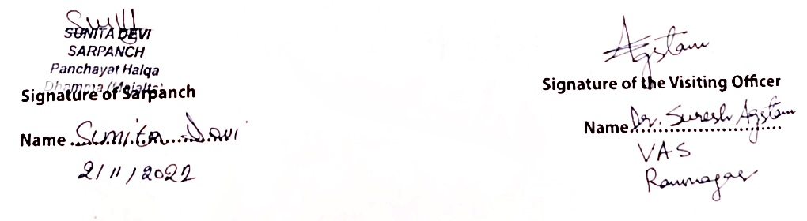

**URGENT PUBLIC DEMANDS**

1. **Requirement of app. 4 metres culvert/ tractor pass at chote sooti bimboo mohalla w no 3which makes connectivity with Pagyal w no 7, Nagola w no3, thereby providing benefits to 80 families by increasing their Agriculture Farming Income.**
2. **Electric wires level are down posing a great threat to human as well as animal lives, requirement of poles in whole panchayat**
3. **Shortage of maths, zoology, botany lecturers in H S S Dhamma**
4. **Requirement of veternary dispensary**
5. **Requirement of community hall**
6. **Requirement of atleast 8 hand pumps in whole panchayat**
7. **Problems of monkey in whole panchayat as they distroy agriculture crops**

**6 DOCUMENTS ENCLOSED:**

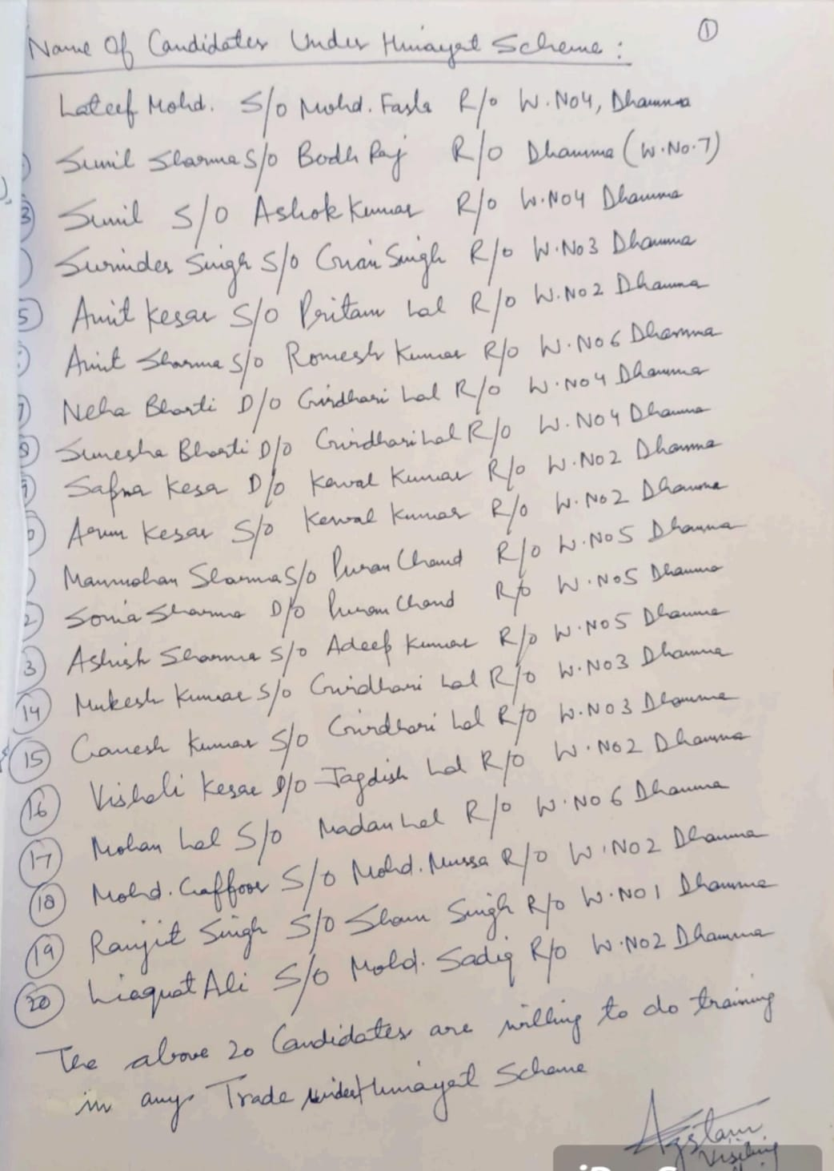

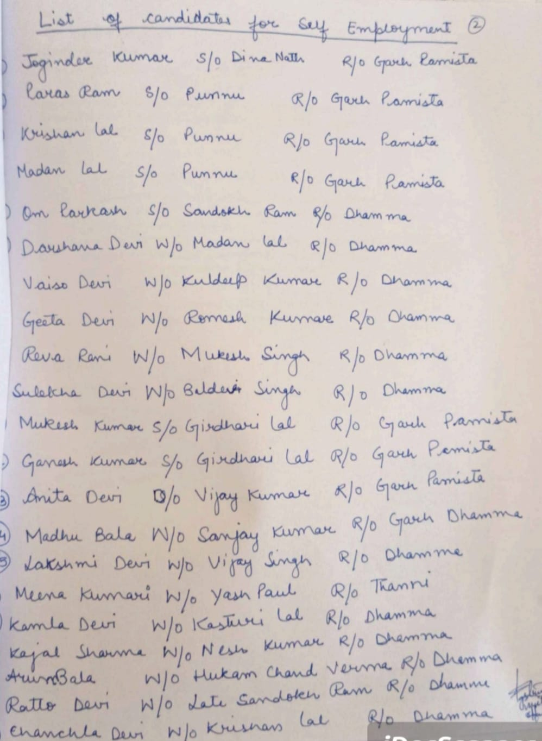

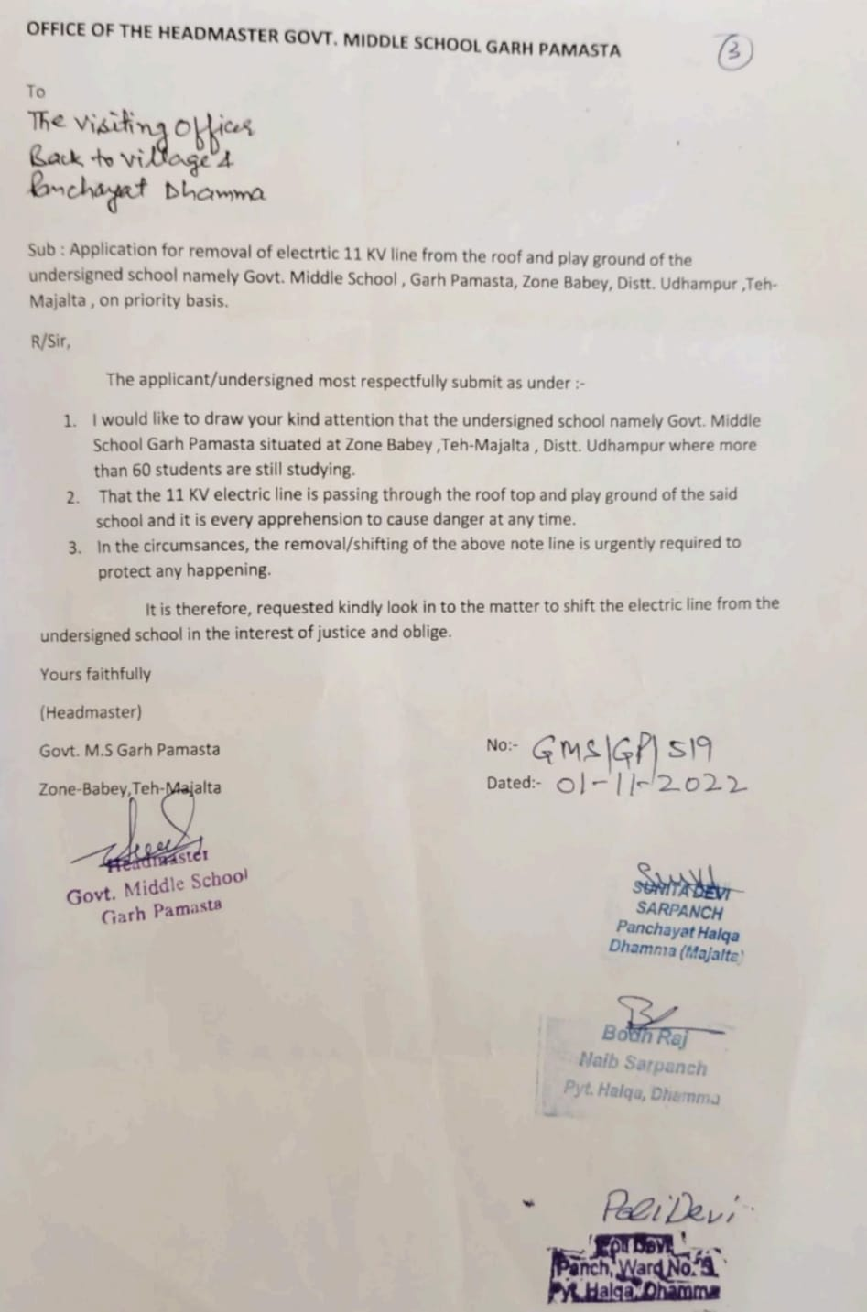

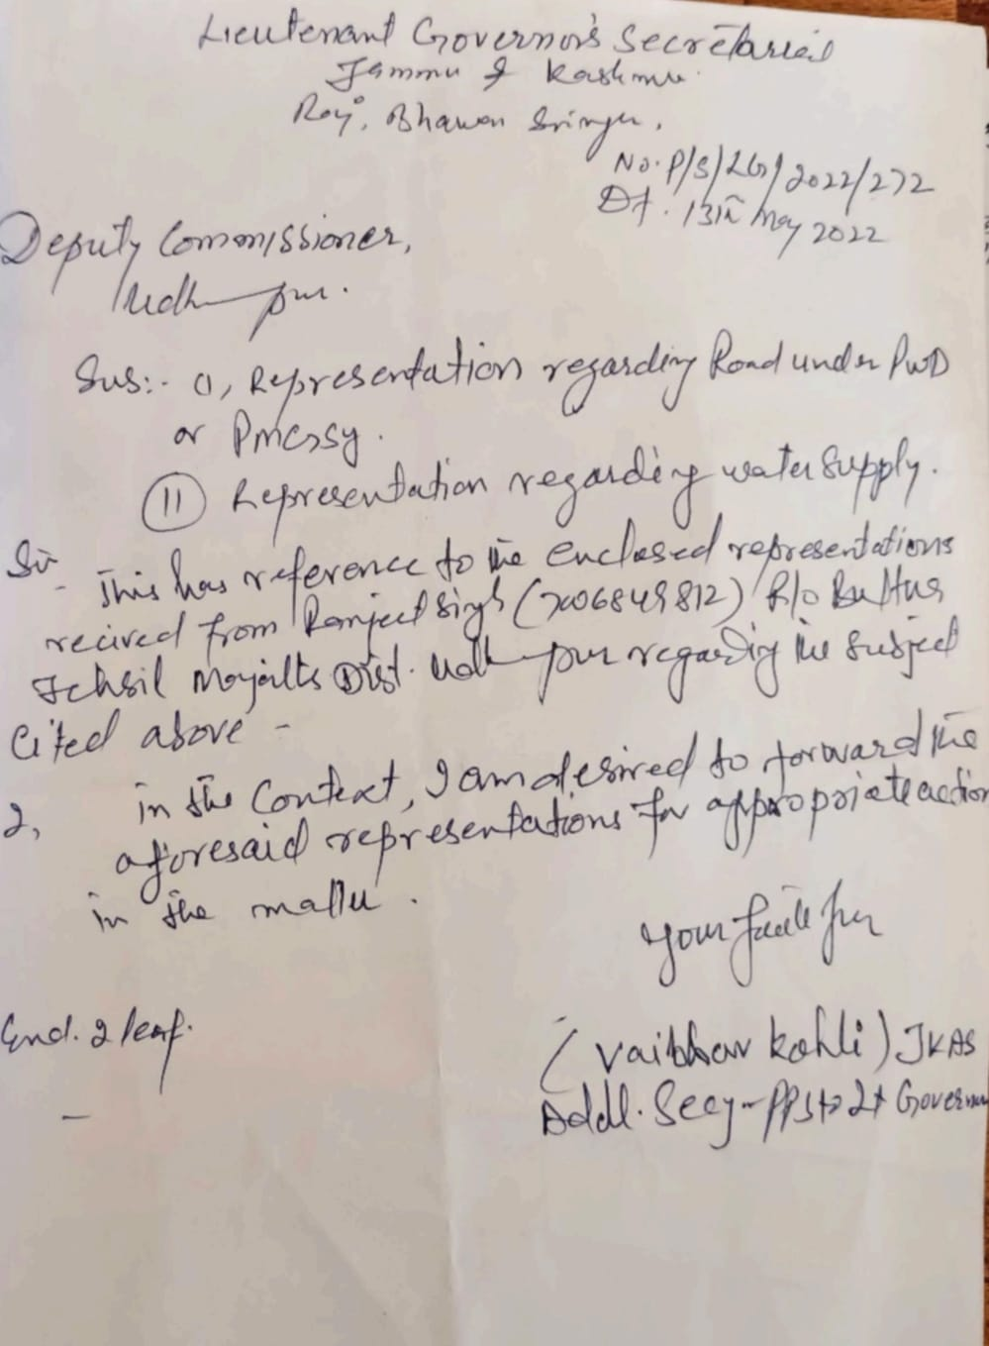

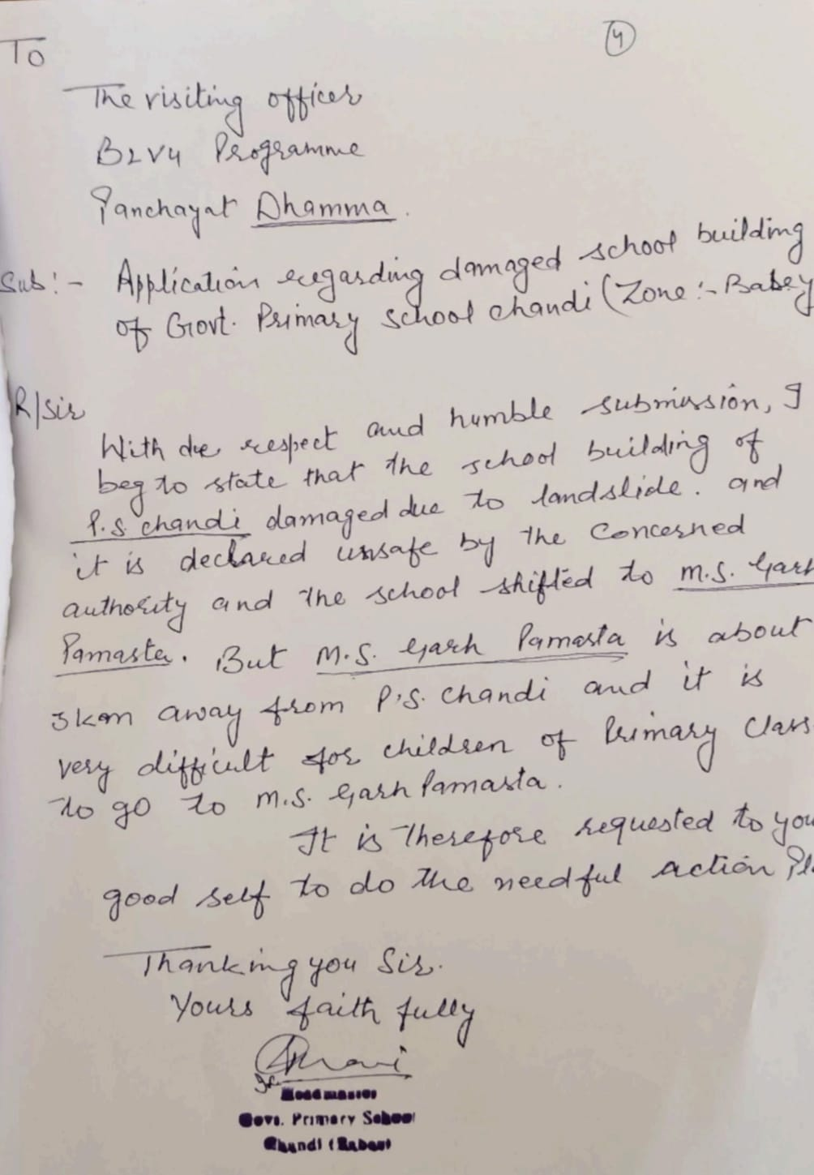

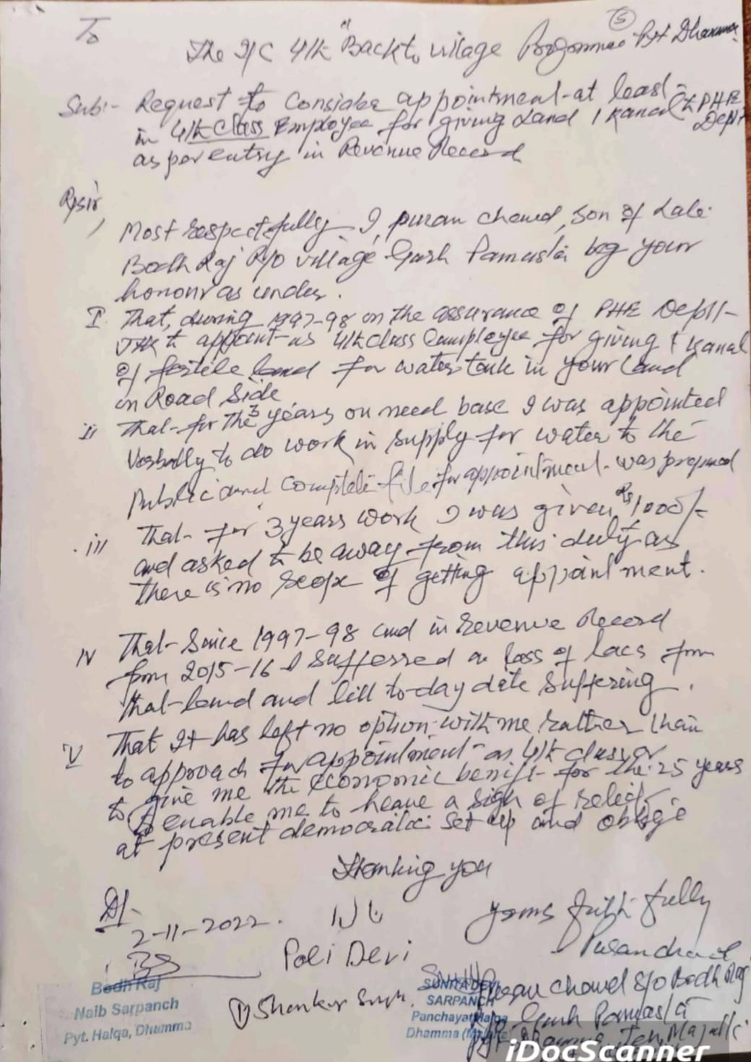

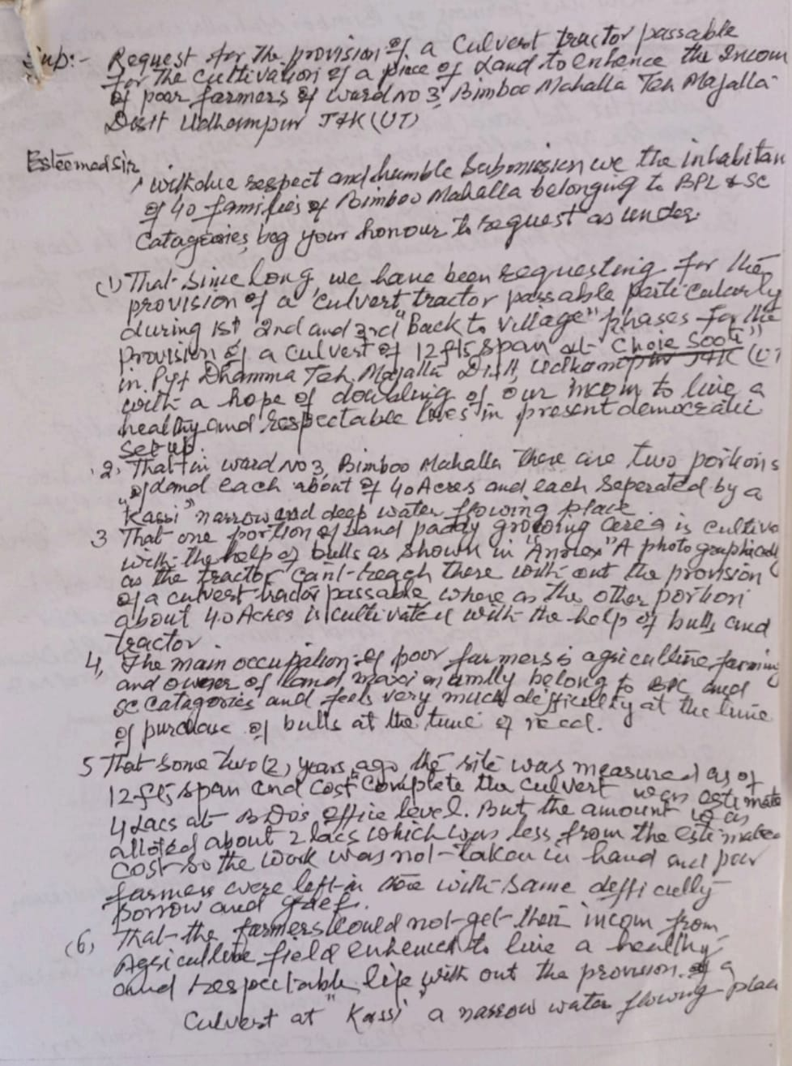

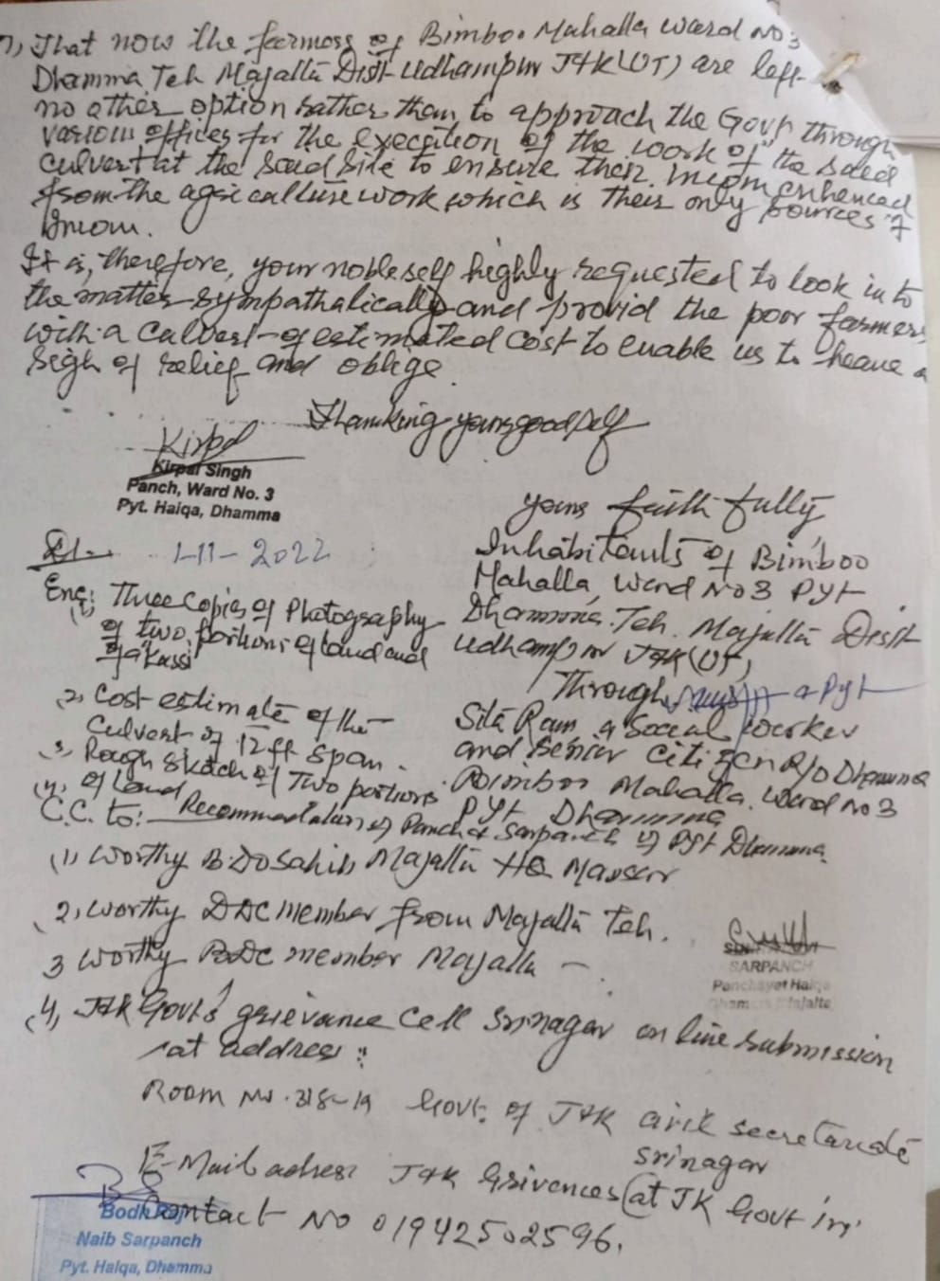

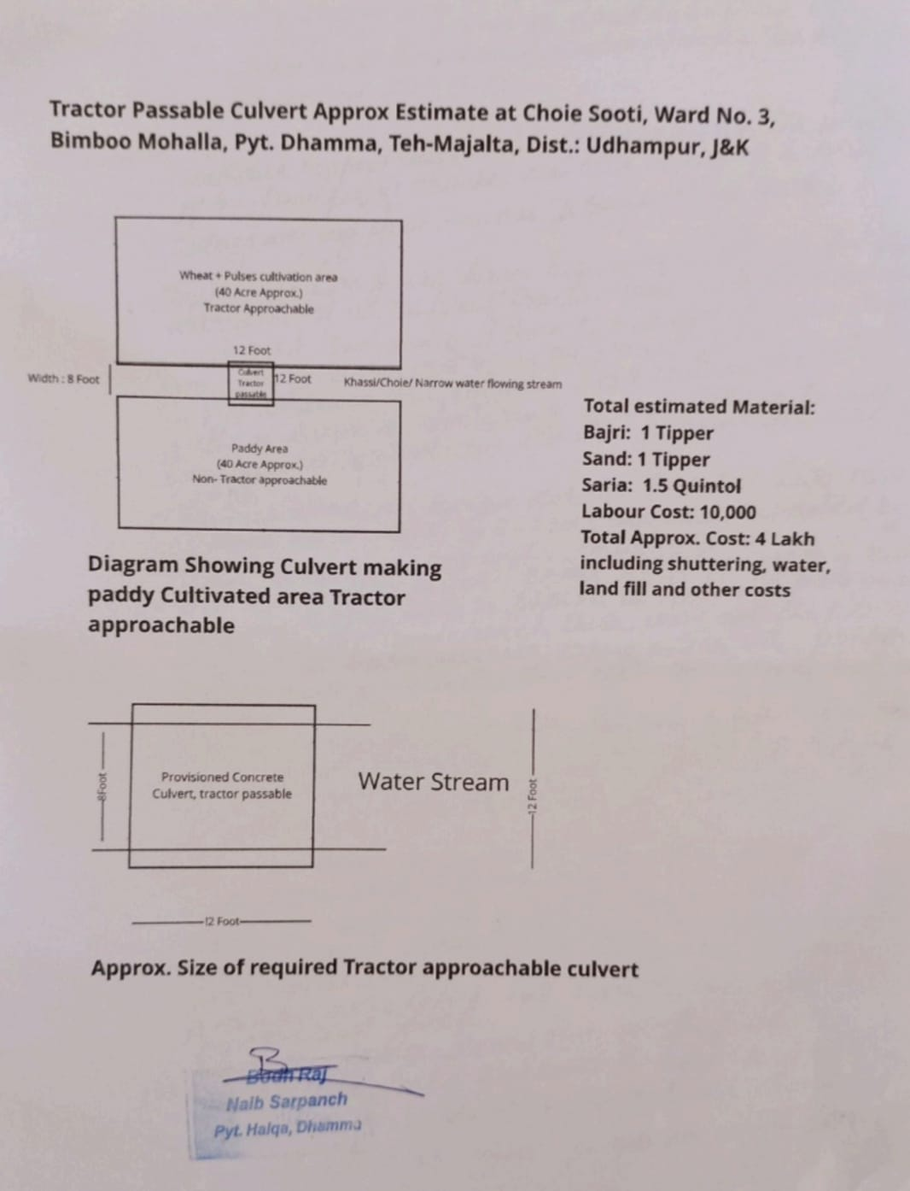

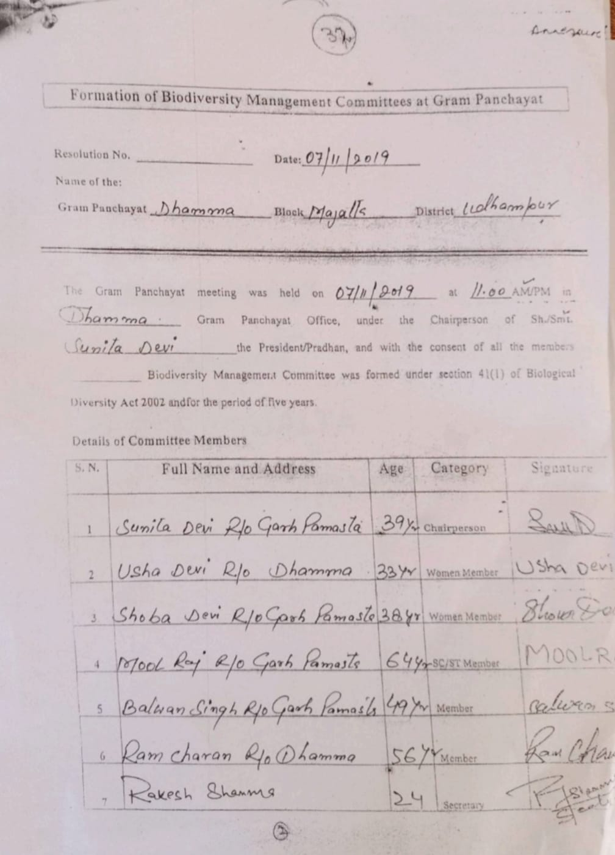



**DepartmentofRuralDevelompentandPanchayatiRaj**

**GovernmentofJammu &Kashmi**