
4
15TH OCT to 3RD NOV, 2022

KEY FEATURES
- Deputy Commissioners to lead the initiative
- Rural development Department to be the nodal department
- Planning Development & Monitoring department and IT to be the support departments

ACTIONS AND TIMELINES
ACTION | RESPONSIBILITY | LATEST BY | REMARKS
Jan abhiyan | All departments | Oct 15 -26th | Going on
Deputation of Sectt staff/ HoDs | GAD | Oct 14 | Done
Deployment of Staff to Panchayats and serving of orders on deployed officers | DCs | Oct 25 | DCs will deploy senior level staff from the districts. Strict action to be taken against abstentions. No exemptions to be given
Training of district trainors on B2V4 | RDD | Oct 26
Training of visiting officers | DCs | Oct 27
Field Visits to be completed by | Visiting Officers | Nov 3 | DCs to supervise and ensure that each Panchayat is visited within the period specified
Data of B2V4 to be uploaded by | Visiting Officers | Nov 10 | DCs to supervise and ensure that data of all Panchayats is upload- ed by the visiting officer within the period specified

INSTRUCTIONS FOR THE VISITING OFFICER (DAY WISE)

DATE | INSTRUCTIONS | ACTION POINTS
Day 0 | Meeting with deputy commissioner and his/her team | a. Take print outs of filled booklets of B2V1, B2V2 and B2V3 from www.jkpanchayat.in
 |  | b. Also take print outs of the summarized excel sheets of the previous phases from www.jkpanchayat.in
 |  | c. Collect ATRs on issues raised during previous 3 phases from the office of Deputy Commissioner (Planning deptt)
 |  | d. Take prints of blank 2 booklets of B2V4 from www.jkpanchayat.in
 |  | e. Take plans for 2 previous years and ATRs from the planning deptt
 |  | f. Complete trainings on different components of B2V4 being organized by respective Deputy Commissioners
- Collect List ofnew works started/ ongoing/ completed during the previous and current Financial year under the following heads:
  - PRI grants
  - District Plan
  - UT plan
  - MGNREGA
  - Other schemes of other departments
  - Any other work
- Plans/ beneficiary lists:
  - MGNREGA draft plan document for the year 2022-23.
  - List of Awaas+ beneficiaries alongwith IHHL Convergence
  - List of pension beneficiaries.
  - List of SHGs
  - List of agriculture scheme beneficiaries
- Lists of beneficiaries for:
  - Various certificates/ benefits to be distributed by the visiting officer.
  - Any other activities identified by different departments

Day 1 | Reach the village | - Ensure that all front line workers of different deptts are present.  - Ensure exhibition by different depts. about individual beneficiary schemes  - Inspect JKB/PSB counters/outlets  - Participate/ensure organization of sports activity in playfield, talent hunt/cultural event/youth activity  - Gandhi Katha (suggested details uploaded on jkpanchayat.in)  - Visit atleast 2 amritsarovars and get its geo tagged photos  - Inspect Khidmat (CSC) Centres and create Generate awareness on 225 schemes particularly G2C schemes like BEAMS, Janbhagidari, AapkiZaminAapkiNigrani, Digital J&K  - Visiting officer shall also plan and conduct panchayat level conver- gence meeting of all departments  - Check effectiveness of Centrally sponsored schemes  - Visit and inspect all government establishments including PHE, AWC, FPS, schools, etc  - Attempt saturation of deliverable so Jan Abhiyan and wherever deficiencies found, lead a drive to achieve all deliverables  - Assess effectiveness of sanitation campaign in the panchayat  - Ensure self employment activities for 15 youth per panchayat  - Identify 20 potential candidates per panchayat for HIMAYAT training alongwith the trade on which they want training  - Wherever possible, distribute employment letters for people select- ed under various government employments  - In the evening, hold normal meeting with senior citizens, govt em- ployees including retired employees, ex servicemen, youth club, and any citizens of the village who are enrolled in college/university  - Open discussion on Nasha Mukt Abhiyan

Day2 | Have a meeting with all stakeholders- deptt officials and panchayat members | - Discussion on the and assess the progress of different schemes relating to the localized SDGs prioritized for that village as per the resolution passed by that Gram Panchayat on 21st April 22, on National Panchayti Raj Day.  - Sensitize village residents about myScheme” portal (myscheme.in) which includes information about all the schemes being run by Cen- tral/ State/ UT govt across the country  - Hold meeting of the Biodiversity Management Committees to deliber- ate on issues pertaining to conservation of biodiversity and sustaina- ble utilization of biological resources.  - Prepare Village development plan, in consultancy with Gram panchayat, discuss it in gram sabha and get it approved.  - Ensure saturation of soil health card and golden health card under Gold- en Health Card under Ayushman Bharat,  - Ensure saturation of Old Age Pension Scheme  - Ensure Domicile Saturation.  - Ensure KCC Saturation  - Ensure saturation of land pass books  - Ensure registration of village vendors needed for any scheme, on GEM portal  - Ensure panchayat contractors registration  - Encourage Panchayat members for importance of plantation drive in Panchayat under Har Gaon Hariyali  - Ensure painting on digital J&K in panchayat ghars  - Ensure painting on panchayat activites and CSS in panchayat ghars  - The visiting office shall check no of kindergarten and playfields present in the panchayat for kids and students, if the infrastructure present in these are good enough.  - Hold meeting with panchayat members to discuss about corruption menace and steps required to make J&K corruption free  - Obtain a candid assessment about performance of various deptts in- cluding fair feedback about discrepancies in functioning  - Check the status of Nasha Mukt Abhiyan and reporting of drug ad- dicts to Deputy Commissioner.  - Identify Tourist Destinations, Circuits, Theme Treks, Identify Homestays, provide support for tourism activities through Village Cooperative  - Organize Talent Hunt at Panchayat Level  - Conduct social audit of atleast 5 works under following schemes:  - MGNREGA  - PMAY  - IHHL toilets and payments  - CSCs  - AMRIT SAROVARS  - Hold a mahilasabha and a balsabha and record proceedings in the for- mat given  - Inaugurate village haat under JKSRLM  - Check if youth clubs are formed in the panchayat and what activities they are engaged in  - Organize a village level cultural event to engage panchayat members  - Sensitize GP about E-kitab kosh an initiative of J&K Govt for empowering youths through online digital literacy

GENERAL INSTRUCTIONS
- The visiting officer shall refrain himself/ herself giving or offering any commitment on behalf of the government and shall adopt an unbiased attitude in reporting issues. As far as possible, his/her observation should be based on a fair and analytical view emerging from his/her interaction in the village.
- He is going to the village as planning officer, not for sanctioning any works or for making any com- mitments.
- While preparing village development plan, he has to ensure that, demands are prioritized and re- flected under available schemes, wherever necessary the larger works are to be referred to adminis- trative deptt under CSS/UT plans under intimation to DCs and rest of the works to DCs for reflecting it under district/CSS plans
- His work shall be hard core planning and audit and is not a PR exercise.
- Every Deputy Commissioner has to ensure that atleast one RDD official (ideally Panchayat Secre- tary) is present in every panchayat with relevant panchayat records, to ensure conduct of all activi- ties as planned. Panchayat wise order needs to be issued in advance.
- Visiting officer should ideally carry his/her laptop to complete the reports at the panchayat level itself and upload the final report, duly signed both by the sarpanch and by the visiting officer on www.jkpanchayat.in portal, before they leave panchayat.
- Focus of visit are youth, skills, self-employment, nasha mukt, bhrashtrachar mukt, Rozgar yukt J&K, besides to carry forward the activities during Jan Abhiyan and saturate them.
- In addition attention may be given to the following areas
  - Make full use of Centrally Sponsored Schemes
  - Saturation of individual beneficiary schemes
  - Self-employment schemes
  - Bank linked schemes- including departmental subsidy schemes
  - Empowerment and transparency through digital initiatives
  - Effectiveness of grass roots machinery –
    - Patwari, VLW present and available
    - Available funds utilized in public interest and as per Gram Sabha resolutions
    - Fairness in governance
    - CSS/Individual beneficiary schemes etc
    - BrashtacharMukt J&K
    - Bhai Mukt J&K
    - NashaMukt J&K

- The PRI members (Sarpanchs, Panchs, BDC Chairperson) shall be at the forefront of all activities and given due importance and the approach should be to strengthen them and make them feel em- powered. He/she shall ensure that the BDC chairperson and Sarpanch/Panch are present at the time of inauguration and ceremonies.
- Visiting officer shall not leave the district without uploading the report, duly signed on the www. jkpanchayat.in portal. Every Deputy Commissioner has to ensure that.

Details of Reporting Officer:

Name: ARJUMAND NISA

Designation: Pvt. Secretary to Secretary in Deptt.

Department/ place of posting: Housing and urban Development Deptt.

Mobile No: 9622682922

Email ID: arjumandnisa168@gmail.com

Home District: Srinagar

Dates of visit: 31th Oct & 1st November 2022

Locational details of Panchayat: (to be pre-filled, information to be taken from the previous phases booklets/summarized excel sheet uploaded on jkpanchayat.in/b2v4.php) (to be vali- dated by the visiting officer and missing details to be filled)

Name of the Panchayat: Theed A

Local Government Directory(LGD) code of the Panchayat: 922937

Name of CD Block: Harwan

Name of Tehsil: Srinagar North

Name of District: Srinagar

Panchayat Profile:

No. of revenue villages in the Panchayat: 1

No. of hamlets in the Panchayat: 1

No. of households in the Panchayat: 331

Population (approx) of the Panchayat: 2058

Part-II:
(To be filled up by the Visiting Officer during his/her two day visit to the Panchayat. All Fields have to be filled by the Visiting Officer before the booklet is handed over to the DC

Frontline Officers/Officials who were assigned to the Panchayat for the programme:

Department | Name | Designation
Labour Department | Ansar Ahmad | Labour Officer
Employment | Showkat Ahmad Beigh | Head Assistant
Agriculture | Dr. Muzain Masood | A.E.O
Social Welfare | Zamrooda | C/A
ICDS | Bilquees Khaliq | Healt and nutrition Mobolizer
KVIB | Nuzhat parveen | Supervisor
R&B | Azaad Ahmad | W/S
I&FC | Bilal Ahmad | W/S
CAPD | Mehraj uddin | Storekeeper
CSC | Taufeeq Ahmad Bhat | CSC
Animal Husbandary | Manzoor ahmad | SVP
Floriculture | Khurshid Ahmad | Class IV
Geology & Mining | Mohd Maqbool | Area Incharge

Details of absent employees vis-à-vis list furnished by the DC office:

Department | Name | Designation
Tourism
Culture
Skill Development
Science and Technology
Tribal
NDMA
Other Departments present: ICDS, Fisheries, Revenue, Youth Services & Sports, Sheep Husbandry, Social forestry, Urban Forestry, PWD, PDD, JKSRLM, Sericulture, Apiculture, Labour Deptt, Floriculture, I&FC Deptt, CAPD, Geology and Mining

DAY 1- ACTIVITIES

AGENDA 1: PANCHAYAT ASSET REGISTER

Infrastructure:

  - Panchayat Ghar Infrastructure: Panchayat Ghar not available
    - Govt building/private
    - New/needing repairs
  - Furniture (Y/N) No
  - Computer/printer (Y/N) NO
  - Internet (Y/N) No
  - Telephone (Y/N) No
  - Toilet (CSC/part of panchayat ghar) (Y/N) No
  - Water (Y/N) No
  - Electricity (Y/N) No
  - Bank branch (Y/N) Yes (JK Bank)
  - CSC (Y/N) No
  - Patwarkhana (Y/N) No
  - Village haat (Y/N) Yes
  - Playground (Y/N) NO
  - School-
    - Kindergarten (Y/N) No
    - Primary (Y/N) (upper Primary)
    - Secondary (Y/N) NO
    - College (Y/N) No
    - University (Y/N) No
  - Anganwadi Centre (Y/N) Yes
    - (govt/private) 2 No
    - Total children enrolled 233
- Amrit Sarovars – details, location, condition Approved 3 No, Executed 1
- Government offices- details, whether functional or not : functional
- Ration shop (Y/N) Yes
- Places oftourism importance– names, little details on historical/cultural importance. Tarsar Marsar trek.
- Village heritage sites/ treks- names, little details on historical/cultural importance:
- VLW Office (Y/N) Yes
- Primary Healthcare Centre (Y/N), Yes (NTPC)
- List of Incomplete Buildings- names, year of construction Middle school Mulnar, 2020
- List of Underutilized Buildings- names Nil

DAY 1-ACTIVITIES

AGENDA 2:
DIFFERENT INSTITUTIONS/INFRASTRUCTURE PROJECTS TO BE VISITED

AMRIT SAROVARS

Visit, verify

COMMENTS

Khidmat Centres
Create /Generate awareness on 225 schemes particularly G2C schems Aapki Zamin Aapki Nigrani, Beams, Janbhagidari, Digital J&K
Stall installed

JKB/PSB counters/outlets

Incomplete buildings/pro- jects

PDS PHC
Youth clubs SHG
- Status of counter
- Number of visitors

Verify whether identification and redistribution done

Visit, evaluate, online status

Visit- evaluate, status of staff, equipment and quality

Meet, interact, seek suggestions

Meet, identify problems, seek suggestions
Stall installed
School building at mulnar, work needs to be expedited.
Not available in the Halqa

Need more infrastructure
Interacted need play Ground
Require national market

PMAY

My school, my pride progress; schools- water, toilets, staff

Swachh SBM

Panchayat play ground, Sports kits distribution Village games

Har Gaon Hariyali, Planta- tion drive

Village cultural event Dangal/ Haat/Mela

Exhibition of schemes
Inspect, Inaugurate

Visit, check for water, electricity, sanitation, meet students and staff

Evaluate

Ensure, verify. Participate in at least one game in the playground

Evaluate status, feedback

Participate in; ensure that it is held

Ensure that every department participates and that it continues for the entire duration of B2V

No case

All good

Satisfactory

Not Distributed, no response
From YSS

Plantation drive held
Ensured

Jal Jeewan Mission verifica- tion- WSS/JSD
Electricity supply

Verify
Old Water pipe lines need to be
replaced

DAY 1 - ACTIVITIES

AGENDA 3: SATURATE JAN BHIYAN DELIVERABLES AND RECORD DEFICIENCIES IF ANY (INSERT
DELIVERABLES LIST HERE AS PER GAD FORMAT

S.No | DEPARTMENT | WORK/DELIVERABLE | ASSISTED BY | REMARKS
1. | RDD | ALL B2V WORKS- Document,  Verify, Complete | DC | 100% (as  reported by field functionaries present)
 |  | All GPDPs to be prepared and
 |  | finalised under convergence
 |  | mode
 |  | Panchayat Awards to be finalised
 |  | VILLAGE HAATS –Establish | NRLM
2. | IT | - CSC CAMPS- ONE PER PANCHAYAT  - ALL 225 ONLINE SERVICES- Popularise, Inform  - Beams, Jan Bhagidari- Assist in Access, Demonstrate, Educate, Inform,  - Hoardings, Wall Paintings in all Panchayats about Digital J&K and services  - Assist in enrollment of user services- Golden Cards, Domiciles, UDID etc | CSC | Availabe
3. | FINANCE | - SELF EMPLOYMENT TO AT LEAST 15 PERSONS/Panchayat  - All INDIVIDUAL SUBSIDY SCHEMES- Counter to be set up by banks at Panchayat level to verify, Sanction, disburse cases and also accept fresh applications  - ADHAAR SEEDING OF ALL INDIVIDUAL BENEFICIARY SCHEMES | J&K BANK EDI LABOUR | 90% (as reported by field functionaries present)
95% (KCC) (as
reported by field functionaries present)

4

- REVENUE

- HEALTH

- SOCIAL
WELFARE

- FOREST
  - APKI ZAMIN APKI NIGRANI-
Inform, popularise
  - PATWAR KHANA- Verify, Establish, Paint information and timings
  - INHERITANCE MUTATIONS-
Complete
  - LAND PASSBOOKS-generate and Issue for undisputed entries 1)PMJAY GOLDEN CARDS- Saturate
- Swachh hospitals- clean toilets, junk free premises
  - DIVYANG CAMPS- Hold Camps, ensure fittings
  - DISABILITY CARDS (UDID) – All existing 2.5 lakhs UDID Cards to be made digital
  - NOAPS/ISSS PENSIONS- Audit, Saturation of wall paintings of pension beneficiaries
  - POSHAN VATIKA-ensure 100% plantation
  - 500 ANEMIA CHECK UP CAMPS-Conduct
  - AADHAR SEEDING- Ladli Beti beneficiaries, Aanganwadi beneficiaries
  - BBBP events, at least 5 in every district
  - Formation of Senior Citizens club in every Panchayat
    - GREEN J&K CAMAPAIGN
–
Jan Abhiyan
- One Village One Beat Guard
- Forest for Fodder and livelihood
-Complete all preparatory plantation activities in winter Plantation areas
- Audit of summer plantation in non summer plantation areas
-Saturate
DC IT CSC

NHM

Health

100%

100%
nil 100%
(as reported by NT)

90 %
100 %
(as reported by field functionaries present)

100%

100%

done

95 %
(as reported by field functionaries present)

-----

4

8.

9.

10.

11.

12.
TOURISM

CULTURE LABOUR

SCHOOL EDUCATION

HIGHER EDUCATION
  - TOURIST DESTINATIONS/CIRCUITS/THE MES TREKS/- Identify, Delineate, Demarcate
  - HOMESTAYS- Identify
  - VILLAGE COOPERATIVE- Provide Support for Tourism activities
    - TALENT HUNT AT PANCHAYAT LEVEL - Organise
1) e- SHRAM- Saturate

- Bringing back all out of school children
- MY SCHOOL MY PRIDE-
- PARENT TEACHER MEETING

  - INTRODUCE AND START
30
CREDIT SKILL COURSE IN 50 DEGREE COLLEGES
  - INTRODUCE RESEARCH UNDER NEP in 30 GDCs
  - COMPLETE AND Launch HRM MODULE UNDER e-Samarth Gov suite
  - FEEEDBACK OF 1,00,000 STUDENTS OF GDCs across J&K
  - MY COLLEGE MY PRIDE- ClEANLINESS Drive in every GDC
JKTDC

JKAACL CSC

60% approx. (as reported by field functionaries
present)

90 %

100%
50%
(as reported by field functionaries present)

13.

14.
YOUTH AFFAIRS

TRANSPORT
    - Games in every
Panchayat- Organise

- COMPLETE SURVEY OF ALL UNDERSERVED AREAS IN THE UT
- 100 cases under MUMKIN scheme
Done
(as reported by field functionaries present)

done
(as reported by field functionaries present)

4

15.

16.
TRIBAL

PDD
  - ALL SCHOLARSHIP SCHEMES-
Saturate
  - PLAN FORMULATION OF ALL VILLAGES UNDER PMAAGY (ADARSH GRAM SCHEME) – Complete
    - DISTRIBUTION TRANSFORMERS-
- Check unique no,
- identify DTS with low oil and top up,
- identify DTs with load imbalance,
- replace non standard fuses with standard fuses,
- identify DTs without earthing and ensure proper earthing
- remove foliage around DTs
    - All cases of electrical accident claims pending to be resolved and put up for disbursement
CSC

100 % acheived

No accident claim received

(as reported by field functionaries present)

17.

18.

19.

20.

21.

22.
CAPD

SKILL DEVELOPMENT

COOPERATIVES

SCIENCE & TECHNOLOGY PWD

ARI &TRAININGS
- SHIFT TO RATION CARD IT MANGEMENT SYSTEM (RCMS)
- 100% GRIEVANCE REDRESSAL
  - SKILL TRAINING OF 13000 HEALTH STAFF AND
ACCREDITATION TO NSDC/MSDE
  - COMPLETE ALL ADMISSIONS TO POLYTECHNICS
    - 25000 COOPERATIVE MEMBERS TO BE TRAINED
1) Reach out to 10000 farmers for PM KUSUM SCHEME
- 100% ONLINE PAYMENTS WITH NO MANUAL INTERFACE- Implement
- COMPLETE JKPCC MERGER PROCESS
  - INSPECTION OF 100 OFFICES AT BLOCK LEVEL- Evaluate quality of work and grievance disposal, record keeping, inventory
management
100%
100%
(as reported by field functionaries present)

4

23.

24.

25.

26.

27.

28.

29.

30.
MINING

DMRR

GAD

JAL SHAKTI

LAW

ESTATES

PUBLIC GRIEVANCES

HOSPITALITY AND PROTOCOL
1) 100% IMPLEMENTTAION OF E- CHALLAN WITH ZERO MANUAL
INTERFACE
- DISPOSE OFF ALL PENDING GRIEVANCES on relief commissioner grievances portal
- TRAIN 250 APDA MITRAs
  - 100% BIOMETRIC ATTENDANCE ENSURE
  - ENSURE EPM BY ALL EMPLOYEES
  - 100% PROPERTY RETURNS FILED IN
  - 100% ONLINE APRs
  - HRMS IMPLEMENTATION
    - ACTIVATE ALL PANI SAMITIS sensitise the local community/Gram Panchayats/Pani Samitis of their role and responsibilities in Planning, Implementation and Monitoring of JJM 2.
    - Awareness generation regarding mechanism for Water Quality and testing of Water quality using Field
Testing Kits (FTKs) as per JJM guidelines.

      - 250 Awareness and Assistance camps through Legal Service
Authority
1) Identify unauthorized occupants of government accommodation
- PERCEPTION OF DEPARTMENTS AMONG PUBLIC- Assess
- 50 KEY ISSUES OF CONCERN LEADING TO GRIEVANCES- Identify
  - Training of all employees of the department
  - Introduce and Implement Quality policy for the department

100 % Done

100% done (as reported by field functionaries
present)

100 % done (as reported by field functionaries
present)

BACK TO VILLAGE PHASE-IV (15TH OCT TO 3RD NOV)
| 17

4

31.

32.

33.
AGRICULTURE AND ALLIED SECTORS

FLORICULTURE

INDUSTRIES
- Individual beneficiary schemes including bank loan schemes- Accelerate, Saturate
- Soil Health Cards- Saturate
- 5 KISAN MELAS- Organise

  - TRAINING AND AWARENESS CAMPS FOR 1000 FARMERS IN COMMERCIAL FLORICULTURE-
Organise
- LAND ALLOTTMENT FOR PROJECTS WORTH Rs. 6000 crores
- 100% PMEGP TARGETS TO BE ACHIEVED
- PREPARATION AND SUBMISSION OF ALL 352 BRAP EVIDENCE POINTS UNDER EODB
- CENTRAL INSPECTION SYSTEM TO BE MADE LIVE ONLINE
CSC
J&K BANK

100% coverage

3 kisan melas held (as reported by field functionaries present)

90%
(as reported by field functionaries present)

100 % achieved in loan cases
(as reported by field functionaries present)

DAY 1- ACTIVITIES
4

AGENDA 4:
SELF EMPLOYMENT ACTIVITIES
Ensure Self-employment activities for youth, distribute employment letters for people selected under various social schemes (15 IS THE TARGET PER PANCHAYAT)

Number of cases in different categories sanctioned: 9 cases (J&K)
Details of the bank sanctioning it : J&K Shalimar, Theed , Brein, Total amount involved : 41 lacs

DAY 1 ACTIVITIES

AGENDA 5
In the evening, hold informal meetings with senior citizens , govt employees, retd employees, youth club and other citizens who are enrolled on college/university and have discussion on Gandhi Katha, Nasha Mukt Abhiyan, corruption free governance, doubling farmers income and record the proceedings (CONDUCTED)

DAY 2
- No of Individual Compost Pits constructed Nil
- No of Individual Soak Pits constructed Nil
- No.ofBiodiversity management committee meetingsheld: not available
- IsthenameofSarpanchdisplayedoncitizeninformationboardsofallRD&PRschemes:Yes/No Yes
- AreSarpanchsbeinginvolvedinstart/inaugurationofactivities:Yes/No Yes
- Whethersubjectshavebeenassignedbythe Sarpanchtothe Panchs:Yes/No Yes
- Whethergrievancesredressalboxisinstalled:Yes/No Yes
- NoofgrievancesreceivedpertainingtoPanchayatlevel: Zero
- NoofgrievancesdisposedofatPanchayatlevel: Zero
- Whetherthe Sarpanch/PanchayatSecretaryhavedigitalsignatures:Yes/No Yes
- Whether all MGNREGA/ 14th FC payments are being made by Sarpanch through Digital Signature Certificate (DSC): Yes/ No Yes

HUMAN RESOURCE AVAILABLE AT THE PANCHAYAT LEVEL:
SR NO. | DEPARTMENT WISE STAFF | NUMBERS |  | NAMES
 | Rural development department: BDO  JE GRS TA  SCHOOL EDUCATION: TEACHER  HEAD MASTER  ANY OTHER  JAL JEEVAN:  JE  Inspector ALM  D.W  Nbcl  PDD:  LINEMAN  JE  ANY OTHER  FOOD & CIVIL SUPPLIES  AGRICULTURE A.E.O  C/L  Field Assistant  ANIMAL HUS- BANDARY  S.V.P  Attendant  SOCIAL WELFARE  Craft assistant  HEALTH:  ASHA  ANM  AYUSH DOCTOR ALLOPATHIC DOCTOR | SANCTIONED  1  2  9  2  4  1  1 No  1 No  1 No  1 NO  1 No  3 No  - No  2 no  01  01  1  01  01  01  04  01 | ACTUAL  1  1  1  2  4  1  1 No  1 No  1 NO  1 No  1 No  3 No  - No  2 no  01  01  1  01  01  01  04  01 | Raja majid Iqbal Mudasir Shafi Hilal Ah. Beigh  Amir Hussain, Rafiq Phamda  Altaf Ahmad  Mumtaz Ahmad  Ajaz Ahmad  Mukhtar Ahmad Ashraf Dar, Shabir Ah. dar Shareefa Bano  Abdul Wahid  Ab Majeed Bhat  Mohd yousuf Bhat  Ab. Rashid Chopan  Farooq ahmad bhat  Fayaz ahmad beig  Ajaz ahmad lone  Ab. AHad  Kausar Shafi (J.E)  Ab Hamid Kalli Mehraj uddin rather  Dr. Muzain Masoodi  Shakeel ahmad Gh. Nabi rather  Manzoor ahmad bhat  Bashir ahmad rather  Zamrooda Akther  Dilshada firdous Shaziya Yousuf  Naziya Noor  Ulfat Jan  Shamshada

ANY OTHER DEPARTMENT

4

DAY 2-ACTIVITIES

AGENDA NO.1
Discussion on the and assess the progress of different schemes relating to the localized SDGs prior- itized for that village as per the resolution passed by that Gram Panchayat on 21st April 22, on National Panchayati Raj Day (Copy of the resolution to be taken from www.jkpanchayat.in portal under the link of Gram Swaraj Month)

  - SDGs AGREED FOR THAT VILLAGE, TO BE IMPLEMENTED BY MARCH2024
  - STATUS OF WORKS UNDER THE FOLLOWING SCHEMES:

- Clean and green village
- Initiatives taken by the Panchayat for managing Solid and Liquid Waste Compost Pits constructed and Door to Door waste collection initiated
- Initiatives taken by the Panchayat for using green sources of fuel like solar, biogas
Vermin composite pits beigh constructed
- Has mapping of land use, water bodies, forest, slopes, wet lands, degraded forest within the Gram Panchayat been done? Yes/No. If No, reason, thereof Yes
- Has the Climate Resilience Plan been developed for the GP? Yes /No No
- Steps taken by the Gram Sabha about the climate change mitigation factors like reducing energy consumption, usage of fossil fuels, plastics, non-renewable building materials and also to promote measures like planting of trees, conserving forests, usage of good agricultural practices like drip irrigation, water conservation measures and conservation of wetlands. Holding awareness camps
- Whether schools have started segregating waste- yes
- Whether schools have their own compost/soakage pits for solid/liquid waste management yes

- Healthy village
- Are meetings related to Village Health and Sanitation Committee being held regularly? Yes
- Do all the eligible individuals been provided the Golden Card? yes
- Are all the Children being immunized as per the Schedule recommended by Govt. of India? Yes 100%
- Are all the eligible individuals been vaccinated against COVID-19? 100 %
- Does Gram Panchayat ensure that all pregnant women are getting necessary prenatal checkups? Yes 100%
- Whether all the deliveries were Institutionalized or conducted by trained Midwives? Institutionalized deliveries

- Water sufficient village
- Do all the IHHs in the Gram Panchayat have water pipeline connections? yes
- Whether Gram Panchayat has taken steps for grey water management. If Yes please specify
- Do all the IHHs in the Gram Panchayat have toilets? yes
- Are all the IHHs toilets functional or not? yes
- Do all the Schools/Anganwadi centers have a toilet facility or not? yes
- Are all the toilets in the schools/Aaganwadi functional or not?yes
- Whether Gram Pachachayat Bhawan has separate toilets for women or not?

- Child Friendly village
- Do all the children under the age of 0-6 years been enrolled in the Anganwadi centers for pre- schooling? Yes/NO
- How many Bal Sabha’s were organized in the Gram Panchayat 06
- Whether the issues raised by Bal Sabha are addressed during the Gram Sabha. Yes
- Whether Gram Panchayat is tracking the data related to dropout children and children with irregular attendance? Yes
- Do all the schools under the Gram Panchayat have separate toilets for girls and boys? No

- Village with good governance
- Is CSC located in the Gram Panchayat Bhawan or not? NO
- Is the list of beneficiaries related to the Schemes/Programs displayed on the Gram panchayat wall or not? YES
- Does the Gram Panchayat has its building or not? NO
- Is the Gram Panchayat office functional or not? YES
- Are the activities approved under the Halqa Panchayat Development Plan displayed on the Gram Panchayat wall or not? YES
- Is Social Audit of earlier Schemes/Programs carried out or not? YES

- Poverty free and enhanced livelihood village
- Has Gram Panchayat developed any criteria for the identification of the poor? Yes. if yes specify landless and low income
- Have all the eligible households registered in PDS or not?
- Has Gram Panchayat provided space for Self-help Groups in PanchyatGhar for holding meetings or not? NO
- Have all the eligible households been registered for Pension or not? yes
- Has Gram Panchayat facilitated Youth for Skill Enhancement Courses and Placement? yes
- Has Job Cards been distributed to all the eligible individuals under MGNREGA? yes
- Has Gram Panchayat facilitated SHGs for Bank Account Linkages? yes

- Socially secured village
- Whether Gram Panchayat is maintaining data related to Differently Abled People? yes
- Is Gram Panchayat Office Disabled Friendly or not? yes
- Are provisions for a separate Budget under the Resource Envelope for Women and Children made or not? NO
- Do all the Schools in the Gram Panchayat have facilities for Differently Abled Children like toilets, barrier-free access, etc., or not? no
- Are all the eligible individuals are getting pensions, like old age pension, widow pension, etc?
- Are all the eligible households getting benefits from IAY or not?yes

- Engendered Development in Village
- How many Mahila Sabha’s were organized in the Gram Panchayat 12
- Whether SHGs federations have been provided space for meetings in the Panchayat Bhawan ( No)
- Whether GPs have taken steps for increasing women’s participation in Gram Sabha(Yes)
- Number of women beneficiaries headed households covered under PDS system………NA………………
- Number of beneficiaries (out of total eligible population) receiving social protection benefits under Pradhan Mantri Matritva Vandana Yojana………79………….

- Self-sufficient infrastructure in the village
- Whether GP has a Community Hall with access to electricity, furniture, water supply, toilet………NO……………….
- Whether the Disaster management plan is available at the GP Level (No)
- Whether child-friendly park with required facilities is available in GP (No)
- Whether the GP has easy access to Godown for storage (No)
- Whether street lights are provided in public places for ensuring safety (Yes)

DAY 2 ACTIVITIES

AGENDA NO.2
Sensitize village residents about myScheme” portal (myscheme.in) which includes information about all the schemes being run by Central/ State/ UT govt across the country
(Scheme Material available from https://jkpanchayat.in/b2v4.php)

DAY 2 ACTIVITIES

AGENDA NO.3
Hold meeting of the Biodiversity Management Committees to deliberate on issues pertaining to conserva- tion of biodiversity and sustainable utilization of biological resources. He should check People Biodiversity register (PBR) of that panchayat and review if Biodiversity Management Committee constituted for that panchayat is holding minimum 4 meetings in a year and meeting once in every 3 months (Role of BMC available at https://jkpanchayat.in/b2v4.php)
COMMITTEE MEMBERS Records are not available
PRESENT
BIODIVERSITY REGISTER PHOTOS
PAST 4 MEETING DETAILS- DATES, MINUTES PHOTOS

DAY 2 ACTIVITIES

AGENDA 4
Visiting officer shall also plan and conduct panchayat level convergence meeting of all departments and prepare Village development plan for village, in consultancy with Gram panchayat, discuss it in gram sabha and get it approved. (copy enclosed in annexure A)
(GPDP format available on https://jkpanchayat.in/b2v4.php)

In addition GPDP plan shall also include :
Tourist places which need to be developed Specific product which needs to be developed Tourism- home stays
20 candidates for training under Himayat scheme alongwith trade in which training is to be given

DAY 2 ACTIVITIES

AGENDA 5
Ensure saturation of following schemes and give status:
NAME OF THE SCHEME | TOTAL ELIGIBLE BENEFICIARIES IN THE VILLAGE | TOTAL BENEFICIARIES WHO AVAILED THE BENEFITS OF THE SCHEME | REASONS FOR PENDENCY
Golden Health Card under Ayushman Bharat | 1214 | 1214
Janani suraksha yojana | 76 | 76
OLD AGE pension | 130 | 130
Widow pension | 65 | 65
Disability pension | 24 | 24
Domicile certificate | 1200 | 1200
Kisan credit card | 278 | 278
PM kisan sammannidhi | 278 | 2148 | Due to land Mutation problem

Land pass book | 1500 | 1450 | Online generation
Registration of village ven- dors on GEM portal
Registration of village con- tractors on jktenders portal | 06 | 06
Registration of village con- tractors on PWD portal | 06 | 06
Incomplete buildings/pro- jects | 1 | 1 | Low pace of work

DAY 2 ACTIVITIES

AGENDA 6
NASHA MUKT ABHIYAN

- Whether gram sabha resolution passed: YES

- Details of activities conducted: Awareness, rallies, discussions,Pledge Taking Ceremony

- Whether all activities and GS resolution uploaded on jkpanchayats.in portal : yes

- How many drug addicts in the village : none as per panchayat body NIL

- Whether reported to the Deputy Commissioner yes

- How many registered for rehabilitation under government programme; none

DAY 2 ACTIVITIES

AGENDA 7 SOCIAL AUDIT

Conduct social audit of atleast 5 works each under following schemes:

NAME OF THE SCHEME | DETAILS OF THE WORKS | YEAR OF WORK APPROVAL | AMOUNT APPROVED FOR THE WORK | WHETHER  WORK EXECUTED SATISFACTORILY | GEO- TAGGED PHOTOS | ANY GRIEVANCE RECORDED RELATING TO THAT WORK
MGNREGA  PMAY  IHHL  UNDER SBM-G  CSC UNDER SBMG  AMRIT SAROVARS | Desilting of khul from Badambagh to Mavas canal at different spots at theed A  -  Farooq ahmad piswal  Const. of CSC at theed  Restoration of spring at badami bagh bilal colony Theed A | 2021-2022  2021-22  2020-21  2022-23 | 400731  12000  200000  299998 | Yes  Yes  Yes  Yes | Yes  Yes  Yes  yes

DAY 2 ACTIVITIES

AGENDA 8 MAHILA SABHA
Total women in the village above the age of 18: 820
Total attended: 30
Proceedings: enclosed Need Medical facilities at panchayat level, maturity benefits to be increased
(Pl insert pointers to be discussed there – refer palli proceedings)

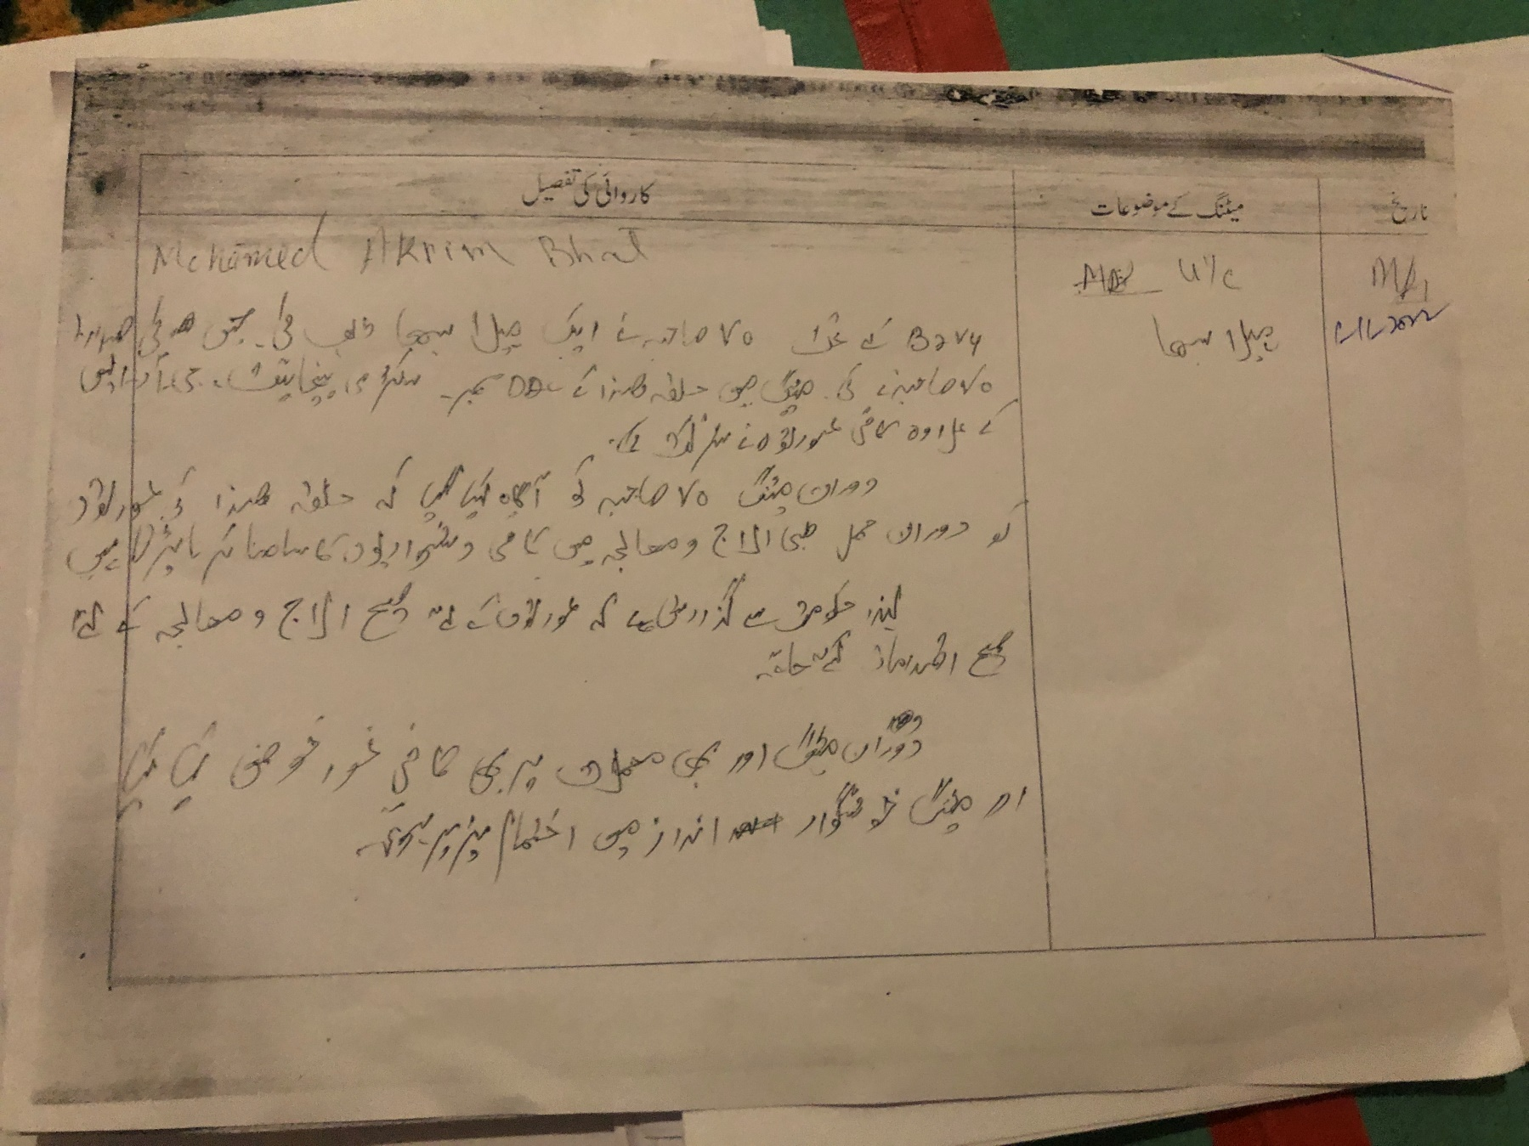

DAY 2 ACTIVITIES

AGENDA 9 BAL SABHA
Hold a balsabha and record proceedings
Total children in the village above the age 100
_ Total attended 50
Proceedings: enclosed need children park, separate washrooms for girls and boys in schools

(Pl insert pointers to be discussed there – refer palli proceedings)
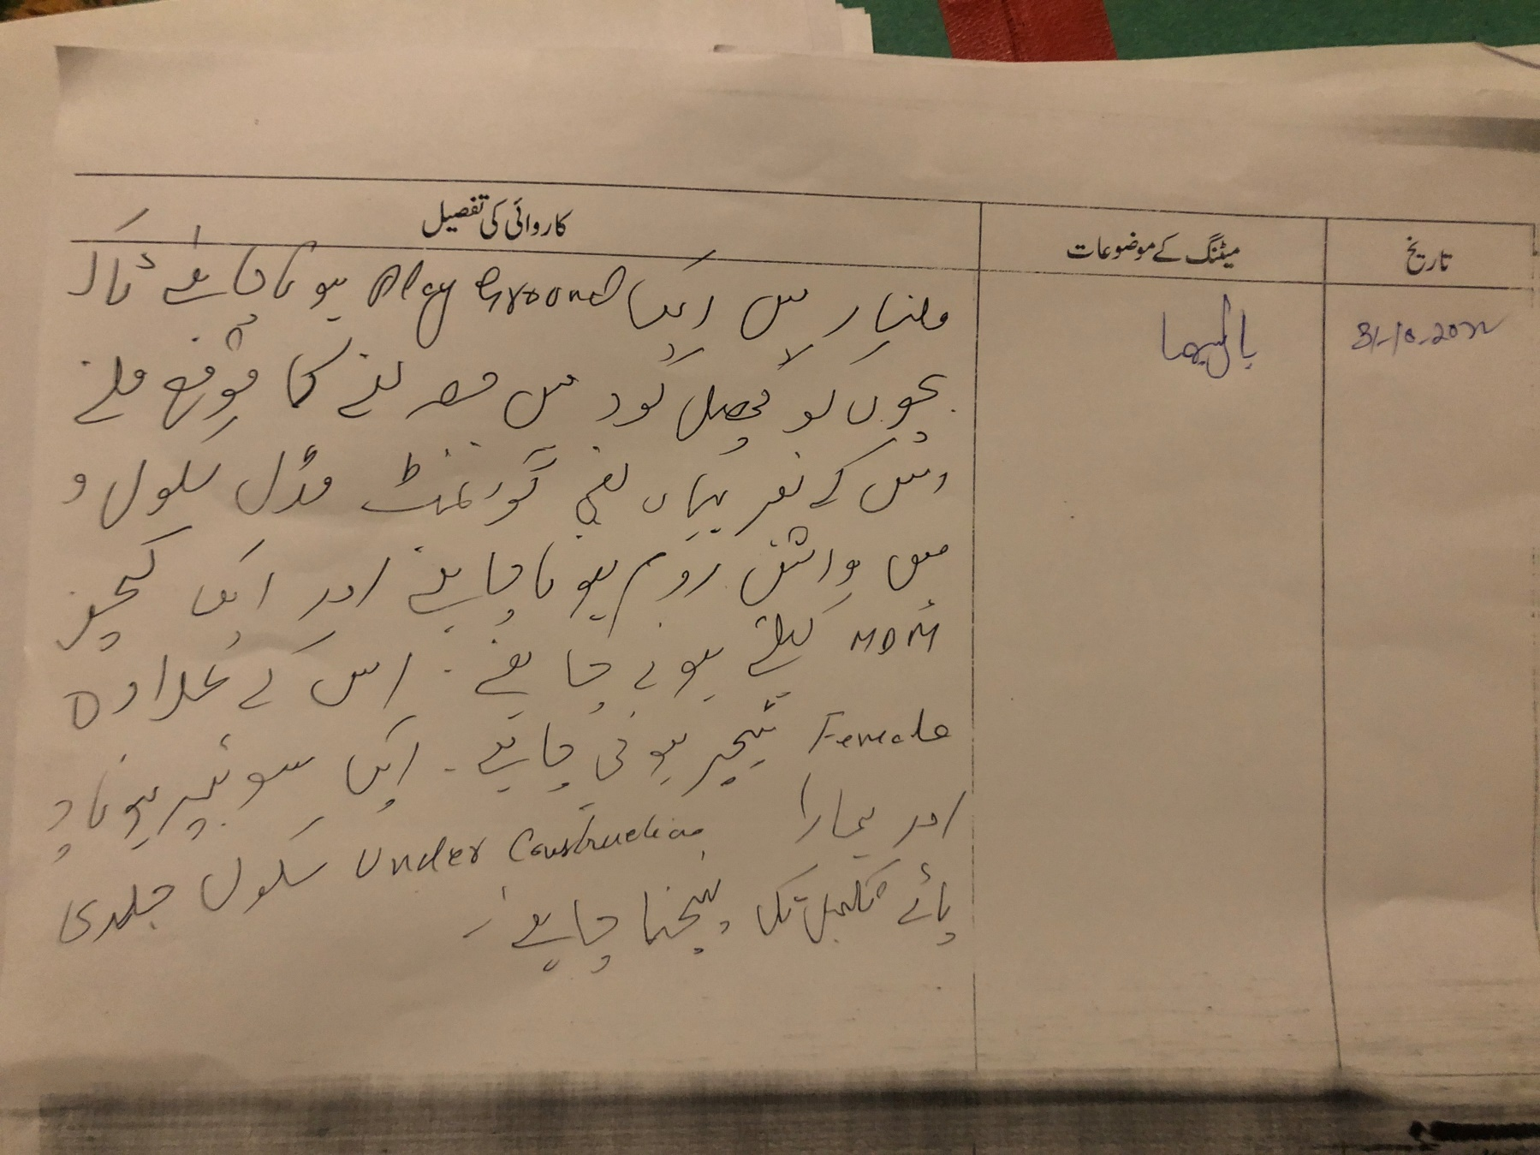

DAY 2 ACTIVITIES
AGENDA 10 INAUGURATIONS
SR NO. | ASSETS /ACTIVITIES INAUGRATED | STATUS OF THE ASSET/AC- TIVITIES (NUMBER, OTHER DETAILS) | GEO-TAGGED PHOTOS
 | VILLAGE HAAT under JKSRLM (SUN- | Stalls installed, Hence inagurated  NIL  Under Process  Constructed/ Developed/ inagurated  Not distributed.  no  inspected at Mulnar Theed | Yes
 | DAY MARKET)
 | PMAY houses if any ready for inaugra-
 | tion
 | Swachh gram projects- segregation |  | Yes
 | sheds etc
 | Amrit sarovars |  | Yes
 | Sports kits |  | no
 | Village cultural events |  | no
 | JJM assets/projects
 | Any other to be identified at district |  | Yes
 | level

FOLLOW UP OF (B2V1, B2V2 & B2V3):
(Pre filled excel sheet to be taken from district level/ and also to be downloaded from www.jkpanchayat.in)

S.No |  | Particulars |  | Action Taken |  | Remarks
Urgent Public Requirements/ Demands -B2V2
1 | Land for new PHC |  | No action |  | Not found genuine as mentioned gram sabha
2 | Augmentation of substation |  | No action |  | Very genuine demand, As per AEE PDD they will install 100 kva transformer if feasible
3 | Multiple Hr. Secondary for theed A |  | No action |  | Not feasible
4 | Filtration plant at gandtal be made functional |  | As per 14th F.C 95% work done |  | Work in progress
5 | Play ground at theed A |  | No action |  | Land not available
 | Urgent Public Requirements/ Demands -B2V3
01 | p. bund r-wall from nallah maloori near gandtal |  | Completed |  | Payment pending
02 | New building at sumo stand |  | No action |  | As per information two bridges arealready connectiong the area
03 | SBI ATM near H/O G.M Zaildar |  | No action |  | JK Bank ATM exists in theed A
04 | Road from right side of Mavas Canal to Rajpura |  | Work allotted |  | Issue / local problem
05 | PHC building |  | No action |  | PHC functioning in sufficient building as per health DEptt
06 | Gandtal filtration plant |  | No Action
5 | r/wall /road from h/o A.M Mir to Wanpora |  | No action

4

Any major complaints brought to the notice-B2V3

01 wild bear issue
as per wildlife deptt. Control measures have been put in force
02 land ownership/ property rights..
No action taken

1

Major Complaints-B2V3

4
4

OVERALL PERCEPTION OF FUCNTIONING OF GOVERNMENT DEPARTMENTS
4

BEST DEPARTMENT: RDD, Agriculture; RDD
- LEAST RESPONSIVE DEPARTMENT: Youth Service and sports

GENERAL ASSESSMENT OF THE VISTING OFFICER

  - Any major complaint brought to the notice of the Visiting Officer: (enclosed)

  - Major/ urgent public demands that was/ were reflected earlier but have not been addressed so far: (enclosed)

Overall assessment of the visit and suggestions:
  - (The visiting officer to ensure that the overall assessment is recorded in details along with concrete sugges- tions) A lot has been done however massive budgeting needs to be framed for infrastructure development.

  - Overall Rating of govt functioning as given by the Panchayat (Scale of 0 to 10): 7/10

  - Certificate from Sarpanch that the visiting officer has stayed in the panchayat for 2 days

Signature of Sarpanch Signature of the Visiting Officer Name ……………………… Name………………………

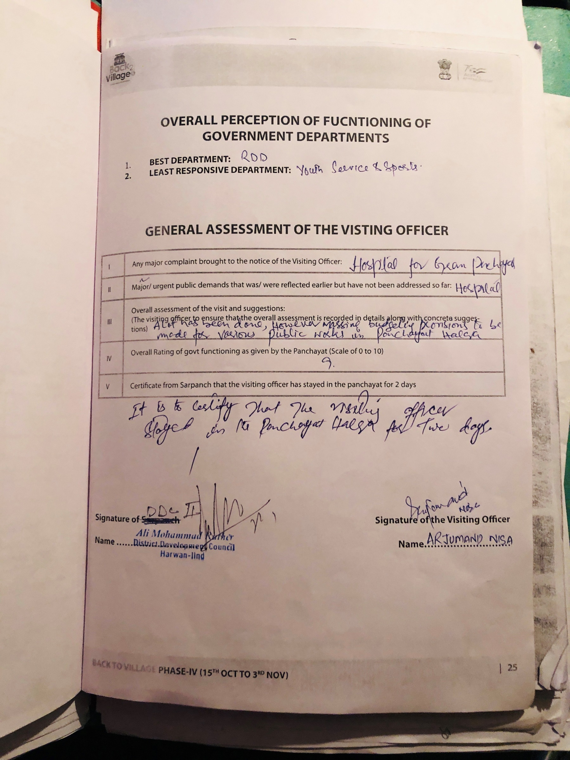

Major demands
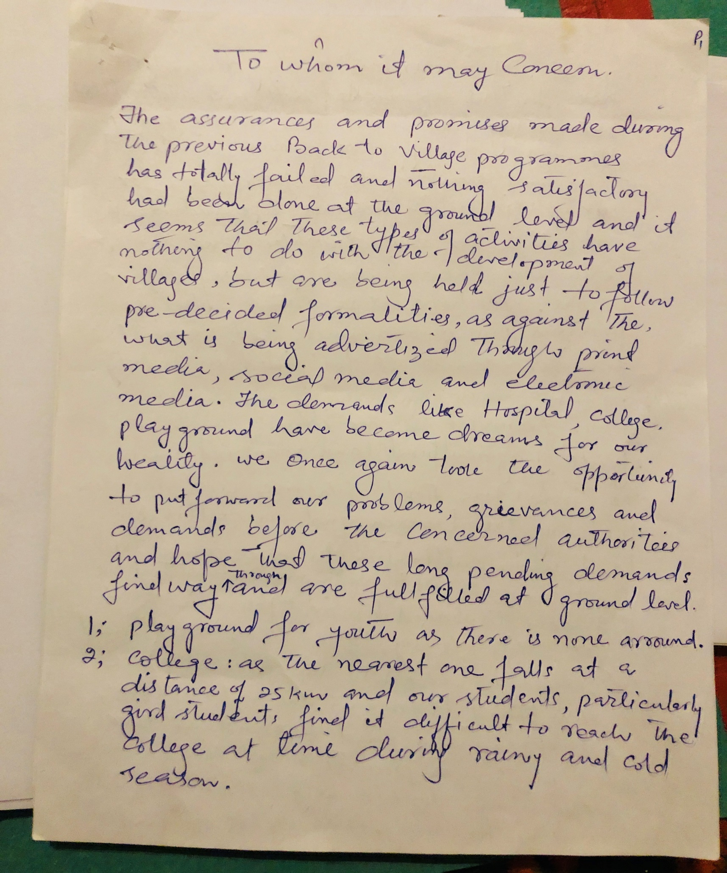
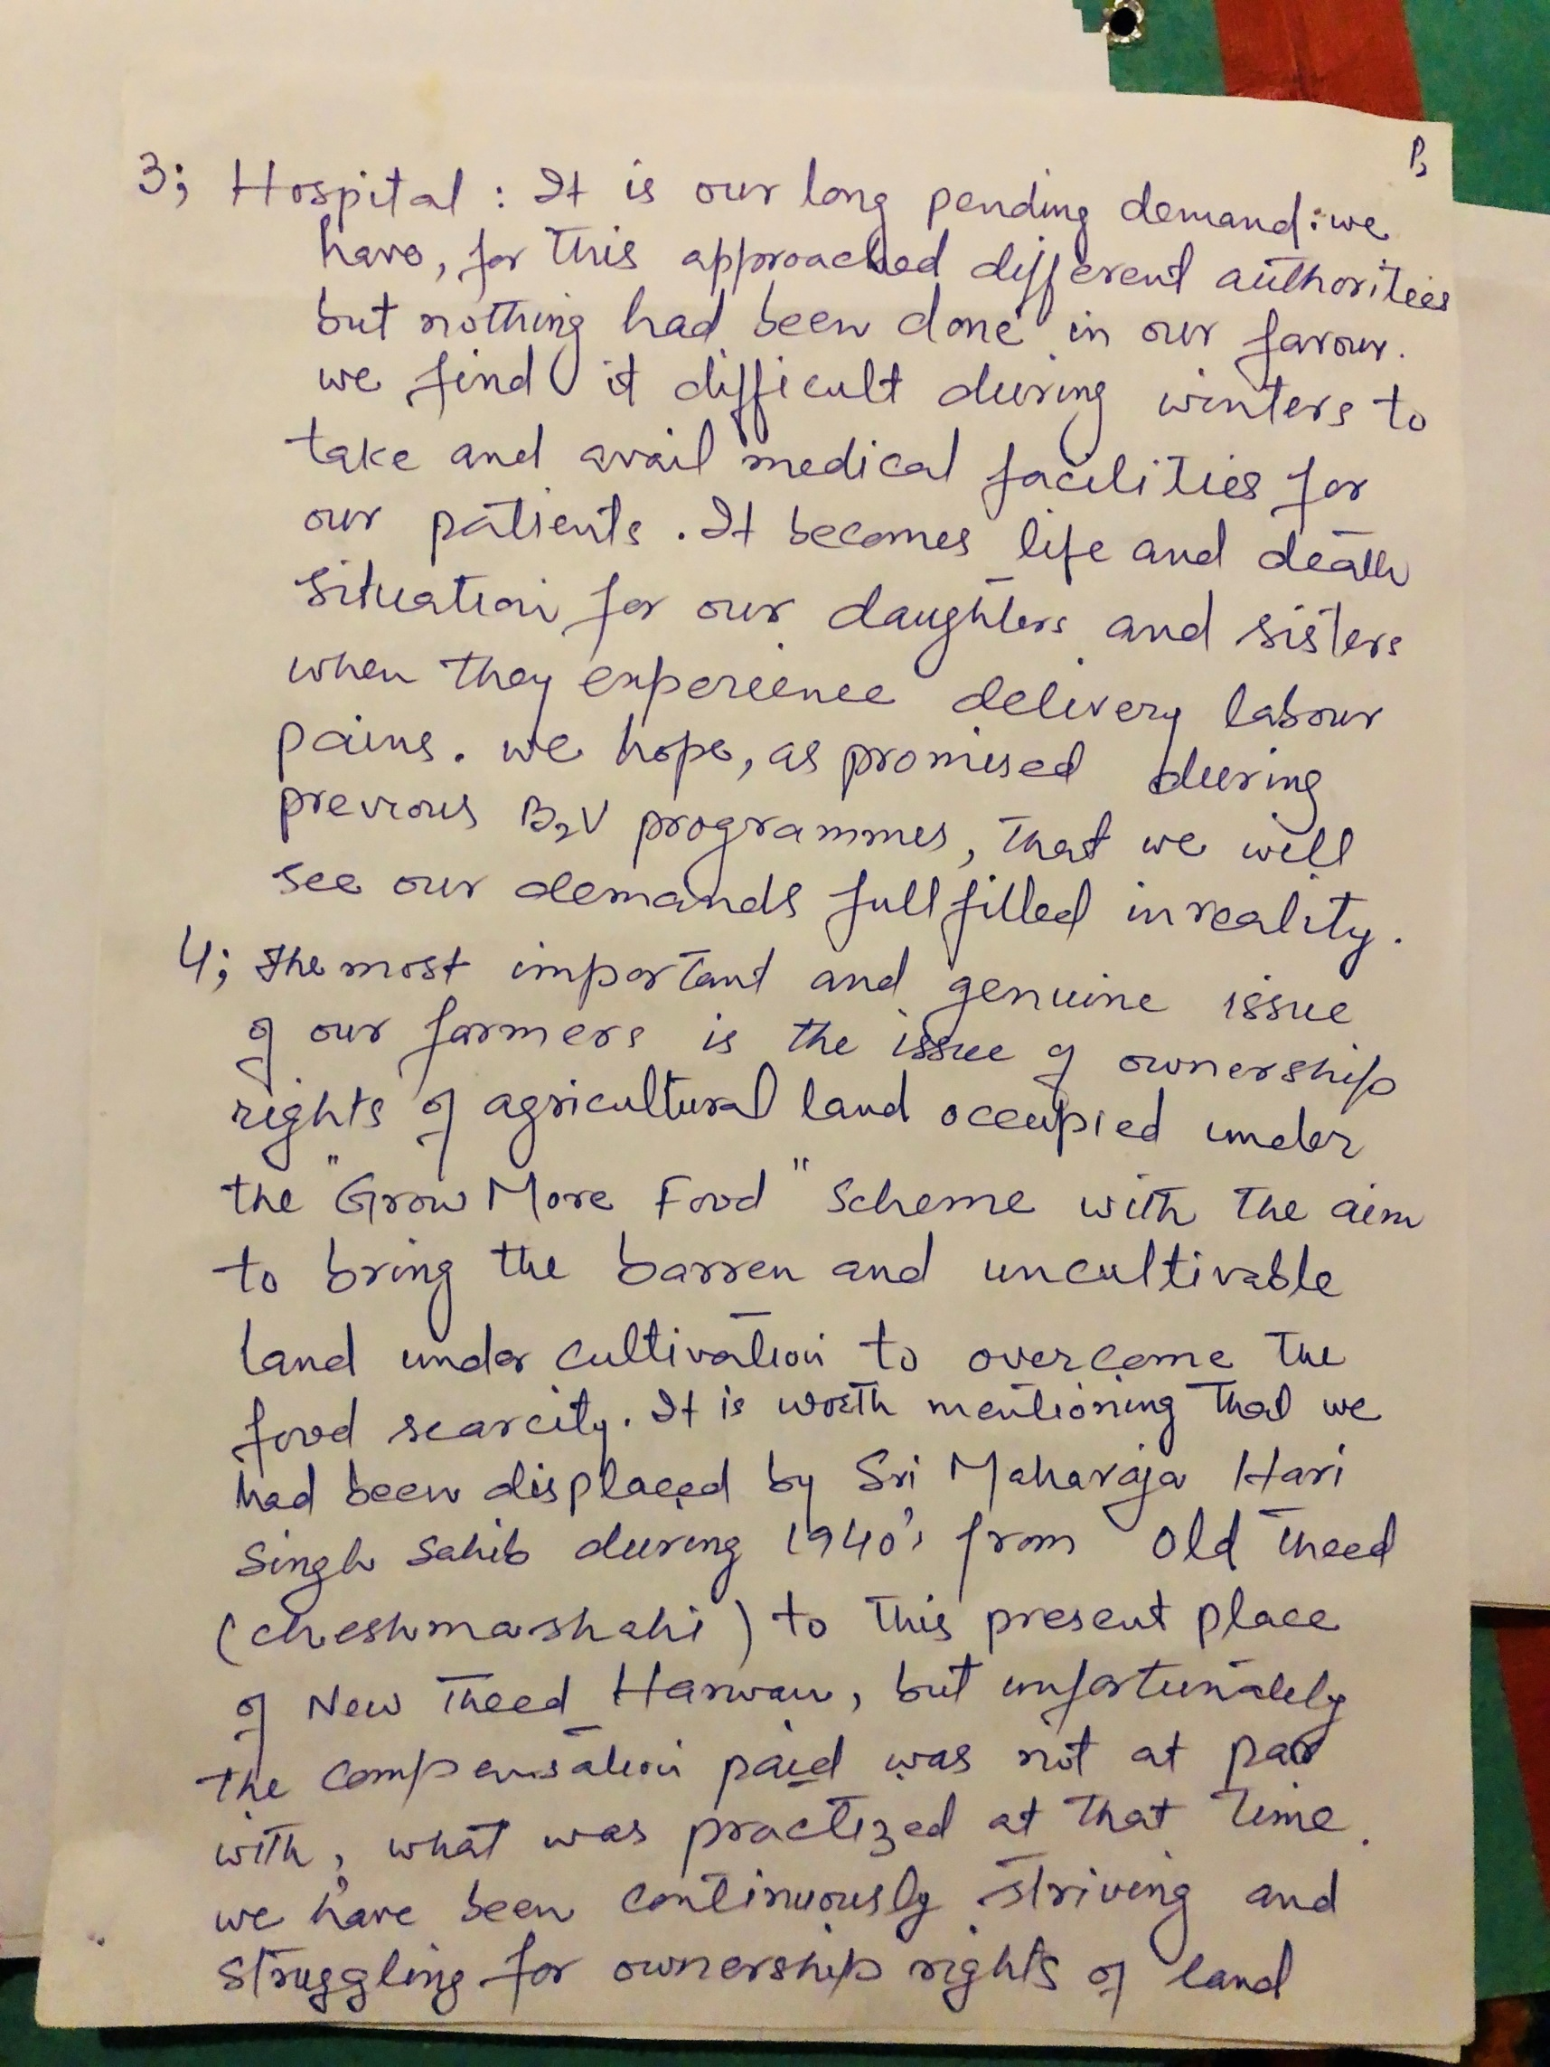

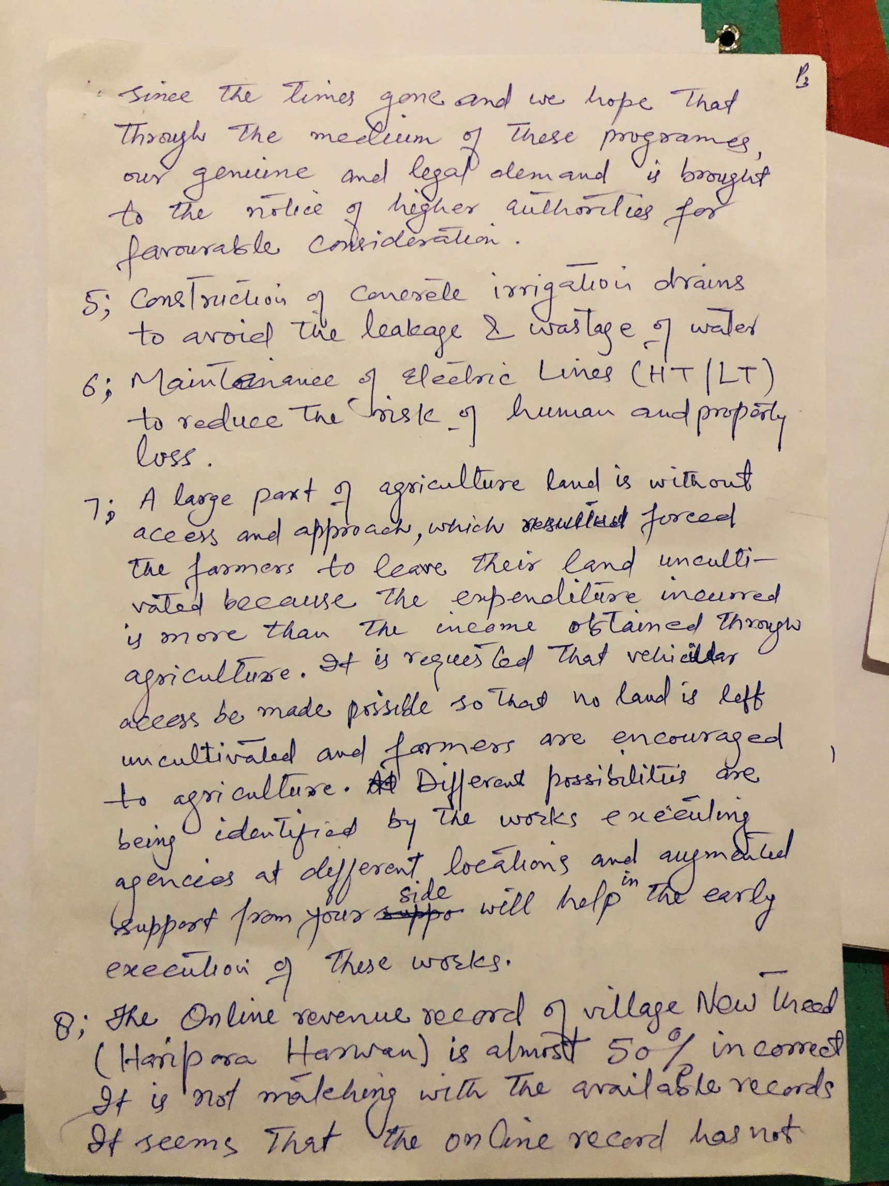

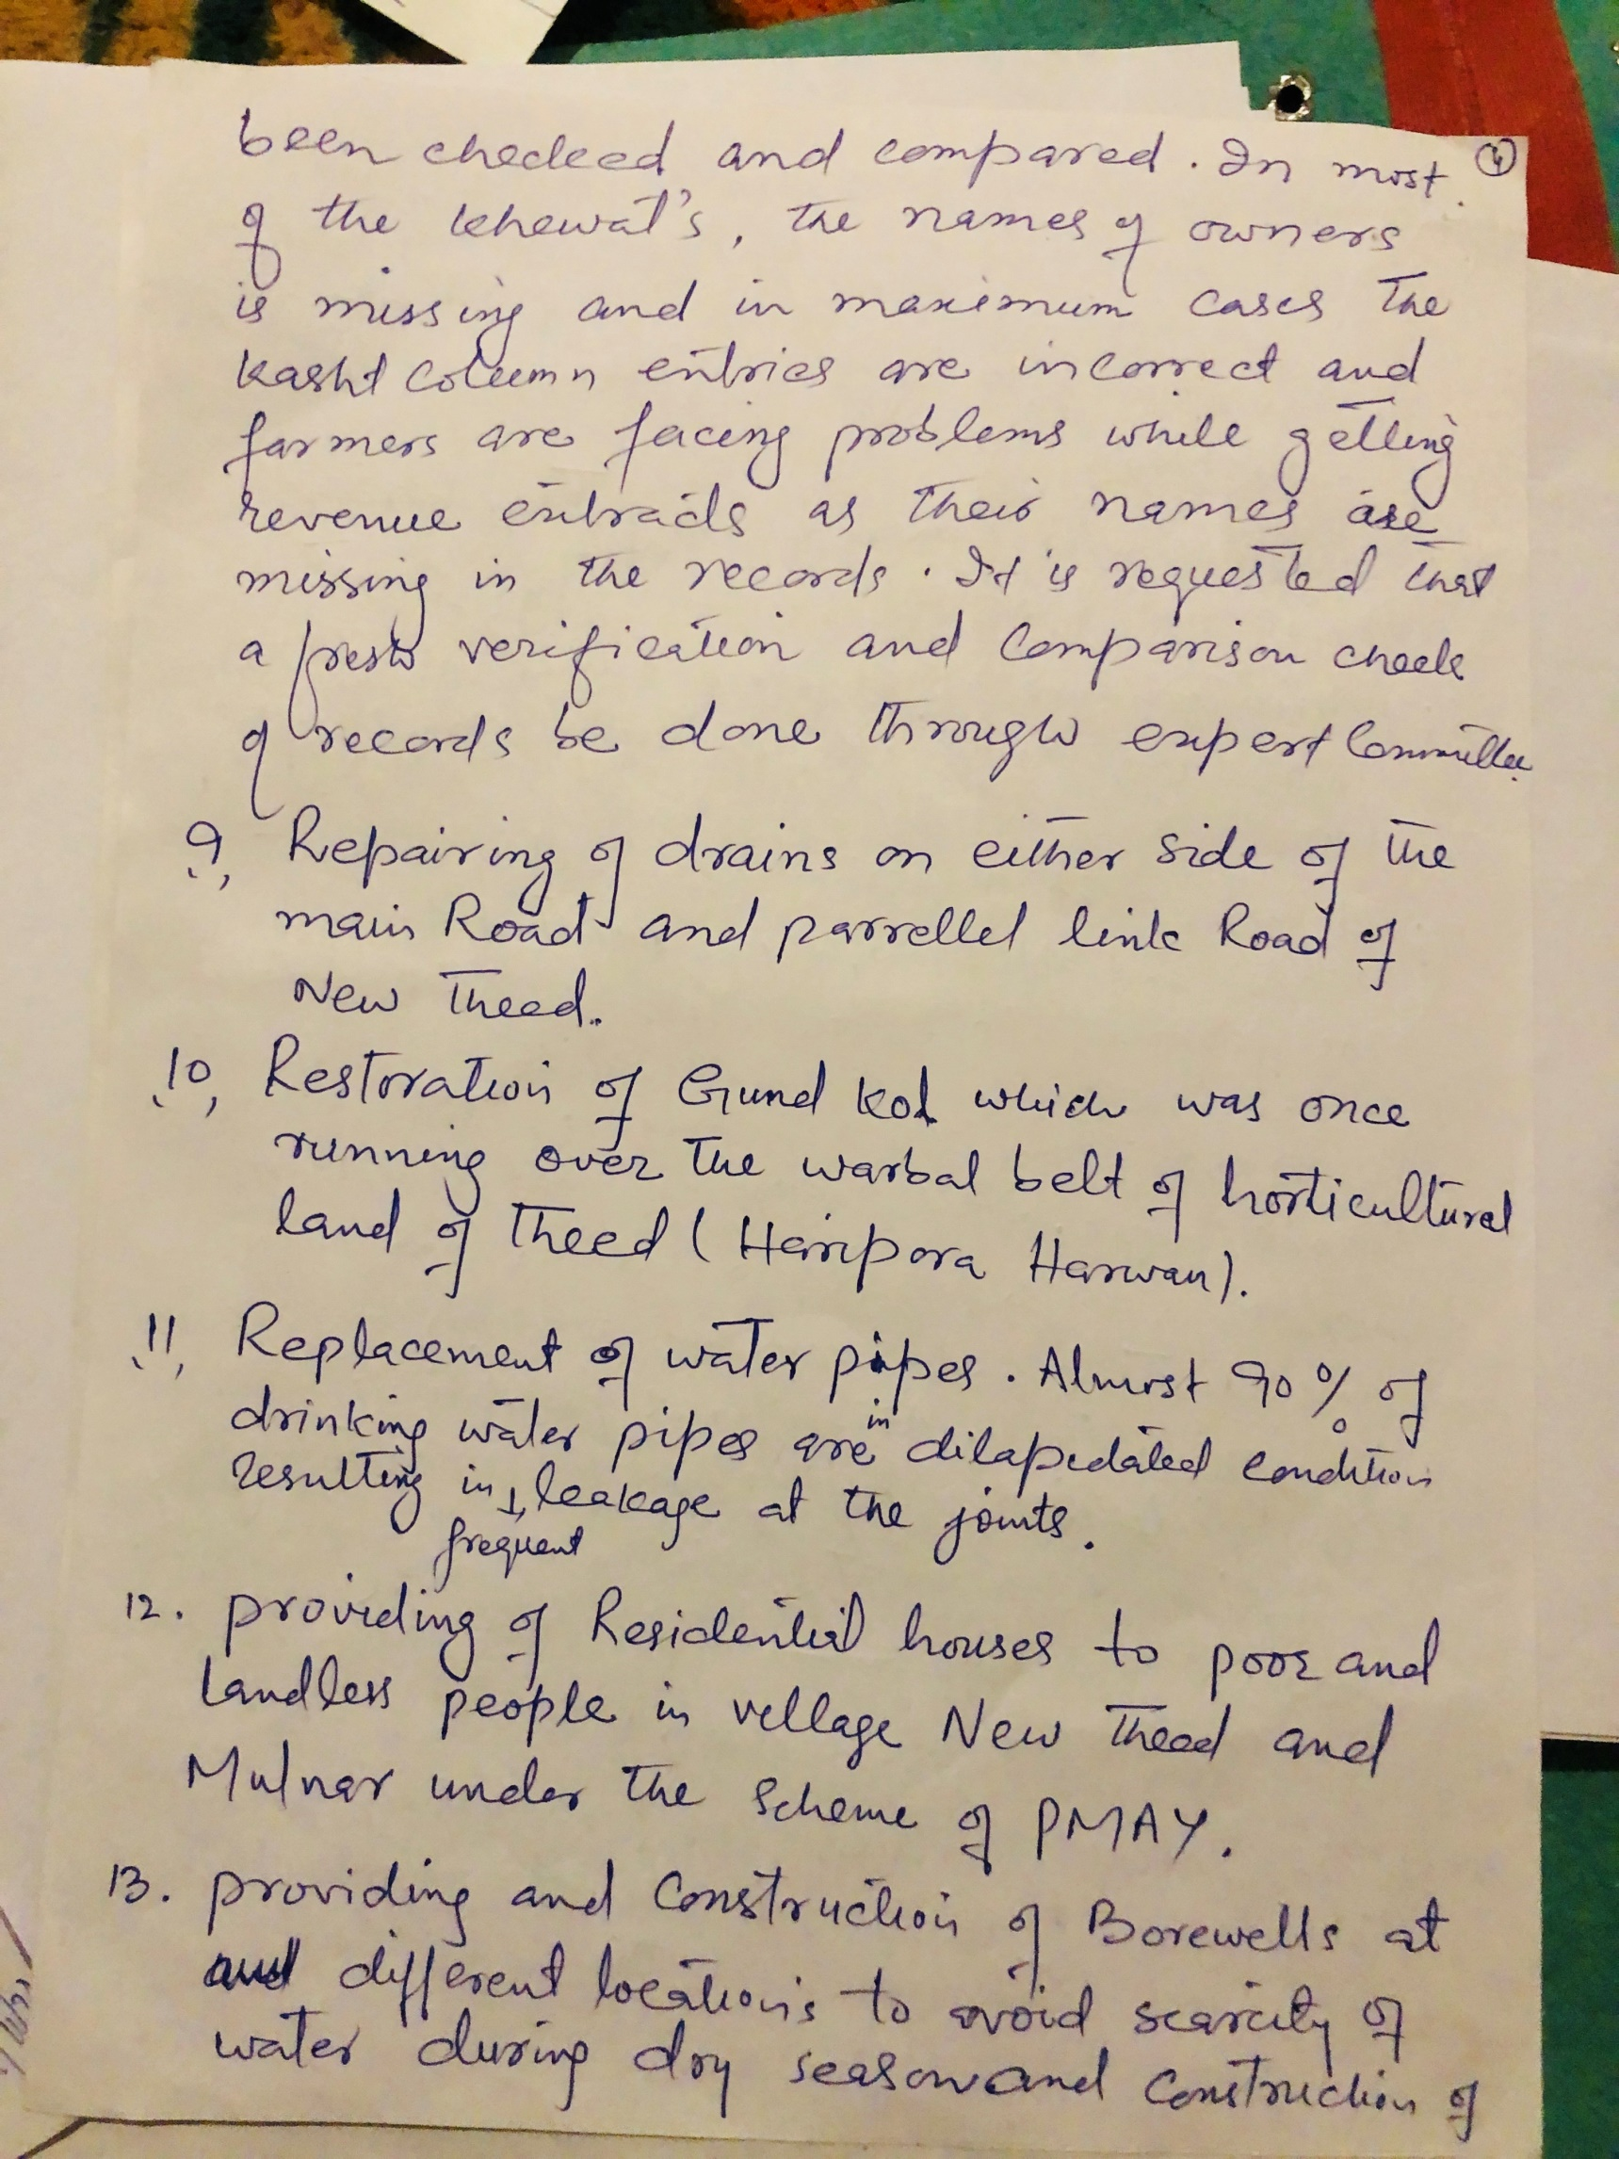

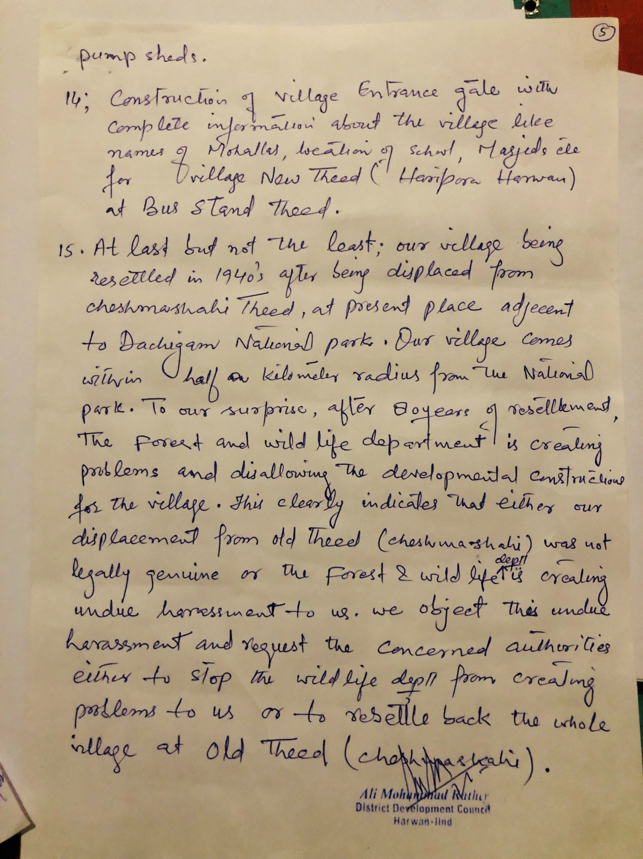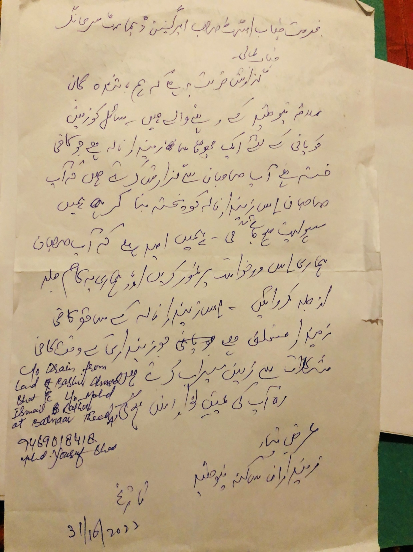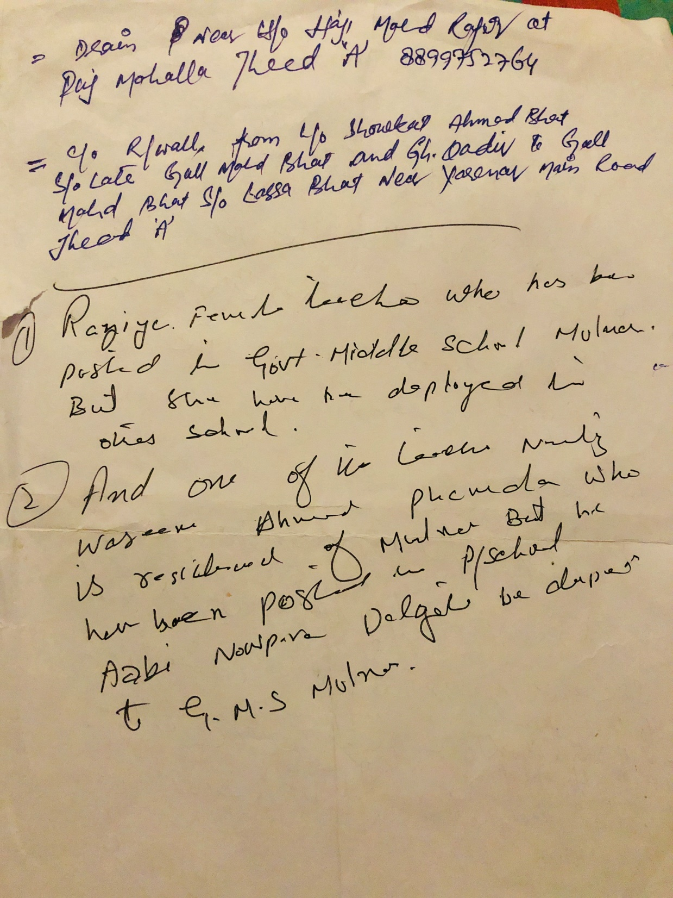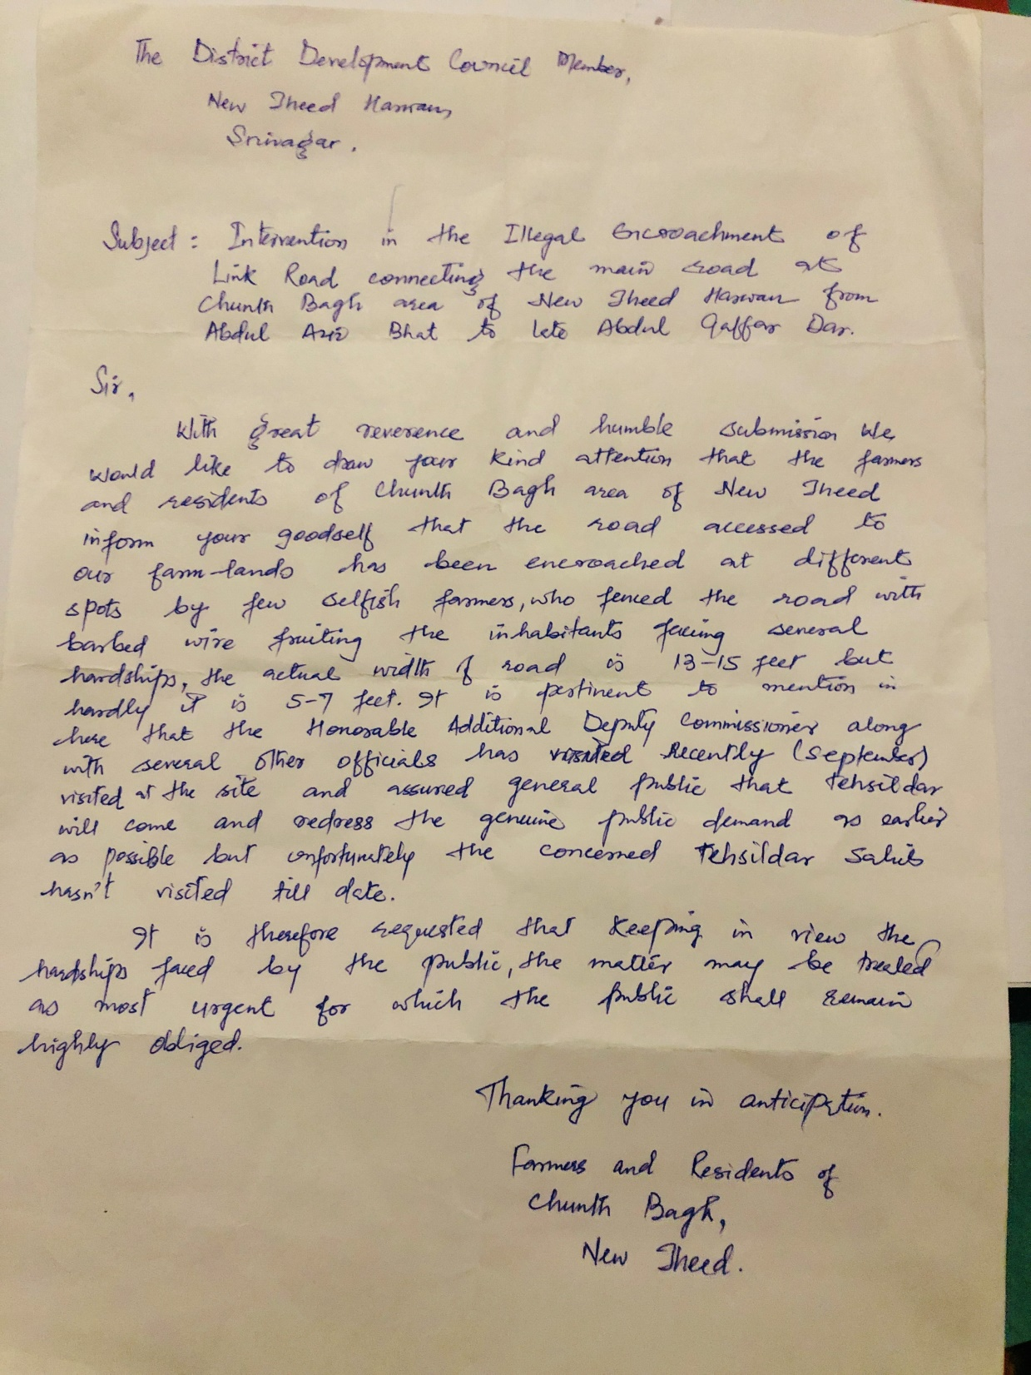
ANNEXURE-A

Gram Panchayat Development Plan of Panchayat DARA A Block Harwan District Srinagar (Mere Sapno ki Panchayat)
S.no | Name of the Village | Name of the concerned Department | Scheme |  | Name of the proposed work | Ward.no | Estt Cost
1 | DARA A | Department of Rural Development | MGNREGA | 1
2 |  |  |  | 2
3 |  |  |  | 3
4 |  |  |  | 4
5 |  |  |  | 5
6 |  |  | JKRLM (UMEED) | 1
7 |  |  |  | 2
8 |  |  |  | 3
9 |  |  | PMAY-G (10 beneficiaries to be identified) | 1
10 |  |  |  | 2
11 |  |  |  | 3
12 |  |  | HIMAYAT (DDU-GKY) (20 candidates to be identified per panchayat) | 1
13 |  |  |  | 2
14 |  |  |  | 3

15 |  |  | SWACHH BHARAT MISSION (GRAMEEN ) | 1
16 |  |  |  | 2
17 |  |  |  | 3
18 | DARA A |  | Saansad Adarsh Gram Yojana (SAGY) | 1
19 |  |  |  | 2
20 |  |  |  | 3
21 |  |  | Pradhan Mantri Kisan Samman Nidhi Yojana(PM-KISAN) | 1
22 |  |  |  | 2
23 |  |  |  | 3
24 |  |  | Pradhan Mantri Kisan Maan Dhan Yojana(PM-KMY) | 1
25 |  |  |  | 2
26 |  |  |  | 3
27 |  |  | Pradhan Mantri Annadata Aay Sanrakshan Abhiyan (PM-AASHA) | 1
28 |  |  |  | 2
29 |  |  |  | 3
30 |  |  | Pradhan Mantri Fasal BimaYojana (PMFBY) | 1
31 |  |  |  | 2
32 |  |  |  | 3

DARA A
33
34
35
36
37
38
39
40
41
42
43
44
45
46
47
48
49
50

 |  | 1
Department of | Pradhan Mantri Krishi Sinchayee Yojana (PMKSY) | 2
Agriculture, |  | 3
Cooperation & Farmers
Welfare |  | 1
(DAC&FW)
 | National Food Security Mission (NFSM) | 2
 |  | 3
 |  | 1
 | Mission for Integrated Development of  Horticulture (MIDH) | 2
 |  | 3
 |  | 1
 | Rashtriya Krishi Vikas Yojana | 2
 |  | 3
 |  | 1
 | Paramparag at Krishi Vikas Yojana (PKVY) | 2
 |  | 3
 |  | 1
 | Mission Organic Value Chain Development
 | for North Eastern | 2
 | Region (MOVCDNER)
 |  | 3

DARA A
51
52
53
54
55
56
57
58
59
60
61
62
63
64
65
66
67
68

Department of Elementary Education | Samagra Shiksha | 1
 |  | 2
 |  | 3
 | National Program for Education of Girls at Elementary Education ( NPEGEL) | 1
 |  | 2
 |  | 3
 | Mid-day Meal Scheme | 1
 |  | 2
 |  | 3
 | National Means-cum-Merit Scholarship Scheme (NMMSS) | 1
 |  | 2
 |  | 3
 | National Scheme of Incentive to Girls for Secondary  Education(NSIGSE) | 1
 |  | 2
 |  | 3
 | Integrated Child Development Services (ICDS) | 1 | No. of Anganwadi Centres to be enhanced
 |  | 2
 |  | 3

69
70
71
72
73
74
75
76
77
78
79
80

Deptt of social welfare | National Social Assistance Programme (NSAP) | 1
 |  | 2
 |  | 3
 | POSHAN Abhiyan | 1
 |  | 2
 |  | 3
 | Ayushman Bharat - Health and Wellness Centres (AB-HWCs) | 1
 |  | 2
 |  | 3
 | Janani Suraksha Yojana (JSY) | 1 | Facilities of sub centre be upgraged and brought at par with facilities of NTPHC visa-viz increase of personals, paramedics, facilities like X-rays and laboratories
 |  | 2
 |  | 3

DARA A
81
82
83
84
85
86
87
88
89
90
91
92
93
94
95

Department of Health and
Family Welfare
Janani Shishu Suraksha Karyakram (JSSK) | 1
 | 2
 | 3
Universal Immunization Programme (UIP) | 1
 | 2
 | 3
Home Based Care of Newborn and Young Children | 1
 | 2
 | 3
(HBNC/HBYC) Rashtriya Bal Swasthya Karyakram (RBSK) | 1
 | 2
 | 3
National Ambulance Service (NAS) | 1
 | 2
 | 3

DARA A
96
97
98
99
100
101
102
103
104
105
106
107
108
109
110
111
112
113
114
115

 | Disease Control Programs | 1
 |  | 2
 |  | 3
National Disaster Management Authority (NDMA) | National Cyclone Risk Mitigation Project | 1
 |  | 2
 |  | 3
Department of Drinking water  and Sanitation | Jal Jeevan Mission | 1
 |  | 2
 |  | 3
Department of Animal Husbandry and Dairying | Rashtriya Gokul Mission | 1
 |  | 2
 |  | 3
 | National Dairy Plan-II | 1
 |  | 2
 |  | 3
 | Dairy Processing and Infrastructure Development Fund | 1
 |  | 2
 |  | 3
 | Supporting Dairy Cooperatives and Farmer Producer | 1
 |  | 2

DARA A
116
117
118
119
120
121
122
123
124
125
126
127
128
129
130
131

 |  | 3
 | National Livestock Mission | 1
 |  | 2
 |  | 3
 | Livestock Census and Integrated Sample Survey | 1
 |  | 2
 |  | 3
Food Processing Industries | Pradhan Pantri Kisan SamapdaYojana (PMKSY) | 1
 |  | 2
 |  | 3
 | Pradhan Mantri Kaushal Vikas Yojana (PMKVY) | 1
 |  | 2
 |  | 3
 | National Apprenticeship Promotion Scheme (NAPS) | 1
 |  | 2
 |  | 3

DARA A
132
133
134
135
136
137
138
139
140
141
142
143
144
145
146
147
148
149
150
151

Skill Development and Entrepreneurship | Jan Shikshan Sansthan | 1
 |  | 2
 |  | 3
 | Skills Acquisition and Knowledge Awareness for Livelihood  Promotion (SANKALP) | 1
 |  | 2
 |  | 3
 | Mahatma Gandhi National Fellowship (MGNF) | 1
 |  | 2
 |  | 3
Tribal Affairs | Inclusive and sustainable growth of tribal population | 1
 |  | 2
 |  | 3
Capex Plan | UT Capex | 1
 |  | 2
 |  | 3
 | District Capex | 1 | C/o kitchen at Govt. High school, Shallakhud |  | 3 Lakhs
 |  | 2
 |  | 3
PMGSY | Road connectivity projects | 1
 |  | 2

152 | DARA A |  |  | 3
153 |  | Irrigation and Flood Control |  | 1 | Desilting of Nallah from Bus stop to Faqir Gujree |  | 10 Lakhs
154 |  | Power Development Department |  | 1 | Shifting of H/T lines from :
155 |  |  |  | 1.a | Nagbal to Astan Mohalla by road including one 100 kva transformer |  | 10 Lakhs
156 |  |  |  | 1.b | Harwan to Dara by road (2.5 kms) |  | 12 Lakhs
157 |  |  |  | 1.c | L/T poles required for dara A (30 poles) |  | 4 Lakhs
158 |  | Consumer affairs and publics distribution |  | 1 | Ration Ghat at Nagbal to be provided
159 |  | Science and Technology |  | 1 | Providing of solar Street lights |  | 12000 per pole per light

