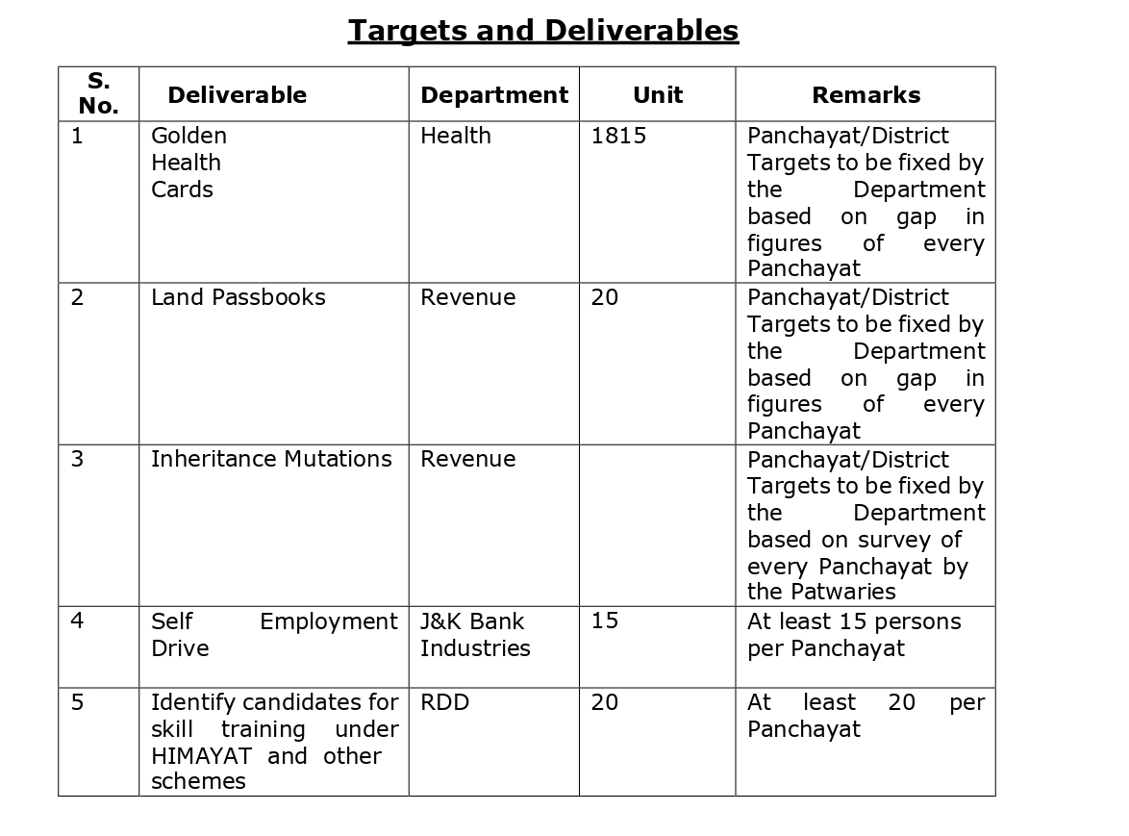

4





**15TH OCTto3RD NOV,2022**

Panchayat Halqa Qammer B Block Verinag

**KEYFEATURES**

• Deputy Commissioners to lead the initiative

• Rural development Department to be the nodal department

• Planning Development & Monitoring department and IT to be the support departments

**ACTIONSANDTIMELINES**

|  |  |  |  |
| --- | --- | --- | --- |
| **ACTION** | **RESPONSIBILITY** | **LATESTBY** | **REMARKS** |
| **Janabhiyan** | All departments | Oct15-26th | Going on |
| **Deputation of Sectt staff/ HoDs** | GAD | Oct14 | Done |
| **Deployment of Staff to Panchayats and serving of orders on deployed officers** | DCs | Oct25 | DCs will deploy senior level staff fromthedistricts.Strictactionto betakenagainstabstentions.No exemptionstobegiven |
| **Trainingofdistricttrainors onB2V4** | RDD | Oct26 |  |
| **Trainingofvisitingofficers** | DCs | Oct27 |  |
| **FieldVisitstobecompleted by** | VisitingOfficers | Nov3 | DCstosuperviseandensurethat eachPanchayatisvisitedwithin theperiodspecified |
| **DataofB2V4tobe uploadedby** | VisitingOfficers | Nov10 | DCstosuperviseandensurethat dataofallPanchayatsisupload- edbythevisitingofficerwithin theperiodspecified |

**INSTRUCTIONSFORTHEVISITINGOFFICER(DAYWISE)**

|  |  |  |
| --- | --- | --- |
| **DATE** | **INSTRUCTIONS** | **ACTIONPOINTS** |
| **Day0** | Meetingwithdeputy commissionerandhis/her team | a. TakeprintoutsoffilledbookletsofB2V1,B2V2andB2V3from [www.jkpanchayat.in](http://www.jkpanchayat.in)  b.Alsotakeprintoutsofthesummarizedexcelsheetsofthe previousphasesfrom[www.jkpanchayat.in](http://www.jkpanchayat.in)  c. CollectATRsonissuesraisedduringprevious3phasesfromthe officeofDeputyCommissioner(Planningdeptt)  d.Takeprintsofblank 2bookletsofB2V4from[www.jkpanchayat.in](http://www.jkpanchayat.in)e.Takeplansfor2previousyearsandATRsfromtheplanningdeptt f. CompletetrainingsondifferentcomponentsofB2V4being  organizedbyrespectiveDeputyCommissioners  g.CollectListofnewworksstarted/ongoing/completedduringthe previousandcurrentFinancialyearunderthefollowingheads:  • PRIgrants  • DistrictPlan  • UTplan  • MGNREGA  • Otherschemesofotherdepartments  • Anyotherwork  h. Plans/beneficiarylists:  • MGNREGAdraftplandocumentfortheyear2022-23.  • ListofAwaas+beneficiariesalongwithIHHL Convergence  • Listofpensionbeneficiaries.  • ListofSHGs  • Listofagricultureschemebeneficiaries  i. Listsofbeneficiariesfor:  • Variouscertificates/benefitstobedistributedbythe visitingofficer.  • Anyotheractivitiesidentifiedbydifferentdepartments |

|  |  |  |  |
| --- | --- | --- | --- |
| **Day1** | Reachthevillage | 1. | Ensurethatallfrontlineworkersofdifferentdepttsarepresent. |
|  |  | 2. | Ensureexhibitionbydifferentdepts.aboutindividualbeneficiary schemes |
|  |  | 3. | InspectJKB/PSBcounters/outlets |
|  |  | 4. | Participate/ensureorganizationofsportsactivityinplayfield,talent hunt/culturalevent/youthactivity |
|  |  | 5. | GandhiKatha(suggesteddetailsuploadedonjkpanchayat.in) |
|  |  | 6. | Visitatleast2amritsarovarsandgetitsgeotaggedphotos |
|  |  | 7. | InspectKhidmat(CSC)CentresandcreateGenerateawarenesson  225schemesparticularlyG2CschemeslikeBEAMS,Janbhagidari, AapkiZaminAapkiNigrani,DigitalJ&K |
|  |  | 8. | Visitingofficershallalsoplanandconductpanchayatlevelconver- gencemeetingofalldepartments |
|  |  | 9. | CheckeffectivenessofCentrallysponsoredschemes |
|  |  | 10. | VisitandinspectallgovernmentestablishmentsincludingPHE, AWC,FPS,schools,etc |
|  |  | 11. | Attemptsaturationofdeliverableso JanAbhiyanandwherever deficienciesfound,leadadrivetoachievealldeliverables |
|  |  | 12. | Assesseffectivenessofsanitationcampaigninthepanchayat |
|  |  | 13. | Ensureselfemploymentactivitiesfor15youthperpanchayat |
|  |  | 14. | Identify20potentialcandidatesperpanchayatforHIMAYATtraining alongwiththetradeonwhichtheywanttraining |
|  |  | 15. | Whereverpossible,distributeemploymentlettersforpeopleselect- edundervariousgovernmentemployments |
|  |  | 16. | Intheevening,holdnormalmeetingwith seniorcitizens,govtem- ployeesincludingretiredemployees,exservicemen,youthclub,and any citizens ofthevillagewhoareenrolledincollege/university |
|  |  | 17. | OpendiscussiononNashaMuktAbhiyan |

Day2 Haveameetingwithall stakeholders-depttofficials andpanchayatmembers

1. Discussionontheandassesstheprogressofdifferentschemesrelating tothelocalizedSDGsprioritizedforthatvillageaspertheresolution passedby thatGramPanchayaton21st April22,onNationalPanchayti RajDay.

2. Sensitizevillage residentsaboutmyScheme”portal(myscheme.in) whichincludesinformationaboutalltheschemesbeingrunbyCen- tral/State/UTgovtacrossthecountry

3. Hold meeting of theBiodiversityManagementCommitteestodeliber- ateonissuespertaining toconservation of biodiversityandsustaina- bleutilizationof biologicalresources.

4. PrepareVillagedevelopmentplan,inconsultancywithGrampanchayat, discussitingramsabhaandgetitapproved.

5. Ensure saturationofsoilhealthcardandgoldenhealthcardunderGold- enHealthCardunderAyushmanBharat,

6. Ensuresaturation of OldAge PensionScheme

7. EnsureDomicileSaturation.

8. EnsureKCCSaturation

9. Ensure saturationoflandpassbooks

10. Ensureregistrationofvillagevendorsneededforanyscheme,onGEM

portal

11. Ensurepanchayatcontractors registration

12. EncouragePanchayatmembers forimportanceofplantationdrivein

PanchayatunderHarGaonHariyali

13. Ensure paintingondigitalJ&Kinpanchayatghars

14. Ensure paintingonpanchayatactivitesandCSSinpanchayatghars

15. Thevisiting officeshallchecknoof kindergarten andplayfields present inthepanchayat for kidsandstudents,iftheinfrastructure present inthesearegoodenough.

16. Holdmeeting withpanchayatmembers todiscussaboutcorruption menaceandstepsrequiredtomakeJ&Kcorruptionfree

17. Obtaina candidassessmentaboutperformanceofvariousdeptts in- cludingfairfeedbackaboutdiscrepanciesinfunctioning

18. Check thestatusof NashaMuktAbhiyanandreporting of drugad- dictstoDeputyCommissioner.

19. IdentifyTouristDestinations,Circuits,ThemeTreks,IdentifyHomestays, providesupportfortourismactivities throughVillageCooperative

20. OrganizeTalentHuntatPanchayatLevel

21. Conductsocialauditofatleast5worksunderfollowingschemes:

a. MGNREGA

b.PMAY

c. IHHLtoiletsandpayments d.CSCs

e.AMRITSAROVARS

22. Holda mahilasabha anda balsabhaandrecordproceedingsinthefor- matgiven

23. InauguratevillagehaatunderJKSRLM

24. Checkifyouthclubsareformedinthepanchayatandwhatactivities theyareengagedin

25. Organizea villagelevelculturaleventtoengagepanchayatmembers

26. SensitizeGPaboutE-kitabkoshaninitiativeofJ&KGovtforempowering youthsthrough onlinedigitalliteracy

**GENERALINSTRUCTIONS**

1. Thevisitingofficershallrefrainhimself/herselfgivingorofferinganycommitmentonbehalfofthe governmentandshalladoptanunbiasedattitudeinreportingissues.As faraspossible,his/her observation shouldbebasedona fairandanalytical viewemergingfromhis/herinteractioninthe village.

2. Heisgoingtothevillageasplanningofficer,notforsanctioninganyworksorformakinganycom- mitments.

3. Whilepreparingvillagedevelopmentplan,hehastoensurethat,demandsareprioritizedandre- flectedunderavailableschemes,wherevernecessarythelargerworksaretobereferredtoadminis- trativedepttunderCSS/UTplansunderintimationtoDCsandrestoftheworkstoDCsforreflecting itunderdistrict/CSS plans

4. His workshallbehardcoreplanningandauditandisnota PRexercise.

5. EveryDeputyCommissionerhastoensurethatatleastoneRDDofficial(ideallyPanchayatSecre- tary)ispresent ineverypanchayatwithrelevantpanchayatrecords,toensureconductofallactivi- tiesasplanned.Panchayatwiseorderneedstobeissuedinadvance.

6. Visitingofficershouldideallycarryhis/herlaptoptocompletethereportsatthepanchayatlevel itselfanduploadthefinalreport,duly signedbothbythesarpanchandbythevisitingofficeron [www.jkpanchayat.in](http://www.jkpanchayat.in)portal,beforetheyleavepanchayat.

7. Focus ofvisitareyouth,skills,self-employment,nashamukt,bhrashtracharmukt,Rozgaryukt J&K, besidestocarryforwardtheactivities duringJanAbhiyanandsaturatethem.

8. Inadditionattentionmaybegiventothefollowingareas a. MakefulluseofCentrallySponsoredSchemes

b.Saturationofindividualbeneficiaryschemes c. Self-employmentschemes

d.Banklinkedschemes-includingdepartmentalsubsidyschemes e.Empowermentandtransparencythrough digitalinitiatives

f. Effectivenessofgrassrootsmachinery–

i. Patwari,VLWpresent andavailable

ii. AvailablefundsutilizedinpublicinterestandasperGramSabharesolutions iii. Fairness ingovernance

iv. CSS/Individual beneficiaryschemesetc v. BrashtacharMuktJ&K

vi. BhaiMuktJ&K

vii. NashaMuktJ&K

9. ThePRImembers (Sarpanchs,Panchs,BDCChairperson)shallbeattheforefrontofallactivities and givendueimportanceandtheapproach shouldbetostrengthenthemandmakethemfeelem- powered.He/sheshallensurethattheBDCchairpersonandSarpanch/Panch arepresent atthetime ofinaugurationandceremonies.

10. Visitingofficershallnotleavethedistrictwithoutuploadingthereport,duly signedonthe**www. jkpanchayat.in**portal.EveryDeputyCommissionerhastoensurethat.

**A) DetailsofReportingOfficer:**

Name: Ajaz Ahmad Najar

Designation:Sr. Lecturer

Department/placeof posting: Education/Govt. Girls Higher Secondary School Anantnag

MobileNo:7006695445

EmailID:ajazmalikphy@gmail.com

HomeDistrict:ANANTNAG

Datesof visit:28/29 Oct 2022

**B) LocationaldetailsofPanchayat:(tobepre-filled,informationtobetakenfromtheprevious phasesbooklets/summarizedexcelsheetuploadedonjkpanchayat.in/b2v4.php)(tobevali- datedbythevisitingofficerandmissingdetailstobefilled)**

NameofthePanchayat:QAMMAR-B

LocalGovernmentDirectory(LGD)codeof thePanchayat:274666

Nameof CDBlock:VERINAG

NameofTehsil:SHAHABAD BALA

Nameof District:ANANTNAG

**C) PanchayatProfile:**

No.ofrevenuevillagesinthePanchayat:02

No.ofhamletsinthePanchayat:1. DUDWAGAN 2. HEWARD, 3. NAI BASTI HEWARD, 4. NAI BASTI DUDWAGAN

No.ofhouseholdsinthePanchayat:465

Population(approx)of thePanchayat:3642

**Part-II:**

(TobefilledupbytheVisitingOfficerduringhis/hertwodayvisittothePanchayat.AllFieldshavetobe

filledbytheVisitingOfficerbeforethebookletishandedovertotheDC

**FrontlineOfficers/OfficialswhowereassignedtothePanchayatfortheprogramme:**

|  |  |  |
| --- | --- | --- |
| Department | Name | Designation |
| RDD | Zahid Ahmad Lone | GRS |
| RDD | Ajaz Ahmad Khanday | Panchayat Secretary |
| ICDD | Muzafara Akhter | AwW |
| YSS | Mohammad Ashraf | PEM |
| HORTICULTURE | Rafiq Ahmad Dar | Technician II |
| EDUCATION | Mohammad Iqbal Malik | Teacher |
| AGRICULTURE | Sheraz Ahmad Mantoo | VLF |
| HEALTH | Saima Jan | MLHP |
| FLORICULTURE | Showket Hussain | Casual Labour |
| PDD | Syed Maqbool | PDL |
| FLOOD CONTROL | Ajaz Ahmad Budroo | Works Supervisor |
| FOREST | Ghulam Nabi Banday | Forest Guard |
| CSC | Muneeb Ahmad Malik | VLE |

**Details of absent employees vis-à-vis list furnished by the DC office:**

|  |  |  |
| --- | --- | --- |
| Department | Name | Designation |
| REVENUE |  |  |
| JK BANK |  |  |
|  |  |  |
| FOOD AND SUPPLIES |  |  |
| IRRIGATION |  |  |
| JAL JEEVAN |  |  |
| SOCIAL WELFARE |  |  |
|  |  |  |
|  |  |  |
|  |  |  |
|  |  |  |
|  |  |  |
|  |  |  |
|  |  |  |
|  |  |  |

**DAY1-ACTIVITIES**

**AGENDA1: PANCHAYAT ASSET REGISTER**

**Infrastructure:**

1. PanchayatGharInfrastructure

a. Govtbuilding/private (Government)

b. New/needingrepairs(Yes)

2. Furniture(Y/N). YES

3. Computer/printer(Y/N) YES

4. Internet(Y/N) YES

5. Telephone(Y/N) NO

6. Toilet(CSC/part of panchayat ghar)(Y/N) YES

7. Water(Y/N) YES

8. Electricity(Y/N) YES

9. Bank branch(Y/N) NO

10. CSC(Y/N) YES

11. Patwar khana(Y/N) YES

12. Village haat(Y/N) YES

13. Playground(Y/N) YES

14. School-

a. Kindergarten(Y/N) NO

b. Primary (Y/N) YES

c. Secondary(Y/N) NO

d. College (Y/N) NO

e .University(Y/N) NO

15. Anganwadi Centre(Y/N) YES

a. (govt/private) PRIVATE

b. Total children enrolled 197 in 05 Anganwadi Centers

15. Amrit Sarovars–details, location, condition

A total of 03 Amrit Sarovars were visited and all have been preserved and protected by concrete walls.

16. Government offices-details ,whether functional or not

17. Ration shop (Y/N) YES

18. Places of tourism importance–names little details on historical/cultural importance

Tourism Hut constructed by tourism department at Hern ard, a beautiful natural beauty can be seen at the said place.

19. Village heritage sites/treks-names ,little detail son historical/culturalimportance NIL

20. VLWOffice (Y/N) YES

21. PrimaryHealthcareCentre(Y/N), NO

22. ListofIncompleteBuildings-names,yearofconstruction NIL

23. ListofUnderutilizedBuildings-names

Patwar Khana constructed but is underutilized by the concerned patwari. The said Patwari resides in a rented accommodation

**DAY1-ACTIVITIES**

**AGENDA2:**

**DIFFERENTINSTITUTIONS/INFRASTRUCTUREPROJECTSTOBEVISITED**

|  |  |  |
| --- | --- | --- |
| **AMRITSAROVARS** | **Visit,verify** | **COMMENTS** |
| KhidmatCentres | Create/Generateawarenesson225schemes particularlyG2CschemsAapkiZaminAapkiNigrani, Beams,Janbhagidari,DigitalJ&K | All E- Unnat services to be mapped with digital seva portal of CSC. |
| JKB/PSBcounters/outlets | a)Statusofcounter b)Numberofvisitors | No JKB/PSB Counters were installed |
| Incomplete buildings/projects | Verify whetheridentificationandredistribution done | NA |
| PDS | Visit,evaluate,onlinestatus | Active |
| PHC | Visit-evaluate,statusofstaff,equipmentand quality | NA |
| Youthclubs | Meet,interact,seeksuggestions | Unemployment an issue, advised and enrolled them for Himayat |
| SHG | Meet,identifyproblems,seeksuggestions |  |
| PMAY | Inspect,Inaugurate | Inspected and inaugurated |
| Myschool,mypride progress;schools-water, toilets,staff | Visit,checkforwater,electricity,sanitation,meet studentsandstaff | No electricity in the schools directed the concerned for the same |
| SwachhSBM | Evaluate |  |
| Panchayatplayground, Sportskitsdistribution Villagegames | Ensure,verify.Participateinatleastonegamein theplayground | Done |
| HarGaonHariyali, Planta- tiondrive | Evaluatestatus,feedback |  |
| Villageculturalevent  Dangal/Haat/Mela | Participatein;ensurethatitisheld | Held successfuly |
| Exhibitionofschemes | Ensurethateverydepartmentparticipatesand thatitcontinuesfortheentiredurationofB2V |  |
| JalJeewanMission verifica- tion- WSS/JSD  Electricitysupply | Verify | Verified |

**DAY1-ACTIVITIES**

**AGENDA3:SATURATEJANBHIYAN**

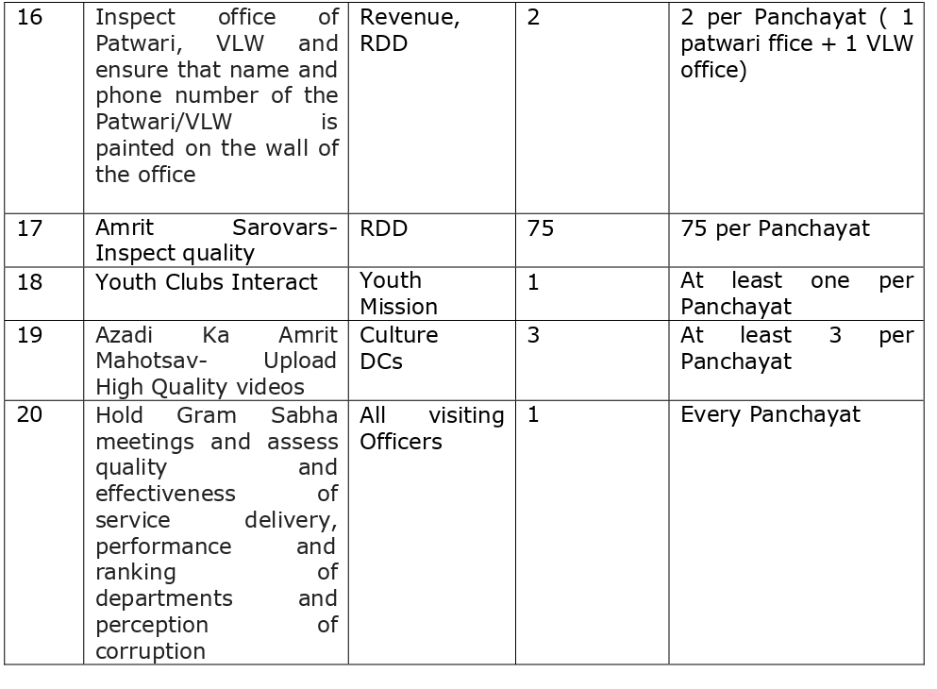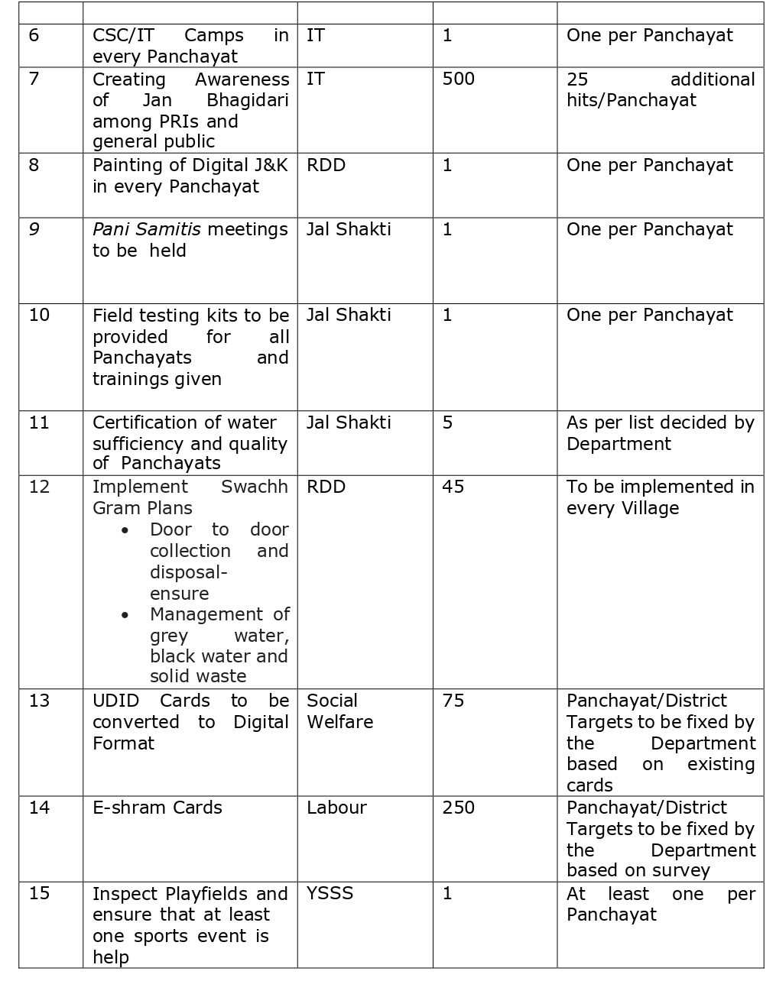**DELIVERABLESANDRECORDDEFICIENCIESIFANY(INSERTDELIVERABLESLISTHEREASPERGADFORMAT**

**DAY1-ACTIVITIES**

**AGENDA4:**

**SELFEMPLOYMENTACTIVITIES**

EnsureSelf-employmentactivities foryouth,distributeemploymentlettersforpeopleselectedunder varioussocialschemes(15ISTHETARGETPERPANCHAYAT)

**Numberofcasesindifferentcategoriessanctioned: Detailsofthebanksanctioningit:**

**Totalamountinvolved:**

**DAY1ACTIVITIES**

**AGENDA5**

Intheevening,holdinformalmeetings withseniorcitizens,govtemployees,retdemployees,youthclub andothercitizenswhoareenrolledoncollege/universityandhavediscussiononGandhiKatha,Nasha MuktAbhiyan,corruptionfreegovernance,doublingfarmersincomeandrecordtheproceedings

**DAY2**

a. NoofIndividualCompostPitsconstructed b.NoofIndividualSoakPitsconstructed

V. No.ofBiodiversitymanagementcommitteemeetingsheld:

VI. IsthenameofSarpanchdisplayedoncitizeninformationboardsofallRD&PRschemes:Yes/No

VII. AreSarpanchsbeinginvolvedinstart/inaugurationofactivities:Yes/No

VIII. WhethersubjectshavebeenassignedbytheSarpanchtothePanchs:Yes/No

IX. Whethergrievancesredressalboxisinstalled:Yes/No

X. NoofgrievancesreceivedpertainingtoPanchayatlevel: XI. NoofgrievancesdisposedofatPanchayatlevel:

XII. WhethertheSarpanch/PanchayatSecretaryhavedigitalsignatures:Yes/No

XIII. WhetherallMGNREGA/14thFCpayments arebeingmadebySarpanchthrough DigitalSignature

Certificate(DSC):Yes/No

**HUMAN RESOURCEAVAILABLEATTHEPANCHAYAT LEVEL:**

|  |  |  |  |  |
| --- | --- | --- | --- | --- |
| **SRNO.** | **DEPARTMENTWISESTAFF** | **NUMBERS** | | **NAMES** |
|  |  | SANCTIONED | ACTUAL |  |
|  | Ruraldevelopmentdepartment: BDO  JE GRS TA | 1  1  1  1 | 1  1  1  1 | Zubaida akhter  Jhangir ahmad  Zahid ahmad lone  Zakir majeed malik |
|  | SCHOOLEDUCATION: TEACHER  HEADMASTER ANYOTHER | 16  2 | 9  2 |  |
|  | JAL JEEVAN: | 2 | 2 | Abdul rehman khanday  Mohd rafiq want |
|  | PDD: LINEMAN JE  ANYOTHER | 1  1 | 1  1 | Syed ghulam Mustafa  Sartaj ahmad |
|  | FOOD&CIVILSUPPLIES | 2 | 2 | Rayees ahmad khanday  Mohd shafeeq hargah (private) |
|  | AGRICULTURE&ANIMALHUS- BANDARY | 1  1 | 1  1 | Sheeraz ahmad mantoo  Abdul Rashid rather |
|  | SOCIALWELFARE | Absent |  | absent |
|  | HEALTH: ASHA ANM  AYUSHDOCTOR ALLOPATHICDOCTOR | 2  2  N  N | 2  1 | Mehbooba akhter fareeda  Saima  Nill  Nill |
|  | ANYOTHERDEPARTMENT |  |  |  |

**DAY2-ACTIVITIES**

**AGENDANO.1**

DiscussionontheandassesstheprogressofdifferentschemesrelatingtothelocalizedSDGsprior-itizedforthatvillageaspertheresolutionpassedbythatGramPanchayaton21stApril22,onNational PanchayatiRajDay(Copyoftheresolutiontobetakenfrom[www.jkpanchayat.in](http://www.jkpanchayat.in)portalunderthelinkof GramSwarajMonth)

1. SDGs AGREED FORTHATVILLAGE,TOBEIMPLEMENTED BYMARCH2024:

2. STATUSOFWORKSUNDERTHEFOLLOWINGSCHEMES:

**1 Cleanandgreenvillage**

I.InitiativestakenbythePanchayatformanagingSolidandLiquidWasteSumps and Dustbins

ii. InitiativestakenbythePanchayatforusinggreensourcesoffuellikesolar,biogas ( Solar panels are being used by the households. No

iii. Hasmappingoflanduse, waterbodies, forest, slopes, wetlands, degraded forest within the Gram

Panchayatbeendone?Yes/No.IfNo,reason,thereof yes

iv. HastheClimateResiliencePlanbeendevelopedfortheGP?Yes/No NO

v. StepstakenbytheGramSabhaabouttheclimatechangemitigationfactorslikereducingenergy consumption,usageoffossilfuels,plastics,non-renewablebuildingmaterialsandalsotopromote measureslikeplantingoftrees,conservingforests,usageofgoodagriculturalpracticeslikedrip irrigation,waterconservationmeasuresandconservationofwetlands. No such initiatives have been taken, the conserned departments are advised to hold seminars on the same.

vi. Whetherschoolshavestartedsegregatingwaste YES

vii. Whetherschoolshavetheirowncompost/soakagepitsforsolid/liquidwastemanagement YES

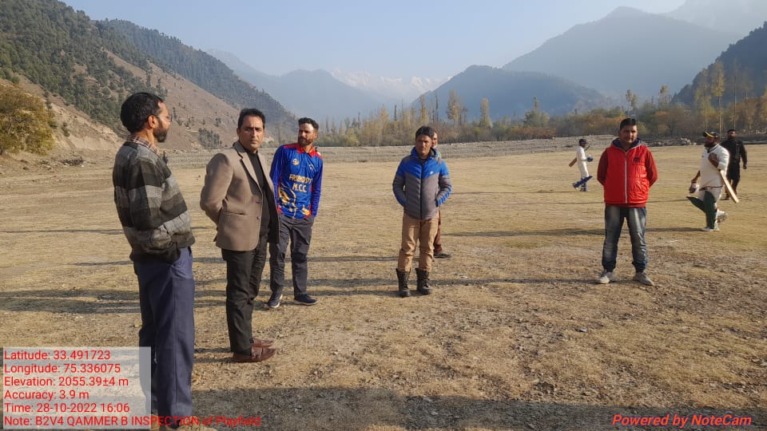

**2 Healthyvillage**

i) Aremeetings relatedtoVillageHealthandSanitationCommitteebeingheldregularly? NO

ii) DoalltheeligibleindividualsbeenprovidedtheGoldenCard? Some Pendency still lies.

iii) ArealltheChildrenbeingimmunizedaspertheSchedulerecommendedbyGovt.ofIndia? YES

iv) ArealltheeligibleindividualsbeenvaccinatedagainstCOVID-19? YES

v) DoesGramPanchayatensurethatallpregnantwomenaregettingnecessaryprenatalcheckups? YES

vi) WhetherallthedeliverieswereInstitutionalizedorconductedbytrainedMidwives? YES

**3 Watersufficientvillage**

i) DoalltheIHHsintheGramPanchayathavewaterpipelineconnections? YES

ii) WhetherGramPanchayathastakenstepsforgreywatermanagement.IfYespleasespecify NO

iii) DoalltheIHHsintheGramPanchayathavetoilets? YES

iv) ArealltheIHHstoiletsfunctionalornot? YES

v) DoalltheSchools/Anganwadicentershavea toiletfacilityornot? YES

vi) Areallthetoiletsintheschools/Aaganwadifunctionalornot?YES

vii) WhetherGramPachachayatBhawanhasseparate toiletsforwomenornot? Yes

Mahila Sabha/ Bal Sabha

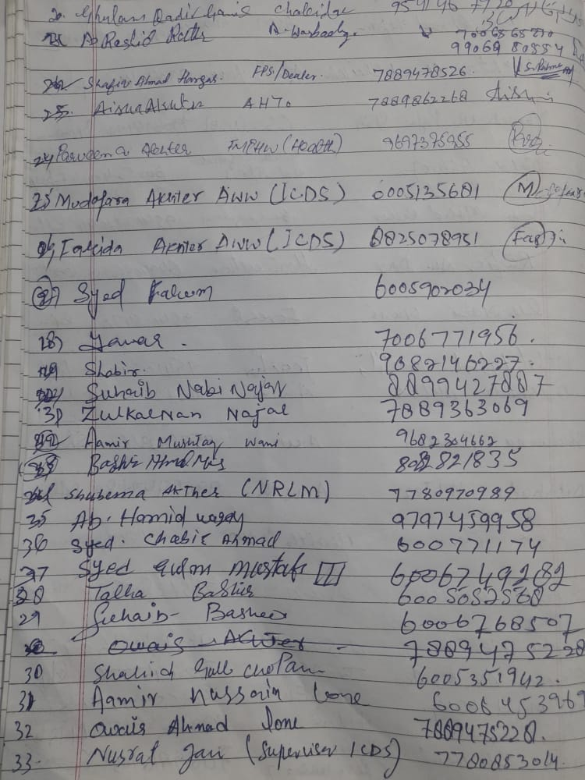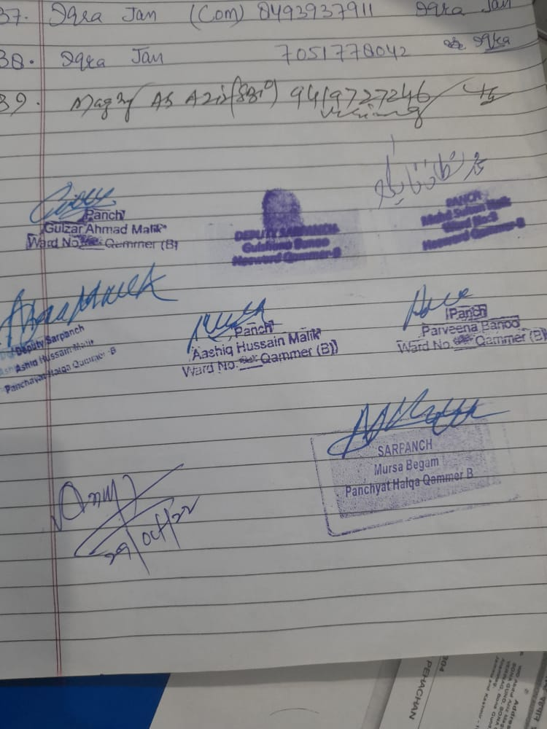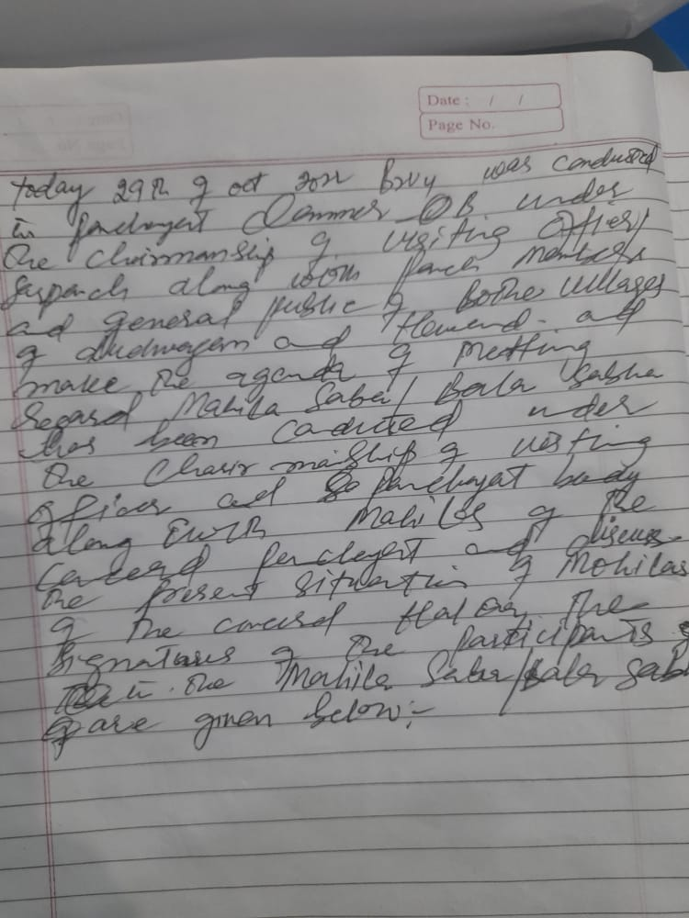

**4 ChildFriendlyvillage**

i) Doallthechildrenundertheageof0-6yearsbeenenrolledintheAnganwadicentersforpre- schooling?Yes/NO YES

ii) HowmanyBalSabha’swereorganizedintheGramPanchayat---------01----------

iii) WhethertheissuesraisedbyBalSabhaareaddressedduringtheGramSabha. Yes/NO YES

iv) WhetherGramPanchayatistrackingthedatarelatedtodropoutchildrenandchildrenwithirregular attendance?Yes/NO. YES

v) DoalltheschoolsundertheGramPanchayathaveseparate toiletsforgirlsandboys?Yes/No NO

**5 Villagewithgoodgovernance**

i) IsCSClocatedintheGramPanchayatBhawanornot? YES

ii) IsthelistofbeneficiariesrelatedtotheSchemes/ProgramsdisplayedontheGrampanchayatwallor not?YES

iii) DoestheGramPanchayathasitsbuildingornot?YES

iv) IstheGramPanchayatofficefunctionalornot?YES

v) Aretheactivities approved undertheHalqaPanchayatDevelopmentPlandisplayedontheGram

Panchayatwallornot? YES

vi) IsSocialAuditofearlierSchemes/Programscarriedoutornot? YES

**6 Povertyfreeandenhancedlivelihoodvillage**

i) HasGramPanchayatdevelopedanycriteria fortheidentificationofthepoor?Yes/Noifyesspecify NO

ii) HavealltheeligiblehouseholdsregisteredinPDSornot? YES

iii) HasGramPanchayatprovidedspaceforSelf-helpGroupsinPanchyatGharforholdingmeetings or not? YES

iv) HavealltheeligiblehouseholdsbeenregisteredforPensionornot? PARTIALLY

v) HasGramPanchayatfacilitatedYouthforSkillEnhancementCoursesandPlacement? YES

vi) HasJobCardsbeendistributedtoalltheeligibleindividualsunderMGNREGA? YES

vii) HasGramPanchayatfacilitatedSHGsforBankAccountLinkages? YES

**7 Sociallysecuredvillage**

i) WhetherGramPanchayatismaintainingdatarelatedtoDifferentlyAbledPeople? YES

ii) IsGramPanchayatOffice DisabledFriendlyornot? YES

iii) Areprovisionsfora separate BudgetundertheResourceEnvelopeforWomenandChildrenmadeor not? NO

iv) DoalltheSchools intheGramPanchayathavefacilitiesforDifferentlyAbledChildrenliketoilets, barrier-freeaccess,etc.,ornot? YES

v) Arealltheeligibleindividualsaregettingpensions,likeoldagepension,widowpension,etc? YES

vi) ArealltheeligiblehouseholdsgettingbenefitsfromIAYornot?

YES

**8 EngenderedDevelopmentinVillage**

i) HowmanyMahilaSabha’swereorganizedintheGramPanchayat. 04

ii) WhetherSHGsfederationshavebeenprovidedspaceformeetings inthePanchayatBhawan(Yes/ No) YES

iii) WhetherGPshavetakenstepsforincreasingwomen’sparticipationinGramSabha(Yes/No) YES

iv) NumberofwomenbeneficiariesheadedhouseholdscoveredunderPDSsystem. 60

v) Numberofbeneficiaries(outoftotaleligiblepopulation)receivingsocialprotectionbenefitsunderPradhanMantriMatritvaVandanaYojana………………….

9 Self-sufficientinfrastructureinthevillage

i. WhetherGPhasa CommunityHallwithaccesstoelectricity,furniture,watersupply, toilet. Only community hall

ii. WhethertheDisastermanagementplanisavailableattheGPLevel(Yes/No) NO

iii. Whetherchild-friendlyparkwithrequiredfacilitiesisavailableinGP(Yes/No)NO

iv. WhethertheGPhaseasyaccesstoGodownforstorage(Yes/No) NO

v. Whetherstreetlightsareprovidedinpublicplacesforensuringsafety(Yes/No)NO

**DAY2ACTIVITIES**

**AGENDANO.2**

SensitizevillageresidentsaboutmyScheme”portal(myscheme.in)whichincludesinformationaboutall theschemesbeingrunbyCentral/State/UT govtacrossthecountry

*(SchemeMaterialavailablefromhttps://jkpanchayat.in/b2v4.php)*

**DAY2ACTIVITIES**

**AGENDANO.3**

HoldmeetingoftheBiodiversityManagementCommitteestodeliberateonissues pertainingtoconserva- tionofbiodiversityandsustainableutilizationofbiologicalresources.HeshouldcheckPeopleBiodiversity register(PBR)ofthatpanchayatandreviewifBiodiversityManagementCommittee constitutedforthat panchayatis holdingminimum4meetings inayearandmeeting onceinevery3months *(RoleofBMC availableathttps://jkpanchayat.in/b2v4.php)*

COMMITTEEMEMBERS PRESENT

BIODIVERSITYREGISTERPHOTOS

PAST 4MEETINGDETAILS-DATES,MINUTESPHOTOS

No meetings have been conducted yet.

**DAY2ACTIVITIES**

**AGENDA4**

Visitingofficershallalsoplanandconductpanchayatlevelconvergencemeeting ofalldepartmentsand prepareVillagedevelopmentplanforvillage,inconsultancywithGrampanchayat,discussitingram sabhaandgetitapproved.

(GPDPformatavailableonhttps://jkpanchayat.in/b2v4.php)

**InadditionGPDPplanshallalsoinclude:**

▪ Touristplaceswhichneedtobedeveloped. Tourism park at Dudwagan

▪ Specificproductwhichneedstobedeveloped Nil

▪ Tourism-homestays Nil

▪ 20candidatesfortrainingunderHimayatschemealongwithtradeinwhich trainingistobegiven. List framed.

**DAY2ACTIVITIES**

**AGENDA5**

Ensuresaturationoffollowingschemesandgivestatus:

|  |  |  |  |
| --- | --- | --- | --- |
| **NAMEOFTHESCHEME** | **TOTALELIGIBLE BENEFICIARIESIN THE VILLAGE** | **TOTALBENEFICIARIESWHO AVAILEDTHEBENEFITSOFTHESCHEME** | **REASONSFOR PENDENCY** |
| GoldenHealthCardunder  AyushmanBharat | 1815 |  |  |
| Jananisurakshayojana | 220 | 180 |  |
| OLDAGEpension | 110 | 68 | Incomplete documents |
| Widowpension | 45 | 17 | Incomplete documents |
| Disabilitypension | 37 | 25 | Incomplete documents |
| Domicilecertificate | No accurate data was available with the department |  |  |
| Kisancreditcard | 267 | 267 | Nil |
| PMkisansammannidhi | 215 | 97 | Problem with mutation |

|  |  |  |  |
| --- | --- | --- | --- |
| Landpassbook | No accurate information was | Provided by the revenue department |  |
| Registrationofvillageven- dorsonGEMportal | 20 | 04 | Not applied |
| Registrationofvillagecon- tractorsonjktendersportal | 100 | 23 | Unknown |
| Registrationofvillagecon- tractorsonPWDportal | 25 | 20 |  |
| Incompletebuildings/pro- jects | Nil | Nil |  |

**DAY2ACTIVITIES**

**AGENDA6**

**NASHAMUKTABHIYAN**

1. Whethergramsabharesolutionpassed. YES

2. Detailsofactivities conducted. Creation of plan 2023-2024 under diffent heads,route map for development of village.

3. Whetherallactivities andGSresolutionuploadedonjkpanchayats.inportal. YES

4. Howmanydrugaddictsinthevillage. 03

5. WhetherreportedtotheDeputyCommissioner. YES

6. Howmanyregisteredforrehabilitationundergovernmentprogramme. Nil

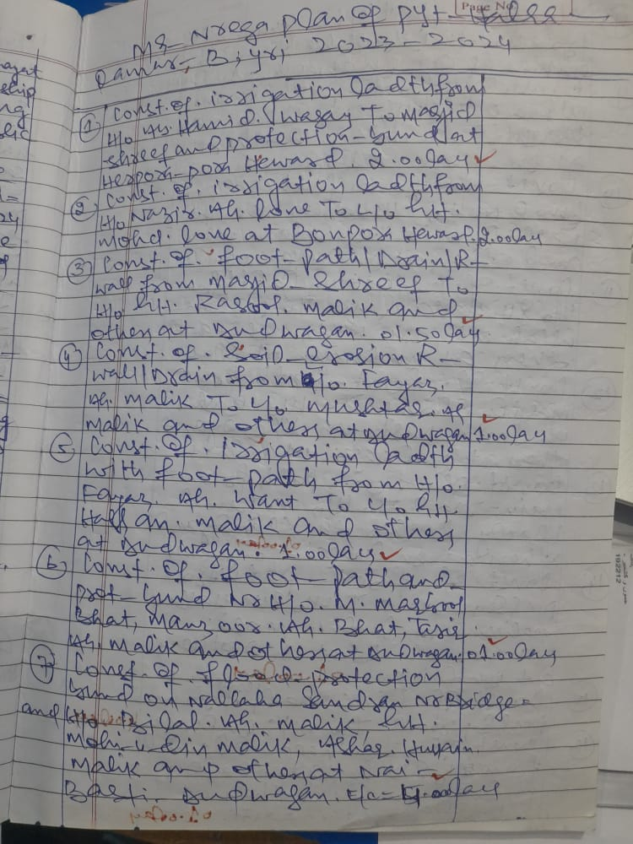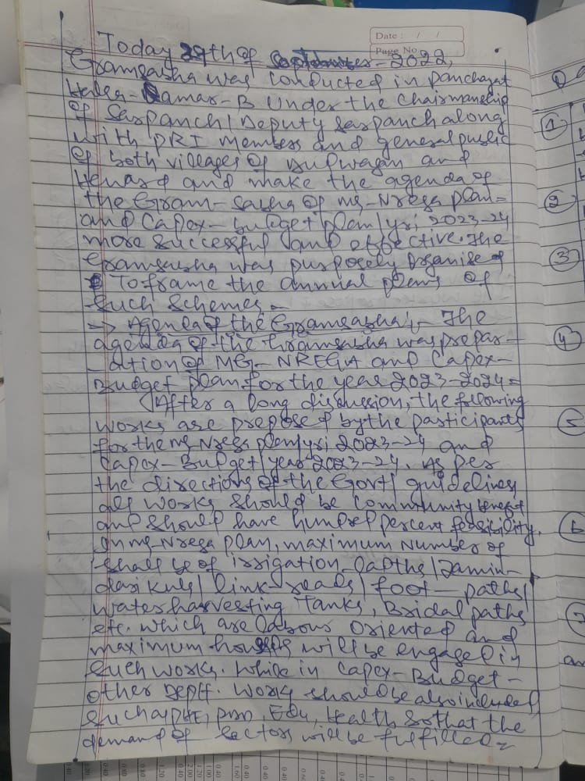

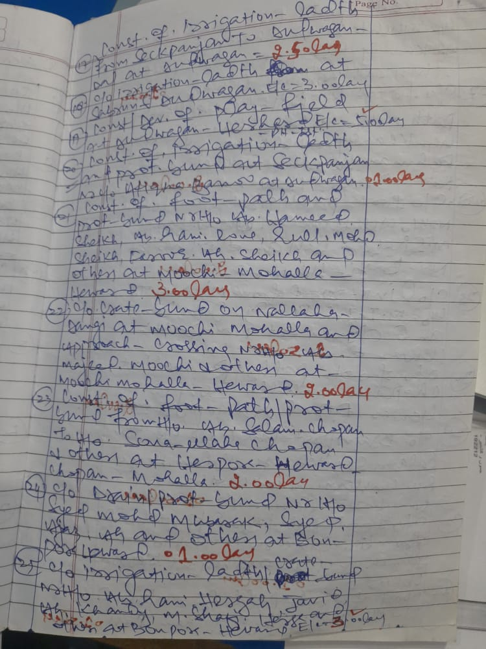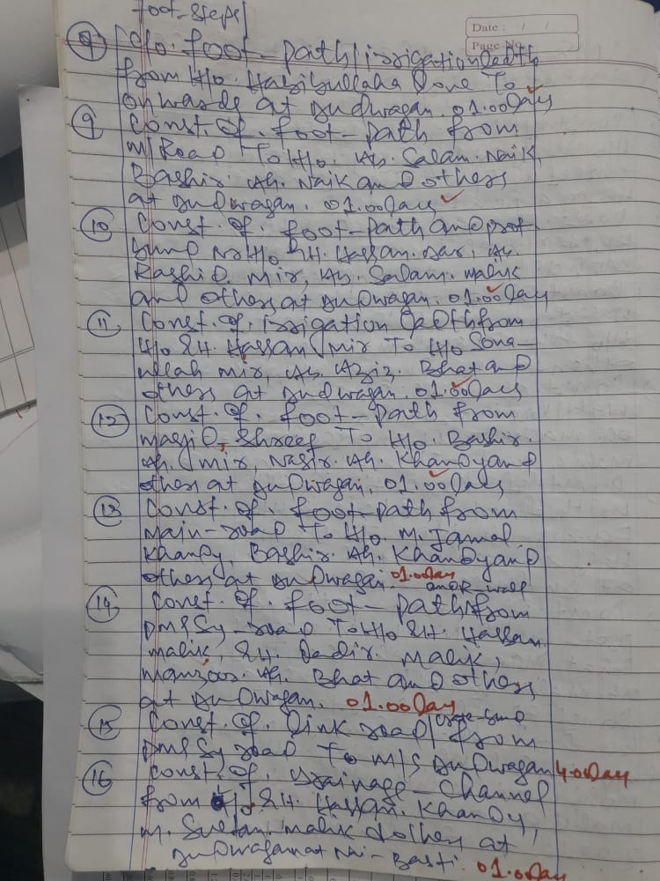

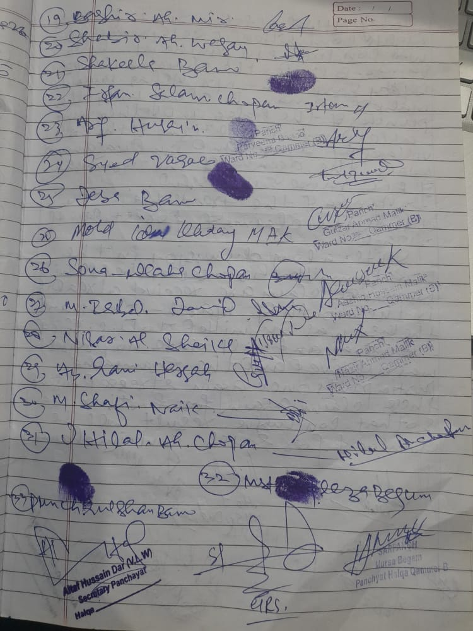

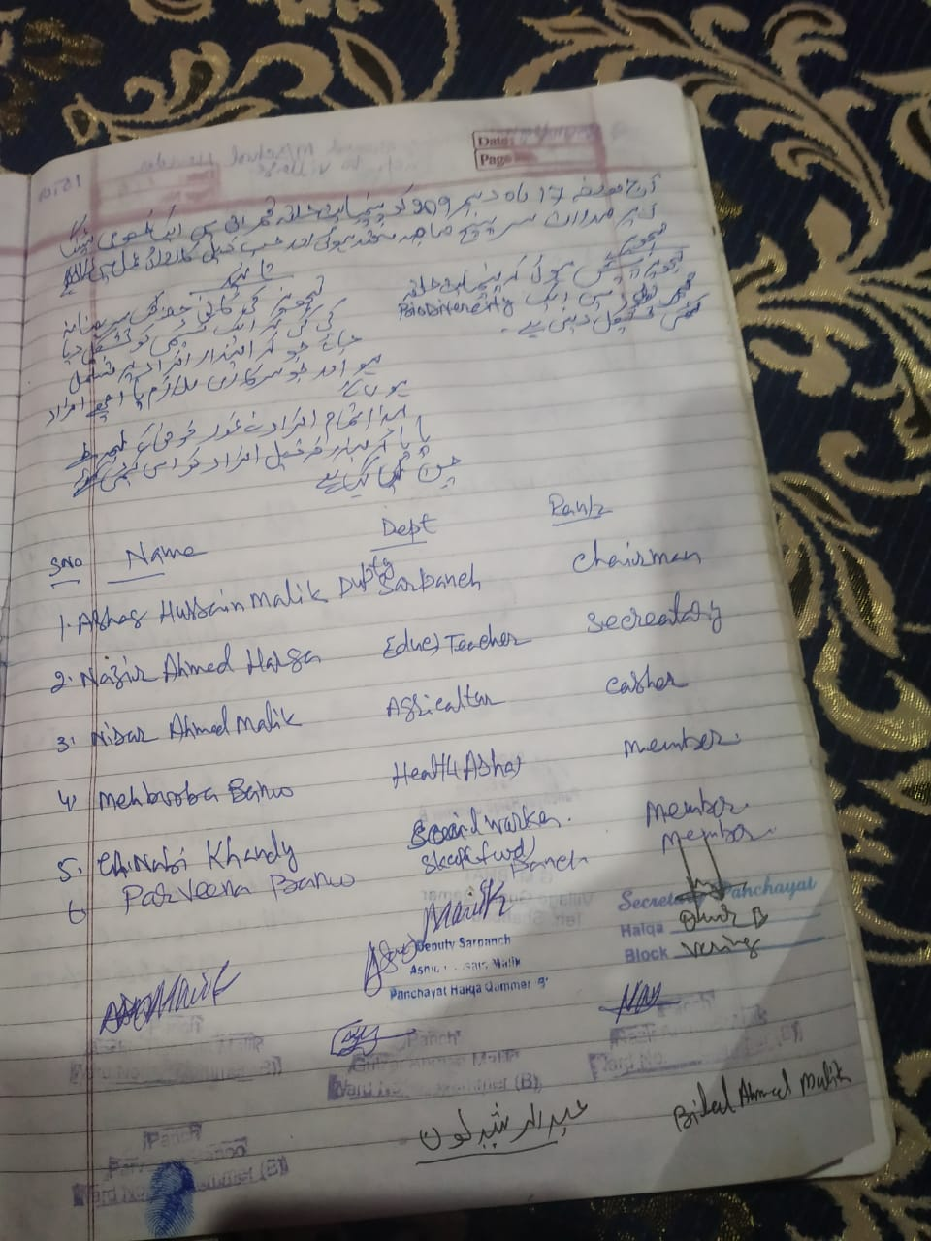

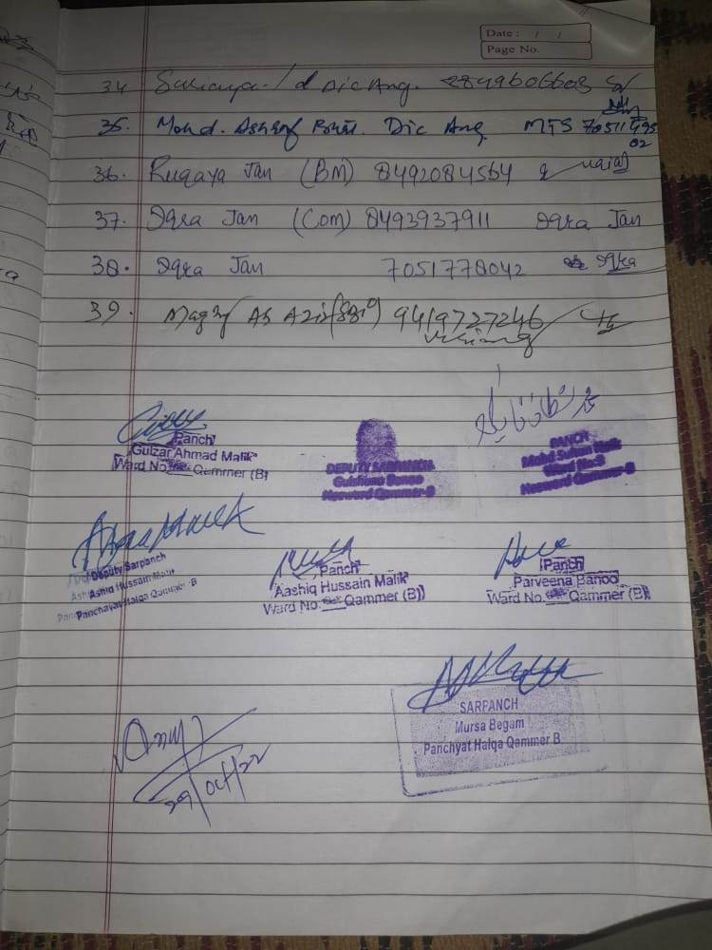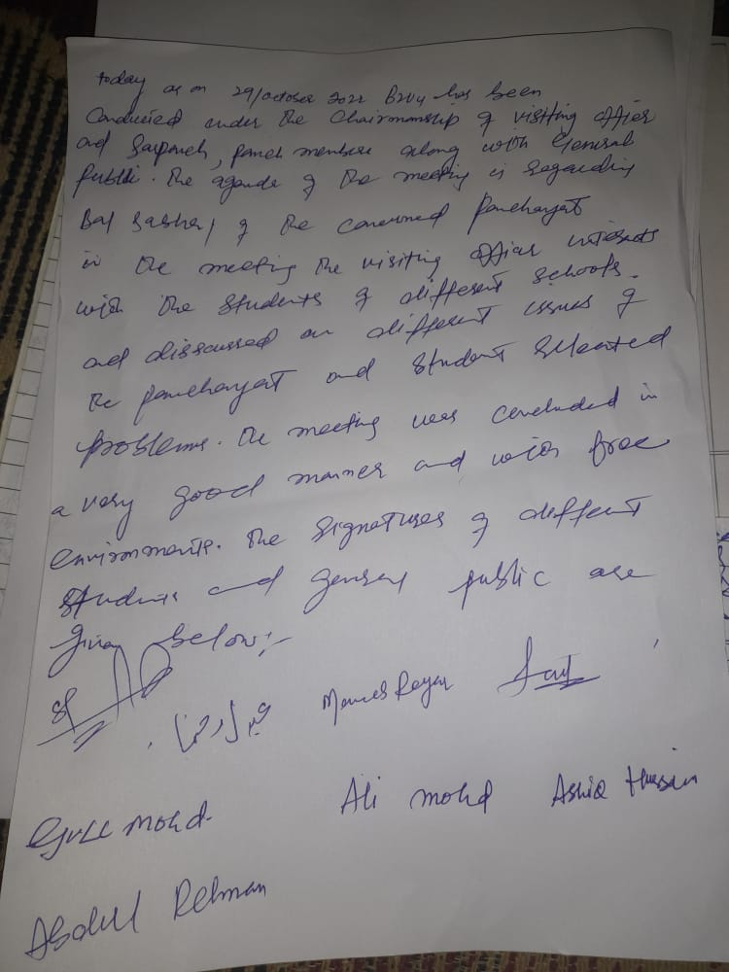

**DAY2ACTIVITIES**

**AGENDA7**

**SOCIALAUDIT**

Conductsocialauditofatleast5workseachunderfollowingschemes:

|  |  |  |  |  |  |  |
| --- | --- | --- | --- | --- | --- | --- |
| NAMEOFTHE SCHEME | DETAILSOFTHE WORKS | YEAROFWORK APPROVAL | AMOUNT APPROVED  FORTHEWORK | WHETHER  WORKEXECUTED SATISFACTORILY | GEO- TAGGED PHOTOS | ANY GRIEVANCE RECORDED RELATINGTOTHAT WORK |
| MGNREGA |  | 2022-2023 | 10.5L | YES | YES | Nil |
| PMAY |  | 2022-2023 | 8.00L | YES | YES | Nil |
| IHHL  UNDERSBM-G |  | 2022-2023 | 0.60L | YES | YES | Nil |
| CSCUNDER SBMG |  | 2021-2022 | 1.80L | YES | YES | Nil |
| AMRIT SAROVARS |  | 2022-2023 | 2.00L | YES | YES | Nil |

**DAY2ACTIVITIES**

**AGENDA8**

**MAHILASABHA**

Totalwomeninthevillageabovetheageof18. 600

Totalattended. 30

Proceedings: Mahila sabha was all about the different schemes run by the government for women, registration of women's in the self help groups and the complaints and suggestions from the women.

*(Plinsertpointerstobediscussedthere–referpalliproceedings)*

**DAY2ACTIVITIES**

**AGENDA9**

**BALSABHA**

Holda balsabhaandrecordproceedings

Totalchildreninthevillageabovetheageof5 years 200

Totalattended. 75

Proceedings: Drug free environment, human trafficking, sex abuse among children, cleanliness and Amrit Mahal utsav.

*(Plinsertpointerstobediscussedthere–referpalliproceedings)*

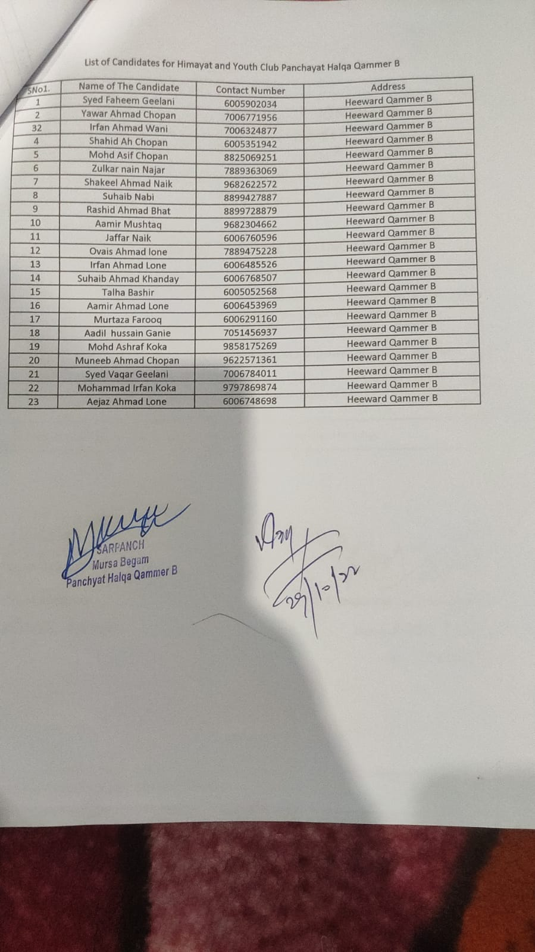

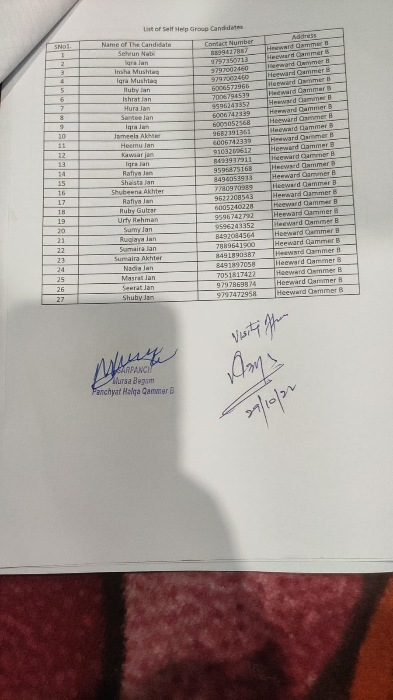

**DAY2ACTIVITIES**

**AGENDA10**

**INAUGURATIONS**

|  |  |  |  |
| --- | --- | --- | --- |
| **SR NO.** | **ASSETS/ACTIVITIES INAUGRATED** | **STATUSOFTHEASSET/AC- TIVITIES(NUMBER,OTHER DETAILS)** | **GEO-TAGGED PHOTOS** |
|  | VILLAGEHAATunderJKSRLM (SUN- DAYMARKET) | Space identified for village haat. | Yes |
|  | PMAYhousesifanyreadyforinaugra- tion | Completed and inaugurated | Yes |
|  | Swachhgramprojects-segregation shedsetc | Nil | Yes |
|  | Amritsarovars | Completed |  |
|  | Sportskits | Foot ball 01 no distributed to the school children | Yes |
|  | Villageculturalevents | Conducted 3 nos | Yes |
|  | JJMassets/projects | 01 completed | Yes |
|  | Anyothertobeidentifiedatdistrict level | Nil |  |

**FOLLOWUPOF(B2V1,B2V2&B2V3):**

*(Prefilledexcelsheet tobetakenfromdistrictlevel/andalsotobedownloaded*

*from*[*www.jkpanchayat.in)*](http://www.jkpanchayat.in)

|  |  |  |  |
| --- | --- | --- | --- |
| S.NO. | Particulars | Actiontaken | Remarks# |
| I. UrgentPublicRequirements/Demands-B2V1 | | | |
| 1.construction of culvet | 50 mtrs | No Action | No funds |
| 2.C/o Boundary wall to | Middle school | Pending |  |
| 3. Play Field | Phase III | Completed |  |
| 4. Internet walling to | Save encroachment | Completed |  |
| 5. Proper drainage | System | Partially completed |  |
| 6. Road connectivity to | Chopan basti | Pending | No funds |
| 7 |  |  |  |
| II. UrgentPublicRequirements/Demands-B2V2 | | | |
| 1. Building for MS | Dodwagan | No action | No funds |
| 2. Foot crossing at | Nala sandran | No action | No funds |
| 3. Bund both sides of | Nala sandran | No action |  |
| 4. Internal walling to | Save environment | Completed |  |
| 5. Proper drainage | Walling under Panchayat ghar | Completed |  |
| 6. Revenue village |  | No action |  |
| 7. Road for chopan | Mohalla | No action |  |
| S.NO. | Particulars | Actiontaken | Remarks# |
| III. MajorProblems–B2V1 | | | |
| 1. Construction of culvet | Foot crossing at Nala sandran | No action taken | No funds |
| 2 |  |  |  |
| 3 |  |  |  |

|  |  |  |  |
| --- | --- | --- | --- |
| 4 |  |  |  |
| 5 |  |  |  |
| IV. MajorProblems-B2V2 | | | |
| 1. Construction of culvet | foot bridge at Nala sandran | No Action taken |  |
| 2 |  |  |  |
| 3 |  |  |  |
| 4 |  |  |  |
| 5 |  |  |  |
| V. MajorProblems-B2V3 | | | |
| 1. Foot bridge at nala | Sandran | No action taken |  |
| 2 |  |  |  |
| 3 |  |  |  |
| 4 |  |  |  |
| 5 |  |  |  |
| VI. MajorComplaints-B2V1 | | | |
| 1. |  |  |  |
| 2 |  |  |  |
| 3 |  |  |  |
| VII. MajorComplaints-B2V2 | | | |
| 1 |  |  |  |
| 2 |  |  |  |
| 3 |  |  |  |
| VIII. MajorComplaints-B2V3 | | | |
| 1 |  |  |  |
| 2 |  |  |  |
| 3 |  |  |  |

